Extended data

Table of Contents

# PD-vulnerable neurons are less resilient to cell stress induced by hydrogen peroxide

## Figure 2-1

Nuclei (DAPI) count

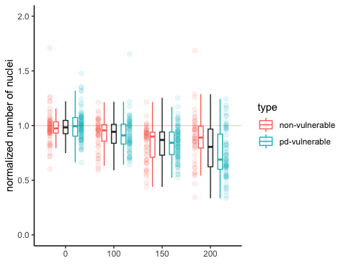

Kurskal-Wallis

Kruskal-Wallis rank sum test  
  
data: dapi_normalized by hydrogen_peroxide  
Kruskal-Wallis chi-squared = 91.227, df = 3, p-value < 2.2e-16

Dunn test

| Comparison | Z | P.unadj | P.adj |
| --- | --- | --- | --- |
| 0 - 100 | 3.4001879 | 0.0006734 | 0.0040404 |
| 0 - 150 | 7.8043915 | 0.0000000 | 0.0000000 |
| 100 - 150 | 3.9718484 | 0.0000713 | 0.0004279 |
| 0 - 200 | 8.1835348 | 0.0000000 | 0.0000000 |
| 100 - 200 | 4.5069337 | 0.0000066 | 0.0000395 |
| 150 - 200 | 0.7245953 | 0.4687004 | 1.0000000 |

Neuron count

## Figure 2-2

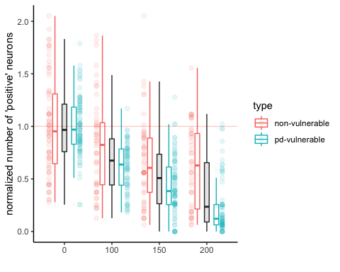

Kurskal-Wallis

Kruskal-Wallis rank sum test  
  
data: neuron_normalized by hydrogen_peroxide  
Kruskal-Wallis chi-squared = 164.32, df = 3, p-value < 2.2e-16

Dunn test

| Comparison | Z | P.unadj | P.adj |
| --- | --- | --- | --- |
| 0 - 100 | 5.867938 | 0.0000000 | 0.0000000 |
| 0 - 150 | 9.779527 | 0.0000000 | 0.0000000 |
| 100 - 150 | 3.408957 | 0.0006521 | 0.0039127 |
| 0 - 200 | 11.754230 | 0.0000000 | 0.0000000 |
| 100 - 200 | 5.563542 | 0.0000000 | 0.0000002 |
| 150 - 200 | 2.386850 | 0.0169934 | 0.1019605 |

# Differential vulnerability of neurons to hydrogen peroxide

## Figure 3-1

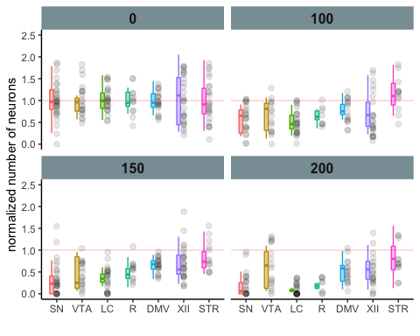

Kruskal-Wallis and Dunn test for each concetration

0 micromollar

Kruskal-Wallis rank sum test  
  
data: neuron_normalized by neuron  
Kruskal-Wallis chi-squared = 0.43515, df = 6, p-value = 0.9985

| Comparison | Z | P.unadj | P.adj |
| --- | --- | --- | --- |
| DMV - LC | 0.0460099 | 0.9633024 | 1 |
| DMV - R | -0.0170668 | 0.9863833 | 1 |
| LC - R | -0.0570271 | 0.9545236 | 1 |
| DMV - SN | 0.0596846 | 0.9524069 | 1 |
| LC - SN | 0.0120472 | 0.9903880 | 1 |
| R - SN | 0.0686879 | 0.9452381 | 1 |
| DMV - STR | 0.3880572 | 0.6979737 | 1 |
| LC - STR | 0.3587423 | 0.7197879 | 1 |
| R - STR | 0.3499389 | 0.7263845 | 1 |
| SN - STR | 0.3661004 | 0.7142902 | 1 |
| DMV - VTA | 0.3929825 | 0.6943324 | 1 |
| LC - VTA | 0.3644469 | 0.7155243 | 1 |
| R - VTA | 0.3573996 | 0.7207927 | 1 |
| SN - VTA | 0.3708062 | 0.7107819 | 1 |
| STR - VTA | 0.0223996 | 0.9821292 | 1 |
| DMV - XII | 0.3419833 | 0.7323635 | 1 |
| LC - XII | 0.3099783 | 0.7565775 | 1 |
| R - XII | 0.3087642 | 0.7575009 | 1 |
| SN - XII | 0.3153817 | 0.7524719 | 1 |
| STR - XII | -0.0591645 | 0.9528211 | 1 |
| VTA - XII | -0.0792485 | 0.9368350 | 1 |

100 micromollar

Kruskal-Wallis rank sum test  
  
data: neuron_normalized by neuron  
Kruskal-Wallis chi-squared = 27.496, df = 6, p-value = 0.0001169

| Comparison | Z | P.unadj | P.adj |
| --- | --- | --- | --- |
| DMV - LC | 3.0576763 | 0.0022306 | 0.0468427 |
| DMV - R | 1.3473497 | 0.1778676 | 1.0000000 |
| LC - R | -0.9882252 | 0.3230424 | 1.0000000 |
| DMV - SN | 2.1096460 | 0.0348889 | 0.7326661 |
| LC - SN | -0.9597891 | 0.3371614 | 1.0000000 |
| R - SN | 0.2807619 | 0.7788930 | 1.0000000 |
| DMV - STR | -1.8377294 | 0.0661023 | 1.0000000 |
| LC - STR | -4.7762384 | 0.0000018 | 0.0000375 |
| R - STR | -2.8157629 | 0.0048662 | 0.1021893 |
| SN - STR | -3.8739054 | 0.0001071 | 0.0022492 |
| DMV - VTA | 1.1366643 | 0.2556787 | 1.0000000 |
| LC - VTA | -1.7571423 | 0.0788936 | 1.0000000 |
| R - VTA | -0.3995113 | 0.6895165 | 1.0000000 |
| SN - VTA | -0.8624297 | 0.3884511 | 1.0000000 |
| STR - VTA | 2.8668055 | 0.0041464 | 0.0870739 |
| DMV - XII | 1.2946210 | 0.1954510 | 1.0000000 |
| LC - XII | -1.9376752 | 0.0526629 | 1.0000000 |
| R - XII | -0.3945921 | 0.6931439 | 1.0000000 |
| SN - XII | -0.9231033 | 0.3559534 | 1.0000000 |
| STR - XII | 3.1542542 | 0.0016091 | 0.0337909 |
| VTA - XII | 0.0389910 | 0.9688976 | 1.0000000 |

150 micromollar

Kruskal-Wallis rank sum test  
  
data: neuron_normalized by neuron  
Kruskal-Wallis chi-squared = 43.006, df = 6, p-value = 1.163e-07

| Comparison | Z | P.unadj | P.adj |
| --- | --- | --- | --- |
| DMV - LC | 3.4092318 | 0.0006515 | 0.0136807 |
| DMV - R | 1.8603390 | 0.0628376 | 1.0000000 |
| LC - R | -0.9981418 | 0.3182106 | 1.0000000 |
| DMV - SN | 4.5926293 | 0.0000044 | 0.0000919 |
| LC - SN | 1.1229937 | 0.2614402 | 1.0000000 |
| R - SN | 1.9281774 | 0.0538331 | 1.0000000 |
| DMV - STR | -0.9114641 | 0.3620509 | 1.0000000 |
| LC - STR | -3.8608477 | 0.0001130 | 0.0023729 |
| R - STR | -2.4791760 | 0.0131686 | 0.2765412 |
| SN - STR | -4.8615781 | 0.0000012 | 0.0000245 |
| DMV - VTA | 2.0924238 | 0.0364006 | 0.7644130 |
| LC - VTA | -1.0786649 | 0.2807371 | 1.0000000 |
| R - VTA | 0.0290625 | 0.9768148 | 1.0000000 |
| SN - VTA | -2.1280995 | 0.0333288 | 0.6999055 |
| STR - VTA | 2.7134661 | 0.0066583 | 0.1398251 |
| DMV - XII | 0.5206388 | 0.6026184 | 1.0000000 |
| LC - XII | -3.0994014 | 0.0019391 | 0.0407215 |
| R - XII | -1.5027565 | 0.1329018 | 1.0000000 |
| SN - XII | -4.3683599 | 0.0000125 | 0.0002629 |
| STR - XII | 1.3973720 | 0.1623017 | 1.0000000 |
| VTA - XII | -1.7165660 | 0.0860585 | 1.0000000 |

200 micromollar

Kruskal-Wallis rank sum test  
  
data: neuron_normalized by neuron  
Kruskal-Wallis chi-squared = 55.538, df = 6, p-value = 3.608e-10

| Comparison | Z | P.unadj | P.adj |
| --- | --- | --- | --- |
| DMV - LC | 4.6306976 | 0.0000036 | 0.0000765 |
| DMV - R | 1.7772743 | 0.0755231 | 1.0000000 |
| LC - R | -1.7758038 | 0.0757653 | 1.0000000 |
| DMV - SN | 3.6600377 | 0.0002522 | 0.0052957 |
| LC - SN | -0.8816647 | 0.3779581 | 1.0000000 |
| R - SN | 1.0949050 | 0.2735583 | 1.0000000 |
| DMV - STR | -0.9378490 | 0.3483220 | 1.0000000 |
| LC - STR | -5.2402220 | 0.0000002 | 0.0000034 |
| R - STR | -2.4707312 | 0.0134837 | 0.2831579 |
| SN - STR | -4.3427853 | 0.0000141 | 0.0002954 |
| DMV - VTA | 0.2734029 | 0.7845435 | 1.0000000 |
| LC - VTA | -4.3311997 | 0.0000148 | 0.0003114 |
| R - VTA | -1.5540418 | 0.1201745 | 1.0000000 |
| SN - VTA | -3.3718458 | 0.0007467 | 0.0156799 |
| STR - VTA | 1.1909709 | 0.2336650 | 1.0000000 |
| DMV - XII | -0.0642890 | 0.9487401 | 1.0000000 |
| LC - XII | -5.0075611 | 0.0000006 | 0.0000116 |
| R - XII | -1.8911995 | 0.0585977 | 1.0000000 |
| SN - XII | -3.9502450 | 0.0000781 | 0.0016395 |
| STR - XII | 0.9217728 | 0.3566471 | 1.0000000 |
| VTA - XII | -0.3524809 | 0.7244776 | 1.0000000 |

Estimation statistics

0 micromollar

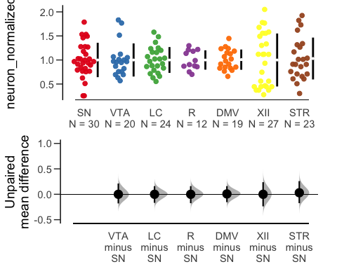

| control_group | test_group | difference | bca_ci_low | bca_ci_high |
| --- | --- | --- | --- | --- |
| SN | VTA | 0.000 | -0.179 | 0.212 |
| SN | LC | 0.000 | -0.168 | 0.160 |
| SN | R | 0.000 | -0.175 | 0.160 |
| SN | DMV | 0.007 | -0.155 | 0.160 |
| SN | XII | 0.000 | -0.237 | 0.238 |
| SN | STR | 0.030 | -0.174 | 0.259 |

100 micromollar

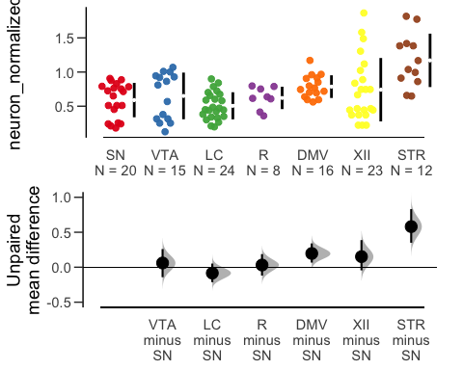

| control_group | test_group | difference | bca_ci_low | bca_ci_high |
| --- | --- | --- | --- | --- |
| SN | VTA | 0.061 | -0.142 | 0.260 |
| SN | LC | -0.084 | -0.213 | 0.052 |
| SN | R | 0.031 | -0.119 | 0.187 |
| SN | DMV | 0.197 | 0.066 | 0.340 |
| SN | XII | 0.152 | -0.044 | 0.388 |
| SN | STR | 0.581 | 0.350 | 0.831 |

150 micromollar

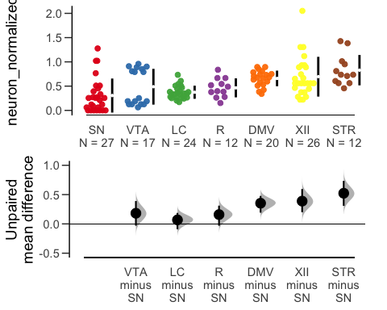

| control_group | test_group | difference | bca_ci_low | bca_ci_high |
| --- | --- | --- | --- | --- |
| SN | VTA | 0.182 | -0.031 | 0.390 |
| SN | LC | 0.068 | -0.092 | 0.188 |
| SN | R | 0.159 | -0.032 | 0.311 |
| SN | DMV | 0.353 | 0.192 | 0.478 |
| SN | XII | 0.388 | 0.200 | 0.595 |
| SN | STR | 0.523 | 0.308 | 0.734 |

200 micromollar

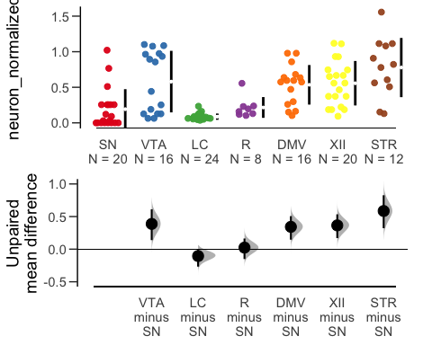

| control_group | test_group | difference | bca_ci_low | bca_ci_high |
| --- | --- | --- | --- | --- |
| SN | VTA | 0.387 | 0.139 | 0.611 |
| SN | LC | -0.105 | -0.268 | -0.011 |
| SN | R | 0.024 | -0.151 | 0.163 |
| SN | DMV | 0.342 | 0.146 | 0.507 |
| SN | XII | 0.365 | 0.170 | 0.534 |
| SN | STR | 0.585 | 0.322 | 0.827 |

# No overt difference in mitochondrial ROS production observed between neurons

## Figure 4-2

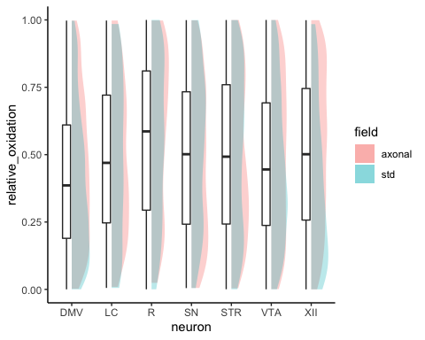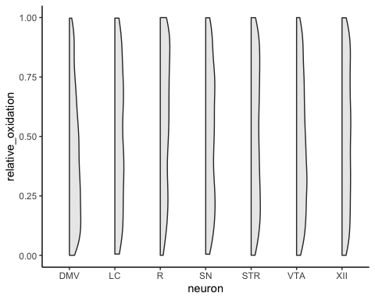

Kruskal-Wallis

Kruskal-Wallis rank sum test  
  
data: relative_oxidation by neuron  
Kruskal-Wallis chi-squared = 133.58, df = 6, p-value < 2.2e-16

Dunn

| Comparison | Z | P.unadj | P.adj |
| --- | --- | --- | --- |
| DMV - LC | -3.3231328 | 0.0008901 | 0.0186926 |
| DMV - R | -7.8362467 | 0.0000000 | 0.0000000 |
| LC - R | -2.3435415 | 0.0191016 | 0.4011343 |
| DMV - SN | -5.8719183 | 0.0000000 | 0.0000001 |
| LC - SN | -0.2064038 | 0.8364755 | 1.0000000 |
| R - SN | 2.8602152 | 0.0042335 | 0.0889043 |
| DMV - STR | -7.9501041 | 0.0000000 | 0.0000000 |
| LC - STR | -0.3988749 | 0.6899854 | 1.0000000 |
| R - STR | 2.9232967 | 0.0034635 | 0.0727327 |
| SN - STR | -0.2802927 | 0.7792529 | 1.0000000 |
| DMV - VTA | -5.1989318 | 0.0000002 | 0.0000042 |
| LC - VTA | 0.9733339 | 0.3303874 | 1.0000000 |
| R - VTA | 4.6926942 | 0.0000027 | 0.0000566 |
| SN - VTA | 1.8997528 | 0.0574656 | 1.0000000 |
| STR - VTA | 2.7090509 | 0.0067476 | 0.1416996 |
| DMV - XII | -7.9440379 | 0.0000000 | 0.0000000 |
| LC - XII | -0.5001405 | 0.6169762 | 1.0000000 |
| R - XII | 2.7666535 | 0.0056635 | 0.1189333 |
| SN - XII | -0.4371405 | 0.6620094 | 1.0000000 |
| STR - XII | -0.1955555 | 0.8449581 | 1.0000000 |
| VTA - XII | -2.8474318 | 0.0044074 | 0.0925544 |

Estimation statistics

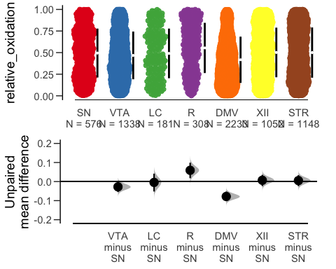

| control_group | test_group | difference | bca_ci_low | bca_ci_high |
| --- | --- | --- | --- | --- |
| SN | VTA | -0.028 | -0.055 | 0.001 |
| SN | LC | -0.004 | -0.052 | 0.041 |
| SN | R | 0.059 | 0.018 | 0.099 |
| SN | DMV | -0.078 | -0.103 | -0.052 |
| SN | XII | 0.007 | -0.023 | 0.035 |
| SN | STR | 0.005 | -0.024 | 0.033 |

Comparing axonal vs std (note - very small effect - significant)

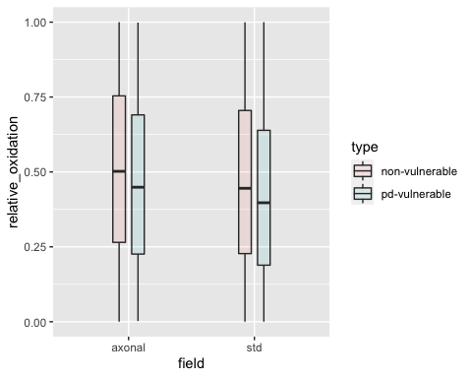

Welch Two Sample t-test - Axonal only

Welch Two Sample t-test  
  
data: relative_oxidation by type  
t = 4.0736, df = 3485, p-value = 4.732e-05  
alternative hypothesis: true difference in means is not equal to 0  
95 percent confidence interval:  
 0.01993059 0.05691848  
sample estimates:  
mean in group non-vulnerable mean in group pd-vulnerable   
 0.5063470 0.4679225

Welch Two Sample t-test - STD only

Welch Two Sample t-test  
  
data: relative_oxidation by type  
t = 4.0736, df = 3485, p-value = 4.732e-05  
alternative hypothesis: true difference in means is not equal to 0  
95 percent confidence interval:  
 0.01993059 0.05691848  
sample estimates:  
mean in group non-vulnerable mean in group pd-vulnerable   
 0.5063470 0.4679225

Comparing vulnerable vs non-vulnerable - significant by very small effect size

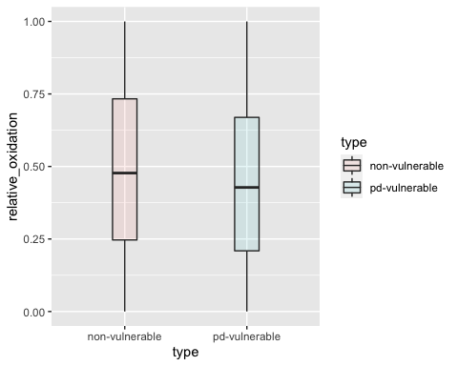

Welch Two Sample t-test

Welch Two Sample t-test  
  
data: relative_oxidation by type  
t = 6.016, df = 6820.1, p-value = 1.881e-09  
alternative hypothesis: true difference in means is not equal to 0  
95 percent confidence interval:  
 0.02759581 0.05427272  
sample estimates:  
mean in group non-vulnerable mean in group pd-vulnerable   
 0.4884508 0.4475166

### Intermitochondrial distance (roGFP)

## Figure 4-3

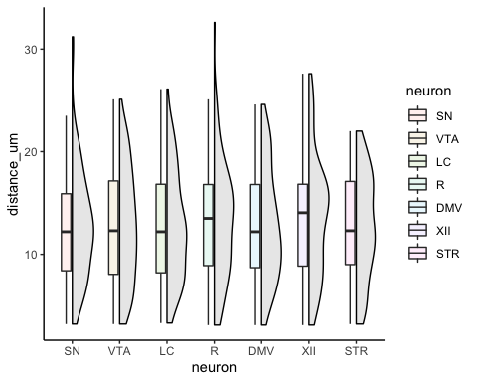

Kurskal-Wallis

Kruskal-Wallis rank sum test  
  
data: distance_um by neuron  
Kruskal-Wallis chi-squared = 1.4927, df = 6, p-value = 0.96

Estimation statistics — not applicable

# PD-vulnerable neurons have large axonal domains, that are globally more complex than PD-resilient neurons

## Figure 6-1

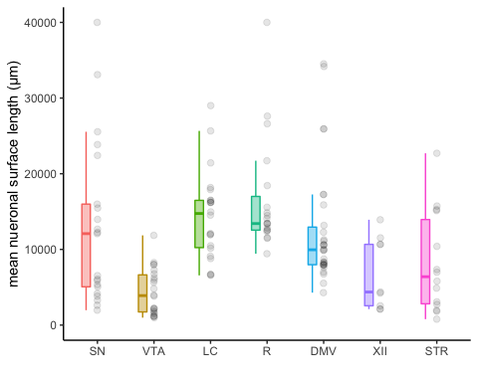

Kruskal-Wallis

Kruskal-Wallis rank sum test  
  
data: axon_area_per_neuron by neuron  
Kruskal-Wallis chi-squared = 49.602, df = 6, p-value = 5.649e-09

Dunn

| Comparison | Z | P.unadj | P.adj |
| --- | --- | --- | --- |
| DMV - LC | -1.4910572 | 0.1359465 | 1.0000000 |
| DMV - R | -2.1697753 | 0.0300239 | 0.6305013 |
| LC - R | -0.6949384 | 0.4870939 | 1.0000000 |
| DMV - SN | 0.3799178 | 0.7040065 | 1.0000000 |
| LC - SN | 1.7261794 | 0.0843151 | 1.0000000 |
| R - SN | 2.3506380 | 0.0187413 | 0.3935664 |
| DMV - STR | 1.8240271 | 0.0681480 | 1.0000000 |
| LC - STR | 2.9510478 | 0.0031670 | 0.0665066 |
| R - STR | 3.4823377 | 0.0004971 | 0.0104382 |
| SN - STR | 1.3978009 | 0.1621729 | 1.0000000 |
| DMV - VTA | 4.2860413 | 0.0000182 | 0.0003820 |
| LC - VTA | 5.3781860 | 0.0000001 | 0.0000016 |
| R - VTA | 5.8726242 | 0.0000000 | 0.0000001 |
| SN - VTA | 3.5891017 | 0.0003318 | 0.0069682 |
| STR - VTA | 1.7920665 | 0.0731223 | 1.0000000 |
| DMV - XII | 1.8995788 | 0.0574884 | 1.0000000 |
| LC - XII | 2.8822979 | 0.0039479 | 0.0829051 |
| R - XII | 3.3562827 | 0.0007900 | 0.0165895 |
| SN - XII | 1.5407671 | 0.1233735 | 1.0000000 |
| STR - XII | 0.3079467 | 0.7581229 | 1.0000000 |
| VTA - XII | -1.2158840 | 0.2240291 | 1.0000000 |

Estimation statistics

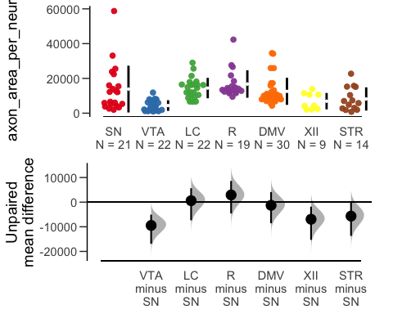

| control_group | test_group | difference | bca_ci_low | bca_ci_high |
| --- | --- | --- | --- | --- |
| SN | VTA | -9453.439 | -16873.614 | -5078.015 |
| SN | LC | 594.818 | -7337.320 | 5639.899 |
| SN | R | 2921.211 | -4572.159 | 8595.133 |
| SN | DMV | -1285.267 | -8569.333 | 4096.503 |
| SN | XII | -6943.180 | -15300.619 | -1848.567 |
| SN | STR | -5664.433 | -13692.202 | -190.316 |

*PD-vulnerable vs PD-resilient*

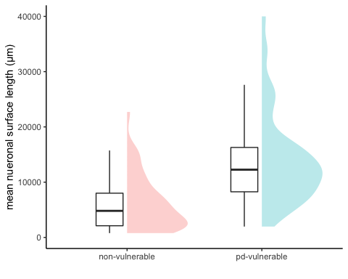

Wilcoxon rank sum test with continuity correction  
  
data: data$axon_area_per_neuron by data$type  
W = 723, p-value = 6.78e-10  
alternative hypothesis: true location shift is not equal to 0

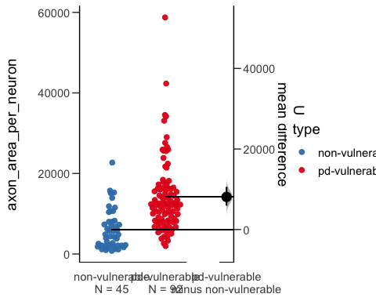

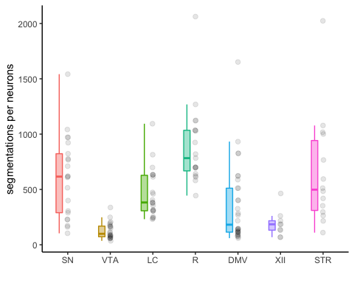

Kruskal-Wallis

Kruskal-Wallis rank sum test  
  
data: count_per_neuron by neuron  
Kruskal-Wallis chi-squared = 67.386, df = 6, p-value = 1.403e-12

Dunn

| Comparison | Z | P.unadj | P.adj |
| --- | --- | --- | --- |
| DMV - LC | -2.1117441 | 0.0347084 | 0.7288765 |
| DMV - R | -4.9124144 | 0.0000009 | 0.0000189 |
| LC - R | -2.7062408 | 0.0068050 | 0.1429043 |
| DMV - SN | -2.8158643 | 0.0048646 | 0.1021570 |
| LC - SN | -0.6831796 | 0.4944934 | 1.0000000 |
| R - SN | 2.0185955 | 0.0435293 | 0.9141149 |
| DMV - STR | -2.4474832 | 0.0143858 | 0.3021014 |
| LC - STR | -0.5833195 | 0.5596782 | 1.0000000 |
| R - STR | 1.8401285 | 0.0657494 | 1.0000000 |
| SN - STR | 0.0260784 | 0.9791948 | 1.0000000 |
| DMV - VTA | 2.7269895 | 0.0063915 | 0.1342216 |
| LC - VTA | 4.5046159 | 0.0000066 | 0.0001396 |
| R - VTA | 7.0429233 | 0.0000000 | 0.0000000 |
| SN - VTA | 5.1351081 | 0.0000003 | 0.0000059 |
| STR - VTA | 4.5560173 | 0.0000052 | 0.0001095 |
| DMV - XII | 1.1254594 | 0.2603944 | 1.0000000 |
| LC - XII | 2.5790534 | 0.0099071 | 0.2080501 |
| R - XII | 4.6164416 | 0.0000039 | 0.0000820 |
| SN - XII | 3.0845492 | 0.0020386 | 0.0428108 |
| STR - XII | 2.8552967 | 0.0042997 | 0.0902929 |
| VTA - XII | -0.8534673 | 0.3934002 | 1.0000000 |

Estimation statistics

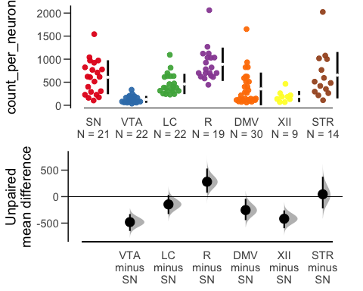

| control_group | test_group | difference | bca_ci_low | bca_ci_high |
| --- | --- | --- | --- | --- |
| SN | VTA | -480.637 | -647.429 | -330.347 |
| SN | LC | -146.549 | -328.531 | 30.970 |
| SN | R | 280.998 | 73.514 | 530.019 |
| SN | DMV | -253.894 | -443.260 | -42.919 |
| SN | XII | -417.482 | -595.935 | -259.965 |
| SN | STR | 43.933 | -221.949 | 374.863 |

*PD-vulnerable vs PD-resilient*

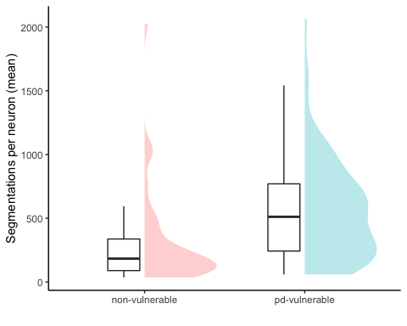

Wilcoxon rank sum test with continuity correction  
  
data: data$count_per_neuron by data$type  
W = 1068, p-value = 4.433e-06  
alternative hypothesis: true location shift is not equal to 0

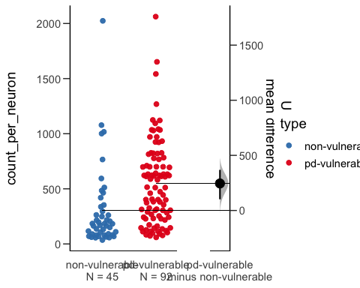

Average segmentation length (µm)

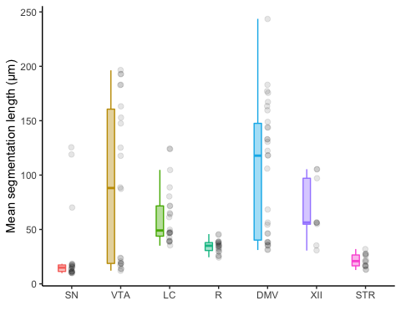

Kruskal-Wallis

Kruskal-Wallis rank sum test  
  
data: Average Size by neuron  
Kruskal-Wallis chi-squared = 63.024, df = 6, p-value = 1.092e-11

Dunn

| Comparison | Z | P.unadj | P.adj |
| --- | --- | --- | --- |
| DMV - LC | 1.0305973 | 0.3027297 | 1.0000000 |
| DMV - R | 3.6099861 | 0.0003062 | 0.0064305 |
| LC - R | 2.4559112 | 0.0140528 | 0.2951085 |
| DMV - SN | 6.3579580 | 0.0000000 | 0.0000000 |
| LC - SN | 4.9813038 | 0.0000006 | 0.0000133 |
| R - SN | 2.3704309 | 0.0177674 | 0.3731146 |
| DMV - STR | 5.3220750 | 0.0000001 | 0.0000022 |
| LC - STR | 4.1924230 | 0.0000276 | 0.0005796 |
| R - STR | 1.8856112 | 0.0593474 | 1.0000000 |
| SN - STR | -0.2503577 | 0.8023108 | 1.0000000 |
| DMV - VTA | 1.8588286 | 0.0630514 | 1.0000000 |
| LC - VTA | 0.7710414 | 0.4406824 | 1.0000000 |
| R - VTA | -1.7136144 | 0.0865996 | 1.0000000 |
| SN - VTA | -4.2192807 | 0.0000245 | 0.0005147 |
| STR - VTA | -3.5124283 | 0.0004440 | 0.0093247 |
| DMV - XII | 0.8190679 | 0.4127477 | 1.0000000 |
| LC - XII | 0.0556341 | 0.9556333 | 1.0000000 |
| R - XII | -1.8463948 | 0.0648349 | 1.0000000 |
| SN - XII | -3.7591493 | 0.0001705 | 0.0035803 |
| STR - XII | -3.3032427 | 0.0009557 | 0.0200705 |
| VTA - XII | -0.5319001 | 0.5947952 | 1.0000000 |

Estimation statistics

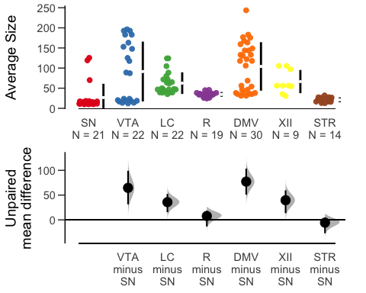

| control_group | test_group | difference | bca_ci_low | bca_ci_high |
| --- | --- | --- | --- | --- |
| SN | VTA | 64.612 | 31.380 | 99.114 |
| SN | LC | 35.757 | 15.428 | 52.260 |
| SN | R | 7.734 | -13.329 | 18.413 |
| SN | DMV | 77.256 | 50.864 | 103.509 |
| SN | XII | 39.640 | 13.643 | 59.692 |
| SN | STR | -5.698 | -27.024 | 5.072 |

*PD-vulnerable vs PD-resilient*

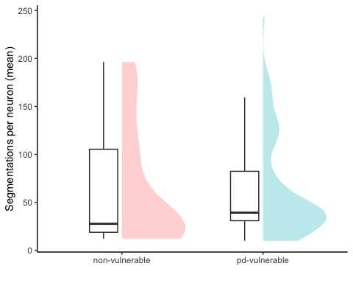

Wilcoxon rank sum test with continuity correction  
  
data: data$`Average Size` by data$type  
W = 1887, p-value = 0.4029  
alternative hypothesis: true location shift is not equal to 0

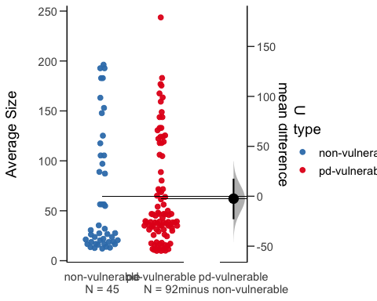

# PD-vulnerable neurons have a higher proportion of varicosities that are positive for Syt1

## Figure 7-1

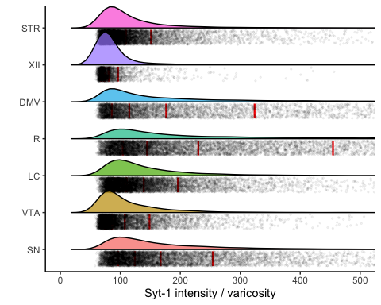

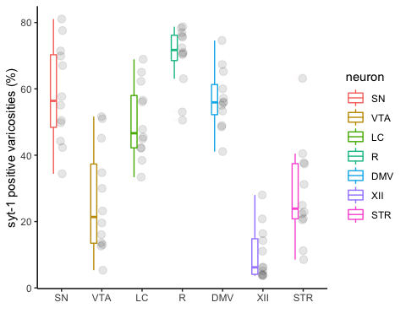

Kruskal-Wallis

Kruskal-Wallis rank sum test  
  
data: percentage_syt1_positive by neuron  
Kruskal-Wallis chi-squared = 59.589, df = 6, p-value = 5.456e-11

Dunn

| Comparison | Z | P.unadj | P.adj |
| --- | --- | --- | --- |
| DMV - LC | 0.8368274 | 0.4026896 | 1.0000000 |
| DMV - R | -1.5062893 | 0.1319929 | 1.0000000 |
| LC - R | -2.3431167 | 0.0191234 | 0.4015914 |
| DMV - SN | -0.1422607 | 0.8868741 | 1.0000000 |
| LC - SN | -0.9790881 | 0.3275365 | 1.0000000 |
| R - SN | 1.3640287 | 0.1725585 | 1.0000000 |
| DMV - STR | 3.0042104 | 0.0026627 | 0.0559169 |
| LC - STR | 2.1673830 | 0.0302057 | 0.6343189 |
| R - STR | 4.5104997 | 0.0000065 | 0.0001358 |
| SN - STR | 3.1464711 | 0.0016525 | 0.0347033 |
| DMV - VTA | 3.1632076 | 0.0015604 | 0.0327686 |
| LC - VTA | 2.3263802 | 0.0199983 | 0.4199638 |
| R - VTA | 4.6694969 | 0.0000030 | 0.0000634 |
| SN - VTA | 3.3054683 | 0.0009482 | 0.0199117 |
| STR - VTA | 0.1589972 | 0.8736711 | 1.0000000 |
| DMV - XII | 4.7197066 | 0.0000024 | 0.0000496 |
| LC - XII | 3.8828792 | 0.0001032 | 0.0021678 |
| R - XII | 6.2259959 | 0.0000000 | 0.0000000 |
| SN - XII | 4.8619672 | 0.0000012 | 0.0000244 |
| STR - XII | 1.7154962 | 0.0862543 | 1.0000000 |
| VTA - XII | 1.5564990 | 0.1195895 | 1.0000000 |

Estimation statistics

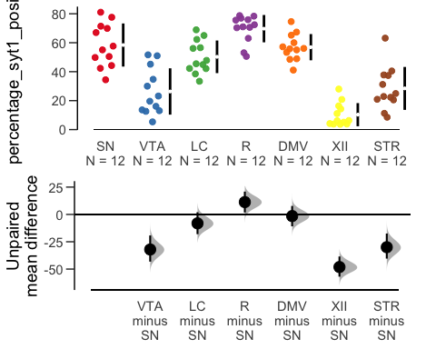

| control_group | test_group | difference | bca_ci_low | bca_ci_high |
| --- | --- | --- | --- | --- |
| SN | VTA | -32.085 | -43.167 | -19.261 |
| SN | LC | -8.150 | -18.037 | 2.028 |
| SN | R | 11.295 | 1.790 | 20.876 |
| SN | DMV | -1.493 | -10.867 | 7.755 |
| SN | XII | -48.120 | -56.935 | -38.492 |
| SN | STR | -29.978 | -40.417 | -17.486 |

*PD-vulnerable vs PD-resilient*

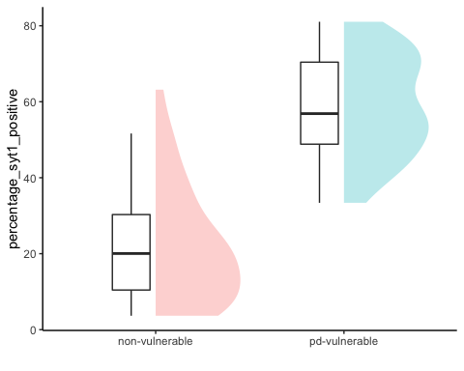

Wilcoxon rank sum exact test  
  
data: data_percentage_syt1_positive$percentage_syt1_positive by data_percentage_syt1_positive$type  
W = 79, p-value = 2.941e-16  
alternative hypothesis: true location shift is not equal to 0

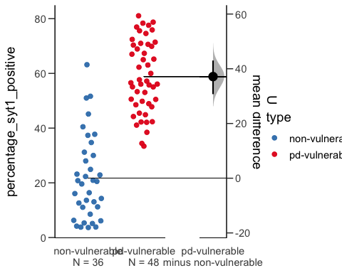

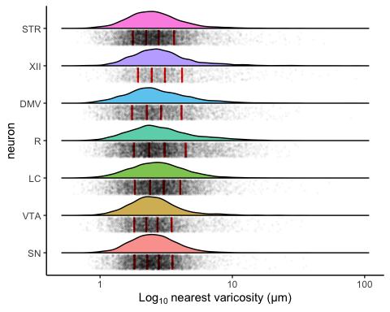

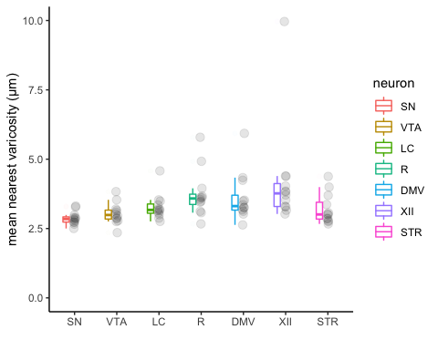

Kruskal-Wallis

Kruskal-Wallis rank sum test  
  
data: mean_nearest_varicsotiey by neuron  
Kruskal-Wallis chi-squared = 28.368, df = 6, p-value = 8.011e-05

Dunn

| Comparison | Z | P.unadj | P.adj |
| --- | --- | --- | --- |
| DMV - LC | 0.8703005 | 0.3841362 | 1.0000000 |
| DMV - R | -0.5941475 | 0.5524135 | 1.0000000 |
| LC - R | -1.4644480 | 0.1430716 | 1.0000000 |
| DMV - SN | 3.1297345 | 0.0017496 | 0.0367425 |
| LC - SN | 2.2594340 | 0.0238564 | 0.5009844 |
| R - SN | 3.7238820 | 0.0001962 | 0.0041198 |
| DMV - STR | 1.5732355 | 0.1156643 | 1.0000000 |
| LC - STR | 0.7029350 | 0.4820962 | 1.0000000 |
| R - STR | 2.1673830 | 0.0302057 | 0.6343189 |
| SN - STR | -1.5564990 | 0.1195895 | 1.0000000 |
| DMV - VTA | 2.0334906 | 0.0420030 | 0.8820626 |
| LC - VTA | 1.1631901 | 0.2447524 | 1.0000000 |
| R - VTA | 2.6276381 | 0.0085980 | 0.1805579 |
| SN - VTA | -1.0962439 | 0.2729721 | 1.0000000 |
| STR - VTA | 0.4602551 | 0.6453331 | 1.0000000 |
| DMV - XII | -1.2133997 | 0.2249770 | 1.0000000 |
| LC - XII | -2.0837002 | 0.0371874 | 0.7809363 |
| R - XII | -0.6192523 | 0.5357502 | 1.0000000 |
| SN - XII | -4.3431343 | 0.0000140 | 0.0002950 |
| STR - XII | -2.7866353 | 0.0053258 | 0.1118426 |
| VTA - XII | -3.2468903 | 0.0011667 | 0.0245014 |

Estimation Statistics

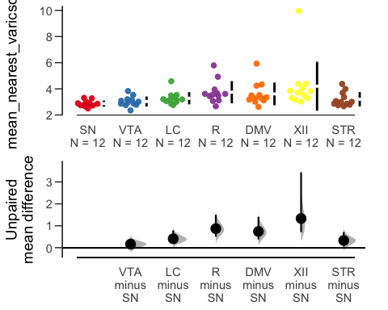

| control_group | test_group | difference | bca_ci_low | bca_ci_high |
| --- | --- | --- | --- | --- |
| SN | VTA | 0.162 | -0.077 | 0.415 |
| SN | LC | 0.406 | 0.183 | 0.789 |
| SN | R | 0.871 | 0.507 | 1.500 |
| SN | DMV | 0.740 | 0.375 | 1.411 |
| SN | XII | 1.332 | 0.708 | 3.438 |
| SN | STR | 0.331 | 0.056 | 0.717 |

*PD-vulnerable vs PD-resilient*

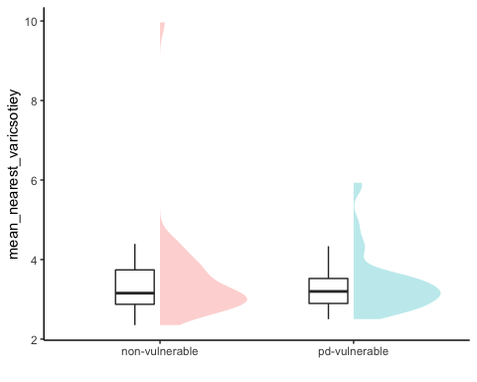

Wilcoxon rank sum exact test  
  
data: mean_varicosity_nn_length$mean_nearest_varicsotiey by mean_varicosity_nn_length$type  
W = 875, p-value = 0.9248  
alternative hypothesis: true location shift is not equal to 0

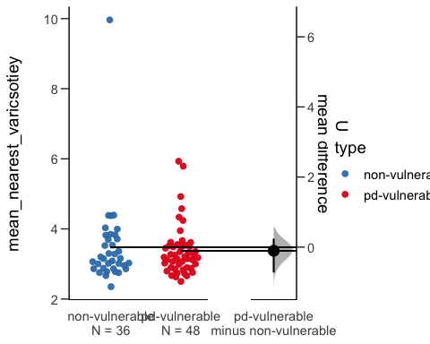

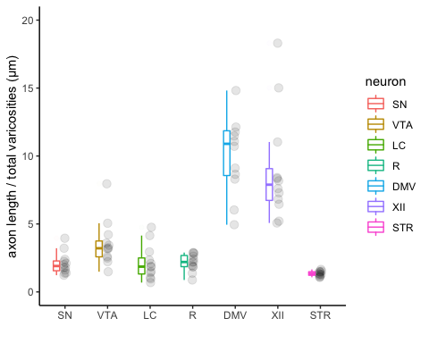

Kruskal-Wallis

Kruskal-Wallis rank sum test  
  
data: mean_axon_per_var_px by neuron  
Kruskal-Wallis chi-squared = 62.576, df = 6, p-value = 1.346e-11

Dunn

| Comparison | Z | P.unadj | P.adj |
| --- | --- | --- | --- |
| DMV - LC | 4.6611287 | 0.0000031 | 0.0000660 |
| DMV - R | 4.1506639 | 0.0000332 | 0.0006962 |
| LC - R | -0.5104647 | 0.6097259 | 1.0000000 |
| DMV - SN | 4.4519218 | 0.0000085 | 0.0001787 |
| LC - SN | -0.2092069 | 0.8342868 | 1.0000000 |
| R - SN | 0.3012579 | 0.7632179 | 1.0000000 |
| DMV - STR | 6.1255766 | 0.0000000 | 0.0000000 |
| LC - STR | 1.4644480 | 0.1430716 | 1.0000000 |
| R - STR | 1.9749127 | 0.0482781 | 1.0000000 |
| SN - STR | 1.6736548 | 0.0941985 | 1.0000000 |
| DMV - VTA | 2.5857967 | 0.0097154 | 0.2040239 |
| LC - VTA | -2.0753320 | 0.0379558 | 0.7970713 |
| R - VTA | -1.5648673 | 0.1176140 | 1.0000000 |
| SN - VTA | -1.8661251 | 0.0620239 | 1.0000000 |
| STR - VTA | -3.5397799 | 0.0004005 | 0.0084097 |
| DMV - XII | 0.4602551 | 0.6453331 | 1.0000000 |
| LC - XII | -4.2008736 | 0.0000266 | 0.0005584 |
| R - XII | -3.6904089 | 0.0002239 | 0.0047018 |
| SN - XII | -3.9916667 | 0.0000656 | 0.0013778 |
| STR - XII | -5.6653216 | 0.0000000 | 0.0000003 |
| VTA - XII | -2.1255416 | 0.0335414 | 0.7043703 |

Estimation Statistics

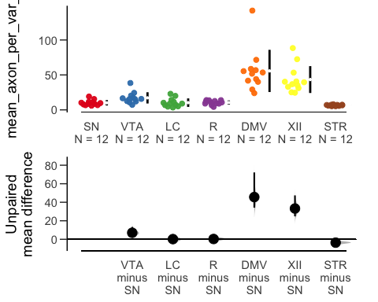

| control_group | test_group | difference | bca_ci_low | bca_ci_high |
| --- | --- | --- | --- | --- |
| SN | VTA | 7.053 | 3.235 | 13.312 |
| SN | LC | 0.197 | -3.298 | 4.452 |
| SN | R | 0.326 | -2.720 | 2.683 |
| SN | DMV | 45.600 | 34.165 | 72.217 |
| SN | XII | 33.246 | 24.793 | 47.406 |
| SN | STR | -3.624 | -6.413 | -1.893 |

*PD-vulnerable vs PD-resilient*

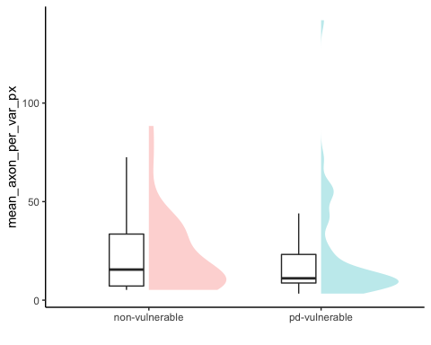

Wilcoxon rank sum exact test  
  
data: mean_varicosity_lengthpervar_length$mean_axon_per_var_px by mean_varicosity_lengthpervar_length$type  
W = 917, p-value = 0.6369  
alternative hypothesis: true location shift is not equal to 0

