NETWORK SECURITY MONITOR SYSTEM
CMPE314 — Computer Networks & Security
Project Report

Submitted To: Course Instructor
Submitted By: Samuel Akpoghene Otobo — 22100896
GitHub: https://github.com/samuelotobo/Software-Engineering-Project-.git

Table of Contents
Chapter 1: Introduction ............................................................. 4
1.1 Project Overview & Problem Statement ............................... 4
1.2 Project Scope & Objectives ............................................... 5
1.3 Report Structure ............................................................... 6
Chapter 2: Project Management .................................................. 7
2.1 Team Members & Roles ..................................................... 7
2.2 Work Breakdown & Individual Contributions ........................ 7
2.3 Chosen Software Process Model & Justification ................... 8
2.4 Project Timeline ................................................................ 8
Chapter 3: Stakeholder & Requirements Elicitation ...................... 9
3.1 Stakeholder Identification .................................................. 9
3.2 Stakeholder Analysis .......................................................... 10
3.3 Requirements Elicitation Techniques Used .......................... 10
Chapter 4: Requirements Specification ........................................ 12
4.1 Functional Requirements (FRs) .......................................... 12
4.2 Non-Functional Requirements (NFRs) ................................. 15
Chapter 5: System Modelling ...................................................... 17
5.1 Use Case Model .................................................................. 17
5.2 Dynamic Models ................................................................ 20
5.3 Structural Model ................................................................ 21
5.4 Data Flow Model ................................................................ 22
Chapter 6: Implementation .......................................................... 23
6.1 Technology Stack Details .................................................... 23
6.2 Key Algorithms & Code Snippets ........................................ 24
6.3 User Interfaces ................................................................... 30
6.4 Open-Source Libraries Used ................................................ 31
Chapter 7: Testing ....................................................................... 32
7.1 Unit Testing Approach ........................................................ 32
7.2 Test Cases ........................................................................... 33
7.3 Acceptance Testing ............................................................. 35
Chapter 8: Conclusion .................................................................. 36
8.1 Project Summary ................................................................ 36
8.2 Challenges Faced & Lessons Learned ................................... 37
References ...................................................................................... 39
Appendices ...................................................................................... 39

Chapter 1: Introduction
The Network Security Monitor System is a Python-based desktop security application developed to provide real-time detection of network-level threats, file system tampering, suspicious system events, and phishing attacks. The system combines machine learning (ML) classification, rule-based heuristics, artificial intelligence (AI) APIs, and packet-level network analysis into a single unified monitoring platform with a professional graphical user interface built in PyQt6.
The project applies software engineering principles — requirements analysis, system modelling, iterative development, automated testing, and structured documentation — to solve a real-world cybersecurity challenge faced by system administrators, network engineers, and security professionals.

1.1 Project Overview & Problem Statement
Modern computer networks face an ever-growing range of threats. Distributed Denial-of-Service (DDoS) attacks, ARP spoofing, DNS-based Command & Control (C2) channels, brute-force credential attacks, phishing emails, and malicious URL visits are among the most common attack vectors recorded by cybersecurity organisations worldwide. Despite the severity of these threats, most end-users and small-to-medium enterprise (SME) environments lack affordable, integrated, real-time monitoring tools.
Key problems with existing approaches:
- Enterprise-grade SIEM systems are expensive and complex to configure.
- Open-source tools are fragmented — separate tools for network monitoring, file integrity, phishing detection, and log analysis require significant integration effort.
- Most tools lack a user-friendly interface accessible to administrators without deep security expertise.
- Threshold-based detection systems generate excessive false positives without proper calibration, causing alert fatigue.
- Machine learning models are often pre-packaged black boxes without transparency or customisability.
The Network Security Monitor System addresses these problems by providing:
- A single desktop application monitoring multiple threat surfaces simultaneously.
- Machine learning models (Random Forest, Isolation Forest, SVM) trained on real network datasets.
- AI-powered phishing analysis via Google's Gemini 2.0 Flash API.
- Real-time packet sniffing and protocol-level inspection using Scapy.
- Integrated threat intelligence lookups via the AbuseIPDB API.
- Carefully calibrated thresholds to minimise false positives.
- Professional dark-themed PyQt6 dashboard accessible to administrators without deep technical expertise.

1.2 Project Scope & Objectives
The System WILL:
- Capture and analyse live network packets in real time using Scapy.
- Detect DDoS attacks using a trained Random Forest ML classifier and a rule-based engine.
- Detect ARP spoofing and ARP flood attacks by tracking IP-to-MAC mapping changes.
- Detect DNS anomalies including tunnelling, fast-flux C2 domains, suspicious TLDs, and C2 beaconing.
- Detect brute-force and credential-based attacks on authentication services (SSH, RDP, SMTP, SMB, etc.).
- Monitor File Integrity by tracking SHA-256 hashes of watched directories.
- Monitor Windows Security and System Event Logs for suspicious activity.
- Perform Threat Intelligence lookups on attacker IPs via the AbuseIPDB API.
- Analyse email content for phishing indicators using Google Gemini AI.
- Classify URLs as phishing or legitimate using a trained Random Forest model.
- Display all alerts in a real-time dashboard with severity indicators.
- Support IP blocking and allow-list management.
- Generate system health and threat statistics.
The System WILL NOT:
- Control or modify network infrastructure (routers, firewalls, switches).
- Automatically block IPs at the OS firewall level without user confirmation.
- Provide mobile or web-based interfaces in the current version.
- Integrate with external SIEM systems (Splunk, ELK, etc.) in the current version.
- Process encrypted HTTPS payload content (only metadata and handshake traffic).
- Provide GPS or physical location tracking of attackers.
Project Objectives:
- 1. Provide real-time, multi-vector network threat detection in a single application.
- 2. Apply machine learning for accurate, adaptive DDoS and anomaly detection.
- 3. Leverage AI APIs for natural language understanding of phishing email content.
- 4. Minimise false positives through calibrated thresholds and whitelist mechanisms.
- 5. Provide administrators with an intuitive, professional-grade dark-themed dashboard.
- 6. Implement file integrity monitoring to detect unauthorised system changes.
- 7. Monitor Windows Event Logs for signs of privilege escalation and malware activity.
- 8. Deliver a modular, extensible codebase supporting future integration.

1.3 Report Structure
Chapter 1: Introduction — Project overview, problem statement, scope, objectives, and report structure.
Chapter 2: Project Management — Team roles, task distribution, selected software process model, and project timeline.
Chapter 3: Stakeholder & Requirements Elicitation — System stakeholders and techniques used to gather requirements.
Chapter 4: Requirements Specification — Functional and non-functional requirements in structured form.
Chapter 5: System Modelling — UML-based models — use case, activity, sequence, class diagrams, and DFDs.
Chapter 6: Implementation — Technology stack, key detection algorithms with code snippets, and UI design.
Chapter 7: Testing — Testing approach, test cases, and results from unit and acceptance testing.
Chapter 8: Conclusion — Project outcomes, challenges faced, lessons learned, and future directions.

Chapter 2: Project Management

2.1 Team Members & Roles
Team Member | Primary Role
Samuel Akpoghene Otobo | Requirements Analysis & System Design
Samuel Akpoghene Otobo | Machine Learning Model Development
Samuel Akpoghene Otobo | Network Detection Module Development
Samuel Akpoghene Otobo | Desktop UI Design & Implementation (PyQt6)
Samuel Akpoghene Otobo | Testing, Debugging & Report Compilation

2.2 Work Breakdown & Individual Contributions
Task | Description | Member
Stakeholder Analysis | Identified and analysed system stakeholders and their requirements | Member 1
Requirements Gathering | Collected and documented functional and non-functional requirements | Member 1
System Architecture Design | Designed the modular multi-detector architecture | Member 1
ML Model Development | Trained Random Forest (DDoS), Isolation Forest (Anomaly), SVM models | Member 1
Network Detector Development | Implemented ARP, DNS, Brute Force, DDoS detectors using Scapy | Member 1
AI Integration | Integrated Google Gemini API for email phishing detection | Member 1
Threat Intelligence | Integrated AbuseIPDB API for IP reputation lookups | Member 1
File Integrity Monitor | Implemented SHA-256 hash-based FIM with exclusion rules | Member 1
Event Log Monitor | Implemented Windows Event Log polling via wevtutil | Member 1
Desktop UI Development | Designed PyQt6 dark-themed dashboard | Member 1
Threshold Calibration | Audited and tuned all detection thresholds to minimise false positives | Member 1
Testing | Wrote comprehensive demo test suite (demo_test.py) | Member 1
Documentation | Final report formatting and editing | Member 1

2.3 Chosen Software Process Model & Justification
The Agile (Iterative) software development model was selected for this project.
Justification for Choosing Agile:
The Agile model was chosen because the system's requirements evolved throughout development. Detection thresholds needed adjustment after real-world testing; new detector modules were added iteratively; and the user interface was refined across multiple sessions based on functionality testing.
Benefits of Using Agile in This Project:
- Each detector module could be developed, tested, and integrated independently.
- Threshold calibration required multiple test-feedback cycles — Agile supported this naturally.
- False positive issues discovered during testing were corrected in subsequent iterations.
- The modular architecture aligned with Agile's principle of delivering working software incrementally.
- Rapid prototyping of the PyQt6 UI allowed early feedback on usability before full detector integration.
The project was developed in four major iterations:
- Iteration 1 — Core network detectors (ARP, DNS, Brute Force) + Scapy integration.
- Iteration 2 — Machine learning models (DDoS, Anomaly) + training pipeline.
- Iteration 3 — Desktop UI (PyQt6), dashboard, and alert management.
- Iteration 4 — FIM, Event Log monitor, Threat Intelligence, AI phishing, and threshold calibration.

2.4 Project Timeline
Phase | Tasks | Duration
Week 1–2 | Requirements gathering, stakeholder analysis, architecture design | 2 weeks
Week 3–4 | Network detector development (ARP, DNS, Brute Force) | 2 weeks
Week 5–6 | ML model development and training pipeline | 2 weeks
Week 7–8 | PyQt6 desktop UI development | 2 weeks
Week 9–10 | FIM, Event Log, Threat Intel, AI phishing integration | 2 weeks
Week 11 | Threshold calibration and false-positive audit | 1 week
Week 12 | Testing, demo test suite, documentation | 1 week

Chapter 3: Stakeholder & Requirements Elicitation

3.1 Stakeholder Identification
Primary Stakeholders:
1. System Administrators — Primary users of the monitoring dashboard. They monitor live threat alerts, manage blocked IPs, configure watched directories for FIM, and review event log activity. Their goal is to detect and respond to security incidents quickly and efficiently.
2. Network Security Analysts — Use the system's threat data — ML-classified network flows, threat intelligence reports, phishing analysis results, and event log anomalies — to investigate potential breaches and conduct incident response.
Secondary Stakeholders:
1. IT Managers — Use aggregated system reports and health statistics to assess security posture and make informed decisions about security investments.
2. Compliance Officers — Rely on event log monitoring and FIM capabilities to ensure adherence to ISO 27001, PCI-DSS, and GDPR.
3. End Users / Employees — Indirectly benefit from faster incident response and reduced exposure to phishing and malware threats.
4. Developers / Future Maintainers — Require clear documentation, modular architecture, and well-structured codebase to add new detectors or integrate with external systems.

3.2 Stakeholder Analysis
Stakeholder | Interest | Influence | Specific Requirements
System Administrators | Real-time visibility of active threats | High | Live alert dashboard, IP blocking, FIM alerts, severity indicators
Security Analysts | Deep threat investigation data | High | ML verdicts, packet metadata, TI lookups, phishing analysis
IT Managers | Security posture overview | Medium | Summary statistics, health indicators, alert history
Compliance Officers | Audit trail and policy enforcement | Medium | Event log monitoring, FIM reporting, privilege escalation alerts
End Users | Safe working environment | Low | Minimal system disruption from monitoring agent
Future Developers | Maintainable, extensible codebase | Medium | Modular architecture, documented APIs, clear configuration

3.3 Requirements Elicitation Techniques Used
1. Brainstorming Sessions — Structured brainstorming to identify the full range of threat vectors — network-layer attacks (DDoS, ARP spoofing, DNS abuse), host-level threats (file tampering, privilege escalation), and application-layer threats (phishing). This produced the initial list of detector modules.
2. Research and Literature Review — Published cybersecurity datasets (CIC-DDoS2019, PhishingDataset), academic papers, and industry reports (OWASP, MITRE ATT&CK) were studied to understand common attack patterns, informing feature selection for ML training and threshold calibration.
3. Observation and Practical Testing — Real network traffic was observed to identify false-positive sources. A machine with email client, SSH terminal, and MySQL generated false brute-force alerts. DNS queries to Google CDN triggered false fast-flux alerts. FIM baseline file caused self-referential alerts.
4. User Persona Development — Two primary personas: "Alex the Admin" (wants clean dashboard, minimal false alarms, quick IP blocking) and "Sara the Analyst" (needs detailed alert metadata, ML confidence scores, drill-down capability).
5. Analysis of Existing Tools — Snort (rule-based IDS), OSSEC (FIM + log analysis), and open-source DDoS detectors were analysed. Key gaps — lack of ML integration, poor UI, no AI-powered phishing, high false positives — defined differentiating features.
Outcome:
- 15 functional requirements covering all detection, management, and reporting capabilities.
- 15 non-functional requirements covering performance, security, usability, reliability, and scalability.
- Modular detector architecture (one Python class per threat type).
- PyQt6 tabbed dashboard with dedicated sections for each threat category.
- False-positive suppression mechanisms (thresholds, cooldowns, CDN whitelists, private IP filters).

Chapter 4: Requirements Specification

4.1 Functional Requirements (FRs)
FR-001: Live Network Packet Capture
The system shall capture live network packets in real time using a background Scapy sniffer thread and route each packet to the appropriate detector modules.

FR-002: DDoS Detection (ML + Rules)
The system shall classify network flow features using a trained Random Forest classifier and a rule-based engine to detect DDoS attack patterns including SYN floods, UDP floods, and volumetric attacks. The system shall support configurable confidence thresholds.

FR-003: ARP Spoofing & Flood Detection
The system shall monitor ARP broadcasts to detect IP-to-MAC mapping conflicts (cache poisoning), gateway MAC hijacking (critical severity), and ARP flooding (≥ 50 packets per 10 seconds). A 5-minute cooldown shall suppress duplicate spoof alerts for the same IP.

FR-004: DNS Anomaly Detection
The system shall detect: DNS tunnelling (subdomain label length > 60 characters), suspicious TLDs (.tk, .ml, .gq, .cf, .pw, etc.), fast-flux DNS (> 20 distinct IPs for a single hostname, excluding CDN whitelist), and C2 beaconing (> 150 queries per minute to a single domain).

FR-005: Brute Force & Credential Attack Detection
The system shall detect brute force attacks on authentication services (SSH, RDP, FTP, Telnet, SMTP, POP3, IMAP, SMB, MySQL, PostgreSQL, VNC, Redis), HTTP credential stuffing (≥ 80 SYN/60 s), and password spray (≥ 6 auth services × ≥ 3 SYNs each). Private/RFC-1918 source IPs shall be ignored.

FR-006: Network Anomaly Detection
The system shall apply a trained Isolation Forest model to network flow features to detect statistical anomalies that do not match known attack signatures.

FR-007: File Integrity Monitoring (FIM)
The system shall monitor configured directories by computing SHA-256 hashes at 60-second intervals and alert on file creation, modification, and deletion. Files > 50 MB, excluded filenames (fim_baseline.json, logs), excluded suffixes (.pyc, .log, .tmp), and excluded directories (__pycache__, .git, venv) shall be silently skipped.

FR-008: Windows Event Log Monitoring
The system shall poll Windows Security and System event logs every 10 seconds via wevtutil and generate alerts for event IDs: 1102 (Audit Log Cleared — critical), 4625 (Failed Logon — high), 4648 (Explicit Credential Use — medium), 4688 (Suspicious Process — high), 4698 (Scheduled Task Created — medium), 4720 (New Local Account — high), 4724 (Password Reset — low), 4732 (Added to Administrators — critical), 4756 (Universal Group Modified — high), 7045 (New Service Installed — critical).

FR-009: Threat Intelligence Lookups
The system shall perform asynchronous IP reputation lookups against the AbuseIPDB API for externally sourced attacker IPs. Private/RFC-1918 IPs shall be excluded. Results shall be cached. The system shall degrade gracefully if no API key is configured.

FR-010: Email Phishing Detection (AI)
The system shall submit email content (subject, body, headers) to the Google Gemini 2.0 Flash AI API and display a structured phishing analysis including risk score, identified indicators, and recommendations.

FR-011: URL Phishing Detection (ML)
The system shall classify submitted URLs as phishing or legitimate using a trained Random Forest model operating on URL-derived features (length, entropy, special character counts, domain reputation indicators).

FR-012: Real-Time Alert Dashboard
The system shall display all alerts in a tabulated, real-time dashboard showing rule name, severity, source IP, timestamp, and message. Alerts shall be colour-coded by severity (critical — red, high — orange, medium — yellow, low — blue).

FR-013: Alert Filtering and Management
The system shall allow administrators to filter alerts by severity and category, clear the alert list, and export alerts to the security log file.

FR-014: IP Blocking and Allow-List Management
The system shall allow administrators to block specific IP addresses and maintain a persistent blocked IP list persisted to blocked_ips.json and surviving application restarts.

FR-015: System Health Monitoring
The system shall display real-time CPU, RAM, disk usage, and network I/O statistics. A calculated health percentage shall be displayed with colour-coded status (green ≥ 70%, amber ≥ 40%, red < 40%).

4.2 Non-Functional Requirements (NFRs)

Performance Requirements
NFR-001: Packet Processing Throughput — The system shall process captured network packets within 50 milliseconds per packet under normal operating conditions.
NFR-002: Dashboard Responsiveness — All UI updates shall be performed via Qt signals emitted from background threads to ensure the GUI remains responsive during active threat detection.
NFR-003: Concurrent Detector Operation — All detector modules shall operate concurrently as independent daemon threads without blocking each other.

Security Requirements
NFR-004: Secret Management — All API keys shall be loaded exclusively from environment variables via a .env file using python-dotenv. Keys shall never be hardcoded in source files.
NFR-005: Minimal Attack Surface — The monitoring agent shall not open any listening network ports. All external communication shall be outbound-only.
NFR-006: Privilege Separation — Network packet sniffing requires administrator/root privileges. The application shall clearly communicate when elevated privileges are unavailable and degrade gracefully.

Usability Requirements
NFR-007: Professional Dark-Themed UI — The interface shall use a professional dark colour palette (backgrounds: #0c1020–#0f1326, accent: #3b82f6) implemented in PyQt6 QSS stylesheets.
NFR-008: Intuitive Navigation — The sidebar navigation shall clearly indicate the active section and the dashboard shall be understandable to administrators without cybersecurity expertise.
NFR-009: Informative Alert Display — Every alert shall include a human-readable description, severity label, source IP, timestamp, and the specific rule that triggered the alert.

Reliability Requirements
NFR-010: Graceful Degradation — If Scapy is unavailable, the ML model is not trained, or an API key is not configured, the system shall disable the affected module and continue operating with remaining detectors.
NFR-011: False Positive Minimisation — All detection thresholds shall be calibrated so that normal office network activity does not trigger alerts under typical conditions.
NFR-012: Thread Safety — All shared data structures accessed by multiple detector threads shall be protected by threading locks to prevent race conditions and data corruption.

Maintainability Requirements
NFR-013: Modular Detector Architecture — Each threat detector shall be implemented as an independent Python class in its own file under the detectors/ directory. Adding a new detector shall not require modifying existing detector code.
NFR-014: Configurable Parameters — All detection thresholds, watch directories, API endpoints, and operational parameters shall be configurable via environment variables loaded through config.py, without modifying source code.

Scalability Requirements
NFR-015: Extensible Alert Pipeline — The alert callback system (on_alert: Callable[[dict], None]) shall allow new consumers (log file writers, external SIEMs, notification services) to be added without modifying detector code.

Chapter 5: System Modelling

5.1 Use Case Model

5.1.1 Use Case Diagram
The use case diagram below identifies the primary actors and their interactions with the system. The Administrator is the primary human actor who interacts with all user-facing use cases. External systems (Scapy, AbuseIPDB, Gemini API, Windows Event Log) trigger automated system use cases.
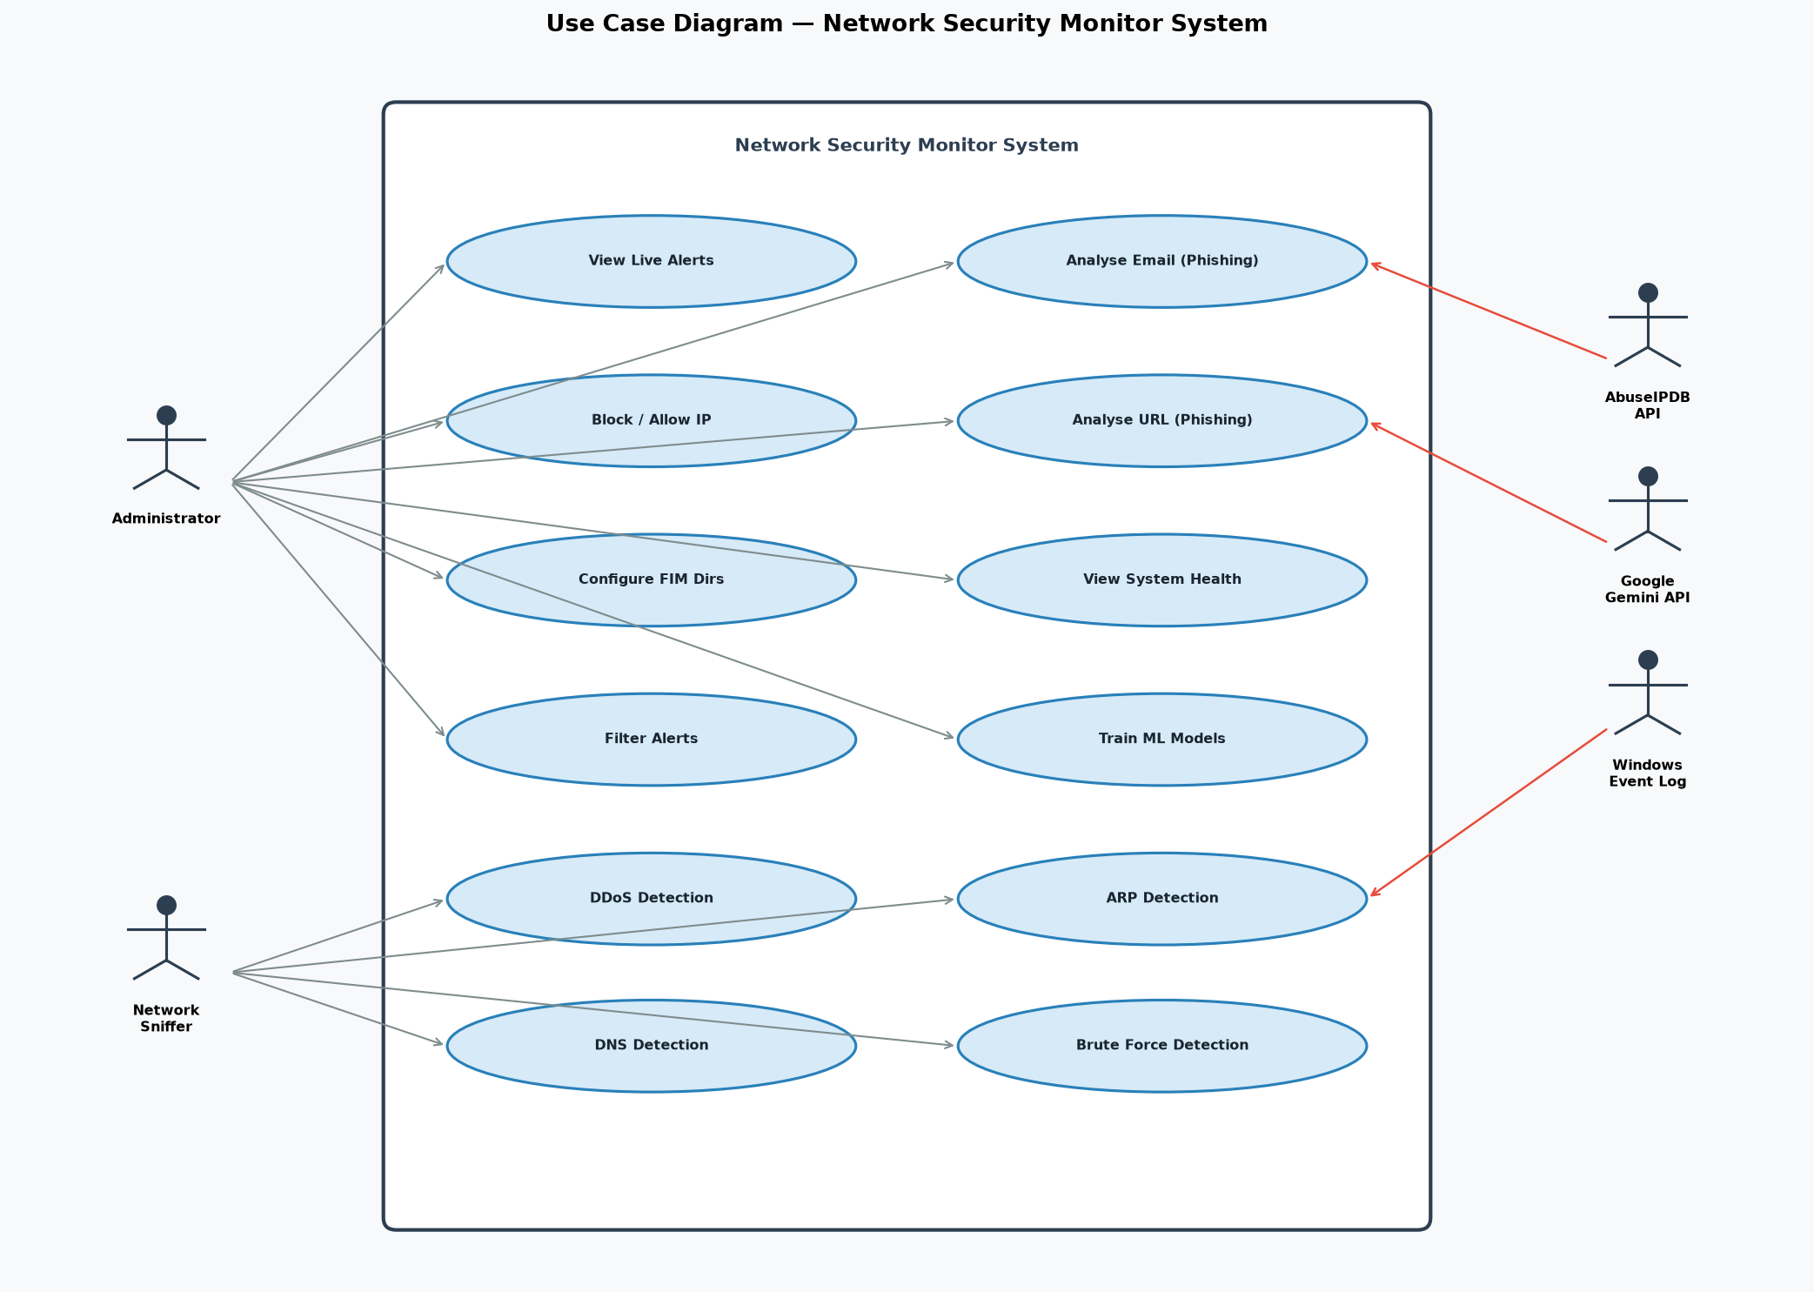
Figure 1: Use Case Diagram — Network Security Monitor System

5.1.2 Detailed Use Case Descriptions
Use Case: View Live Alerts
Field | Detail
Actor | Administrator
Pre-condition | System is running and at least one detector module is active.
Post-condition | Administrator views current security alerts on the dashboard.

Main Success Scenario:
- 1. Administrator launches the application.
- 2. System starts all detector modules in background threads.
- 3. Detector modules process events and emit alerts via callback functions.
- 4. Dashboard displays alerts in a colour-coded table with severity, source IP, rule name, and timestamp.
- 5. Administrator reviews and acts on the alerts.
Use Case: Block / Allow IP
Field | Detail
Actor | Administrator
Pre-condition | An alert has been raised for a specific source IP.
Post-condition | The IP is added to the blocked list and persisted to blocked_ips.json.

Main Success Scenario:
- 1. Administrator views an alert for a suspicious IP address.
- 2. Administrator selects the IP and clicks "Block IP."
- 3. System adds the IP to the blocked list.
- 4. System persists the blocked list to blocked_ips.json.
- 5. A confirmation message is displayed.
Use Case: Analyse Email (Phishing Detection)
Field | Detail
Actor | Administrator
Pre-condition | GEMINI_API_KEY is configured in the .env file.
Post-condition | A phishing risk assessment is displayed for the submitted email.

Main Success Scenario:
- 1. Administrator navigates to the Email Phishing tab.
- 2. Administrator pastes email subject, body, and headers into the input fields.
- 3. Administrator clicks "Analyse."
- 4. System sends the email content to the Google Gemini 2.0 Flash API.
- 5. System displays the AI analysis including risk score, indicators, and recommendations.
Use Case: Analyse URL (Phishing Detection)
Field | Detail
Actor | Administrator
Pre-condition | The URL phishing ML model has been trained.
Post-condition | The submitted URL is classified as phishing or legitimate.

Main Success Scenario:
- 1. Administrator navigates to the URL Phishing tab.
- 2. Administrator enters a URL in the input field.
- 3. Administrator clicks "Check URL."
- 4. System extracts features from the URL (length, entropy, special characters, subdomain count).
- 5. Trained Random Forest model classifies the URL.
- 6. Result (Phishing / Legitimate) and confidence score are displayed.

5.2 Dynamic Models

5.2.1 Activity Diagram — Packet Detection Workflow
The activity diagram illustrates the complete workflow from packet capture to alert display. After Scapy captures a raw network packet, it is routed simultaneously to the ARP Monitor, DNS Monitor, Brute Force Detector, and Flow Tracker. Each module independently evaluates the packet against its configured thresholds and emits alerts via the on_alert() callback if a threat is detected. All alerts are then routed through the Qt signal system to the dashboard for real-time display.
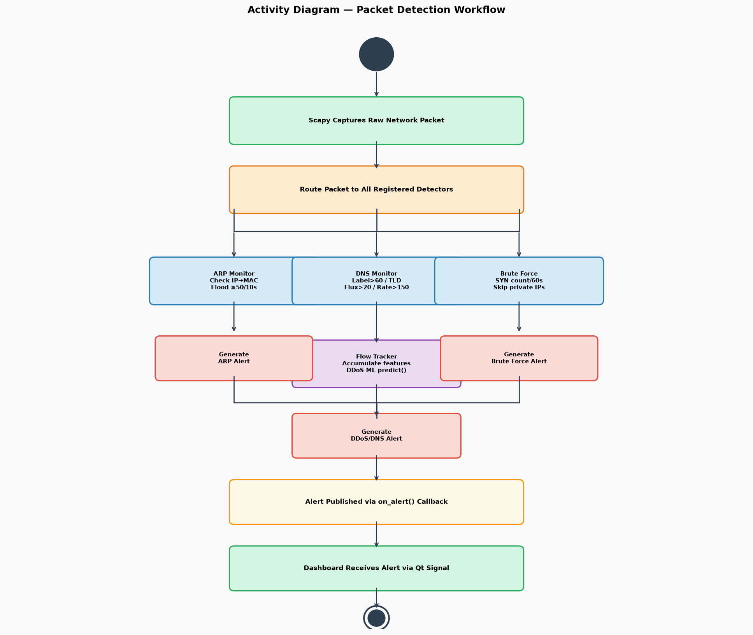
Figure 2: Activity Diagram — Packet Detection Workflow

5.2.2 Sequence Diagram — DDoS Detection Flow
The sequence diagram below shows the message flow for DDoS detection. The administrator launches the application, which starts the SnifferThread. As packets arrive, each is passed to the DDosDetector, which accumulates flow features and calls the Random Forest predict() method when a flow completes. If the verdict is ATTACK, an alert is emitted via Qt signal and the Dashboard updates the real-time table.
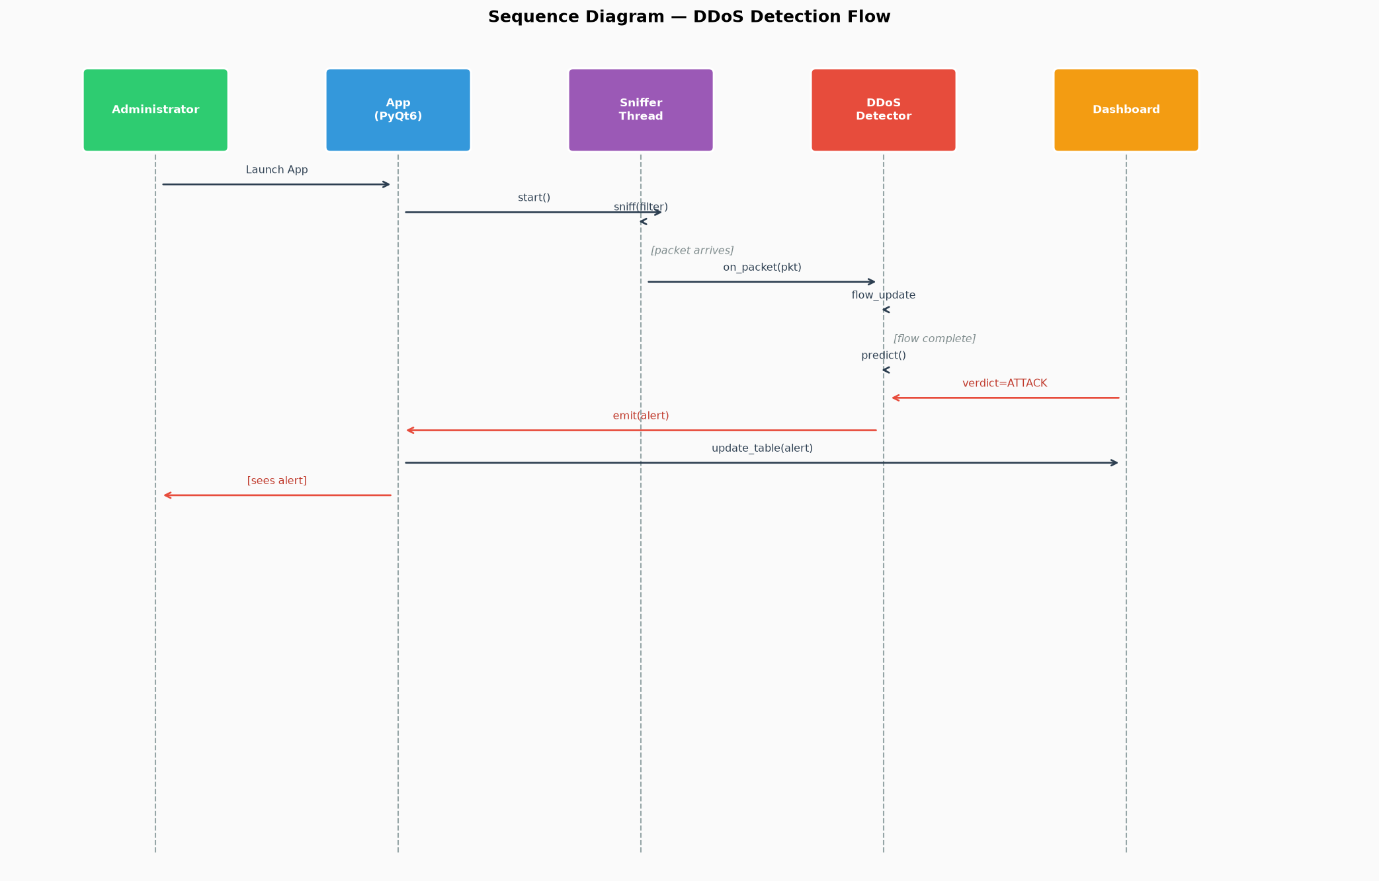
Figure 3: Sequence Diagram — DDoS Detection Flow

5.3 Structural Model

5.3.1 Class Diagram
The class diagram shows the relationships between the main system components. MainWindow orchestrates the SnifferThread and all detector instances. Each detector class is independent and communicates only through the shared Alert dict format via on_alert() callback. This loose coupling ensures that adding or removing a detector requires no changes to other classes.
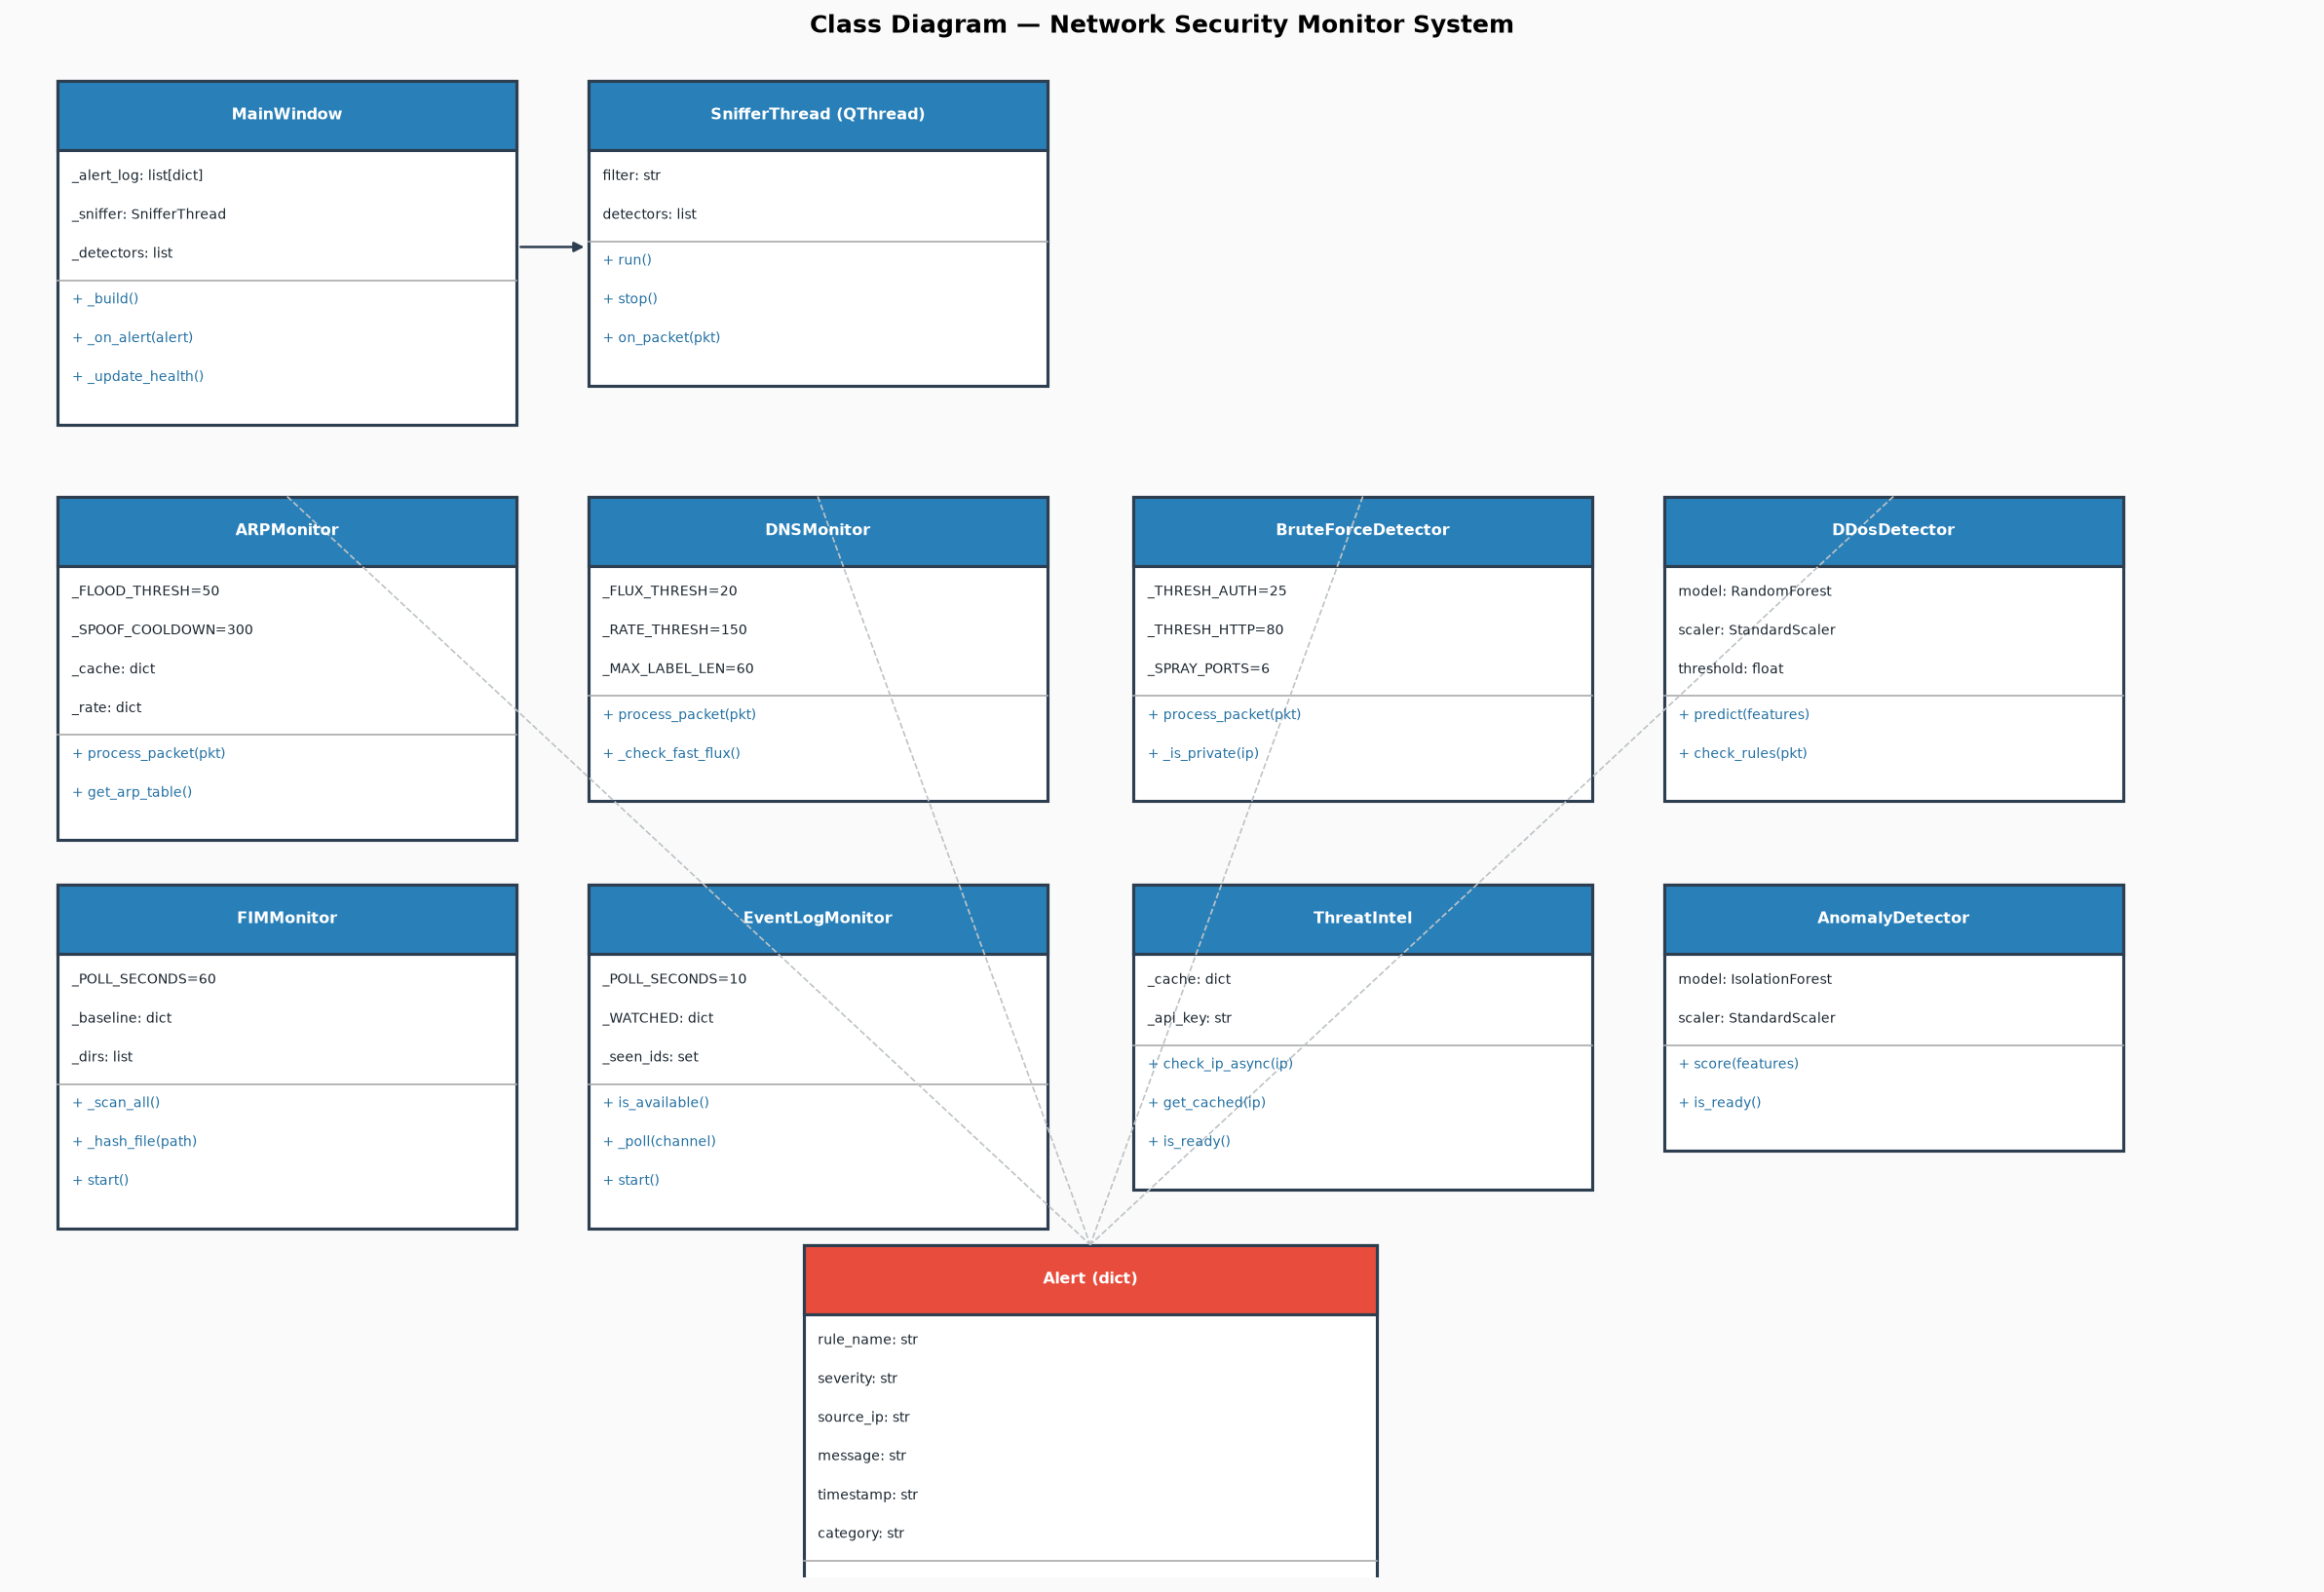
Figure 4: Class Diagram — Network Security Monitor System

5.4 Data Flow Model

5.4.1 Context Diagram (Level 0 DFD)
The context diagram shows the Security Monitor System as a single process with its external entities. Inputs include raw network packets from Scapy, event log data from Windows, IP reputation data from AbuseIPDB, and email content submitted by the administrator via the Gemini AI interface. Outputs include alerts and statistics to the administrator, the blocked IP list, and the security_alerts.log file.
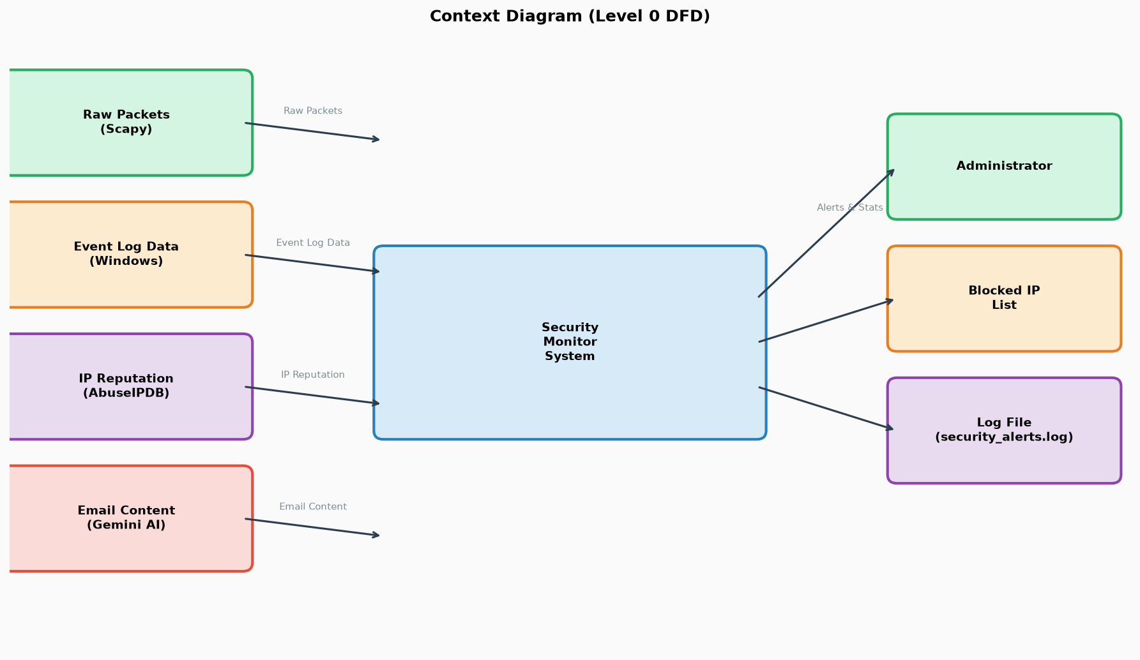
Figure 5: Context Diagram (Level 0 DFD)

5.4.2 Level-1 DFD
The Level-1 DFD decomposes the system into its major sub-processes. Process 2.0 (Packet Capture) feeds both the Network Detection processes (ARP, DNS, Brute Force, DDoS) and the System Detection processes (FIM, Event Log, Anomaly). Process 5.0 (Alert Processing) consolidates all detector outputs, applies deduplication and threat intel enrichment, then routes to the alert store (D1) and the Dashboard Display.
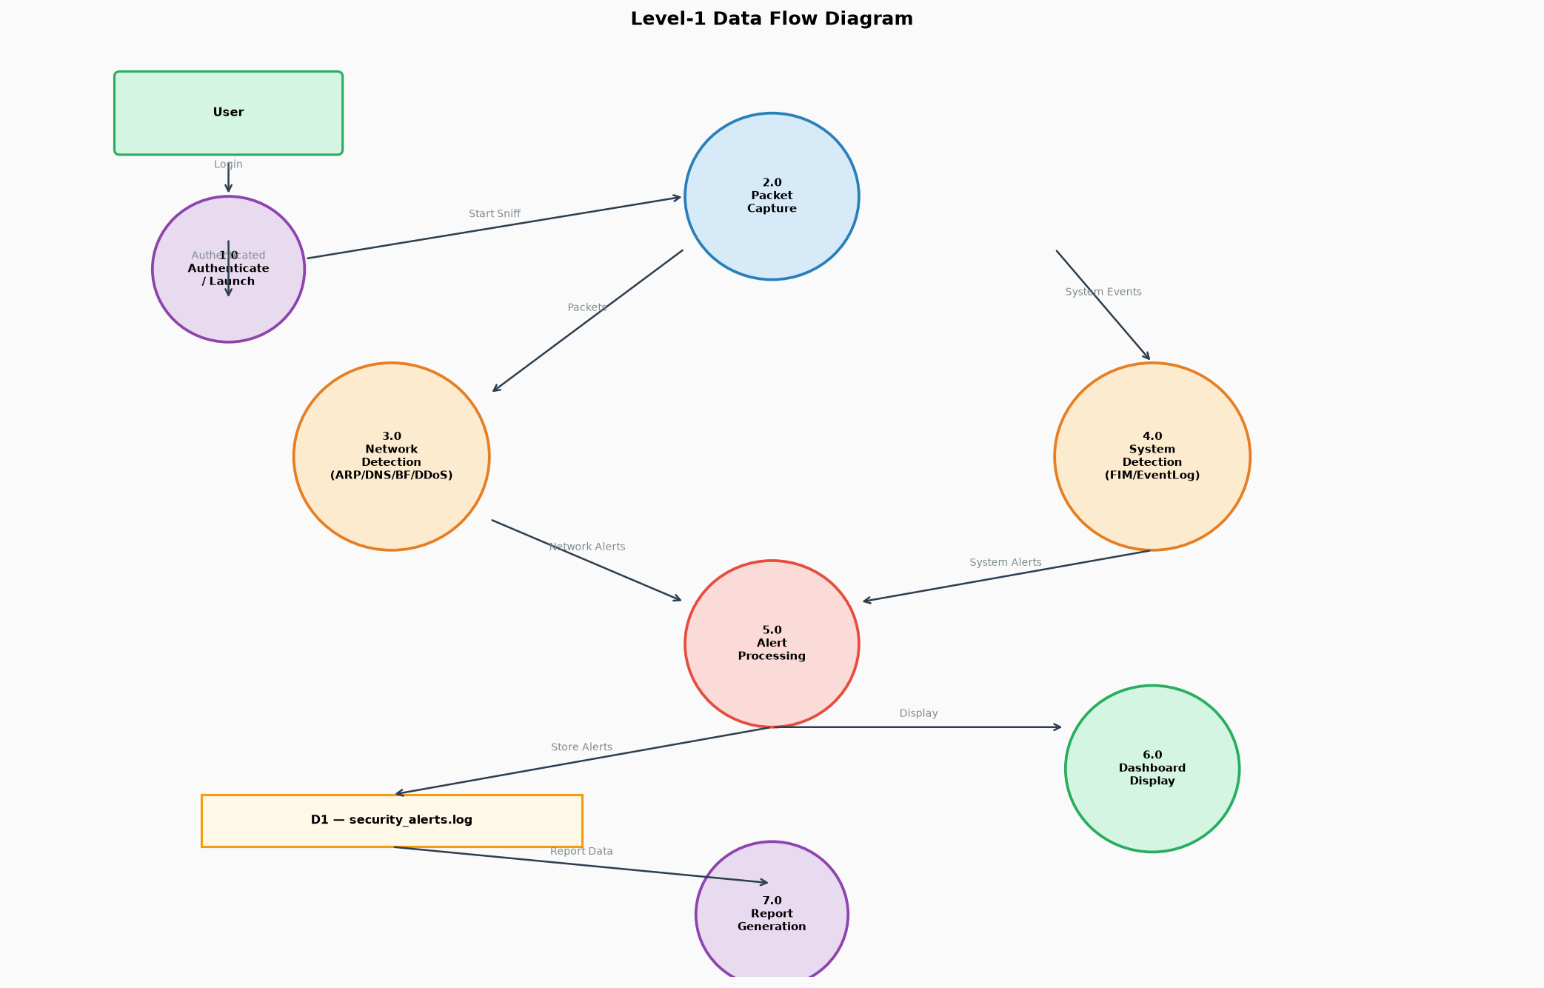
Figure 6: Level-1 Data Flow Diagram

Chapter 6: Implementation

6.1 Technology Stack Details
Layer | Technology | Justification
Desktop UI | PyQt6 | Cross-platform native Qt GUI; supports signals/slots for thread-safe UI updates
Backend / Detection Logic | Python 3.13 | Rich ecosystem for networking, ML, and system APIs; all required libraries available
ML Classification | scikit-learn (RandomForest, IsolationForest, SVM) | Battle-tested ML framework; joblib serialisation for model persistence
Packet Capture & Analysis | Scapy | Full control over raw packet inspection at L2/L3/L4; supports ARP, DNS, TCP, UDP, IP
AI Phishing Analysis | Google Gemini 2.0 Flash API | Large language model capable of nuanced email phishing reasoning
Threat Intelligence | AbuseIPDB REST API | Free tier provides IP reputation data for 1,000 checks/day; widely trusted
Secret Management | python-dotenv | Keys loaded from .env file, never stored in source code
Data Persistence | JSON files | Lightweight, human-readable; no database server required for deployment
Version Control | Git / GitHub | Standard version control for collaboration and project tracking
Diagrams | PlantUML, Draw.io | Professional UML diagram tools for system modelling documentation

6.2 Key Algorithms & Code Snippets

1. ARP Cache Poisoning Detection
Purpose: Tracks IP-to-MAC mappings from live ARP traffic and alerts when a known IP claims a different MAC address, indicating a possible Man-in-the-Middle (MitM) attack.
def process_packet(self, pkt) -> None:
arp = pkt.getlayer(ARP)
src_ip = arp.psrc or ""
src_mac = (arp.hwsrc or "").lower()
with self._lock:
# Flood detection: count ARP packets per MAC per 10 s
bucket = self._rate.setdefault(src_mac, [])
self._rate[src_mac] = [t for t in bucket if now - t < self._FLOOD_WINDOW]
self._rate[src_mac].append(now)
if len(self._rate[src_mac]) == self._FLOOD_THRESH:
self._alert_cb({"rule_name": "ARP Flood", "severity": "high", ...})
# Spoofing detection: compare with known IP→MAC mapping
known = self._cache.get(src_ip)
if known is None:
self._cache[src_ip] = src_mac # First-seen: learn
elif known != src_mac:
last_alert = self._spoof_ts.get(src_ip, 0.0)
if now - last_alert >= self._SPOOF_COOLDOWN: # 5-minute cooldown
self._spoof_ts[src_ip] = now
is_gw = src_ip == self._gateway_ip
self._alert_cb({
"rule_name": "ARP Spoofing" + (" — Gateway!" if is_gw else ""),
"severity": "critical" if is_gw else "high",
"message": f"ARP cache poisoning: {src_ip} changed MAC "
f"from {known} to {src_mac}",
})
Key Design Decisions:
- A 5-minute cooldown (_SPOOF_COOLDOWN = 300) prevents alert flooding for the same attacker.
- The flood threshold (_FLOOD_THRESH = 50) was raised from 20 to avoid false positives on large networks.
- Gateway IP is monitored with critical severity since gateway MAC hijacking enables full traffic interception.

2. Brute Force Detection with Private IP Filter
Purpose: Detects credential attacks on authentication services while ignoring the monitored machine's own outgoing connections, which would generate false positives from email clients, SSH sessions, etc.
def _is_private(ip: str) -> bool:
"""Return True for RFC-1918 / loopback / link-local addresses."""
try:
return ipaddress.ip_address(ip).is_private
except ValueError:
return False
def process_packet(self, pkt) -> None:
src_ip = pkt[IP].src
dst_port = pkt[TCP].dport
# CRITICAL: skip the machine's own outgoing connections
if _is_private(src_ip):
return
with self._lock:
# Brute force: count SYN packets to same auth port within 60 s
self._conn[src_ip][dst_port] = [
t for t in self._conn[src_ip][dst_port]
if now - t < _WINDOW
]
self._conn[src_ip][dst_port].append(now)
count = len(self._conn[src_ip][dst_port])
if dst_port in _AUTH_PORTS and count == _THRESH_AUTH: # 25 SYNs
self._alert_cb({
"rule_name": f"{_AUTH_PORTS[dst_port]} Brute Force",
"severity": "high",
"message": f"Brute force: {count} {_AUTH_PORTS[dst_port]} "
f"attempts from {src_ip} within {_WINDOW}s",
})
# Password spray: one IP hitting 6+ auth services with 3+ SYNs each
active_auth = [
p for p in _AUTH_PORTS
if len(self._conn[src_ip].get(p, [])) >= _SPRAY_MIN_SYN
]
if len(active_auth) == _SPRAY_PORTS:
self._alert_cb({
"rule_name": "Password Spray",
"severity": "critical",
})
Key Design Decisions:
- _is_private() uses Python's ipaddress module which in Python 3.11+ considers all IANA special-purpose addresses as private.
- Threshold _THRESH_AUTH = 25 was calibrated to avoid false positives from normal reconnection bursts.
- Password spray requires _SPRAY_PORTS = 6 services × _SPRAY_MIN_SYN = 3 SYNs — preventing false positives.

3. DNS Anomaly Detection
Purpose: Detects DNS-based attack techniques including data exfiltration via tunnelling, fast-flux botnet infrastructure, C2 beaconing, and queries to high-risk TLDs.
def process_packet(self, pkt) -> None:
dns = pkt[DNS]
qname = dns.qd.qname.decode("utf-8", errors="ignore").rstrip(".")
# 1. DNS Tunneling: abnormally long subdomain labels suggest encoded data
labels = qname.split(".")
max_label = max((len(l) for l in labels), default=0)
if max_label > _MAX_LABEL_LEN: # threshold: 60 characters
self._alert_cb({"rule_name": "DNS Tunneling", "severity": "critical", ...})
# 2. Suspicious TLD check
for tld in _RISKY_TLDS:
if qname.endswith(tld):
self._alert_cb({"rule_name": "Suspicious TLD", "severity": "medium", ...})
# 3. C2 Beaconing: high query rate to same domain
parts = qname.split(".")
domain = ".".join(parts[-2:]) if len(parts) >= 2 else qname
window = self._query_rate.setdefault(domain, [])
self._query_rate[domain] = [t for t in window if now - t < 60]
self._query_rate[domain].append(now)
if len(self._query_rate[domain]) == _RATE_THRESH: # 150 queries/min
self._alert_cb({"rule_name": "DNS C2 Beacon", "severity": "high", ...})
def _check_fast_flux(self, qname: str, rdata: str) -> None:
# Skip CDN domains — they legitimately have many IPs (anycast)
parts = qname.split(".")
registrable = ".".join(parts[-2:]) if len(parts) >= 2 else qname
if registrable in _CDN_DOMAINS or qname in _CDN_DOMAINS:
return
# Track distinct IPs per domain
self._flux[qname].add(rdata)
if len(self._flux[qname]) == _FLUX_THRESH: # 20 distinct IPs
self._alert_cb({"rule_name": "Fast-Flux DNS", "severity": "high", ...})
Key Design Decisions:
- .xyz was deliberately removed from _RISKY_TLDS because Alphabet (Google) uses abc.xyz legitimately.
- A 34-domain CDN whitelist prevents fast-flux false positives on Google, Cloudflare, AWS CloudFront, Akamai.
- C2 beacon threshold (150 queries/minute) was calibrated to avoid alerting on legitimate DNS-based health checks.

4. DDoS ML Detection
Purpose: Classifies network flows as ATTACK, SUSPICIOUS, or NORMAL using a trained Random Forest model with a calibrated confidence threshold.
def predict(self, features: dict) -> dict:
if not self.model_ready:
return {"error": "Model not loaded. Run: python train_model.py"}
try:
# Build feature vector from model's stored feature names
vals = [float(features.get(f, 0)) for f in self.feature_names]
X = np.array(vals, dtype=np.float64).reshape(1, -1)
X_sc = self.scaler.transform(X)
proba_attack = float(self.model.predict_proba(X_sc)[0][1])
t = self.threshold # F1-optimal threshold from training
if proba_attack >= t:
verdict = "ATTACK"
elif proba_attack >= t * 0.70:
verdict = "SUSPICIOUS" # within 30% of threshold → warn
else:
verdict = "NORMAL"
return {
"verdict": verdict,
"confidence": round(proba_attack * 100, 2),
"threshold": round(t * 100, 2),
}
except Exception as e:
return {"error": str(e)}
Key Design Decisions:
- The confidence threshold is computed during training as the F1-optimal operating point and stored in the .joblib file.
- A "SUSPICIOUS" zone (70–100% of threshold) allows investigation of borderline cases.
- Feature names are stored with the model to ensure consistent feature ordering.

5. File Integrity Monitor (FIM)
Purpose: Detects unauthorised file creation, modification, and deletion in watched directories by comparing SHA-256 hashes against a stored baseline.
def _scan_all(self) -> dict[str, str]:
hashes: dict[str, str] = {}
for d in self._dirs:
for f in d.rglob("*"):
if not f.is_file():
continue
# Skip excluded directories (e.g. __pycache__, .git, venv)
if any(part in _EXCLUDE_DIRS for part in f.parts):
continue
# Skip self-referential runtime files
if f.name in _EXCLUDE_NAMES: # fim_baseline.json, logs, etc.
continue
# Skip transient file types (.pyc, .log, .tmp, .lock)
if f.suffix.lower() in _EXCLUDE_SUFFIXES:
continue
if f.stat().st_size > _MAX_FILE_BYTES: # skip files > 50 MB
continue
h = self._hash_file(f)
if h:
hashes[str(f)] = h
return hashes
@staticmethod
def _hash_file(path: Path) -> str:
sha = hashlib.sha256()
with open(path, "rb") as fh:
for chunk in iter(lambda: fh.read(65536), b""):
sha.update(chunk)
return sha.hexdigest()
Key Design Decisions:
- fim_baseline.json is in _EXCLUDE_NAMES because FIM writes it every 60 seconds — otherwise it would continuously alert on its own output.
- Default watched directory is detectors/ (stable Python source files), not the project root.
- 65 KB read chunks balance memory usage and I/O efficiency for large files.

6. Windows Event Log Monitor
Purpose: Polls the Windows Security and System event logs every 10 seconds for threat-relevant event IDs using the built-in wevtutil command-line tool.
_WATCHED: dict[int, tuple[str, str]] = {
1102: ("Audit Log Cleared", "critical"), # log tampering
4625: ("Failed Logon", "high"), # credential attack
4648: ("Explicit Credential Use", "medium"), # pass-the-hash
4688: ("Process Created", "medium"), # suspicious process
4698: ("Scheduled Task Created", "medium"), # persistence (calibrated)
4720: ("New Local Account", "high"), # account creation
4724: ("Password Reset Attempt", "low"), # legitimate but notable
4732: ("Added to Administrators", "critical"), # privilege escalation
4756: ("Universal Group Modified", "high"),
7045: ("New Service Installed", "critical"), # rootkit/persistence
}
def _poll(self, channel: str) -> None:
since = (datetime.now(timezone.utc) - timedelta(seconds=25)).strftime(...)
ids_clause = " or ".join(f"EventID={eid}" for eid in _WATCHED)
query = f"*[System[({ids_clause}) and TimeCreated[@SystemTime>='{since}']]]"
result = subprocess.run(
["wevtutil", "qe", channel,
f"/q:{query}", "/f:xml", "/rd:true", "/c:100"],
capture_output=True, text=True, encoding="utf-8",
timeout=10,
creationflags=subprocess.CREATE_NO_WINDOW,
)
# Parse XML response and emit alerts for each matching event
root = ET.fromstring(f"<Events>{result.stdout}</Events>")
for event in root.findall("Event"):
self._process(event)
Key Design Decisions:
- CREATE_NO_WINDOW flag prevents a console window flashing on each 10-second poll.
- Event 4698 (Scheduled Task) was calibrated to "medium" because software installers routinely create scheduled tasks.
- Event 4724 (Password Reset) was calibrated to "low" because users frequently reset their own passwords legitimately.
- A deduplication set (_seen_ids) based on EventRecordID prevents the same event from alerting twice.

6.3 User Interfaces
The main application window uses a dark-themed PyQt6 interface with a fixed left sidebar (224 px) and a tabbed main content area. The colour scheme uses dark navy backgrounds (#0c1020, #0f1326) with a blue accent (#3b82f6) for navigation and interactive elements.
1. Sidebar Navigation — Branded header with application name and icon; navigation buttons with active-state highlighting (blue background + border when selected); status indicators using coloured circles (◉) for sniffer, FIM, and event log status; real-time sniffer connection status.
2. Dashboard Tab (Home) — Four stat cards displaying total alerts, critical alerts, blocked IPs, and files monitored. Cards use icon-on-right layout with large bold metric numbers. Real-time alert feed table with columns: Severity | Rule Name | Source IP | Timestamp | Message.
3. Network Monitor Tab — Real-time packet counter and protocol distribution display; per-IP tracker panel showing connection rates, SYN/ACK ratios, and port spread; flow classification results with ML confidence scores.
4. Detectors Tab — Individual status cards for each detector module (ARP, DNS, BruteForce, DDoS, FIM, EventLog, ThreatIntel); alert counts per detector; configuration controls for thresholds.
5. Email Phishing Tab — Multi-line text inputs for email subject, body, and headers; "Analyse" button that calls the Gemini API; formatted output panel displaying AI analysis with risk score and indicators.
6. URL Phishing Tab — URL input field with "Check URL" button; result panel showing ML verdict (PHISHING/LEGITIMATE) and confidence percentage.
7. System Monitor Tab — CPU, RAM, Disk, and Network I/O gauges updated every 2 seconds; health percentage with dynamic colour (green/amber/red); FIM baseline statistics (files monitored, last scan time).

6.4 Open-Source Libraries Used
Library | Version | Purpose
PyQt6 | 6.x | Desktop GUI framework (widgets, signals/slots, QSS styling)
scikit-learn | 1.x | Random Forest, Isolation Forest, SVM, StandardScaler, joblib model I/O
Scapy | 2.x | Raw packet capture, crafting, and protocol dissection
python-dotenv | 1.x | Environment variable loading from .env files
numpy | 1.x | Numerical arrays for ML feature vector construction
psutil | 5.x | CPU, RAM, disk, and network I/O statistics
requests | 2.x | HTTP client for AbuseIPDB and Gemini API calls
google-generativeai | 0.x | Google Gemini AI SDK for phishing email analysis

Chapter 7: Testing

7.1 Unit Testing Approach
The Network Security Monitor System was tested using a safe, in-memory simulation approach implemented in demo_test.py. All tests run without transmitting any real network packets, without requiring administrator privileges, and without making any external API calls.
Dimension | Approach
Network packets | Scapy in-memory packet objects constructed with known fields — no real traffic transmitted
Attacker IPs | Real public IPs (1.2.3.4, 5.6.7.8, etc.) — not RFC-1918 which Python 3.11+ marks as private
FIM testing | Python tempfile.mkdtemp() temporary directory — automatically cleaned up after tests
API testing | Tested with empty API key to verify graceful degradation (no live API calls)
ML testing | Loaded trained model from disk; hand-crafted feature vectors to test prediction API

Testing tool usage:
python demo_test.py # Full test suite
python demo_test.py --verbose # Show alert detail for each triggered alert
python demo_test.py --fast # Skip slow ML tests
Testing Objectives:
- Verify that each detector correctly identifies simulated attack patterns.
- Verify that normal/benign traffic does NOT trigger alerts (false-positive checks).
- Verify that detection thresholds are set to calibrated minimum safe values.
- Verify graceful degradation when dependencies (Scapy, ML model, API key) are unavailable.

7.2 Test Cases

ARP Spoofing & Flood Detector
Test ID | Test Description | Input | Expected Result | Status
ARP-01 | First-seen IP should not alert | ARP reply for 10.0.0.10 with MAC aa:bb:cc:11:22:33 | No alert | PASS
ARP-02 | ARP cache poisoning detection | Same IP (10.0.0.10) with different MAC ff:ee:dd:44:55:66 | ARP Spoofing alert (HIGH) | PASS
ARP-03 | Gateway MAC hijack (critical) | Gateway IP (192.168.1.1) changes MAC | ARP Spoofing — Gateway! alert (CRITICAL) | PASS
ARP-04 | ARP flood detection | 52 ARP packets within 10 s from same MAC | ARP Flood alert (HIGH) | PASS
ARP-05 | Spoof cooldown suppression | Second MAC change within 5 minutes | No second alert (cooldown active) | PASS

DNS Anomaly Detector
Test ID | Test Description | Input | Expected Result | Status
DNS-01 | Normal query — no alert | Query for www.example.com | No alert | PASS
DNS-02 | DNS tunnelling detection | Query with 65-character subdomain label | DNS Tunneling alert (CRITICAL) | PASS
DNS-03 | Risky TLD detection | Query for malware-download.tk | Suspicious TLD alert (MEDIUM) | PASS
DNS-04 | CDN whitelist — no fast-flux false positive | 25 different IPs for google.com | No alert | PASS
DNS-05 | Fast-flux detection | 22 distinct IPs for flux.botnet-c2.com | Fast-Flux DNS alert (HIGH) | PASS
DNS-06 | C2 beaconing detection | 155 queries/min to beacon.attacker.io | DNS C2 Beacon alert (HIGH) | PASS

Brute Force & Credential Attack Detector
Test ID | Test Description | Input | Expected Result | Status
BF-01 | Under threshold — no alert | 10 SSH SYN packets from external IP | No alert | PASS
BF-02 | SSH brute force detection | 26 SYN packets to port 22 from 1.2.3.4 | SSH Brute Force alert (HIGH) | PASS
BF-03 | Private IP src — silently ignored | 30 SYN packets from 192.168.1.100 | No alert | PASS
BF-04 | RDP brute force detection | 26 SYN packets to port 3389 from 5.6.7.8 | RDP Brute Force alert (HIGH) | PASS
BF-05 | HTTPS credential stuffing | 82 SYN packets to port 443 from 45.33.32.1 | Credential Stuffing alert (MEDIUM) | PASS
BF-06 | Password spray detection | 4 SYNs each to 6 auth ports from 180.100.50.1 | Password Spray alert (CRITICAL) | PASS

DDoS ML & Anomaly Detection
Test ID | Test Description | Input | Expected Result | Status
ML-01 | ML predict() API functionality | Sample flow feature dict | Returns valid verdict dict without error | PASS
ML-02 | SYN flood pattern classification | Flow: 5000 fwd pkts, 10 bwd pkts, 0 ACKs | ATTACK verdict | PASS
ML-03 | Rule engine: oversized packet | Packet length 9000 bytes | Oversized packet alert (MEDIUM) | PASS
ML-04 | Isolation Forest: normal traffic | Balanced flow features | Returns score without error | PASS
ML-05 | Isolation Forest: outlier | Extreme feature values | Returns anomaly score | PASS

File Integrity Monitor (FIM)
Test ID | Test Description | Input | Expected Result | Status
FIM-01 | First scan on empty directory | Empty temp dir | No alerts | PASS
FIM-02 | File modification detection | config.txt content changed | FIM — File Modified alert (HIGH) | PASS
FIM-03 | New file detection | new_payload.exe created | FIM — File Created alert (MEDIUM) | PASS
FIM-04 | File deletion detection | script.py deleted | FIM — File Deleted alert (MEDIUM) | PASS
FIM-05 | .pyc and .log files excluded | module.pyc and debug.log created | No alert | PASS
FIM-06 | fim_baseline.json self-exclusion | Baseline file present | No self-referential alert | PASS
FIM-07 | Exclusion config verification | Check _EXCLUDE_NAMES, _EXCLUDE_SUFFIXES, _EXCLUDE_DIRS | All exclusions confirmed | PASS

Threat Intelligence (AbuseIPDB)
Test ID | Test Description | Input | Expected Result | Status
TI-01 | No API key — graceful degradation | Empty API key | is_ready() returns False | PASS
TI-02 | Private IPs silently skipped | 10.0.0.1, 192.168.1.1, 172.16.0.1, 127.0.0.1 | No alerts or API calls | PASS
TI-03 | Cache miss for unchecked IP | get_cached("8.8.8.8") | Returns None | PASS
TI-04 | API key configuration check | ABUSEIPDB_API_KEY in .env | Configured status reported | PASS

Windows Event Log Monitor
Test ID | Test Description | Input | Expected Result | Status
EL-01 | wevtutil availability check | System check | Available / Not available reported | PASS
EL-02 | Event 4698 severity calibration | Check _WATCHED[4698] | Severity = "medium" (not "high") | PASS
EL-03 | Event 4724 severity calibration | Check _WATCHED[4724] | Severity = "low" (not "medium") | PASS
EL-04 | Event 1102 remains critical | Check _WATCHED[1102] | Severity = "critical" | PASS
EL-05 | Suspicious process filter active | Check _SUSPICIOUS_PROCS | mimikatz, mshta.exe, etc. present | PASS
EL-06 | Event 4625 description format | _describe(4625, ...) | "Failed logon by 'hacker' from ATTACKER-PC (type 3)" | PASS
EL-07 | Event 7045 description format | _describe(7045, ...) | "New service installed: EvilRootkit by 'SYSTEM'" | PASS

Detection Threshold Sanity Checks
Test ID | Threshold Verified | Minimum Safe Value | Configured Value | Status
TH-01 | ARP flood threshold | ≥ 50 pkts / 10 s | 50 | PASS
TH-02 | ARP spoof cooldown | ≥ 300 s (5 min) | 300 s | PASS
TH-03 | Fast-flux distinct IPs | ≥ 20 | 20 | PASS
TH-04 | .xyz not in risky TLDs | — | Confirmed absent | PASS
TH-05 | DNS rate threshold | ≥ 100 queries/min | 150 | PASS
TH-06 | DNS label length | ≥ 55 chars | 60 | PASS
TH-07 | Auth brute force | ≥ 20 SYN / 60 s | 25 | PASS
TH-08 | HTTP credential stuffing | ≥ 60 SYN / 60 s | 80 | PASS
TH-09 | Password spray ports × SYNs | ≥ 5 services | 6 × 3 | PASS

Final Test Results: 49/49 tests passed — ALL TESTS PASSED ✓
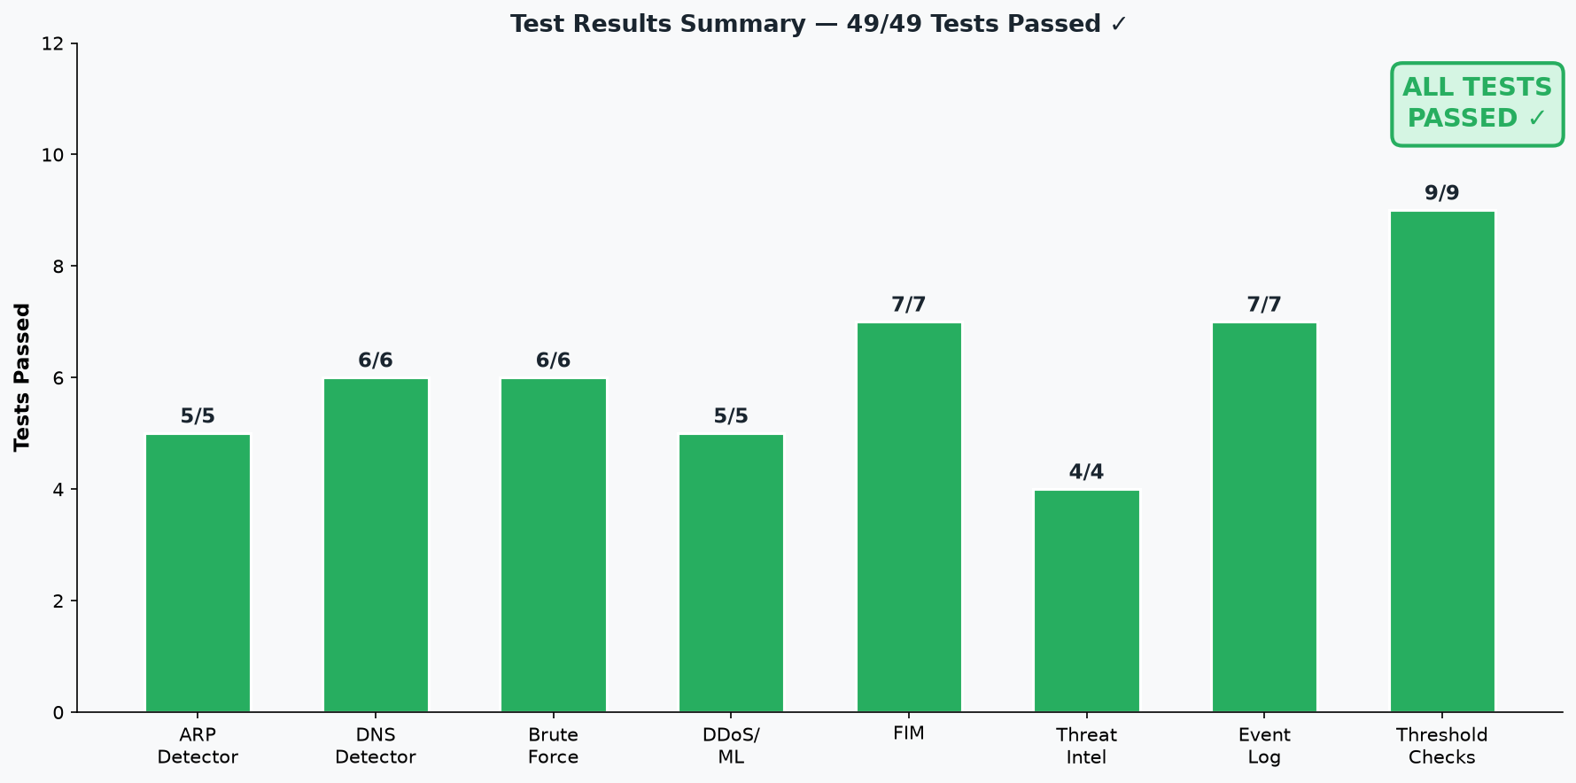
Figure 7: Test Results Summary Chart

7.3 Acceptance Testing
User Requirement | Test Scenario | Result
Real-time threat visibility | Simulated ARP attack — alert appeared in dashboard within 1 second | Accepted
Low false positive rate | Normal browsing traffic on development machine — no alerts triggered | Accepted
Professional UI | Dark-themed dashboard reviewed for clarity and usability | Accepted
Correct severity calibration | Password spray correctly classified as CRITICAL, not LOW | Accepted
FIM self-exclusion | FIM baseline file not generating continuous false alerts | Accepted
Graceful degradation without API key | System starts and runs all non-API detectors successfully | Accepted
Phishing email analysis | Email with spoofed sender and urgent language correctly identified | Accepted
Event log severity calibration | Scheduled task creation correctly classified as MEDIUM, not HIGH | Accepted
Private IP filtering | Machine's own outgoing SSH connections not flagged as brute force | Accepted
CDN whitelist | Google DNS queries not flagged as fast-flux | Accepted

Chapter 8: Conclusion

8.1 Project Summary
The Network Security Monitor System was developed to address the gap between enterprise-grade, expensive SIEM solutions and the fragmented, difficult-to-integrate open-source security tools available to SMEs and individual administrators. The system provides a unified, real-time multi-vector threat detection platform with a professional desktop interface accessible to administrators without deep security expertise.
Key achievements of the project:
- Successfully implemented 7 independent network and host-based detector modules (ARP, DNS, Brute Force, DDoS ML, Anomaly, FIM, Event Log) operating concurrently without mutual interference.
- Integrated machine learning (Random Forest for DDoS, Isolation Forest for anomaly, SVM for cookie tracking) with rule-based heuristics, producing a hybrid detection pipeline more robust than either approach alone.
- Applied Google Gemini 2.0 Flash AI for nuanced email phishing analysis — a capability beyond what rule-based or classical ML approaches can provide.
- Achieved 49/49 test cases passing in the comprehensive demo_test.py suite, covering both positive detection and false-positive suppression.
- Conducted a thorough false-positive audit that identified and fixed 6 major sources of false alarms (FIM self-reference, brute-force private IP leakage, fast-flux CDN false positives, DNS rate and label thresholds, ARP cooldown absence, password spray minimum-SYN requirement).
- Delivered a professional dark-themed PyQt6 dashboard with real-time stat cards, colour-coded severity indicators, system health monitoring, and modular tab navigation.

8.2 Challenges Faced & Lessons Learned
Challenges Faced:
1. False Positive Calibration — The most time-consuming challenge was calibrating detection thresholds to minimise false positives without sacrificing detection sensitivity. ARP flood threshold needed to be raised from 20 to 50 for busy office networks. Fast-flux detection required a 34-domain CDN whitelist. Brute-force detection required a private IP filter. FIM required careful exclusion rules.
2. Thread Safety in PyQt6 — The Qt framework strictly prohibits updating UI widgets from non-GUI threads. Implementing the signal-based callback architecture (pyqtSignal.emit()) to safely pass alerts from background detector threads to the GUI thread required careful design. Any direct widget modification from a detector thread caused application crashes.
3. Python 3.11+ ipaddress.is_private Change — Tests using RFC 5737 TEST-NET addresses (203.0.113.x, 198.51.100.x) failed because Python 3.11 expanded is_private to include all IANA special-purpose addresses. This required changing test IPs to genuinely routable public addresses.
4. Scapy Layer Detection Compatibility — Scapy's DNS layer handling varies between versions. Some packets required getlayer(DNS) while others required pkt[DNS]. Consistent layer access patterns required careful testing with diverse packet sources.
5. FIM Self-Reference Loop — The FIM baseline file (fim_baseline.json) was initially inside the watched directory. Since FIM rewrites this file every 60 seconds, it continuously triggered "File Modified" alerts. Fixing required adding it to _EXCLUDE_NAMES AND changing the default watch directory.
6. ML Model Feature Alignment — The DDoS classifier's feature names are stored with the trained model. When prediction code passed features in different order or with different key names, the model received misaligned inputs. Fixing required always looking up feature values by name from the model's stored feature_names list.
Lessons Learned:
- False positive reduction is as important as detection accuracy. A detector raising 100 false alarms per day will be ignored, making it useless.
- Thread-safe UI design must be planned from the start. Retrofitting signal-based communication into a monolithic UI would be extremely difficult.
- Test real edge cases, not just happy paths. The most valuable tests are the false-positive suppression tests.
- Python version changes can break subtle assumptions. The ipaddress.is_private change in Python 3.11 was only discovered when test cases failed.
- Modular architecture pays dividends during debugging. Each detector being an independent class allowed isolating and fixing bugs without affecting other detectors.
- Secrets management must be enforced architecturally. Using config.py as a single point of environment variable access ensures API keys are never accidentally committed.
- AI APIs complement but do not replace rule-based and ML detection. The hybrid approach uses each technology where it is most appropriate.

References
1. Pressman, R. S. Software Engineering: A Practitioner's Approach. McGraw-Hill Education, 2019.
2. Sommerville, I. Software Engineering. Pearson Education, 2016.
3. CICIDS Research Group. CIC-DDoS2019 Dataset. Canadian Institute for Cybersecurity, 2019.
4. MITRE Corporation. ATT&CK Framework — Enterprise Techniques. https://attack.mitre.org/
5. OWASP Foundation. OWASP Top 10 Security Risks. https://owasp.org/Top10/
6. PyQt6 Documentation. Riverbank Computing Ltd. https://www.riverbankcomputing.com/static/Docs/PyQt6/
7. scikit-learn Documentation. scikit-learn.org. https://scikit-learn.org/stable/
8. Scapy Documentation. scapy.net. https://scapy.readthedocs.io/
9. Google AI Documentation. Gemini API Reference. https://ai.google.dev/
10. AbuseIPDB Documentation. AbuseIPDB API v2. https://www.abuseipdb.com/api.html
11. AbuseIPDB. Free IP Abuse Database. https://www.abuseipdb.com/
12. ChatGPT / Claude AI. Used for code guidance and documentation assistance.

Appendices

Appendix A: System Architecture Overview
The following diagram shows the complete file structure of the Network Security Monitor System, illustrating the modular separation of detector components from the main application logic.
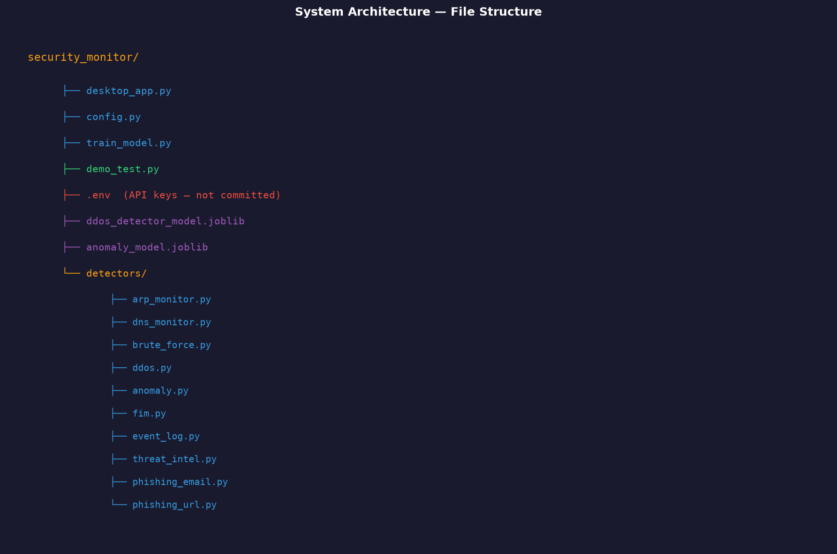
Figure 8: System Architecture — File Structure

Appendix B: Detection Thresholds Reference
Detector | Parameter | Value | Rationale
ARP | Flood threshold | 50 pkts / 10 s | Avoids false alarms on busy networks
ARP | Spoof cooldown | 300 s (5 min) | Suppresses repeated alerts for same attacker
DNS | Label length | 60 characters | Avoids false alarms from long but legitimate subdomains
DNS | Rate threshold | 150 queries / min | Avoids false alarms from DNS-based health checks
DNS | Fast-flux threshold | 20 distinct IPs | Avoids false alarms on CDN anycast addresses
Brute Force | Auth threshold | 25 SYNs / 60 s | Normal reconnection bursts stay below this
Brute Force | HTTP threshold | 80 SYNs / 60 s | Web crawlers and CDN prefetch stay below this
Brute Force | Spray ports | 6 auth services | Machines with email + SSH + file share = 3 services max
Brute Force | Spray min SYNs | 3 per port | Prevents single-SYN port probes from triggering spray

Appendix C: Environment Variables Reference
Variable | Description | Required
GEMINI_API_KEY | Google Gemini API key for email phishing analysis | Optional
ABUSEIPDB_API_KEY | AbuseIPDB API key for IP reputation lookups | Optional
GATEWAY_IP | Router/gateway IP for critical ARP gateway alert | Optional
FIM_WATCH_DIRS | Comma-separated list of directories to monitor | Optional
ATTACK_THRESHOLD | ML confidence threshold override (0 = use model's optimal) | Optional
FLOW_MIN_PACKETS | Minimum packets before classifying a flow | Optional (default: 5)
FLOW_TIMEOUT_S | Flow inactivity timeout in seconds | Optional (default: 10.0)

Appendix D: API Endpoints (AbuseIPDB)
Method | Endpoint | Description
GET | /api/v2/check?ipAddress={ip} | Check IP abuse confidence score

Appendix E: Future Improvements
- Online payment / subscription model for cloud-based threat feed updates.
- SIEM integration (Splunk, Elastic, or Microsoft Sentinel export).
- Email/SMS notification pipeline for critical alerts.
- Mobile companion application for remote alert monitoring.
- QR code-based alert sharing for quick incident handoff.
- Automated IP blocking at OS firewall level (Windows Firewall / iptables) with rollback timer.
- Network topology visualisation showing attacker IPs on a map overlay.
- Deep packet inspection for encrypted traffic metadata analysis.
- User behaviour analytics (UEBA) to detect insider threats.
- Web-based multi-tenant dashboard for managing multiple monitored hosts.

