Network Security Monitor - Detailed Technical Report
  - Generated on April 20, 2026 09:47:52

1. Executive Summary
This project is an end-to-end security monitoring platform built in Python, focused on detecting suspicious network behavior, especially DDoS-like traffic patterns, in near real time. The solution combines packet capture, deterministic rule-based scoring, machine-learning inference, automated response controls, and a desktop operations interface.
The current implementation emphasizes practical operations: readable telemetry, immediate risk visibility, configurable controls, and export/report capabilities for incident follow-up.

2. Business and Technical Objectives
Primary objectives:
1) Detect anomalous and attack-like traffic from live packets.
2) Present actionable data to an operator through a desktop UI.
3) Trigger mitigations (e.g., firewall block) when policy thresholds are met.
4) Preserve operational records via logs, DB records, and exports.
Secondary objectives:
1) Cross-platform behavior (Windows/Linux/macOS) with platform-specific command mapping.
2) Maintainable module boundaries (capture, ML, response, UI, orchestration).

3. System Architecture
The architecture is layered: input collection, feature and rule engine, ML ensemble scoring, enforcement layer, persistence, and operator presentation. The core orchestrator in runtime is EnhancedPacketExtractorCore, while CrossPlatformGUI is the primary desktop control plane.
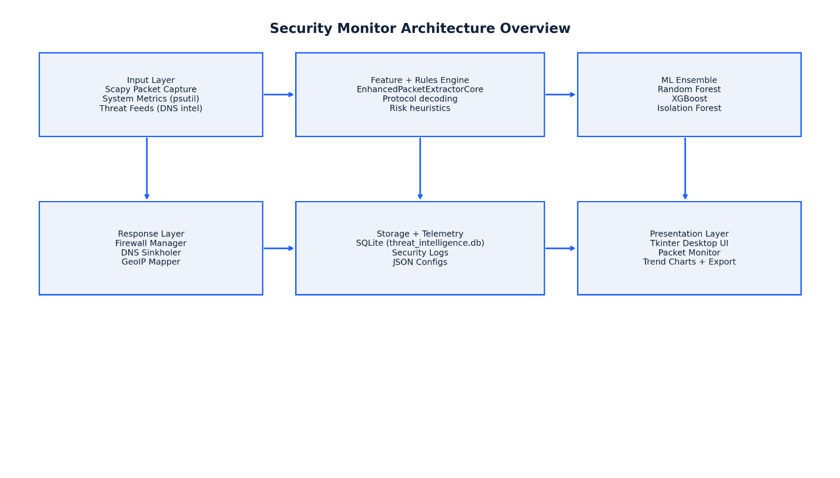
Figure 1. High-level architecture and component relationships.

4. Runtime Processing Pipeline (How the Program Works)
Step 1: Packet ingestion. If Scapy is available, packet sniffing runs in a background thread. Each packet is handed to extraction logic.
Step 2: Feature extraction. IP/TCP/UDP/ICMP fields are normalized into a structured feature record (e.g., protocol, ports, flags, TTL, packet size, inferred indicators).
Step 3: Rule-based risk scoring. Deterministic checks add to Risk_Score and map to indicators such as SYN flood behavior, low TTL anomalies, or UDP flood signatures.
Step 4: Ensemble prediction. The feature vector is evaluated by the ML ensemble (Random Forest, XGBoost, Isolation Forest). The system derives ML_STATUS and confidence and blends it with rule score.
Step 5: Enforcement decision. If threshold and policy conditions are satisfied, automated controls (notably firewall blocking) are triggered and logged.
Step 6: Presentation + persistence. Results are pushed to live UI views, logs are updated, and relevant artifacts can be exported to CSV/JSON/PNG.
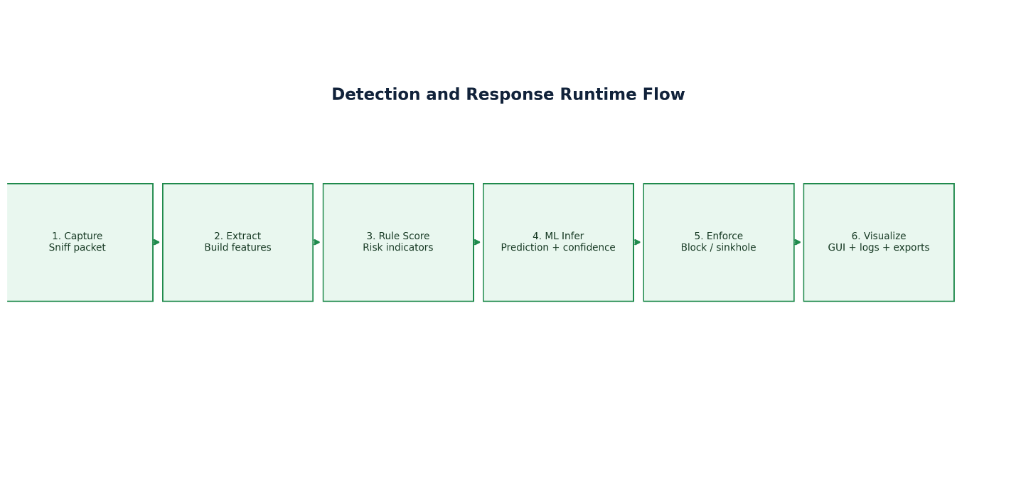
Figure 2. Detailed runtime flow from packet capture to response and visualization.

5. Main Components and Responsibilities

5.1 network_usage.py (Primary Desktop Runtime)
Contains the largest portion of application behavior: configuration handling, model integration, packet extraction core, threat intelligence support, firewall controls, trend analytics, and modern Tkinter desktop UI.

5.2 run_project.py (Orchestrator/Launcher)
Performs startup checks, ensures directories exist, validates dependencies and privileges, optionally runs traffic simulation/training helpers, and launches the main runtime process.

5.3 main_app.py (Flask/Web path)
Provides route-based access for dashboard and prediction workflows in web/API mode. Useful when integrating with browser-based monitoring or external API consumers.

5.4 tests/test_simulation_detection.py (Quality checks)
Validates key simulation and detection assumptions: expected fields are generated, and detection behavior exceeds a baseline threshold under SYN-flood simulation.

6. Desktop UI Walkthrough With Screenshots

6.1 Dashboard Tab
Dashboard is the operations landing page. It aggregates system cards (CPU, memory, attack ratio, blocked IPs), platform summary, quick actions, and real-time monitoring status text.
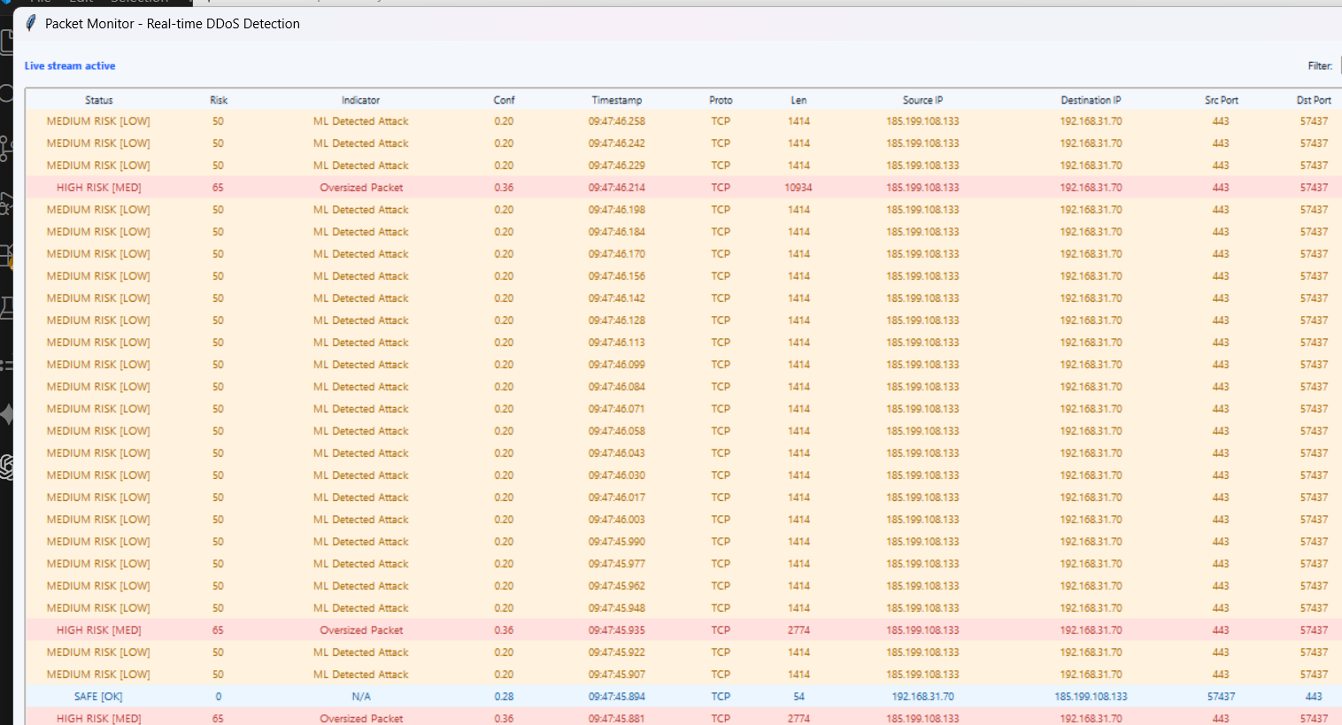
Figure 3. Sentinel Desktop Dashboard tab.

6.2 Security Tab
Security tab exposes security-feature state and high-value actions, including threat-intelligence updates, attack-stat views, malicious-domain search, and firewall manager access.
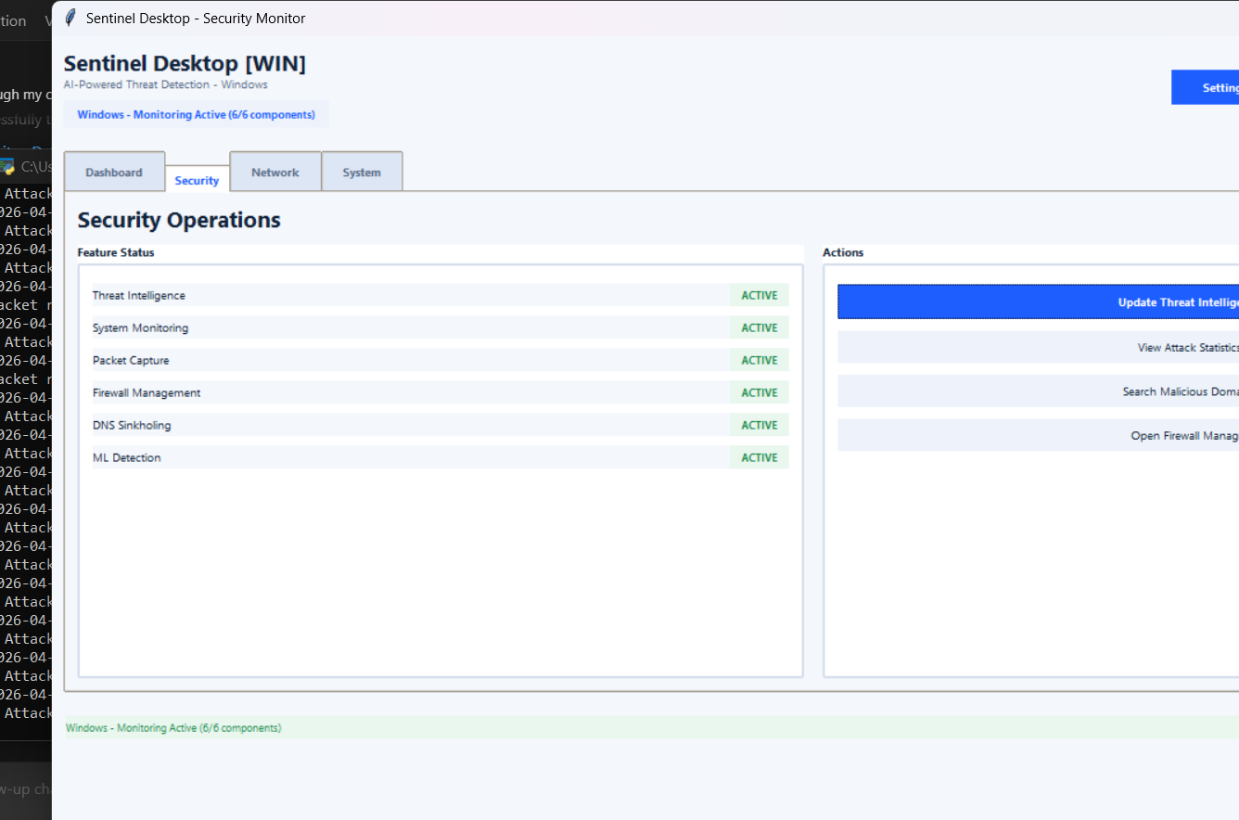
Figure 4. Security operations tab with feature statuses and controls.

6.3 Network Tab
Network tab contains interface snapshot information and packet-capture controls. It is used to start/stop packet capture and open live packet monitoring.
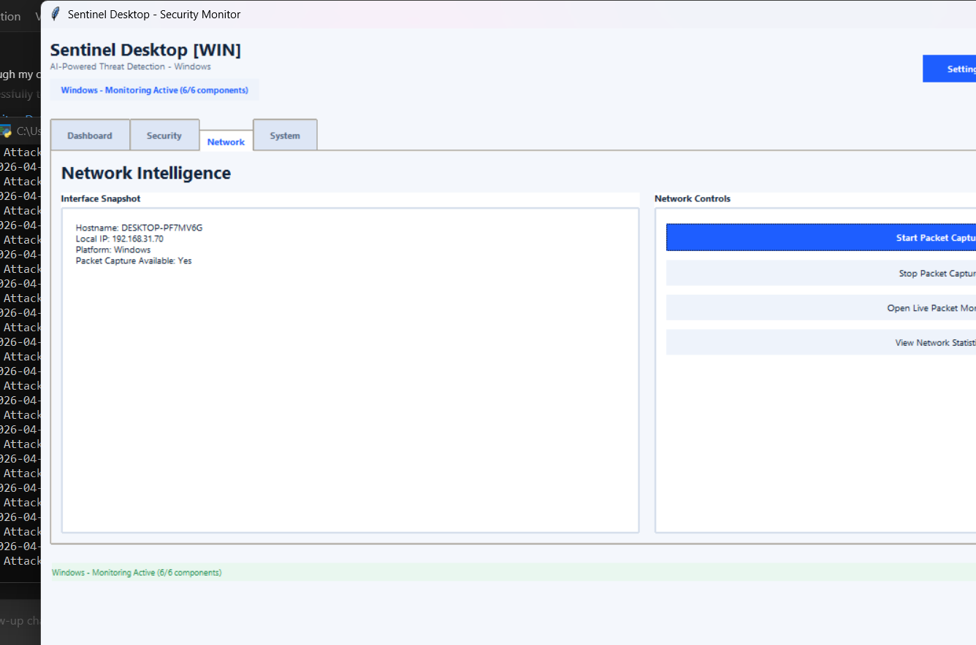
Figure 5. Network intelligence tab and packet capture controls.

6.4 System Tab
System tab provides live health metrics (CPU, memory, disk) and platform diagnostics (Python version, core count, privilege state, capture availability).
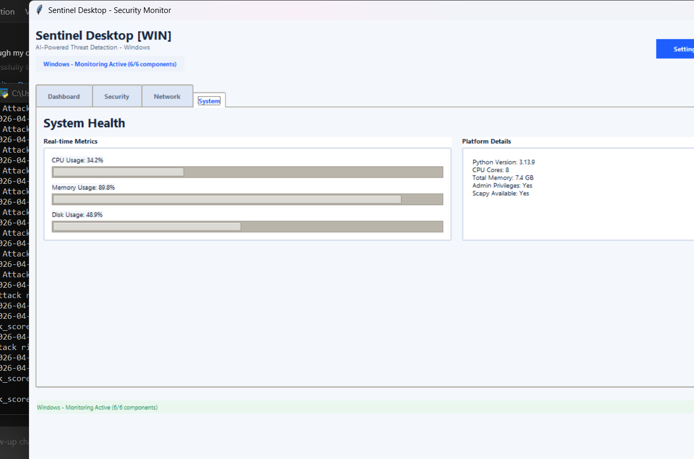
Figure 6. System health tab with real-time metric bars.

7. Specialized Operator Windows
Packet Monitor Window: real-time stream of packet rows with risk coloring, filtering, pause/resume, and CSV export for the visible dataset.
Firewall Manager Window: block/unblock management and status feedback for enforced IP controls.
Domain Search Window: query malicious domain intelligence and export findings to CSV.
Historical Trends Window: render trend charts from historical query data and export PNG charts.

8. Data, Model, and Configuration Flow
Model artifacts are loaded from local joblib files. The system supports fallback model loading paths and scaler usage when available.
Config values are loaded from JSON files (notably config.json and cross_platform_config.json), controlling thresholds, retraining intervals, sinkhole behavior, and UI/monitoring limits.
Threat-intelligence and DNS event history are stored in SQLite (threat_intelligence.db), enabling lookup and trend chart generation.

9. Detection and Response Logic in Practice
Risk attribution is not ML-only; it is a fusion model. Rule checks generate explainable signals while ML adds probabilistic classification confidence. This dual path improves practical usability because analysts can inspect both a numeric score and a categorical indicator.
Automated response is policy-gated. Firewall blocks occur only when prediction state, risk score threshold, and auto-block settings align, reducing accidental overblocking.

10. Export and Reporting Workflows
Current export implementation supports user-selected destinations via Save dialogs.
Supported exports:
1) Security report (JSON).
2) Packet table export (CSV).
3) Domain-search export (CSV).
4) Trend chart save (PNG).
This improves operational usability by removing hardcoded output destinations and letting analysts save directly to required folders.

11. Deployment and Runtime Considerations
The repository contains PyInstaller spec files for executable packaging. Runtime behavior is influenced by privilege level, especially packet capture and host-level firewall actions.
Recommended operational baseline:
1) Run in a controlled environment with least-necessary elevated privileges.
2) Keep model artifacts and sklearn-compatible versions synchronized.
3) Validate auto-block policy before enabling in sensitive environments.

12. Validation and Test Observations
Unit-style simulation tests exist for core detection behavior. In addition, compile and import checks are useful quick gates before release.
For production hardening, add integration tests that validate GUI workflows, export paths, and rollback behavior around firewall controls.

13. Limitations and Improvement Path
Current limitations include environment-sensitive packet capture, dependency on local model artifacts, and modest automated test coverage relative to platform breadth.
Planned improvement areas:
1) Broader integration tests and CI validation for GUI and exports.
2) Better model drift reporting and periodic health scoring.
3) Enhanced audit trails and role-based operation controls.
4) Extended screenshot/report automation for recurring governance reviews.

14. Conclusion
The program is a strong practical foundation for desktop-driven security monitoring. Its combined rules-plus-ML strategy, modern interface, and built-in response controls make it suitable for iterative hardening into a production-grade monitoring workstation.

