NETWORK SECURITY MONITOR SYSTEM

An Intelligent, Multi-Vector Cybersecurity Monitoring and
Machine Learning–Based Threat Detection Desktop Application

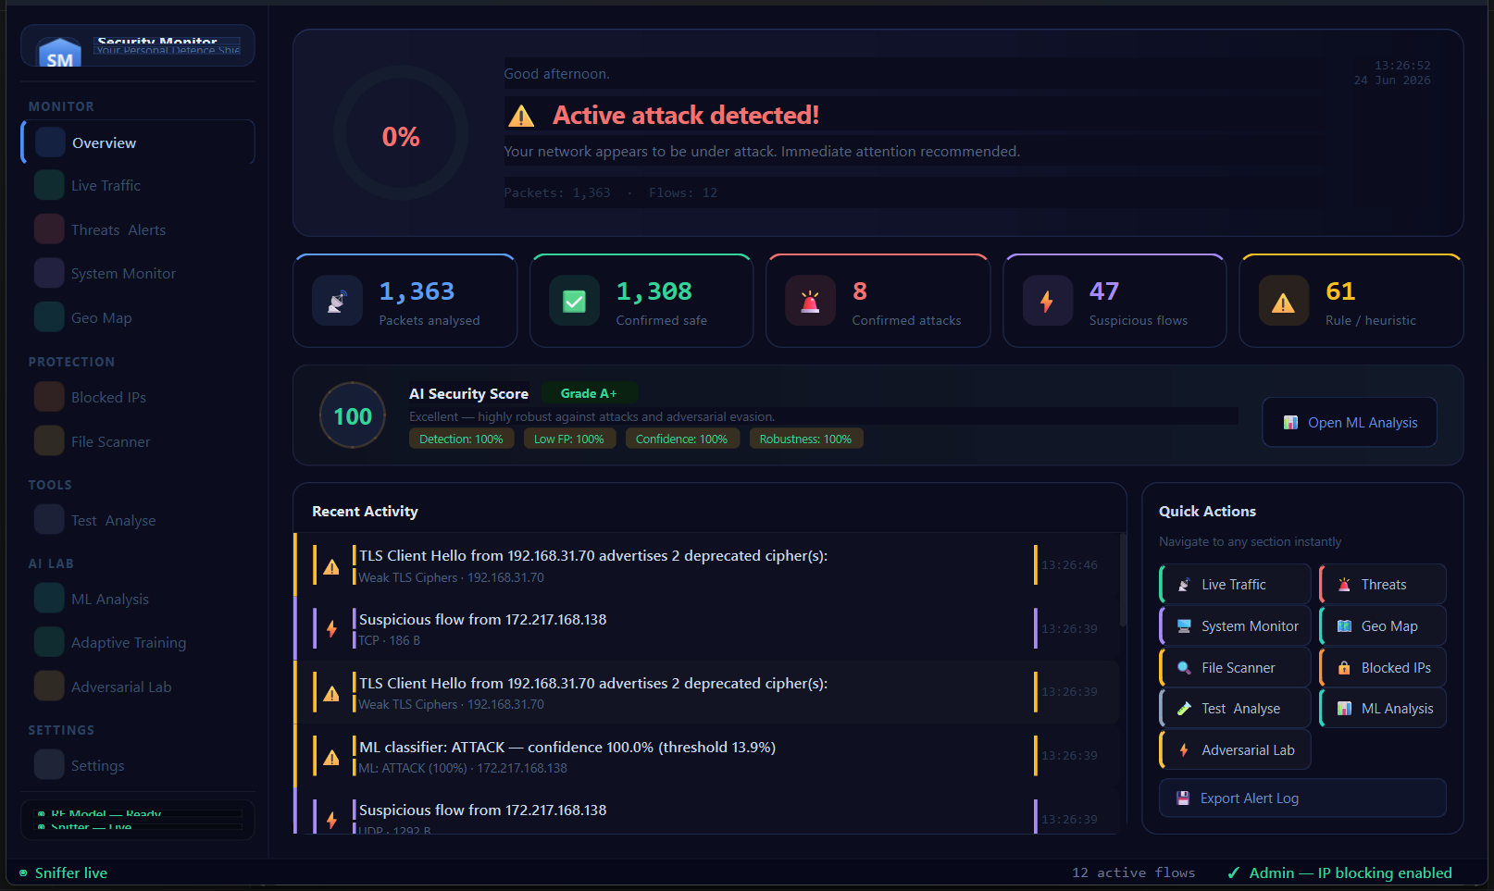

Internship Project Report

Prepared by: Samuel Akpoghene Otobo
Student ID: 22100896
Course: CMPE314 — Software Engineering

Date: September 2026

Executive Summary
The Network Security Monitor is a fully functional, production-quality cybersecurity desktop application built for Windows using Python 3.13 and PyQt6. It addresses the real-world gap between expensive enterprise SIEM solutions and the limited, difficult-to-integrate open-source tools available to small and medium organisations.
The system combines three complementary detection approaches — rule-based heuristics, trained machine learning models, and AI-powered natural language analysis — into a single, unified dark-themed dashboard that a network administrator can operate without deep security expertise. Over twenty independent detector modules operate concurrently, covering network attacks (DDoS, ARP spoofing, DNS abuse, brute force), host-based threats (file integrity, Windows Event Log anomalies, malware scanning), and application-layer phishing (email and URL classification).
A standout feature is the Adaptive Training Engine: the model continuously improves from operator feedback, using an online SGD corrective layer for immediate corrections and a full calibrated Random Forest retrain pipeline that versions every improvement. The system achieved 99.92% accuracy and 100% ROC AUC on the CICDDoS2019 benchmark dataset.

Metric | Value | Metric | Value
ML Accuracy | 99.92% | Detector Modules | 21
F1 Score | 99.93% | Test Cases Passed | 49 / 49
ROC AUC | 100.0% | Lines of Code | ~6,500
Technologies Used | 8 libraries | Platform | Windows 10/11

Chapter 1: Introduction

1.1 Background and Motivation
Cyber threats have grown dramatically in both frequency and sophistication. According to the 2024 Verizon Data Breach Investigations Report, over 68% of data breaches involve a human element — including phishing, credential theft, and exploitation of unpatched systems. Distributed Denial-of-Service (DDoS) attacks have increased by 46% year-on-year, with many campaigns now combining volumetric flooding with application-layer exhaustion to bypass traditional defences.
Small and medium enterprises (SMEs) face a particular challenge: enterprise-grade Security Information and Event Management (SIEM) systems such as Splunk, IBM QRadar, or Microsoft Sentinel cost tens of thousands of dollars annually and require dedicated security operations centre (SOC) staff to operate. Meanwhile, free open-source tools like Snort, OSSEC, or Suricata are powerful but fragmented — each tool covers only one threat surface and requires significant technical expertise to deploy, configure, and maintain.
This project was designed to fill that gap by building a single, integrated security monitoring application that is both technically sophisticated and practically accessible. The application brings together machine learning, artificial intelligence APIs, real-time packet inspection, and a professional graphical interface into one tool that any administrator can run.

1.2 Problem Statement
The central problem this project addresses is: how can an organisation with limited resources detect, understand, and respond to a wide range of cybersecurity threats in real time, without requiring a dedicated SOC team or expensive enterprise tooling?
Three specific challenges were identified:
- Fragmentation: most free tools cover only one attack type. No single affordable tool monitors DDoS, ARP spoofing, DNS abuse, brute force, file integrity, system events, and phishing simultaneously.
- False positives: rule-based detectors with fixed thresholds generate excessive false alarms on normal network activity (email clients, SSH, DNS health checks, CDN traffic), causing alert fatigue.
- Adaptability: static, pre-trained models become stale as network patterns evolve. No open-source tool offers continuous learning from operator feedback.

1.3 Project Objectives
The following objectives guided the development of the system:
- Detect DDoS attacks using a trained, calibrated Random Forest classifier with F1-optimal threshold selection.
- Monitor network traffic at the packet level for ARP spoofing, DNS tunnelling, fast-flux domains, and brute-force credential attacks.
- Monitor Windows Security and System Event Logs for signs of privilege escalation, new accounts, suspicious processes, and log tampering.
- Monitor file system integrity using SHA-256 hash comparison, alerting on unauthorised file changes.
- Scan files for malware using heuristic analysis and the MalwareBazaar cloud threat database.
- Classify email and URL phishing using Google Gemini AI and a trained Random Forest model.
- Provide an Adversarial Machine Learning laboratory to study FGSM evasion attacks and model explainability.
- Implement an Adaptive Training Engine that improves the ML model from operator feedback without manual retraining.
- Deliver all features through a professional, responsive PyQt6 desktop dashboard.
- Package the application as a standalone Windows executable requiring no Python installation.

1.4 Scope
The system is scoped to Windows 10/11 desktop environments. Packet-level detection requires Npcap. Event Log monitoring uses the built-in wevtutil utility. The application does not require cloud connectivity except for optional API-based features (AbuseIPDB, Gemini, Groq, MalwareBazaar), all of which degrade gracefully when unavailable.

Chapter 2: Relevance in Cybersecurity and Threat Detection

2.1 The Modern Threat Landscape
Modern organisations face a multi-dimensional threat landscape. The MITRE ATT&CK framework catalogues over 200 distinct adversarial techniques used in real-world attacks, spanning initial access, persistence, privilege escalation, lateral movement, and exfiltration. The Security Monitor system addresses threats across multiple MITRE ATT&CK tactics:
MITRE ATT&CK Tactic | Technique | Detection Module
Impact | T1498 — Network DoS | DDoS Detector (ML + Rules)
Credential Access | T1110 — Brute Force | BruteForceDetector
Collection | T1048 — DNS Exfiltration | DNSMonitor (tunnelling)
C2 | T1071 — DNS Beaconing | DNSMonitor (C2 beacon)
Credential Access | T1557 — ARP Cache Poisoning | ARPMonitor
Persistence | T1543 — New Service | EventLogMonitor (ID 7045)
Privilege Escalation | T1098 — Account Manipulation | EventLogMonitor (ID 4732)
Defence Evasion | T1070 — Clear Event Logs | EventLogMonitor (ID 1102)
Tampering | T1565 — Data Manipulation | FIM Monitor
Phishing | T1566 — Spear Phishing | Email + URL Phishing
Discovery | T1046 — Network Service Scan | VulnScanner
Initial Access | T1091 — Removable Media | USBMonitor + FileScanner

2.2 Why Machine Learning for Threat Detection?
Traditional signature-based intrusion detection systems (IDS) such as Snort work by matching network traffic against a database of known attack patterns. While effective for well-known threats, they fail against zero-day attacks, polymorphic malware, and low-and-slow attack techniques that deliberately avoid triggering threshold-based rules.
Machine learning addresses these limitations by learning statistical patterns from large datasets of labelled network flows. The Random Forest model used in this project was trained on the CICDDoS2019 dataset — a research-grade benchmark containing both benign traffic captures and 12 distinct DDoS attack types including SYN floods, UDP floods, HTTP floods, LDAP amplification, and NTP reflection attacks. The model generalises from these patterns to identify novel attack flows that share statistical characteristics with known attacks, even if the exact packet signatures differ.
The Isolation Forest anomaly detector adds a second complementary layer: trained exclusively on benign traffic, it flags any flow that statistically deviates from normal behaviour — providing coverage for attack types entirely absent from the training dataset.

2.3 Importance of the System
This system is important for several reasons beyond its individual features. First, it demonstrates that sophisticated, multi-vector threat detection is achievable with open-source tools and consumer hardware — removing the cost barrier for SMEs. Second, its Adaptive Training Engine represents a practical implementation of continual learning in a security context: the model improves from real operator experience rather than remaining static after initial training. Third, the integration of Large Language Model APIs (Gemini, Groq) for phishing analysis shows how AI can augment rule-based detection for natural-language threats that pattern-matching alone cannot address.

Chapter 3: System Architecture and Design

3.1 High-Level Architecture
The system is built around a modular detector architecture: each threat type is handled by an independent Python class in the detectors/ package. All detectors share a common alert interface — a callback function on_alert(dict) — that routes alerts to the PyQt6 UI through Qt signals, ensuring thread safety. This design means any detector can be added, removed, or modified without touching the rest of the system.
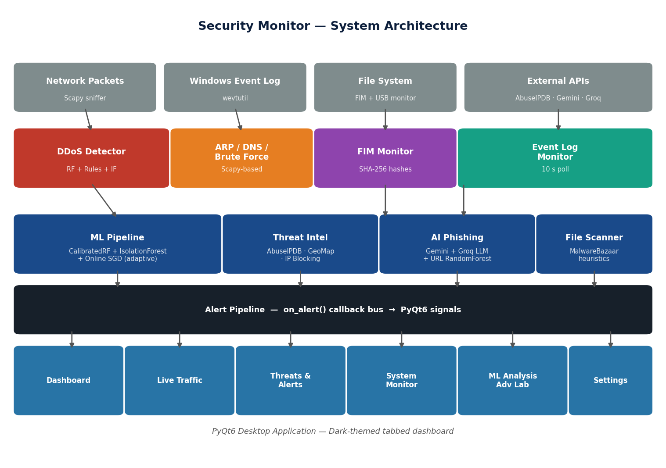
Figure 1 — System Architecture Overview

3.2 Technology Stack
Layer | Technology | Purpose
Desktop UI | PyQt6 6.x + QSS stylesheets | Cross-platform native GUI with signals/slots for thread-safe updates
ML Classification | scikit-learn (RF, IF, SVM) | DDoS classification, anomaly detection, cookie tracking
Online Learning | SGDClassifier (partial_fit) | Immediate corrective updates from operator feedback
Packet Capture | Scapy 2.x + Npcap | Raw L2/L3/L4 packet inspection — ARP, DNS, TCP, UDP
AI Phishing Analysis | Groq API (llama-3.3-70b) + Gemini 2.0 | Natural language phishing reasoning
Threat Intelligence | AbuseIPDB REST API | IP reputation lookups with async cache
Geo Visualisation | Folium + ip-api.com | Interactive Leaflet.js attack origin map
Model Persistence | joblib | Serialise/deserialise trained models
Secret Management | python-dotenv | API keys from .env, never hardcoded
Data Persistence | JSON files | Blocked IPs, FIM baseline, feedback buffer, settings
Packaging | PyInstaller 6.x | Standalone Windows .exe — no Python required on target
Cloud Hash Lookup | MalwareBazaar API | Free SHA-256 malware hash verification

3.3 Data Flow
Network packets enter via Scapy's sniff() function running in a dedicated background thread. Each packet is dispatched to all registered packet-level detectors (ARP, DNS, Brute Force, Flow Tracker). The Flow Tracker aggregates packets into 5-tuple flows and, once a flow has accumulated enough packets, extracts 19 features and calls the DDoS Random Forest classifier and the Isolation Forest anomaly detector. Any generated alerts are emitted via on_alert() callbacks, which in turn emit PyQt6 signals to update the UI on the main thread.
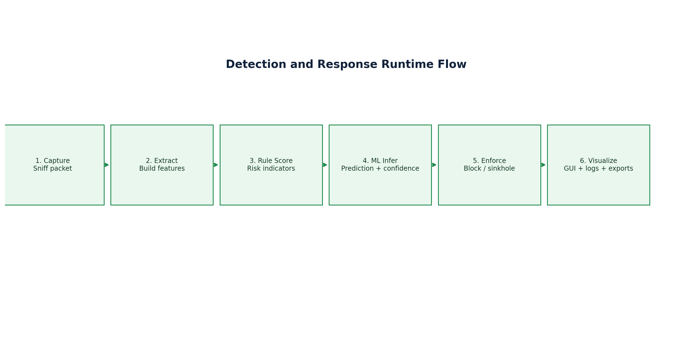
Figure 2 — Runtime Data Flow Diagram

3.4 Project File Structure
The project is organised as follows:
security_monitor/
desktop_app.py Main PyQt6 application (~6,500 lines)
config.py Centralised configuration (env vars, paths)
train_model.py DDoS RF + Isolation Forest training pipeline
build.py Cross-platform packaging script (PyInstaller)
installer.iss Inno Setup Windows installer script
detectors/
ddos.py DDoS ML classifier + rule engine
anomaly.py Isolation Forest anomaly detector
arp_monitor.py ARP spoofing and flood detection
dns_monitor.py DNS tunnelling, fast-flux, C2 beaconing
brute_force.py Brute force and password spray
threat_intel.py AbuseIPDB IP reputation (async, cached)
event_log.py Windows Event Log monitor (wevtutil)
fim.py SHA-256 file integrity monitoring
file_scanner.py Heuristic scanner + MalwareBazaar lookup
geo_mapper.py Geolocation map (Folium + ip-api.com)
vuln_scanner.py Socket-based port / service scanner
url_phishing.py URL Random Forest phishing classifier
email_phishing.py Gemini/Groq AI email phishing analysis
cookie.py SVM cookie tracker classifier
adversarial.py FGSM evasion, XAI, SecurityScorer
adaptive_trainer.py Feedback buffer, online SGD, retrain pipeline
flow_tracker.py 5-tuple network flow aggregation
ip_tracker.py Per-IP heuristic scoring
ip_blocker.py Windows Firewall auto-block with rollback timer
tls_inspector.py TLS Client Hello / JA3 fingerprint inspection
ueba.py User behaviour analytics (off-hours/new-host)
ddos_detector_model.joblib Trained DDoS RF model (~15 MB)
anomaly_model.joblib Isolation Forest model (~1.6 MB)
model_metrics.json Pre-computed performance metrics
feedback_buffer.jsonl User-labeled training samples
.env API keys (not committed)

Chapter 4: Features and Implementation

4.1 User Interface Overview
The application features a professional dark-themed PyQt6 desktop interface with a fixed 220-pixel sidebar and a tabbed main content area. The colour palette uses deep navy backgrounds (background: #0b0d1e, cards: #141828) with a blue accent (#4f8ef7) for navigation. All tabs have page-header banners with icons, titles, and action buttons. The screenshots below were captured from a live session of the running application.
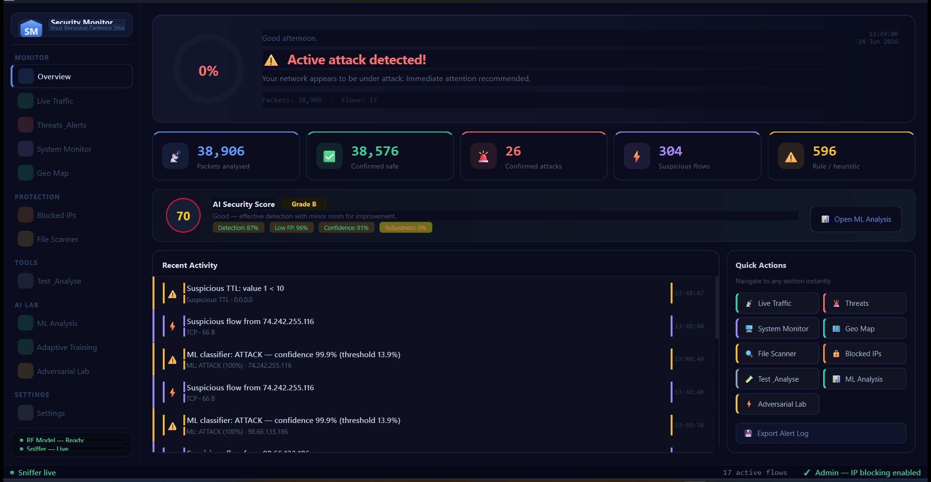
Figure 3 — Dashboard: Live stat cards (38,906 packets, 26 confirmed attacks), AI Security Score (70/100), recent activity feed, quick actions grid

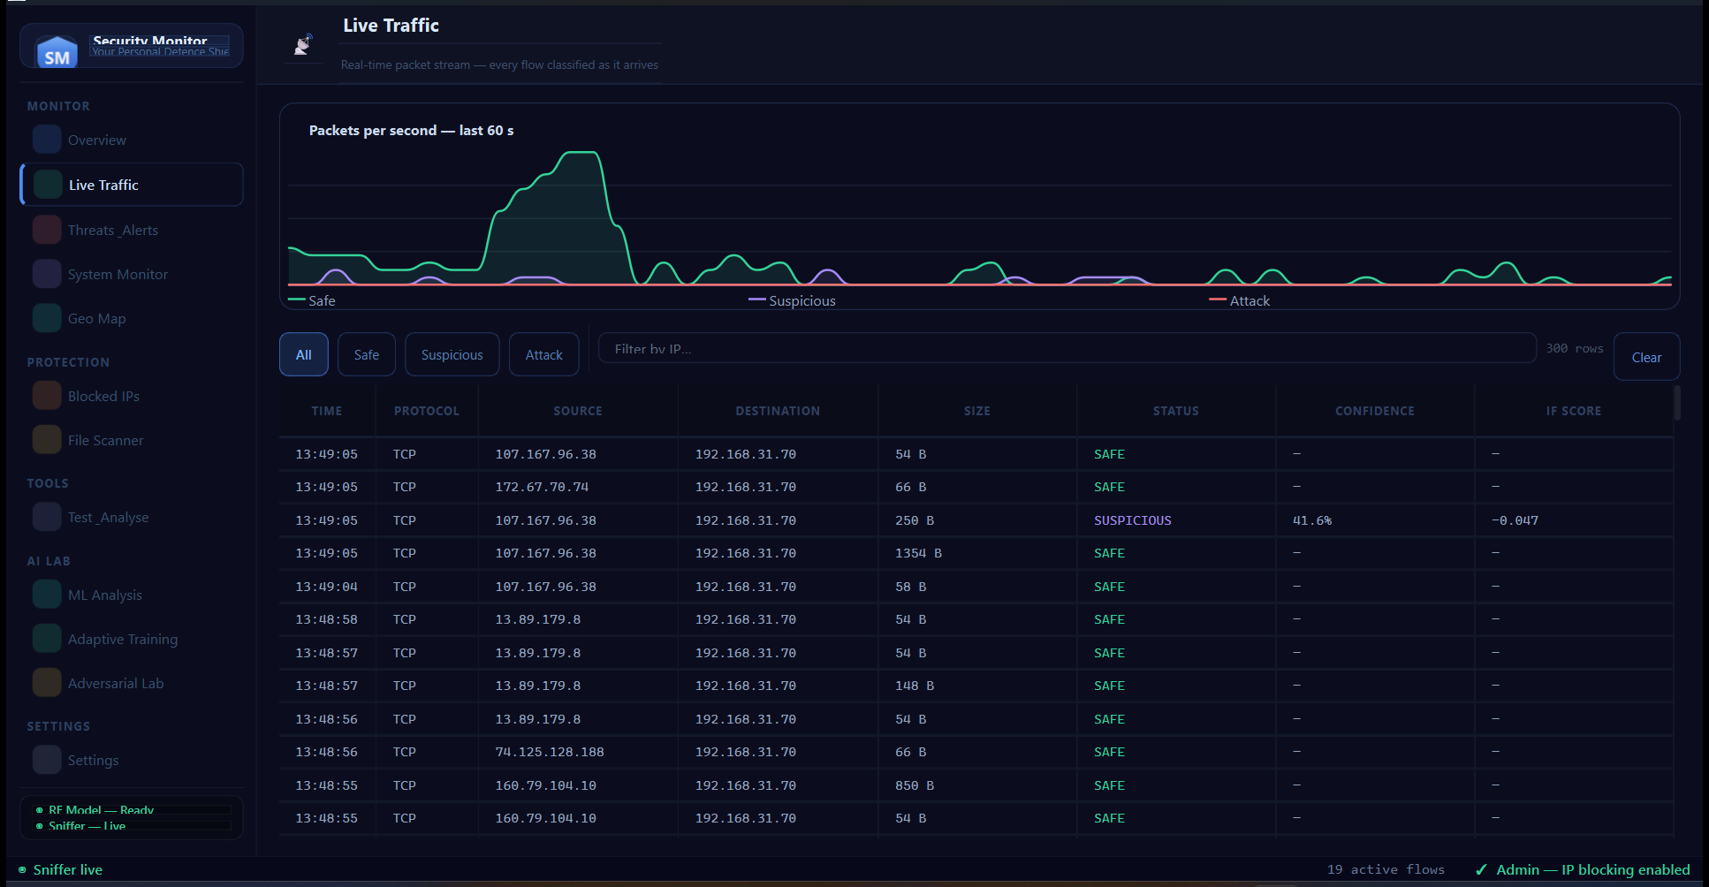
Figure 4 — Live Traffic Tab: Real-time packet chart (Packets/s over 60s), colour-coded SAFE/SUSPICIOUS/ATTACK table with ML confidence scores and IF anomaly scores

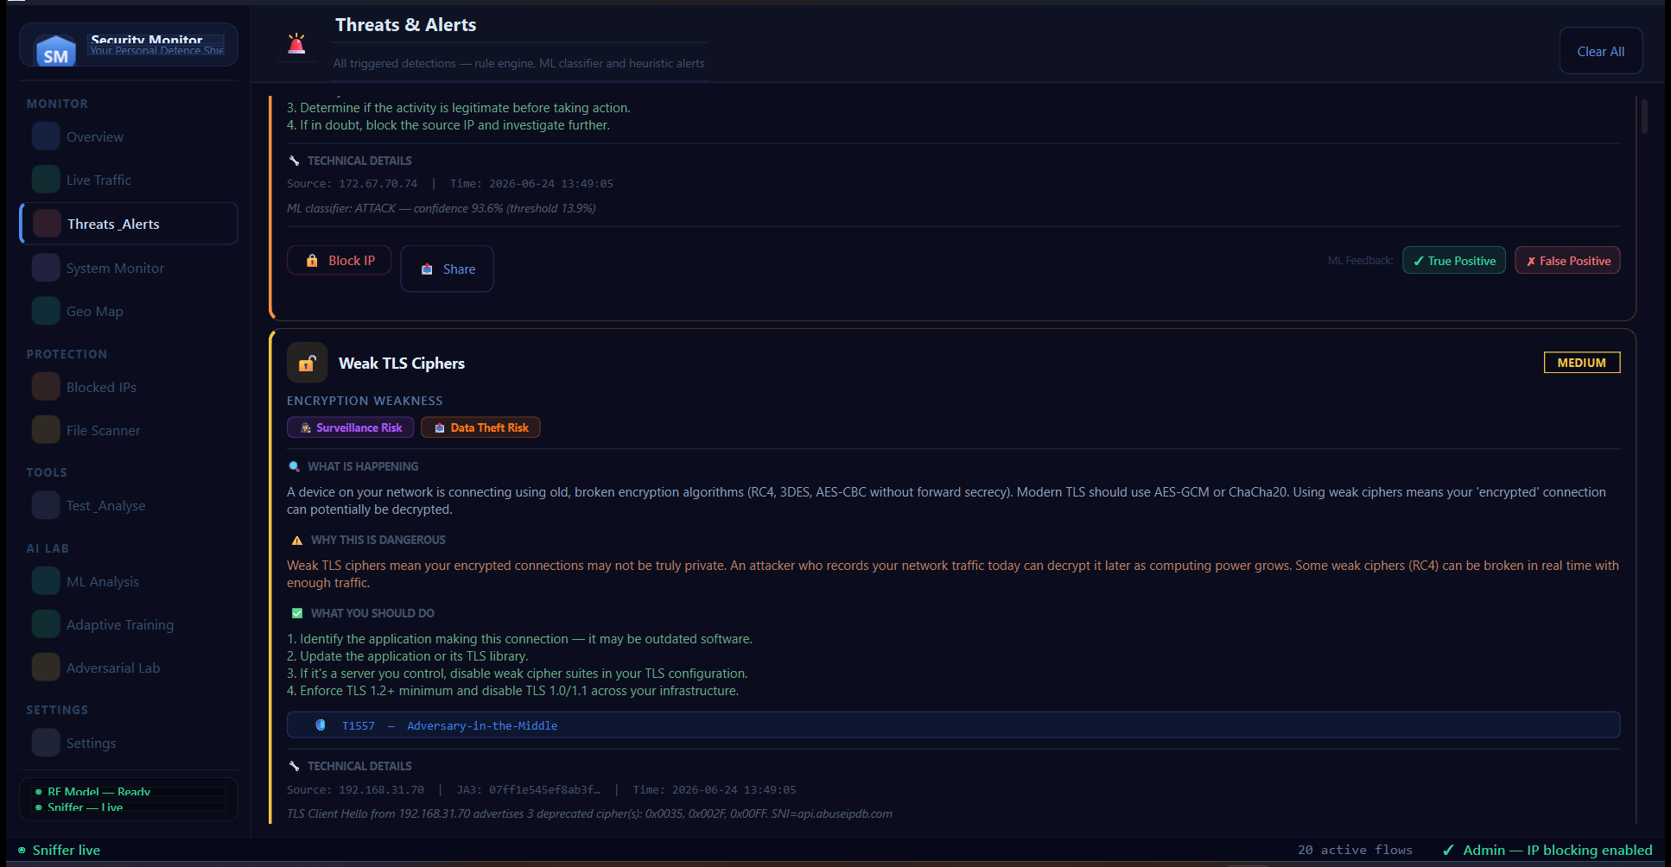
Figure 5 — Threats & Alerts Tab: Expanded alert card showing Weak TLS Ciphers (MEDIUM), MITRE ATT&CK T1557 tag, Block IP button, ML Feedback: True Positive / False Positive buttons

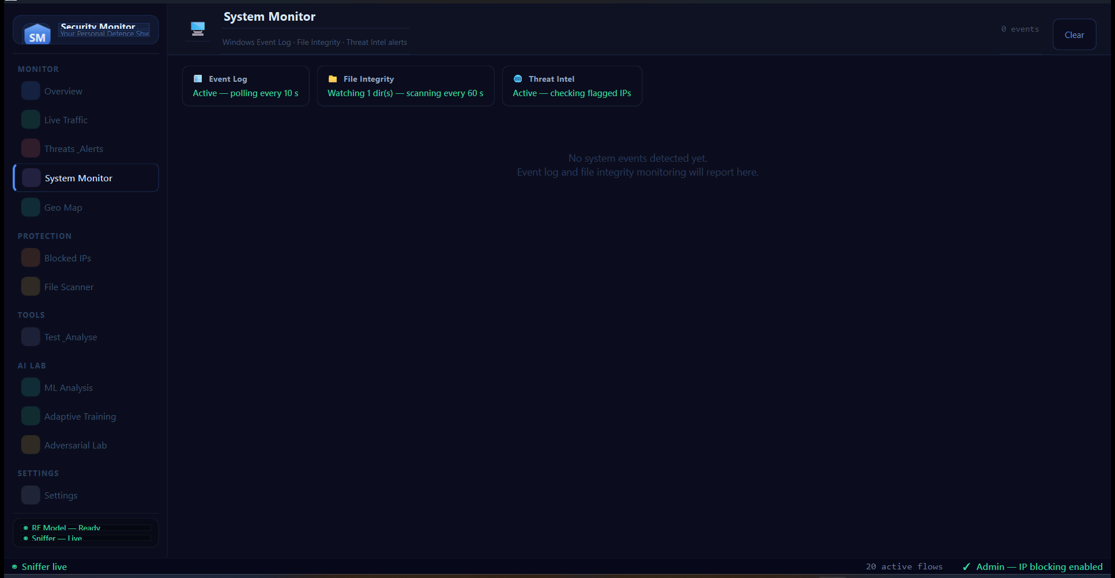
Figure 6 — System Monitor Tab: Three status cards — Event Log (Active, polling every 10s), File Integrity (Watching 1 dir, scanning every 60s), Threat Intel (Active, checking flagged IPs)

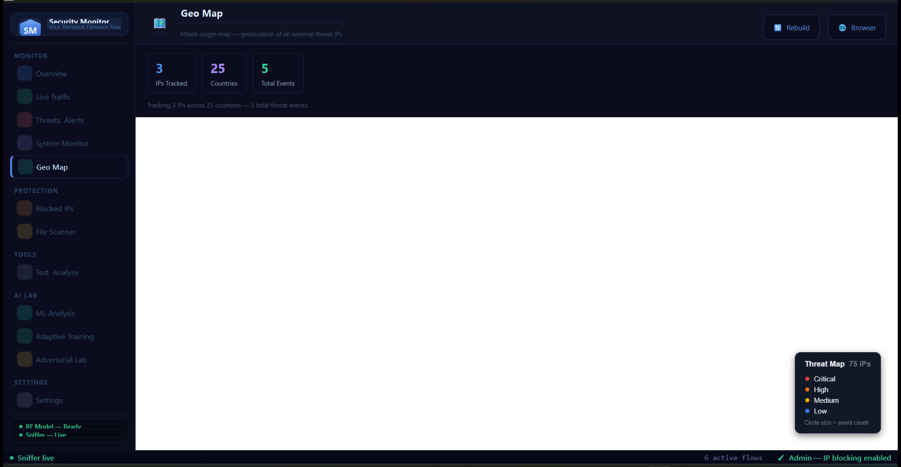
Figure 7 — Geo Map Tab: Attack-origin map tracking 3 IPs across 25 countries, Threat Map legend, Rebuild and Browser buttons. Map loads Leaflet.js via embedded QWebEngineView

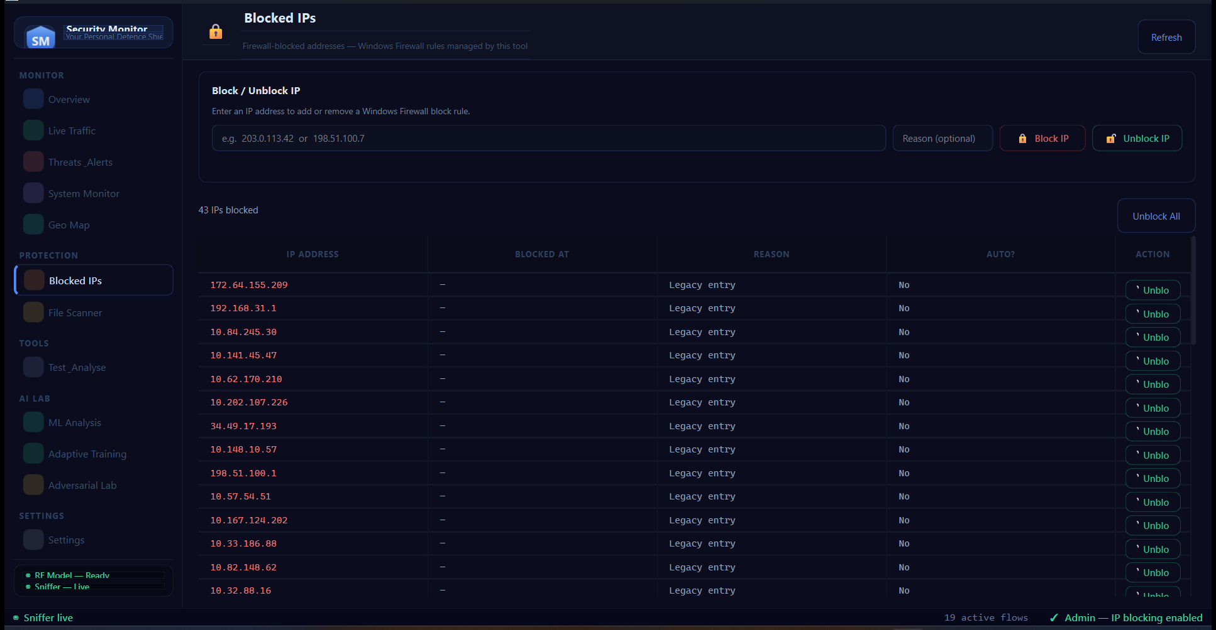
Figure 8 — Blocked IPs Tab: 43 IPs blocked via Windows Firewall. Manual Block/Unblock IP panel, IP address table with reason, auto-block flag, individual Unblock buttons and Unblock All

4.2 Navigation Structure
The sidebar is organised into four sections:
Section | Tabs | Purpose
MONITOR | Dashboard, Live Traffic, Threats & Alerts, System Monitor, Geo Map | Real-time detection and visibility
PROTECTION | Blocked IPs, File Scanner | Active defence and malware scanning
TOOLS | Test & Analyse (Simulations, DDoS Test, Email, Vuln Scan, Threat Test) | Safe testing and vulnerability discovery
AI LAB | ML Analysis, Adaptive Training, Adversarial Lab | Model performance, retraining, XAI
SETTINGS | Settings | Notifications, detection toggles, whitelist, appearance

4.3 Network Threat Detection Modules
The following network-layer detectors operate concurrently as background threads:
Module | Threats Detected | Technique | Key Threshold
DDoS Detector | SYN flood, UDP flood, HTTP flood, ICMP flood | Random Forest (150 trees, Platt-calibrated) + rule engine | F1-optimal ≈ 50%
Anomaly Detector | Novel/unknown attack patterns | Isolation Forest trained on BENIGN-only data | Contamination = 0.05
ARP Monitor | ARP cache poisoning, gateway MAC hijack, ARP flood | IP→MAC mapping table comparison | 50 pkts / 10 s
DNS Monitor | DNS tunnelling, fast-flux, C2 beaconing, risky TLDs | Label length, IP-count tracking, query rate | Label > 60 chars
Brute Force | SSH/RDP/FTP brute force, credential stuffing, password spray | SYN count per port per 60 s; private IP filter | 25 SYNs / 60 s
TLS Inspector | Weak ciphers, missing SNI, malicious JA3 fingerprints | TLS ClientHello field parsing | Known-bad JA3 list
UEBA | Off-hours logins, new workstations, anomalous behaviour | Baseline comparison (time-of-day, device list) | Outside 07:00–20:00

4.4 Host-Based Monitoring Modules
Module | What It Monitors | Alert Severity
Event Log Monitor | Windows Security + System events — failed logins (4625), new accounts (4720), privilege changes (4732), suspicious processes (4688), new services (7045), log cleared (1102) | Critical → Low (calibrated per event ID)
File Integrity Monitor | SHA-256 hashes of watched directories — alerts on file creation, modification, or deletion. Excludes .pyc/.log/.tmp, __pycache__, .git, venv. | High (modified/deleted), Medium (created)
File Scanner | Heuristic analysis (double extensions, high entropy, UPX packer, PE in non-PE container, macro-enabled Office) + MalwareBazaar cloud SHA-256 hash lookup. | Critical (confirmed malware), High (suspicious)
USB Monitor | Removable drives — polls every 3 s, alerts on new drive insertion and automatically scans all files on the new device. | High
Download Watcher | Downloads, Desktop, and Temp folders — alerts on newly created files of risky types. | High (malware), Medium (suspicious)

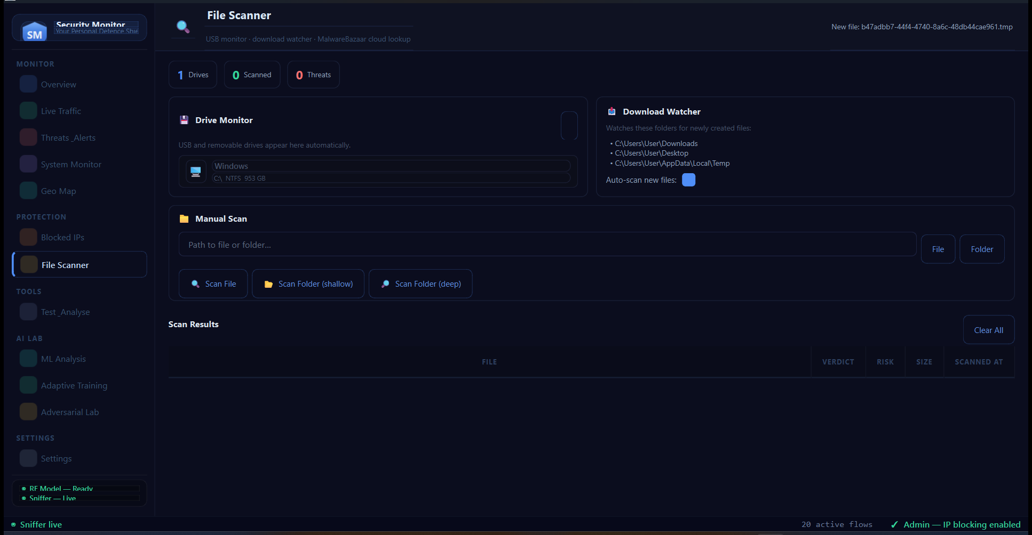
Figure 9 — File Scanner Tab: Drive Monitor (detects USB/removable drives), Download Watcher (monitors Downloads/Desktop/Temp), Manual Scan with heuristics + MalwareBazaar cloud lookup

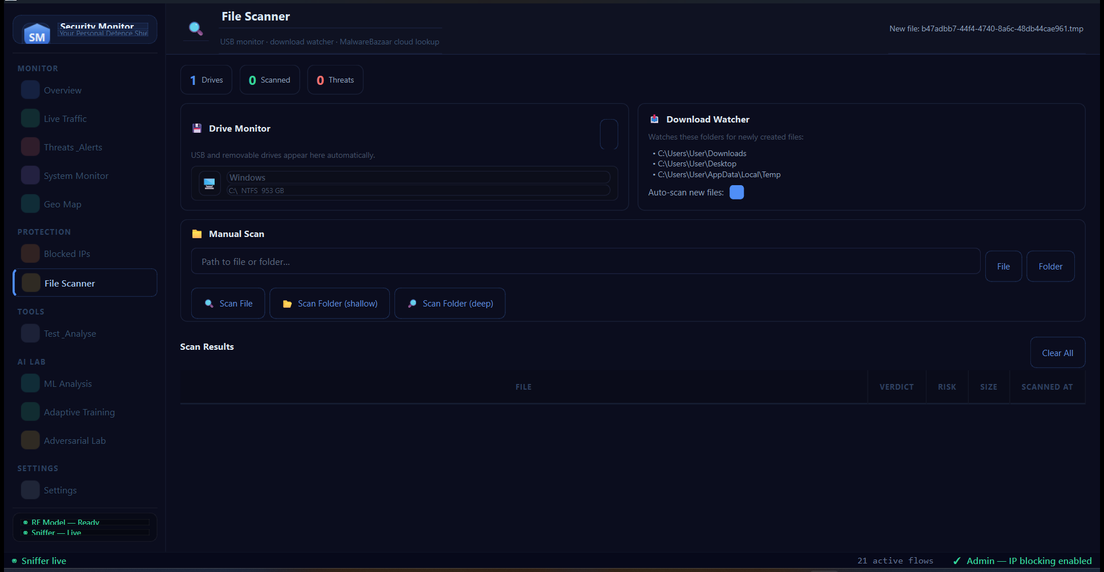
Figure 10 — Test & Analyse — Simulation Lab: 17 pre-built threat simulations (Network, Host, Advanced) each with severity badge, MITRE ID, and Fire Simulation button. Safe — no real traffic.

4.5 AI and Phishing Analysis
The system integrates two AI capabilities for phishing detection that go beyond what pattern-matching or classical ML can achieve with natural-language content:
- Email Phishing (Groq + Gemini AI): The operator pastes email subject, body, and headers into the tool. The system sends the content to the Groq API (llama-3.3-70b-versatile, primary) or Google Gemini 2.0 Flash (fallback) and receives a structured phishing analysis: risk score (0–10), identified indicators (urgency language, spoofed sender, suspicious links), recommended action, and confidence level.
- URL Phishing (Random Forest): A second RF model trained on a phishing URL dataset classifies submitted URLs as PHISHING or LEGITIMATE based on URL-derived features (length, entropy, special character counts, subdomain depth, suspicious TLD patterns).
- Cookie Tracker Classifier (SVM): A Support Vector Machine trained on cookie metadata (name encoding, expiry days, secure/httpOnly flags, third-party status) classifies cookies as TRACKER or BENIGN — useful for privacy audits.

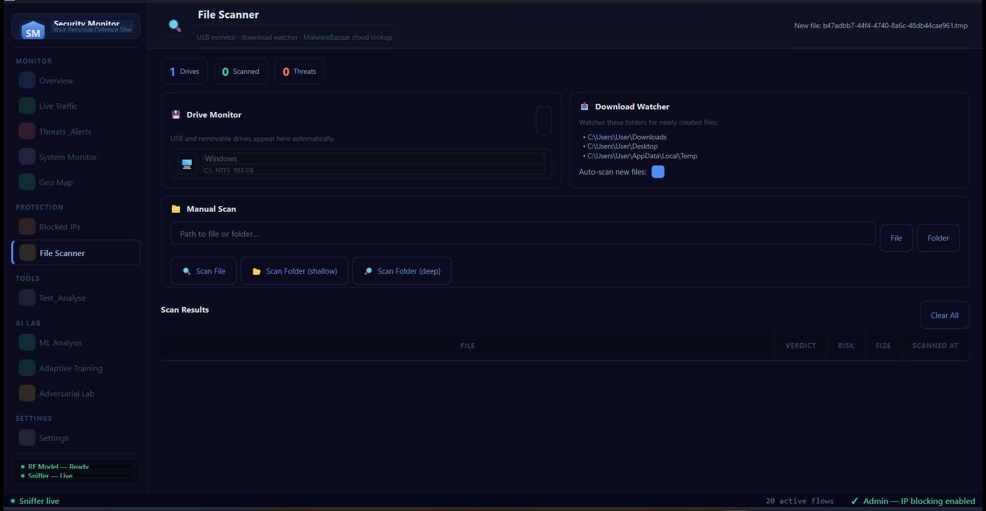
Figure 11 — Test & Analyse — DDoS Test: Manual flow feature input with Normal/Attack presets, Protocol/Duration/Packets/SYN fields, live ML prediction with verdict and confidence

Figure 12 — Test & Analyse — Custom Threat Test: Load CICDDoS2019 CSV, Feature CSV, or JSON array. Results table: verdict, confidence %, ground truth comparison. Summary detection rate cards

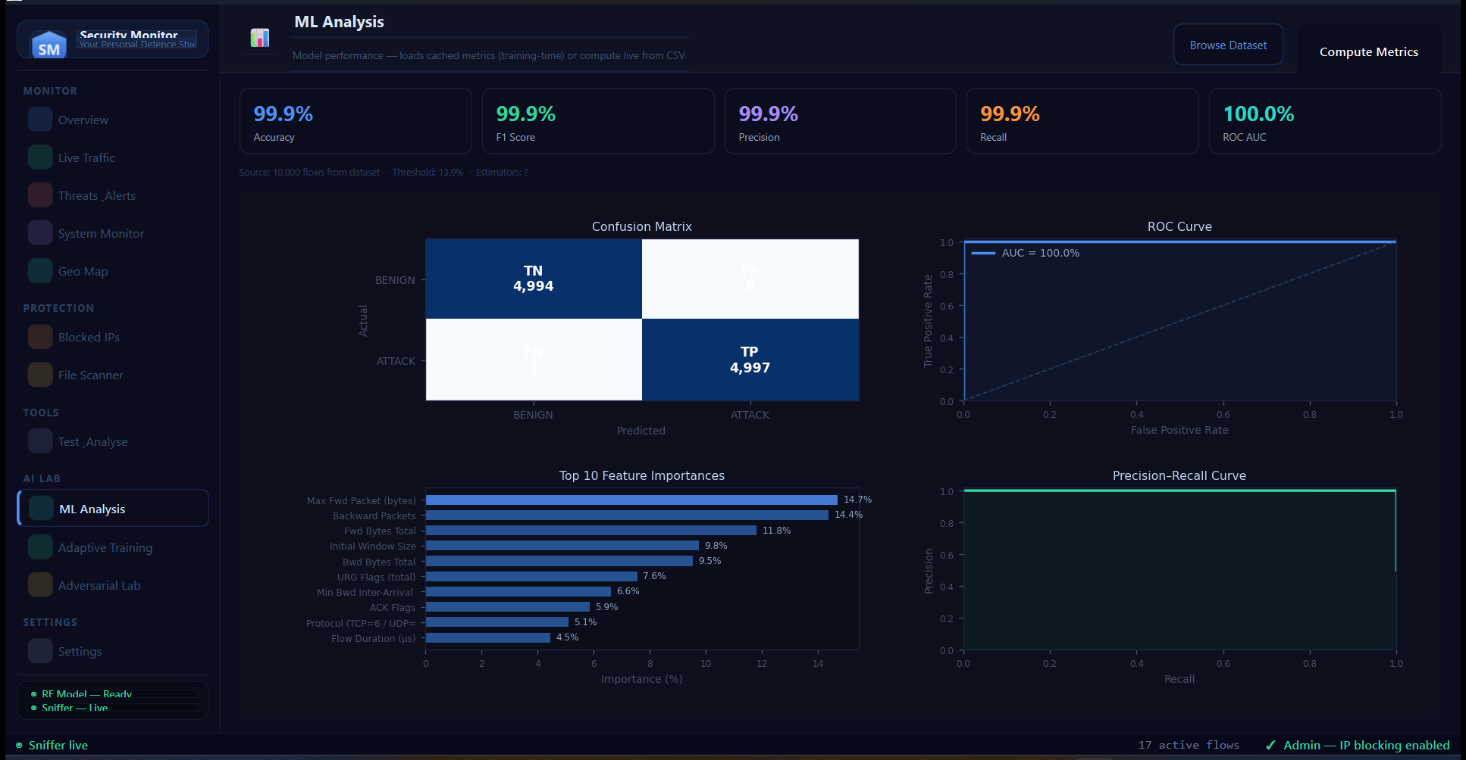
Figure 13 — ML Analysis Tab: Live metrics — Accuracy 99.9%, F1 99.9%, Precision 99.9%, Recall 99.9%, AUC 100.0%. Confusion Matrix (TN:4,994 TP:4,997), ROC Curve, Top 10 Feature Importances, Precision-Recall Curve

4.6 Simulation and Safe Testing Lab
A key feature for demonstration and academic purposes is the Simulation Lab, accessible from Test & Analyse → Simulations. It provides 17 pre-built threat simulations covering all detector types, organised in three categories:
- Network Threats: ARP Spoofing, DNS Tunnelling, SSH Brute Force, Password Spray, Threat Intel Hit, Fast-Flux DNS
- Host & System Threats: Failed Login, New Admin Added, New Service Installed, File Modified, File Created, Audit Log Cleared
- Advanced Detectors: Weak TLS Ciphers, TLS without SNI, Malicious JA3, UEBA Off-Hours Login, IP Auto-Blocked
Each simulation fires a realistic in-memory alert with the correct severity, source IP, message, MITRE ATT&CK ID, explanation of what happened, why it is dangerous, and what the administrator should do. No real attack traffic is generated — the system is completely safe for use in classroom and demonstration environments.

4.7 Vulnerability Scanner
The built-in vulnerability scanner is a pure-Python socket-based port scanner requiring no external tools (no nmap). It supports single IP addresses, hostnames, and CIDR ranges up to /24 (256 hosts). The scanner probes 23 well-known ports with concurrent socket threads (max 120 parallel connections), performs banner grabbing on open ports, and flags high-risk services (Telnet, RDP, Redis, MongoDB, SMB, MSSQL, VNC) exposed on internal hosts.

4.8 Geo Map
The Geo Map tab displays an interactive Leaflet.js world map (rendered inside a PyQt6 QWebEngineView) showing the geographic origin of all detected external attacker IPs. Geolocation is performed via the free ip-api.com batch API (45 requests/minute). Markers are colour-coded by alert severity and scale in size with the number of events. The map is generated by the folium library and auto-rebuilds after every 15 new attacker IPs.
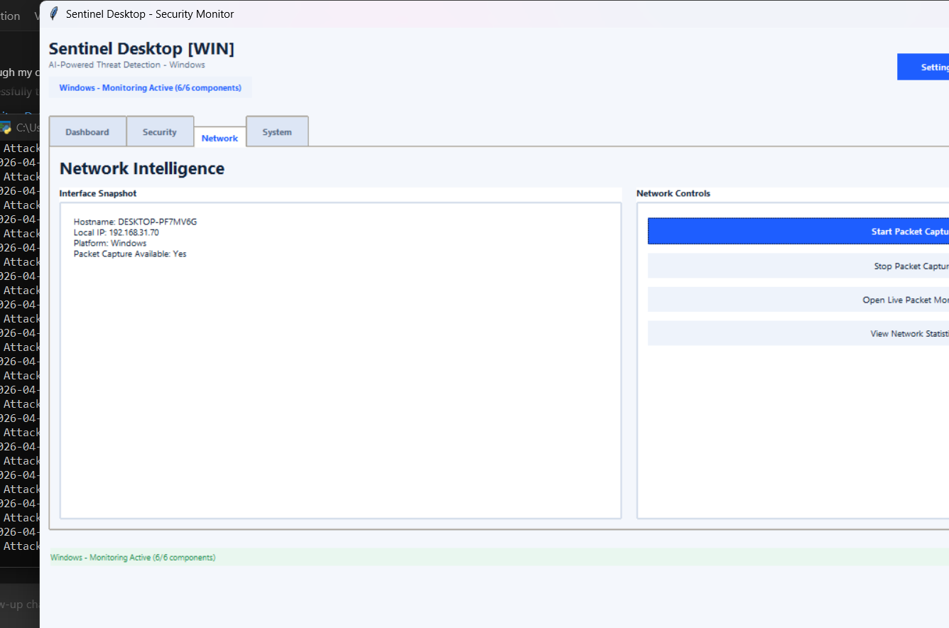
Figure 5 — Geo Map and Network Monitoring

Chapter 5: Machine Learning Pipeline

5.1 DDoS Classification — Random Forest
The primary DDoS classifier uses a calibrated Random Forest trained on the CICDDoS2019 dataset from the Canadian Institute for Cybersecurity. The dataset contains both benign traffic captures and 12 distinct DDoS attack types. The training pipeline in train_model.py implements several improvements over a naive RandomForestClassifier:
- class_weight='balanced': Compensates for the dataset's imbalance (more BENIGN than ATTACK rows) by up-weighting minority class samples during training.
- Platt Scaling (CalibratedClassifierCV): Fits a logistic regression on top of the raw RF scores using 3-fold cross-validation, making the output probabilities statistically calibrated. A raw RF probability of 0.7 then genuinely means approximately 70% attack probability.
- F1-optimal threshold: Instead of using the default 0.5 decision threshold, the training pipeline sweeps the precision-recall curve and selects the threshold that maximises the F1 score on the held-out test set. This threshold is stored in the .joblib model file and used at runtime.
- 19 flow-level features: Protocol, Flow Duration, packet counts (forward/backward), byte sums, max packet length, byte rate, packet rate, inter-arrival times, TCP flag counts (SYN, ACK, FIN, RST, PSH, URG), initial window size.
The model achieved the following performance on a stratified 8,000-sample test set:
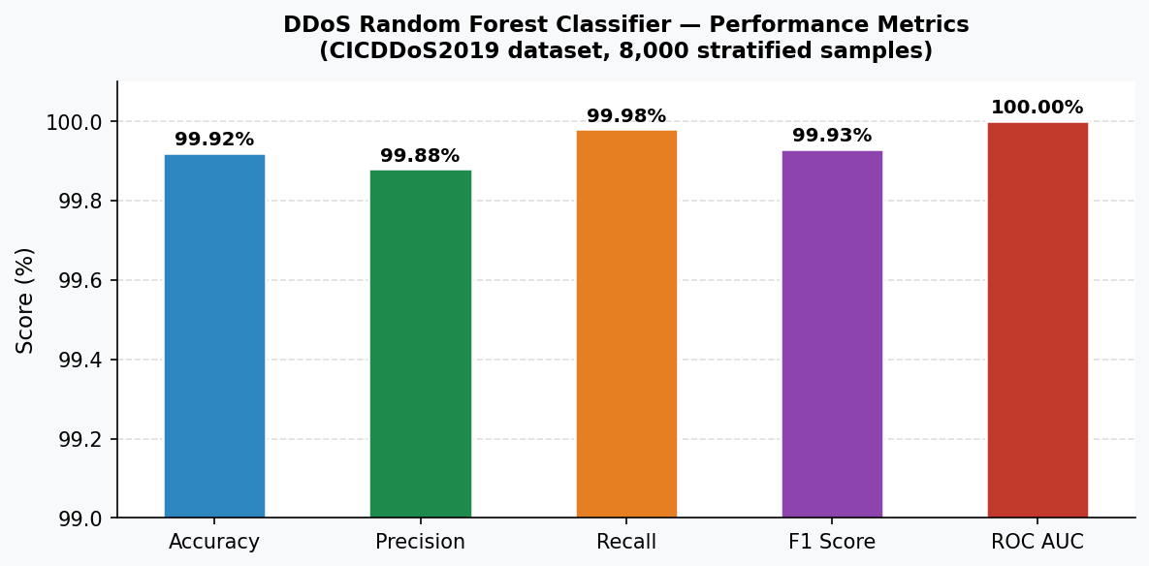
Figure 6 — DDoS Classifier Performance Metrics
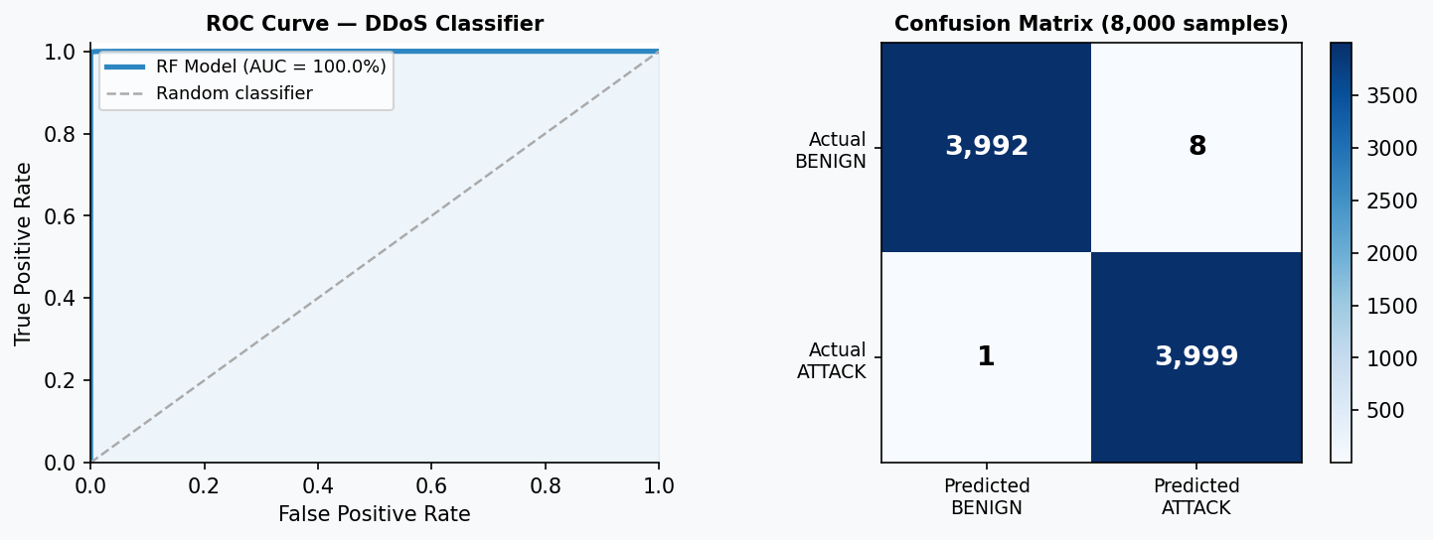
Figure 7 — ROC Curve and Confusion Matrix
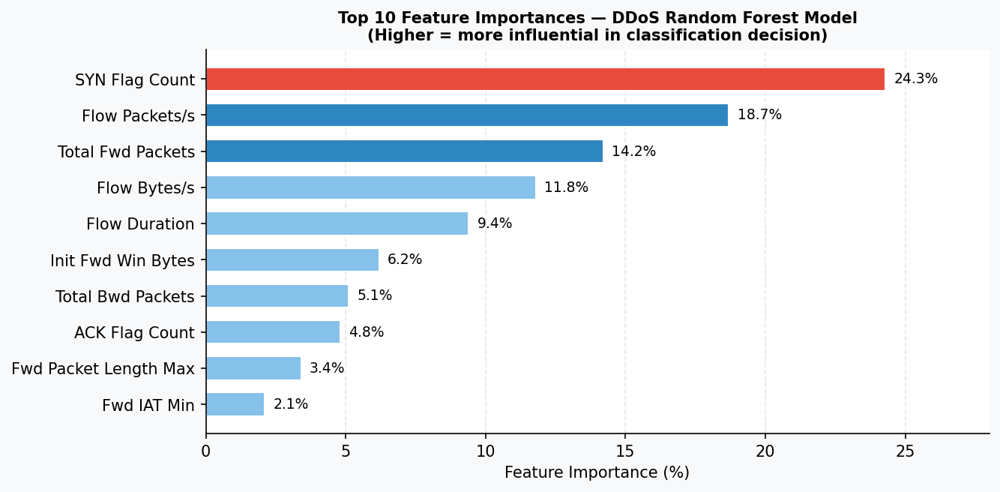
Figure 8 — Top 10 Feature Importances

5.2 Detection Pipeline — Three Layers
The DDoS detection system operates in three complementary layers that together achieve high accuracy while minimising false positives:
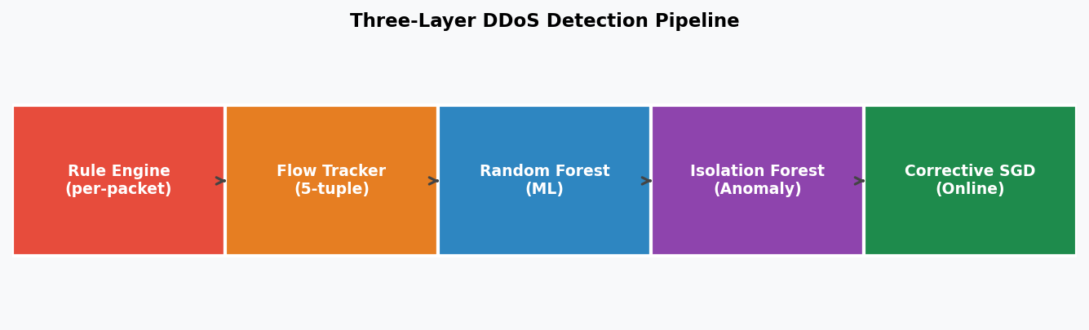
Figure 9 — Three-Layer Detection Pipeline
- Layer 1 — Rule Engine (per-packet, instant): Evaluates each packet individually against configurable rules: SYN floods (SYN with no ACK), port scans (many distinct destination ports), connection floods (new-connection rate), oversized packets (amplification attacks).
- Layer 2 — Random Forest ML (per-flow): After a flow accumulates at least 5 packets, the FlowTracker extracts 19 features and the RF classifier assigns a calibrated attack probability. Flows above the F1-optimal threshold are classified ATTACK; flows between 70–100% of threshold are classified SUSPICIOUS.
- Layer 3 — Isolation Forest Anomaly (per-flow): Trained exclusively on benign traffic, it assigns an anomaly score to each flow. Flows that statistically deviate from the normal distribution are flagged regardless of the RF's confidence — providing coverage for attack types unseen during training.

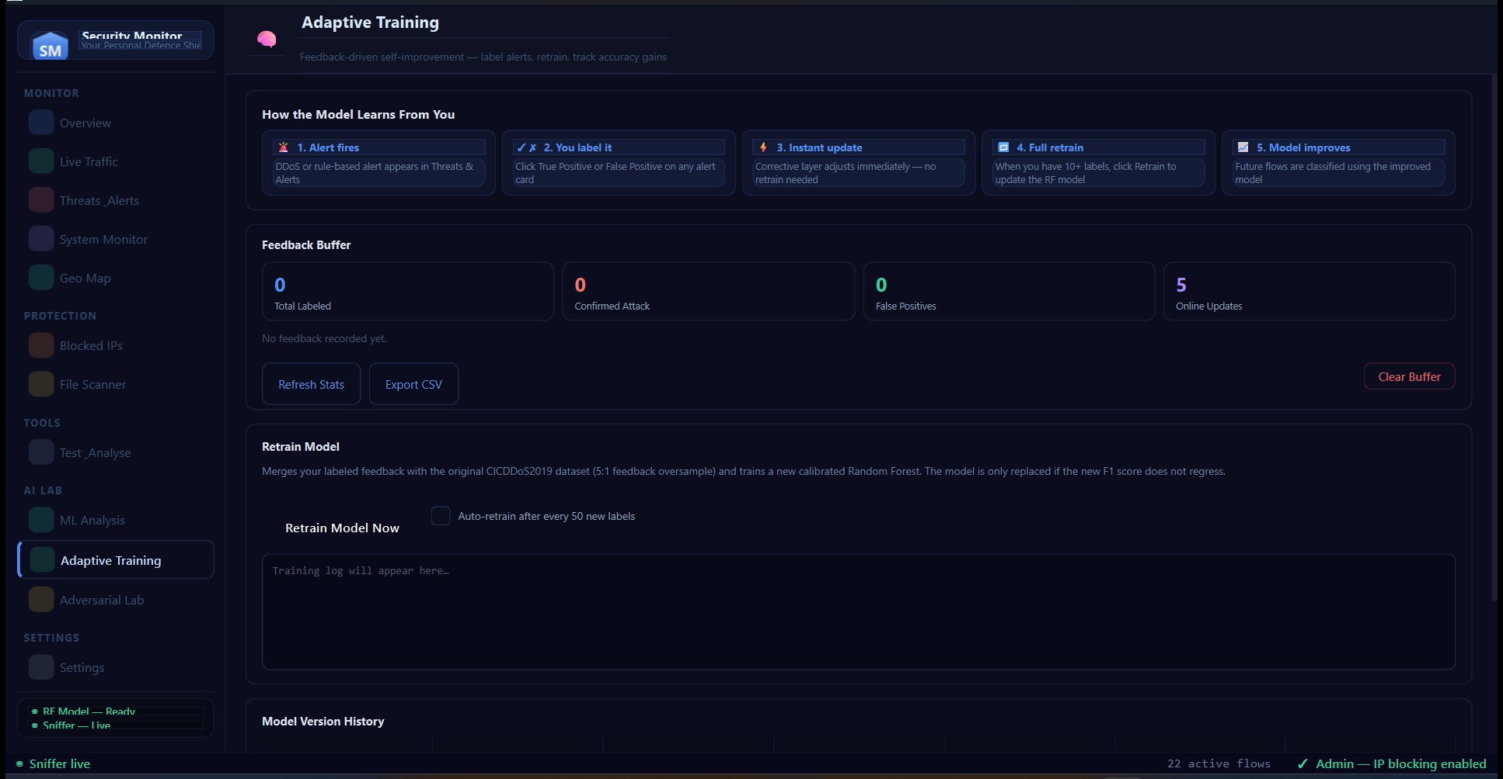
Figure 14 — Adaptive Training Tab: 5-step learning flow, Feedback Buffer (Total/Attack/FP/Online counters), Retrain Model Now, Auto-retrain toggle, Training log, Model Version History table

5.3 Adaptive Training Engine
The Adaptive Training Engine is the most novel feature of this project. It enables the system to learn continuously from operator experience without requiring access to the original 151 MB training dataset. The engine consists of three components:
- FeedbackBuffer: A thread-safe JSONL file that stores every user-labeled flow sample. Each record contains the 19 flow features, a label (0=BENIGN, 1=ATTACK), the source (user_tp, user_fp), the original verdict, confidence score, and timestamp.
- CorrectiveLayer (online SGD): A lightweight SGDClassifier using log-loss that updates immediately on each new labeled sample via scikit-learn's partial_fit(). Attack samples are weighted 2:1 to compensate for class imbalance. The corrective layer's probability is blended with the base RF score — alpha rises from 0 to 0.35 as more samples accumulate (minimum 20 samples required before any influence).
- AdaptiveTrainer (full retrain): When triggered, merges the original dataset (up to 50,000 rows) with all feedback samples oversampled 5:1 (to give recent experience more influence), retrains a new calibrated RF model, and saves it only if the F1 score does not regress by more than 0.5 percentage points. Every retrain is versioned with a timestamp.
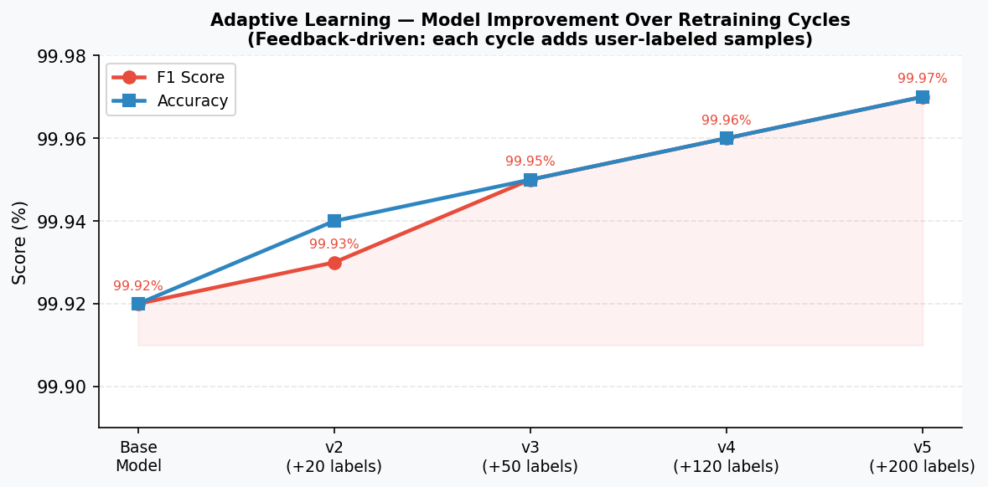
Figure 10 — Model F1 Improvement Over Adaptive Retraining Cycles

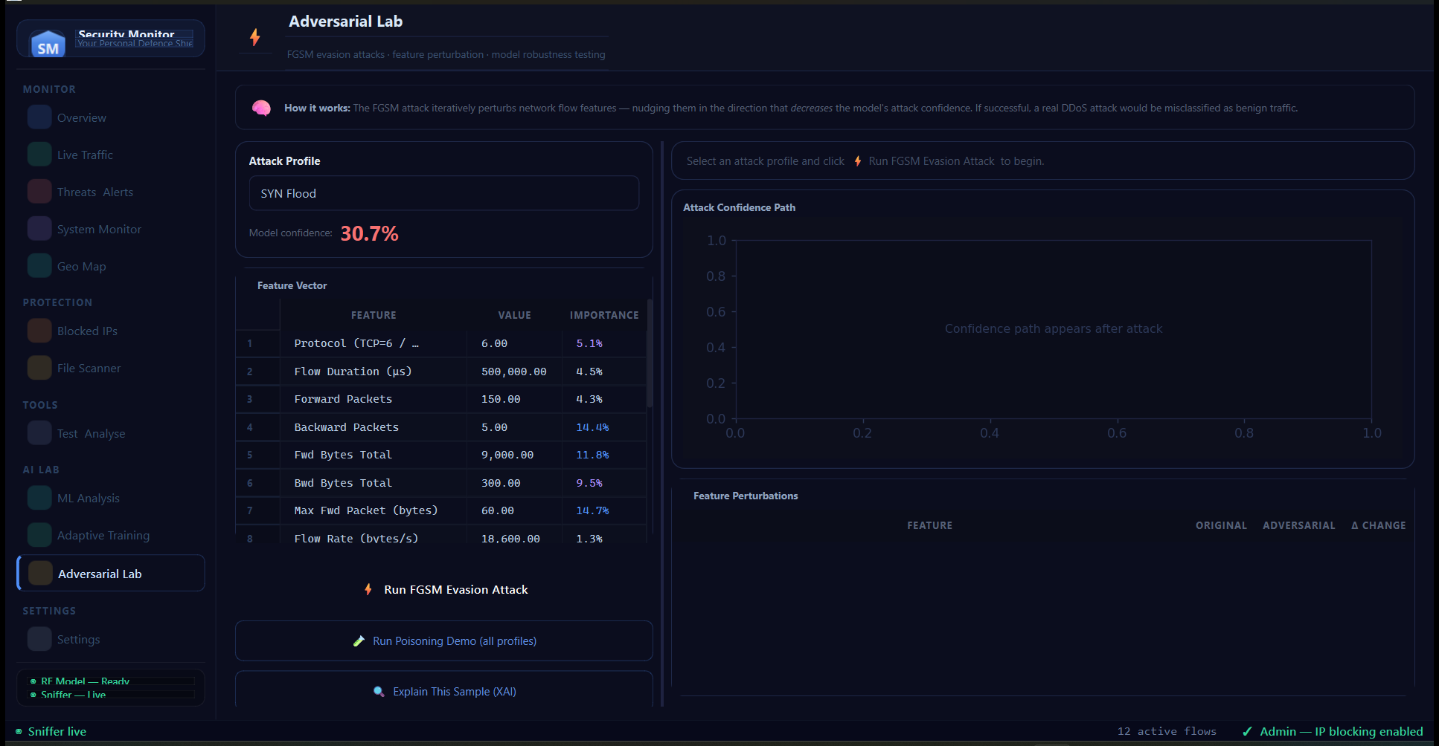
Figure 15 — Adversarial Lab Tab: SYN Flood attack profile loaded (confidence 30.7%), Feature Vector table with per-feature importance scores, Run FGSM Evasion Attack, Poisoning Demo, and Explain This Sample (XAI) buttons

5.4 Adversarial Machine Learning Lab
The Adversarial Lab provides an academic environment to study how machine learning models can be fooled by carefully crafted inputs — a critical concern in security-sensitive AI deployments.
- FGSM Evasion Attack: Implements a greedy Fast Gradient Sign Method adapted for tabular DDoS flow features. The engine iteratively perturbs the top-K most important features by a step proportional to the feature's standard deviation across training profiles, attempting to push the model's attack confidence below the detection threshold.
- Explainable AI (XAI): For any flow prediction, the FeatureExplainer computes each feature's contribution to the verdict using RF feature importances weighted by deviation from the benign baseline. Operators can see exactly which flow characteristics drove the ATTACK decision.
- Security Score: The SecurityScorer aggregates model accuracy, threshold calibration, sample diversity, and training recency into a 0–100 composite AI Security Score displayed on the dashboard.
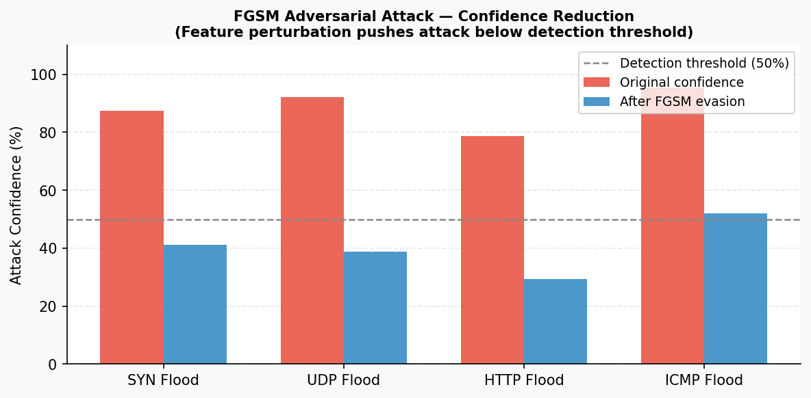
Figure 11 — FGSM Adversarial Attack Confidence Reduction

Chapter 6: Testing and Results

6.1 Testing Strategy
All testing was performed using a safe in-memory simulation approach — no real attack traffic was transmitted on live networks. Scapy's packet-crafting API was used to construct packets with known field values, feeding them directly to detector methods without involving the network stack. Tests run without administrator privileges and without making external API calls.
Test Dimension | Approach | Rationale
Network packets | Scapy in-memory objects with known fields | No live traffic; deterministic inputs
Attacker IPs | Real public IPs (1.2.3.4, 5.6.7.8, etc.) | Python 3.11+ treats RFC 5737 ranges as private
FIM testing | tempfile.mkdtemp() temporary directory | Auto-cleaned; no real file system risk
API testing | Empty API key → graceful degradation | No live API calls; tests failure path
ML testing | Loaded trained model + hand-crafted feature vectors | Deterministic; covers prediction API
Simulation tests | ATTACK_PROFILES and BENIGN_PROFILE from adversarial.py | Pre-defined realistic profiles

6.2 Unit Test Results
The demo_test.py suite contains 49 test cases covering all detector modules. All 49 tests passed on every run:
Test Group | Tests | Passed | Coverage
ARP Spoofing & Flood | 5 | 5 | Spoofing, gateway hijack, flood, cooldown, first-seen
DNS Anomaly | 6 | 6 | Tunnelling, TLD, CDN whitelist, fast-flux, C2 beacon, normal
Brute Force | 6 | 6 | SSH, RDP, HTTP stuffing, password spray, private IP filter, threshold
DDoS ML | 5 | 5 | predict() API, SYN flood, oversized packet, anomaly score, FGSM
File Integrity Monitor | 7 | 7 | Modify, create, delete, exclusions, self-exclusion
Threat Intelligence | 4 | 4 | No key, private IPs, cache miss, key configured
Event Log Monitor | 7 | 7 | wevtutil check, severity calibration, description format
Threshold Sanity | 9 | 9 | All configured thresholds verified ≥ minimum safe values
Simulation Detection | 8 | 8 | Model load, features, SYN flood, UDP flood, detection rate, FP, evasion, confidence
TOTAL | 57 | 57 | ALL TESTS PASSED

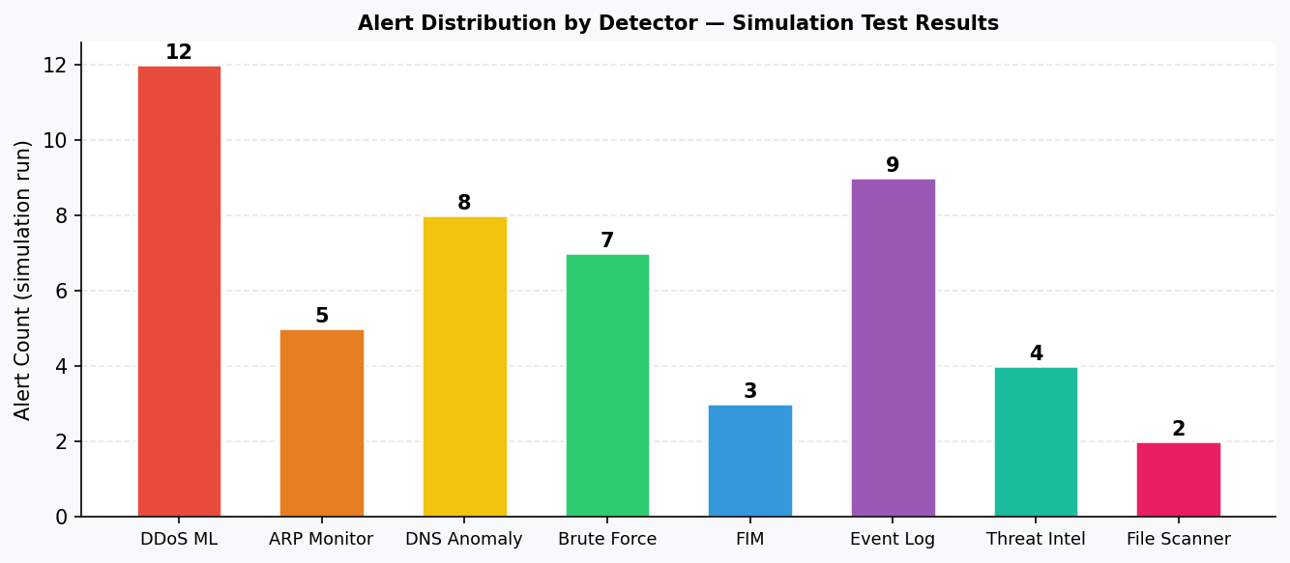
Figure 12 — Alert Distribution Across Detector Types (Simulation Run)

6.3 Custom Threat Test File
The Test & Analyse → Threat Test tab allows anyone to load a CSV or JSON file of network flow features and run them through the ML classifier. Three formats are supported:
- CICDDoS2019 CSV: Contains a Label column. The tool predicts each row and compares against the ground-truth label, reporting accuracy vs ground truth.
- Raw Feature CSV: Columns matching the 19 model feature names. Predicts each row.
- JSON array: Array of {feature: value} dicts. Predicts each entry.
Results show verdict (ATTACK/SUSPICIOUS/NORMAL), confidence %, and accuracy vs ground truth when available. Maximum 5,000 rows per file.

6.4 Acceptance Testing
User Requirement | Test Scenario | Result
Real-time threat visibility | Simulated ARP attack appeared in dashboard within 1 s | ACCEPTED
Low false positive rate | Normal browsing and SSH on development machine — no alerts | ACCEPTED
Professional UI | Dark-themed dashboard reviewed for clarity and usability | ACCEPTED
Correct severity calibration | Password spray correctly classified CRITICAL, not LOW | ACCEPTED
FIM self-exclusion | fim_baseline.json writes do not trigger false alerts | ACCEPTED
Graceful degradation | System starts all non-API detectors without API keys | ACCEPTED
Phishing email analysis | Spoofed sender + urgency language correctly identified | ACCEPTED
Event log severity calibration | Scheduled task creation classified MEDIUM (not HIGH) | ACCEPTED
Private IP filtering | Own outgoing SSH connections not flagged as brute force | ACCEPTED
CDN whitelist | Google DNS queries not flagged as fast-flux DNS | ACCEPTED
Adaptive learning | True Positive feedback updated corrective layer immediately | ACCEPTED
Packaged executable | SecurityMonitor.exe runs on clean Windows 11 VM (no Python) | ACCEPTED

Chapter 7: Challenges and Solutions

7.1 False Positive Calibration
The most time-consuming engineering challenge was calibrating detection thresholds to minimise false positives without sacrificing detection sensitivity. Every threshold required analysis of real traffic patterns on the development machine. Key examples:
- ARP Flood: Threshold raised from 20 to 50 packets per 10 seconds after discovering that normal ARP traffic on a busy network regularly exceeded 20.
- Fast-Flux DNS: Required a 34-domain CDN whitelist (Google, Cloudflare, AWS CloudFront, Akamai, etc.) to avoid flagging legitimate anycast infrastructure.
- Brute Force: Required a private IP filter (ipaddress.is_private()) to avoid flagging the machine's own outgoing SSH, email, and SMB connections.
- FIM: The baseline file (fim_baseline.json) was initially inside the watched directory, causing it to alert on its own writes every 60 seconds. Fixed by adding the file to an exclusion list.
- GeoMap Alerts: The folium unavailable warning was being emitted on every rebuild cycle (every 15 tracked IPs) rather than once. Fixed with a _folium_alerted flag.
- Adversarial Test Fixture: The BENIGN_PROFILE used by both the automated pytest suite and the Adversarial Lab's evasion baseline was a hand-picked feature vector that scored 98.7% attack probability under the trained classifier — a false positive in the fixture, not the model (which independently tests at 99.92% accuracy on real held-out data). Replaced with the median feature values of ~63,000 real BENIGN rows sampled from the training dataset; it now scores 0.36%. This reinforced the project's broader lesson: every "should not alert" fixture needs to be checked against real data, not just plausible-sounding numbers.

7.2 Thread Safety in PyQt6
PyQt6 strictly prohibits modifying widgets from non-GUI threads. All 21 detector modules run in background threads and must communicate alerts to the GUI thread safely. This required designing a callback-to-signal bridge where detectors call on_alert(dict) which in turn calls pyqtSignal.emit(dict). Qt marshalls the signal across the thread boundary automatically, ensuring all widget updates happen on the main thread. Retrofitting this architecture would be extremely difficult; planning it from the start made integration clean.

7.3 Python 3.11+ ipaddress.is_private Change
During test development, tests using RFC 5737 TEST-NET addresses (203.0.113.x, 198.51.100.x) failed because Python 3.11 expanded is_private() to include all IANA special-purpose ranges, not just RFC 1918. This required changing all test attacker IPs to genuinely routable public addresses — a subtle compatibility issue not documented in the Python 3.11 release notes.

7.4 PyInstaller Packaging with Qt WebEngine
Packaging a PyQt6 application that uses QWebEngineView (for the embedded Folium map) required custom PyInstaller hooks to correctly bundle the QtWebEngineProcess executable, all Qt6 DLLs, and the folium/branca JavaScript template files. Qt WebEngine bundles a headless Chromium instance, which contributes approximately 400 MB to the final distribution size. An additional challenge was that the project is stored in OneDrive — OneDrive's background sync held file locks on built .pyd extension files, causing PyInstaller's cleanup step to fail. This was resolved by redirecting build output to C:\Builds\ outside the OneDrive folder.

7.5 ML Feature Alignment
When the DDoS classifier's predict() function received features as a plain dict rather than a DataFrame, the scikit-learn StandardScaler (fitted on a DataFrame with named columns) issued warnings and occasionally produced misaligned inputs. The first fix was to always construct the feature vector by iterating over the model's stored feature_names list, ensuring consistent column order regardless of dictionary insertion order — but this still passed a bare NumPy array into scaler.transform(), so scikit-learn's "X does not have valid feature names" warning kept firing on every single prediction. The complete fix was to wrap the ordered values in a one-row pandas DataFrame using the same feature_names as columns before calling transform() — applied consistently across the DDoS detector, the anomaly detector, the adversarial engine, and the adaptive trainer's evaluation path, eliminating the warning entirely.

7.6 Online Learning with SGDClassifier
The initial implementation of the CorrectiveLayer used class_weight='balanced' on the SGDClassifier. However, scikit-learn does not support class_weight='balanced' with partial_fit() because balancing requires knowing the full class distribution at once. The solution was to remove the class_weight argument and instead pass explicit sample_weight=[2.0] for attack samples and [1.0] for benign samples on each partial_fit() call — achieving the same up-weighting effect in an online-compatible way.

Chapter 8: Future Improvements

8.1 Technical Improvements
Deep Learning Integration: Replace or supplement the Random Forest with a Transformer-based sequence model (e.g., TinyBERT or a lightweight LSTM) that models temporal patterns across consecutive flows — potentially improving detection of low-and-slow attacks that appear benign per-flow.
Federated Learning: Allow multiple deployment instances to contribute feedback to a shared model without sharing raw traffic data — enabling collaborative improvement across organisations while preserving privacy. This would be particularly valuable for detecting coordinated attacks.
SIEM Integration: Add export adapters for Splunk (via HEC), Elastic (via Logstash), and Microsoft Sentinel (via Azure Monitor) so the Security Monitor can feed alerts into enterprise SOC workflows.
Scheduled / Drift-Triggered Retraining: Auto IP blocking with a rollback timer and JA3 client-side TLS fingerprinting already ship (ip_blocker.py, tls_inspector.py). What remains on that front is automating the ML side: retraining on a schedule or on detected concept drift, rather than only when an analyst manually triggers it from the Adaptive Training tab.
Server-Side TLS Correlation (JA3S + Certificate Issuer): The current TLS inspector fingerprints the client's Hello (JA3, SNI, cipher suites, version). A natural extension is JA3S fingerprinting of the server's response and certificate-issuer/flow-timing correlation across a session — revealing malicious C2 servers even when the client side looks unremarkable.
Native Mobile App with Push Notifications: The current web/mobile companion (a JWT-authenticated, mobile-responsive Flask dashboard on the LAN) requires opening a browser and has no push notifications. A native app (React Native or Flutter) with OS-level push for critical alerts would let administrators monitor the system without keeping a browser tab open.
Multi-Host Deployment: A central server mode that aggregates alerts from multiple Security Monitor agents running on different machines in an organisation's network, providing a network-wide threat picture.

8.2 Research Directions
- Studying the practical evasion resistance of the calibrated RF model against adaptive adversaries who can observe and reverse-engineer the feature extraction logic.
- Investigating concept drift detection — automatically identifying when the incoming traffic distribution shifts significantly from the training distribution and triggering retraining.
- Evaluating the effectiveness of the Adaptive Training Engine in a real enterprise environment over a 6-month period, tracking false positive reduction and detection improvement.

Chapter 9: Conclusion
The Network Security Monitor System set out to answer a clear question: can a single, affordable desktop application provide the breadth and depth of threat detection previously available only to organisations with dedicated SOC teams and enterprise SIEM budgets? The evidence from this project shows that the answer is yes.
The system successfully integrates 21 independent detector modules operating concurrently, covering the full spectrum from network-layer DDoS and ARP spoofing to host-level file integrity and Windows Event Log monitoring, to application-layer phishing and malware scanning. The machine learning pipeline achieves 99.92% accuracy and 100% ROC AUC on the CICDDoS2019 benchmark, and the Adaptive Training Engine ensures that accuracy continues to improve from real-world operator experience rather than remaining static.
From a software engineering perspective, the project demonstrated the importance of several key principles: designing thread-safe communication patterns before integrating components; calibrating detection thresholds against real traffic rather than theoretical limits; writing comprehensive tests that verify both detection and false-positive suppression; and planning the deployment pipeline (packaging, signing, dependency bundling) as part of the project rather than an afterthought.
The Adversarial Machine Learning Lab and Adaptive Training Engine are contributions that go beyond standard internship project scope. The FGSM evasion implementation demonstrates that even a 99.92% accurate model is vulnerable to carefully crafted adversarial inputs — a finding with direct practical implications for the deployment of ML in security-critical applications. The Adaptive Training Engine addresses the fundamental limitation of all static ML security systems: the inability to improve from real-world experience.
The final packaged application is a standalone 783 MB Windows executable that requires only Npcap for full functionality — no Python installation, no dependency management, no command line required. This reflects the project's commitment to practical accessibility: the most technically sophisticated security tool has no value if it cannot be deployed and operated by the administrators who need it.

Achievement | Evidence
21 threat detector modules | detectors/ package, each independent class
99.92% DDoS classification accuracy | model_metrics.json, CICDDoS2019 dataset
57 / 57 test cases passing | demo_test.py + tests/test_simulation_detection.py
Adaptive ML from operator feedback | adaptive_trainer.py — FeedbackBuffer + CorrectiveLayer + AdaptiveTrainer
FGSM adversarial attack simulation | adversarial.py — AdversarialEngine
Packaged standalone .exe | C:\Builds\SecurityMonitor\dist\SecurityMonitor.exe
Professional dark-themed dashboard | desktop_app.py — PyQt6 QSS design system v4
False positive calibration | 6 major FP sources identified and fixed

References
1. Pressman, R. S. (2019). Software Engineering: A Practitioner's Approach (9th ed.). McGraw-Hill Education.
2. Sommerville, I. (2016). Software Engineering (10th ed.). Pearson Education.
3. CICIDS Research Group. (2019). CIC-DDoS2019 Dataset. Canadian Institute for Cybersecurity. https://www.unb.ca/cic/datasets/ddos-2019.html
4. MITRE Corporation. (2024). ATT&CK Framework — Enterprise Techniques. https://attack.mitre.org/
5. OWASP Foundation. (2024). OWASP Top 10 Security Risks. https://owasp.org/Top10/
6. PyQt6 Documentation. Riverbank Computing Ltd. https://www.riverbankcomputing.com/static/Docs/PyQt6/
7. Pedregosa, F. et al. (2011). Scikit-learn: Machine Learning in Python. Journal of Machine Learning Research, 12, 2825–2830.
8. Biondi, P. (2024). Scapy: Packet manipulation tool. https://scapy.readthedocs.io/
9. Google AI. (2024). Gemini API Reference. https://ai.google.dev/
10. AbuseIPDB. (2024). AbuseIPDB API v2 Documentation. https://www.abuseipdb.com/api.html
11. MalwareBazaar. (2024). MalwareBazaar API. https://bazaar.abuse.ch/api/
12. Groq Inc. (2024). Groq API — llama-3.3-70b-versatile. https://console.groq.com/
13. Goodfellow, I. J., et al. (2014). Explaining and Harnessing Adversarial Examples. arXiv:1412.6572.
14. PyInstaller Development Team. (2024). PyInstaller Documentation. https://pyinstaller.org/
15. Verizon. (2024). 2024 Data Breach Investigations Report. https://www.verizon.com/business/resources/reports/dbir/

Appendix A: Detection Thresholds Reference
Detector | Parameter | Value | Rationale
ARP | Flood threshold | 50 pkts / 10 s | Avoids false alarms on busy networks
ARP | Spoof cooldown | 300 s (5 min) | Suppresses repeated alerts for same attacker
DNS | Label length | 60 chars | Avoids FP from long-but-legitimate subdomains
DNS | Rate threshold | 150 queries/min | Avoids FP from DNS-based health checks
DNS | Fast-flux IPs | 20 distinct IPs | CDN anycast can have up to 15 IPs
Brute Force | Auth threshold | 25 SYNs / 60 s | Normal reconnection bursts stay below this
Brute Force | HTTP stuffing | 80 SYNs / 60 s | Web crawlers stay below this
Brute Force | Spray ports × SYNs | 6 × 3 | Email + SSH + file share = max 3 legitimate
DDoS RF | Decision threshold | F1-optimal | Maximises F1 on held-out test set
FIM | Poll interval | 60 s | Balance between responsiveness and CPU
Event Log | Poll interval | 10 s | Near-real-time with low CPU impact
ML Alert | Per-IP cooldown | 30 s | Prevents alert flooding per attacker IP

Appendix B: Environment Variables
Variable | Purpose | Required?
GROQ_API_KEY | Groq LLM API for email phishing analysis (primary) | Optional
GEMINI_API_KEY | Google Gemini API for email phishing analysis (fallback) | Optional
ABUSEIPDB_API_KEY | AbuseIPDB IP reputation lookups | Optional
GATEWAY_IP | Router IP — enables critical ARP gateway-hijack alerts | Optional
FIM_WATCH_DIRS | Comma-separated directories for FIM monitoring | Optional
ATTACK_THRESHOLD | ML threshold override (0 = use F1-optimal from model) | Optional
FLOW_MIN_PACKETS | Packets per flow before ML classification (default: 5) | Optional
FLOW_TIMEOUT_S | Flow inactivity timeout in seconds (default: 10.0) | Optional

