School of Electrical Engineering, Computing and Mathematical Sciences

Pavlok Nudge: A Feedback Mechanism for Atomic Behaviour Modification with Snoring Use Case

by

Phua Kia Joon, Samuel

A thesis submitted for the degree of

Bachelor of Engineering (Honours) in Electrical and Electronics Engineering

October 2026

Abstract
Snoring is considered a widespread sleep issue which diminishes quality of sleep and disrupts bed partners, however existing clinical interventions often faces high costs and poor adherence.
This thesis presents a development and evaluation of a real-time closed-loop snore detection and haptic intervention concept that pairs bedside audio sensing with a wearable stimulus via a Pavlok wearable to prompt the user using subtle behavioural adjustments without waking the user fully. The system was realised on an Android platform featuring a custom user interface that executes an explainable baseline detection pipeline. Using root-mean-square (RMS) signal level, low-frequency band ratio analysis, consecutive-hit filtering and cooldown controls to ensure mitigation of false triggering. Beyond heuristic thresholding, work was undertaken to integrate a 1D Convolutional Neural Network (1DCNN) model into the processing workflow as a method of refining the classification accuracy. Transitioning of the system into a privacy-preserving, standalone product independent of external networks, local edge hardware deployment was investigated by using Raspberry Pi 3 Model A+ and ESP32 XC3800 microcontroller (MCU) boards via Bluetooth Low Energy (BLE) communication with Pavlok 2 and Pavlok 3 devices. Although the cloud-based Wi-Fi API path successfully validated the complete sensing-decision-actuation loop, local BLE connectivity on constrained microcontrollers encountered hardware integration and stability bottlenecks. This highlights the crucial trade-offs between cloud dependency and local wearable actuation. Socially, the privacy of users is safeguarded by the system through local processing of audio without any audio storage. Overall, this project builds on the initial concept through establishing a functional engineering foundation and highlights key deployment trade-offs for future non-clinical, non-invasive wearable snore mitigation devices.

Keywords – Snore detection, Closed-loop system, Pavlok, Pavlok wearable, Pavlok 2, Pavlok 3, Haptic intervention, Behavioural modification, 1DCNN, BLE, Edge computing, real-time monitoring
Phua Kia Joon, Samuel
Curtin University
Kent Street, Bentley
25 October 2026

Dr Ehsan Pashajavid
Discipline Lead in Electrical and Electronic Engineering
Curtin University
Kent Street, Bentley

Dear Dr Ehsan Pashajavid,

I, Phua Kia Joon Samuel, hereby submit my thesis entitled “Pavlok Nudge: A Feedback Mechanism for Atomic Behaviour Modification with Snoring Use Case.” as part of my requirements for completion of the Bachelor of Engineering in Bachelor of Engineering (Honours) in Electrical and Electronics Engineering.
I declare that this thesis is entirely my own work with the exception of the acknowledgements and references mentioned.


Yours sincerely,

Phua Kia Joon, Samuel
21115082

Declaration of published work
I declare that the work presented in this thesis build on the initial concept published in the following preprint:
- [5] R. Hasan, S. Ghosh, P. Agrawal, Z. Cai, and T. Gedeon, "Pavlok Nudge: A Feedback Mechanism for Atomic Behaviour Modification," May 10, 2023. arXiv preprint arXiv:2305.06110 (2023).
I also acknowledge that parts of the progress report presented at the end of the first semester of this project have been used in the following chapters of this thesis, and the report has been properly referenced:
- Chapter 1 (Introduction) and Chapter 2 (State of the Art): Conceptual grounding and literature justification adapted from [26, Section I-II].
- Chapter 3 (Detailed Methodology): Mathematical formulation of RMS decibel levels and low-frequency band analysis adapted from [26, Section III].
- Chapter 4 (Development of Pavlok Nudge): Android proof-of-concept architecture, API integration and CSV logging pipeline adapted from [26, Section IV].
- Chapter 6 (Sustainability Considerations): Environmental, social and economic sustainability frameworks adapted from [26, Section V].

Acknowledgements

This academic year has been both a challenge and joy. Although challenging, this Engineering Research Project has proved fruitful, allowing me to gain new knowledge through research and development of the Pavlok Nudge.

I would like to acknowledge and express my gratitude to Professor Tom Gedeon, Project Supervisor, for his supervision and valuable guidance for this project. His expertise and mentorship during my project have been beneficial in grounding my research and endeavours in furthering the Pavlok Nudge. I am deeply fortunate to have him as my supervisor and appreciate all his advice and feedback during our meetings that he has provided me during this project.

Similarly, I would like to extend my gratitude to Dr Rakib Hasan, Project Co-supervisor, for his counsel during this Engineering Research Project. He has been patient and in helping me with the technical aspects of this project, taking the time to explain to me the various concepts and learnings related to Pavlok Nudge.

I have enjoyed this Engineering Research Project, being able to work on something exciting.

Table of Contents
Abstract I
Declaration of published work III
Acknowledgements IV
1. Introduction 1
2. State of the Art 2
3. Detailed Methodology 5
4. Development of Pavlok Nudge 9
5. Results and Validation 18
6. Sustainability Considerations 20
7. Conclusion 22
8. References 24
Appendix 26

Introduction
  - Background and Motivation
Snoring is an acoustic phenomenon produced by the vibrations of the upper airway tissue during sleep. Mild to moderate snoring represents a widespread consumer health issue, sitting between favourable night noise and clinical Obstructive Sleep Apnea (OSA) [1].
While clinical systems such as Continuous Positive Airway Pressure (CPAP) and Mandibular Advancement Devices (MAD) exist, the adoption rate of these methods for non-apnoeic snoring is severely hindered by the discomfort, high costs and poor adherence [2]. CPAP machines require a facial mask and a continuous pressurised airstream, which can lead to mask leaks and may cause claustrophobia [7]. MADs require a custom dental-fitting and prolonged nightly use may often cause temporomandibular joint pain [3][8][9]. Similarly, non-invasive passive positional devices lack real-time feedback. This proves a clear research and engineering gap exist for an open, low-burden, non-invasive consumer system capable of continuous real-time bedside sensing coupled with targeted haptic feedback to prompt atomic behavioural modifications without fully waking the user.

  - Problem Statement
Primary problem is the lack of an open, non-invasive, low-burden consumer system capable of:
- Real-time monitoring acoustic snore events continuously without intrusive body-worn systems
- Actuating targeted and localised haptic intervention through consumer wearables to prompt behavioural modification and postural corrections without waking the user
- Operating with zero raw audio storage to safeguard bedroom privacy.

  - Project Objectives and Research Scope
This thesis presents the design, implementation and empirical evaluation of Pavlok Nudge. An end-to-end, privacy-preserving, closed-loop snore detection and haptic intervention system. The core objectives are multi-stage detection engine, privacy-preserving edge architecture, multi-platform prototyping, communication protocol analysis and empirical bedroom validation.

  - Thesis Outline
Chapter 2 reviews existing sleep monitoring modalities, acoustic classification models, wearable communication protocols and identifies key research gaps. Chapter 3 details the mathematical formulations for acoustic feature extraction, energy threshold bounds, 1DCNN architecture and wearable protocols. Chapter 4 describes the software architecture of the Android APP, edge hardware prototypes, API integrations and direct BLE GATT technical failure analysis. Chapter 5 presents the empirical evaluation of overnight bedside testing and telemetry log analysis. Chapter 6 evaluates the environmental, social and economic implications of the system. Chapter 7 concludes the thesis and outlines directions for future research for the Pavlok Nudge or similar systems.

State of the Art
  - Literature Review of Existing Solutions
    - Sensing Modalities
Within sleep monitoring literature, sensing modalities are divided into contact-based body sensors and non-contact bedside acoustic monitors.

Contact and wearable body sensors advantages include direct physiological signal measurement, ensuring data sensed is unaffected by room acoustics and bed partner noise [16]. However, they may cause sleep intrusion, such as wire tangle risks, increasing low user acceptance for a non-critical home usecase [17].

Bedside acoustic sensing offers ‘non-contact’ usage, this method brings essentially zero physical burden on the user and has comparatively low hardware cost with rather straightforward set-up [15]. Still, it may be susceptible to ambient background noise, which includes and not limited to speech, home device sounds and bed partner interference.

Highlighted in recent studies [6][11][14][19]], bedside acoustic sensing is the most practical direction for a consumer-grade sleep monitor type. Provided that adequate effective filtering algorithms and safeguards are employed.

    - Classification Algorithms
Snore detection algorithms range from fixed heuristic thresholding to modern deep learning.

For heuristic and energy-based thresholding time-domain, RMS decibel calculations combined with Fast Fourier Transform (FTT) spectral energy band ratios are utlilised [18]. The typical target range of snoring are low frequencies between 80 Hz and 500 Hz, offering computationally lightweight and fully transparent model during early debugging. Energy threshold alone was found to be struggling with being able to differentiate snoring from ambient background noises, which led to high false-positive rates.

TinyML and Microcontroller Frameworks: Literature demonstrates that TensorFlow Lite for Microcontrollers (TFLM) can run on low-power microcontrollers to detect continuous acoustic keywords or snoring pattern [22][23].

1DCNN: Recent literature emphasises on processing raw frame-based 1D audio time-series waveforms directly through 1DCNN [12][13]. Pavlok Nudge was developed with 1DCNN architecture on Linux, demonstrating 8-16 channel 1DCNN achieving ~0.99 test accuracy with only 1337 trainable parameters. This architecture eliminates the manual feature extraction pipeline for a 2D Mel-Frequency Cepstral Coefficients (MFCCs) and log-mel spectrograms, ensuring that parameters size can be compressed, making it suitable for low-latency edge deployment.

    - Actuation and Communication Protocols
For a snore detector to be a closed-loop system, actuation commands must be transmitted to a haptic wearable.
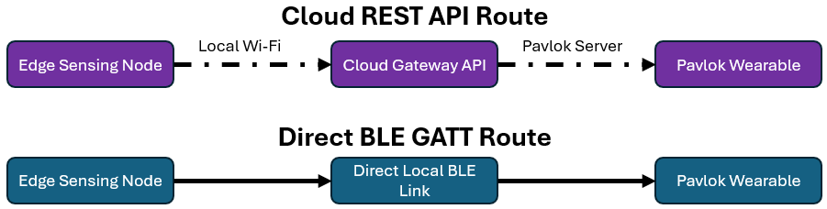
Figure 1. Communication protocol general pipeline

Figure 1 shows the two routes investigated, Cloud REST API and Direct BLE GATT.
Cloud REST API offers a documented OAuth authentication, where Pavlok have a verified command delivery and a relatively easy set-up [25]. It however requires a constant active internet connection, which may result in network-latency issues and cloud server dependency.

Direct BLE GATT allows for a fully offline pipeline, ensuring zero internet dependencies. This ensures for maximum privacy and low transmission latency. However, GATT stack can be unstable on low-power MCUs, which can lead to connection dropouts and issue with pairing handshakes.

The signal trade-offs between the two routes are as follows. Cloud REST API offers fast prototyping validation though it introduces internet dependencies. While Direct BLE GATT links offer standalone operation, but it can face memory and protocol bottlenecks on resource-contrained MCUs.

  - Research Gaps Identified
    - User-Specific Attribution and Multi-Person Interference
Prior closed-loop studies trained their snore classifiers on general snore datasets. This potentially creates a system which is unable to distinguish between the user and a snoring bed partner, which makes it susceptible to high risk of misapplied haptic triggers.

    - Real Bedroom Robustness
Most high-accuracy snoring classifiers are evaluated using clean public audio datasets. This lacks the overnight empirical validation under unconstrained bedroom acoustics and background noises [4][10].

    - Practical Engineering Challenge
Although software feasibility has been well established on high-level host, such as Linux, moving the concurrent audio buffer processing and BLE GATT stacks onto a memory-constrained microcontroller remains an under-documented failure point.

    - Closed-loop Intervention Privacy and Comfort Controls
There is not enough documentation of sleep-disruption risks caused by over-triggering haptic wearables. An adequate consecutive-hit filtering, cooldown windows and zero-raw audio local memory are rarely evaluated together in unified frameworks.

  - Selection and Justification of Proposed Techniques
The chosen closed-loop bedside wearable architecture is bedside acoustic sensing. It was selected to ensure close-to-zero physical sleep disruption. By coupling it with a targeted haptic biofeedback via a Pavlok wearable, the goal is to prompt behavioural modification through postural change.

Classifier progressions were taken in two stages.
Stage 1 was an explainable heuristic energy threshold engine, to validate the end-to-end processing and actuation loop as seen in Figure 2.

Figure 2. Stage 1 Heuristic energy threshold pipeline

Stage 2 was presented for Part 2, to integrate a compressed 1DCNN classifier to suppress false positives caused by non-snore ambient bedroom sounds.

Deployment platform and protocol strategy was achieved through the following.
Primary validation platform was an Android smartphone app (APP) which utilises background services and Cloud REST API calls to ensure complete closed-loop functionality. Secondary validation for Part 2 was to implement migration to a dedicated edge hardware, where attempt via BLE actuation was made and a documented failure analysis of MCU stack memory limits and BLE connection issues.

Addressing of bedroom privacy concerns was identified, and deployment of a method of audio sensing was ensured for zero raw audio files recording or saved. For experimental analysis, only numeric telemetry is logged in a local CSV file to help with snore-rate analysis purposes.

Detailed Methodology
  - Acoustic Feature Extraction and heuristic Energy Thresholding
Time-domain audio signal processing (DSP) is reliant on calculating acoustic signal energy across a windowed and discrete-time audio frames. The RMS amplitude evaluates statistical power of an audio signal by calculating the square root of the arithmetic mean of the squared sample values within a buffer of N samples [24].

$$\begin{aligned}x_{RMS}=\sqrt{\frac{1}{N}\sum_{n=1}^{N}{x{[n]}^{2}}}\#1\end{aligned}$$
Where:
$x[n]$ represents discrete amplitude of the $n^{th}$ audio sample in the buffer
N is the total number of audio samples per windowed frame

To align logarithmic human acoustic perception and standard decibel measurement scales, $x_{RMS}$ is converted to a relative sound level $L_{RMS}$ in decibels (dB) against a full-scale digital reference amplitude.

$$\begin{aligned}L_{RMS}=20\log_{10}\left(\frac{x_{RMS}}{x_{ref}}\right)\#2\end{aligned}$$

To then evaluate frequency distribution, the discrete time-series audio frames are transformed into frequency domain using FFT. This spectral power density across specific acoustic bands is then isolated to compute the low-band energy ratio ($R_{low}$). In snore detection, $R_{low}$ measures the proportion of spectral energy concentrated within fundamental human snore frequency band relative to the total spectral energy across the full acoustic spectrum.

The decision control logic enforces strict heuristic bounds.
- Minimum Noise Floor Ceiling
$L_{RMS} ≥ -30dB$ ensures that ambient bedroom silence is filtered out. All dB values were sourced from the literature [12].

- Maximum Loudness Ceiling
$L_{RMS} ≤ -15dB$ ensures loud non-snore sounds are rejected.

- Low-band Spectral Energy Threshold
$R_{low} ≥0.6$ ensures low-frequency dominance.

- Consecutive-hit Filtering Requirement
$≥5$ consecutive positive frames (approximately 10 seconds of snoring) are detected before setting the snore detection flag, preventing transient noises or speech from causing immediate triggers.

- Timed Cooldown Window
Enforce a mandatory 10-seconds refractory state following actuation to prevent rapid, repeated haptic stimulation from a single snore episode.

    - Application Methodology of Energy-based Threshold
Application in Stage 1 shows that this methodology provided an explainable audio classification pipeline in the Android prototype, validating closed-loop triggering.

    - Drawback of Energy-based Threshold
This method of energy-based threshold however falls short as it is highly sensitive to acoustic environment variations. Unable to discriminate complex non-stationary acoustic patterns with low-frequency components, it leads to high potential for false positives in unconstrained bedrooms.

  - 1D Convolutional Neural Networks (1DCNN)
1DCNN processes sequential time-series audio waveform or 1D feature vectors directly without requiring transformation into computationally heavy 2D MFCC or log-mel spectrogram images.

As demonstrated in prior literature [5], lightweight 1DCNN architectures utilising 8-16 channels achieve classification accuracy of up to 99% with as few as 1337 trainable parameters. This yield a memory footprint of under 2 MB in unquantized 32-bit floating-point format.
    - Application Methodology of 1DCNN
Attemp was made to implement a compressed 1DCNN architecture onto designated MCU(s), however bottleneck and failure was evident.

    - Drawback of 1DCNN
1DCNN will require annotated training audio datasets, higher computational overhead and demands runtime engine compatibility such as PyTorch, ExecuTorch or ONNX Runtime for deployment on edge processors as compared to Energy-based Threshold.

  - Wearable Communication Protocols
Currently only 2 architectures of protocols for the Pavlok wearable are available, Cloud REST API and BLE GATT.
    - Cloud REST API
This actuation path utlilises standard Internet protocol stacks (TCP/IP over Wi-Fi). The edge sensing device acts as a HTTP client, which issues encrypted HTTPS POST requests to Pavlok’s cloud API endpoint.

It is then authenticated via OAuth 2.0 Bearer Token in the request header, where a JSON payload specifies the target stimulus modality (beep, vibe, zap) and the intensity level (10-100%). The cloud then receives this request, performing a validation of the token credentials before routing a push notification to the user’s Pavlok wearable via the official background smartphone link.

    - Bluetooth Low Energy (BLE) GATT
The Pavlok wearable has the capability to connect through BLE, using local 2.4 GHz ISM band via GATT architecture. The edge controller operates in GATT Central Mode, scanning for BLE advertising packets from Pavlok wearables. Upon a successful pairing, the edge controller discovers custom service UUIDs and characteristic UUIDs, which allows for direct execution of write commands to transmit hex-encoded stimulus control frames without needing an external network routing.

    - Comparison between Cloud REST API and BLE GATT
Comparison was done between the protocols using their communication attributes.
For the Cloud REST API (v5 endpoint), the network requirements is a local Wi-Fi and internet WAN access. Its implementation is simple, requiring only a software setup using standard HTTPS libraries. Given its network dependent nature, its actuation latency can face hinderance, however, it allows for highly stable connection between edge device and Pavlok wearable.

The BLE GATT protocol on the other hand can operate fully offline with zero internet of Wi-Fi dependency. Although implementation complexity is more complex, due to high firmware complexity such as custom GATT service discovery, it offers low transmission latency. However, its connection stability is subjected to MCU stack overflows, pairing drops and GATT timeout failures.

  - Edge Computing Platforms
For this project, three platforms were investigated: Smartphone OS, Single-Board Computer and MCU.

Using an Android smartphone, the smartphone OS environment allowed for high-level operations through its multi-core ARM application processors. This provided high-level audio capture APIs, multithread execution, native SQLite and CSV file management. It also had rich user interface framework support.

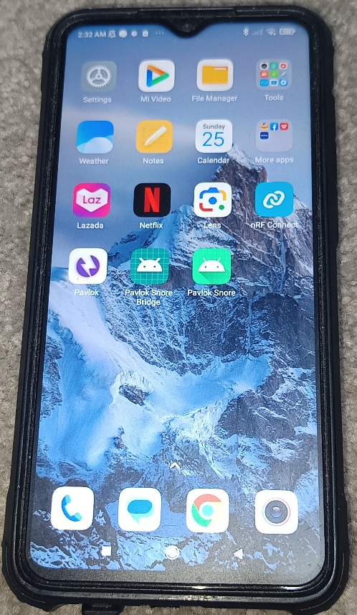
Figure 3. Android smartphone used in this research project

A Raspberry Pi 3 Model A+ was selected as an experiment as it is powered by a Broadcom BCM2837B0 quad-core 64-bit ARM Cortex-A53 CPU, operating at 1.0 GHz with 512 MB SDRAM. It can support standard Python execution stacks, possess native USB and I2S interfaces and carry onboard Wi-Fi and BLE chipsets [20].

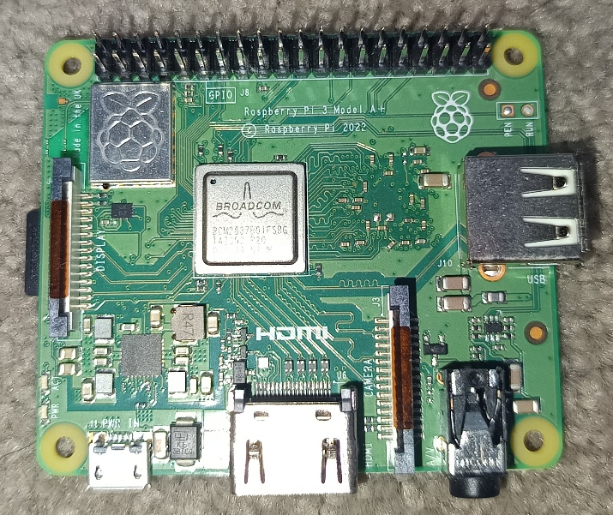
Figure 4. Raspberry Pi 3 Model A+ used in this project

A ESP32 XC3800 was selected for investigation due to its low cost. It features an ESPRESS-IF ESP32-WROOM-32E dual-core 32-bit LX6 processor, operating at 240 MHz with 512 kB RAM and 4MB of flash memory. It has integrated 2.4 GHz Wi-Fi (802.11 b/g/n) and Bluetooth/BLE dual mode (v4.2), it supports I2S connection [21].

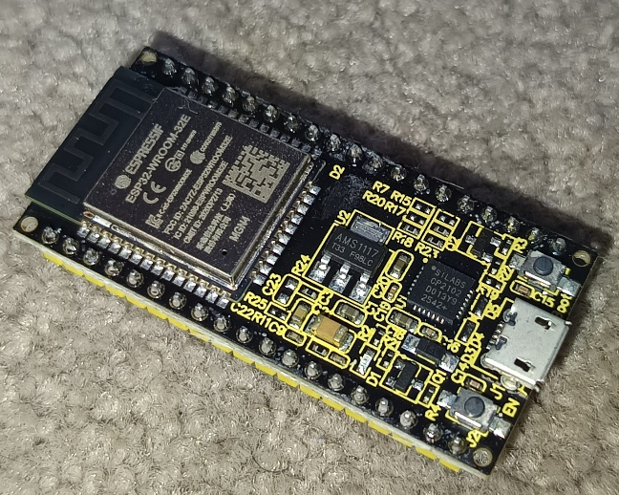
Figure 5. ESP32 XC3800 obtained for this project

Development of Pavlok Nudge
  - Overall System Architecture and Engineering Progression
The closed-loop snore mitigation system follows a three-stage sensing-decision-actuation paradigm. The architecture integrates continuous bedside acoustic capture, real-time feature extraction and classification, decision-filtering state machines and remote haptic actuation via a Pavlok wearable.

The figures below show the previous approach taken and my approach taken.

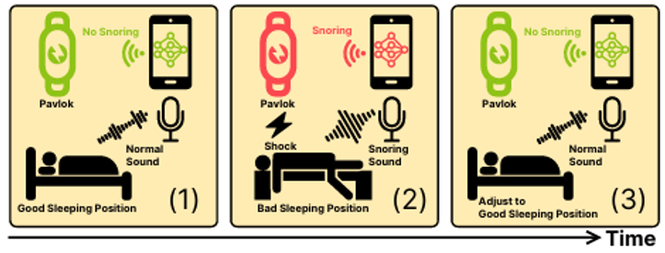
Figure 6. Approach previously taken by M. R. Hasan et al [5]

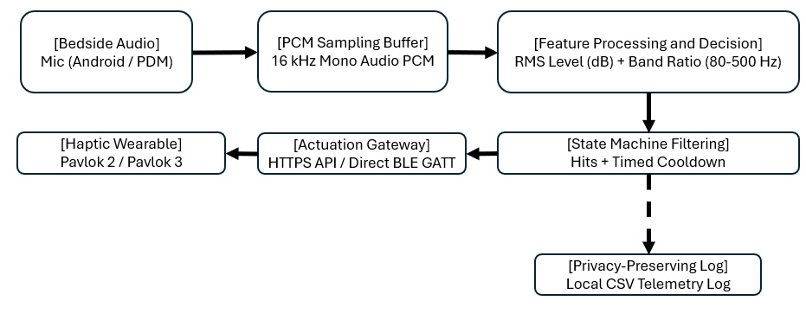
Figure 7. Approach developed and taken in this project

The design progressed across these development phases.
Phase 1: Proof-of-Concept realised using Android Studio, running decibel-based audio detection logic and utilising HTTPS REST API connectivity. This paved the way for realising an integrated mobile application which executes continuous audio capture, state machine filtering, user UI controls, local CSV logging and cloud API actuation [26].

Phase 2: Standalone Embedded Hardware Migration allowed for experimenting and testing physical hardware connecting the Raspberry Pi 3 Model A+ and ESP32 XC3800 with an external I2S Microphone Module. This enabled evaluation of standalone edge processing and direct BLE control.

  - Software Implementation and Audio Processing Pipeline
    - Audio Capture Configuration
The system configures the microphone to capture single-channel (mono) pulse-code modulation (PCM) audio at a 16 kHz sampling rate with 16-bit depth.

The audio stream data is then captured in real time and segmented into continuous 1 second windowed frames, where N = 16000 samples per frame.

Streaming PCM buffers reside exclusively in volatile system RAM, where frame processing is completed within the buffer memory and raw PCM audio frames are immediately overwritten without saving .wav or .mp3 audio files to storage.

    - Baseline Heuristic Feature Extraction Engine
The baseline detection engine processes streaming PCM buffers to evaluate the following acoustic conditions.

Root Mean Square (RMS) Amplitude:
$$\begin{aligned}x_{\text{RMS}}=\sqrt{\frac{1}{N}\sum_{n=1}^{N}{x}{\left[n\right]}^{2}}\#3\end{aligned}$$
Evaluates signal amplitude $x_{\text{RMS}}$ across N = 16000 samples.

Decibel Conversion ($L_{\text{RMS}}$):
$$\begin{aligned}L_{\text{RMS}}=20\log_{10}\left(\frac{x_{\text{RMS}}}{x_{\text{ref}}}\right)\#4\end{aligned}$$

Converts amplitude to relative full-scale decibels (dB).

Low-Band Spectral Energy Ratio ($R_{\text{low}}$):
$$\begin{aligned}R_{\text{low}}=\frac{\sum_{f=80\text{ Hz}}^{500\text{ Hz}}{|}X\left(f\right)|​^{2}}{\sum_{f=0\text{ Hz}}^{f_{\text{nyquist}}}{|}X\left(f\right)|​^{2}}\#5\end{aligned}$$
Applies Fast Fourier Transform (FFT) analysis to measure the energy proportion within the snore frequency band (80-500 Hz) relative to total spectral power (0-8000 Hz).

The state machine filter then applies the following decision rules:
Noise Floor Bound: $L_{\text{RMS}}≥-30.0\text{ dB}$
Maximum Ceil Bound: $L_{\text{RMS}}≤-15.0\text{ dB}$
Spectral Ratio Ceiling: $R_{\text{low}}≥0.60$
Consecutive Hit Requirement: $N_{\text{hits}}≥5$ consecutive positive frames
Refractory Cooldown State: 10 seconds timer lock actuation upon triggering

    - 1DCNN Pipeline
To overcome false-positive limitations of heuristic thresholding in noisy bedroom environments, 1DCNN architecture implementation is recommended. The model architecture of the 1DCNN contains three convolutional layers with 1D spatial filters, non-linear ReLU activation and 1D Max-Pooling layers which feeds into a dense classifier layer. The unquantized FP32 PyTorch model yields a footprint of 2 MB. Next the time-series PCM audio frames (16,000 points) pass into the input layer, where the output node computes snore probability using the following logic: P(snore) ∈ [0.0,1.0].

  - Android Application Architecture
The core software deliverable was developed in Android Studio using Kotlin, targeting usage on Android platforms.
    - Service Components
Within the Android APP, the following components were designed.
Main application entry point provides the UI navigation across four tabs, Dashboard, API Setup, Remote and Logs.

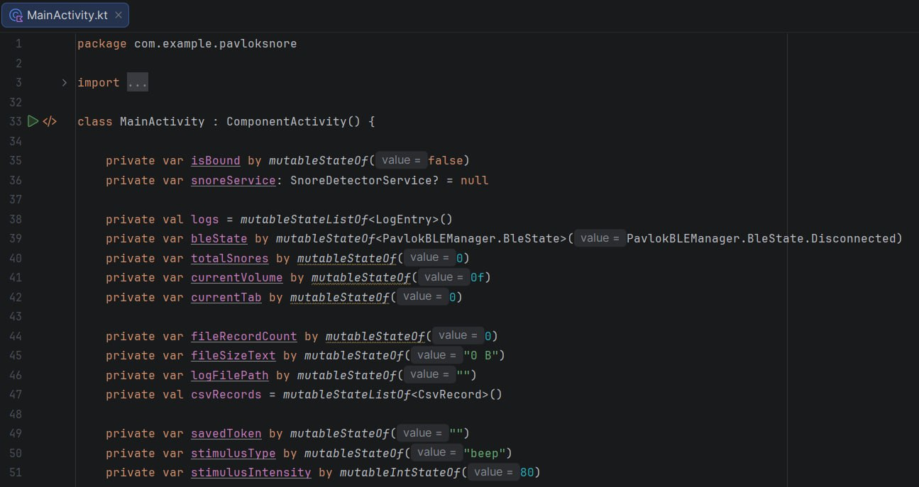
Figure 8. Snippet of Kotlin file showing entry point for the UI

Foreground Android service then utilises a sticky notification channel to prevent OS memory garbage collection during overnight sleep sessions.

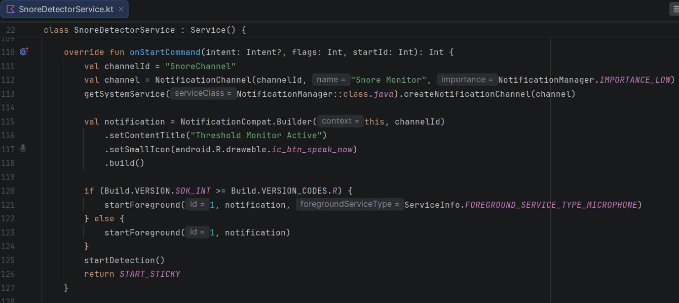
Figure 9. Snippet of Kotlin file showing foreground Android service

Live telemetry variables, hit counts, cooldown timers and trigger history are then managed by a local state store.

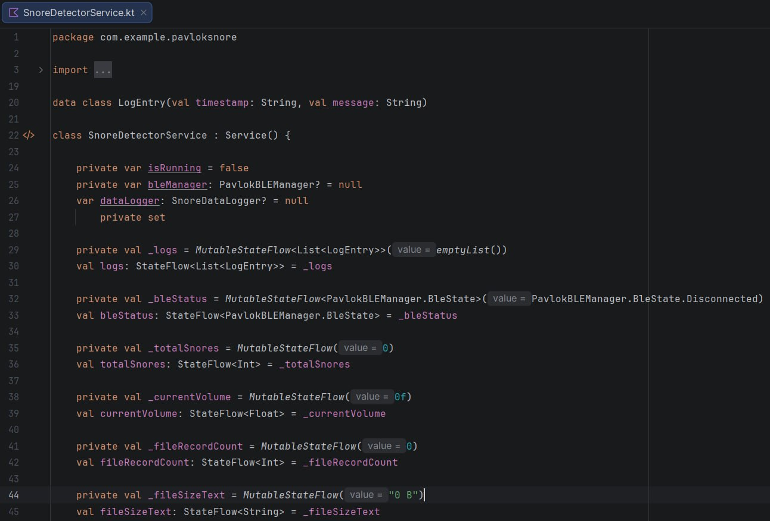
Figure 10. Snippet of Kotlin file showing local state store

A local file manager then formats and writes a CSV telemetry record directly into the internal storage.

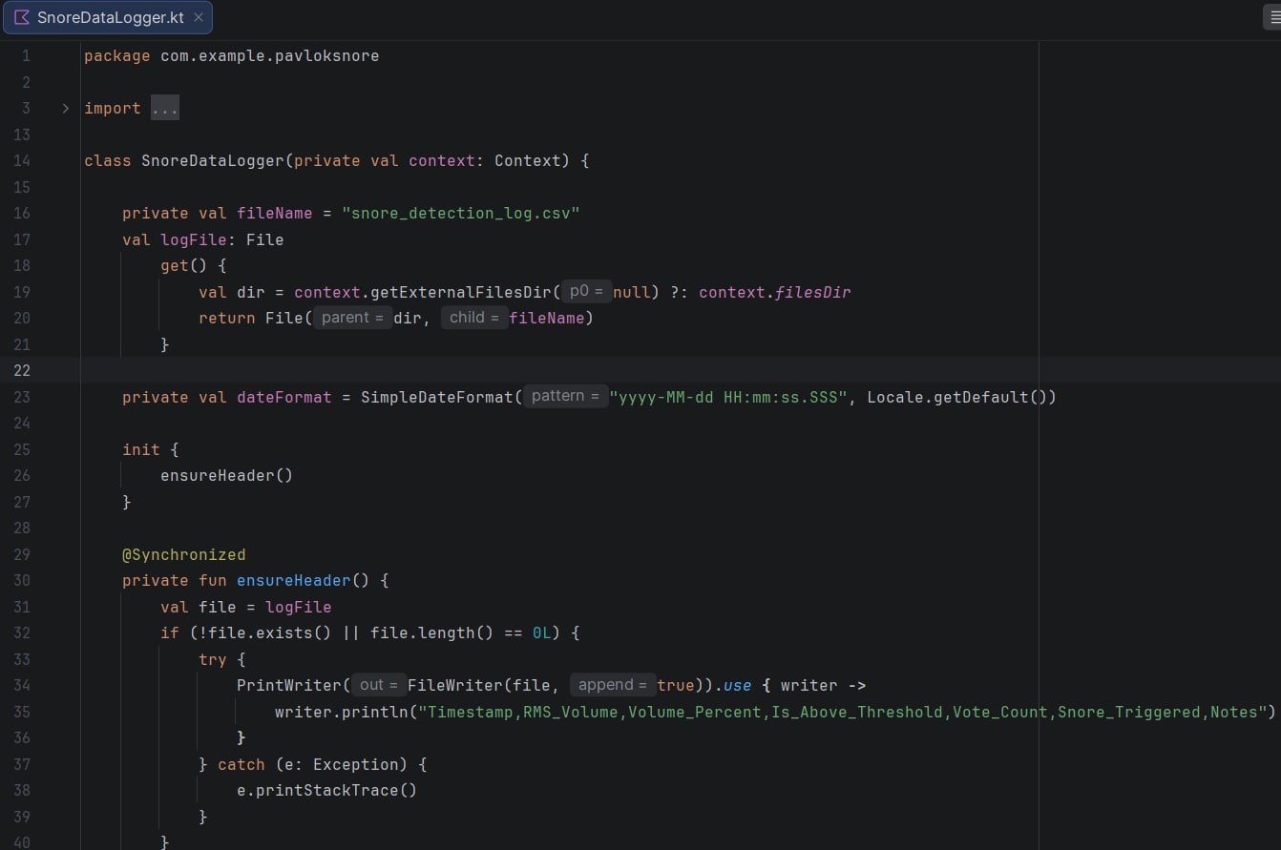
Figure 11. Snippet of Kotlin file showing local file manager

    - UI Iteration
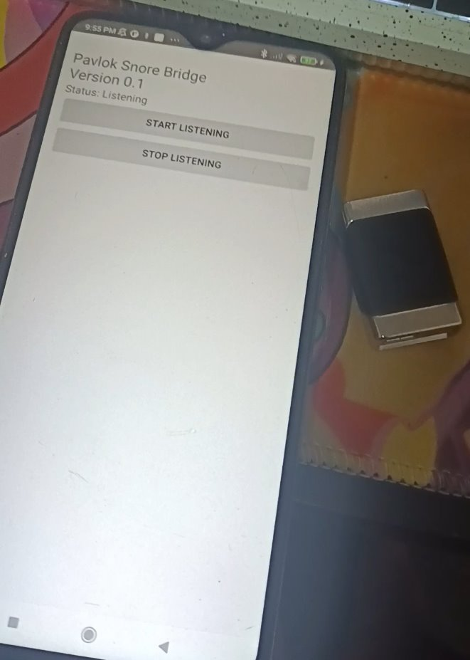
Figure 12. First prototype

Figure 12 displays the very first version of the UI. Initially to realise and test the closed-loop API route, it offers only start/stop listening buttons while running the energy-based Threshold.

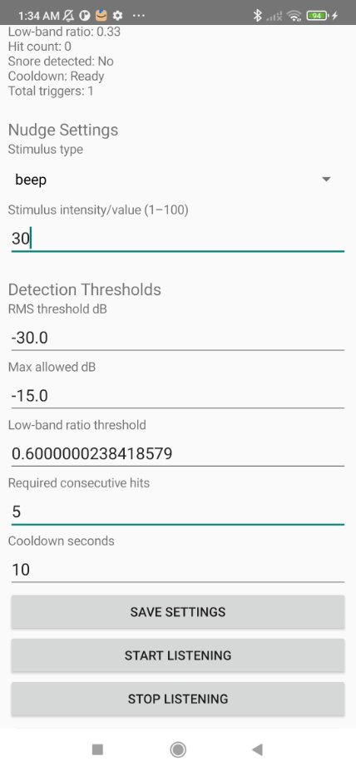
Figure 13. Improved prototype UI

Figure 13 shows the improved version where the UI displays basic text lines for status, decibel level adjustments, low-band ratio settings, hit count and an additional save setting button.

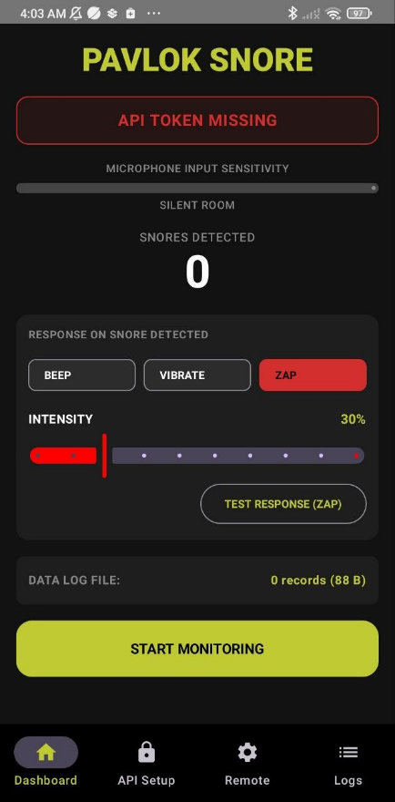
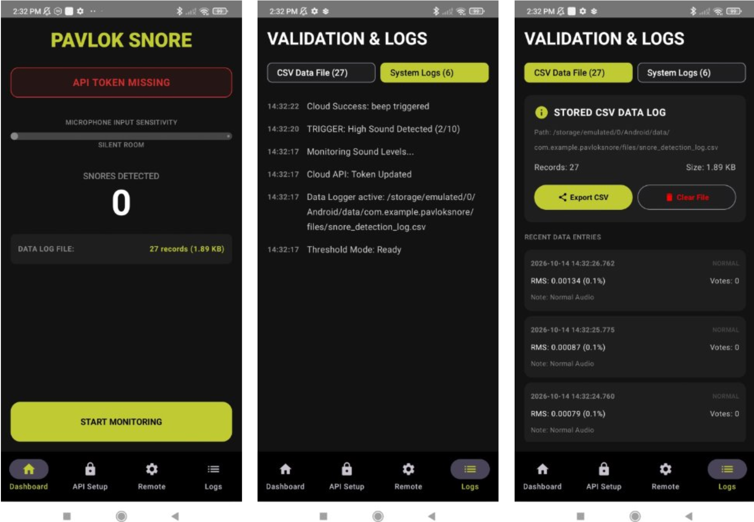
Figure 14. Snippets of most updated and improved Android APP

The newest version as displayed in Figure 14, shows an advanced and improved UI for the ‘PAVLOK SNORE’ APP. It features a dark theme for better user comfort during sleep time, it introduces a multi-tab interface featuring a dynamic status bar (API TOKEN MISSING / CLOUD LINK ACTIVE), a live sound meter for when snoring detection is active, snore trigger counter to for a quick glance of how many times the system triggered, remote test sliders for quick Pavlok wearable connection tests, a log manager for a more detailed system report during monitoring cycle and a CSV data file export option for the logged telemetry data.

  - Hardware Prototyping and Migration Analysis
Exploration of a standalone edge device independent of personal smartphones was investigated. Through hardware prototyping using single-board computers and microcontrollers.

    - Raspberry Pi 3 Model A+
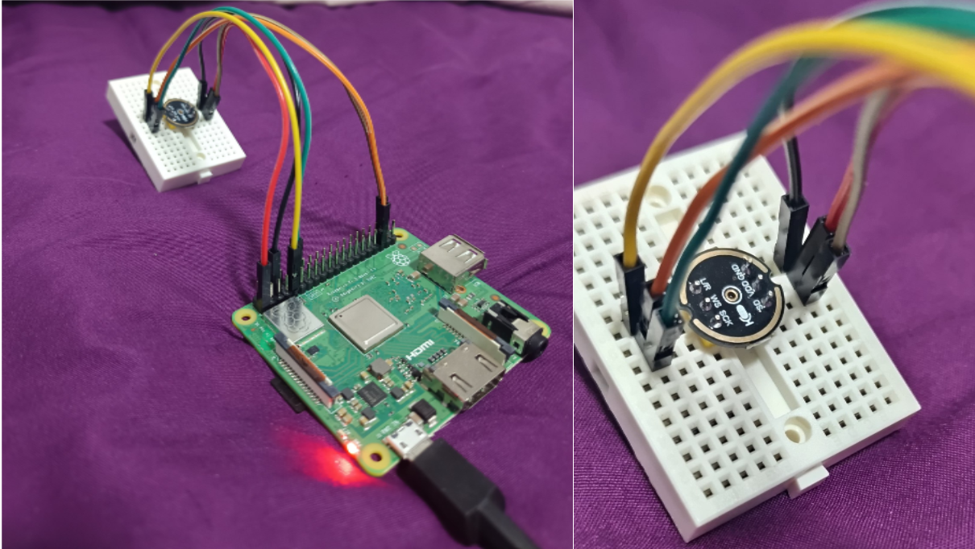
Figure 15. Wiring and connection setup of Raspberry with I2S microphone

For investigative experimentation, the Raspberry Pi 3 Model A+ was connected with the I2S Microphone Module.

By utilising ssh to communicate and program the Raspberry Pi 3 Model A+, the cloud REST API route was first tested to ensure that the Pavlok wearable can connect and pair.

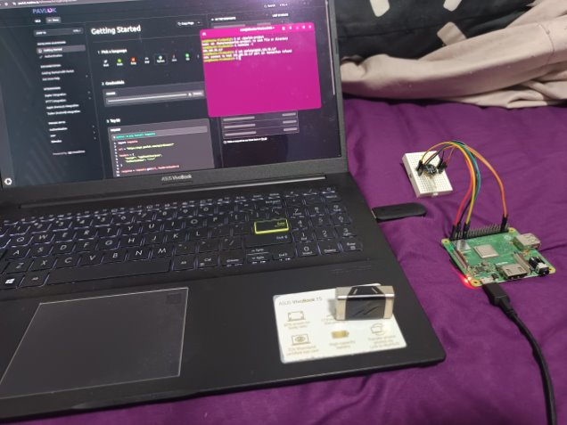
Figure 16. ssh connection trial with Raspberry Pi and Pavlok 2

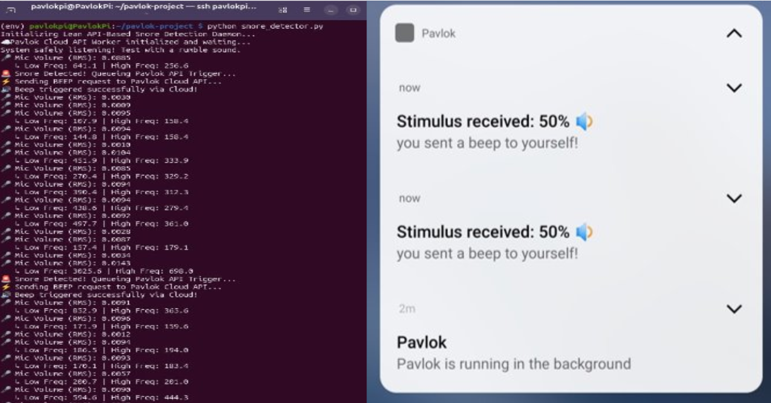
Figure 17. Successful API pathway between Raspberry and Pavlok 2

Through configuring and running a background Python daemon on the Raspberry Pi 3 Model A+, it validated the API pathway with the captured snore-like audio from the I2S Microphone Module successfully triggered the Pavlok beep stimulus.

    - ESP32 XC3800
The ESP32 XC3800 was considered for its low-power operation and substantial processing and memory capabilities.

However, not much work was done with it as I obtained it late due to prolonged delivery.

  - Communication pathways and Integration Failures
    - Cloud REST API Pathway (Successful Validation)
The official development published by Pavlok allows for developers to make use and tinker with its wearables. By issuing a HTTP POST request to https://api.pavlok.com/api/v5/stimulus using OAuth 2.0 bearer tokens, protocols can be executed. Payload verification was also established via triggering of haptic feedback (beep, vibe, zap). Operational results are positive, delivering 100% actuation reliability whenever Wi-Fi was present, which verified complete closed-loop functionality.

    - Direct BLE GATT Pathway (Technical Failure Analysis)
However, it faced issues when trying to execute GATT service discovery using Python (bleak). The Raspberry Pi Model 3 A+ would often face issues discovering the BLE broadcast of the Pavlok wearables (both Pavlok 2 and Pavlok 3). Though when it does discover it, the next bottleneck was the failure to connect. Methods of remedy included targeting the specific GATT characteristic UUIDs of the Pavlok wearables by scanning for them using nrf Connect APP. After debugging and further research, the conclusion was that the Pavlok wearables may have proprietary encryption protocols. This meant that they require proprietary handshake sequences for a successful pairing and this GATT characteristic write protocols are publicly undocumented by Pavlok. It was then inferred that un-authenticated third-party BLE control was highly impossible without official firmware access.

  - Privacy Design and Telemetry Logging Pipeline
To address bedroom privacy concerns identified in literature, privacy-by-design was implemented.

Audio sampling buffers will only exist solely in volatile RAM memory during frame analysis. These frames then are immediately overwritten upon completion of feature processing, such that no audio files are ever recorded, written or transmitted.

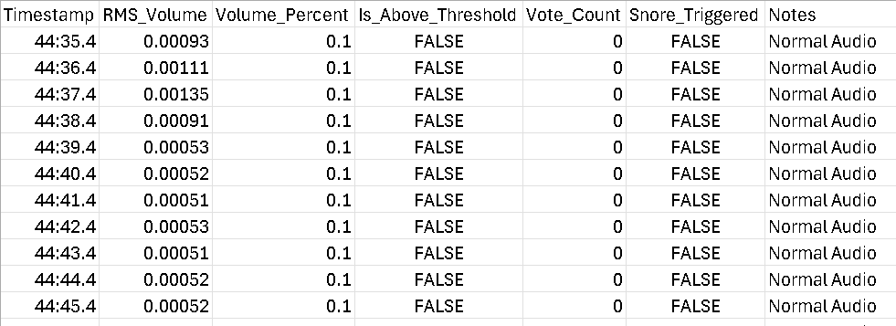
Figure 18. Snippet of CSV data logged

Shown in Figure 18 is a snippet of the actual CSV telemetry log for post-monitoring snore detection analysis. This is crucial for input into understanding and verifying positive triggers of snore during the monitoring.

Results and Validation
  - Experimental Setup and Evaluation Methodology
    - Bedside Testing Environment
Pilot testing was conducted using the ‘PAVLOK SNORE’ APP on myself in a real-world home bedroom setting, to evaluate system performance under unconstrained acoustic conditions. It is considered pilot testing as validating system workability prior to a wider testing, which is beyond the scope of this thesis..

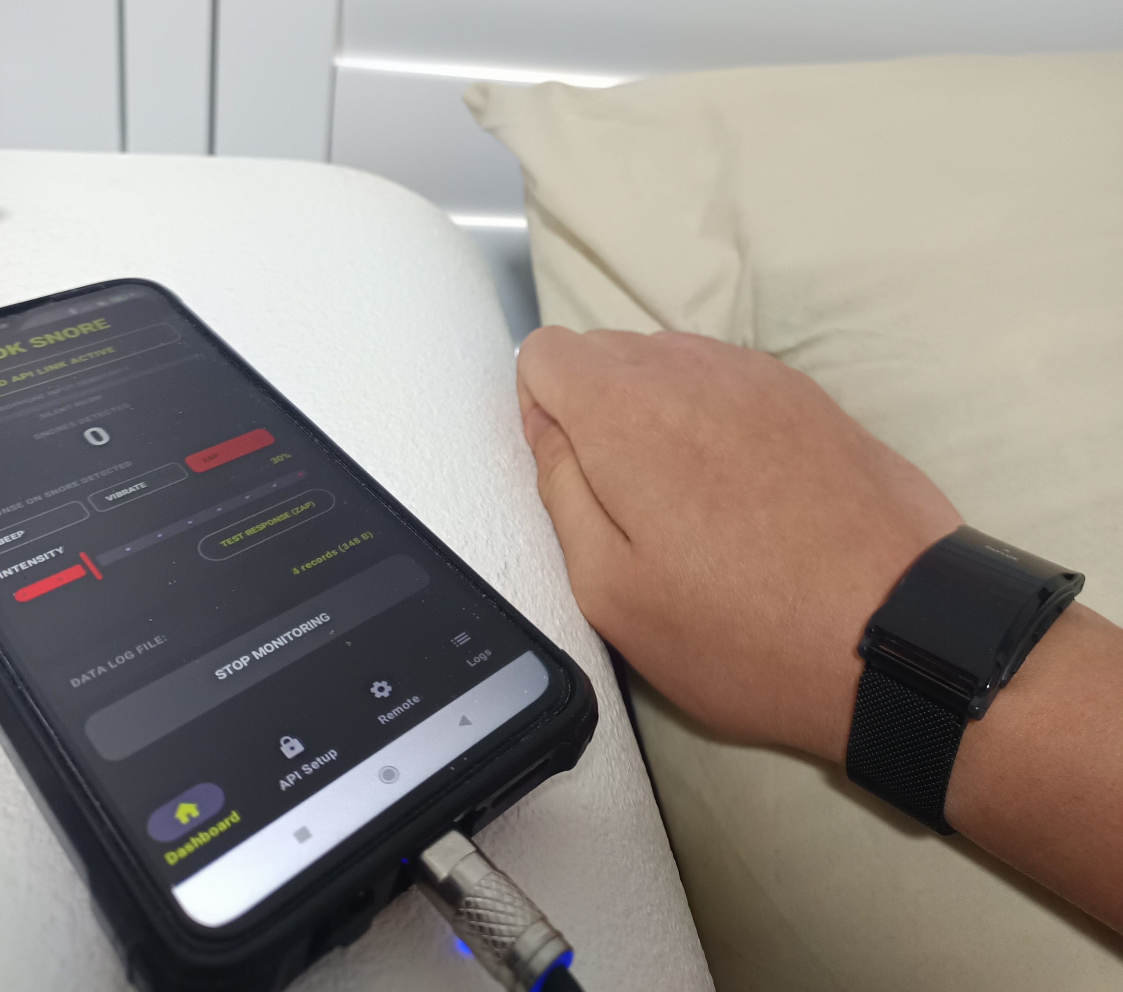
Figure 19. Bedroom test setup

By placing the Android smartphone on the bedside table and running the APP, testing was conducted during sleep cycles to validate if the closed-loop system served its purpose as a feedback mechanism for atomic behaviour modification with snoring use case.

    - Acoustic Test Sequence
Before running the sleep cycle tests, system evaluation was performed using four distinct acoustic scenarios.

To establish a baseline acoustics, the system was tested in an isolated quiet room with the air conditioning unit turned on. Providing the baseline of ambient sound levels. Next, tests were conducted to discover natural snoring episodes. After which non-snore ambient bedroom noises were evaluated, this included and was not limited to normal speech and background TV audio. Finally abrupt impulsive transient noises were used to test the maximum decibel cutoffs, which included and is not limited to slamming door, clapping and dropped objects.

  - Empirical Analysis of Overnight Telemetry Logs
After the sleep tests, system performance was recorded via the automated CSV data logging pipeline.

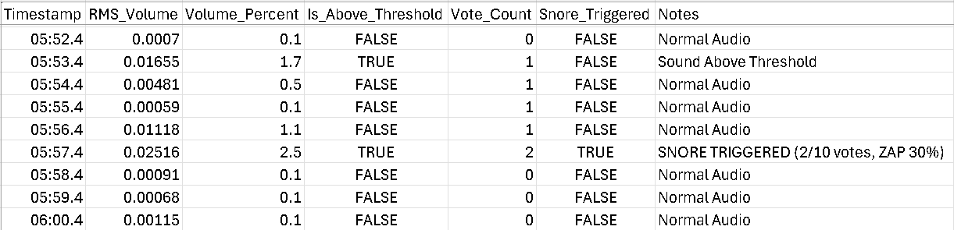
Figure 20. Snippet of CSV data log file showing positive trigger

From the CSV data, the heuristic baseline performance validates the step-by-step operation of the state machine filter. When a ‘snoring’ event is detected, the system starts a vote count to enable the consecutive hit count accumulation within the stipulated timeframe, this is to ensure that false-positive triggering does not occur during ambient silence or isolated abrupt impulsive transient noise. If detection is true during the stipulated timeframe and the relevant vote count is attained, the APP will then send a trigger via Cloud REST API to the Pavlok wearable as seen in Figure 20, actuating a haptic response of a zap at 30% intensity (customisable intensity, 30% was chosen personally for the purpose of the tests). After a positive trigger and actuation, the vote count is reset back to zero to ensure that continuous haptic response isn’t triggered for the same event allowing for the system to re-arm itself in preparation for the next snore event.

The overnight experiments were taken 2 nights with a total duration of approximately 11 hours and 16 minutes. Across both sessions, a total of 89 sound events were detected above volume threshold (Night 1: 9, Night 2: 80). These triggered 30 active interventions (Night 1: 3x VIBE 20%, Night 2: 27x ZAP 30%). Night 2 showed significant increase in sound events and triggers particularly towards the end of the monitoring window (after 0745AM) along with 14 instances where a sound exceeded the threshold during a cooldown period. This is most likely due to my room facing the main road near a school, and the ambient noise caused by students heading to school and parents with their vehicles dropping of their children for school. This data collected is valuable, as it provided a real-world test of the boundaries of threshold limits.

Sustainability Considerations
  - Environmental Sustainability
    - Local Edge Processing vs. Cloud Computational Overhead
Traditionally, voice assistants and cloud-connected acoustic sensors continuously stream raw audio data over wireless networks to remote could data centres for centralised processing. Continuous overnight audio streaming consumes substantial network bandwidth and incurs high server-side computational energy expenditures.

The Pavlok Nudge architecture prioritises local edge processing [26] via conducting real-time audio feature extraction locally on edge device, eliminating raw audio transmission over WAN. The edge node only dispatches tiny payloads via the Cloud REST API when a verified snore event occurs, reducing continuous wireless transmission energy and remote server processing overhead.

    - Modular Software Architecture and E-Waste Reduction
The sensing, feature extraction, neural classification, state machine logic and actuation layers were engineered as decoupled and independent modules [26].

Allowing for individual system components to be updated or upgraded, which includes and is not limited to replacing the baseline heuristic energy detector with an improved 1DCNN model. Allowing for the reduction of hardware redesigns and physical hardware disposal, which mitigates e-wastes and extends hardware longevity.

    - Energy-Conscious Embedded hardware Deployment
Investigation of system migration onto dedicated single-board computers and low-power microcontrollers establishes a pathway towards minimal wattage hardware deployment. Operating on 5V-USB or 3.7V LiPo batteries, it reduces overnight electrical power draw, supporting long-term energy efficiency and home-based operations.

  - Social Sustainability
    - Privacy Design and Bedroom Acoustic Safeguards
Bedside acoustic monitoring inherently introduces severe privacy risks regarding unintended capture and storage of sensitive bedroom audio, private conversions and non-consensual sound recordings. By ensuring that the PCM audio frames reside only in volatile RAM memory and is immediately overwritten upon completion of evaluation, it prevents raw audio files to be recorded, written or saved to persistent storage. Only telemetry data are stored in a CSV file for this current version of the system for snore data analysis purposes [26].

During snore data tests, users will also be made to complete and sign a consent form, ensuring that they are made aware of the system architecture and relevant privacy risks before undergoing the test procedures. This allows for non-intrusion of respective privacy.

    - User Comfort and Preservation of Sleep
Delivery of inappropriate, aggressive or excessive physical stimulation during sleep will bring sleep disruption, causing awakenings, night-time stress and ultimately product abandonment.

Social acceptance and long-term user adherence are prioritised by incorporating consecutive hit filtering and refractory cooldown windows. Ensuring that the Pavlok wearable only delivers subtle, comfort-calibrated nudges which serves to prompt minor behavioural modification through postural change, preserving the sleep continuity of user and bed partner.

    - Ethical Positioning as a Non-Clinical Behavioural Aid
This project is explicitly defined as an engineering system aimed as a feedback mechanism for atomic behavioural modification, serving the purpose for a non-invasive consumer-level behavioural mitigation aid.

It avoids overstating clinical diagnostic capabilities or attempting to replace accredited medical therapies such as CPAP and MADs for OSA, giving it the transparent position to ensure responsible and ethically aligned technology deployment.

  - Economic Sustainability
    - Utilising Commercially Available Hardware
Through using widely accessible, off-the-shelf development platforms such as Android OS, Raspberry Pi 3 Model A+ and commercial consumer products such as the Pavlok 2 and Pavlok 3, avoids expensive custom integrated circuit fabrication, custom tooling and proprietary wearable manufacturing during the research and developmental phase of this project.

    - Low-Cost Alternative to Invasive Clinical Equipment
This project though focused on the Pavlok wearable, paves the way for a bedside edge-sensing application linked to a reusable consumer wearable. It presents a highly accessible, low-cost behavioural alternative for atomic behavioural modification for simple primary snoring, lowering economic entry barriers for home sleep wellness.

Conclusion
  - Summary of Work
This thesis investigated the development, architectural trade-offs and empirical validation of Pavlok Nudge, a closed-loop, bedside-sensing snore detection and haptic intervention.

The project successfully validated the core sensing-decision-actuation pipeline which confirms the central research hypothesis within an Android software environment while uncovering critical hardware and protocol bottlenecks on standalone single-board computers and microcontrollers. Further work should demonstrate accuracy improvement and effective behavioural intervention.

The primary achievements of this project have been met, which includes validation of the closed-loop system pipeline, classifier progression and accuracy optimisation, implementation of privacy design and telemetry logging, empirical evaluation of standalone edge hardware bottlenecks.

  - Conclusion
The Pavlok Nudge benefits users through a low-burden, non-invasive behavioural biofeedback for non-clinical usage and atomic behaviour modification. By combining bedside acoustic monitoring and private localised wearable nudges, Pavlok Nudge aims to prompt subtle postural shifts without causing full sweep awakenings. The assurance of privacy was designed and implemented to ensure that processed audio is done exclusively in RAM and zero raw audio files are saved in persistent storage. Technical failure was analysed in regard to why commercial consumer wearable, in the project case a Pavlok 2 and Pavlok 3, resisted unauthenticated direct BLE control on single-board computers and microcontrollers, serving as a documented foundation for future engineering students or stakeholders working on the Pavlok Nudge or any similar architecture.

The engineering key takeaways learnt are API gateway versus direct BLE GATT trade-offs and heuristics versus deep learning. High-level API over Wi-Fi provided an exceptionally validated pathway, however, transitioning to standalone BLE actuation on single-board computers and microcontrollers required deep consideration of stack memory footprints, proprietary handshakes and GATT service discovery overhead. Heuristics pipeline is a straightforward method to test and validate the system, allowing for debugging and state-machine verification. However, for distinct snoring classification, end-to-end deep learning (1DCNN) appears to be required for discrimination in real, unconstrained bedroom environments.

Reflecting, for future engineering projects, deeper profiling of single-board computers and microcontrollers should be made early before committing to any specific hardware platform. Modular software and hardware architectures ensure that system modification can be done easily without disturbing and altering the core system pipeline. Keeping in mind that in any engineering circumstance, having a curious and open mindset allows for systematic tackling of the problems at hand, which is essential for success.

  - Future Work
It is recommended to reduce the 1DCNN model footprint, allowing the new compressed model to exist comfortably on any single-board computer or microcontroller for bedside edge sensing. Understanding and deeper research should be done on dedicated hardware BLE architectures to investigate pairing handshakes, mitigate connection dropouts and tackle GATT stack memory bottlenecks.

Apart from the 1DCNN classifier model, a multi-user discrimination should be designed and implemented. By creating a deep learning model to learn and tune the snore detection system to only trigger for a specific user. This is to prevent misapplied haptic triggers in multi-person bedrooms and sleep environments.

Adaptive nudge escalation is also one future improvement that can be made, where stimulus modality and intensity automatically scale up if snoring persists across consecutive cooldown windows, subject to maximum intensity settings and avoidance of sleep disruption. Future work should prioritise proving detection accuracy and actual snoring reduction before escalating interventions.

Overnight sleep quality validation can also be performed. By conducting sleep lab trials paired with sleep trackers such as actigraphy and EEG sensors, measurement of actual snore suppression rates and total sleep cycle preservation can be accessed and documented to validate the Pavlok Nudge usecase.

References
[1] J. M. Slowik and J. F. Collen, “Obstructive sleep apnea,” PubMed, 2024. https://www.ncbi.nlm.nih.gov/books/NBK459252/
[2] D. Hynes and D. Mansfield, “Diagnosis and management of obstructive sleep apnoea in adults,” Australian prescriber, vol. 47, no. 2, pp. 52–56, Apr. 2024, doi: https://doi.org/10.18773/austprescr.2024.010.
[3] K. Ramar et al., “Clinical Practice Guideline for the Treatment of Obstructive Sleep Apnea and Snoring with Oral Appliance Therapy: An Update for 2015,” Journal of Clinical Sleep Medicine, vol. 11, no. 7, Jul. 2015, doi: https://doi.org/10.5664/jcsm.4858.
[4] P. Baptista et al., “Daytime Neuromuscular Electrical Therapy of Tongue Muscles in Improving Snoring in Individuals with Primary Snoring and Mild Obstructive Sleep Apnea,” Journal of Clinical Medicine, vol. 10, no. 9, pp. 1883–1883, Apr. 2021, doi: https://doi.org/10.3390/jcm10091883.
[5] R. Hasan, S. Ghosh, P. Agrawal, Z. Cai, and T. Gedeon, “Pavlok Nudge: A Feedback Mechanism for Atomic Behaviour Modification,” May 10, 2023. https://www.researchgate.net/publication/370656432_PavlokNudge_A_Feedback_Mechanism_for_Atomic_Behaviour_Modification
[6] Ainhoa Osa-Sanchez, J. Ramos-Martinez-de-Soria, Amaia Mendez-Zorrilla, I. O. Ruiz, and Begonya Garcia-Zapirain, “Wearable Sensors and Artificial Intelligence for Sleep Apnea Detection: A Systematic Review,” Journal of Medical Systems, vol. 49, no. 1, May 2025, doi: https://doi.org/10.1007/s10916-025-02199-8.
[7] L. Pinilla, C. L. Chai‐Coetzer, and D. J. Eckert, “Diagnostic Modalities in Sleep Disordered Breathing: Current and Emerging Technology and Its Potential to Transform Diagnostics,” Respirology, Mar. 2025, doi: https://doi.org/10.1111/resp.70012.
[8] P. Ioerger et al., “Mandibular Advancement vs Combined Airway and Positional Therapy for Snoring,” JAMA Otolaryngology–Head & Neck Surgery, vol. 150, no. 7, p. 572, Jul. 2024, doi: https://doi.org/10.1001/jamaoto.2024.1035.
[9] “Treating Sleep Apnea with an Oral Appliance: Procedural Details, Risks & Benefits,” Cleveland Clinic, Apr. 19, 2024. https://my.clevelandclinic.org/health/treatments/21129-oralappliance-therapy-for-sleep-apnea
[10] B. Nokes et al., “Transoral awake state neuromuscular electrical stimulation therapy for mild obstructive sleep apnea,” Sleep and Breathing, May 2022, doi: https://doi.org/10.1007/s11325-022-026449.
[11] T.-T. Chung, M.-T. Lee, M.-C. Ku, K. Yang, and C.-Y. Wei, “Efficacy of a Smart Antisnore Pillow in Patients with Obstructive Sleep Apnea Syndrome,” Behavioural Neurology, vol. 2021, pp. 1–6, Jan. 2021, doi: https://doi.org/10.1155/2021/8824011.
[12] T. Khan, “A Deep Learning Model for Snoring Detection and Vibration Notification Using a Smart Wearable Gadget,” Electronics, vol. 8, no. 9, p. 987, Sep. 2019, doi: https://doi.org/10.3390/electronics8090987.
[13] N. N. Dinh et al., “Implementing deep learning on edge devices for snoring detection and reduction,” Computers in Biology and Medicine, vol. 184, p. 109458, Jan. 2025, doi: https://doi.org/10.1016/j.compbiomed.2024.109458.
[14] H. Nakano et al., “Monitoring Sound To Quantify Snoring and Sleep Apnea Severity Using a Smartphone: Proof of Concept,” Journal of Clinical Sleep Medicine, Jan. 2014, doi: https://doi.org/10.5664/jcsm.3364.
[15] E. Dafna, A. Tarasiuk, and Y. Zigel, “Automatic Detection of Whole Night Snoring Events Using Non-Contact Microphone,” PLoS ONE, vol. 8, no. 12, p. e84139, Dec. 2013, doi: https://doi.org/10.1371/journal.pone.0084139.
[16] P. M. Baptista, F. Martin, H. Ross, C. O’Connor Reina, G. Plaza, and M. Casale, “A systematic review of smartphone applications and devices for obstructive sleep apnea,” Brazilian Journal of Otorhinolaryngology, vol. 88, no. 5, Feb. 2022, doi: https://doi.org/10.1016/j.bjorl.2022.01.004.
[17] G. N. Pires, E. S. Arnardóttir, A. S. Islind, T. Leppänen, and W. T. McNicholas, “Consumer sleep technology for the screening of obstructive sleep apnea and snoring: current status and a protocol for a systematic review and meta‐analysis of diagnostic test accuracy,” Journal of Sleep Research, Feb. 2023, doi: https://doi.org/10.1111/jsr.13819.
[18] H. Jin et al., “Acoustic Analysis of Snoring in the Diagnosis of Obstructive Sleep Apnea Syndrome: A Call for More Rigorous Studies,” Journal of Clinical Sleep Medicine, vol. 11, no. 07, pp. 765 771, Jul. 2015, doi: https://doi.org/10.5664/jcsm.4856.
[19] A. A. Chiang et al., “OSA diagnosis goes wearable: are the latest devices ready to shine?,” Journal of Clinical Sleep Medicine, vol. 20, no. 11, pp. 1823–1838, Nov. 2024, doi: https://doi.org/10.5664/jcsm.11290.
[20] R. P. Ltd, “Buy a Raspberry Pi 3 Model A+,” Raspberry Pi. https://www.raspberrypi.com/products/raspberry-pi-3-model-a-plus/
[21] “Duinotech ESP32 Main Board With Wi-Fi and Bluetooth®,” Jaycar Australia, 2023. https://www.jaycar.com.au/duinotech-esp32-main-board-with-wi-fi-and-bluetooth/p/XC3800
[22] “LiteRT for Microcontrollers,” Google AI for Developers, 2024. https://ai.google.dev/edge/litert/microcontrollers/overview
[23] Edgeimpulse.com, 2026. https://docs.edgeimpulse.com/tutorials/end-to-end/sound-recognition
[24] “ESP-DSP Library - ESP32 - — Espressif DSP Library latest documentation,” Espressif.com, 2019. https://docs.espressif.com/projects/esp-dsp/en/latest/esp32/index.html
[25] D. Don, “API Version 5.0 - Integration - (1233) - ,” Pavlok.com, 2026. https://helpdesk.pavlok.com/en/articles/6610076 api-version-5-0-integration-1233
[26] P. K. J. Samuel, "Milestone Report: Development of a Closed-Loop and Real-Time Pavlok-Based Snore Detection and Intervention Prototype," Engineering Research Project Progress Report (EEET4000), School of Electrical Engineering, Computing and Mathematical Sciences, Curtin University, Perth, Australia, May 2026.

Appendix
All relevant codes and CSV logs can be found here in this repository: https://github.com/samuelphua7/EEET4001-PavlokNudge

