AUTOMATIC SOLAR TRACKING SYSTEM
Single-Axis Solar Tracking Using Two LDR Sensors and Arduino Nano
Technical Project Report
Embedded sensing • Closed-loop tracking • Electrical monitoring

1. Abstract
This project presents a microcontroller-based single-axis automatic solar tracking system designed to continuously orient a photovoltaic panel toward the direction of greater incident sunlight. Unlike a fixed panel, the proposed system uses two Light Dependent Resistors (LDRs) placed on opposite sides of the panel to determine the relative direction of the light source. An Arduino Nano processes the sensor readings and controls a servo motor so that the panel rotates toward the brighter side. A deadband is incorporated into the control logic to avoid unnecessary oscillation when the two sensors receive nearly equal illumination.
The system also incorporates electrical-output monitoring. An ACS712 Hall-effect current sensor measures panel current, while a resistor-divider network scales the panel voltage to a level suitable for the Arduino's analog input. A 16×2 LCD provides real-time operating information, while serial output can be used for debugging and data observation. Sensor filtering, current-sensor zero calibration, and oversampled voltage measurement are included in the implementation to improve measurement stability.

2. Introduction
Solar photovoltaic output depends strongly on the angle at which sunlight strikes the panel. A fixed panel is optimized for only a limited portion of the day because the apparent position of the Sun changes continuously. A tracking mechanism can reduce this angular mismatch by changing the panel orientation as the dominant light direction changes.
The system developed in this project uses a simple closed-loop approach rather than relying on a predetermined time schedule. The two LDRs act as differential light sensors: when one side receives more light, the controller interprets the difference as an indication that the panel should rotate toward that side. The process is repeated continuously, allowing the system to respond to changes in illumination caused by the movement of the Sun or changes in the surrounding light conditions.
The design deliberately uses a single tracking axis. This reduces mechanical complexity, actuator requirements, wiring, and control computation while retaining the fundamental concept of automatic solar tracking.

3. Objectives
- Design and implement a low-cost automatic solar tracker using an Arduino Nano.
- Use two LDR sensors to determine the relative direction of maximum illumination.
- Control a single servo motor through closed-loop feedback.
- Reduce servo hunting by using filtered sensor readings and a deadband.
- Measure photovoltaic-panel current using an ACS712 sensor.
- Measure panel voltage using a resistor-divider interface.
- Display important operating parameters on a 16×2 LCD.
- Provide a modular hardware and software structure that can be extended in future versions.

4. System Specifications
Parameter | Implemented Configuration
Tracking type | Single-axis
Light sensors | 2 × LDR
Controller | Arduino Nano
Actuator | 1 × servo motor
LDR inputs | A0 and A1
Current sensing | ACS712 → A6
Panel voltage sensing | 30 kΩ / 10 kΩ divider → A7
Display | 16×2 LCD, 4-bit interface
LCD pins | RS D2, EN D3, D4-D7 → D4-D7
Servo signal | D10
LDR filter | Exponential Moving Average, α = 0.25
Tracking deadband | 6 ADC counts
Servo limits | 5° to 180°
Initial servo position | 90°

5. Hardware Components
Component | Quantity | Role in the System
Arduino Nano | 1 | Central controller; reads sensors, executes tracking logic and drives the servo/LCD.
LDR | 2 | Detect relative illumination on the two sides of the panel.
10 kΩ resistor | 2 | Forms the LDR voltage-divider circuits.
Servo motor | 1 | Provides mechanical rotation of the solar panel along one axis.
Solar panel | 1 | Photovoltaic energy source being tracked.
ACS712 | 1 | Measures current in the panel output path.
30 kΩ resistor | 1 | Upper resistor of the panel-voltage divider.
10 kΩ resistor | 1 | Lower resistor of the panel-voltage divider.
16×2 LCD | 1 | Displays voltage, current, servo position and status.
10 kΩ potentiometer | 1 | LCD contrast adjustment.
Breadboard / PCB and wires | — | Electrical interconnection and prototype assembly.

6. System Architecture
The architecture is divided into five functional blocks: light sensing, control processing, mechanical actuation, electrical measurement, and user display. The LDR pair provides the feedback signal required for tracking. The Arduino Nano performs filtering, comparison, decision making, and servo positioning. The ACS712 and voltage-divider circuits operate as a separate measurement path so that the electrical performance of the panel can be observed while tracking is active.
LDR Left + LDR Right → Arduino Nano → Servo Motor → Panel Orientation
Solar Panel → ACS712 / Voltage Divider → Arduino Nano → LCD / Serial Monitor

7. Circuit Design and Pin Configuration
The final hardware configuration uses an Arduino Nano and contains only two LDR channels and one servo channel. The unused A2, A3 and D9 channels from the earlier dual-axis implementation are not used in the final design.
Device / Signal | Arduino Nano Pin | Connection Detail
Left LDR sense | A0 | LDR divider midpoint
Right LDR sense | A1 | LDR divider midpoint
ACS712 output | A6 | Analog voltage from ACS712 OUT
Panel voltage sense | A7 | Midpoint of 30 kΩ / 10 kΩ divider
Servo signal | D10 | PWM/control signal
LCD RS | D2 | Register-select
LCD EN | D3 | Enable
LCD D4 | D4 | LCD data bit
LCD D5 | D5 | LCD data bit
LCD D6 | D6 | LCD data bit
LCD D7 | D7 | LCD data bit
LCD RW | GND | Write-only operation
LCD VSS | GND | Ground
LCD VDD | 5V | Supply
LCD VO | 10 kΩ potentiometer | Contrast control

7.1 LDR Interface
Each LDR is connected as an independent voltage divider. The divider midpoint is connected to an analog input. With the LDR connected above the sense node and the 10 kΩ resistor connected from the sense node to ground, increased illumination reduces the LDR resistance and increases the measured analog voltage.
5V → LDR → Sense Node → A0/A1
Sense Node → 10 kΩ → GND

7.2 Panel Voltage Interface
The panel voltage is reduced using a 30 kΩ upper resistor and a 10 kΩ lower resistor. The divider factor is Rbottom/(Rtop+Rbottom) = 10/(30+10) = 0.25. Therefore, the voltage at A7 is approximately one quarter of the panel voltage, within the limits of the sensing interface for the intended operating range.
V_A7 = V_panel × 0.25
V_panel = V_A7 / 0.25

7.3 ACS712 Interface
The ACS712 provides an analog output proportional to the current flowing through its high-current terminals. The implementation reads the sensor output at A6 and calculates current using the measured zero-current offset and the configured sensor sensitivity. The code uses 0.185 V/A as the default sensitivity, corresponding to a 5 A ACS712 version; this value must be changed if a different ACS712 module is installed.

7.4 Servo Interface
The servo control signal is connected to D10. The initial commanded position is 90°, and software limits restrict the commanded position to 5°–180°. Because servo orientation depends on the physical mounting direction, the mechanical installation must be checked so that an increase or decrease in commanded angle produces the intended panel movement.

8. Circuit Diagram
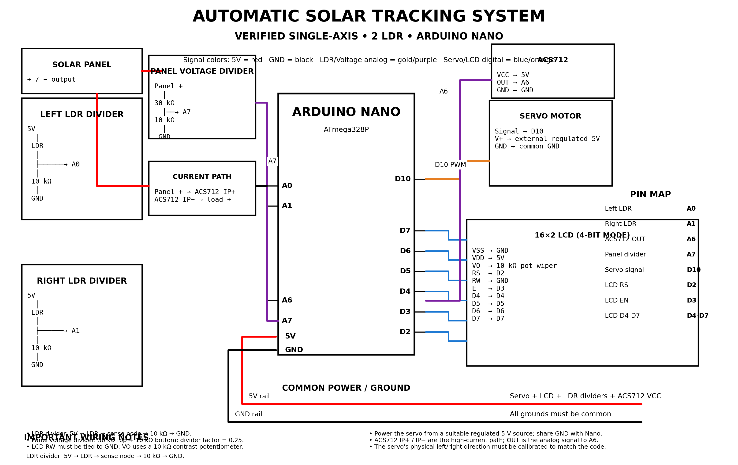
Figure 1. Verified two-LDR, single-axis circuit configuration using Arduino Nano.

9. Working Principle
The tracker operates as a differential feedback system. At every control cycle, the Arduino reads the left and right LDR values. The raw values are filtered using an exponential moving average to suppress short-duration fluctuations.
Filtered = α × New Reading + (1 − α) × Previous Filtered Value
The implementation uses α = 0.25. The filtered left and right values are then compared to obtain the tracking error:
Error = LDR_Left − LDR_Right
If the magnitude of the error exceeds the deadband, the servo position is changed by a small step. If the error remains within the deadband, no movement is commanded. This prevents the servo from repeatedly moving back and forth when the illumination difference is very small.

10. Control Algorithm
- Initialize the LCD, servo, sensor inputs and serial communication.
- Move the servo to the initial 90° position within the configured limits.
- Initialize the filtered LDR values from the first sensor readings.
- Calibrate the ACS712 zero-current offset during startup.
- Read the left and right LDRs during each loop.
- Apply EMA filtering with α = 0.25.
- Calculate the difference between the filtered LDR values.
- Compare the difference with the deadband of 6 ADC counts.
- If the difference exceeds the deadband, move the servo toward the brighter side.
- Measure panel current through the ACS712 and panel voltage through A7.
- Update the LCD at the programmed display interval and send diagnostic values to the Serial Monitor.
- Repeat continuously.

11. Software Implementation
The control program is written for the Arduino environment using the Servo and LiquidCrystal libraries. The software is organized around initialization, sensor acquisition, filtering, tracking control, electrical measurement, display handling, and diagnostic output.
Software Feature | Implementation
Servo control | Servo library; D10; 5°–180° limits; 2° movement step in the corrected implementation.
LDR filtering | Exponential Moving Average, α = 0.25.
Tracking threshold | 6 ADC-count deadband.
Current measurement | ACS712 analog measurement with 200-sample startup zero calibration.
Voltage measurement | A7 voltage divider with oversampling.
LCD refresh | Approximately every 400 ms.
Serial diagnostics | 115200 baud for sensor and measurement values.

12. Measurement and Calibration

12.1 ACS712 Zero Calibration
At startup, the controller samples the ACS712 output repeatedly to estimate the zero-current ADC value. The original implementation uses 200 calibration samples. The panel/load should be in the appropriate idle condition during this calibration so that the measured offset represents the sensor's zero-current reference.

12.2 Voltage Measurement and Oversampling
Panel voltage is measured through A7. The implementation uses repeated ADC readings and averages them to reduce the influence of instantaneous ADC noise. The source code uses 256 oversamples for the panel-voltage measurement and a 30 kΩ/10 kΩ divider.

12.3 Tracking Calibration
The mechanical zero position should be selected so that the initial 90° servo position corresponds to a useful center position of the panel. The direction of correction should then be verified under an asymmetric light source. If the panel moves away from the brighter side, the servo direction in software or the mechanical orientation should be reversed.

13. LCD and Monitoring
The LCD is used as the local user interface. During normal operation it can display the measured current, sensed voltage, and servo position. The Serial Monitor provides additional diagnostic information such as filtered sensor values, tracking error, servo position, current, and panel-voltage measurements. This separation allows the LCD to remain readable while detailed information remains available for testing and debugging.

14. Testing Procedure
- Power the Arduino and verify that the LCD initializes and the servo moves to the starting position.
- Keep the panel stationary and expose one LDR to stronger illumination than the other.
- Confirm that the servo rotates in the direction intended by the mechanical design.
- Reverse the light source and confirm that the servo responds in the opposite direction.
- Illuminate both LDRs similarly and verify that the servo remains approximately stationary within the deadband.
- Check the panel voltage against an external multimeter to verify the voltage-divider scaling.
- Check the ACS712 reading against an appropriate reference measurement and adjust sensor sensitivity if the installed module differs from the configured version.
- Observe the Serial Monitor to confirm stable sensor values and sensible tracking error.

15. Expected System Behaviour
Condition | Expected Response
Left LDR significantly brighter | Servo moves toward the left-side light direction.
Right LDR significantly brighter | Servo moves toward the right-side light direction.
LDR readings nearly equal | Servo holds its current position.
Panel voltage changes | A7 measurement changes proportionally after divider scaling.
Current changes | ACS712-derived current value changes accordingly.
Startup | Servo initializes near 90° and ACS712 zero offset is calibrated.

16. Advantages
- Simple sensor arrangement with only two LDRs.
- Single-axis mechanical design reduces actuator and control complexity.
- Closed-loop operation responds to actual illumination rather than relying only on a time schedule.
- EMA filtering and a deadband improve tracking stability.
- Integrated voltage and current monitoring makes it possible to observe the panel's electrical behaviour.
- The Arduino-based design is inexpensive, accessible, and straightforward to modify.

17. Limitations
- The system tracks only along one mechanical axis.
- Tracking accuracy depends on the relative placement and shading geometry of the two LDRs.
- Servo mechanical range and mounting orientation limit the achievable panel rotation.
- Clouds, reflections, shadows, and diffuse light can affect differential LDR readings.
- ACS712 accuracy depends on the specific module version, calibration, wiring, and electrical noise.
- The measured panel-voltage range must remain compatible with the selected voltage-divider and Arduino input.

18. Future Improvements
- Extend the mechanical system to dual-axis tracking when required.
- Add a more precise position sensor or encoder for closed-loop mechanical positioning.
- Log voltage, current, power, and servo position over time for quantitative performance analysis.
- Add an energy-yield comparison between fixed and tracking operation.
- Introduce a low-power operating mode for battery-powered implementations.
- Add IoT connectivity for remote monitoring and data logging.
- Improve mechanical gearing and structural rigidity for larger photovoltaic panels.

19. Conclusion
The Automatic Solar Tracking System demonstrates a practical embedded implementation of single-axis photovoltaic tracking using two LDR sensors, an Arduino Nano, and a servo motor. The differential sensor arrangement provides a direct feedback signal that can be converted into a simple and effective tracking decision. Filtering and a deadband reduce unnecessary actuator movement, while software limits provide control over the servo operating range.
The integration of ACS712 current sensing and panel-voltage measurement extends the system beyond simple mechanical tracking by providing simultaneous observation of the photovoltaic electrical output. The resulting design is a compact and modular prototype that demonstrates sensor interfacing, analog measurement, closed-loop control, actuator operation, display interfacing, and renewable-energy automation in a single embedded system.

Appendix A — Final Pin Reference
Arduino Nano Pin | Final Use
A0 | Left LDR divider output
A1 | Right LDR divider output
A2 | Unused
A3 | Unused
A4/A5 | Unused in final design
A6 | ACS712 OUT
A7 | Panel voltage-divider output
D2 | LCD RS
D3 | LCD EN
D4 | LCD D4
D5 | LCD D5
D6 | LCD D6
D7 | LCD D7
D9 | Unused
D10 | Servo signal

Appendix B — Final Functional Block Diagram
SUNLIGHT
↓
┌─────────────┐
│ 2 × LDRs │
└──────┬──────┘
↓
┌─────────────┐
│ Arduino Nano│
│ Filter + │
│ Comparison │
└──────┬──────┘
↓
┌─────────────┐
│ Servo Motor │
└──────┬──────┘
↓
PANEL ROTATION
Solar Panel ──→ ACS712 ──→ A6
Solar Panel ──→ 30k/10k divider ──→ A7
Arduino Nano ──→ 16×2 LCD

