5-2 Activity: Packet Tracer
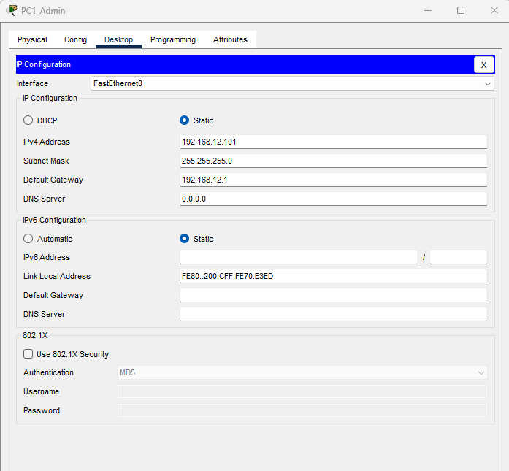

Default gateway was changed to 192.168.12.1 for PC1Admin, PC2Admin, PC3Admin, and Admin Printer. PC1Admin IP address was changed to 192.168.12.101. PC2Admin IP address was changed to 192.168.12.102. PC3Admin IP address was changed to 192.168.12.103. Admin Printer IP address was changed to 192.168.12.150.

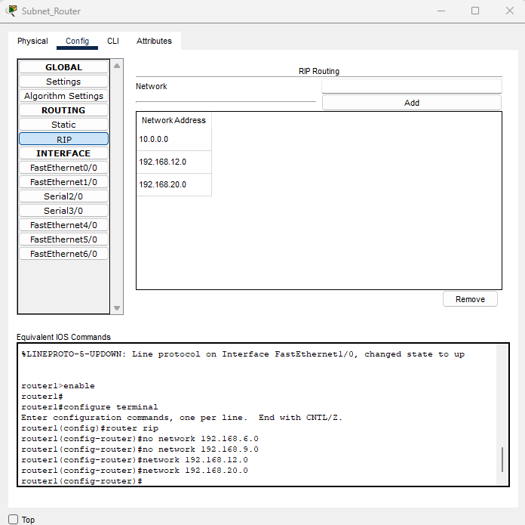
I removed the old configurations and added the two new ones which are 192.168.12.0 and 192.168.20.0

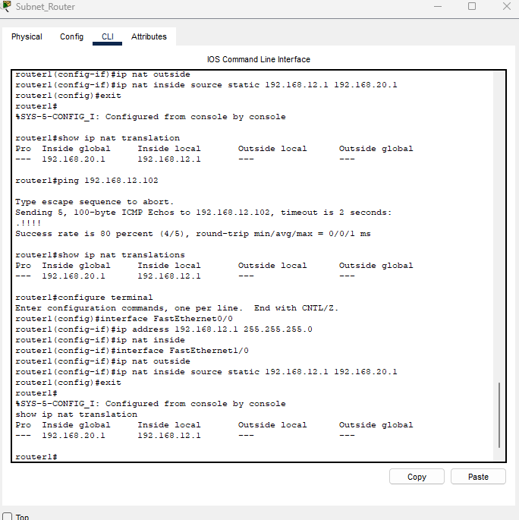

Under CLI in the subnet router I used commands to specify nat inside and outside.

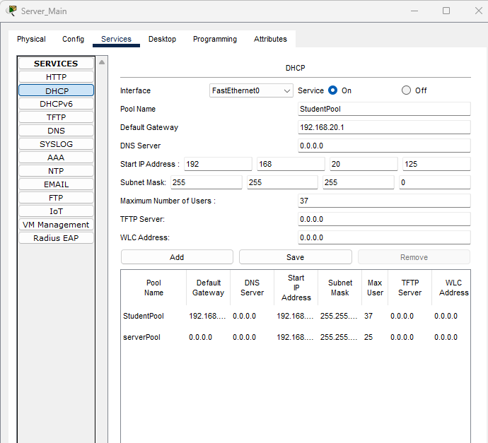

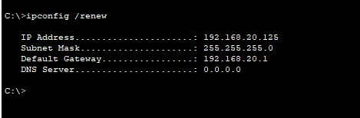

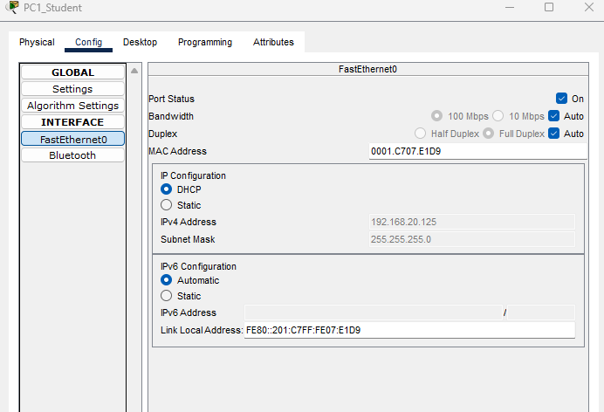
I edited the DHCP on Server Main with the correct IP address and IP address range. Then I populated the new DHCP configuration for the devices.
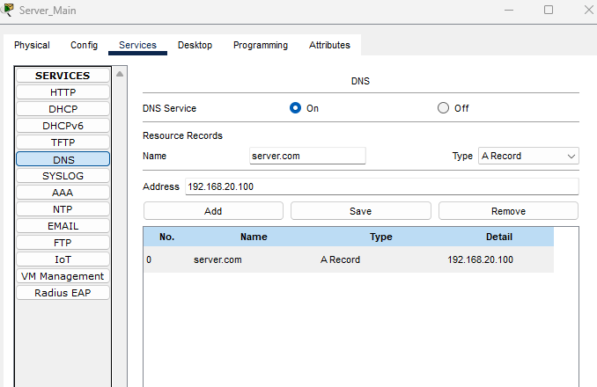

I edited the DNS on Server Main with the new IP address.

