* Training with Dice only, Hausdorff + Dice, LSTM + Dice, Hausdorff + LSTM + Dice. Describe architecture, Dice, Haussdorff loss function LSTM, code origin
* What is different/new in that? What was the motivation to do it differently?
* Adjustments for Hausdorff like Sobel edge detection.
* U-net parameters like voxel sizes. What different CT-scans were used? What kind of CT scan parameters were used?
* Describe original code and transfer to AWS
* Training with skulls with holes and without (open source available skull set). Any differences? When is training with holes not working?
* Learning rate
* Training time
* Run time
* Memory
* Dice score for each 2D image
* Calculate 3D in different ways: average of the 2D slices (not fully correct), harmonic average to calculate 3D Dice score. Direct 3D Dice score (with 3D slicer? Other way?)
* Give Hausdorff errors
* Scores for different regions? Possible to replicate a table like this?
* 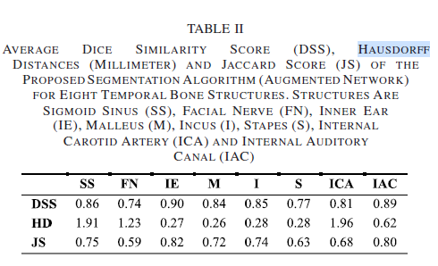
* Randomize training set and run set if possible, to calculate statistical errors
* Behavior of used loss function Dice + Hausdorff, is Hausdorff indeed more important in the begin stadia of the training and Dice later?
* How are different methods influencing artefacts? How reliable is “largest blob is
* Robustness: Can non-skull CT scans automatically filtered out? Influence of crowns, other implants etc.? Manual processing? What percentage of the scans is not suitable?
* Use all or part of the following in the description of the process:
* 