DevOps Lab 3
Building, optimizing, tagging, pushing and scanning OCI container images
Samuel Shine
MCA, Christ University
26 September 2026
GitHub: https://github.com/samuelshine/devops-lab-3
Docker Hub: https://hub.docker.com/r/samuelshine/devops-lab-3

Aim
Build, optimize, tag and push OCI-compliant container images using Docker, and scan the images for vulnerabilities.

Steps
1. Checked the installed versions of Docker, Buildx, Trivy and the GitHub CLI.
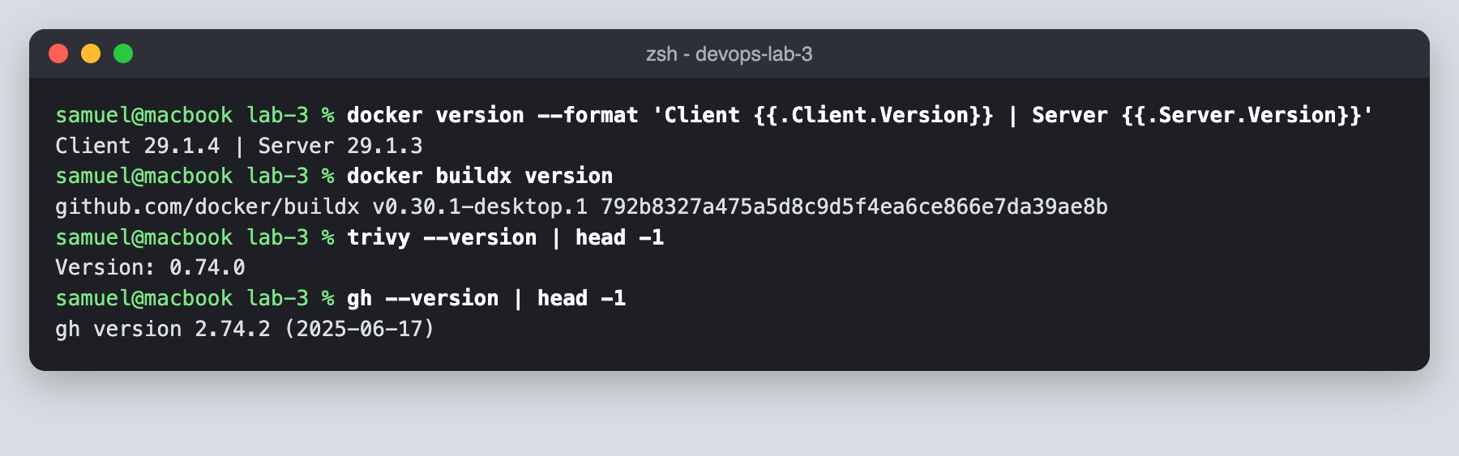
2. Created the lab-3 project with a small Express API in src/server.js.
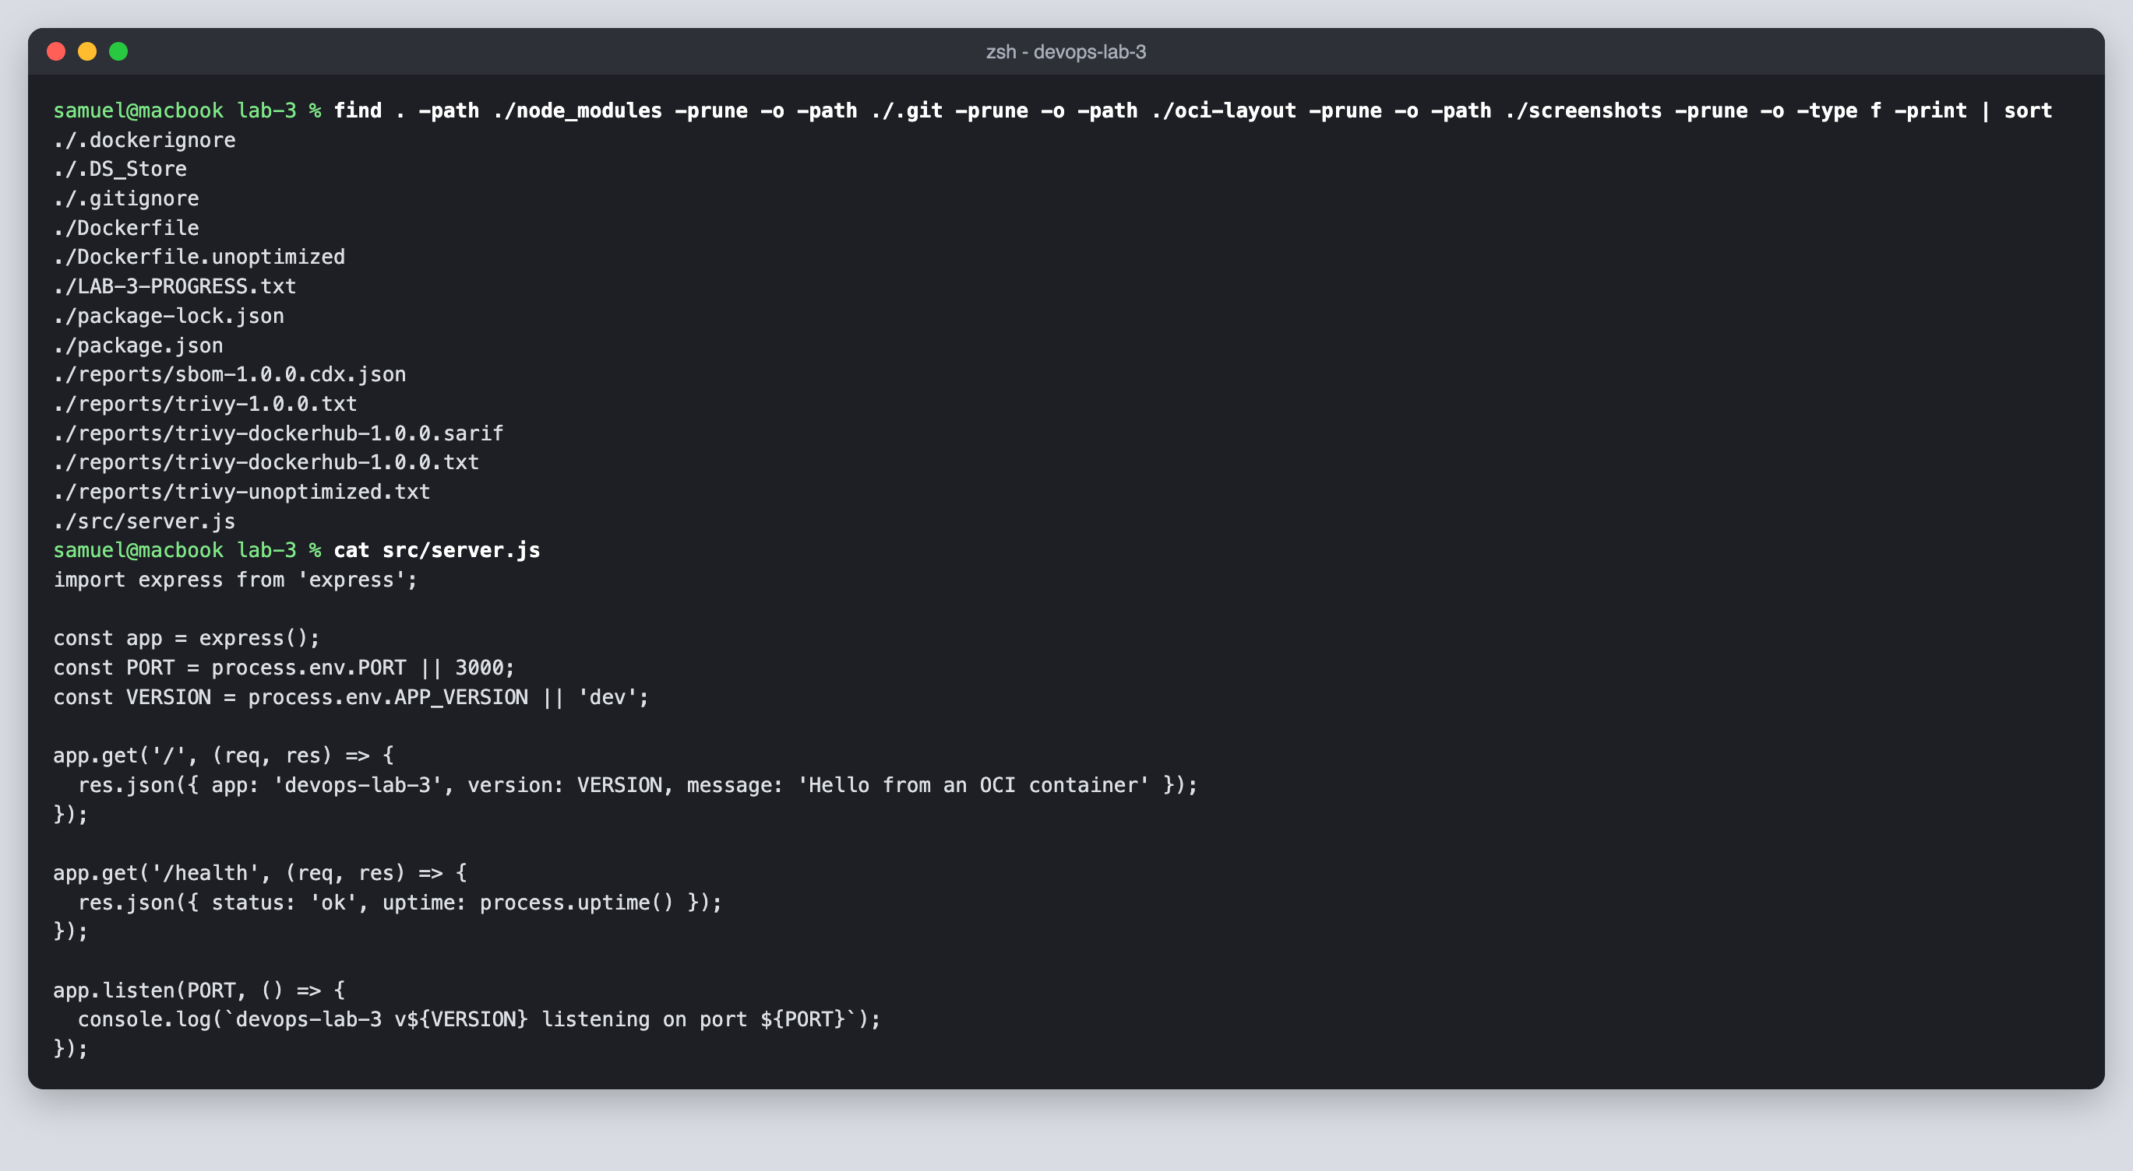
3. Wrote a single-stage Dockerfile.unoptimized as a baseline and a .dockerignore file.
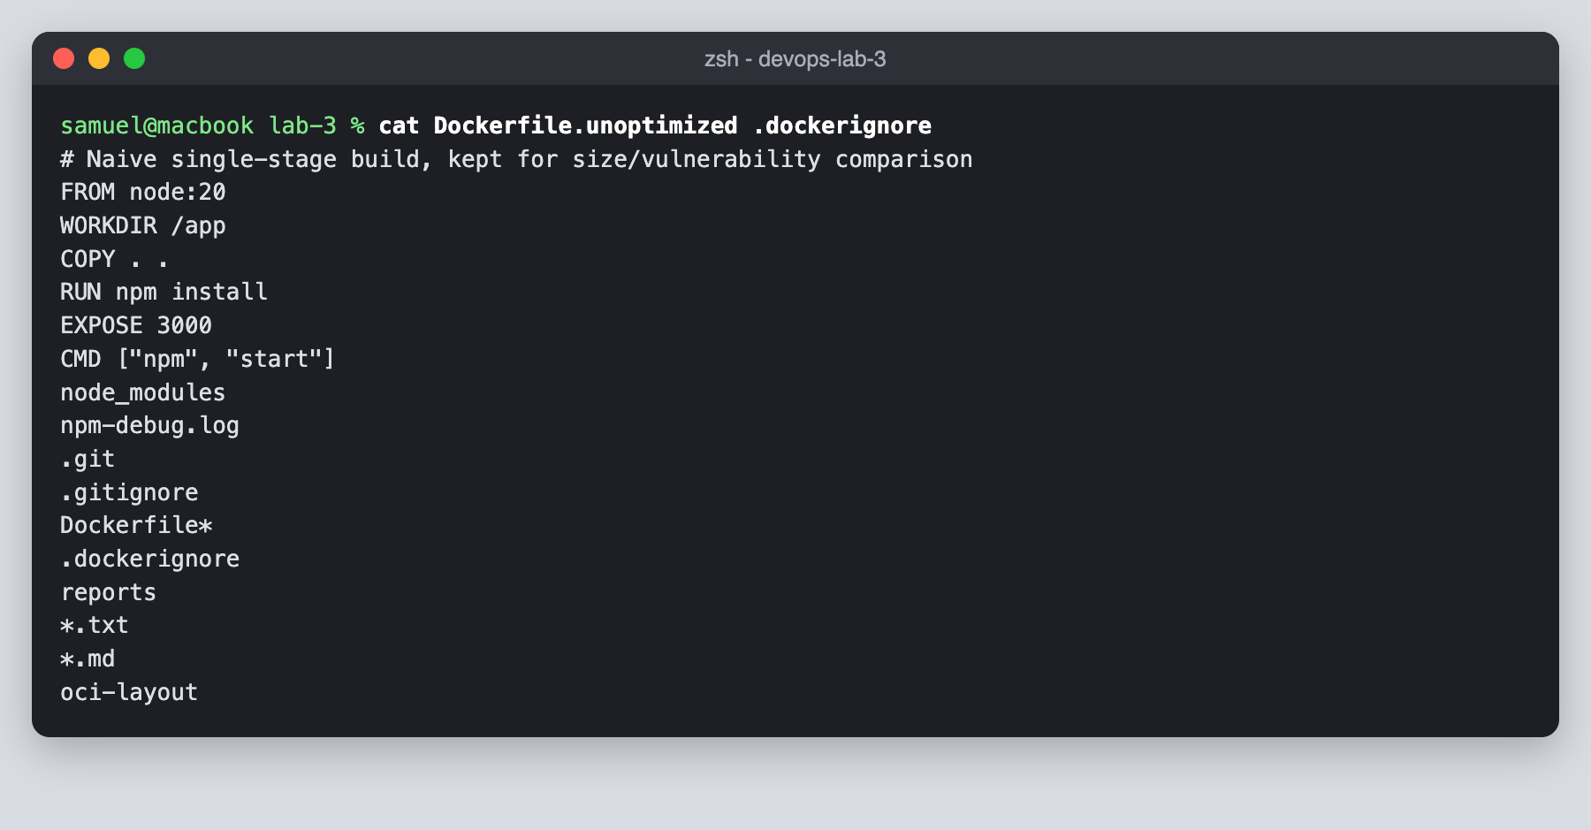
4. Wrote the optimized multi-stage Dockerfile with a distroless non-root base and OCI labels.
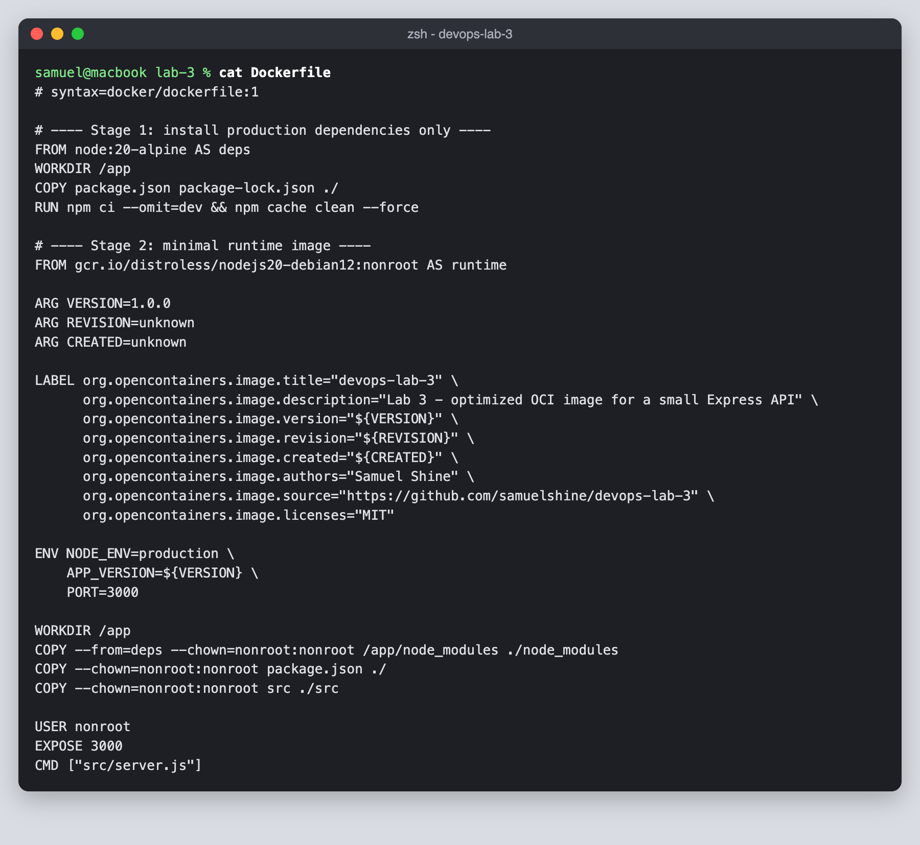
5. Built the unoptimized image.
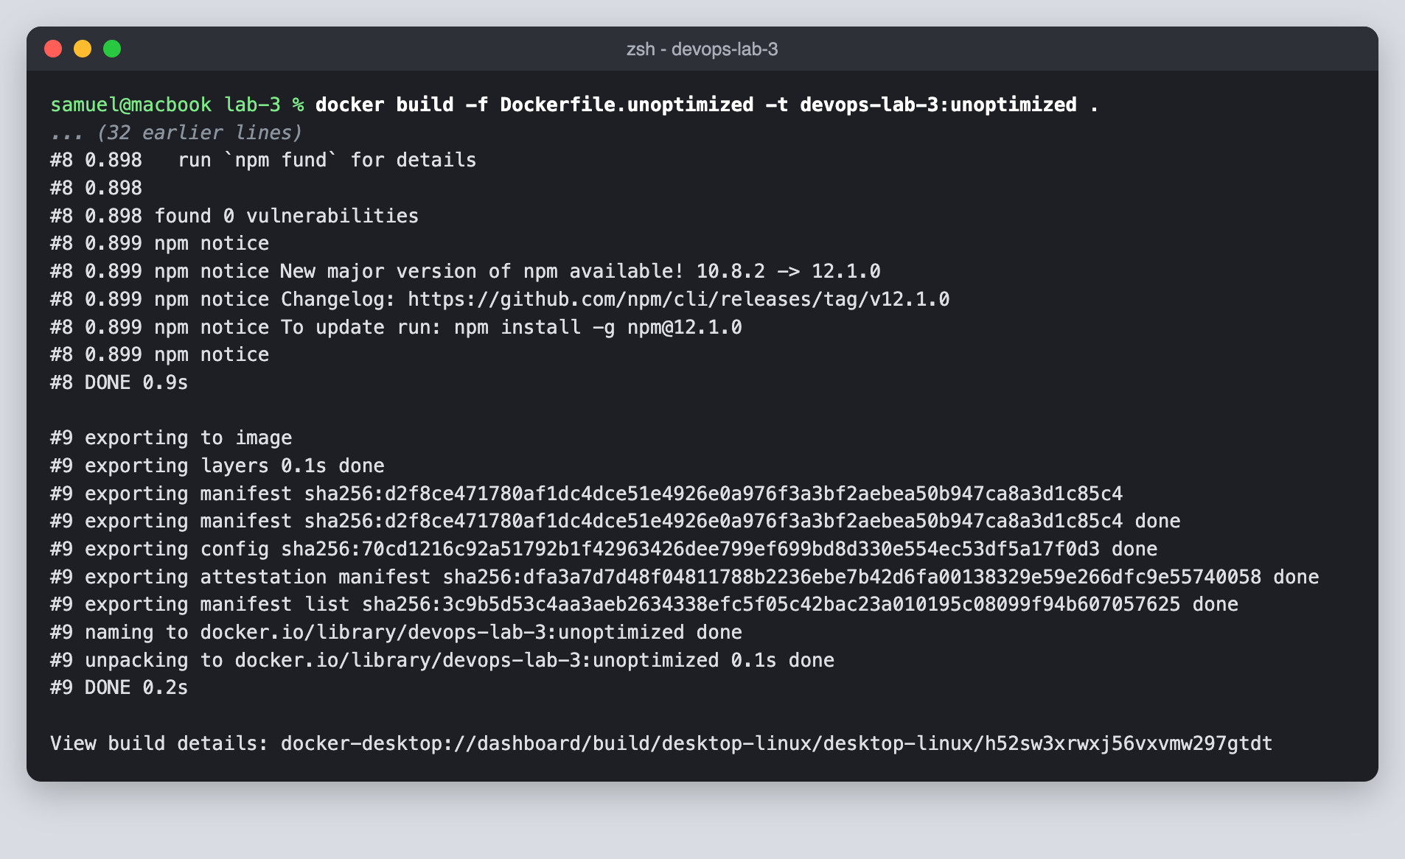
6. Built the optimized image with the version and git commit as build arguments.
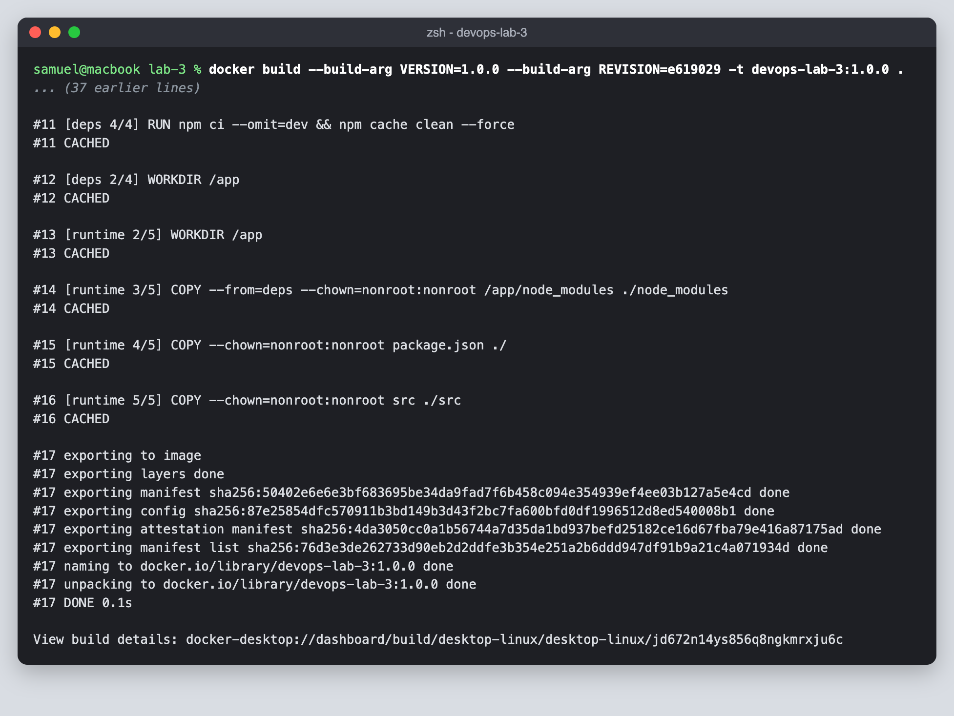
7. Compared the image sizes: 1.59 GB unoptimized against 186 MB optimized.
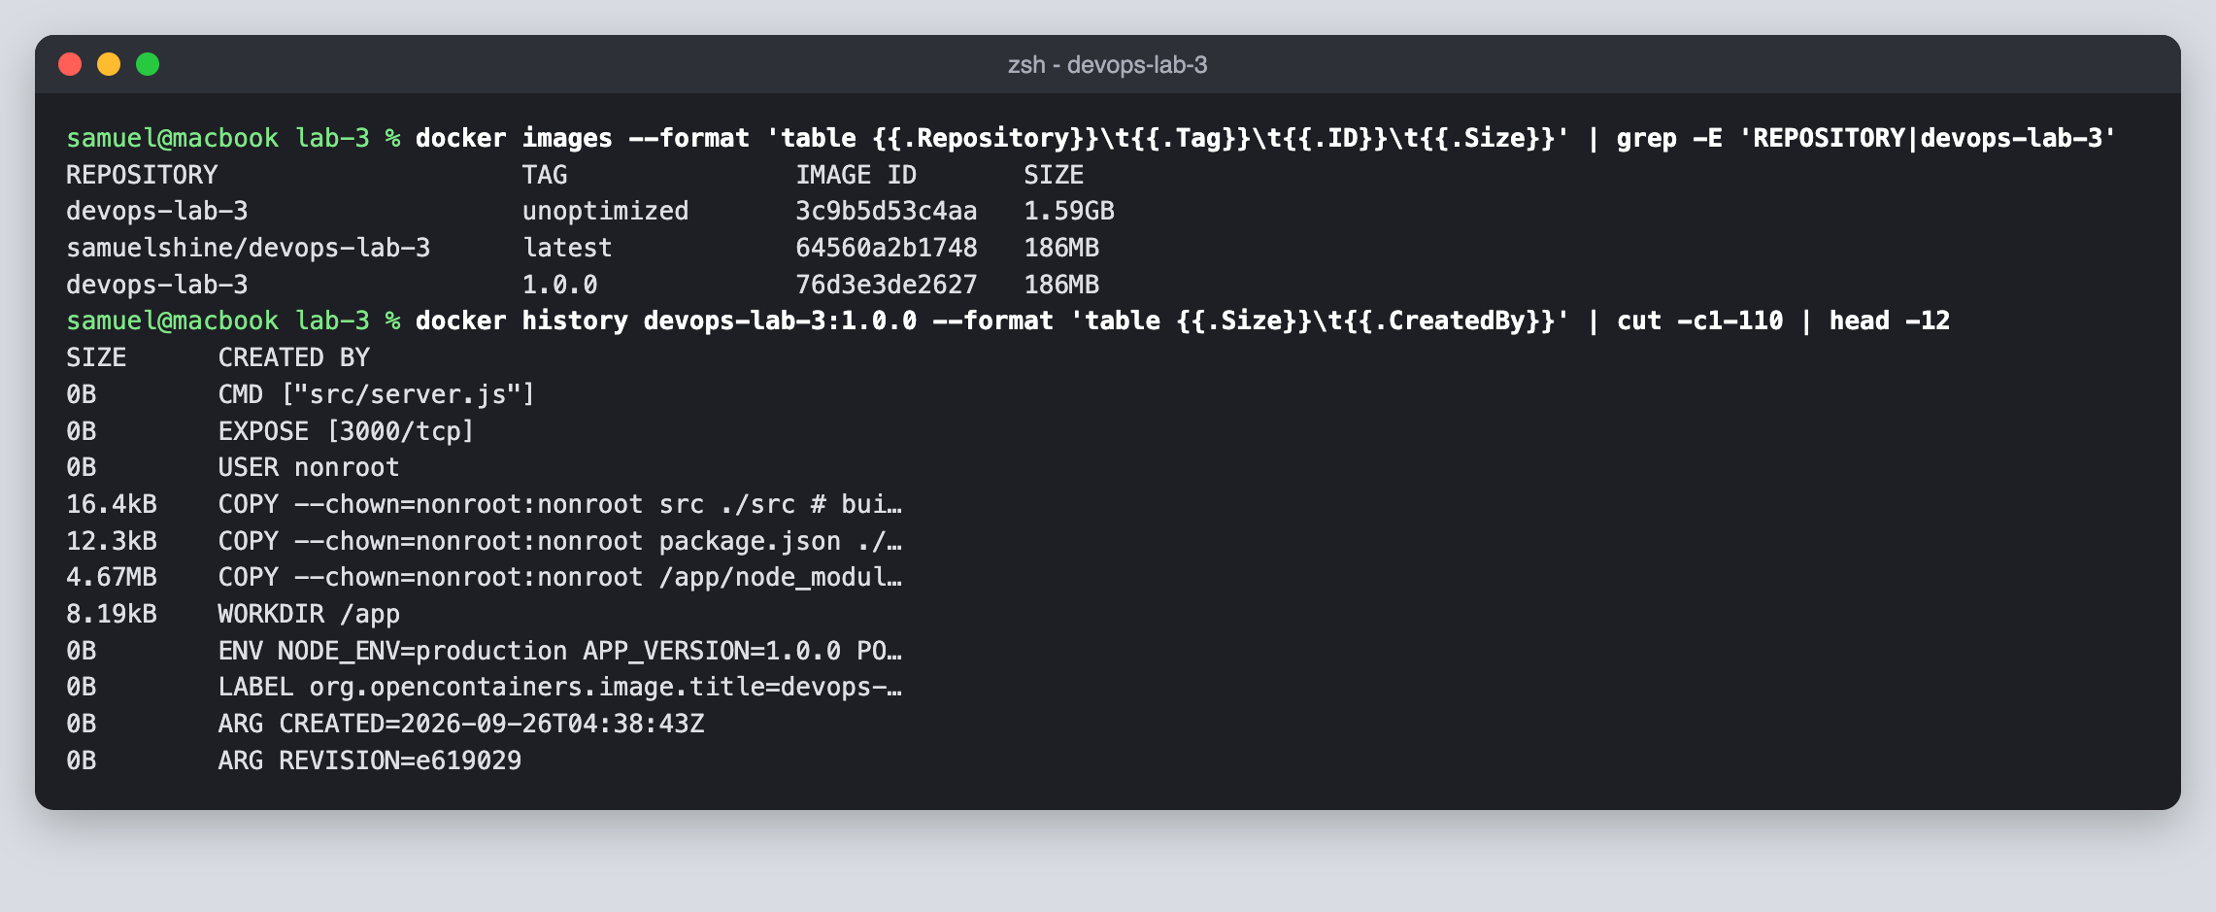
8. Ran the optimized container and tested the / and /health endpoints.
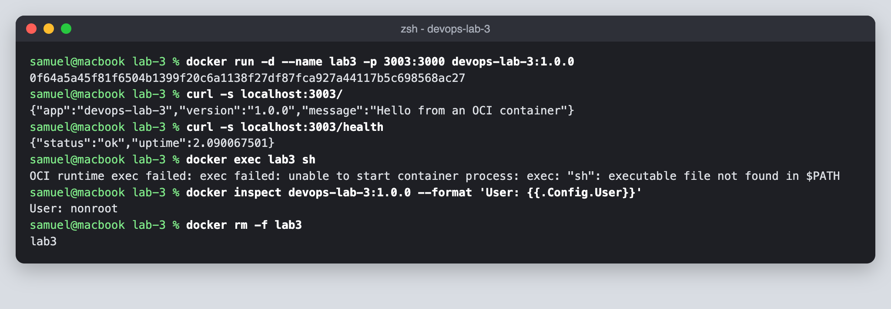
9. Inspected the OCI labels stored in the image.
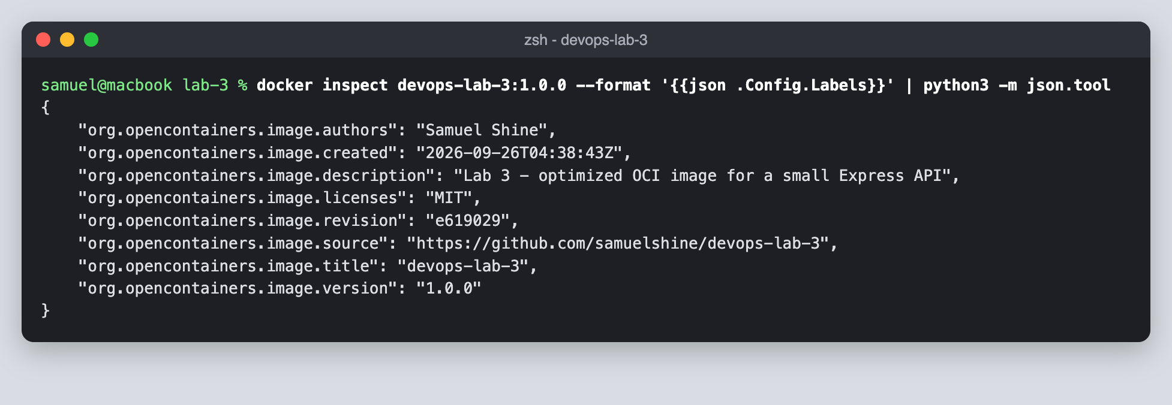
10. Scanned the unoptimized image with Trivy, which found 7,718 vulnerabilities.
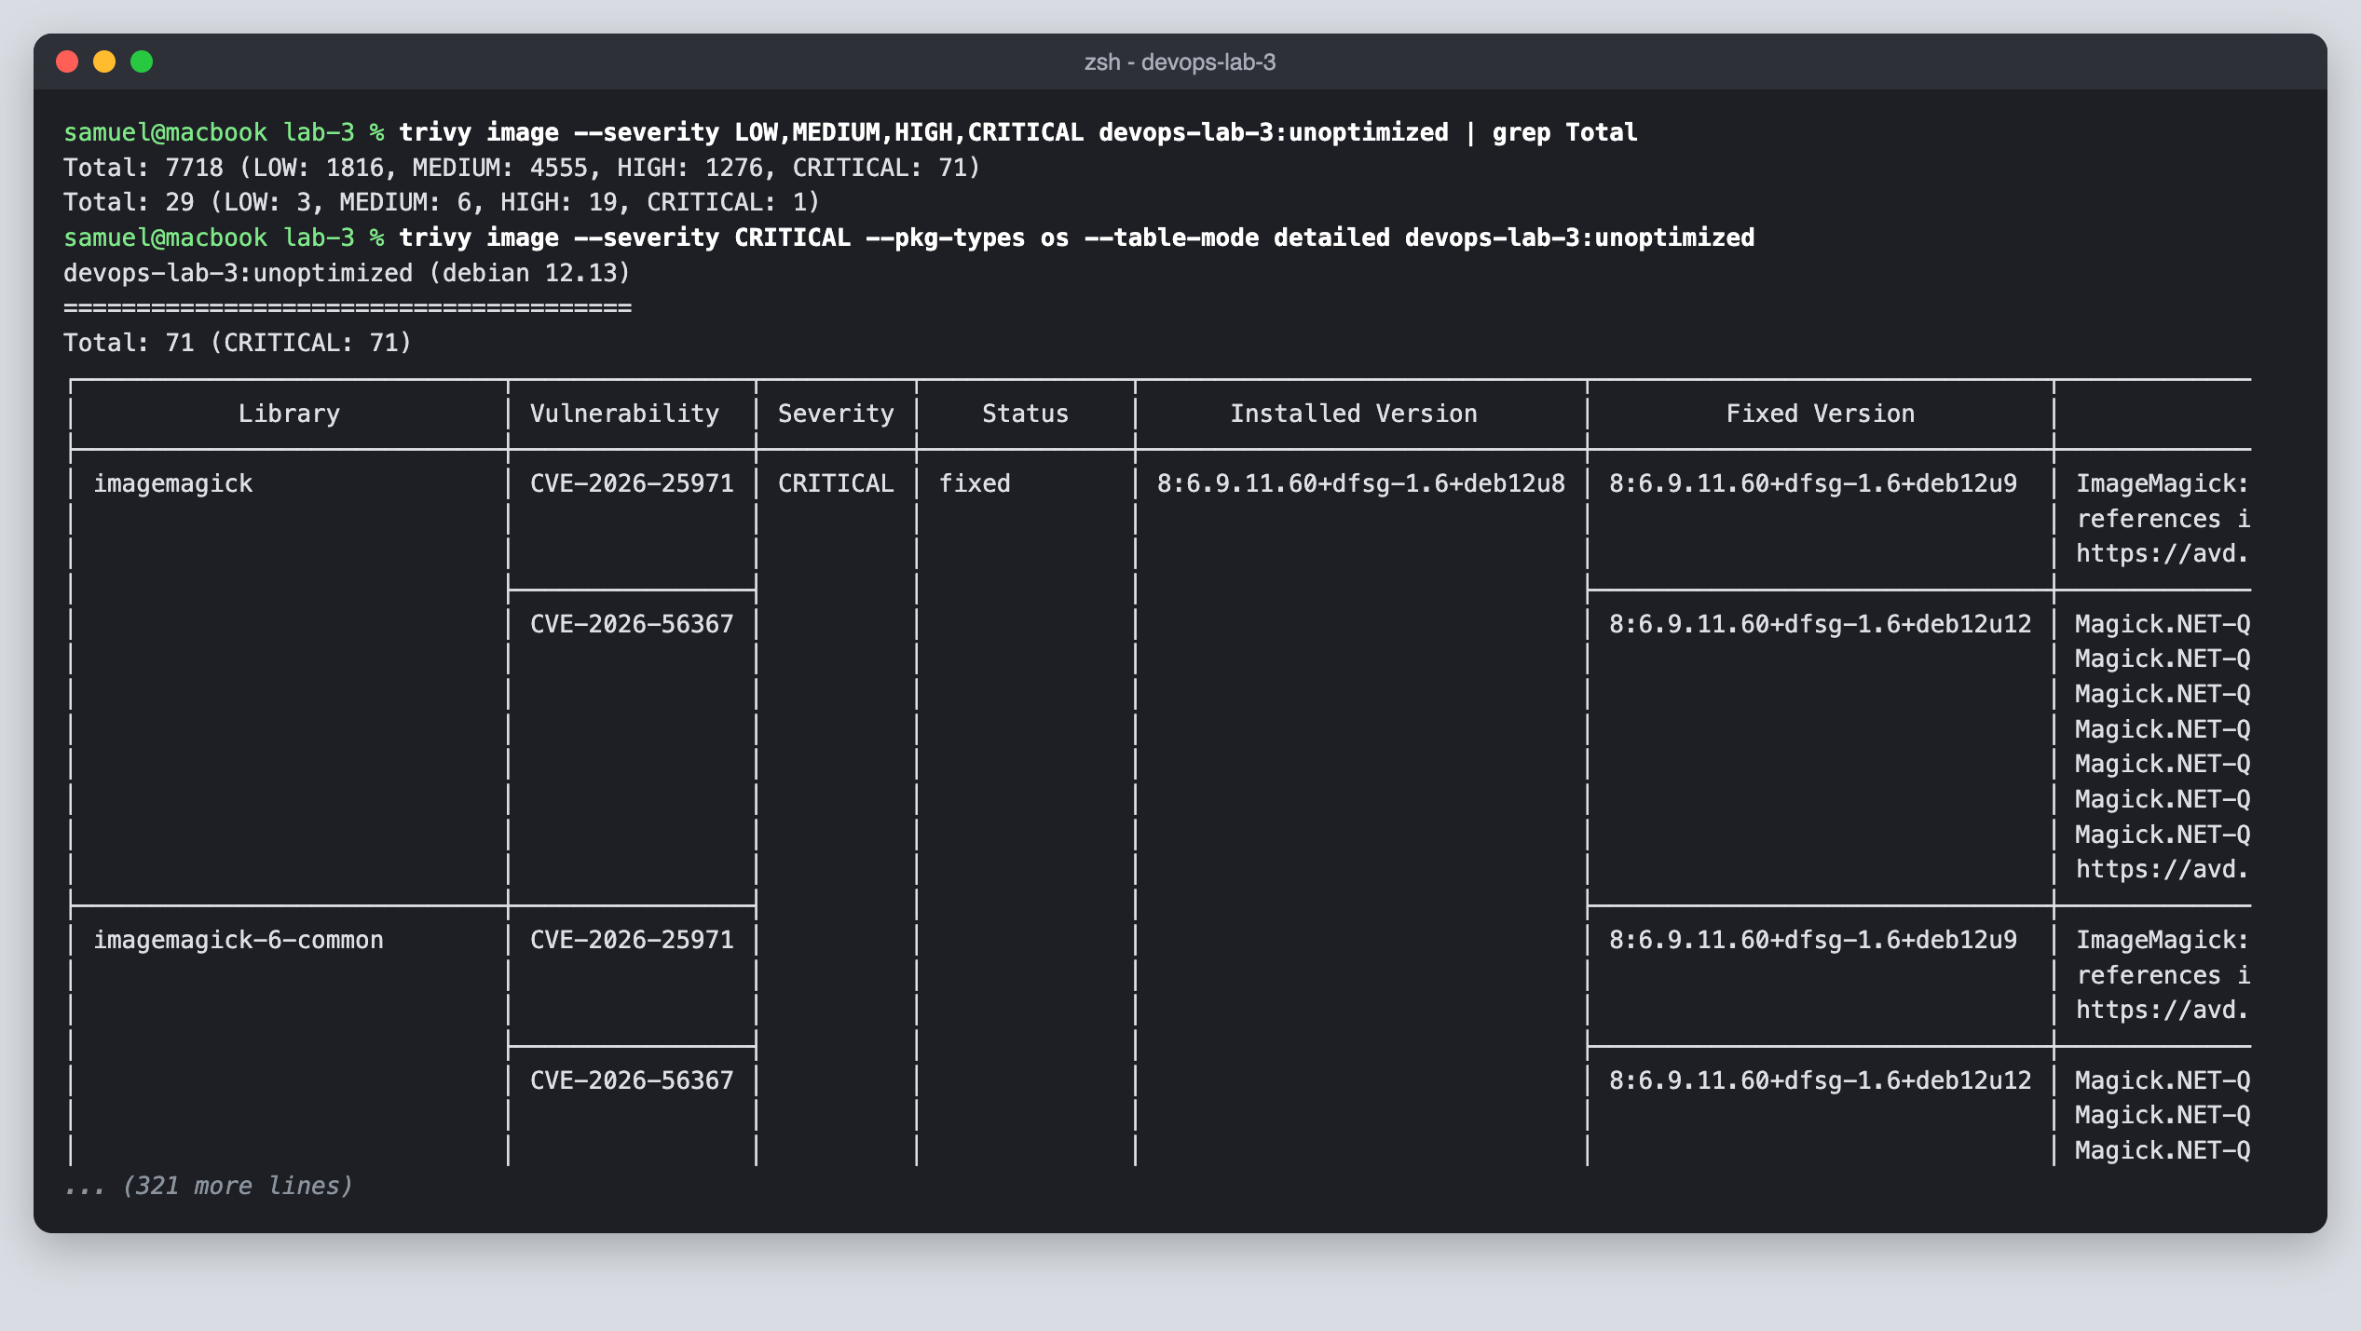
11. Scanned the optimized image with Trivy, which found 54 vulnerabilities.
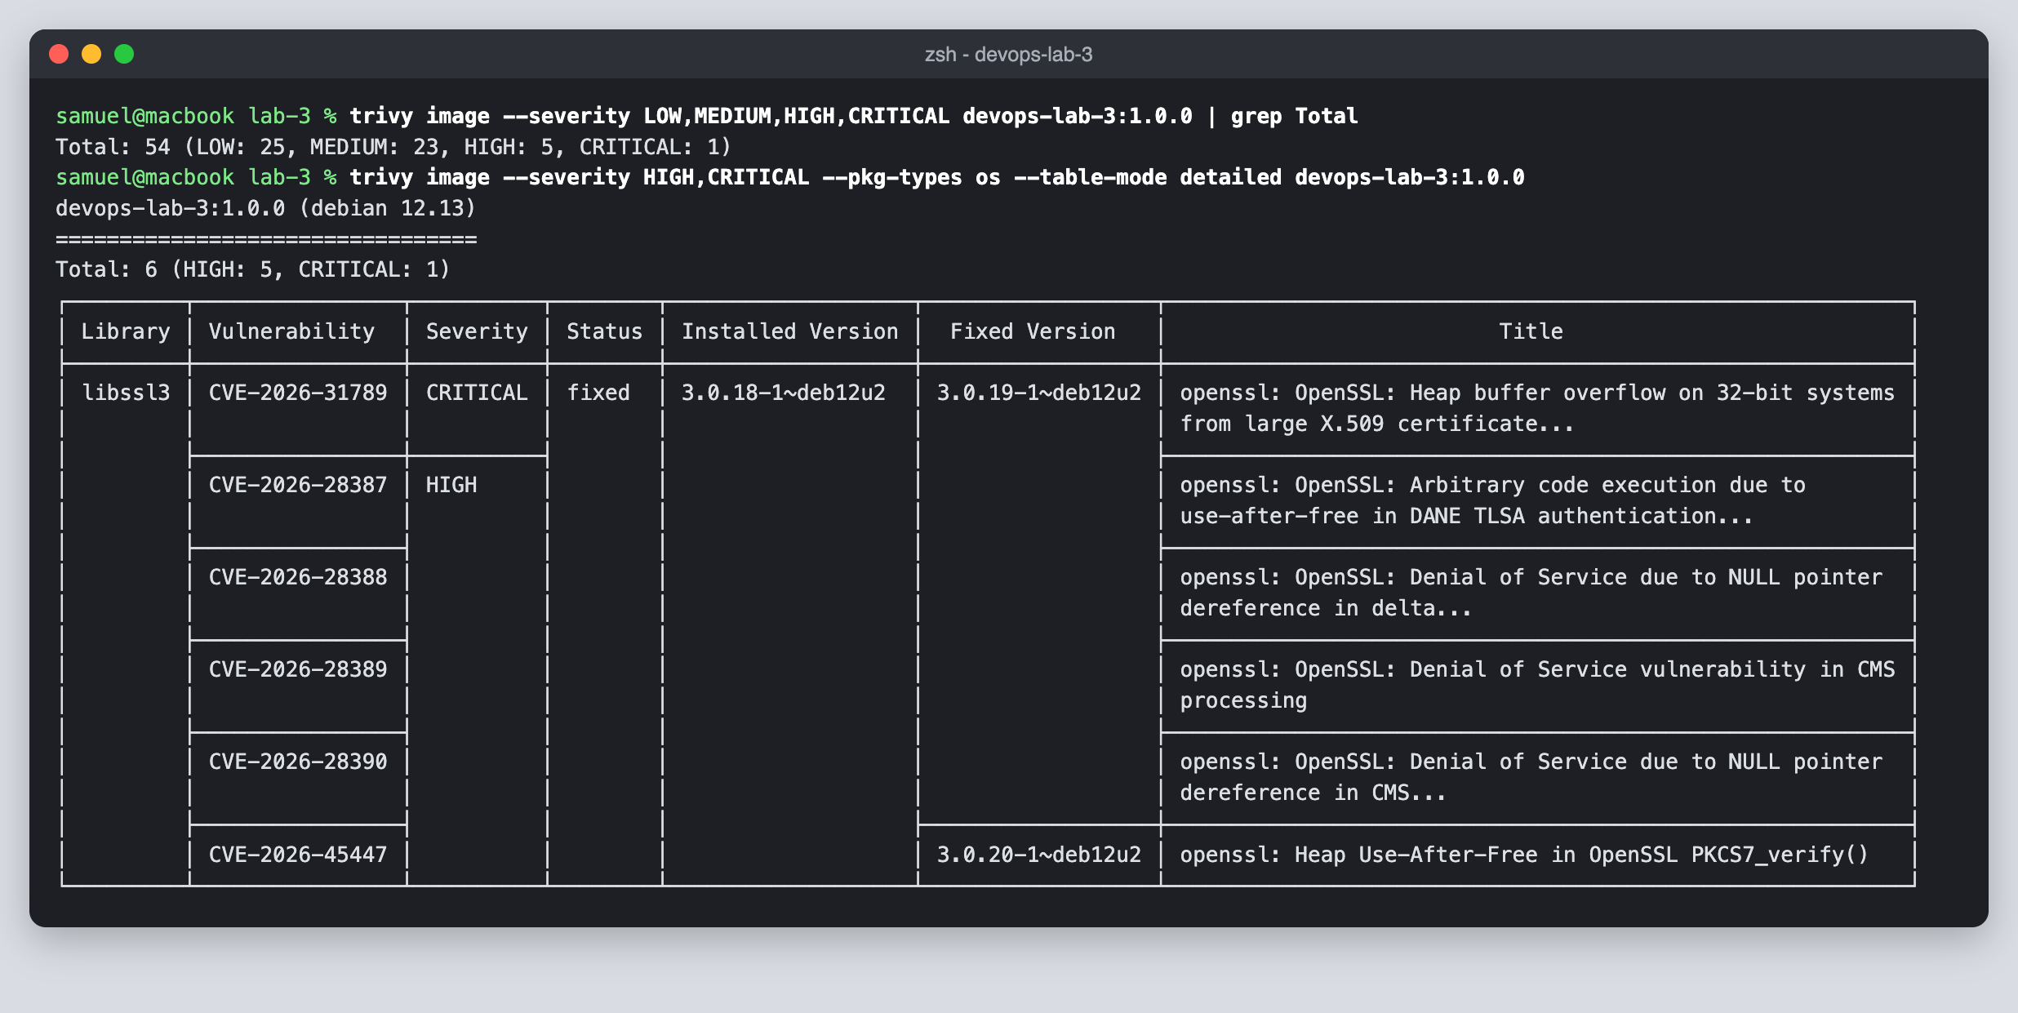
12. Created the devops-lab-3 GitHub repository with gh repo create and pushed the code.
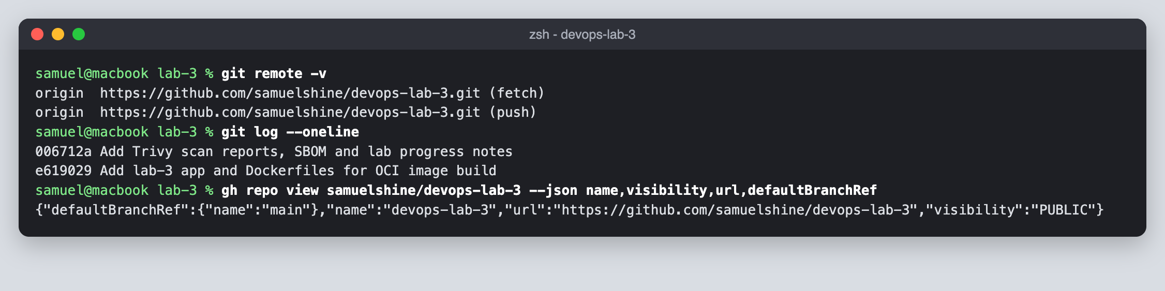
13. Checked the repository on GitHub.
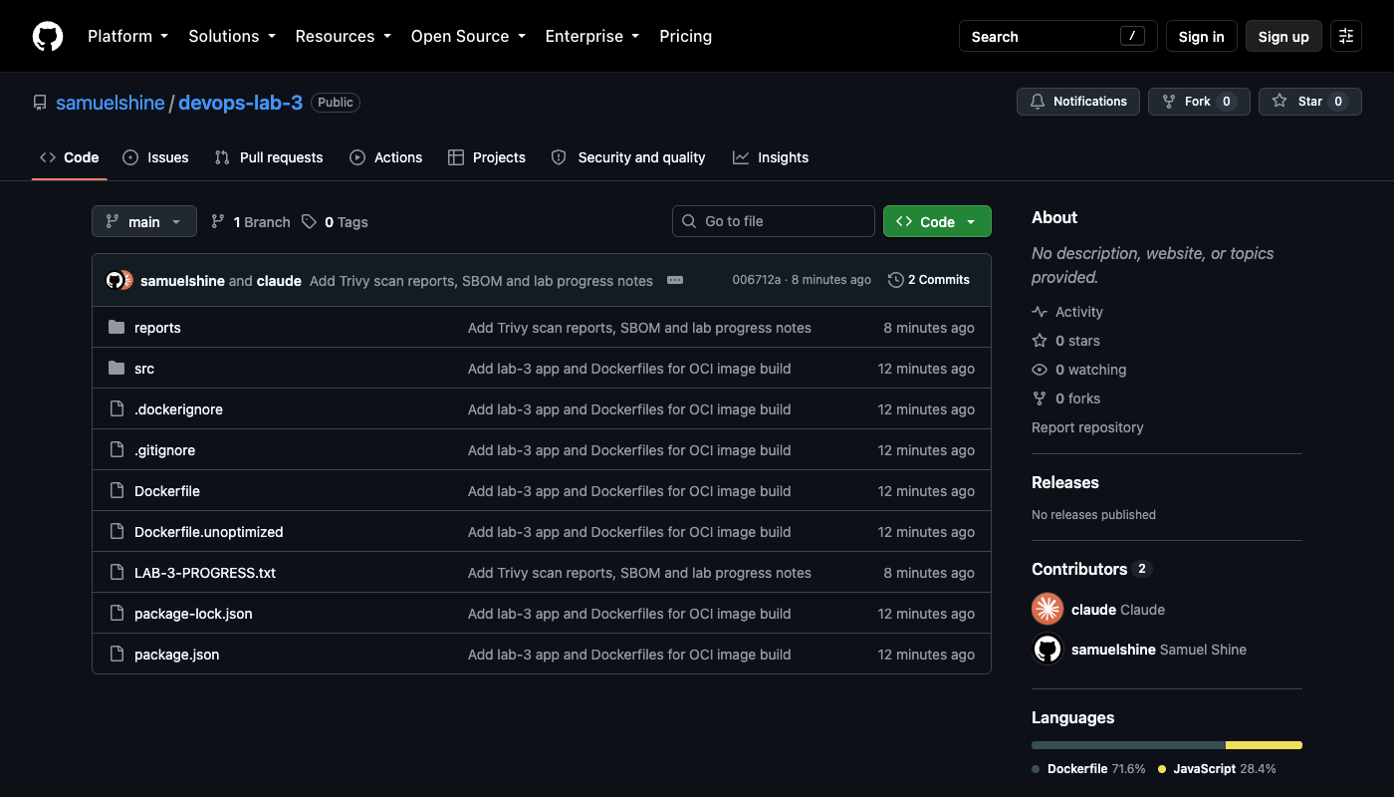
14. Confirmed the Docker Hub login and created the lab3builder Buildx builder.
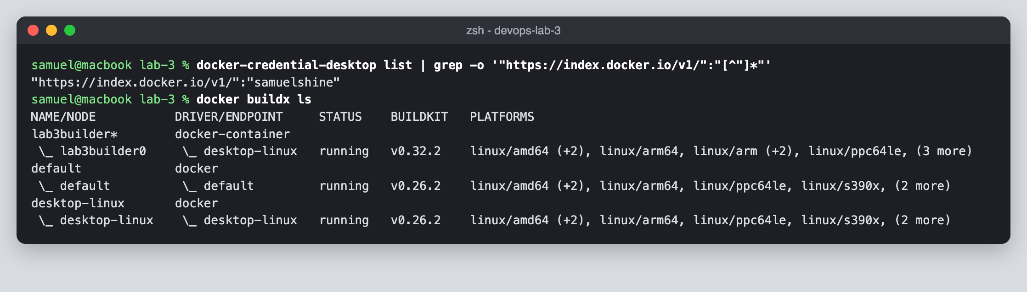
15. Built for amd64 and arm64 and pushed the tags 1.0.0, 1.0, latest and sha-e619029 to Docker Hub.
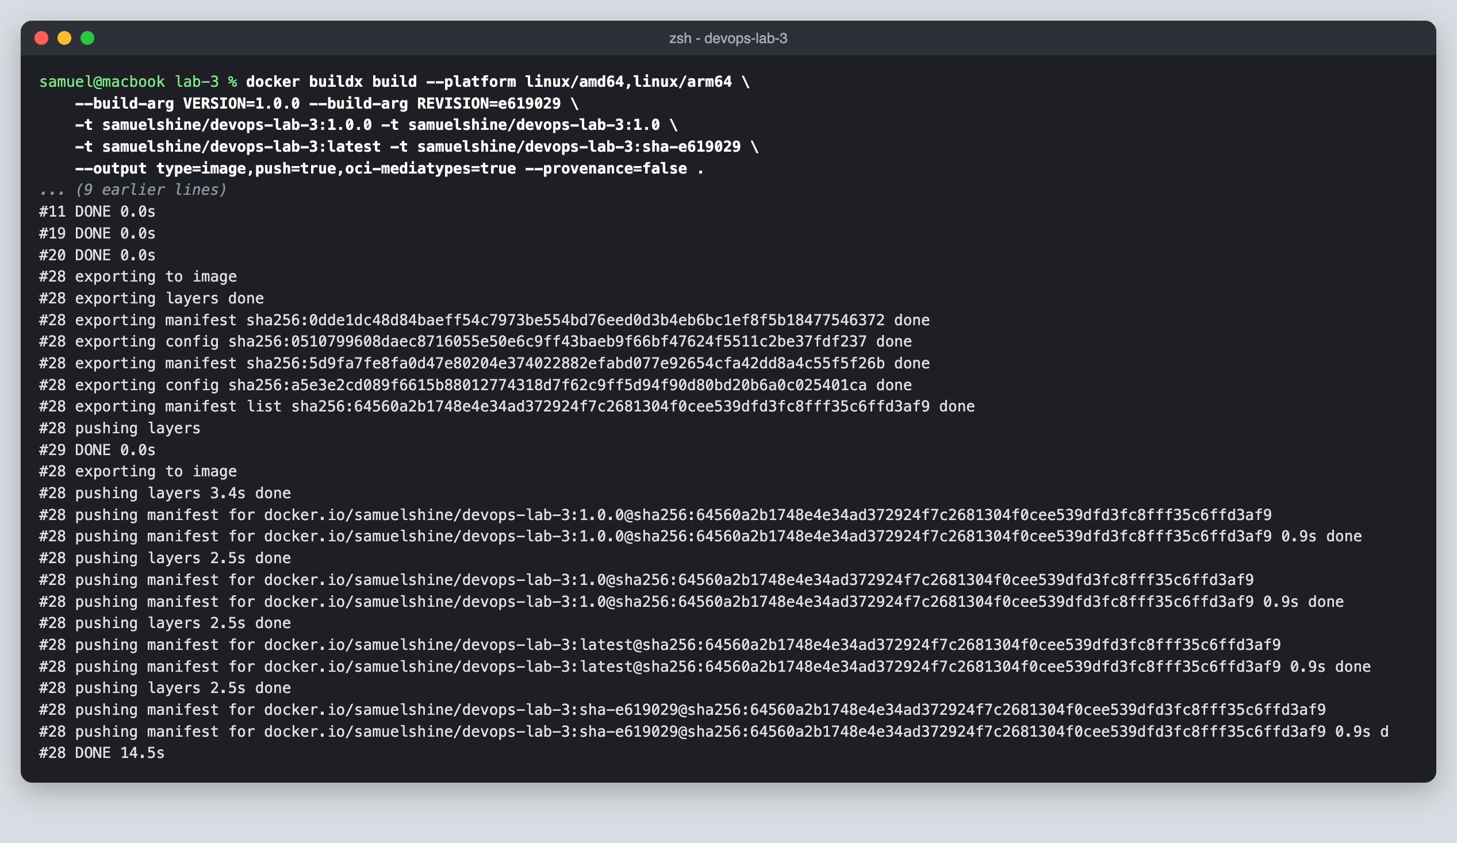
16. Checked the pushed tags on Docker Hub.
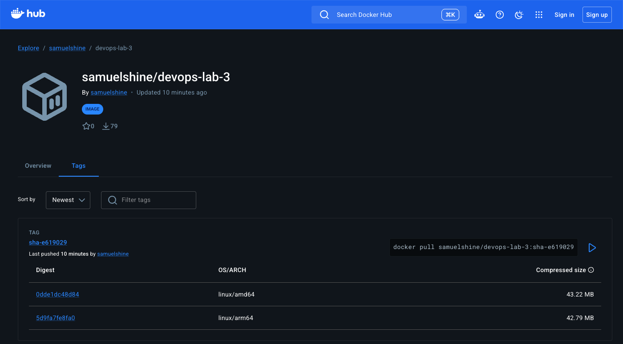
17. Inspected the pushed image to confirm it is an OCI image index.
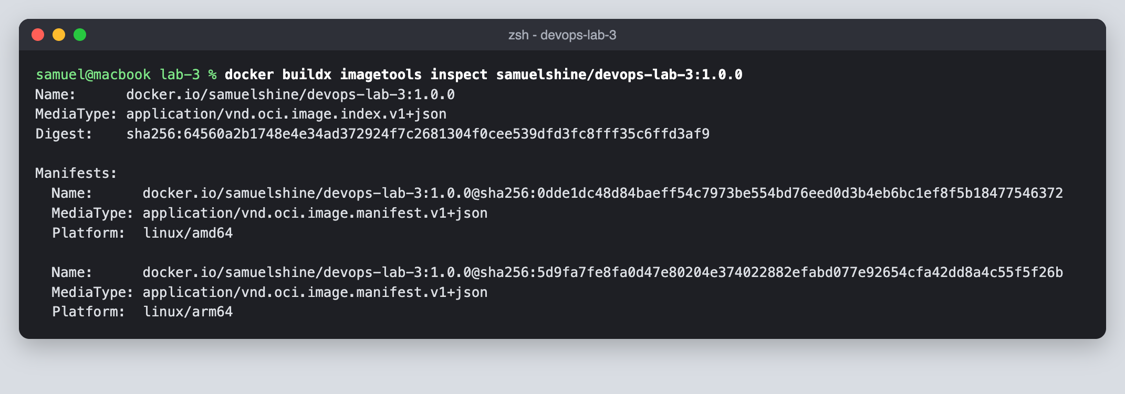
18. Exported the image to disk in the OCI image layout format.
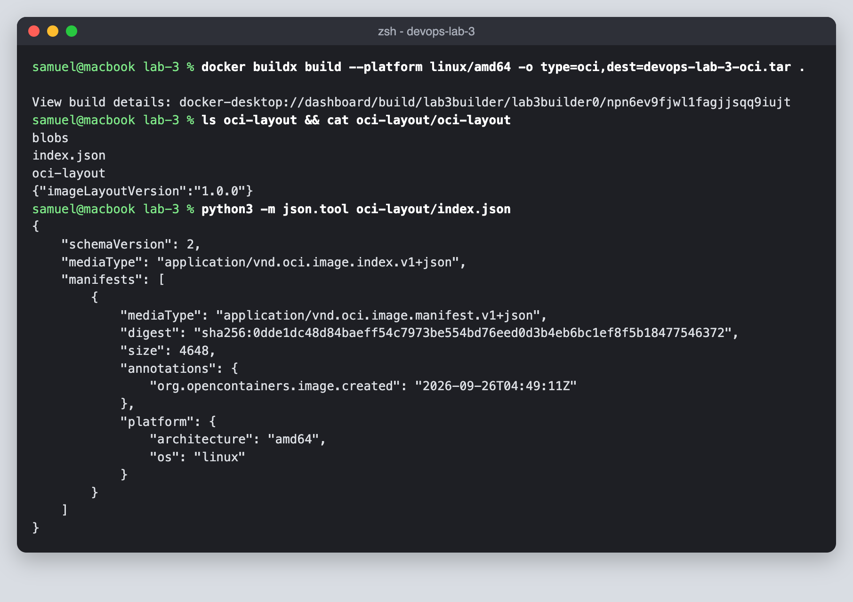
19. Pulled the image back from Docker Hub and ran it.
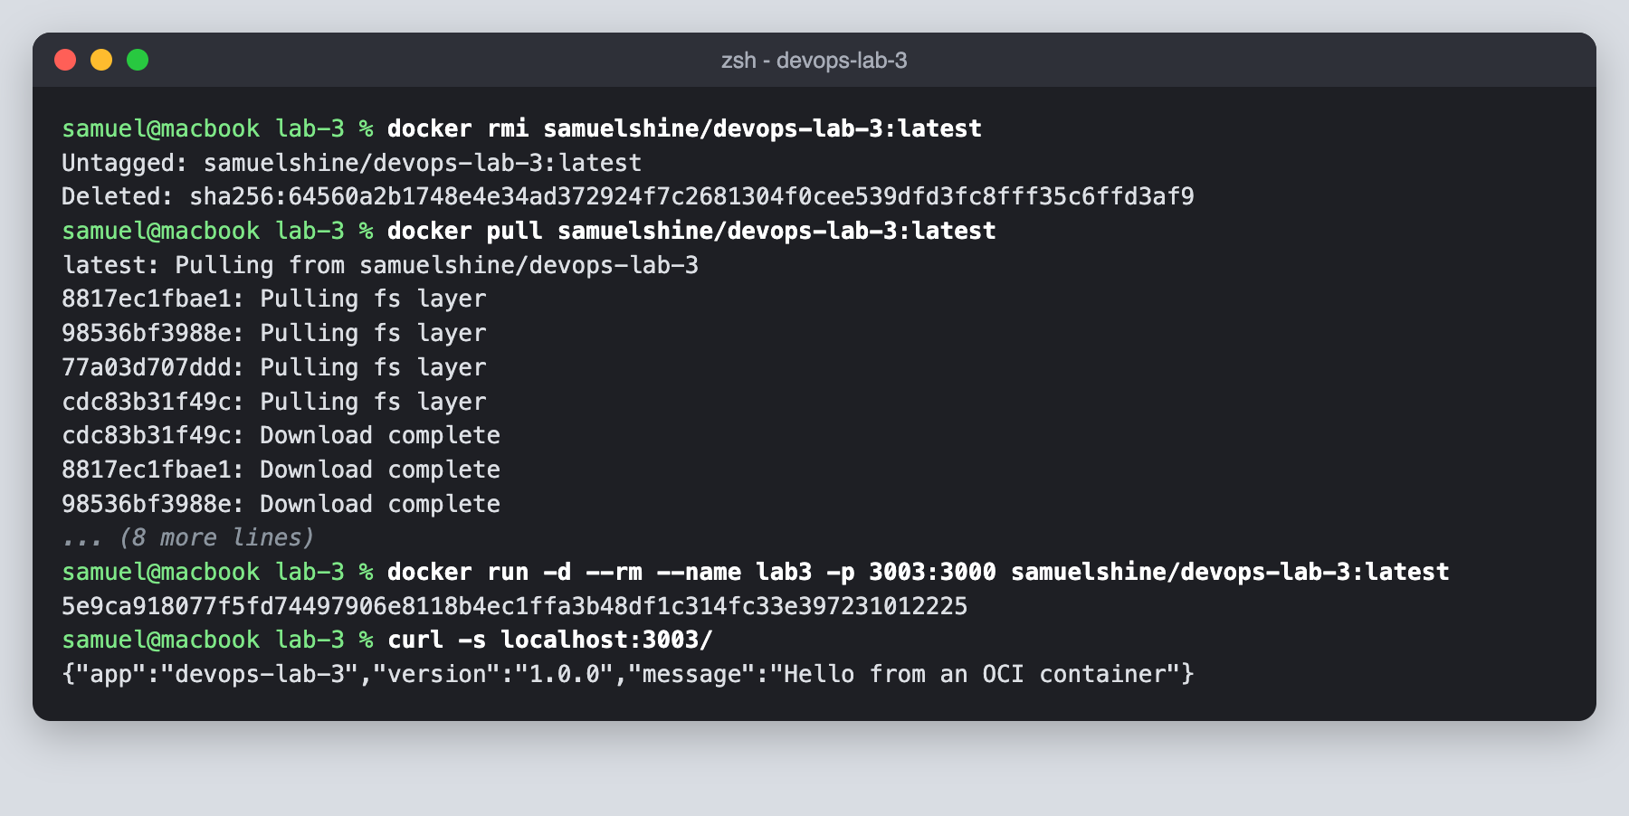
20. A friend pulled samuelshine/devops-lab-3 from Docker Hub on their own machine and got the same digest.
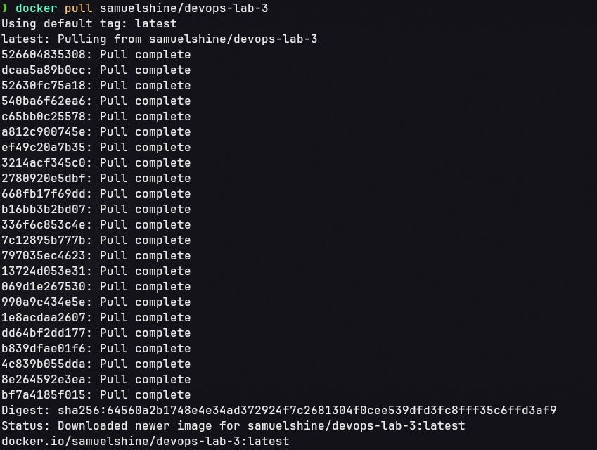
21. Scanned the pushed image on Docker Hub and saved the SARIF report and SBOM.
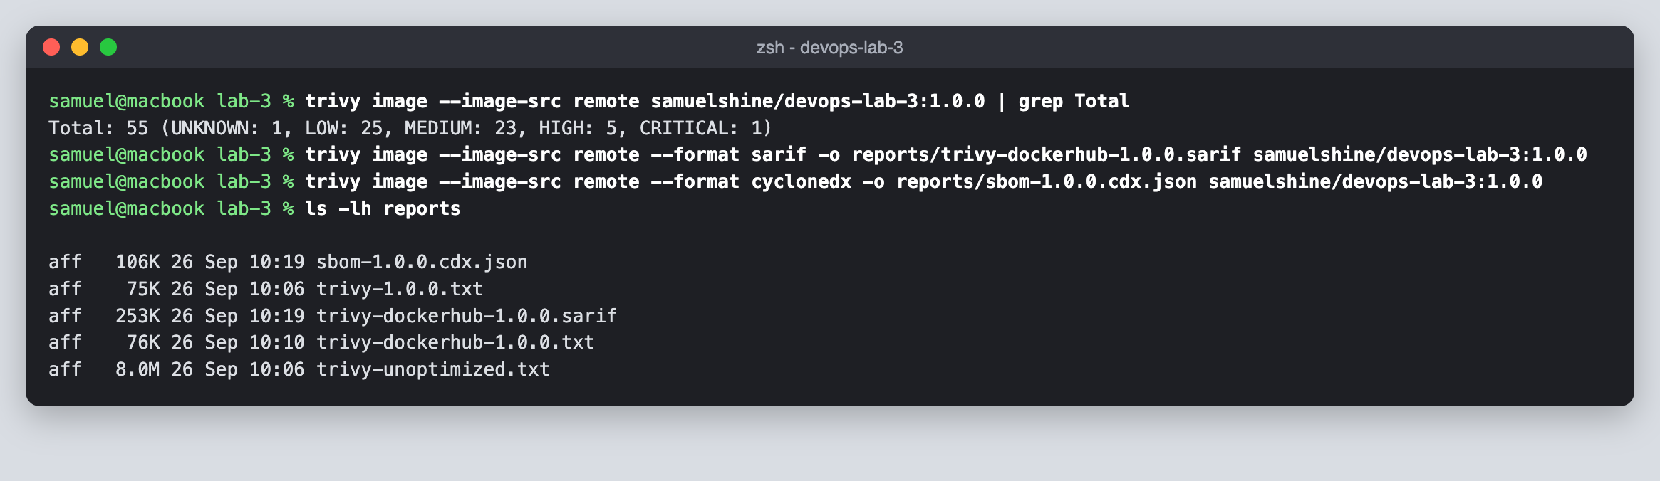
22. Ran a Trivy gate for fixable critical vulnerabilities, which failed on libssl3 in the base image.
