DevOps Lab 4
Deploying a multi-container application with Docker Compose and validating networking and storage
Samuel Shine
MCA, Christ University
26 September 2026
GitHub: https://github.com/samuelshine/devops-lab-4

Aim
Develop and deploy a multi-container application using Docker Compose and validate its networking and storage.

Architecture
Service | Image | Networks | Storage | Host port
web | nginx:1.27-alpine | frontend | nginx.conf and html (bind, read-only) | 8080
api | devops-lab-4-api:1.0.0 (built) | frontend, backend | db_password secret | none
db | postgres:17-alpine | backend | pgdata volume, init.sql (bind, read-only), secret | none
cache | redis:7-alpine | backend | redisdata volume (append-only file) | none

The backend network is internal: true, so db and cache have no route outside it. The api is the only service on both networks, so it is the only path from the web tier to the data tier.

Steps
1. Checked the installed versions of Docker and Docker Compose.
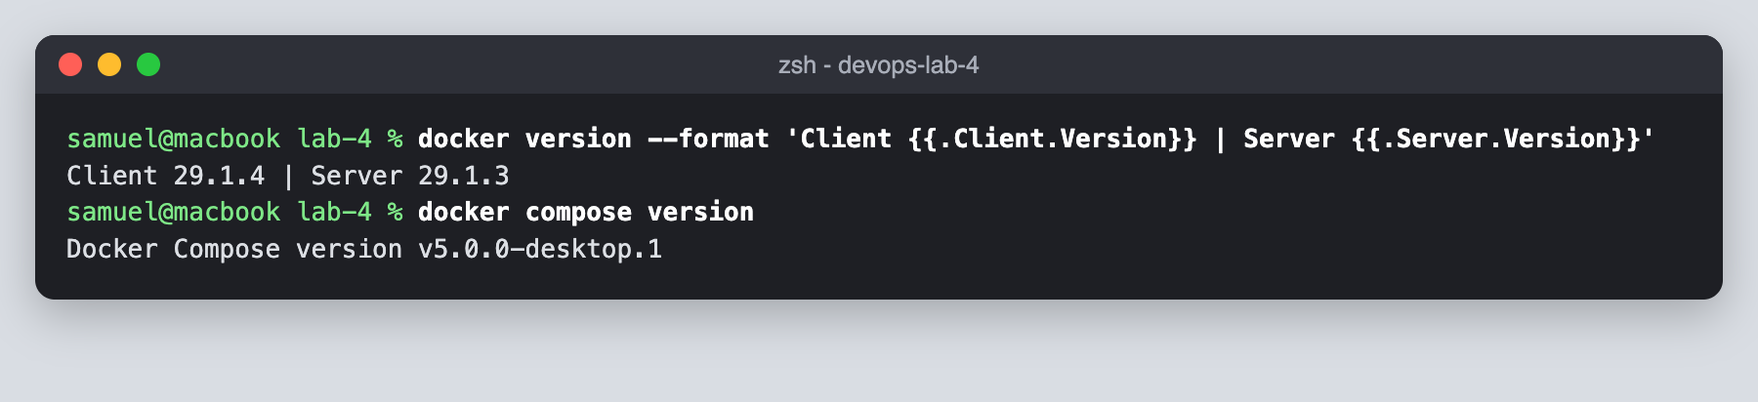
2. Created the lab-4 project with an api, web, db, scripts and secrets folder.
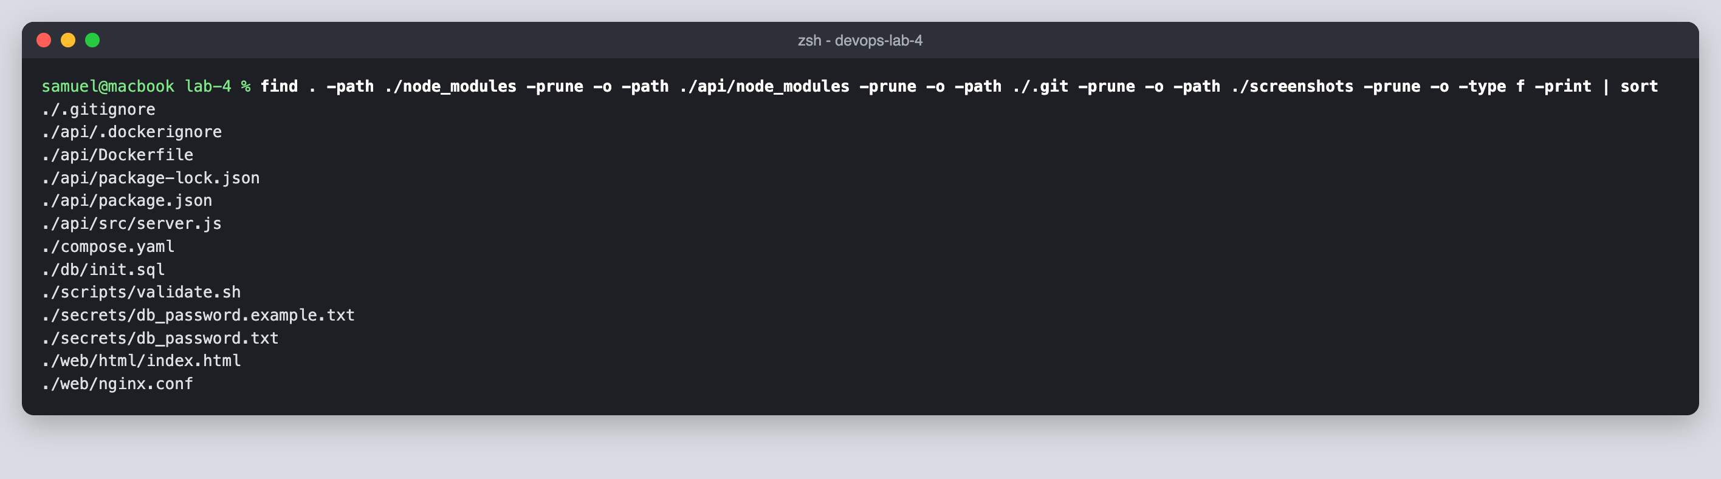
3. Defined the web and api services in compose.yaml with healthchecks, depends_on conditions and the db_password secret.
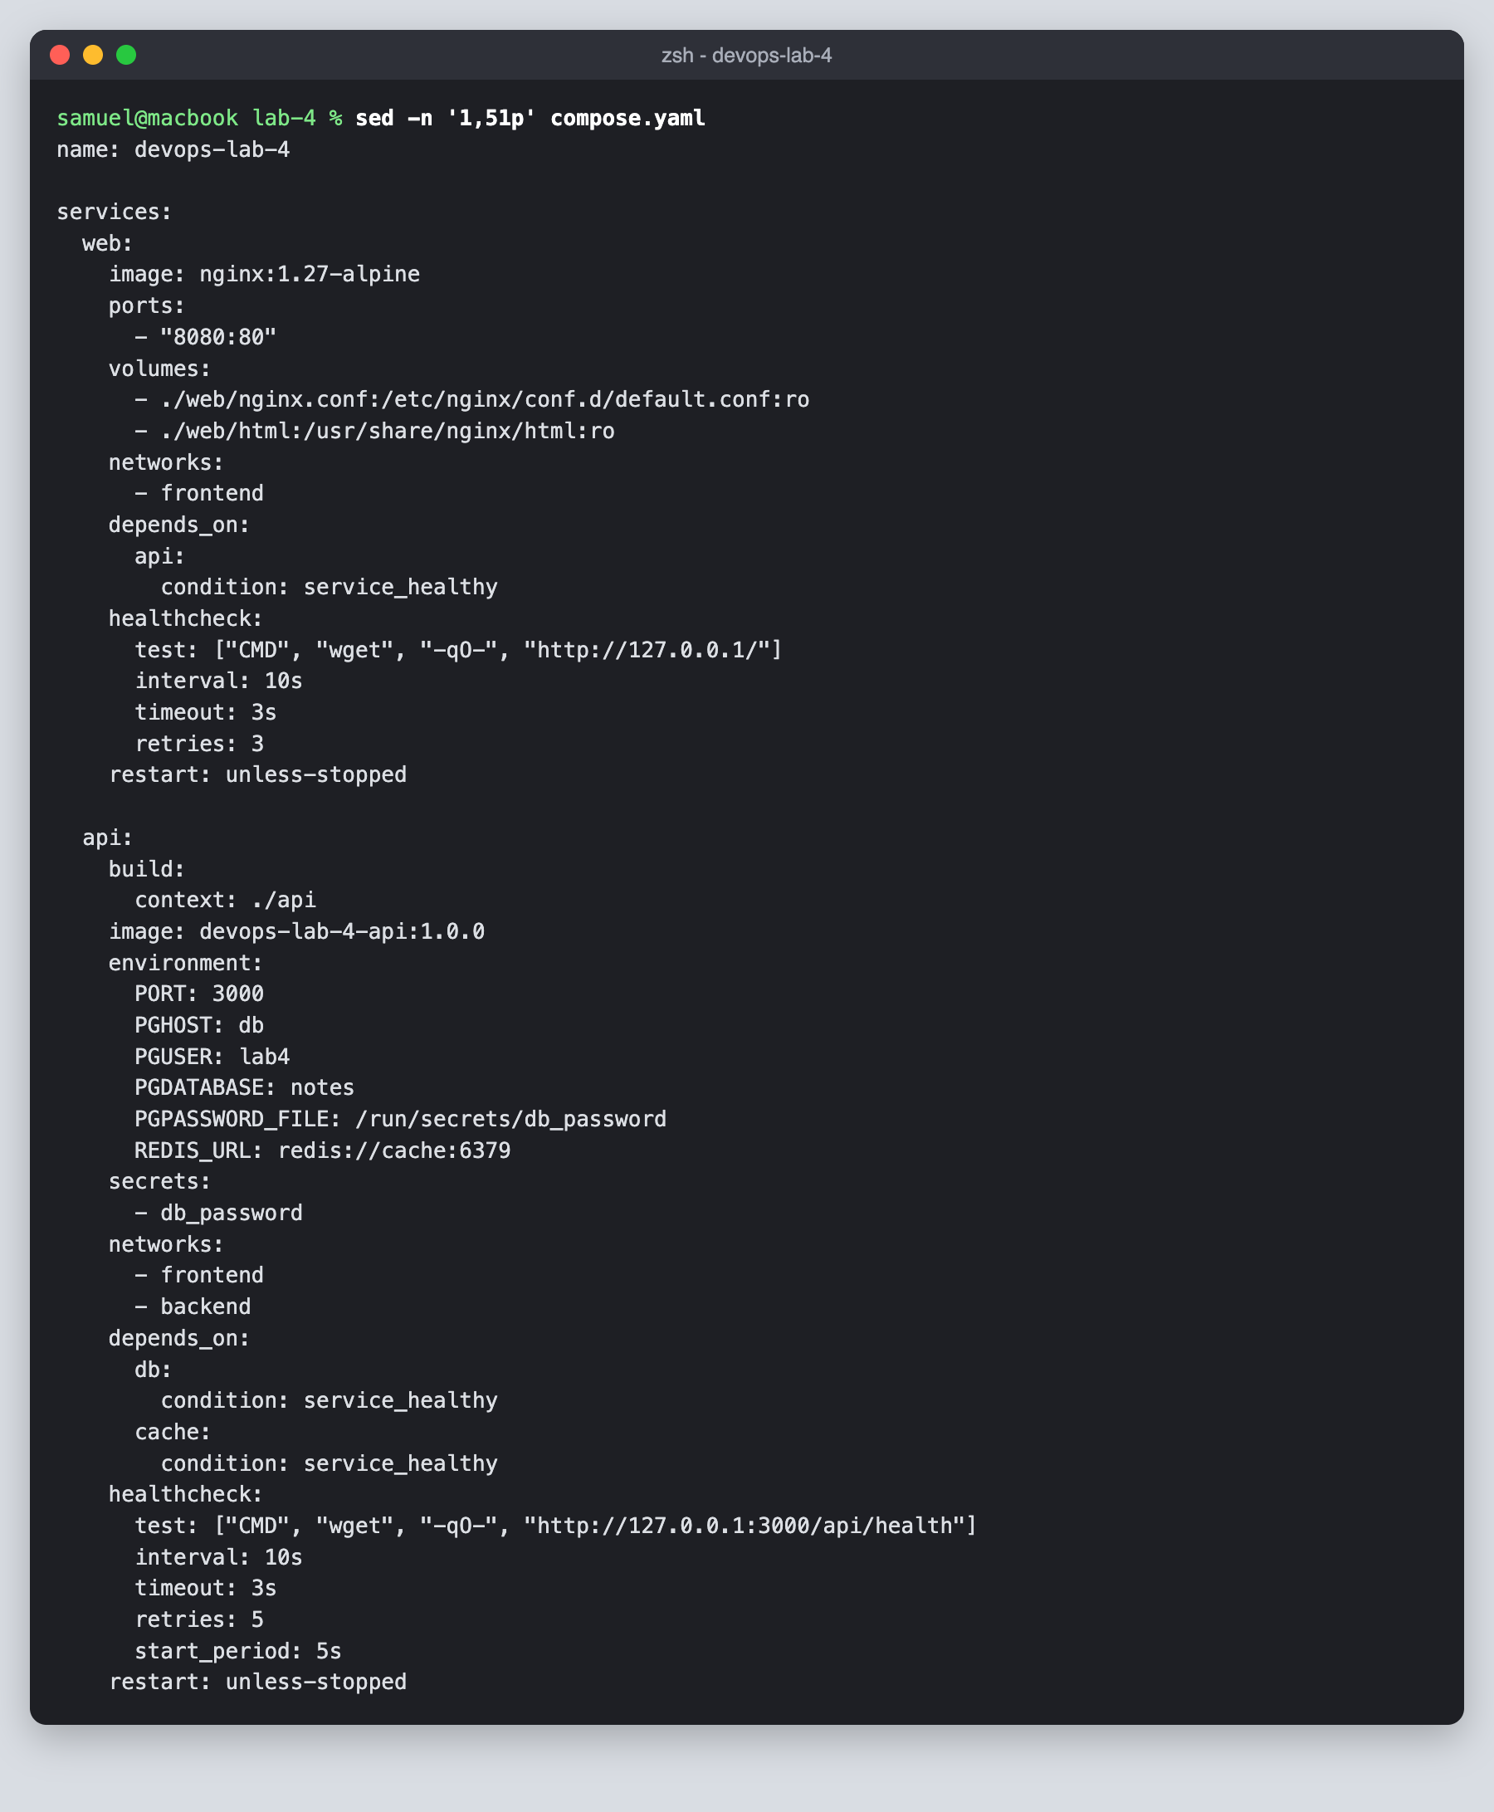
4. Defined the db and cache services, the frontend and internal backend networks, the named volumes and the secret.
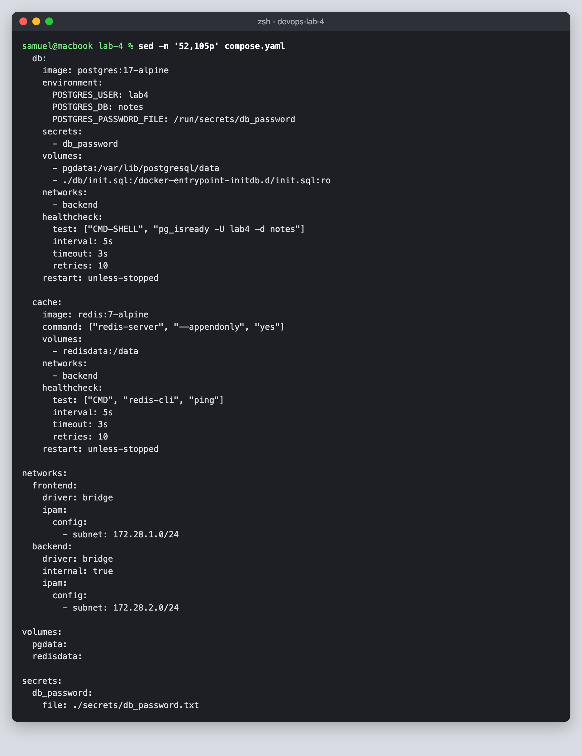
5. Wrote the multi-stage api/Dockerfile and the nginx config that proxies /api/ to the api service.
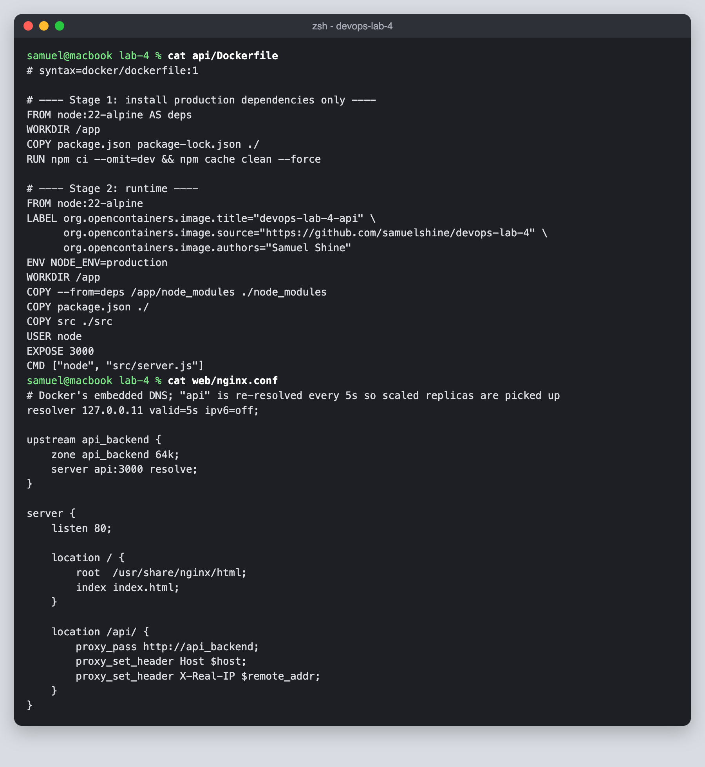
6. Wrote db/init.sql to seed the database and kept the real password file out of git.
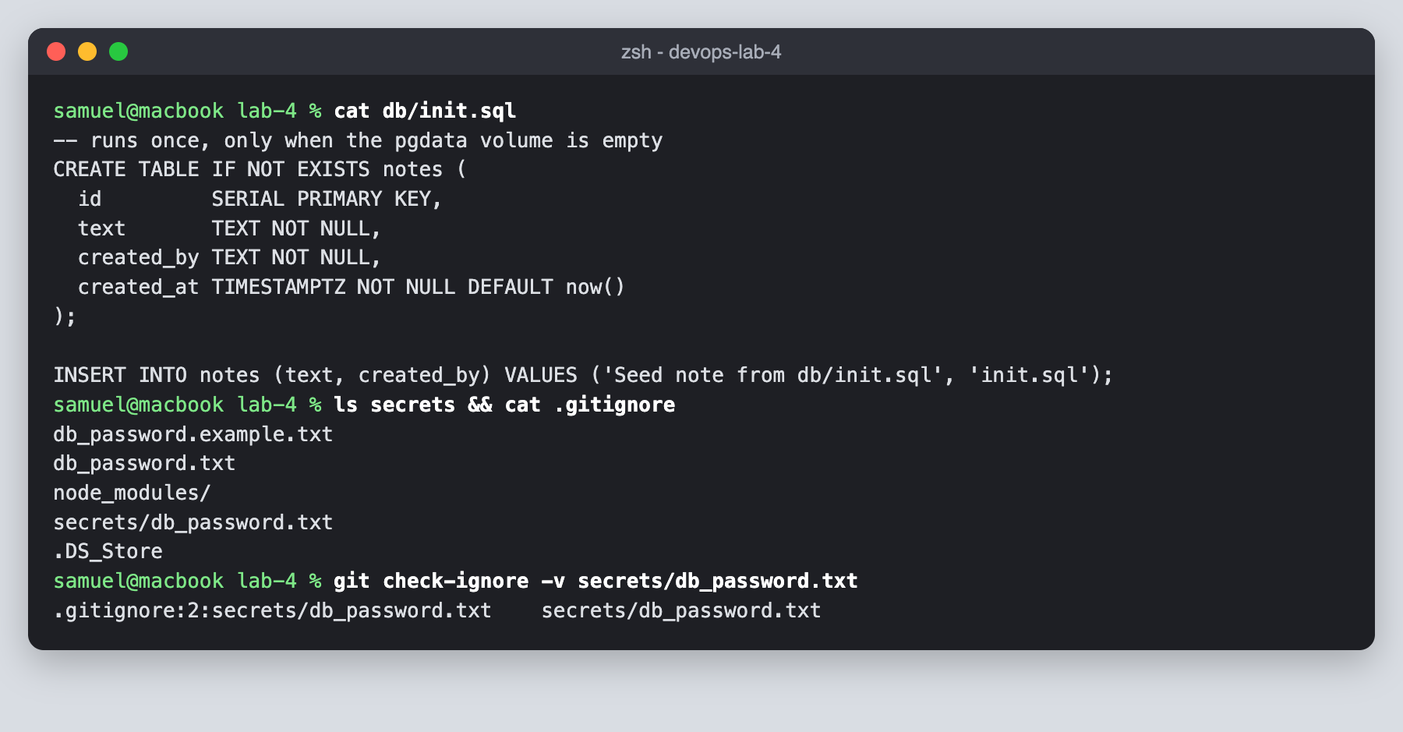
7. Validated compose.yaml and listed its services, volumes and networks.
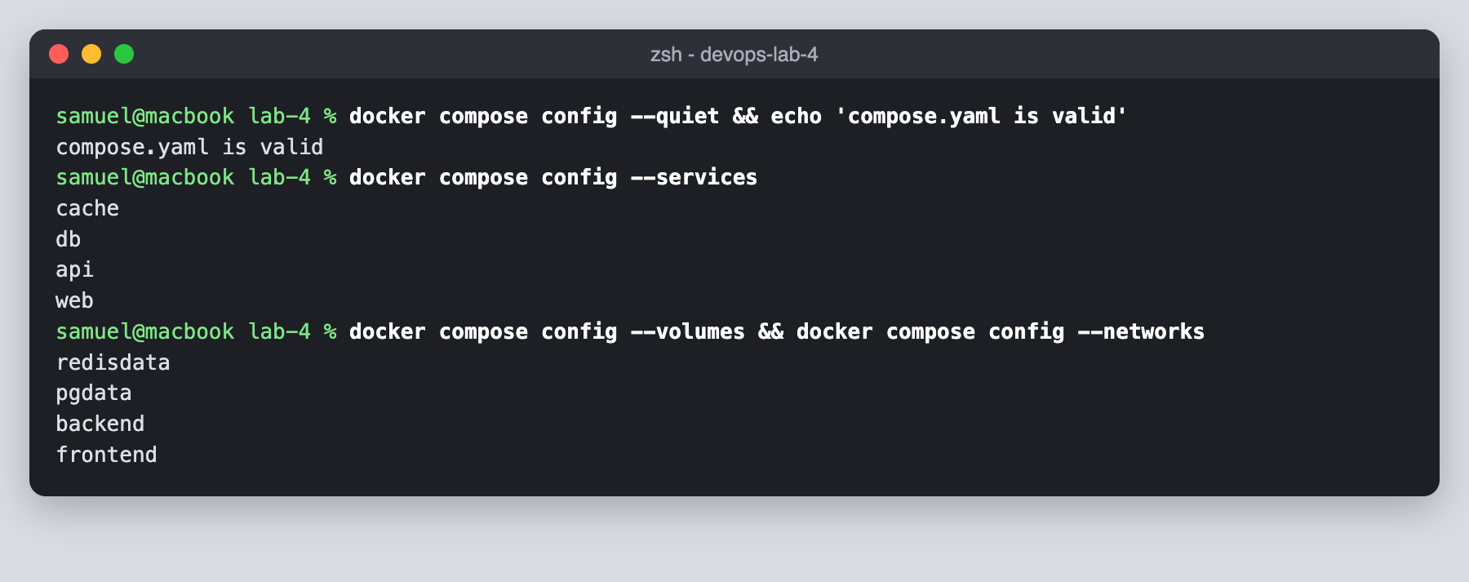
8. Built the api image and started the stack with docker compose up -d --build --wait.
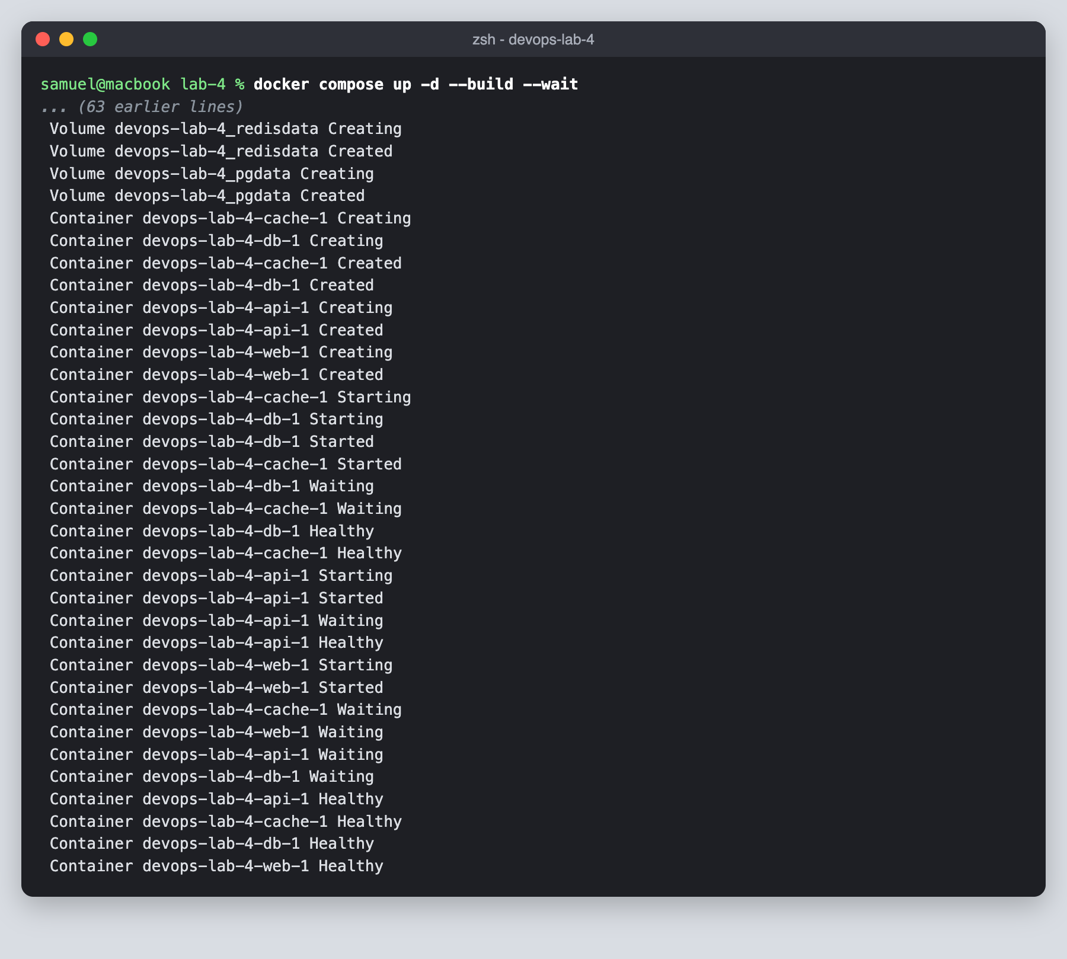
9. Checked that all four containers are healthy and that only web publishes a host port.
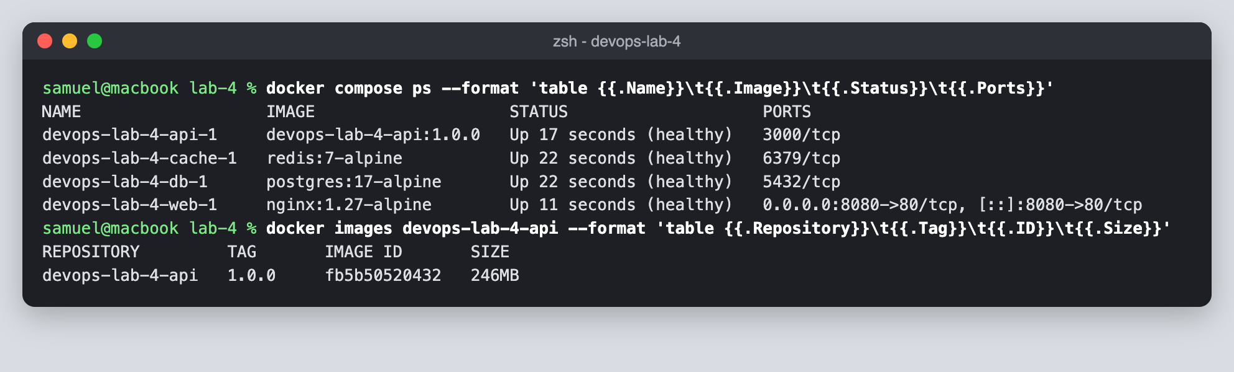
10. Tested the health, notes and whoami endpoints through nginx and added a note.
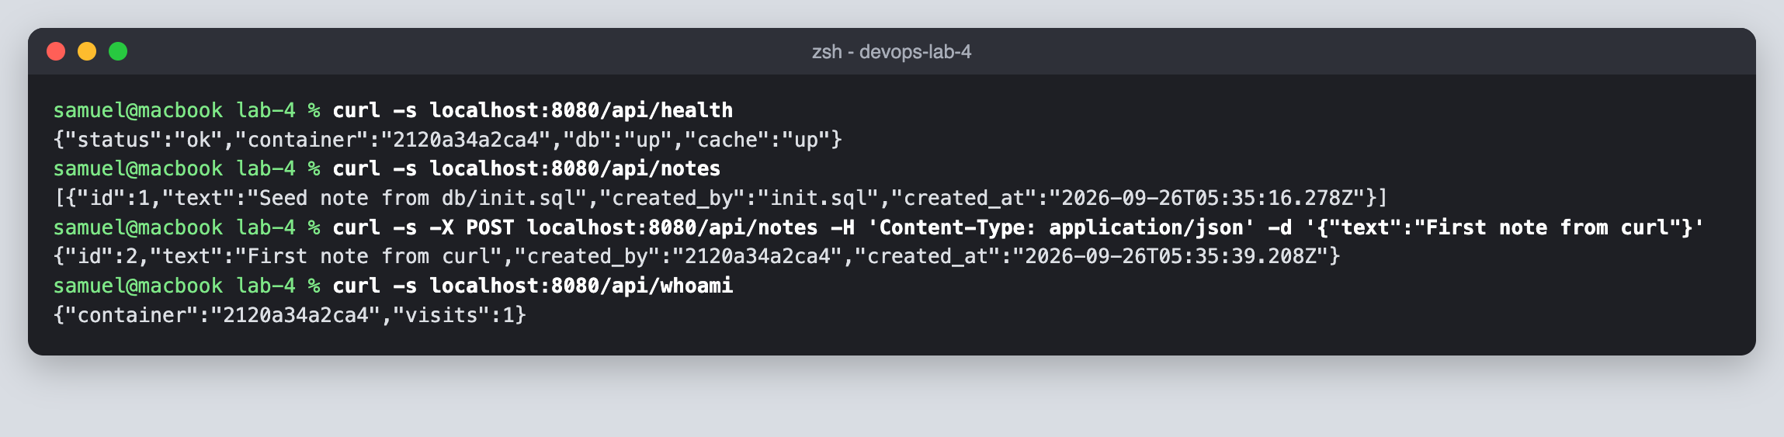
11. Opened the app at http://localhost:8080 in the browser.
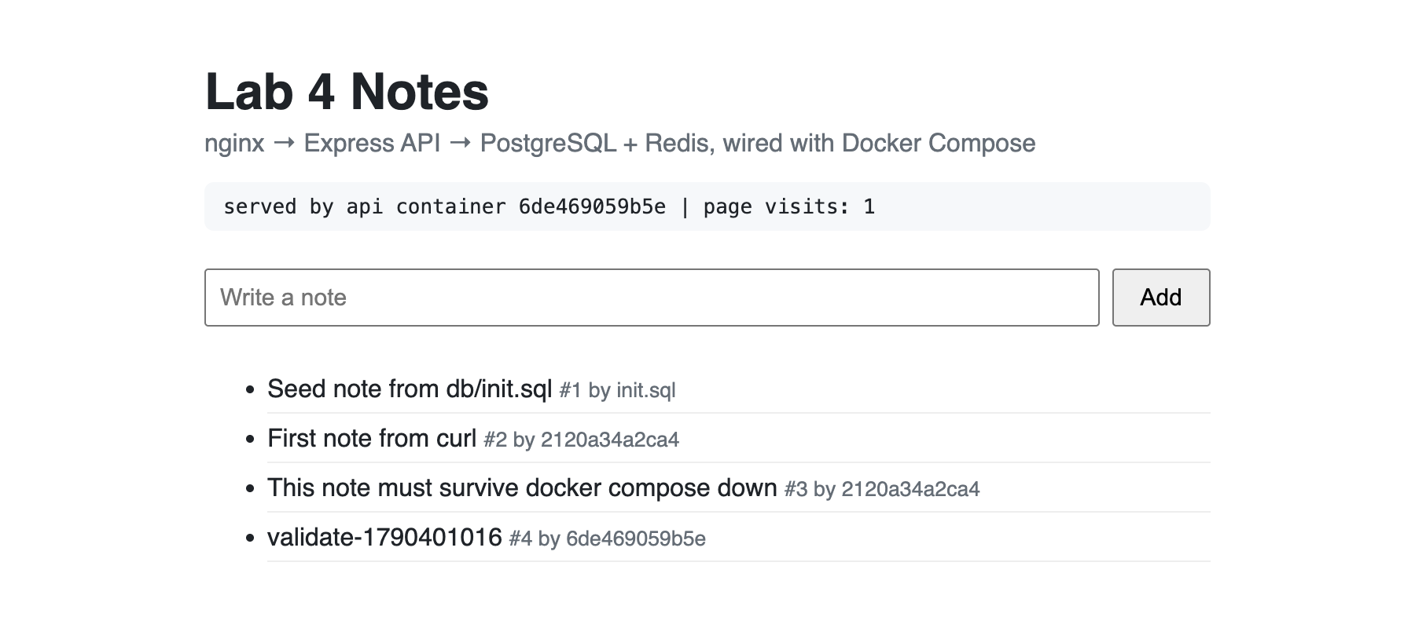
12. Inspected the two networks, their subnets and which containers are attached to each.
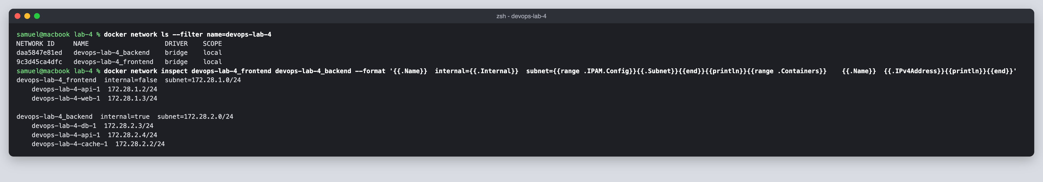
13. Resolved db and cache by service name from the api container and reached the api from web.
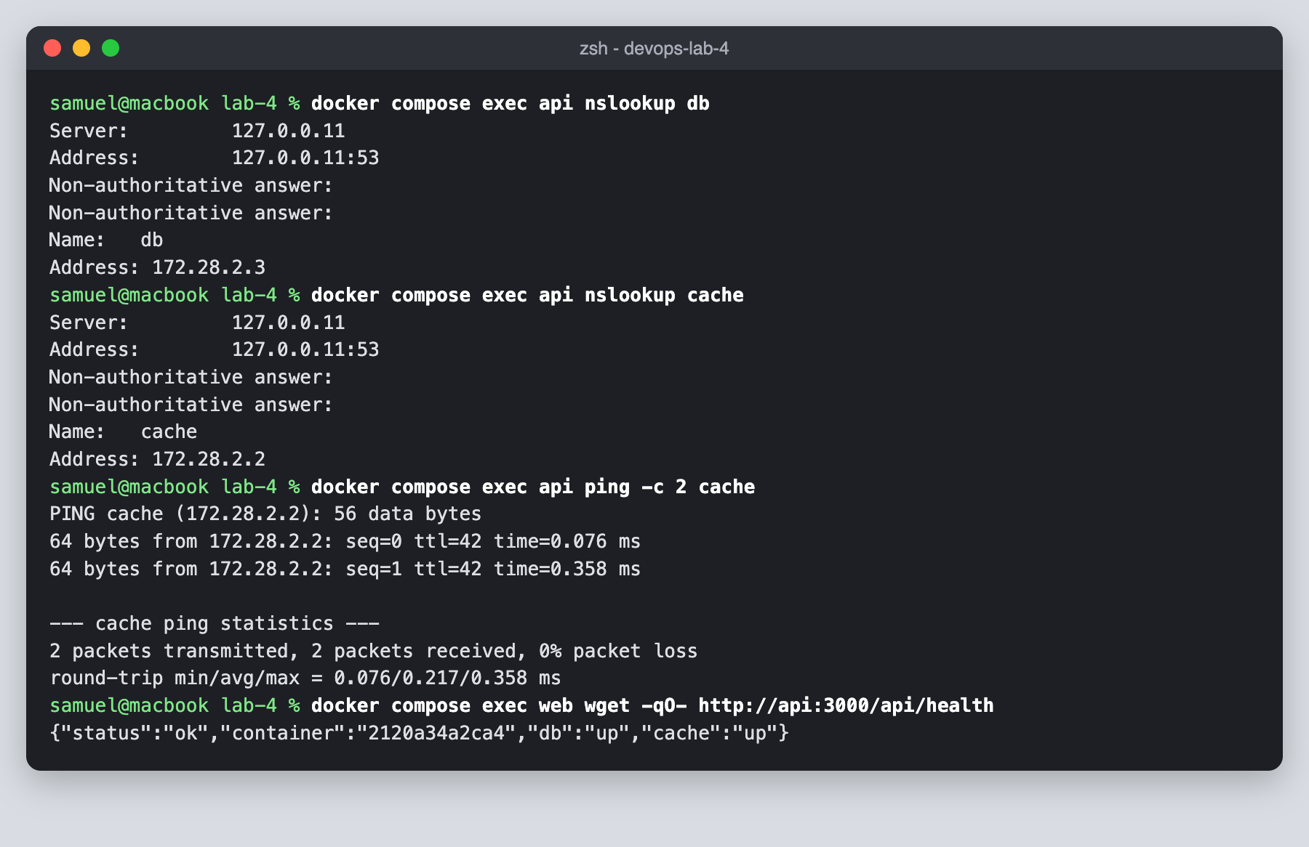
14. Confirmed web cannot resolve db or cache, the backend network has no internet access, and db and cache publish no host ports.
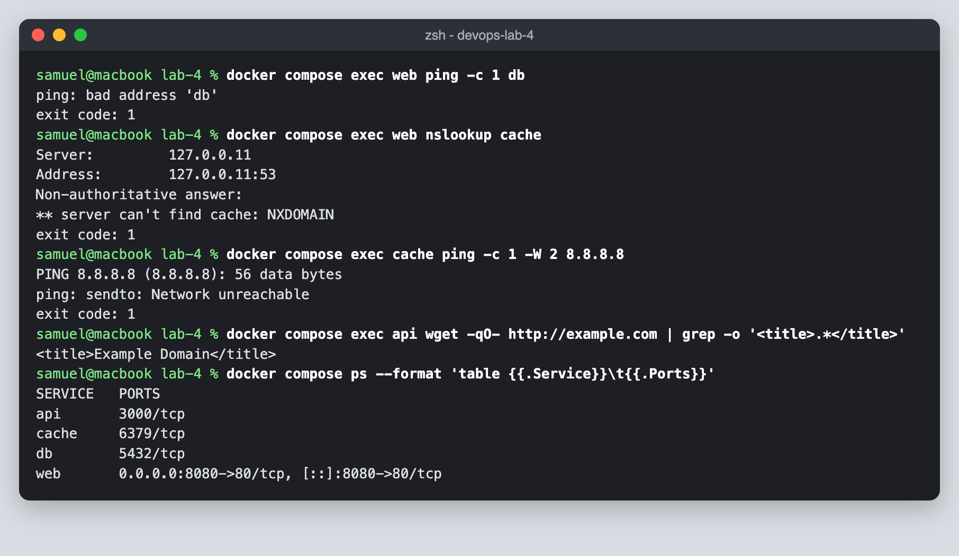
15. Scaled the api to three replicas and saw nginx balance requests across them, then scaled back to one.
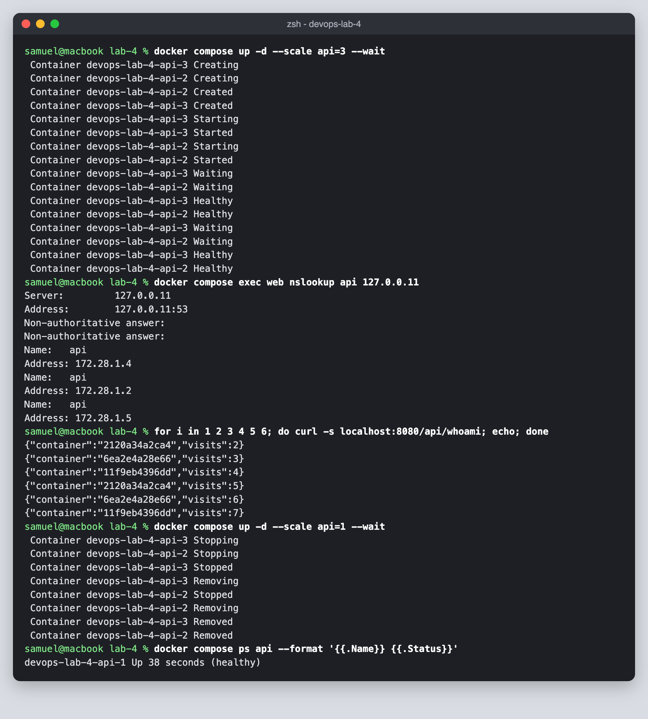
16. Inspected the pgdata and redisdata named volumes and the data stored in them.
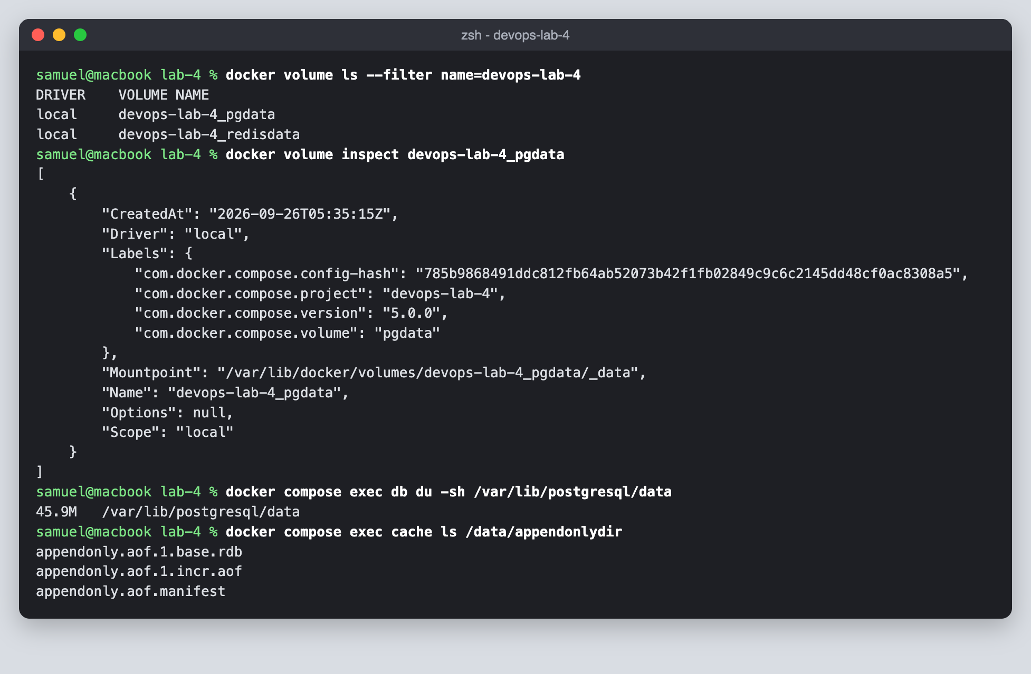
17. Added a note, removed all containers with docker compose down, started again and found the data still there.
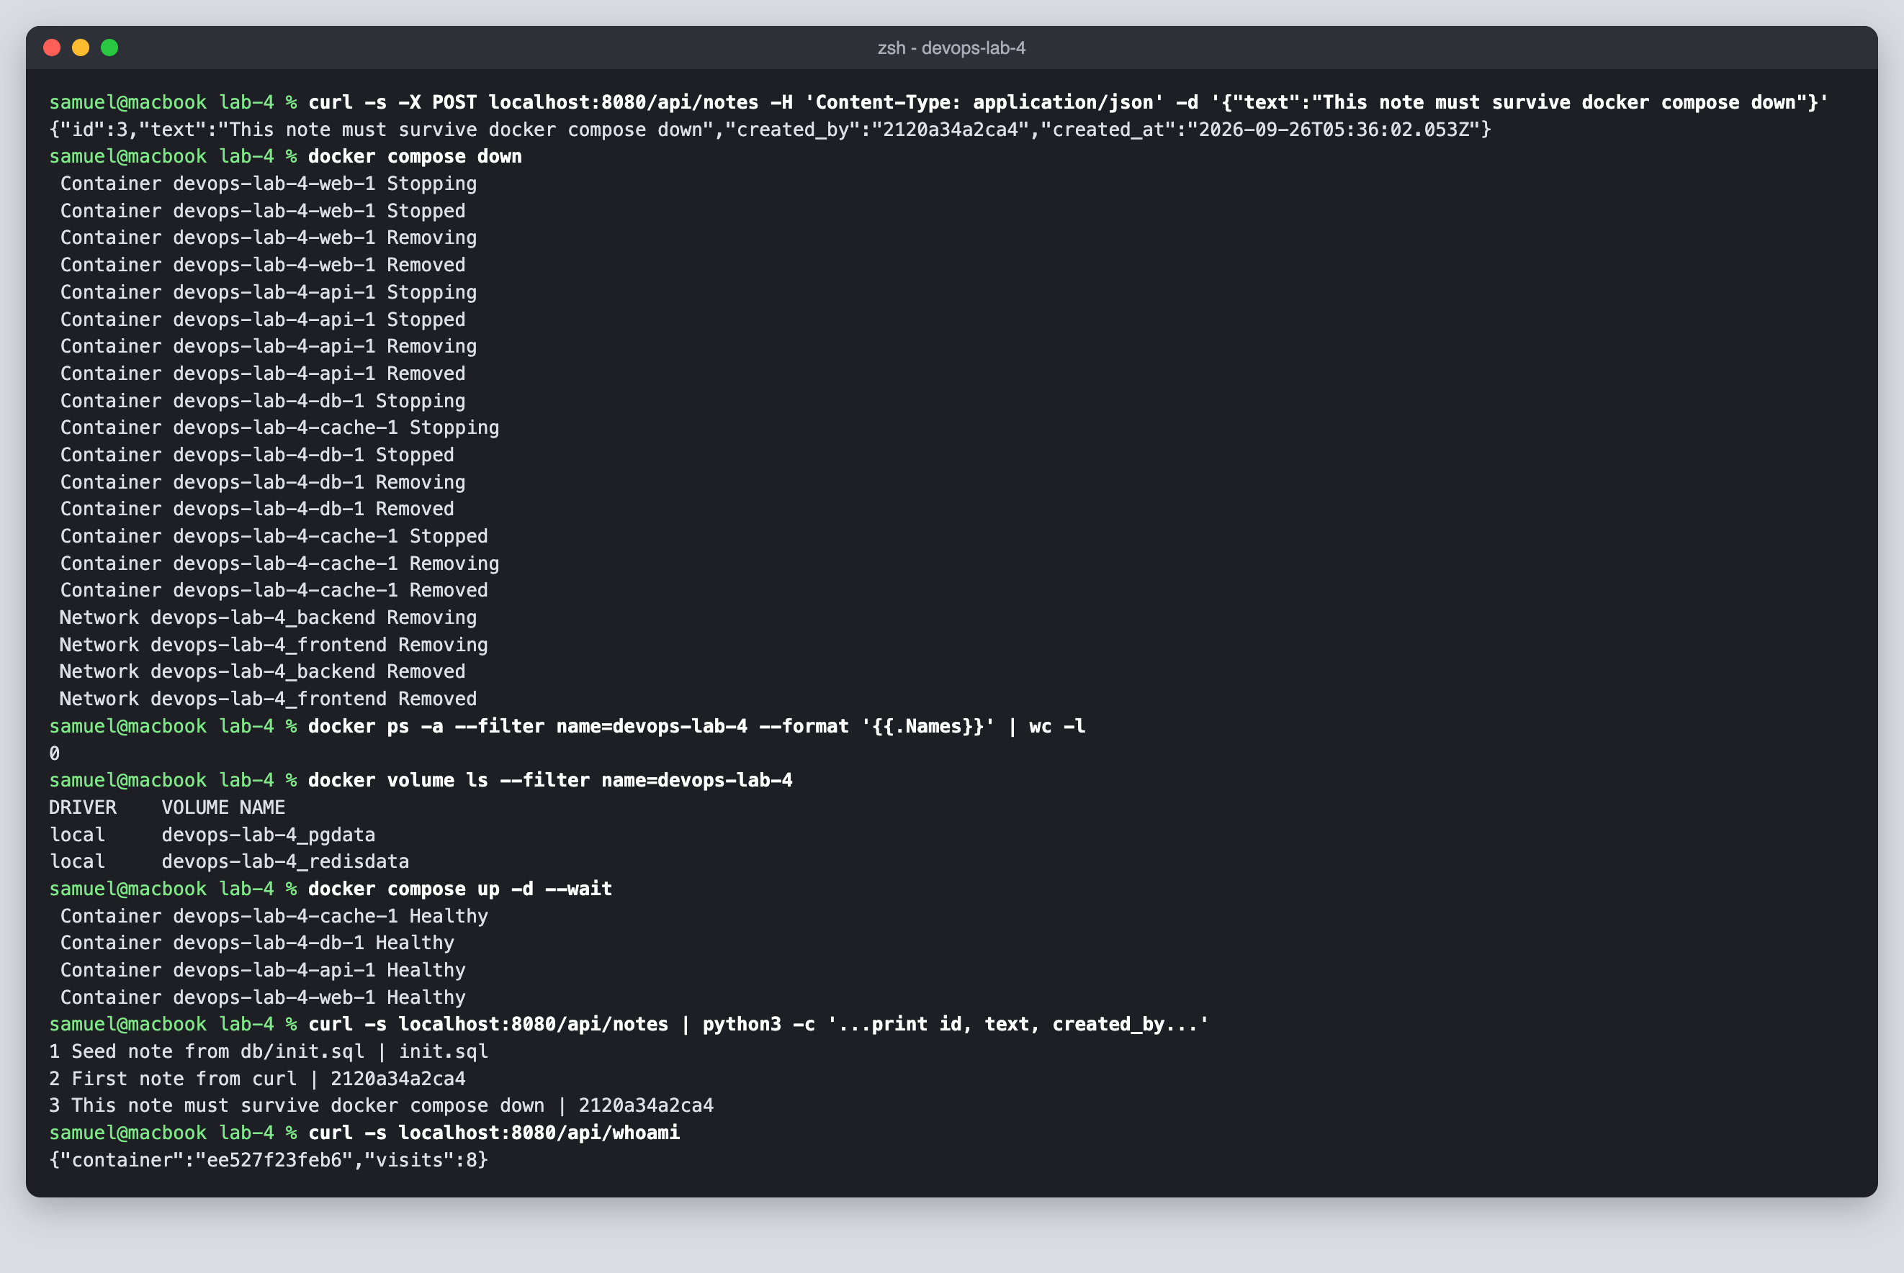
18. Confirmed the html bind mount is read-only in the container and picks up files changed on the host.
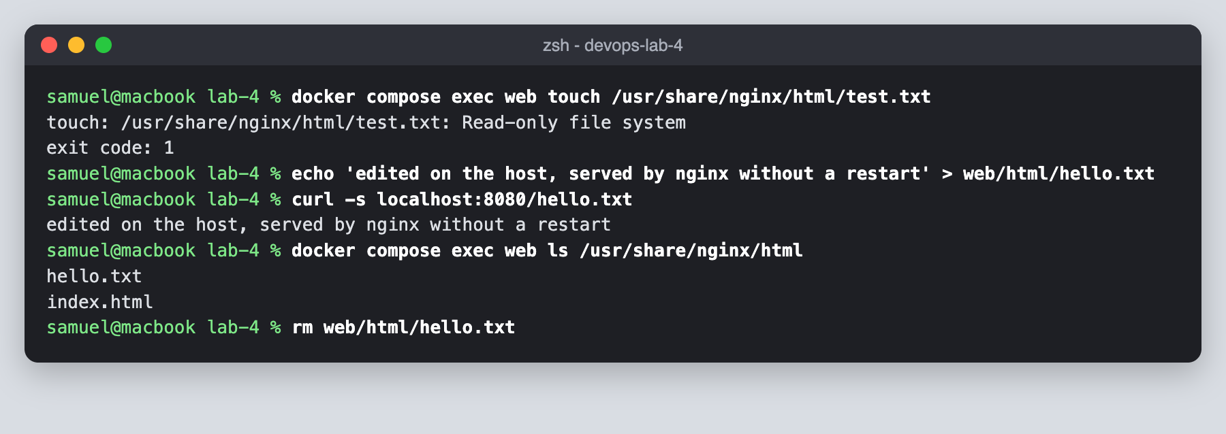
19. Confirmed the database password is a mounted secret file and not an environment variable.
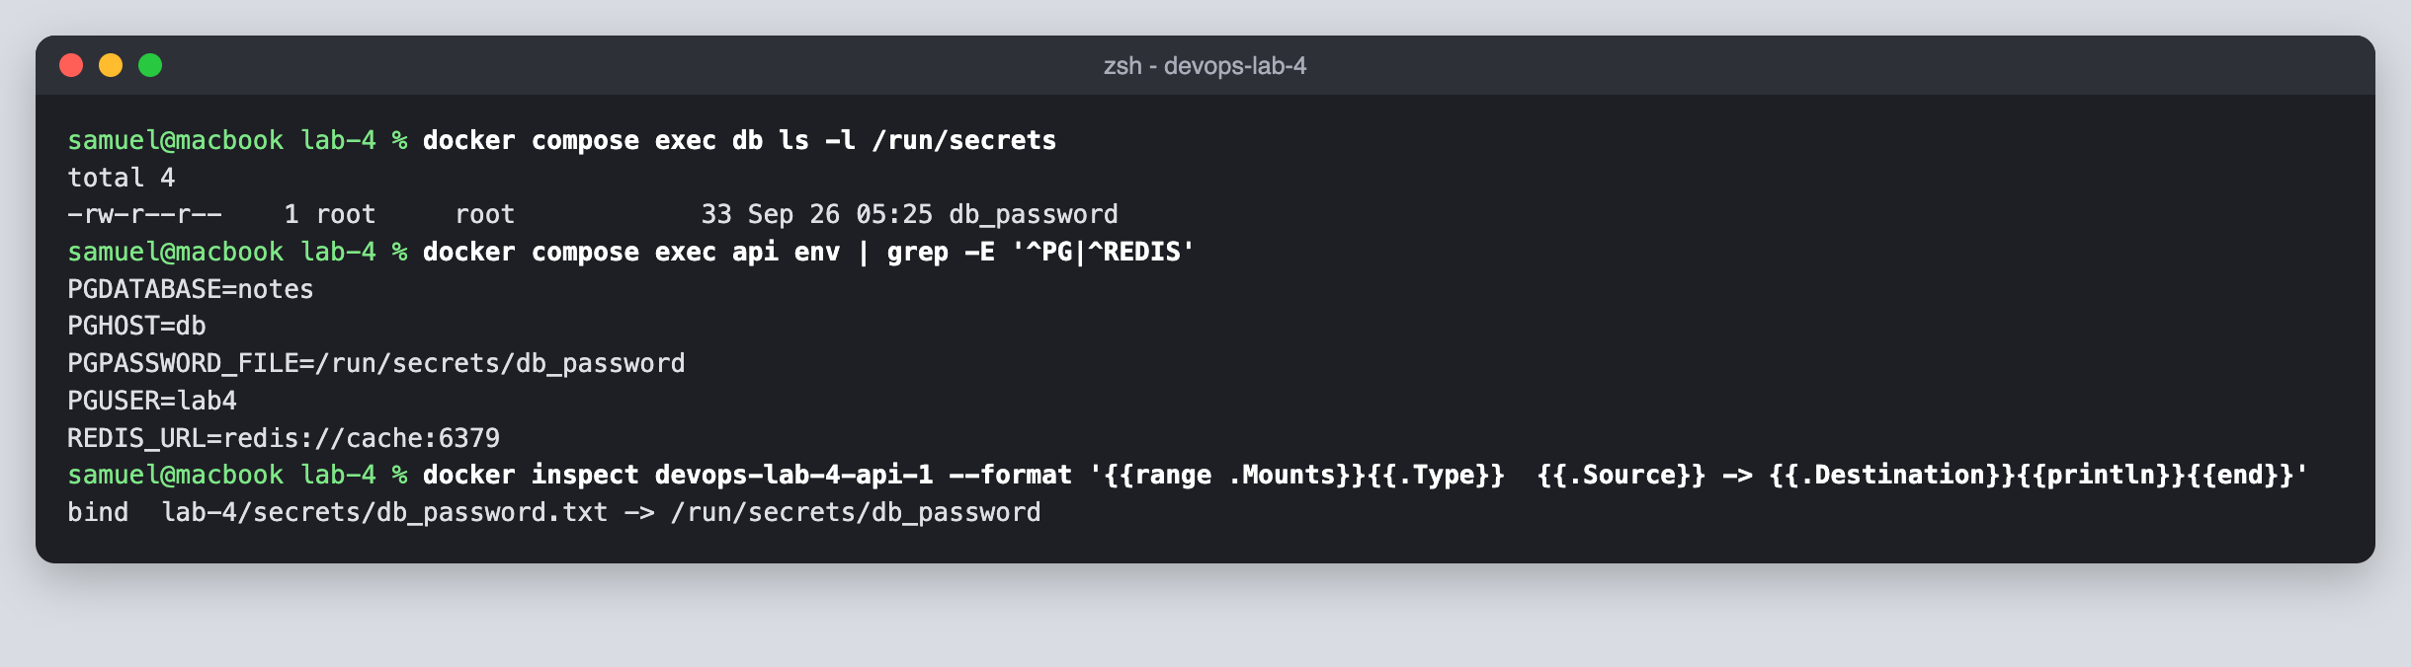
20. Backed up the database to backups/notes-backup.sql with pg_dump.
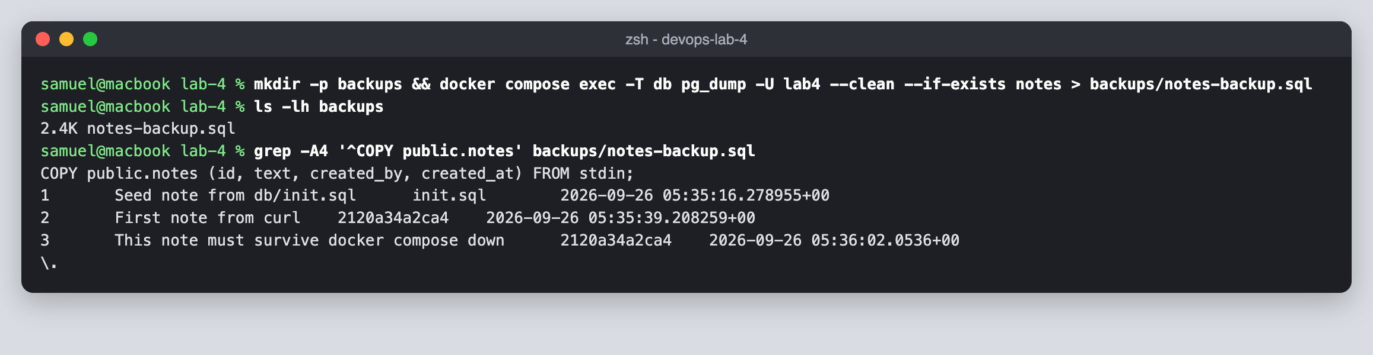
21. Removed the volumes with docker compose down -v and saw the data reset to the seed note.
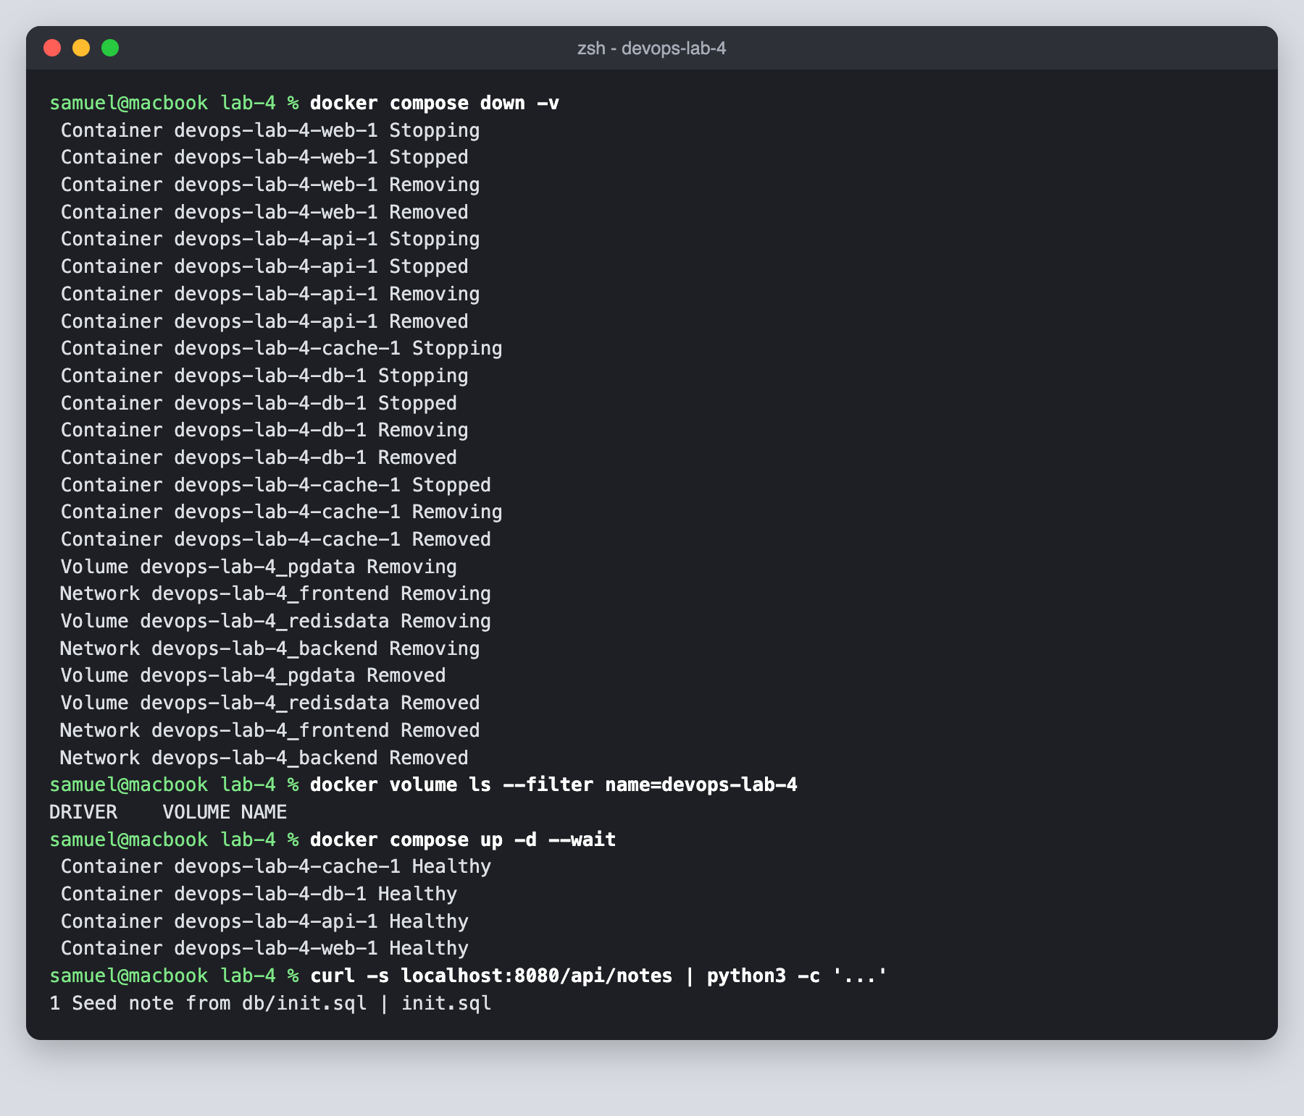
22. Restored the backup with psql and got all notes back.
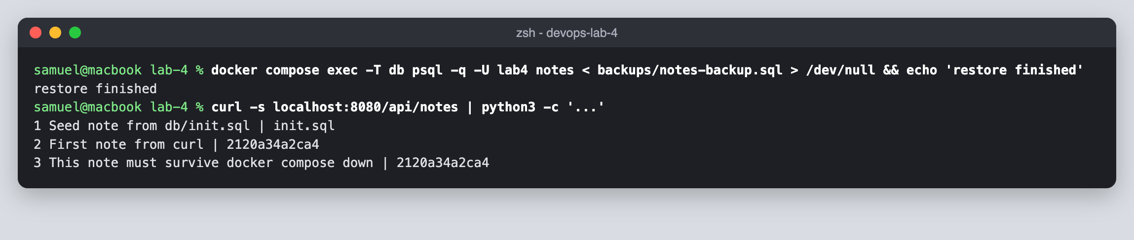
23. Ran scripts/validate.sh, and all 19 networking and storage checks passed.
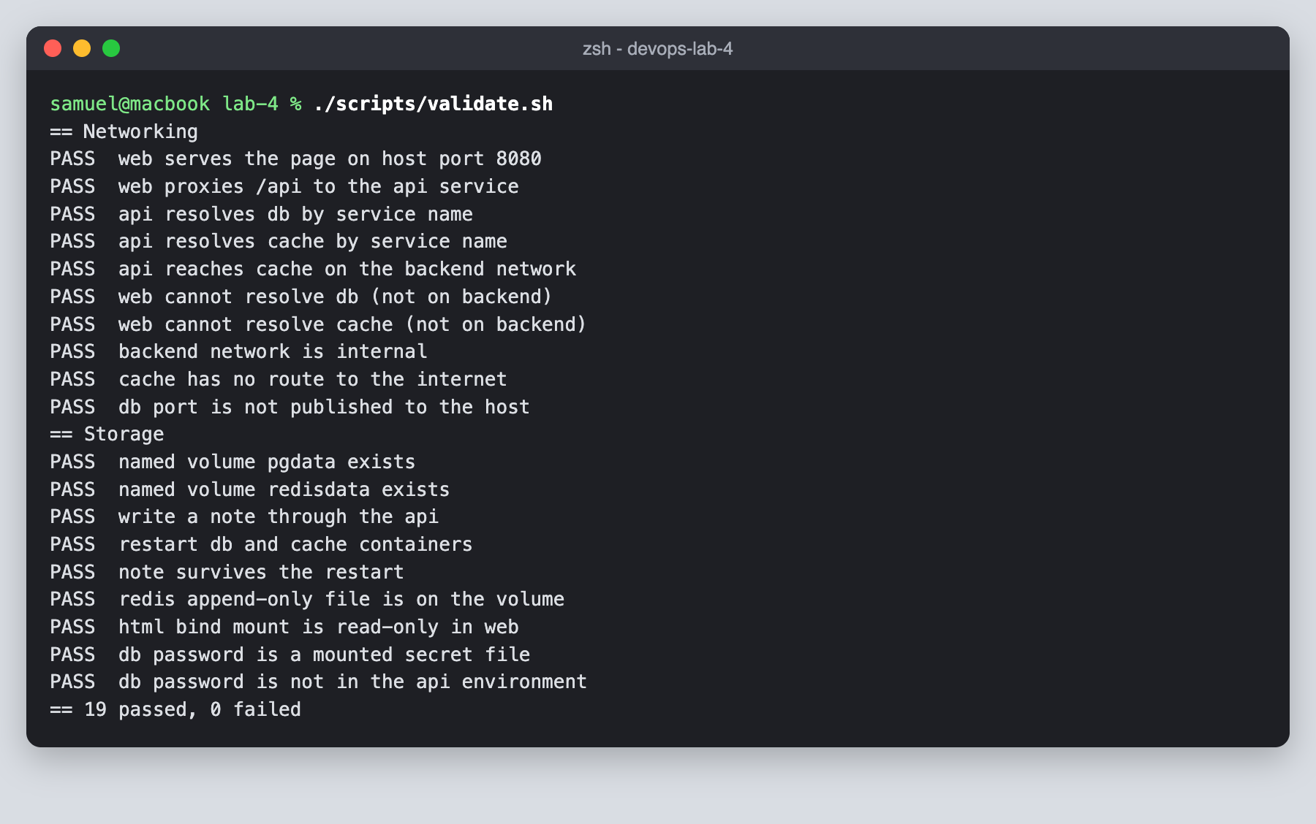
24. Pushed the project to the devops-lab-4 GitHub repository.
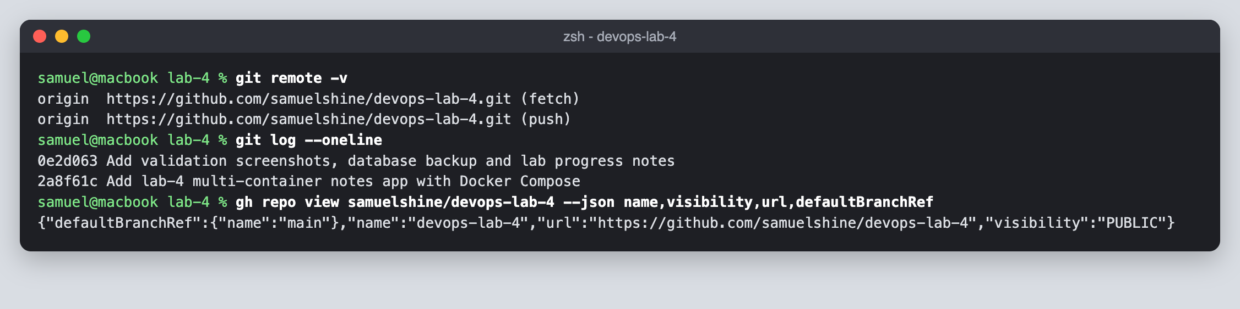
25. Checked the repository on GitHub.
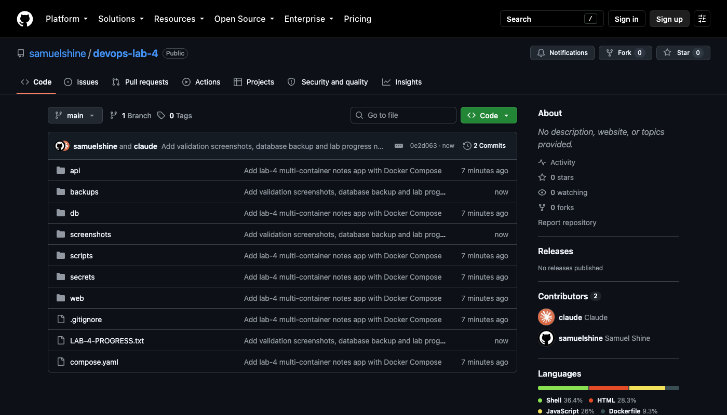

Result
The four-container application was deployed with Docker Compose. Service-name DNS, network isolation, the internal backend network and load balancing across scaled replicas all worked as expected. Data in the named volumes survived docker compose down and was removed only by docker compose down -v, and a pg_dump backup restored it.

