What is Intelligent Reminder

Its origin
Intelligent Reminder was conceived of and written by Mike Samuels, an independent developer. It was first published on December 21, 2009.
Smart phones open a new world of convenience, entertainment, and productivity. In addition to being a phone, they are a complex mini-computer, capable of storing data and running application on par with today’s personal computers. They also have several distinctive attributes, one of the most important of which being a GPS system which can pin-point your location to within a few feet.
Certain smart phones – IPhone and all phones running the Google operating system – are designed to give independent developers the ability to create and publish applications for their phones.
Mike had an IPhone, and being productivity-conscious, soon conceived of a simple, yet highly effective application for his phone ... something that blended the power of the smart phone with today’s complex and chaotic conditions of life. Specifically, just like he was able to enter appointments into his phone and then be alerted by it when the appointment was drawing near, so too he wanted to be able to enter things that he needed to do or buy and associate them with one or more locations, and then be alerted when drawing near to one of the locations.
Despite the fact that there had by then been written thousands of applications, he couldn’t find one that did what we wanted. So he decided to write such an application himself.

Its history
Mike had been a computer programmer for over 30 years. He also wrote and marketed several utility programs for the IBM PC, including one of its most popular background printing engines, Disk Spool II.
Since Mike owned an IPhone, and was pleased with it, he decided to write the app for this phone. However, after studying IPhone’s operating system and application development tools, he realized the reason why this kind of application hadn’t yet been written. The point is that it needed to be running actively in the background so that it could issue an alert … even if the user was on the phone, or in the middle running some other application. The IPhone was capable of doing this – since this is just how the Appointment application functioned – but the IPhone application development technology did not make this kind of functionality public. They only permitted their internally-written applications to do it.
About ready to abandon the entire project, Mike came to find out about the Google application development platform, and how it was designed from its inception to be able to manage concurrently running applications, including the ability of applications running in the background to issue alerts. So he decided to write his application on the Google platform

Its qualities and attributes

It runs concurrently in the background along with any other phone activity.

It allows the user to maintain a database of named “locations”, which can be established in different ways.

Current position

An address

Store name

It allows users to group locations into a single category; e.g. – Hardware Store

It allows the user to enter to-do “items”, and associate them with one or more “locations” or categories.

It issues an alert when the user nears a location to which an item has been associated; after which, the user can

Clear the notification, but keep the item active so that it will issue an alert the next time the location is approached.

Clear the notification, deleting the item, and recording in a history log.

Clear the notification, deleting the item, and not recording in a history log.

It allows the user to share locations and items with other phones so that anther other person also is alerted about the item (along with who the item belongs to) when approaching one of the associated locations. When the other user indicates that they’ve taken care of the item, it is removed from your item list, too.

It maintains a history of item alerts.

Its use and application
You've planned on running some errands on the way home from work. You can pick up the dog-food and kitty litter at the Pet's Mart, and there's an Office Mate right next door ... so you can get those ink cartridges you need. Lastly, you can duck into the food store to pick up the rest of the things on your list. You make a list in morning while you’re fresh, because you know you’ll be pretty tired by the end of the day, and won’t remember what you need. After returning home, and unpacking, you settle down to relax, and it’s then that you realize that you're almost out of coffee. "Dang! And there was a Starbucks right there, too!"
You almost always have your smart phone handy, don’t you? With Intelligent Reminder, you would have recorded your need for coffee at the time you saw that you were running low, and with one click associated it with all of the Starbucks. And so, you would have received an alert: "Are you aware that you're presently located quite close to where you can pick up your coffee?”

Its results and effects
Intelligent Reminder saves you time, thereby promoting a more ordered life. It also saves on the gas bill.
Life today is more complex and chaotic than ever before. Gone are the days when one well-planned trip to the store could provide the necessities of the week. Gone, also, are the days when one person in a household could take on the responsibility of obtaining these necessities as part of his or her “job description”.
Also, our minds are more compartmentalized. We can walk into a Starbuck’s a get a cup of coffee, but not remember that this morning we noticed we were running low on stock.

Its future
Several enhancements to the product are being researched.
- The ability to enter items and locations via voice activation
- The ability to receive pre-recorded voice alerts; e.g. – “Get 1 gallon of whole milk and 1 pint of half-and-half. Prefer Meadow Gold brand.”
- The ability to save and re-activate previously used Items.

Summary
Intelligent Reminder is an application that is ripe for our times. By taking advantage of modern technology, it helps to address our conditions of mobility, lack of time, and fast-paced living. Like texting, GPS navigation, and appointment calendars, Intelligent Reminder has the potential of becoming a part of our daily lives.

User’s guide

Quick Start – 3 steps

Step 1 – Create locations
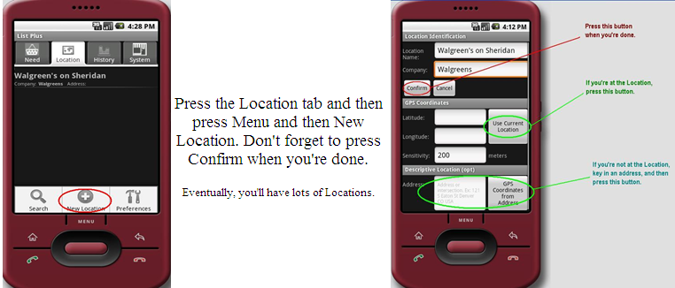

Step 2 – Create a need
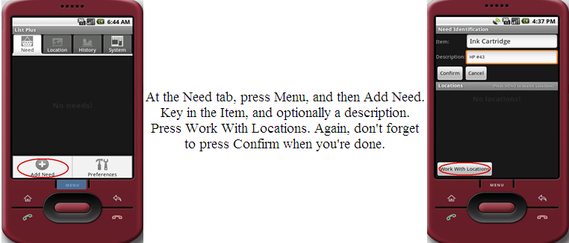

Step 3 – Associate the need with a location
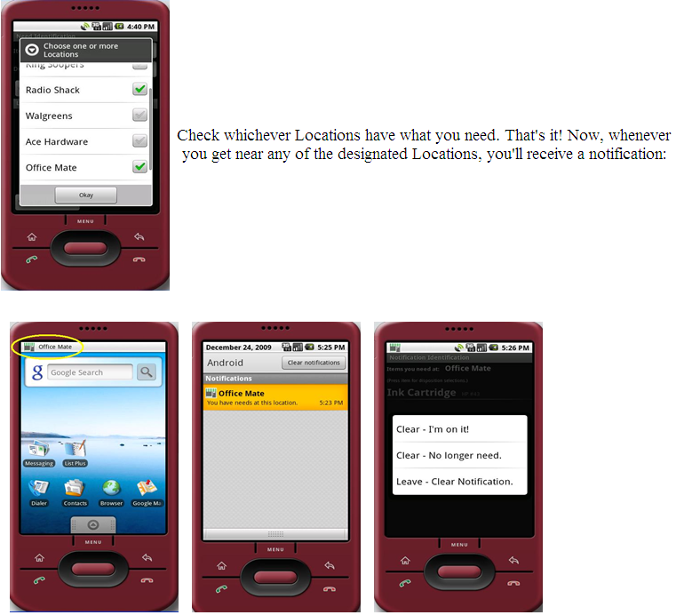

Detailed Guide

Working with Locations
Press the Location tab at the top of the screen

Creating a Location

Press the Menu button
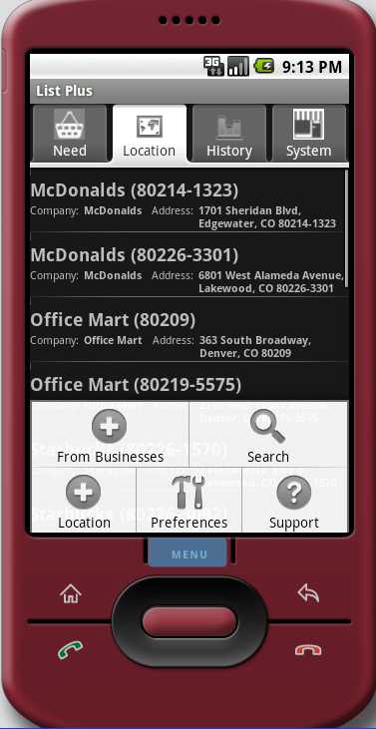

Press the Add Location Icon

At the Location screen

Adding a single Location
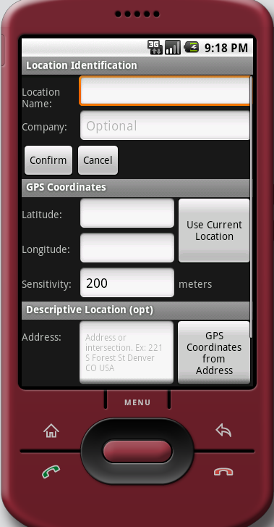

Location Name

Company
A Location refers to a specific place. It has a definite GPS longitude and latitude. There may be, however, several similar locations in where you travel; and you would be able to satisfy your need at any one of them. This is where you make this designation. So, when you associate your Need with a Company, you get alerted when you’re near any of them. (See B.(2) Adding several locations for the same business, below, to learn how to do this more efficiently).

You can specify the Location’s location in one of several ways

Press the Use Current Location button

Key in an address and press the GPS Coordinates from Address button

Key in the Latitude and Longitude

You can add a location that is associated with a Contact

Press the Confirm button.

Adding several locations for the same business
You can quickly add all, or several, of the locations of a given business in the vicinity of your current location. They will then be associated under a single Company name. In this manner, upon associating your Need with this single Company, you’ll receive an alert when you’re near any of them.

At the Locations tab, press the Menu and then the From Businesses button

Key in the name of the business

Specify the “search near” criteria

City and State; and/or

Zip
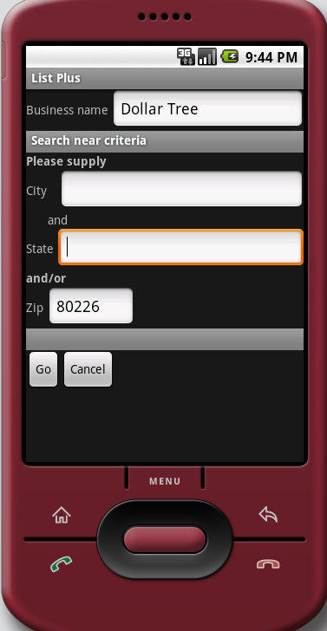

Press go

Intelligent Reminder will present you with a list of all the Businesses with that name in your vicinity, in closest to farthest away order. Check the ones you wish to use, and press Okay. All of them will be added to your list of Locations.
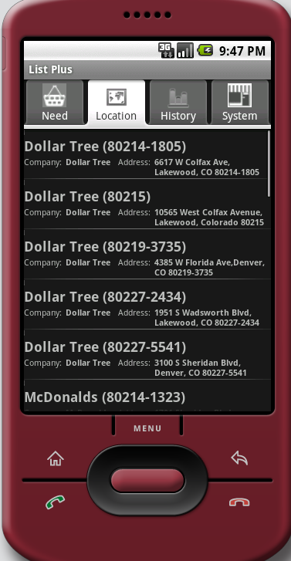

Searching for a Location
- At the Locations tab, click menu, and then the Search button
- Start keying in the Location’s need. You will be presented dynamically with a list that matches what you’ve keyed in.
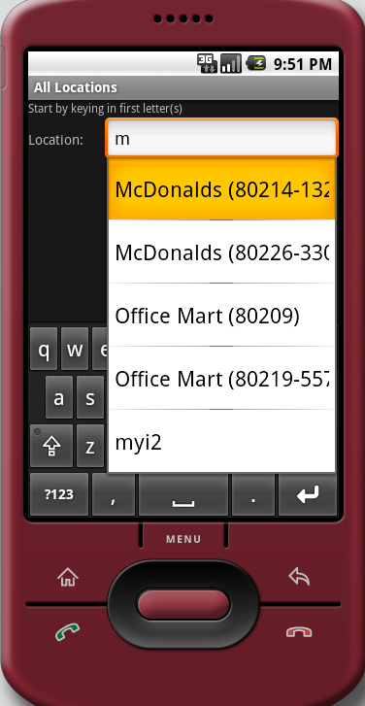

Press the one you wish to select, and then press the Confirm button. (You may have to hide your keyboard in so that the Confirm button becomes visible.)

Deleting a location
From the Locations tab, press and hold the Location that you wish to delete. Then press the Delete button.

Editing a location
From the Locations tab, press and hold the Location that you wish to edit. Then press the Edit button.

Working with Needs

At the Needs List screen

Add a Need by using the Menu

Delete or Edit a need by long-pressing the need.

Adding a Need

From the Needs tab, press the Menu button, and then the Add Need button.
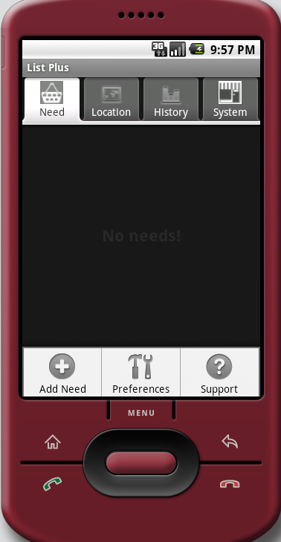

Key in the Item name and optionally a description

Associate the Need with a Location, by pressing the Work With Locations button.

A Locations List appears.

Check one or more Locations, and press Okay
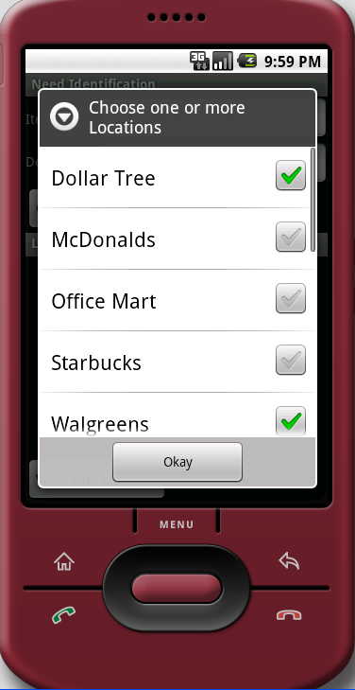

Press Confirm
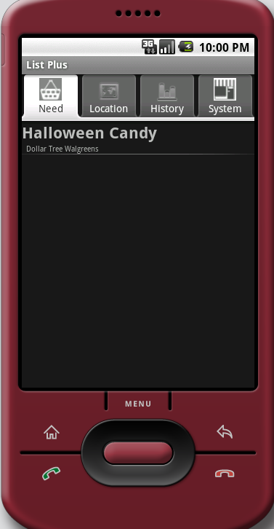

Deleting a Need

Editing a Need

Alerts
When a Intelligent Reminder alert occurs, you handle it by pressing and holding the item. There are three ways to dispose of the alert.

Clear – I’m on it
The alert is cleared, and the item is deleted. The event is recorded in History (see History ,below).

Clear – No longer needed
The alert is cleared, the item is deleted, but the event is not recorded in History.

Leave – Clear notification
Clear the notification, but don’t delete the item. The next time a location is entered for that item, you will receive an alert
Note: an alert is automatically removed when you leave the vicinity of the location.

Other features

Sharing your list
You can share your lists with one or more other phones running Intelligent Reminder. When that other phone nears one of your item locations, an alert is received. Additionally, the alert indicates that it’s one of your items that is involved.
To initiate this feature, follow these steps.

Obtain the Phone Id of a phone to which you wish to publish your data. This is obtained on at the System tab.
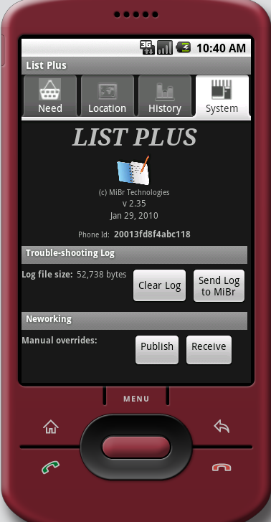

At any screen, press Menu, and Preferences. Press Their PhoneIDs
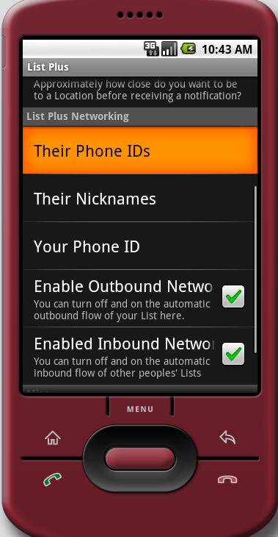

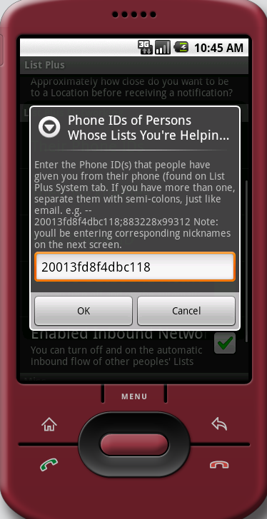

Enter the phone id and press OK

Next, associate the phone ids with a name. At the Preferences screen press Nicknames. Once the link to that phone is established, they will see your items and locations in their lists. The nickname you key in here will be displayed next to the item so that they know it belongs to you. So, too, when they receive an alert for one of your items, your name will appear next to it.
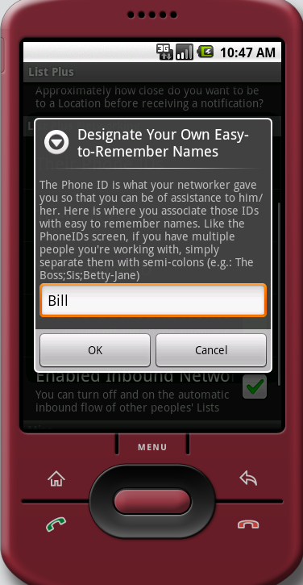

Your phone immediately begins to automatically publish your items and locations, and the recipients will automatically start receiving your lists into their phones. You can override this automatic publication by un-checking the “Enable Outbound Networking” in Preferences; and the recipient can override automatic reception of lists by un-checking the “Enable Inbound Networking”. You can manually publish your list, and recipients can manually receive lists published to them via the Systems tab.
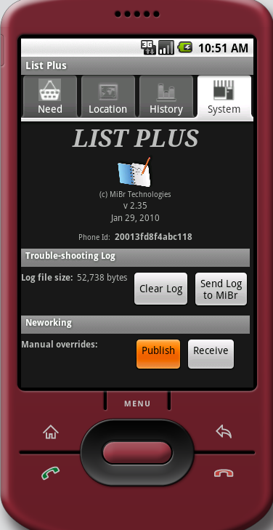

History
The History tab shows you all of the items that have been alerted on your machine, and for which you have taken the “Clear – I’m on it” disposition
Key in a “from” and “to” date, and press Go
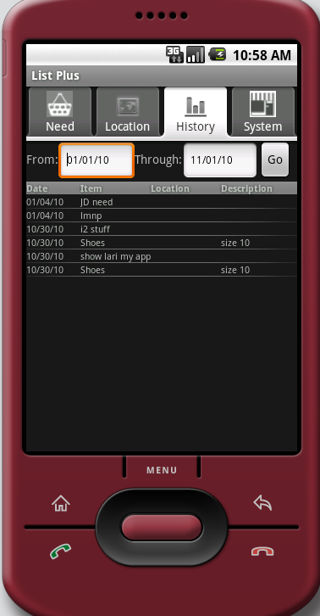

Preferences
Go to the Preferences from any screen by pressing Menu, and taking the Preferences item.

Notifications

Use sound

Use vibrate

Locations

When you create a Location, you can indicate a distance sensitivity. A default distance is established using this preference

Intelligent Reminder Networking
See a) Sharing Your List, above, for a description of these preferences.

Misc

Intelligent Reminder maintains a log of events that have occurred for the application. This log can be used by the technicians of Intelligent Reminder for helping to answer questions and issues that may come up with your application. You can set the sensitivity of this log using this preference item. If you are having issues, you can transmit this log to Intelligent Reminder technicians by going to the System and pressing the Send Log to MiBr button. From time to time you will want to clear the log to recover data space on your phone. This is done at the System menu by pressing the Clear Log button.
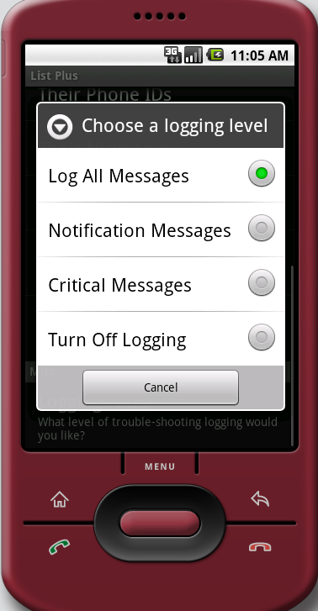

System tab
The contents at the system tab are as follows:

The version of the software

Your Phone ID … needed for list sharing (Seea) Sharing your List , above)

Trouble-shooting Log
The trouble-shooting log is used by Intelligent Reminder technicians to help resolve any difficulties you may experience with your application. If you have issues, increase the logging sensitivity (see , e), above), try to recreate the issue, and then send us the log by pressing the Send Log to MiBr, emailing us telling us your Phone ID, and describing the difficulty. Clear the log periodically to conserve space on your phone.

Networking
If you’ve shared your list with other phones, or if someone is sharing his or her list with you, these lists are automatically kept in sync periodically. If you wish to have more control over this activity, you can turn off this automation, and transmit and receive networked list here.

