Introduction
Has something like this ever happened to you?
You've planned on running some errands on the way home from work. You’re going to pick up the dog-food and kitty litter at the Pet's Mart, and there's an Office Depot right next door ... so you can get those ink cartridges you need. And lastly, you’ll duck into the food store to pick up the rest of the things on your list. You made a list in morning while fresh, because you knew you’d be pretty tired by the end of the day, and might not remember what you need. After returning home, and unpacking, you settle down to relax, and it’s then that you remember that you're almost out of coffee. "Darn! And there was a Starbucks right there, too!"
You almost always have your smart phone handy, don’t you? With Intelligent Reminder, you would have recorded your need for coffee at the time you saw that you were running low, and with one click associated it with the Starbucks in your area. And so, you would have received an alert: "Are you aware that you're presently located quite close to where you can pick up your coffee?”
Intelligent Reminder also allows you to associate needs with people in your Contacts list. When you receive a call from the person, or if you place a call to that person, you receive an alert reminding you of what you needed to talk to that person about. It doesn’t matter which phone your contact calls from. All phone numbers associated with that contact apply.
In short, Intelligent Reminder is a simple and effective tool which saves you time.

User’s guide

Overview
At the heart of Intelligent Reminder are Locations, Contacts, and Needs. A Location is basically a set of GPS coordinates along with a descriptive name. (Don’t worry, you don’t have to worry about the GPS coordinates, as this is done for you. When you enter a Location, you specify here, or you give it an address, or you specify a business name and let Intelligent Reminder find the locations for you. In all cases, Intelligent Reminder obtains all necessary GPS information.)
A Contact is a person in your Contacts list.
A Need is simply a name and description of something which is associated with one or more Locations and/or Contacts.
When you arrive near a Location that has one or more Needs associated with it, you are alerted. Or, in the case of Contacts, if the person calls you, or if you call the person, you receive an alert
You open the alert and it tells you the Location or Contact and any Needs associated with it. (For Locations, you can press the Map It button, if you need help finding the Location.) You can tell Intelligent Reminder that you’re handling the Need, in which case it takes it off your list.

Quick Start using Voice Commands

The quickest way to enter Needs is to use Voice Command technology by pressing the Add Need via Voice Commands button.

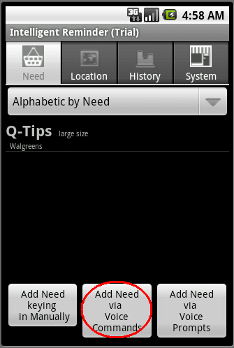
Using the following example formats, describe your need
I NEED diapers LOCATION Safeway
I NEED print cartridge DESCRIPTION hp 21 LOCATION Walgreens OR Office Depot
TALK TO Bill ABOUT application modifications

A second way is to use Voice Prompts by pressing the Add Need via Voice Prompts
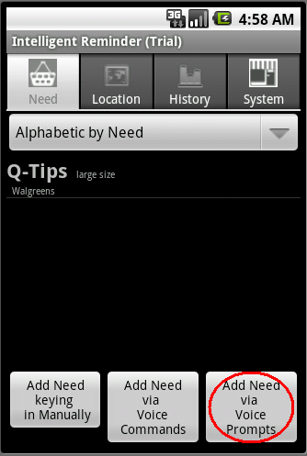
The system will voice-prompt you through the process.

Entering Locations using Voice Prompts
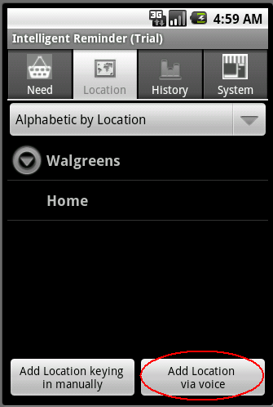
Intelligent Reminder will voice-prompt you through the steps involved in creating a Location.

Quick Start the manual entry way – 3 steps

Step 1 – Create locations
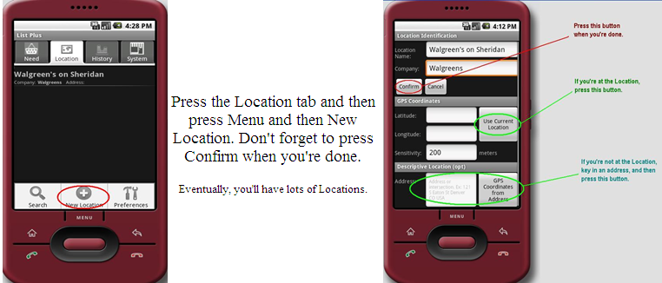

Step 2 – Create a need
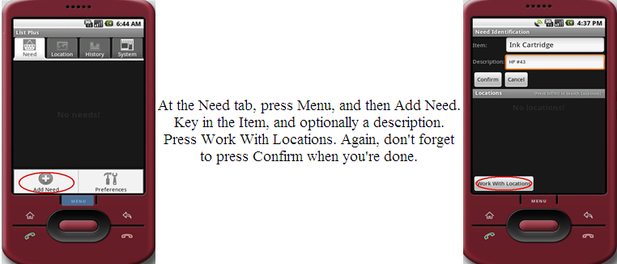

Step 3 – Associate the need with a location
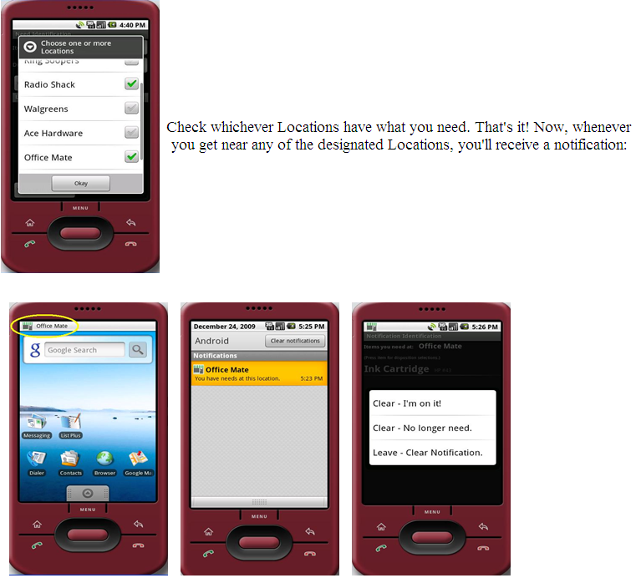

Detailed Guide

Working with Locations
Press the Location tab at the top of the screen

Creating a Location

Press the Menu button
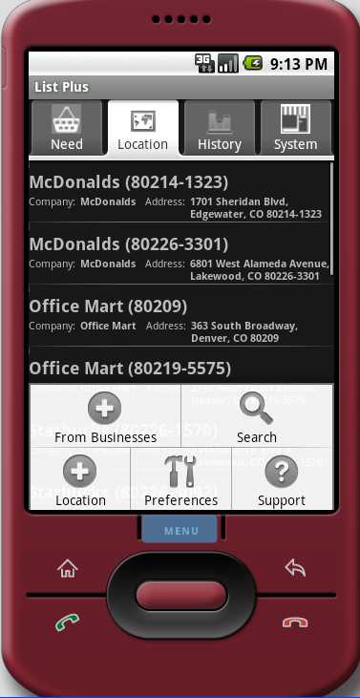

Press the Add Location Icon

At the Location screen

Adding a single Location
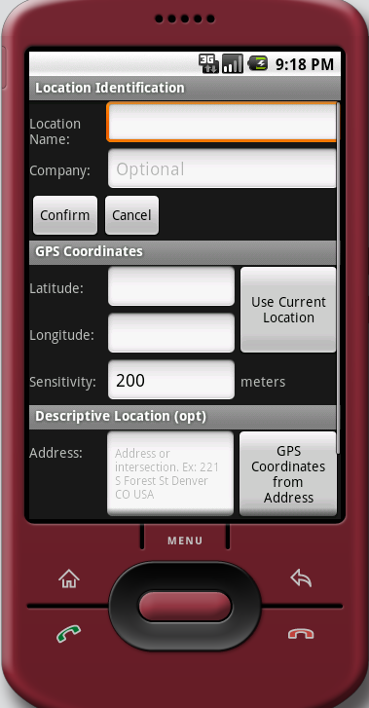

Location Name

Company
A Location refers to a specific place. It has a definite GPS longitude and latitude. There may be, however, several similar locations in where you travel; and you would be able to satisfy your need at any one of them. This is where you make this designation. So, when you associate your Need with a Company, you get alerted when you’re near any of them. (See D.(2) Adding several locations for the same business, below, to learn how to do this more efficiently).

You can specify the Location’s location in one of several ways

Press the Use Current Location button

Key in an address and press the GPS Coordinates from Address button

Key in the Latitude and Longitude

You can add a location that is associated with a Contact. In this way, the Contact’s address is used for the location.

Press the Confirm button.

Adding several locations for the same business
You can quickly add all, or several, of the locations of a given business in the vicinity of your current location. They will then be associated under a single Company name. In this manner, upon associating your Need with this single Company, you’ll receive an alert when you’re near any of them.

At the Locations tab, press the Menu and then the From Businesses button

Key in the name of the business

Specify the “search near” criteria

City and State; and/or

Zip
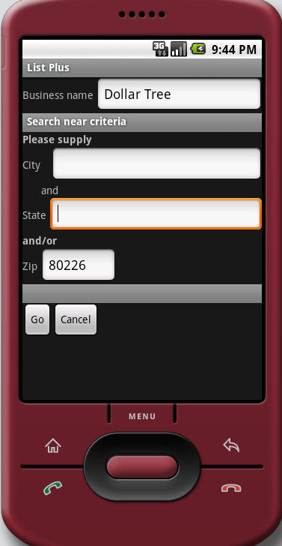

Press Go

Intelligent Reminder will present you with a list of all the Businesses with that name in your vicinity, in closest to farthest away order. Check the ones you wish to use, and press Okay. All of them will be added to your list of Locations.
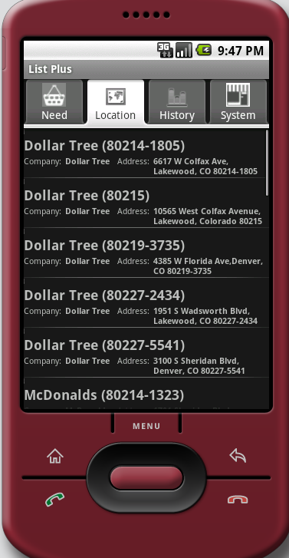

Searching for a Location
- At the Locations tab, click menu, and then the Search button
- Start keying in the Location’s need. You will be presented dynamically with a list that matches what you’ve keyed in.
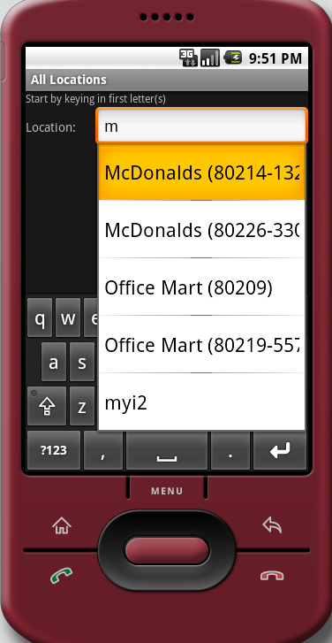

Press the one you wish to select, and then press the Confirm button. (You may have to hide your keyboard in so that the Confirm button becomes visible.)

Deleting a location
From the Locations tab, press and hold the Location that you wish to delete. Then press the Delete button.

Editing a location
From the Locations tab, press and hold the Location that you wish to edit. Then press the Edit button.

Working with Needs

At the Needs List screen

Add a Need by using the Menu or by pressing one of the three buttons at the bottom of the sceen.

Delete or Edit a need by long-pressing the need.

From the menu

From the Needs tab, press the Menu button, and then the Add Need button.

Filling in the Need
Key in the Item name and optionally a description
Note the “Private” checkbox. Intelligent Reminder allows you to share Needs securely with other designated phones. If the “Private” checkbox is checked, then this Need will not be shared.
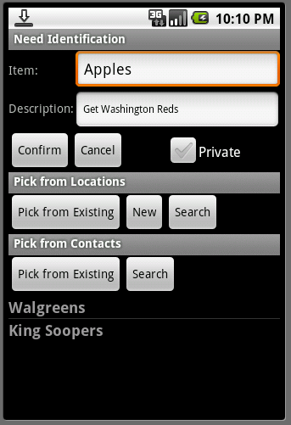

Associate the Need with a Location in one of three ways

By pressing the Pick From Existing button under the Pick From Location heading.

A Locations List appears.

Check one or more Locations, and press Okay
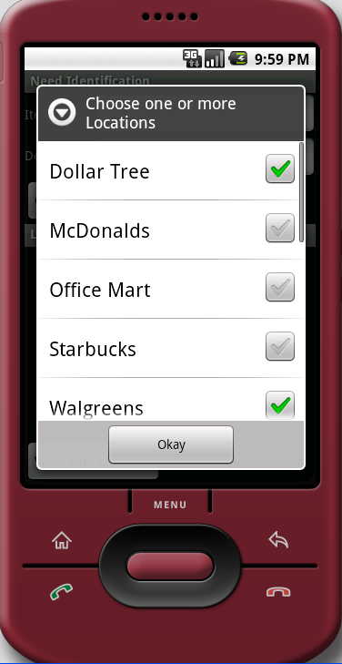

Press Confirm
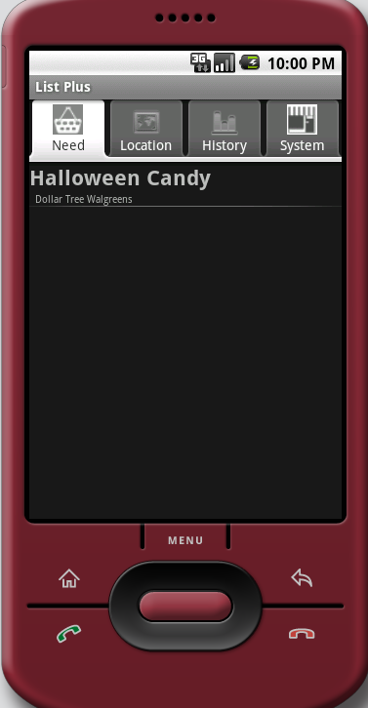

By pressing the New button, which takes you to the Location page so that you can specify the location.

Perform a search, by pressing the Search button. You are taken to a screen where as you key in letters, all matching Locations are presented

Associating a Need with a Contact in much the same fashion

Pull up a list of all your contacts by pressing the Pick from Existing button. You can choose one or more Contacts from this list

Search your Contacts directory by pressing the Search button

Alerts
When a Intelligent Reminder alert occurs, you handle it by pressing and holding the item. There are three ways to dispose of the alert.

Clear – I’m on it
The alert is cleared, and the item is deleted. The event is recorded in History (see History ,below).

Clear – No longer needed
The alert is cleared, the item is deleted, but the event is not recorded in History.

Leave – Clear notification
Clear the notification, but don’t delete the item. The next time a location is entered for that item, you will receive an alert
Note: an alert is automatically removed when you leave the vicinity of the location.

Other features

Sharing your list
You can share your lists with one or more other phones running Intelligent Reminder. When that other phone nears one of your item locations, an alert is received. Additionally, the alert indicates that it’s one of your items that is involved. Note: You have control over which Needs are shared. At the Need screen there is a Private checkbox. If it’s checked, then the Need won’t be shared; otherwise, it will.

To initiate this feature, follow these steps.

Obtain the Phone Id of a phone to which you wish to publish your data. This is obtained on at the System tab.
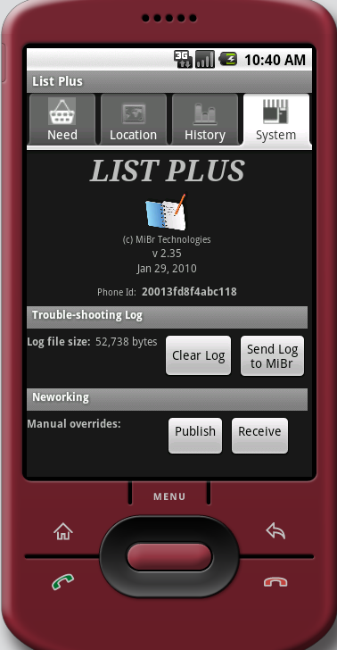

At any screen, press Menu, and Preferences. Press Their PhoneIDs
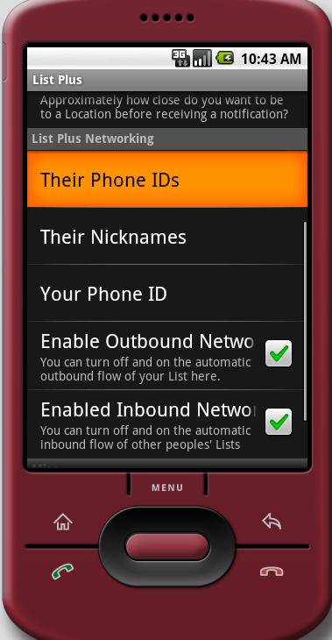

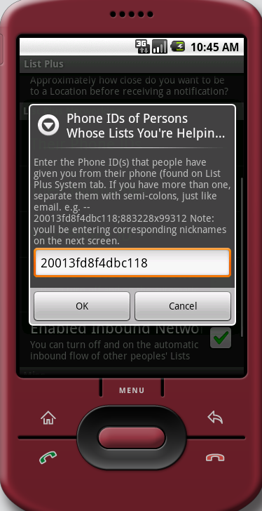

Enter the phone id and press OK. Note that you can share your Needs with several phones. To do so, separate each of the IDs with a semi-colon.

Next, associate the phone ids with a name. At the Preferences screen press Nicknames. Once the link to that phone is established, they will see your items and locations in their lists. The nickname you key in here will be displayed next to the item so that they know it belongs to you. So, too, when they receive an alert for one of your items, your name will appear next to it.
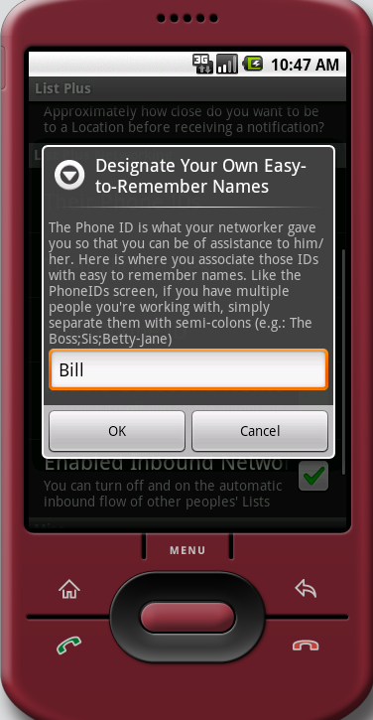
Security Note: The person you’re sharing your Needs with has to also set up your PhoneId in the same fashion. It’s a two-way agreement. Both parties have to agree to share Needs.

Publishing the Needs

You can explicitly publish shared Needs by going to the System menu and pressing the Publish button

The system can be set up to automatically publish them for you.
Go to Preferences and click Enable Outbound Network checkbox

Receiving Needs published by others.

You can explicitly receive others’ shared Needs by going to the System menu and pressing the Receive button.

The system can be set up to automatically receive them for you periodically. (About every 10 minutes)
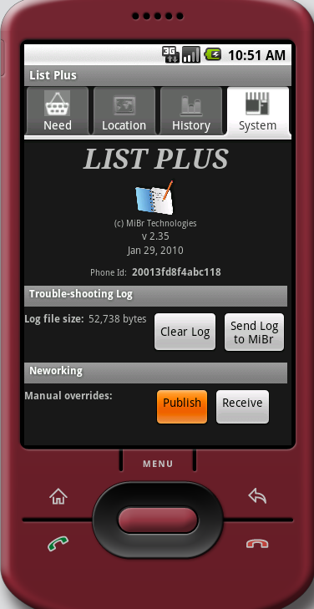

History
The History tab shows you all of the items that have been alerted on your machine, and for which you have taken the “Clear – I’m on it” disposition. It also shows you all alerts that you have received.
Key in a “from” and “to” date, and press Go
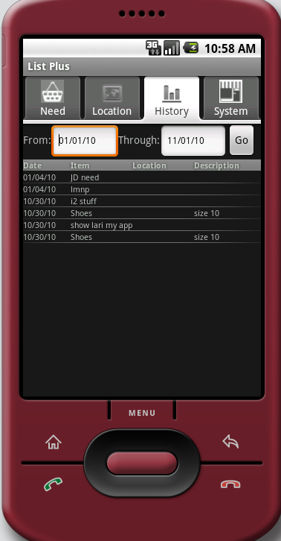

Preferences
Go to the Preferences from any screen by pressing Menu, and taking the Preferences item.

Notifications

Use sound

Use vibrate

Locations

When you create a Location, you can indicate a distance sensitivity. A default distance is established using this preference

Intelligent Reminder Networking
See a) Sharing Your List, above, for a description of these preferences.

Logging Filter
Intelligent Reminder maintains a log of events that have occurred for the application. This log can be used by the technicians of Intelligent Reminder for helping to answer questions and issues that may come up with your application. You can set the sensitivity of this log using this preference item. If you are having issues, you can transmit this log to Intelligent Reminder technicians by going to the System and pressing the Send Log button. From time to time you will want to clear the log to recover data space on your phone. This is done at the System menu by pressing the Clear Log button.
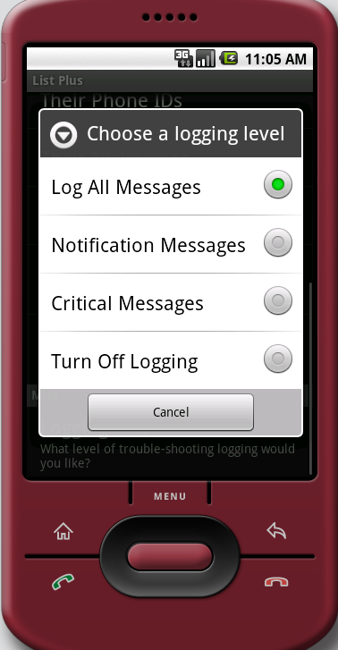

System tab
The contents at the system tab are as follows:

The version of the software

Your Phone ID … needed for list sharing (Seea) Sharing your List , above)

Trouble-shooting Log
The trouble-shooting log is used by Intelligent Reminder technicians to help resolve any difficulties you may experience with your application. If you have issues, increase the logging sensitivity (see , d), above), try to recreate the issue, and then send us the log by pressing the Send Log to MiBr, emailing us telling us your Phone ID, and describing the difficulty. Clear the log periodically to conserve space on your phone.

Networking
If you’ve shared your list with other phones, or if someone is sharing his or her list with you, these lists are automatically kept in sync periodically. If you wish to have more control over this activity, you can turn off this automation, and transmit and receive networked list here.

