Update on H20 Splash 09.05.2024

# IR Camera

An alternative to the pixel averaging approach is to draw a profile in the IR camera’s native (though proprietary) software, IRBIS 3 and conduct the analysis by taking a series of point samples along a line in this 1-dimensional data. This short document is intended to present and contrast the 2 approaches being used on the same data, so that the two approaches can help inform and validate each other.

## Overview of 1D Method

The basic idea of the 1D approach is to manually draw a line down the center of the left hand side of the manifold and basically ignore the right hand side. This is largely because the hoses on the right hand side will likely make the calculation of a meaningful average for those upper right and lower right portions of the image difficult. Furthermore, internally measured values (namely t_0Ei and t_0Eo) can in principal be used to substitute the top right and bottom right cells after some calibration and validation between outside IR measurements and inside measurements with a probe. In this regime, heat transfer rate and heat transfer coefficients can still be calculated, however only in groupings of two rows at a time. Figure 1 displays this approach, whereby a line is drawn (in black) and 7 samples along this line are taken. In theory if the line is drawn carefully and the vertical pixels are calculated accurately, the samples should be in the middle of each gasket cell where water flows out of one row and into the next.

Figure 1: Groupings of Rows and Sampling of IR Pixels

Note the idea here is to use internally sampled Pyscada data for the output of group 1 and input of group 8 respectively, which requires accurately adjusting for times. The difference between the camera time and Pyscada time appears to have been 3:18, with the IR camera ahead, or reading later. Before daylight savings time on March 31st, Pyscada was one hour behind actual time logged in the logbooks. This increased to two hours after daylight savings, but the difference to the IR camera remained constant.

Regardless of approach, the calculation of heat transfer values also requires some sort of calibration or establishment of the relationship between the blackbody temperature on the outside of the plate with the liquid temperature on the other side. This can be done either using measured knowns for t_0Eo and t_0Ei and the corresponding values from the IR camera at the metal elbows and extrapolating that out, or through a calculation using the thermal conductivity and emissivity of painted (galvanized?) steel. Ultimately the goal should be to transform whatever outside IR readings are taken to a ‘true’ working fluid temperature to accurately calculate desired physical quantities.

## Discrepancies from 1D to 2D methods

Figure 2 and Figure 3 capture the output of the two different approaches for the first image in this data set taken on 14/02/24. The first figure depicts roughly the value used for the first row in the 1D method around 16.17 C. The most immediately noticeable thing is that the 1d method has a lower reading from the 2D method with the value, and furthermore through exploration it can be seen that the values along the line never really surpass roughly 16.75 C along the line in this region, while the 2d method cites an average for that square of 17.16 C. Additionally, based on the internally measured temperature, t_0Eo of 15.07 C at the time this picture was taken, and deploying initial efforts to transform IR camera values and capture heat transfer per row, the value from the 2D approach appears to be high.

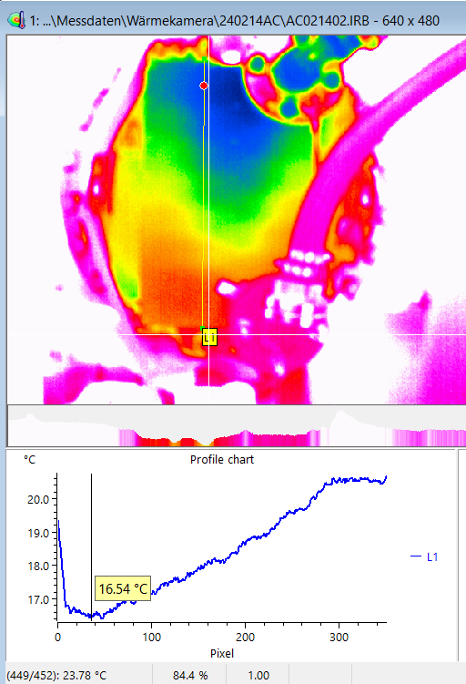

Figure 2: An illustration of the 1 D pixel sampling process for image AA021401. The sample point is depicted by the red dot in the image.

# Calculating Heat Transfer Rate and Heat Transfer Coefficients

## Estimating inside temperature from IR Samples

There are two methods that have been tried so far to estimate the inside temperature from the outside IR readings. Neither are totally satisfactory, but both are based on a heat transfer balance at the surface of the wasserkasten plate, assuming that the heat transfer across the metal plate is dominated by conduction while heat transfer to the room is dominated by radiation. The simplified steady state can then be characterized by equation

$$\frac{k(T_{IR}-T_{h20})}{x}= ∈σ ({T_{amb}}^{4}-{T_{IR}}^{4})$$

Equation 1

Where k is the thermal conductivity of the metal, x is plate thickness, ε is the emissivity of the metal (or paint) and σ is the Stefan-Boltzmann constant, And the three temperatures Tamb Tir,, ToEo. are the temperatures of the room, the blackbody temperature from the painted metal plate surface and the temperature of the water flowing behind the plate respectively.

The first approach involves manually taking samples at the outlet elbows and comaring them to internally sensed temperature data (t_0Eo and t_0Ei) and basically calculating a representative value for k/x. This can then be applied to the plate and optionally normalized. This is captured in the function, innerTempEstimatorFromKnowns(T_IR)

The other is to try to use thermal properties of the material to calculate equilibrium inside temperature from first principles innerTempEstimatorFromMaterials(T_IR). This could be further refined by adding a convective term to the right hand side of Equation 1.

A hybrid approach is to simply linearly map the values based on expected values, and results from rearranging Equation 1 into a general form for T_0Eo, and solving for coefficients based on some knowns. These can come from basically targeting realistic values for the top and bottom row groupings based on the directly measured temperatures or from unique operation conditions, for instance when the refrigerant circulation is turned off and we expect nearly zero temperature change in the upper rows. innerTempFromHandWaving() basically solves for the coefficients in eq 2 using linear algebra, and applies the values to the mapping.

$$T_{h20}={a*T_{IR}}^{4}-T_{IR}+b$$

Equation 2

# New Tray Design Proposals