How the claim overpayment scorer works
ICD-10-CM guideline navigator with MS-DRG grouping and FY 2026 IPPS pricing
Companion to guideline_navigator.html, Claims_Upload_Template.xlsx and Test_Report.xlsx · 10 October 2026

Summary
The navigator gives every claim one overpayment score from 0 to 100: the estimated chance that a review of the claim ends in an overpayment finding. Next to the score it shows the billed MS-DRG and its CMS-priced payment, the DRG and payment if the findings are upheld, the expected and maximum recovery, a one-line title, the claim's metrics and a plain-language explanation.
It reads the ICD-10-CM and ICD-10-PCS codes on each claim, checks them against the FY 2025 ICD-10-CM Official Guidelines, groups the claim with the MS-DRG v43.1 grouper (drgpy logic), and prices it at FY 2026 IPPS rates. The key step is that every finding is tested: its correction is applied, the claim is regrouped and repriced, and only findings that would lower the payment count toward the score. A guideline error that leaves the DRG unchanged is reported as a coding-accuracy issue, not an overpayment, because an overpayment review of it would close as no finding.
All automated tests pass: the grouper matched drgpy on 26,468 claims, the pricer matched an independent reference to the cent on 8,310 cases, and all 33 scenario claims produced the expected findings, DRGs, payments, scores and explanations. The scores are rule-based estimates; they have not yet been calibrated against real audit outcomes.

What goes in
One row per claim (rows with the same claim ID are combined). The upload template's Claims sheet has the 33 test claims and the column guide; the page detects the columns automatically.
Column | Needed? | Used for
claim_id | Required | Combining rows into claims
principal_dx, other_dx | Required | Diagnoses (first = principal); CC/MCC status; guideline checks
icd_procedure_codes | Optional | Surgical DRGs and procedure-linked rules
setting | Optional | Inpatient claims are grouped and priced; outpatient findings count at 10%
sex, discharge_status | Optional | Grouper (sex-specific DRGs, expired patients) and transfer pricing
los, total_charges, wage_index | Optional | Transfer per diem, outliers, claim-specific wage index
paid_amount, audit_outcome | Optional | Paid vs priced comparison; checking the score against real results

How a claim is processed
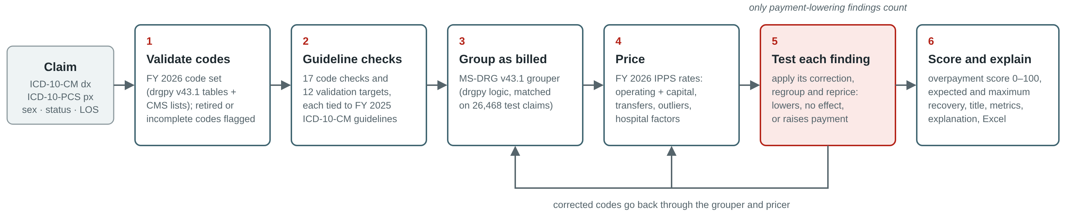
Figure 1. Each claim passes through six steps. Step 5 sends corrected versions of the claim back through the grouper and pricer.
- Validate codes. Each code is checked against the FY 2026 code set (the drgpy v43.1 grouper tables plus the CMS ICD-10-CM and ICD-10-PCS lists). Retired codes such as N18.3 (split into N18.30–N18.32) and incomplete codes such as J18 are flagged.
- Run the guideline checks. 17 claim-level checks look for code patterns the guidelines forbid or question, and 12 validation targets flag high-value diagnoses that auditors routinely confirm in the record. Each finding is linked to the guideline rule behind it and that rule's tier.
- Group the claim as billed. The MS-DRG v43.1 grouper assigns the DRG from the principal diagnosis, secondary diagnoses (CC/MCC with exclusions), procedures, sex and discharge status.
- Price it. The DRG's FY 2026 relative weight is turned into an operating and capital payment, with transfer and outlier rules and the hospital factors you enter.
- Test each finding. The finding's correction (resequence, combine, remove or downgrade a code) is applied, the corrected claim is regrouped and repriced, and the difference is recorded: lowers payment, no effect, or raises payment.
- Score and explain. Payment-lowering findings are combined into the overpayment score and expected recovery; the page writes the title, metrics and explanation, and everything exports to Excel.

The guideline checks
Code checks find patterns visible in the codes themselves. Each has a correction that is tested by regrouping.
Finding | Guideline | Type | Correction tested
External cause code as principal | I.C.20.a.6 | Error | Next non-external diagnosis becomes principal
Severe sepsis / septic shock (R65.2-) as principal | I.C.1.d.3 | Error | Systemic infection becomes principal
Underdosing code as principal | I.C.19.e.5(c) | Error | Next diagnosis becomes principal
Severe sepsis without the systemic infection | I.C.1.d.1(b) | Error | Remove R65.2-
Hypertension + heart failure coded separately | I.C.9.a.1 | Error | I10 → I11.0 (I13.x with CKD)
Hypertension + CKD coded separately | I.C.9.a.2 | Error | I10 → I12.9 / I12.0 (I13.x with heart failure)
'Without complications' code with a complication code | I.C.4.a | Error | Remove E__.9
Principal-only Z code as secondary | I.C.21.c.16 | Error | Remove the Z code
Maternal and newborn codes together | I.C.15.a.2 | Error | None (reported only)
Symptom principal with a definitive diagnosis | II.A | Review | First definitive diagnosis becomes principal
Sepsis sequenced behind a localized infection | I.C.1.d.4 | Review | Sepsis becomes principal (if present on admission)
Heart and kidney involvement not coded as I13 | I.C.9.a.3 | Review | I11/I12 → I13.0, I13.10, I13.11 or I13.2
Diabetes + CKD without the linking code | I.A.15 | Review | Use E__.22
Abnormal findings coded as diagnoses | III.B | Review | Remove R70–R94 codes
Subsequent-encounter injury as inpatient principal | I.C.19.a | Review | None (reported only)
Obstetric codes without an obstetric principal | I.C.15.a.1 | Review | None (reported only)
Several codes from one category | I.B.9, I.A.12.a | Review | None (payment effect not simulable)

Validation targets are valid codes that carry high payment weight and are often unsupported by the record. Their corrections answer the question "what if this diagnosis is not supported?"
Validation target | Guideline | Correction tested
Sepsis as principal | I.C.1.d, I.A.19 | Localized infection (or next diagnosis) becomes principal
Severe sepsis / septic shock coded | I.C.1.d.1(b) | Remove R65.2-
Acute respiratory failure as principal | I.C.10.b.1 | Next diagnosis becomes principal
Acute respiratory failure as secondary (MCC) | I.C.10.b.2, III | Remove J96.0-/J96.2-
Severe malnutrition (E40–E43) | III, I.A.19, I.B.14 | Downgrade to moderate (E44.0)
Encephalopathy | III, I.A.19 | Remove G93.4-/G92
Acute kidney failure | III, I.A.19 | Remove N17.-
Stage 3, 4 or unstageable pressure ulcer | I.C.12.a | Stage 2
Acute myocardial infarction (non-type 2) | I.C.9.e, I.A.19 | Recode to I21.A1 (type 2)
Active cancer without cancer-directed treatment | I.C.2.m | History code (Z85, no CC/MCC)
Complication-of-care code | I.B.16, I.C.19.g | Remove (or next diagnosis principal)
15 or more secondary diagnoses | III | None (payment effect not simulable)

Joint check. When two or more findings each leave the payment unchanged because another code carries the same CC/MCC level (for example severe malnutrition and encephalopathy, both MCCs), the page tests them together. If the payment drops only when all are removed, it adds a combined finding whose chance is the product of the individual chances.

The MS-DRG grouper
The grouper is the drgpy package's MS-DRG v43.1 logic (CMS definitions effective 1 April 2026), translated to JavaScript so it runs in the browser. The MDC rule files were translated mechanically from drgpy's Python source and the engine (features, CC/MCC exclusions, MDC evaluation, the three-pass severity loop and the unrelated-OR-procedure DRGs 981–989) was ported line for line.
- Inputs used: principal and secondary diagnoses, procedures, sex (default F) and discharge status (20 = expired, which drives DRGs such as 283–285).
- Not used: present-on-admission indicators (every diagnosis is treated as present on admission, so hospital-acquired-condition rules do not apply) and age (MS-DRGs do not use it).
- Validation: 26,468 claims (random, clinically coherent and targeted at every DRG family) were grouped by the page and by drgpy in Python; every DRG matched, covering 687 of the 772 MS-DRGs. Grouping takes about 0.06 ms per claim.

The pricer
The CMS IPPS Pricer itself is distributed only from cms.gov, so the page implements its payment steps with FY 2026 final-rule figures:
Operating = (labor × wage index + nonlabor × COLA) × DRG weight × (1 + IME + DSH)
labor/nonlabor = $4,456.72 / $2,295.89 when wage index > 1.0 (66% labor share)
$4,186.62 / $2,565.99 when wage index ≤ 1.0 (62% labor share)
Capital = $524.15 × wage index^0.6848 × DRG weight × (1 + cap IME + cap DSH)
Full DRG payment = operating + capital

- Weights: CMS FY 2026 final rule Table 5, weights with the 10% cap applied, plus geometric mean length of stay and the post-acute and special-pay flags.
- Transfers: per diem = full payment ÷ GMLOS; acute transfers (status 02, 66, 82, 94) and post-acute transfers on post-acute DRGs (03, 05, 06, 62, 63, 65, 83, 85, 86, 90, 91, 93) are paid per diem × (LOS + 1), capped at the full payment. Special-pay DRGs get 50% of the full payment plus 50% of the per diem × (LOS + 1).
- Outliers: cost = charges × cost-to-charge ratio. The threshold is the DRG payment plus $40,397, wage-adjusted and scaled like the payment for transfers; the outlier is 80% of cost above it (90% for burn DRGs). Outliers need a charges column and a ratio entered in the pricing settings.
- Hospital factors (wage index, COLA, IME, DSH, capital IME/DSH, cost-to-charge ratio, uncompensated care per claim) are entered in the page; a per-claim wage index column overrides the default.
- Not included: new-technology add-ons, readmission, HAC and value-based purchasing adjustments, low-volume and sole-community/Medicare-dependent hospital rates.
Example: DRG 871 (weight 1.9425) at wage index 1.0 = $6,752.61 × 1.9425 + $524.15 × 1.9425 = $13,117.00 + $1,018.16 = $14,135.11.

The overpayment score

Step 1: chance that each finding is upheld
chance upheld = base rate × (0.35 + 0.65 × strength) × (1 + 0.15 × (codes − 1))
capped at 95%; codes = number of codes in the finding (max 4)
strength = the rule's weighted metric score, scaled 0–1 across all 486 rules

Finding type | Base rate | Example chance upheld
Likely guideline error | 55% | External cause as principal: 39%; hypertension + CKD: 46%
Needs coding review | 30% | Symptom principal with AMI: 28%
Clinical validation target | 24% | Severe malnutrition: 21%
Data quality | 10% | Invalid code: 6%

The guideline strength comes from the eight metrics in the Guideline hierarchy tab (payment impact, severity, precision, specificity, strength, precedence, breadth, audit risk) with the selected weights, so changing the weights there changes claim scores.

Step 2: does it change the payment?
Result of the correction test | Weight in the score
Payment drops | 100% of the chance upheld
No payment change, or payment rises (possible underpayment) | 0%
Cannot be simulated from codes (no defined correction) | 35%
Outpatient claim (not DRG-paid) | 10%
Unspecified codes (documentation only) | 0%

Step 3: combine
Overpayment score = 100 × [1 − (1 − 2% baseline) × Π (1 − weight of each finding)]
Chance of no finding = 100 − score
Expected recovery = Σ (weight × payment drop), capped at the maximum recovery
Maximum recovery = billed payment − payment after all payment-lowering corrections

Bands: High 40 and above, Medium 25–39, Low 10–24, Minimal below 10. Claims at or above the selection threshold (default 30) are marked selected. One upheld top-tier error that lowers payment scores about 40–55; a single validation target about 20–25. You can rank claims by score or by expected recovery in dollars.

Worked example
The claim behind the page's "Try an example" button (inpatient, no procedures):
Order | Code | Description
Principal | J18.9 | Pneumonia, unspecified organism
2 | E43 | Unspecified severe protein-calorie malnutrition (MCC)
3 | N17.9 | Acute kidney failure, unspecified (CC)
4 | I10 | Essential (primary) hypertension
5 | N18.30 | Chronic kidney disease, stage 3 unspecified
6 | E11.9 | Type 2 diabetes without complications
7 | E11.22 | Type 2 diabetes with diabetic CKD

Grouped and priced as billed: MS-DRG 193, Simple pneumonia and pleurisy with MCC (weight 1.3144). Operating $6,752.61 × 1.3144 = $8,875.63; capital $524.15 × 1.3144 = $688.94; total $9,564.57.
Findings and their correction tests:
Finding | Type | Chance upheld | Correction | New DRG | Payment change | Counts as
Severe malnutrition | Validation target | 21% | E43 → E44.0 | 194 | −$3,700.23 | 21%
Hypertension + CKD not combined | Error | 46% | I10 → I12.9 | 193 | $0 | 0%
Diabetes contradiction | Error | 45% | Remove E11.9 | 193 | $0 | 0%
Acute kidney failure | Validation target | 21% | Remove N17.9 | 193 | $0 | 0%
Mostly unspecified codes | Data quality | 9% | Documentation only | — | — | 0%

Only malnutrition moves the money: without it the claim has no MCC and drops to DRG 194 (weight 0.8059, $5,864.34). The two coding errors are real but change nothing, so an overpayment review built on them would close as no finding.
Score = 100 × [1 − 0.98 × (1 − 0.2055)] = 100 × 0.2214 = 22 (Low)
Chance of no finding = 78%
Expected recovery = 0.2055 × $3,700.23 = $760.40
Maximum recovery = $9,564.57 − $5,864.34 = $3,700.23
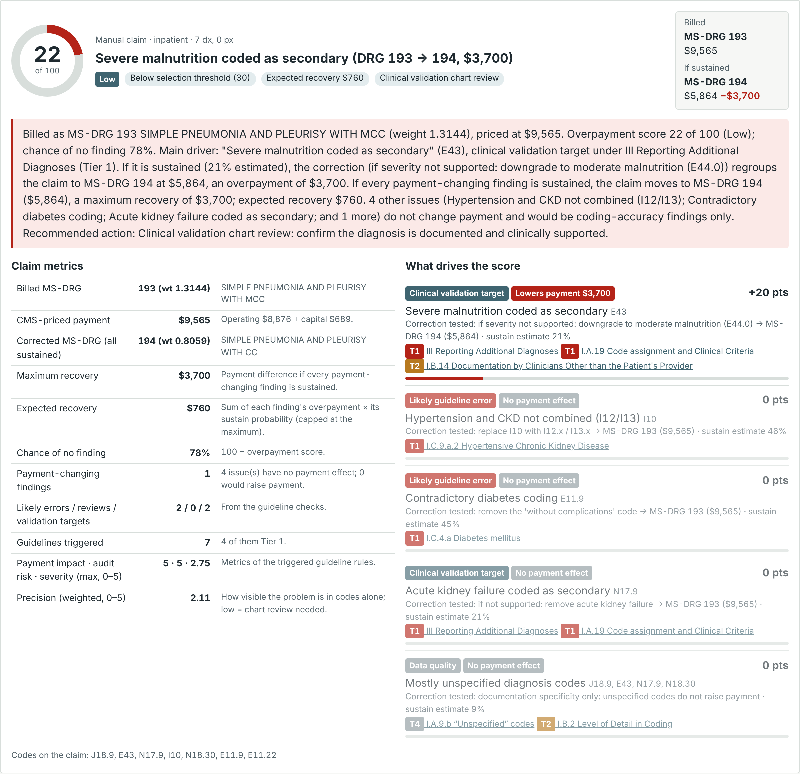
Figure 2. The score card for this claim in the page: score, title, billed and corrected DRG, explanation, metrics and the drivers with their correction tests.
Reviewer action: clinical validation chart review of E43. If the provider documented severe malnutrition and the clinical criteria support it, the claim closes as no finding; if it was moderate, the claim was overpaid by $3,700.

Reading the results
The claims tab ranks every claim and shows the billed DRG, priced payment, the DRG and payment drop if the findings are upheld, expected recovery and the title. Selecting a claim opens its score card.
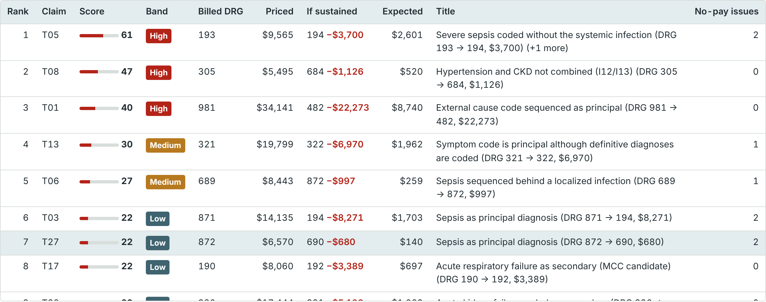
Figure 3. The ranked list for the 33 test claims at default settings.
The Excel download keeps your sheets and adds:
Sheet | One row per | Main columns
Claim_Overpayment_Scores | Claim | score, chance of no finding, band, selected, rank, title, action, explanation, billed and corrected DRG and payment, transfer, outlier, maximum and expected recovery, underpayment risk, top three drivers with their payment effect, metrics
Overpayment_Drivers | Finding type | claims, how often it lowers payment / has no effect / raises payment, average overpayment, expected recovery
Score_Bands | Band | claims, average score, expected and maximum recovery, observed outcome rate (if mapped)
DRG_Summary | Billed DRG | claims, priced payment, expected recovery, claims with a DRG drop
Scoring_Method | Setting | all formulas, base rates, weights, hospital factors and rates used for the run
Guideline_Catalog | Guideline rule | tier, score, eight metrics, plain-language summary, full text

Testing and validation
The tests load the shipped HTML file and run its own embedded code and data in Node; nothing on the page side is re-implemented. Results are compared with independent references: drgpy in Python for grouping, a separately written Python pricer, hand-specified corrections for each scenario, and an independent Python recomputation of the score. A browser test then uploads the template into the page in Chromium and compares the downloaded Excel with the Node results.
Suite | Scope | Result
Grouper parity | 26,468 claims, 687 distinct DRGs | All match drgpy
Pricer parity | 8,310 cases: all DRGs × 3 wage levels, IME/DSH, transfers, outliers | Largest difference $0.005
Pricer hand calculations | DRG 871, DRG 193 at wage index 1.25, DRG 872 post-acute transfer | 3 of 3
Scenario outcomes | 33 claims, one per rule or pricing path | 33 of 33
Scoring math | Chance upheld, weights, score, points, recoveries | 33 of 33
Explanations and titles | DRGs, amounts, driver and closing statement quoted correctly | 33 of 33
Browser test | Template upload, column mapping, scoring, settings, export vs Node | 12 of 12; 0 differences

Issues found and fixed during testing:
- Transfer status codes corrected to CMS SE1411: 05/85 (cancer and children's hospitals) are post-acute transfers; 64, 88, 89, 92 and 95 are not transfers.
- The outlier threshold for transfer cases is now scaled like the transfer payment.
- Code validity now uses the FY 2026 code set. The check caught the retired code N18.3 in the first draft of the test scenarios; they were corrected to N18.30.
- Added the joint check: in scenario T32 two MCCs each kept the DRG, so neither counted, although removing both drops the payment by $3,700.
- Unspecified codes no longer add to the overpayment score; claims whose correction would raise payment are titled as possible underpayments, and ungroupable claims say so in the title.
- Diabetes complication codes no longer trigger the "several codes from one category" flag (the guideline allows as many as needed), and categories already flagged by a specific check are not flagged twice.
- The I13 recode now picks I13.0, I13.10, I13.11 or I13.2 from heart failure and CKD stage.
- The upload now finds the claims sheet by its column headers (it had picked the instructions sheet).
- Changing the threshold no longer rescores every claim; large files score in the background with a progress count; the pricing panel and search box keep their state after repricing.
- Explanation wording fixed for counts and plurals.
Speed: full scoring including every regrouping takes about 0.2 ms per claim in Node, roughly 20–40 seconds per 100,000 claims in a browser.

Limitations and next steps
- The chance-upheld base rates are estimates. Map past audit outcomes to measure the real finding rate per driver and band, then replace the base rates; the page already reports AUC and outcome rates when an outcome column is mapped.
- Validation targets need the record. The score shows what is at stake and how likely a finding is, not whether the diagnosis is supported.
- Present-on-admission indicators are not used, so hospital-acquired-condition logic is off. Adding a POA column is the most valuable next input.
- One grouper version. All claims are grouped with v43.1 (effective April 2026) regardless of discharge date; drgpy supports v36–v43.1, so a date-based version switch is a natural extension.
- Guidelines and code set differ by year: the guideline text is the FY 2025 edition supplied; codes are validated against FY 2026.
- Pricing omits new-technology add-ons, readmission/HAC/VBP adjustments and special hospital rates, and uses one cost-to-charge ratio for outliers.
- Outpatient claims are not priced (they are paid under OPPS, not MS-DRGs); their findings are discounted to 10%.
- 467 new FY 2026 diagnosis codes have no bundled title; they are still valid and grouped normally.

Sources
- ICD-10-CM Official Guidelines for Coding and Reporting FY 2025 (NCHS/CMS, effective 1 October 2024), the PDF supplied.
- drgpy (PyPI): MS-DRG grouper, v43.1 runtime tables and logic. https://pypi.org/project/drgpy/
- CMS FY 2026 IPPS final rule, Table 5 relative weights, as bundled in the drg package (PyPI). https://pypi.org/project/drg/
- FY 2026 IPPS final rule home page, CMS. https://www.cms.gov/medicare/payment/prospective-payment-systems/acute-inpatient-pps/fy-2026-ipps-final-rule-home-page
- Missouri Hospital Association, Final FY 2026 IPPS summary (standardized amounts, capital rate, outlier threshold). https://mhanet.imgix.net/fs_public/08-03-2025-Final-FY-2026-IPPS.pdf
- Wisconsin Hospital Association, Medicare IPPS Final Rule Payment Brief FFY 2026 (federal rates, labor share). https://www.wha.org/getmedia/2841480b-ee53-42e0-8d0e-3a92f63ce568/Inpatient-PPS-Rule-Brief-FFY-2026-Final-Rule-v1_WHA-logo.pdf
- CMS MLN SE1411, IPPS transfer policy and patient discharge status codes. https://www.cms.gov/sites/default/files/repo-new/67/se1411_0.pdf
- CMS Pricer Source Code and Software (reference for the payment steps). https://www.cms.gov/PricerSourceCodeSoftware

