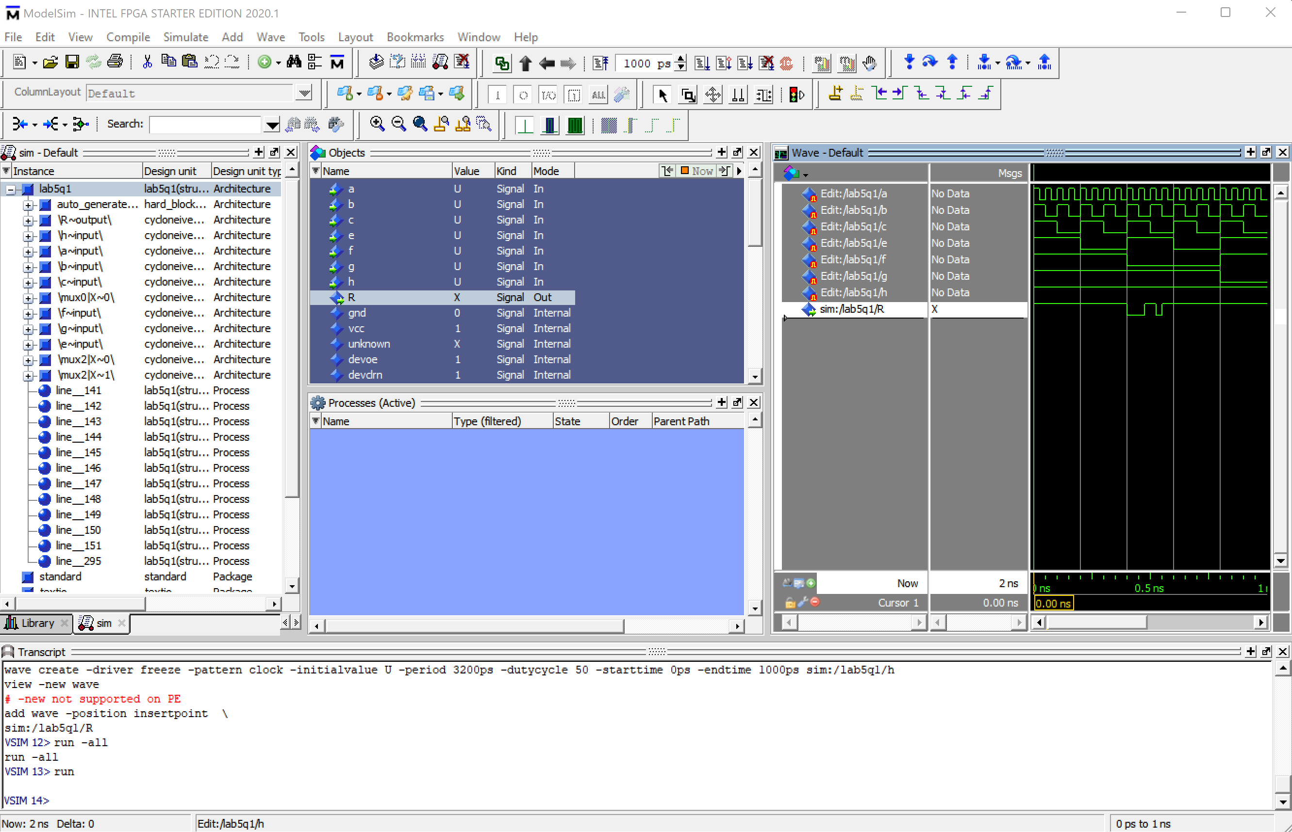

Model Sim simulation shows that the full adder is adding A (0001) and B (0001).

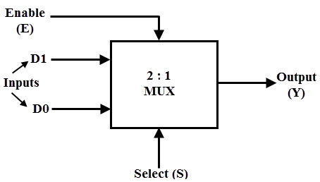

Diagram of multiplexor with VHDL code representing it.

Project uploaded to the FPGA board with B, E, and F flipped on.