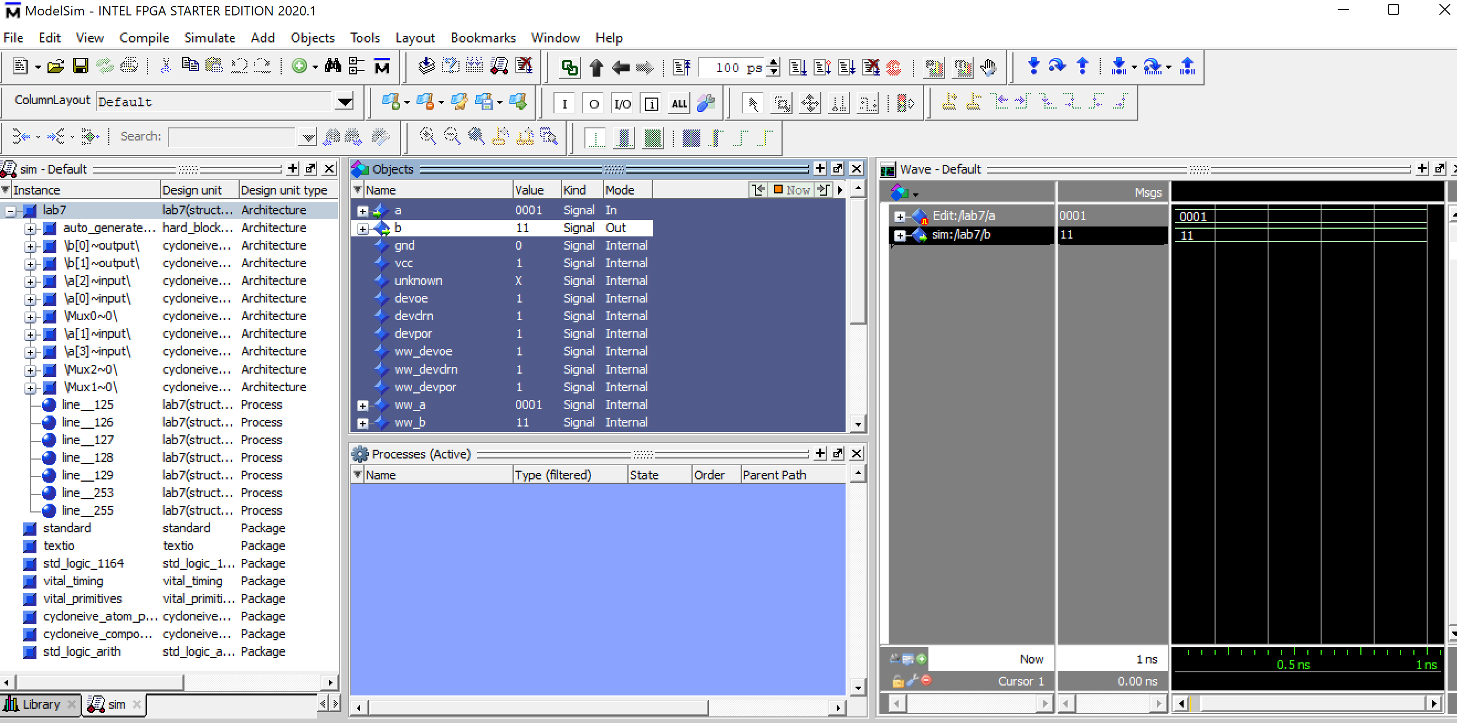

Model sim of 4:2 encoder

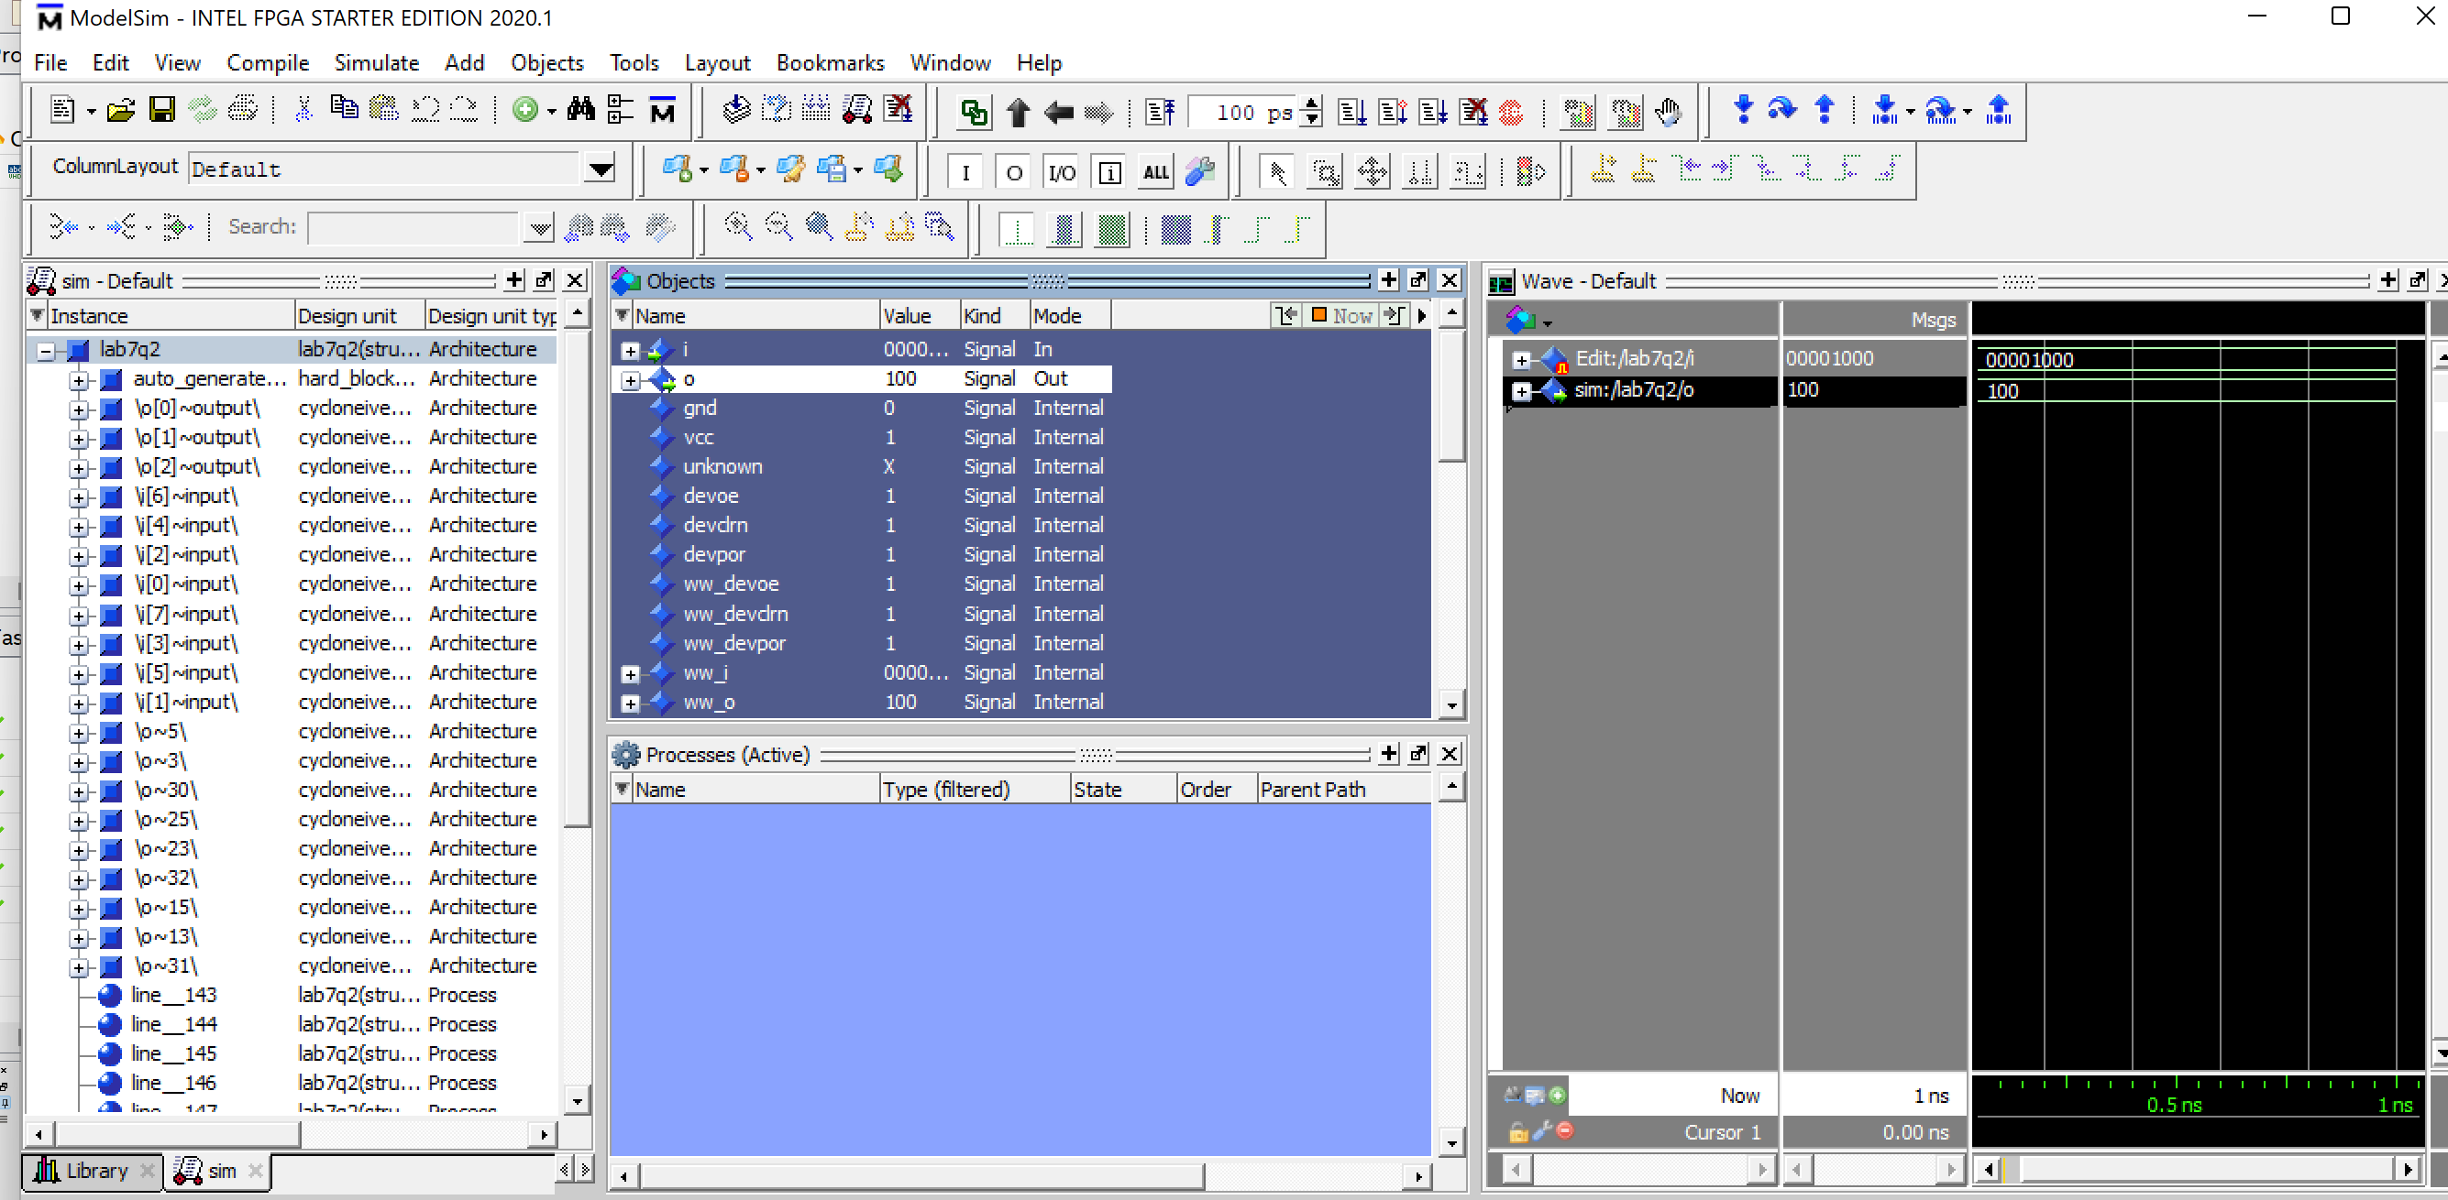

Model Sim simulation showing the waves of a 8:3 encoder using two 4:2 decoders.

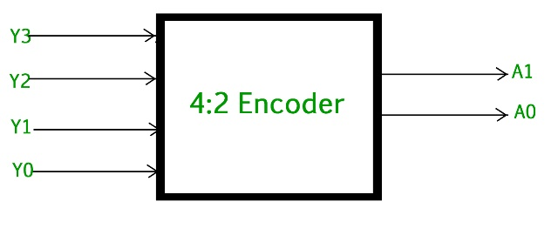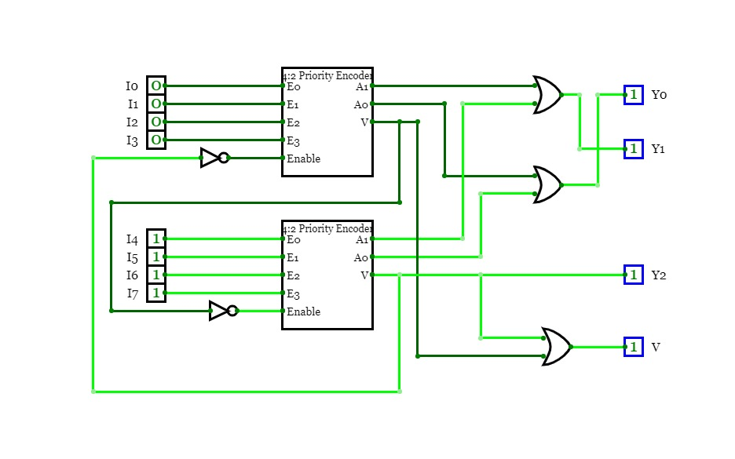

Diagram of a 4:2 encoder and a 8:3 encoder using two 4:2 encoders with VHDL code representing each.

Project uploaded to FPGA board representing i(3) being enabled which shows 011.