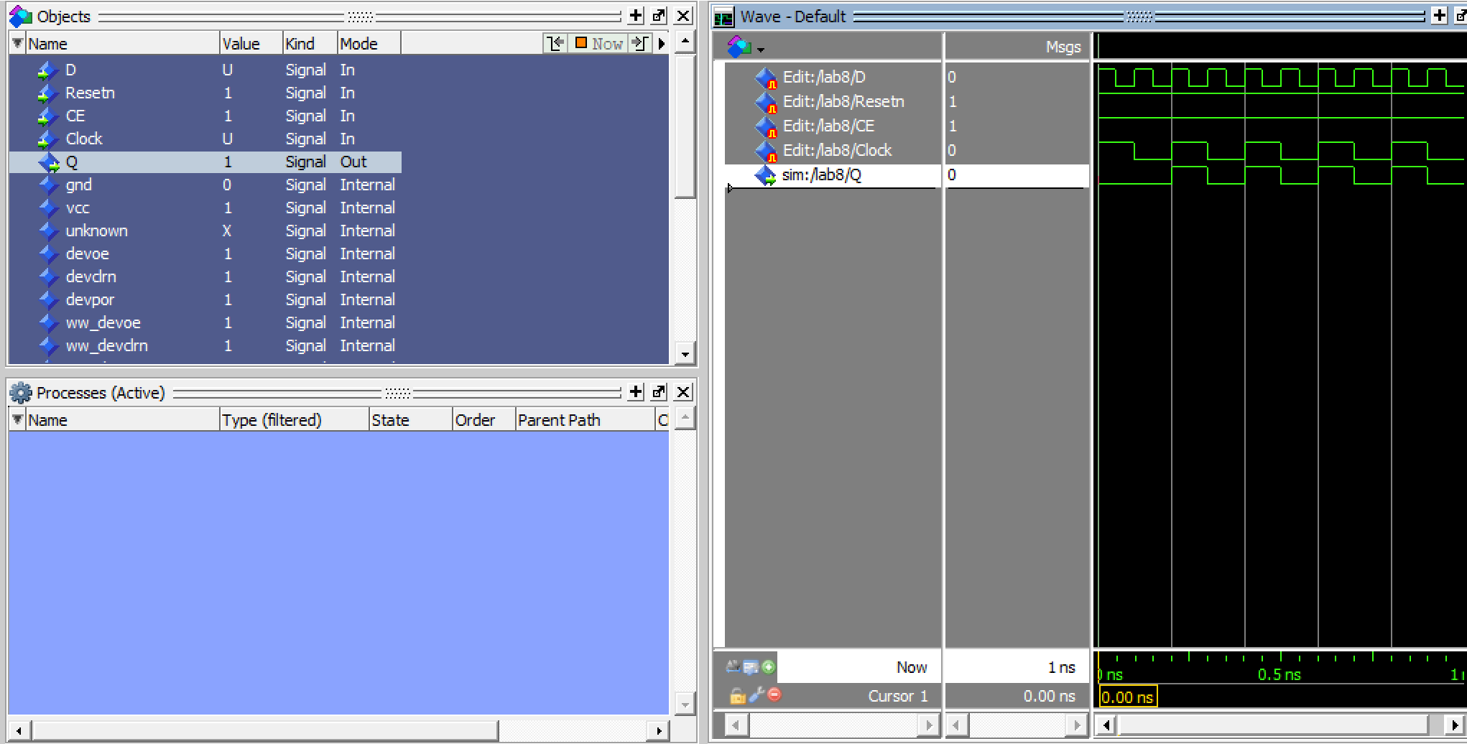

Modelsim of D flipflop

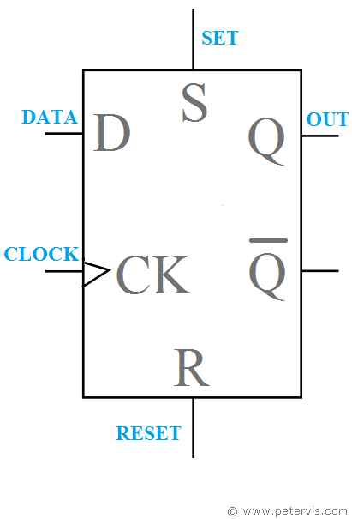

Diagram of a D flip flop with VHDL code representing it

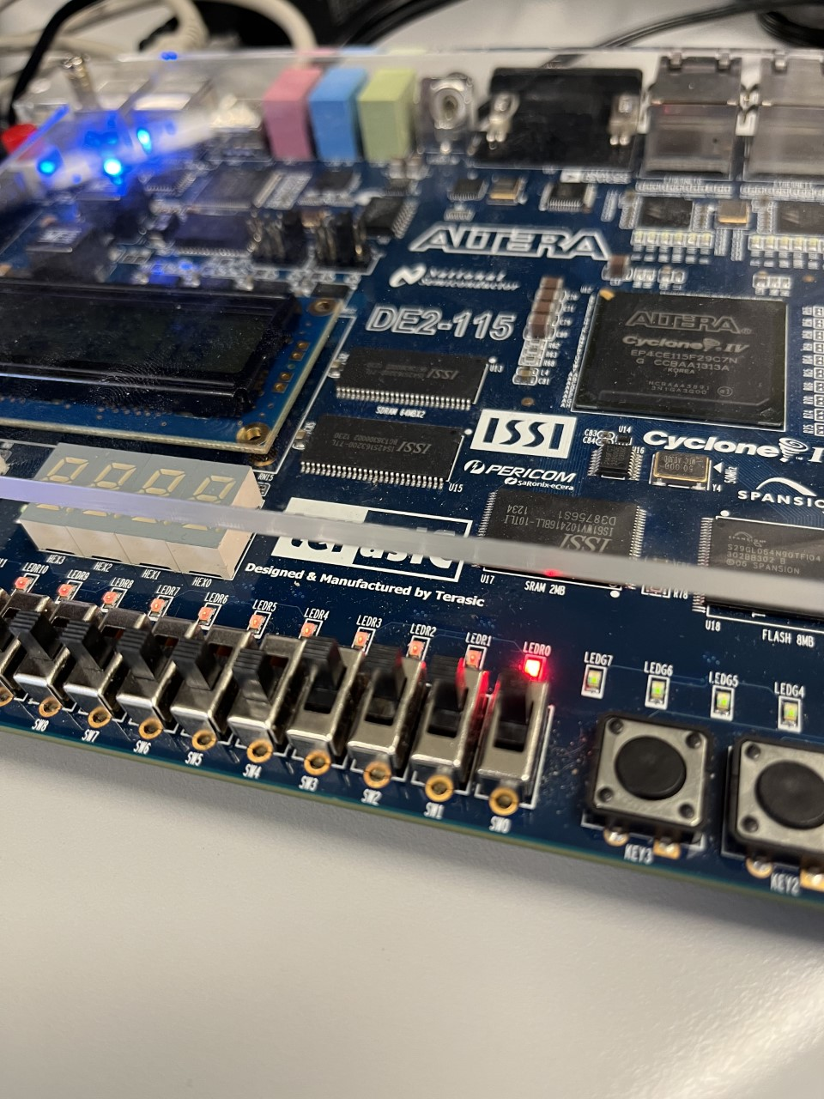

Project uploaded to FPGA board with D and clock enabled