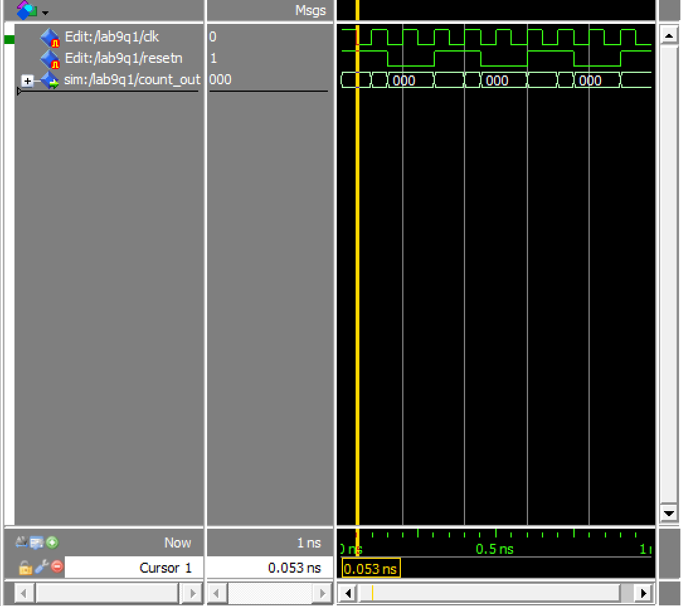

Modelsim of counter using d flip flop and counter using t flip flop

Diagram is counters using d and t flip flops

VHDL of counter using D flip flop and then counter using T flip flop

VHDL of d flip flop and t flip flop