Food

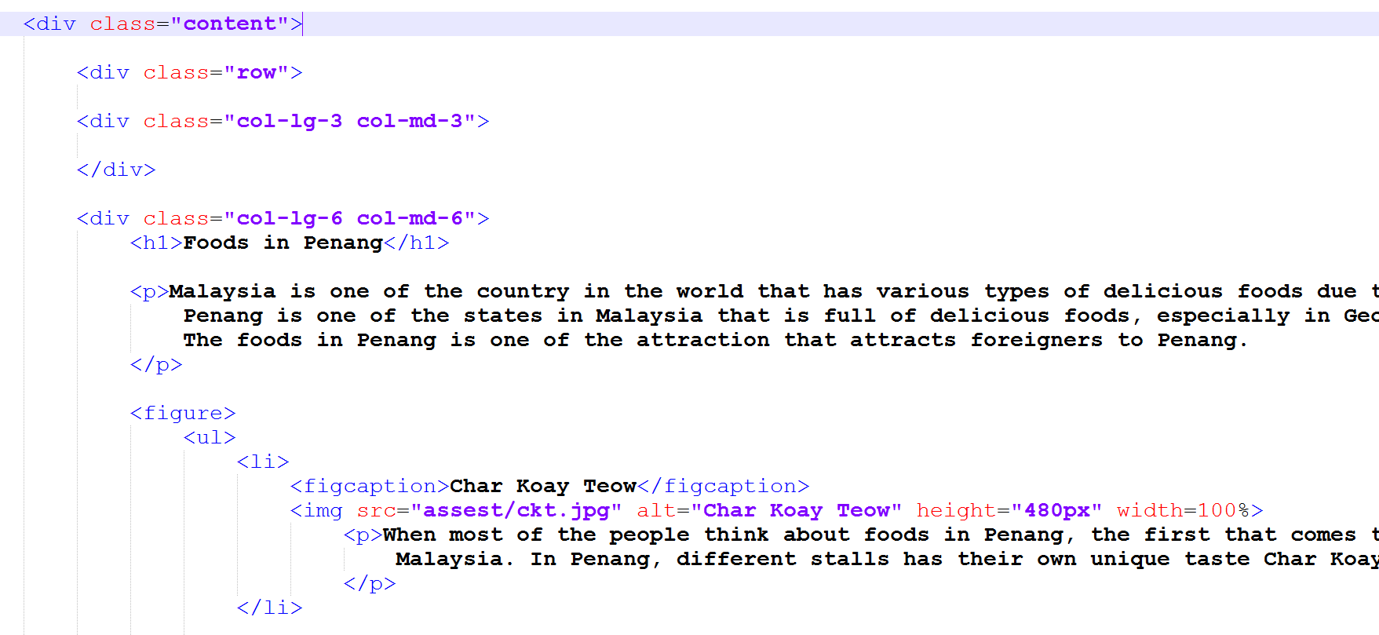In food.html webpage, flexbox grid is used to separate the webpage into 3 divisions vertically and the main content is in the second division, that is the center of the webpage while the other 2 division is left blank. The main content is in figure tag because it has images in it and every types of food is put inside an unordered list tag.

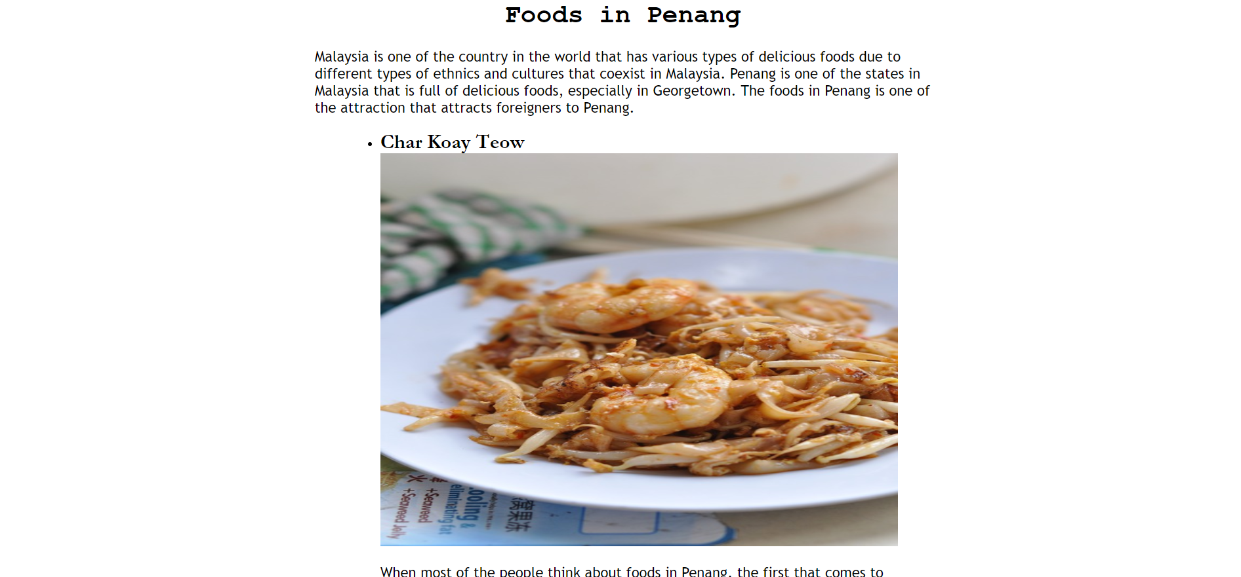

Contact

In contact.html, our group members contacts are put inside an address tag as it is used to define the contact information.