🤖 Building an Insurance FAQ Chatbot with RAG, LangChain and Azure OpenAI

Exploring how to move beyond intent training and still keep GenAI answers under control

🧭 Introduction
Several years ago, if you wanted to build a chatbot—whether using Microsoft LUIS, Google Dialogflow, or IBM Watson—you’d spend days (or weeks) defining intents, grouping utterances, and crafting entity extraction logic. And you had to make sure the distance between intents was linguistically wide enough so the NLU engine wouldn’t get confused.
This required not only domain expertise, but also a lot of training time, trial-and-error testing, and constant tweaking. And even then, the bots struggled with questions that didn’t perfectly match an intent.
Fast forward to today: with the rise of Large Language Models (LLMs) like GPT, we're seeing chatbots that can generate responses to almost any user query—even those they’ve never seen before.
But that power brings risk.
While enterprises are excited about the agility and natural understanding that GenAI offers, they’re also rightfully concerned about hallucinations—LLMs making up answers or providing misleading information. This is especially risky in regulated domains like insurance, where an incorrect answer could lead to customer confusion, compliance issues, or even liability.
So the big question becomes:
🧩 Can we enjoy the intelligence and flexibility of Generative AI, without giving up control over the answers?

🎯 The Challenge: Build a Chatbot Without Intents—But Still Stay On-Message
To explore this, I created a working prototype using a classic insurance Q&A dataset.
The goal was to build an FAQ chatbot that:
- Doesn’t require intent classification
- Doesn’t need corpus annotation or retraining
- Can answer questions in natural language
- But only responds using approved content from the dataset

🛠️ The Solution: Retrieval-Augmented Generation (RAG)
The approach I used is based on Retrieval-Augmented Generation, or RAG—a popular architecture for combining search with LLMs.
Here’s what I used:
- ✅ Azure AI Search to semantically retrieve relevant FAQ snippets
- ✅ Azure OpenAI (GPT-35-Turbo) to generate the answer
- ✅ LangChain to orchestrate the pipeline and prompt
- ✅ A structured CSV of insurance Q&A data as the knowledge source

⚙️ How It Works
- A user asks a question like:
“Is fire damage covered under home insurance?”
- The system uses Azure AI Search to find relevant FAQs based on semantic similarity, not keywords.
- The top-matching chunks are passed into a prompt that instructs GPT to:
“Only answer based on these snippets. Do not invent or guess.”
- GPT returns a helpful, fluent, and accurate response—sourced entirely from the known dataset.
No intents. No NLU. No hallucinations.

🏗️ Architecture Overview
The prototype follows a Retrieval-Augmented Generation (RAG) pattern, designed for simplicity, traceability, and real-time response.
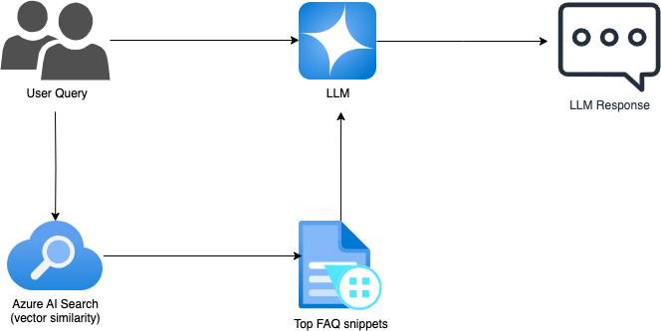
This architecture ensures that the LLM doesn't invent facts—it only uses retrieved FAQ content. The response quality is high, while the risk of hallucination is minimized.

🧰 Getting Started (in case you want to try it out)
You can clone the project and run it locally with just a few steps:
- Clone the repo
bash

git clone https://github.com/samueltin/genai_faq_chatbot.git
cd genai_faq_chatbot
python -m venv .venv
source .venv/bin/activate
- Install dependencies
bash

pip install -r requirements.txt
- Configure environment
Create a .env file with your Azure API keys, OpenAI settings, and embedding deployment name.
- Index the FAQ content
python

from app import create_vector_store
create_vector_store()
- Run the chatbot
bash

streamlit run chat_ui.py
The app supports Azure OpenAI, OpenAI (GPT-4/GPT-4o), and local Ollama models with plug-and-play flexibility.

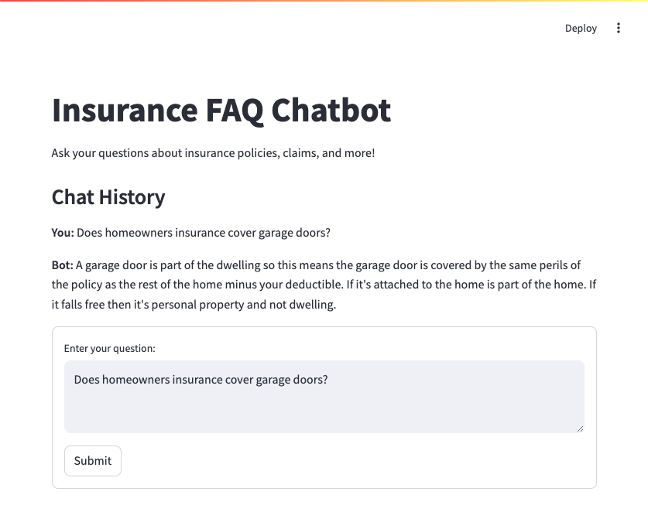

🔗 Link to the GitHub repo
👉 View the full project on GitHub

⚠️ Why Prompting Matters: LLMs Don’t Just Retrieve — They Generate
One of the key differences between traditional chatbots and LLM-powered bots is this:
LLMs don’t retrieve answers — they generate them.
That means even if you give them source material, they may paraphrase, speculate, or completely make something up if not guided carefully.
In regulated domains like insurance, this is a serious concern.
To prevent hallucinations, I made sure to explicitly instruct the LLM in my prompt:
"You must answer the user query using the exact answer from the dataset snippets and do not make up any answers."
This single line dramatically improves reliability. It tells the model not to “be creative,” but to act as a trusted assistant that sticks to verified content.
🧠 Tip for builders: Treat prompt engineering as a form of product design — not just syntax.

🧪 Model Behavior Varies — Choose Carefully
During testing, I found that not all LLMs follow strict instructions equally well. Some models tend to paraphrase or invent details, even when provided with context.
However, models like GPT-4.0 (Azure OpenAI) and Gemma-12B (via Ollama) were notably better at adhering to prompts like:
"You must answer using the exact answer from the dataset snippets and do not make up any answers."
This highlights the importance of evaluating model behavior, not just accuracy scores, when deploying GenAI solutions in sensitive domains like insurance.

💡 Key Learnings

✅ 1. Prompt Design is Crucial
Even in a RAG setup, you must clearly instruct the LLM on what it can (and can’t) do. My prompt explicitly states:
“You must answer the user query using the exact answer from the dataset snippets. Do not make up any answers.”

✅ 2. Semantic Search Outperforms Classic FAQ Matching
Even when user phrasing didn’t exactly match the original question, Azure AI Search could still find the right content. This boosts both accuracy and coverage.

✅ 3. LangChain Makes Orchestration Clean and Modular
LangChain allowed me to build reusable components for prompting, chaining, and LLM integration—perfect for extending the prototype later.

📈 Business Implications
For insurance companies (or any customer-centric organization), this kind of GenAI-powered chatbot provides:
- 💸 Reduced contact center costs — by automating Tier 1 questions
- 🧠 Better self-service experiences — no more “I don’t understand your question”
- ✅ Control and compliance — answers come from verified documents only
- ⏱️ Faster development cycles — no intent training required

📦 What’s Next
This prototype could be extended to:
- Multi-turn dialogue with memory
- Integrate with claims documentation or underwriting guides
- Deploy internally for agent enablement
- Run fully local using Ollama + LangChain + Chroma

🔚 Final Thoughts
LLMs have changed the rules for chatbot development. You no longer need to spend weeks building intent models. You just need good data, strong retrieval, and a smart prompt.
And with the right architecture, you can balance the power of Generative AI with the control enterprises demand.

If you're working on similar solutions or exploring GenAI in insurance, I’d love to connect.
Drop me a message or comment—I’m happy to share code, architecture diagrams, or lessons learned.

#AzureOpenAI #LangChain #GenAI #InsuranceTech #RAG #AIChatbot #AzureAI #EnterpriseAI #DigitalTransformation

