Basic Echo Bot:
https://docs.streamlit.io/develop/tutorials/chat-and-llm-apps/build-conversational-apps

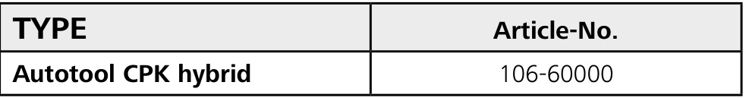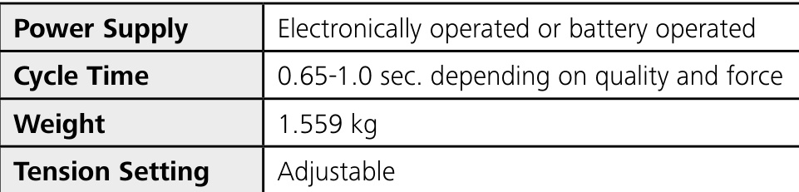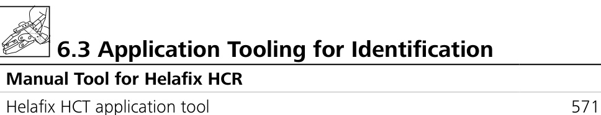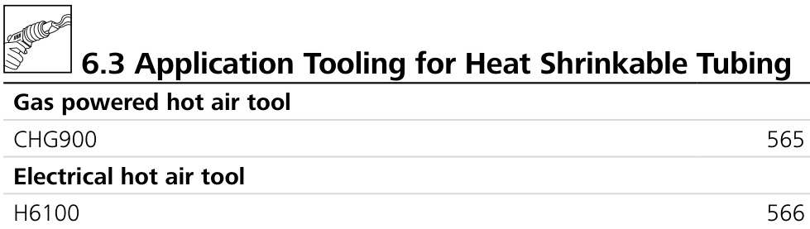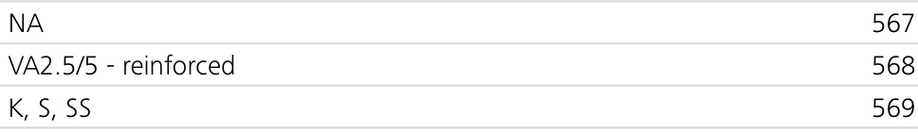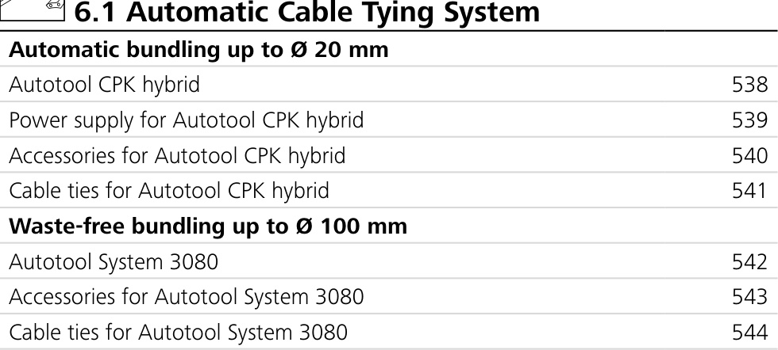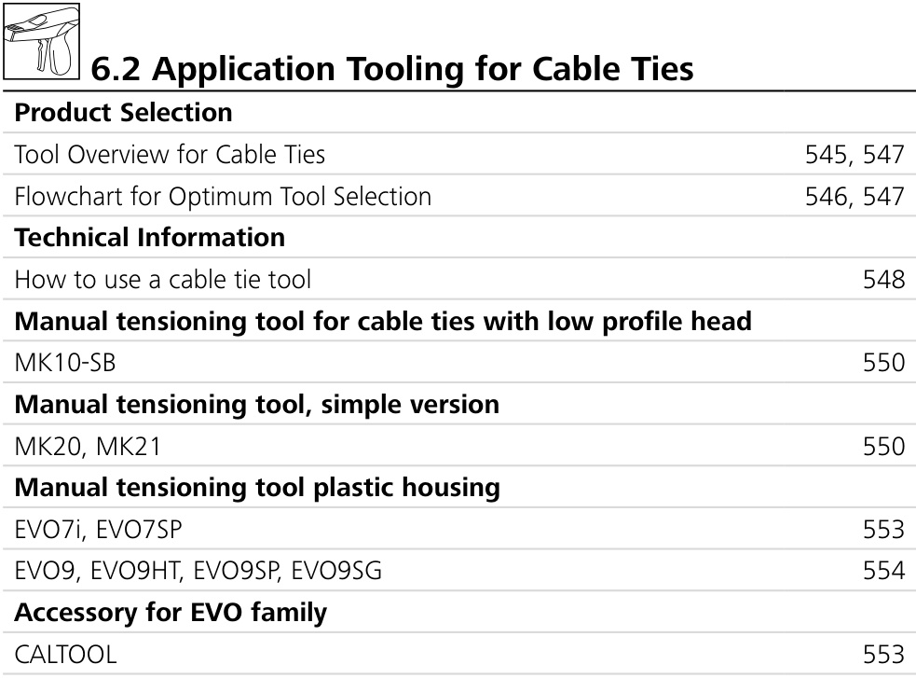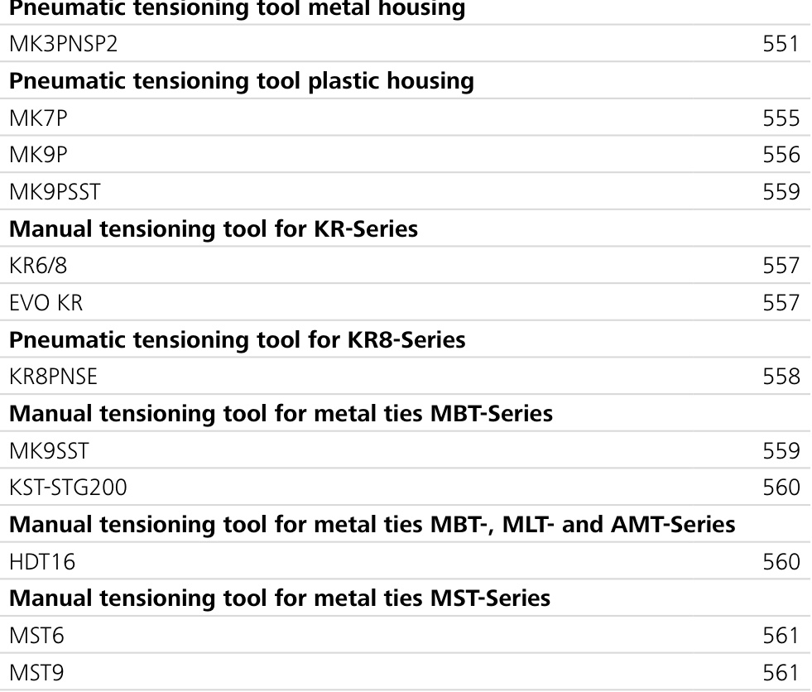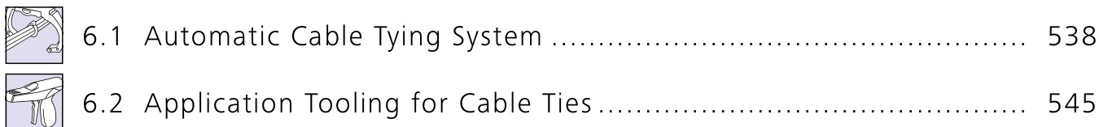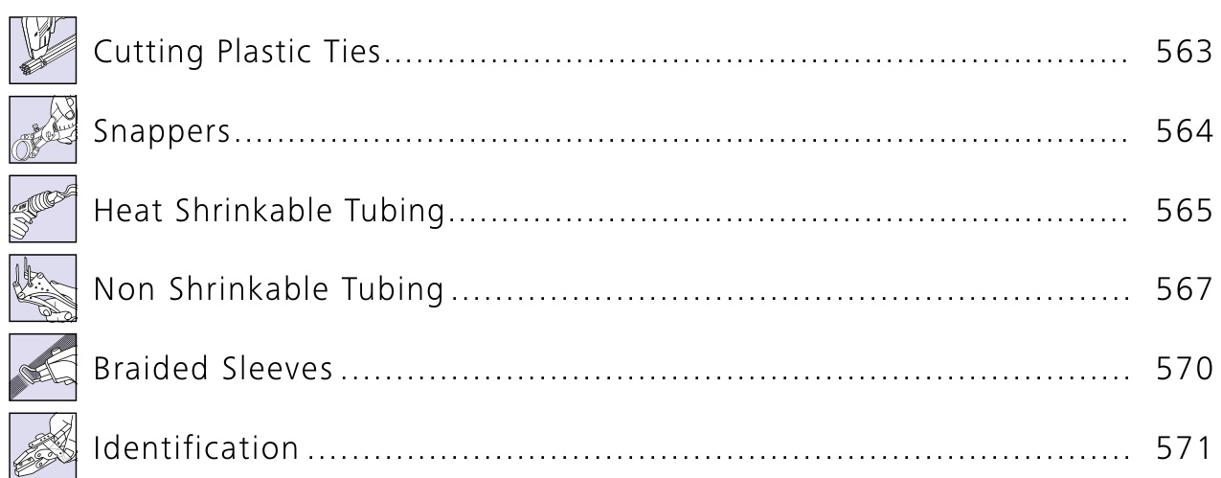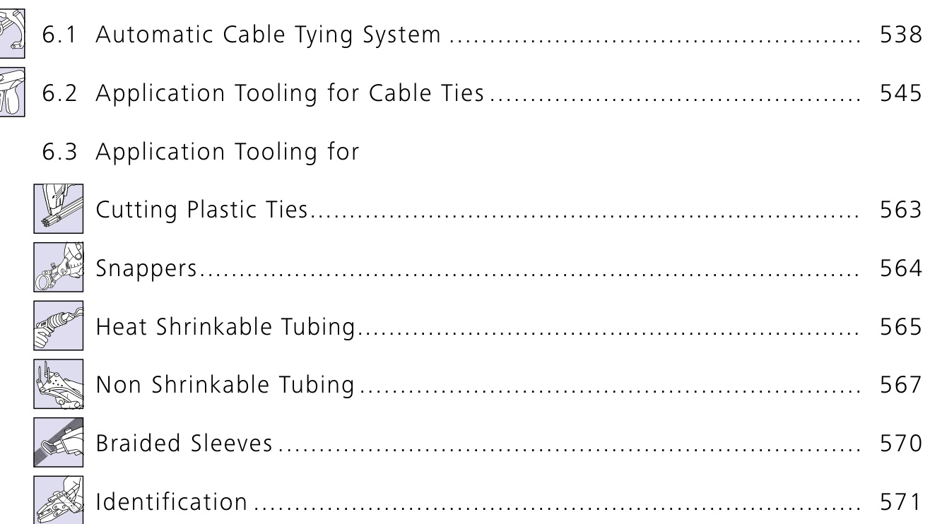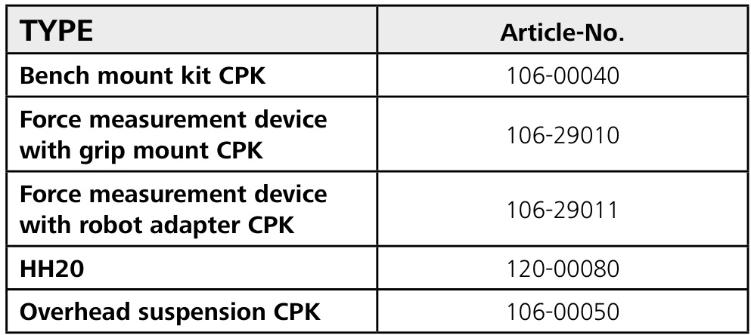

Basic Chat Bot with OpenAI:
https://docs.streamlit.io/develop/tutorials/chat-and-llm-apps/build-conversational-apps#build-a-chatgpt-like-app

Chatbot using OpenAI and Langchain:
https://docs.streamlit.io/develop/tutorials/chat-and-llm-apps/llm-quickstart

Simple RAG
https://medium.com/@shahbaz.gondal588/building-a-simple-retrieval-augmented-generation-rag-system-with-langchain-and-openai-83bcdd073dfb

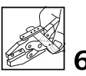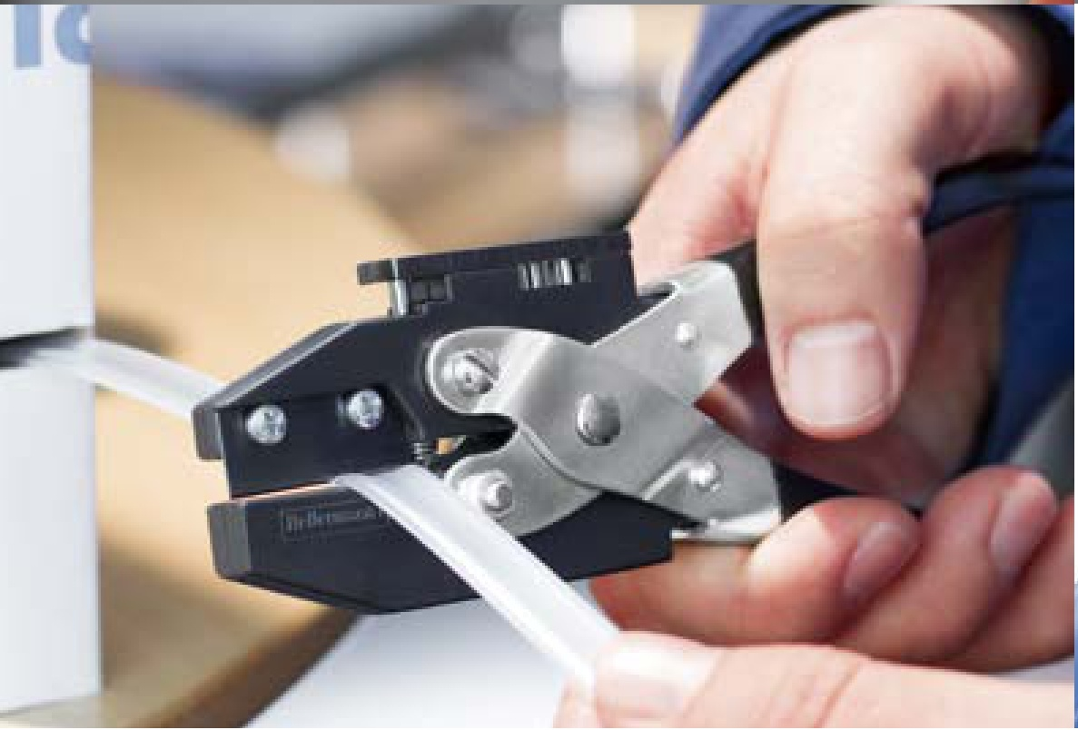

Vector Databases
https://medium.com/@EjiroOnose/vector-database-what-is-it-and-why-you-should-know-it-ae7e7dca82a4
- Just focus on chroma and faiss (2 Simple Vector Databases)

Embeddings
https://www.iguazio.com/glossary/llm-embeddings/

Types of RAG:
https://homayounsrp.medium.com/6-types-of-retrieval-augmented-generation-rag-techniques-you-should-know-b45de9071c79

