Using Big Data Analytics to improve customer Experience and Targeting in the Banking Sector

by
Samuel Ukoha, Toronto Metropolitan University, 2026

A Major Research Project
Presented to Toronto Metropolitan University
In Partial fulfilment of the requirements for the degree of

Master of Science
In the program of
Data Science and Analytics

Toronto, Ontario, Canada 2026

Samuel Ukoha 2026

AUTHOR’S DECLARATION FOR ELECTRONIC SUBMISSION OF A MAJOR RESEARCH PROJECT (MRP)
I hereby declare that I am the sole author of this major research paper. This is a true copy of the MRP, including any required final revisions.
I authorize Toronto Metropolitan University to lend this MRP to other institutions or individuals for the purpose of scholarly research.
I further authorize Toronto Metropolitan University to reproduce this MRP by photocopying or by other means, in total or in part, at the request of other institutions or individuals for the purpose of research
I understand that my MRP may be made electronically available to the public.
Samuel Ukoha
Abstract
Banks worldwide generate vast amounts of customer data through transactions, digital platforms, and marketing campaigns, yet many continue to rely on broad, inefficient targeting strategies that fail to identify customers most likely to respond to financial product offers. This study investigates how big data analytics and machine learning can improve customer experience and targeting in the banking sector, using the UCI Bank Marketing Dataset, collected from a Portuguese bank's direct telemarketing campaigns between 2008 and 2013.
Six machine learning classifiers: Logistic Regression, Decision Tree, Random Forest, XGBoost, Support Vector Machine and K-Nearest Neighbours were evaluated across three progressively refined experiments: a baseline on imbalanced data, an improved experiment with SMOTE (Synthetic Minority Oversampling Technique) applied to the training set and a final experiment with hyperparameter tuning on the top three models via GridSearchCV. All results were evaluated using Accuracy, Precision, Recall, F1-Score, and AUC-ROC and reported as Mean ± Standard Deviation across 10-fold stratified cross-validation.
XGBoost emerged as the best overall classifier, achieving the highest AUC of 0.9321 after hyperparameter tuning, an improvement of 0.13 over the best result reported by Moro et al. (2014) on the same dataset. This is the first time XGBoost has been benchmarked on the UCI Bank Marketing Dataset, establishing a new performance ceiling for classification on this data. The application of SMOTE produced the most significant finding of the study. Logistic Regression recall improved from 27.9% to 77.9%, a 50-percentage point increase and SVM recall improved from 30.9% to 78.1%. These results demonstrate that prior published studies on this dataset which did not apply class imbalance handling were significantly underestimating the potential of their models to identify actual subscribers.
Feature importance analysis using a consensus approach across Random Forest, XGBoost, and Logistic Regression identified call duration (consensus score 0.842), previous campaign outcome (0.413) and number of campaign contacts (0.359) as the three strongest predictors of subscription. The Logistic Regression coefficient for campaign contacts was negative (-7.237), providing empirical evidence that excessive customer contact reduces subscription probability. A finding with direct implications for telemarketing campaign design.
This study contributes to the literature by providing the most comprehensive classifier benchmark to date on the UCI Bank Marketing Dataset, delivering the first systematic evaluation of SMOTE's impact across six models on this data and translating predictive modelling findings into actionable customer targeting recommendations for banking practitioners. All code and results are publicly available at https://github.com/samuelukoha/Bank-Customer-Targeting.
Keywords: Big Data Analytics, Machine Learning, Bank Marketing, Customer Targeting, Classification, SMOTE, XGBoost, Random Forest, Feature Importance, UCI Bank Marketing Dataset.

Acknowledgments
I am very grateful to Professor Victor Xie at Toronto Metropolitan University for their support and assistance in making this project a reality. Professor Xie was my supervisor for this MRP; he has been a great support throughout the term to guide and direct my research and provide valuable feedback.
Thank you, Professor Xie.

Table of Contents
Author’s Declaration …………………………………………………………………………………........................................... ii
Abstract iii
Acknowledgments iv
List of Figures vi
List of Tables vii
1: Introduction ……………………………………………………………………………………………………………………. 1
  - Background …………………………………………………………………………………………………………….. 1
  - Problem Statement…………………………………………………………………………………………………….... 2
  - Research Objectives ……………………………………………………………………………………………………. 2
  - Research Questions …………………………………………………………………………………………………….. 2
  - Independent and Dependent Variables …………………………………………………………………………………. 3
  - Structure of the report ………………………………………………………………………………………………...... 3
2: Literature Review ……………………………………………………………………………………………………………... 3
3: Data Overview …………………………………………………………………………………………………………………. 6
3.1 Data Acquisition …………………………………………………………………………………………………………... 6
3.2 Data Source and Description ……………………………………………………………………………………………… 6
3.3 Data Structure and Description …………………………………………………………………………………………… 6
3.4 Class Distribution and Imbalance ………………………………………………………………………………………… 8
3.5 Key Variable Analysis …………………………………………………………………………………………………….. 9
3.6 Summary …………………………………………………………………………………………………………………. 12
4: Methodology and Experiments ……………………………………………………………………………………………… 13
4.1 Aim of Study ……………………………………………………………………………………………………………... 13
4.2 Response (Dependent) and Independent Variables 13
4.3 Outcome Measure Validation 13
4.3.1 Class Distribution Check 13
4.3.2 Feature-Target Relationship Validation 14
4.3.3 Multicollinearity Check 14
4.4 Data Preprocessing 14
4.5 Train/Test Split 14
4.6 Handling Class Imbalance — SMOTE 15
4.7 Classification Models 15
4.7.1 Justification for Model Selection 15
4.7.2 Logistic Regression (LR) 16
4.7.3 Decision Tree (DT) 16
4.7.4 Random Forest (RF) 16
4.7.5 XGBoost (XGB) 17
4.7.6 Support Vector Machine (SVM) 17
4.7.7 K-Nearest Neighbours (KNN) 17
4.8 Experimental Design 18
4.9 Cross-Validation strategy 20
4.10 Performance Evaluation Metrics 21
4.11 Benchmarking Against Published Work 21
4.12 Tools and Technologies 23
5: Results and Discussion 23
5.1 Introduction 23
5.2 Experiment 1 Results — Baseline (No SMOTE) 23
5.3 Experiment 2 Results — With SMOTE 24
5.4 Experiment 3 Results — Hyperparameter Tuning 25
5.5 Research Questions Answered 25
5.5.1 Research Question 1 — Which Classifier Produces the Highest Predictive Performance? 26
5.5.2 Research Question 2 — How Do Results Compare with Published Work? 26
5.5.3 Research Question 3 — What Is the Impact of SMOTE? 27
5.5.4 Research Question 4 — Which Features Are the Strongest Predictors? 27
5.6 Key Discoveries and New Contributions 28
5.7 Practical Implications for Banking 28
6: Conclusion and Future Work 29
6.1 Summary of the Study 29
6.2 Conclusions 29
6.3 Contributions to Knowledge 30
6.4 Limitations 31
6.5 Future Work 32
6.5.1 Excluding Duration for Practical Deployment 32
6.5.2 Testing Alternative Class Imbalance Techniques 32
6.5.3 Including Deep Learning Models 32
6.5.4 Cross-Dataset Validation 32
6.5.5 Temporal Validation and Concept Drift 32
6.5.6 Fairness and Bias Auditing 33
6.5.7 Real-Time Deployment Architecture 33
6.5.8 Comprehensive Hyperparameter Tuning Across All Models 33
6.6 Closing Statement 33
7: Appendix A — Data Field Descriptions 34
8: Appendix B — GitHub Repository 34
References ………………………………………………………………………………………………………………………… 36

List of Figures
Figure 1 — Class Distribution: Subscribed vs Not Subscribed ………………………………………………. 8
Figure 2 — Distribution of Age, Balance and Call Duration ………………………………………………….9
Figure 3 — Subscription Rate by Job Type ……………………………………………………………………10
Figure 4 — Subscription Rate by Education Level ……………………………………………………………11
Figure 5 — Correlation Heatmap of Numerical Features ……………………………………………………12

List of Tables
Table 1 – Data Variables ……………………………………………………………………………………………. 6
Table 2 – Hyperparameter search spaces for Experiment 3 ………………………………………………………… 19
Table 3 – Comparison of Study Results ………………………………………………………………….................. 21
Table 4 – Experiment 1: Test Set Results (No SMOTE) …………………………………………………………… 22
Table 5 – Experiment 1: Cross-Validation Results (Mean±Std) ……………………………………………………. 22
Table 6 – Experiment 2: Test Set Results (With SMOTE) …………………………………………………………. 23
Table 7 – Experiment 2: Cross-Validation Results (Mean±Std) ……………………………………………………. 23
Table 8 – Impact of SMOTE on Recall ……………………………………………………………………………... 23
Table 9 – Experiment 3: Test Set Results (Tuned Top 3 Models) …………………………………………………... 24
Table 10 – Experiment 3: Cross-Validation Results (Mean±Std) …………………………………………………... 24
Table 11 – Benchmarking Against Published Work ………………………………………………………………… 25
Table 12 – Top 10 Features by Consensus Importance ……………………………………………………………... 26

1: Introduction
  - Background
The rapid advancement of digital technology has fundamentally transformed the banking industry. Financial institutions now generate and store unprecedented volumes of customer data through everyday interactions from transactional records and online banking activity to mobile application usage and direct marketing campaigns [1]. This accumulation of large-scale, complex data commonly referred to as big data presents both a significant opportunity and a growing challenge for banks seeking to remain competitive in an increasingly crowded marketplace [1].
Customer experience has emerged as one of the most critical determinants of success in modern banking. With the rise of financial technology companies and digital-first banking platforms, traditional banks face mounting pressure to move beyond standardised, one-size-fits-all service delivery [2]. Customers today expect personalised, timely and relevant interactions and institutions that fail to meet these expectations risk losing them to more agile competitors [2]. In this context, big data analytics has become an essential tool for understanding customer behaviour, anticipating financial needs, and designing targeted marketing strategies that resonate at the individual level [2].
Despite the enormous volume of data available to them, many banks continue to rely on inefficient and poorly targeted marketing campaigns. Telemarketing, one of the most widely used direct marketing channels in retail banking frequently suffers from low conversion rates, high operational costs and customer dissatisfaction when calls are made to individuals who have no interest in the product being offered [3]. The ability to predict which customers are most likely to respond positively to a campaign before contact is made would represent a significant improvement in both marketing efficiency and customer experience [3].
Machine learning offers a powerful and scalable solution to this problem. By training classification models on historical customer data including demographic characteristics, financial behaviour, and previous campaign interactions, banks can identify patterns that distinguish likely subscribers from non-subscribers and use these patterns to prioritise outreach efforts [4]. However, applying machine learning to real-world banking data is not without its challenges. Class imbalance — where the number of customers who do not subscribe vastly outnumbers those who do is a persistent problem that can cause models to perform poorly on the minority class, precisely the class that matters most for marketing purposes [5].
This study investigates how big data analytics and machine learning can be applied to improve customer targeting and experience in the banking sector. Using the UCI Bank Marketing Dataset — a publicly available, real-world dataset of 45,211 records collected from a Portuguese bank’s direct telemarketing campaigns between 2008 and 2013. This research builds, evaluates, and compares six machine learning classification models. A key methodological contribution of this work is the systematic application of SMOTE (Synthetic Minority Oversampling Technique) to address class imbalance, and the evaluation of its impact on model performance relative to prior studies that did not apply this technique on the same dataset [3][4].

  - Problem Statement
Despite the increasing availability of customer data, many banking institutions still struggle to translate this data into effective, personalised marketing strategies [2]. Campaign conversion rates remain low, customer contacts are often poorly timed or irrelevant, and the insights locked within customer data go largely unexploited [1][2]. The traditional rule-based targeting approaches are no longer sufficient in a data-rich environment where customer behaviour is complex, dynamic, and influenced by a wide range of demographic, financial, and contextual factors [1].
Existing research on the UCI Bank Marketing Dataset — including the foundational study by Moro, Cortez and Rita (2014) [3] and the more recent benchmark by Tran, Le and Nguyen (2023) [4] on the credit card Churn Prediction dataset has made important progress in this area but has evaluated different and incomplete subsets of machine learning models. Neither study applied SMOTE for class imbalance handling and neither includes XGBoost — one of the most powerful and widely adopted gradient boosting algorithms in modern data science [6] in their comparison. There is therefore a clear gap in the literature for a comprehensive, unified benchmark study on this dataset that incorporates modern preprocessing techniques and a broader set of classifiers.
  - Research Objectives
The main objective of this study is to conduct an extended comparative analysis of machine learning classifiers for predicting customer subscription to banking products, and to benchmark results against published work on the same dataset.
The specific objectives are:
- To analyse customer data from the UCI Bank Marketing Dataset to identify patterns in product subscription behaviour.
- To develop and compare six machine learning classification models — Logistic Regression, Decision Tree, Random Forest, XGBoost, SVM, and KNN on the UCI Bank Marketing Dataset.
- To apply SMOTE to address class imbalance and evaluate its impact on model performance relative to prior studies that did not apply this technique.
- To benchmark results against published findings from Moro et al. (2014) and Tran et al. (2023), who used the same dataset with different model subsets.
- To identify the strongest predictors of customer subscription through feature importance analysis across models.
- To translate my findings into actionable customer targeting recommendations for banking practitioners.
  - Research Questions
- Which machine learning classifier produces the highest predictive performance for predicting customer subscription to term deposit products on the UCI Bank Marketing Dataset?
- How do the results of this extended benchmark compare with published findings from Moro et al. (2014) and Tran et al. (2023) on the same dataset?
- What is the impact of applying SMOTE for class imbalance handling on model performance compared to studies that did not apply this technique?
- Which customer characteristics are the strongest predictors of term deposit subscription, and how can these findings inform bank marketing strategies?
  - Independent and Dependent Variables
Dependent Variables
The dependent variable in this study is the binary outcome indicating whether a customer subscribed to a term deposit product, encoded as yes or no in the dataset [3]. This is the target variable that all six machine learning models will be trained to predict.
Independent Variables
The independent variables are the features used as inputs to the classification models, drawn from four categories within the UCI Bank Marketing Dataset [3]:
- Customer Demographics - Age, Job type, Marital status, and Education Level
- Financial Characteristics – Account Balance, Housing loan status and Personal loan status
- Campaign Related Features – Contact method, call duration, number of contacts in the current campaign, days since last contact and previous campaign outcome
- Socio Economic Indicators – Euribor 3-month rate, employment variation rate, consumer price index and consumer confidence index
  - Structure of the Report
This report is organised as follows. Chapter 2 presents a review of the relevant literature on big data analytics in banking and machine learning classification methods. Chapter 3 provides an overview of the dataset, including its source, structure, and key characteristics. Chapter 4 details the methodology and experimental design, including preprocessing steps, SMOTE application, model development, and evaluation framework. Chapter 5 presents the results of all experiments and benchmarks findings against published work. Chapter 6 discusses the key findings, new discoveries, and practical implications for banking practitioners. Chapter 7 concludes the study and outlines directions for future research.

2: Literature Review
The primary focus of this project is to apply machine learning classification techniques to real-world banking data to predict customer subscription to a term deposit product, and to use the results to improve customer targeting and experience in the banking sector. In this section, I provide an overview of the articles and studies used as reference for this project.
I started by reviewing articles related to big data analytics and its growing role in financial services. Chen, Mao and Liu [1] provided a comprehensive survey of big data, defining its core characteristics of volume, velocity, and variety, and demonstrating how organisations across industries are leveraging it for data-driven decision making. Kambatla et al. [8] further identified key trends in big data analytics, including the growing adoption of machine learning frameworks for real-time decisions and it is a trend directly relevant to banking institutions seeking to act on customer data at scale. Provost and Fawcett [9] argued that the true value of big data lies not in the data itself but in the analytical methods used to extract actionable insights, which underpins the approach taken in this study. Ngai et al. [7] demonstrated the power of data mining techniques in financial services, showing that machine learning methods consistently outperform traditional statistical approaches in identifying patterns in banking data, a finding that motivates the use of machine learning for customer subscription prediction in this study.
From a marketing analytics perspective, Wedel and Kannan [2] published a highly influential paper in the Journal of Marketing that provides the strategic framework for this research. They identified three key directions for marketing analytics in data-rich environments: optimising marketing-mix spending, enabling personalisation, and managing data privacy. Their work demonstrated that organisations adopting advanced analytics for customer personalisation and targeted outreach achieve significantly higher marketing returns than those that do not [2]. This is particularly relevant to the banking sector, where inefficient telemarketing campaigns result in high costs and low conversion rates. Han, Kamber and Pei [20] provided a foundational treatment of data mining concepts and techniques that informed the overall analytical framework of this research, covering the theoretical basis for classification, clustering, and model evaluation that underpins the experimental design of this study.
The most directly related study to this project is the foundational work of Moro, Cortez and Rita [3], published in Decision Support Systems in 2014. Using the same UCI Bank Marketing Dataset that this study uses, the authors applied four machine learning models — Logistic Regression, Decision Tree, Neural Network, and SVM — to predict the success of bank telemarketing calls for term deposit subscription. They found that the Neural Network performed best with an AUC of 0.80, allowing the bank to reach 79% of subscribers by contacting only the top 50% of best-classified clients [3]. Key predictors identified included call duration, Euribor rate, and bank agent experience. However, this study did not apply any class imbalance handling technique and did not include Random Forest, KNN, or XGBoost in its comparison — gaps that this study directly addresses.
A more recent benchmark study by Tran, Le and Nguyen [4], published in 2023, compared five classifiers — KNN, Logistic Regression, Decision Tree, Random Forest, and SVM — on a banking customer dataset. Random Forest achieved the highest accuracy of approximately 97%, while Logistic Regression performed at 87.27% [4]. Although this study used a different banking dataset than the UCI Bank Marketing dataset used in this research, the models tested are directly comparable and their results provide a valuable cross-dataset benchmark for evaluating classifier performance on banking classification tasks. The authors also investigated whether applying customer segmentation before prediction improved model accuracy, finding that it did not significantly impact performance. Moro et al. [3] did not apply SMOTE on the UCI Bank Marketing Dataset, and Tran et al. [4] did not apply SMOTE on the Credit Card Churn dataset. Neither study systematically evaluated the impact of class imbalance handling on classification performance
To understand which classification algorithms to use and how to evaluate them, I reviewed several foundational studies on the specific methods employed in this project. Breiman [10] introduced Random Forest — an ensemble method that builds multiple decision trees on bootstrapped samples and aggregates their predictions to reduce overfitting and improve accuracy. This method has been widely applied to banking classification problems due to its robustness and strong performance on tabular data [10][18]. Quinlan [13] established the theoretical basis for decision trees through the ID3 algorithm, showing how information gain can be used to select the most informative features at each split. Decision trees are highly interpretable, producing explicit decision rules that non-technical users can understand and act upon directly [13]. Cortes and Vapnik [11] introduced the Support Vector Machine, which finds the optimal separating hyperplane between classes in a high-dimensional feature space. It is a method that has been successfully applied to banking churn and subscription prediction problems [11][17]. Zhang [12] provided a clear and accessible introduction to the K-Nearest Neighbours algorithm, explaining how it classifies new observations by finding the most similar training examples, a simple but competitive baseline in banking classification tasks [12]. Peng, Lee and Ingersoll [19] provided a comprehensive introduction to logistic regression analysis and reporting, demonstrating its continued value as an interpretable classification method in applied research settings. Logistic regression remains particularly important in banking because its coefficients can be directly interpreted as odds ratios, making model outputs explainable to regulators and stakeholders [19][22]. Malik and Thomas [22] further demonstrated the practical value of statistical classification models in banking, applying credit risk modelling to consumer loan portfolios and showing that interpretable models continue to deliver reliable and actionable predictions in financial services contexts. Chen and Guestrin [6] introduced XGBoost, a gradient boosting framework that builds an ensemble of trees sequentially, each correcting the errors of the previous one, and which has consistently achieved state-of-the-art results on structured tabular data [6]. Despite its strong track record, XGBoost has not previously been benchmarked on the UCI Bank Marketing Dataset — an important gap this study fills.
De Caigny, Coussement and De Bock [5] proposed a hybrid approach — the Logit Leaf Model that combines Decision Trees and Logistic Regression into a two-stage algorithm. The model first uses a decision tree to segment customers into homogeneous groups, then fits a logistic regression within each segment. Benchmarked across multiple real-world datasets, the LLM outperformed both of its individual components and performed competitively with Random Forest while maintaining full model interpretability [5]. This paper is particularly relevant to this study as it demonstrates the complementary strengths of logistic regression and decision trees and reinforces the importance of interpretable models in banking applications where regulatory transparency is required.
A critical challenge in applying machine learning to banking data is class imbalance — where the number of non-subscribers vastly outnumbers subscribers, causing standard classifiers to be biased towards the majority class [14][15]. Chawla et al. [14] proposed SMOTE (Synthetic Minority Over-sampling Technique), which generates new synthetic minority class samples by interpolating between existing examples in the feature space rather than simply duplicating them. He and Garcia [15] confirmed through a comprehensive review that SMOTE consistently improves minority class recall across a wide range of classification problems. Ganganwar [21] further confirmed that SMOTE-based oversampling is among the most effective strategies for addressing class imbalance in classification datasets. Despite this, neither Moro et al. [3] nor Tran et al. [4] applied SMOTE to the UCI Bank Marketing Dataset — a significant methodological gap given that approximately 88% of customers in the dataset did not subscribe to the product. This study directly addresses that gap by applying SMOTE and systematically evaluating its impact on all six classifiers.
Several studies also demonstrated the effectiveness of machine learning for customer targeting and churn prediction in financial services and they are problems closely related to the subscription prediction task in this study. Lemmens and Croux [16] showed that ensemble methods such as bagging and boosting consistently outperform individual classifiers for customer churn prediction, particularly on imbalanced datasets — a finding consistent with the broader machine learning literature [10][6]. Coussement and Van den Poel [17] demonstrated that SVMs achieve competitive churn prediction performance in subscription services with proper feature engineering and parameter selection. Larivière and Van den Poel [18] showed that Random Forest produces robust predictions of customer retention and profitability, and highlighted feature importance analysis as a valuable tool for understanding which customer characteristics drive predictions — an approach directly incorporated into this study to translate model findings into actionable targeting recommendations.
Based on this review of the literature, it is clear that while significant progress has been made in applying machine learning to banking customer classification, no published study has compared all six classifiers used in this research — Logistic Regression, Decision Tree, Random Forest, XGBoost, SVM, and KNN on the UCI Bank Marketing Dataset in a single unified study. Furthermore, neither of the two key published benchmarks applied SMOTE for class imbalance handling. This study addresses both gaps by conducting the most comprehensive classifier comparison to date on this dataset, applying SMOTE, and benchmarking results directly against the published findings of Moro et al. [3] and Tran et al. [4] to demonstrate the contribution of this extended benchmark.

3: Data Overview
3.1. Data Acquisition
The dataset used in this study is the UCI Bank Marketing Dataset, obtained from the UCI Machine Learning Repository — It is a publicly available collection of datasets widely used for machine learning research and benchmarking [3]. The dataset was originally collected and published by Moro, Cortez and Rita [3] as part of their 2014 study on predicting the success of bank telemarketing campaigns. It is freely accessible online and has been used extensively in published academic research, making it a well-validated and reliable source of real-world banking data [3][4].
3.2. Data Source and Description
The dataset contains 45,211 records representing individual customer contacts made during direct telemarketing campaigns conducted by a Portuguese banking institution between May 2008 and November 2010 [3]. Each record corresponds to a single phone call made to a customer, and the target variable indicates whether that customer subscribed to a term deposit product following the contact.
The dataset is structured as a flat tabular file with 17 input features and 1 binary target variable. It contains no missing values, making it suitable for direct use after preprocessing and encoding [3][20].
3.3. Data Structure and Description
The 17 inputs features are organised into four categories as described in Table 1 below.
Table 1 – Data Variables
Category | Variable | Description
Customer Demographics | Age | Customer’s Age
 | Job | Type of job (Admin, Technician,etc)
 | Marital | Marital Status (Single, Married, Divorced)
 | Education | Level of Education (Primary, Secondary, Tertiary)
Financial Status | Default | Credit in Default (Yes/No)
 | Balance | Average annual account balance (Euros)
 | Housing | Housing loan? (Yes/No)
 | Loan | Personal loan? (Yes/No)
Campaign Information | Contact | Contact Communication type (Telephone, Cellular)
 | Day | Last contact day of the month
 | Month | Last contact month of the year
 | Duration | Last contact duration in seconds
 | Campaign | Number of contacts during this campaign
 | Pdays | Days since last contact from previous campaign
 | Previous | Number of contacts before this campaign
 | Poutcome | Outcome of previous marketing campaign
Target Variable | Y | Has the client subscribed to a term deposit? (Yes/No)

The target variable y is binary — encoded as yes (subscribed) or no (did not subscribe). This is the outcome that all six machine learning classifiers in this study are trained to predict [3].

3.4 Class Distribution and Imbalance
One of the most important characteristics of this dataset is its significant class imbalance. As shown in Figure 1 below, most customers did not subscribe to the term deposit product.
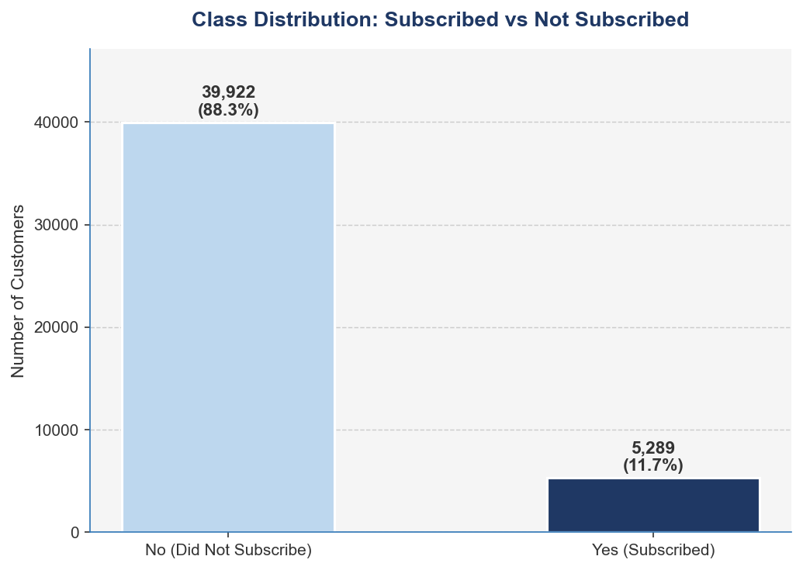
[Figure 1 — Class Distribution: Subscribed vs Not Subscribed] A bar chart showing count of 'yes' (~5,289, 11.7%) vs 'no' (~39,922, 88.3%)
Approximately 88.3% of records belong to the negative class (did not subscribe), while only 11.7% represent the positive class (subscribed). This severe imbalance poses a significant challenge for standard machine learning algorithms, which tend to be biased towards predicting the majority class resulting in high overall accuracy but poor recall for the minority class that matters most for marketing purposes [14][15].
This is a key methodological finding that motivates the application of SMOTE in this study. Neither Moro et al. [3] nor Tran et al. [4] addressed this imbalance in their published benchmarks on the same dataset making the class imbalance handling in this study a direct and measurable improvement over prior work [14].

3.5. Key Variable Analysis
To better understand the dataset before modelling, the distribution of key variables was examined. Figure 2 below shows the distribution of three important numerical features — age, account balance, and call duration.
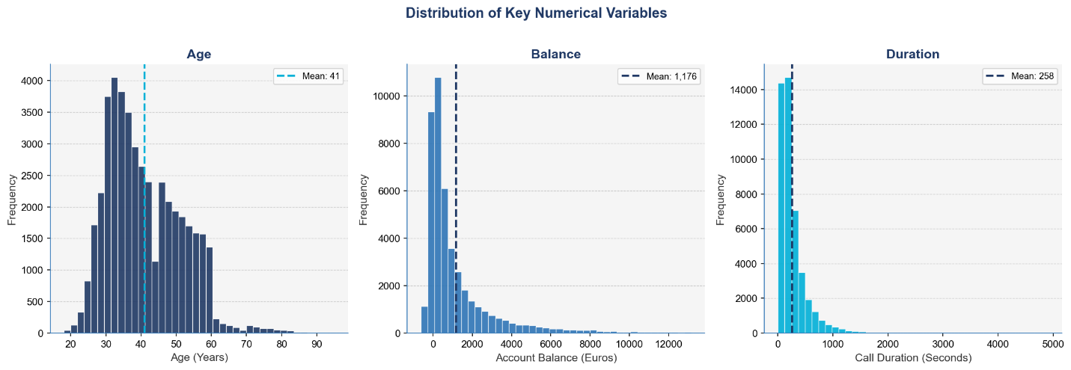
[Figure 2 — Distribution of Age, Balance and Call Duration] Three histograms showing distribution of Age, Balance and Call Duration
The age variable ranges from 18 to 95, with a mean age of 41 years and most customers falling between 25 and 55 years old and it is consistent with a working-age customer base typical of retail banking [3]. Account balance shows a right-skewed distribution with a mean of €1,176, though some customers carry negative balances, indicating overdraft accounts. The long right tail confirms that a small number of high-balance customers are present in the dataset. Call duration is heavily right skewed with a mean of 258 seconds, with most calls lasting under 500 seconds and a small number of notably longer calls extending beyond 4,000 seconds. The distribution of call duration is of particular interest as confirmed by the correlation heatmap in Figure 5, duration has the strongest individual correlation with the subscription outcome (0.39), consistent with the findings of Moro et al. [3].

Figure 3 below examines subscription rates across different job categories, revealing clear differences in how customer occupation relates to the likelihood of subscribing.
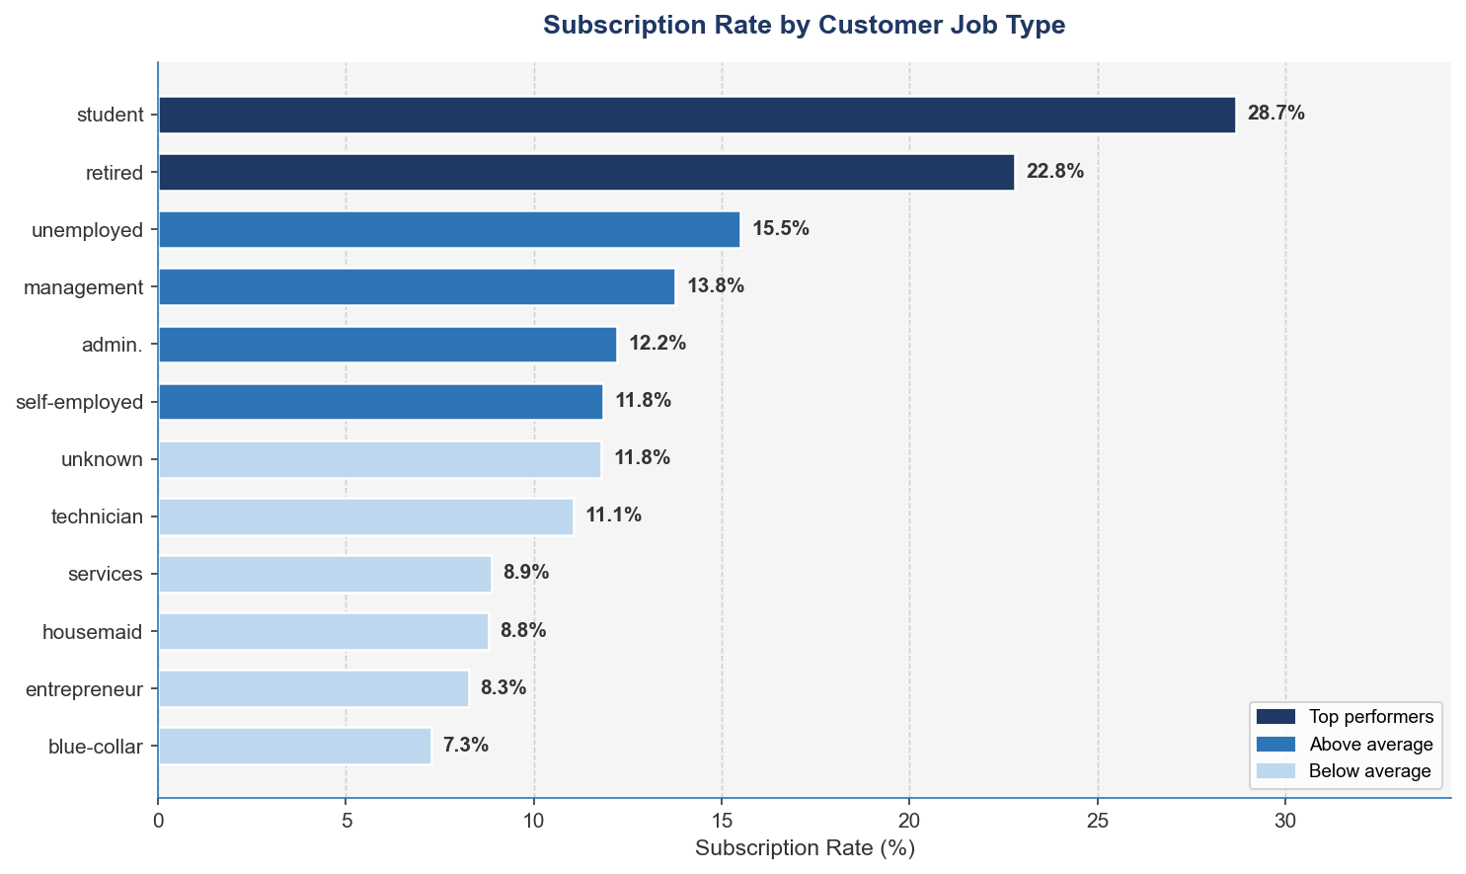
[Figure 3 — Subscription Rate by Job Type] A horizontal bar chart showing subscription rates per job category
Students and retired customers show the highest subscription rates, while blue-collar workers show the lowest. This pattern suggests that customers with more flexible financial situations and fewer financial commitments are more receptive to term deposit products. A finding consistent with the demographic analysis of banking campaign data in prior literature [2][7].

Figure 4 below shows the relationship between education level and subscription rate.
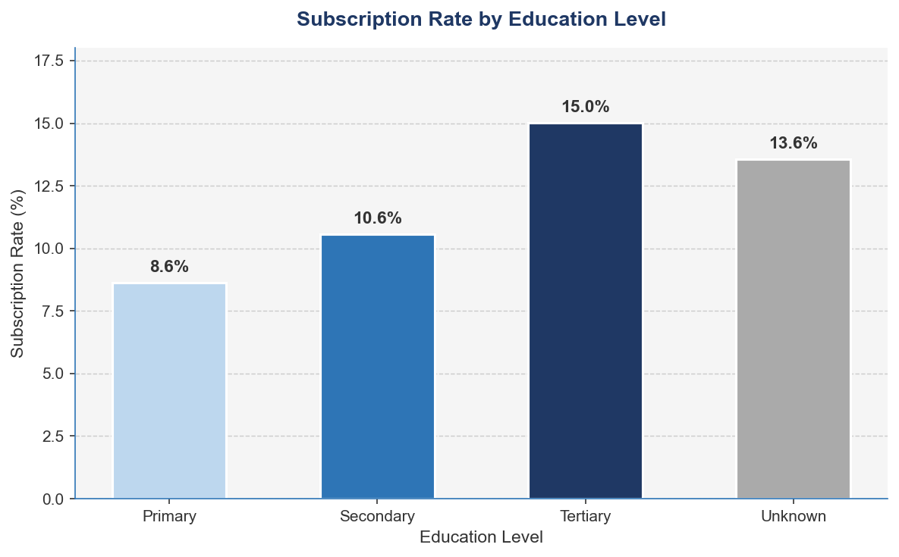
[Figure 4 — Subscription Rate by Education Level] A bar chart showing subscription rates by education level
Customers with tertiary education show the highest subscription rates, followed by those with secondary education. This finding supports the argument that education level is a meaningful predictor of financial product uptake and should be retained as a feature in the classification models [3][20].

Finally, Figure 5 presents a correlation heatmap of the numerical features in the dataset.
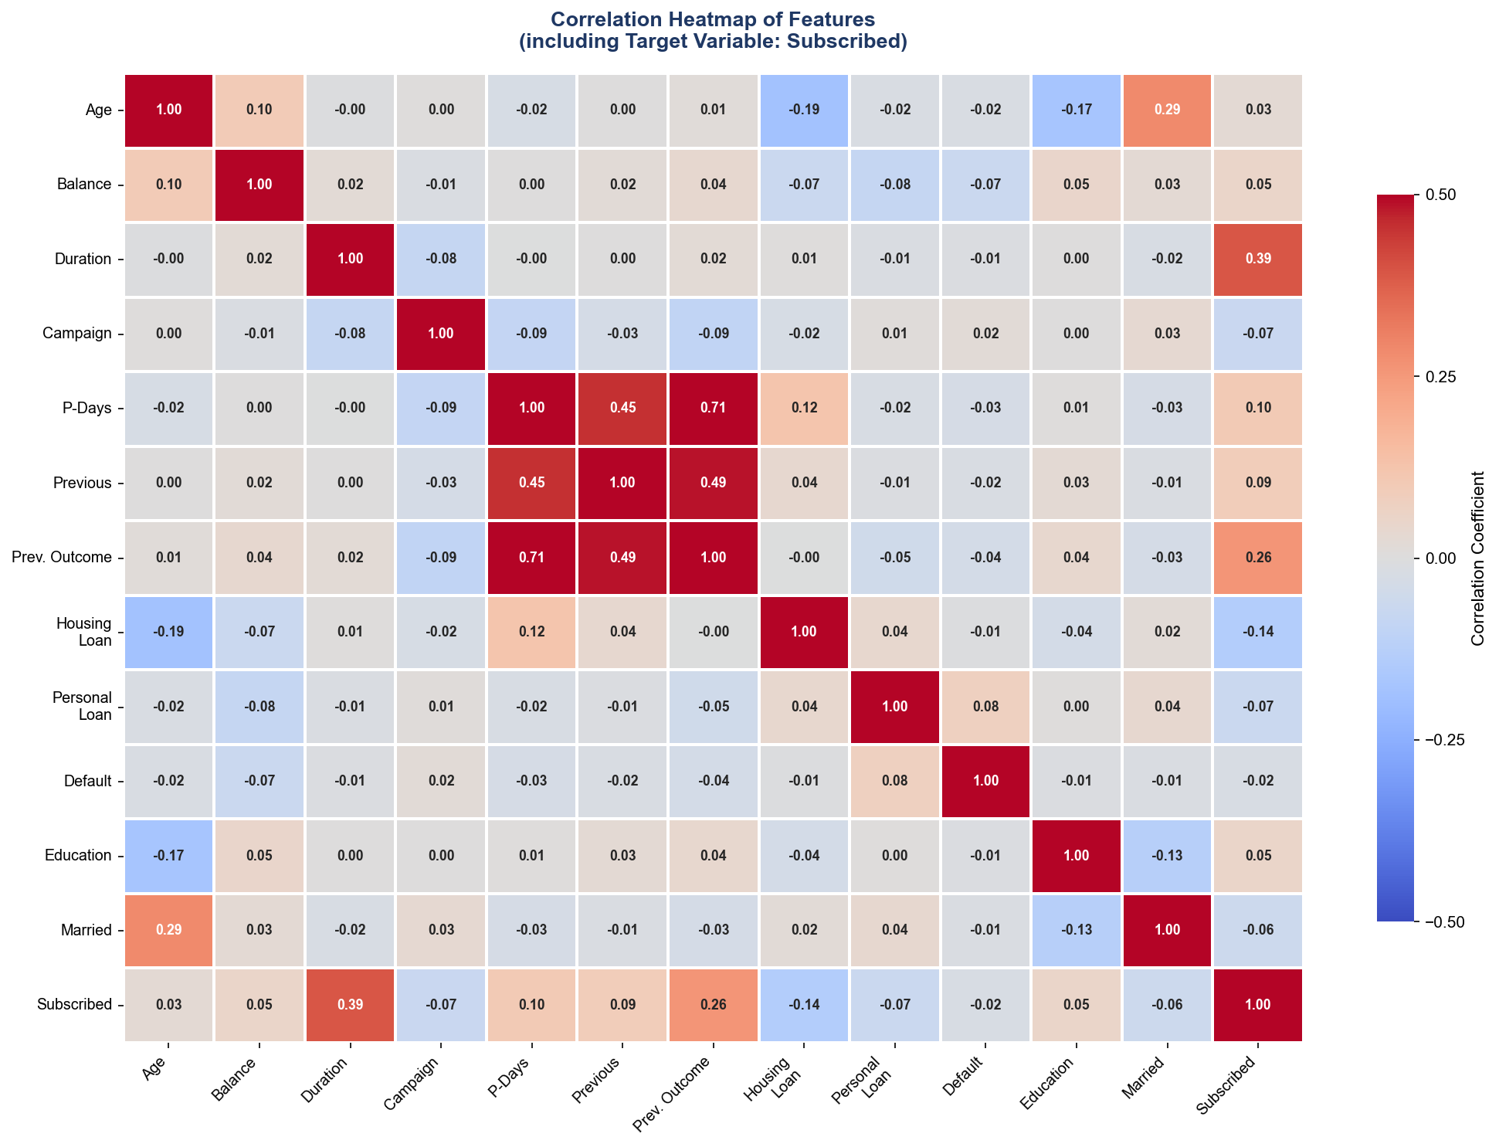
[Figure 5 — Correlation Heatmap of Numerical Features]
The correlation analysis reveals that call duration has the strongest individual correlation with the target variable. The number of days since the previous campaign contact (pdays) and the outcome of the previous campaign (poutcome) also show notable relationships with subscription likelihood. These findings are consistent with Moro et al. [3] and inform the feature engineering and selection decisions that will be described in Chapter 4.
3.6 Summary
This chapter described the UCI Bank Marketing Dataset — its source, structure, variables, class distribution, and key characteristics. The most important finding is the severe class imbalance, with only 11.7% of customers having subscribed to the term deposit product. This imbalance directly motivates the application of SMOTE in the methodology described in Chapter 4. The variable analysis also confirmed that call duration, job type, education level, and previous campaign outcome are among the most informative features for predicting customer subscription, Findings that align with prior published work on the same dataset [3][4] and that guide the experimental design in Chapter 4.

4: Methodology and Experiments
4.1. Aim of Study
The aim of this study is to build, evaluate and compare six machine learning language classification models for predicting customer subscription to bank term deposit products using the UCI Bank Marketing Dataset. The study extends the benchmarks established by Moro et al. [3] and Tran et al. [4] by introducing XGBoost as a new classifier not previously tested on this dataset, applying SMOTE for class imbalance handling and implementing a rigorous cross-validated experimental design. Three experiments are conducted, a baseline without class imbalance handling, an improved experiment with SMOTE applied and a final experiment with hyperparameter tuning on the best-performing models. Results are evaluated using five performance metrics and benchmarked directly against published findings to demonstrate the contribution of this study.
4.2. Response (Dependent) and Independent Variables
The response variable in this study is the binary target variable y — indicating whether a customer subscribed to a term deposit product (yes=1, no=0). All six machine learning classifiers are trained to predict this outcome.
The independent variables are the 16 input features drawn from the dataset, organised into four categories as described in chapter 3. For the modelling purposes, all categories’ features are encoded numerically using the following strategies:
- Binary categorical variables (housing, loan, default, y) are encoded using binary encoding (yes = 1, no = 0) [20]
- Ordinal categorical variables (education) are encoded using ordinal encoding: unknown = 0, primary = 1, secondary = 2, tertiary = 3 [20]
- Nominal categorical variables with more than two categories (job, marital, contact, month, poutcome) are encoded using one-hot encoding, creating binary indicator columns for each category level [20]
Following encoding, the dataset expands from 17 columns to 51 features. Feature scaling using Min-Max normalisation is applied to all numerical features prior to training, ensuring that distance-based algorithms — KNN and SVM — are not disproportionately influenced by features with larger numerical ranges [11][12].
4.3. Outcome Measure Validation
Before any model is built, the outcome measure is validated to confirm it is a meaningful and statistically appropriate target variable for this classification task [20]. This validation step directly follows best practices in applied machine learning research [9].
4.3.1. Class Distribution Check
As demonstrated in Figure 1 (Chapter 3), the target variable is severely imbalanced — 88.3% of customers did not subscribe (negative class) and only 11.7% subscribed (positive class). This confirms that standard accuracy alone will be a misleading evaluation metric and that class imbalance handling is essential before training [14][15].
4.3.2. Feature-Target Relationship Validation
To better confirm that the target variable is meaningfully related to the input features and therefore that a predictive model is theoretically justified, statistical tests are conducted prior to modelling:
- For numerical features (age, balance, duration, campaign, pdays, previous), a Mann-Whitney U test is applied to compare the distribution of each feature between subscribers and non-subscribers. This non-parametric test is appropriate because the numerical features in this dataset are not normally distributed [20]
- For categorical features (job, marital, education, housing, loan, contact, poutcome), a Chi-square test of independence is applied to assess whether each categorical variable has a statistically significant association with the target variable
Features that show no statistically significant relationship with the target variable (p > 0.05) are flagged for consideration in the feature selection step. This validation step ensures that the models are built on features that genuinely carry predictive information [9][20].
4.3.3. Multicollinearity Check
The correlation heatmap presented in Figure 5 (Chapter 3) is used to identify pairs of highly correlated features (|r| > 0.8). High multicollinearity between features can destabilise certain models, particularly Logistic Regression, by inflating coefficient estimates [19]. Where high correlation is identified, one of the correlated features is considered for removal to ensure model stability.
4.4. Data Preprocessing
The following preprocessing steps are applied to the dataset before splitting and model training:
Step 1 — Missing Value Check
The dataset is inspected for missing values. The UCI Bank Marketing Dataset contains no null values; however, several categorical features contain the label 'unknown' which represents missing information. These are retained as a separate category rather than imputed, as 'unknown' itself may carry predictive signal particularly for the contact and poutcome variables [3].
Step 2 — Duplicate Record Removal
The dataset is checked for duplicate records. Any exact duplicate rows are removed to prevent the same observation from appearing in both the training and test sets.
Step 3 — Feature Encoding
All categorical variables are encoded as described in Section 4.2 using binary encoding, ordinal encoding, and one-hot encoding as appropriate [20].
Step 4 — Feature Scaling
Min-Max normalisation is applied to all numerical features, transforming values to a [0, 1] range. This is particularly important for SVM and KNN, which are sensitive to the scale of input features [11][12].
4.5 Train/Test Split
Following preprocessing, the dataset is divided into a training set and a test set using a stratified 80/20 split — 80% of records (approximately 36,169 records) for training and 20% (approximately 9,042 records) for testing [20]. Stratified splitting ensures that the class distribution of the original dataset (88.3% no, 11.7% yes) is preserved in both the training and test sets preventing the test set from being unrepresentative of the original population [15].
A fixed random state of 42 is used throughout all experiments to ensure full reproducibility of results. The test set is held out and not used at any stage of model training, hyperparameter tuning, or SMOTE application. it is used exclusively for final model evaluation. This strict separation is critical for obtaining unbiased performance estimates [9][20].
4.6 Handling Class Imbalance — SMOTE
Class imbalance is addressed using SMOTE (Synthetic Minority Over-sampling Technique), proposed by Chawla et al. [14]. SMOTE is applied exclusively to the training set after the train/test split and never to the full dataset or the test set. Applying SMOTE before splitting would constitute data leakage, artificially inflating model performance by introducing synthetic samples that influence the test evaluation [14][15].
SMOTE works by selecting a minority class instance, identifying its k nearest neighbours within the minority class (k=5 by default), and generating a new synthetic sample at a random point along the line segment connecting the instance to one of its neighbours [14]. This produces a more balanced training set without information loss from undersampling. Following SMOTE application, the training set is balanced to approximately a 50/50 class distribution.
The impact of SMOTE is directly evaluated in the experimental design — Experiment 1 trains all models without SMOTE, and Experiment 2 trains all models with SMOTE. The difference in performance between these two experiments particularly in recall for the minority class constitutes one of the key new findings of this study, as neither Moro et al. [3] nor Tran et al. [4] applied SMOTE to this dataset.
4.7 Classification Models
Six machine learning classification models are developed and compared in this study. Each model is implemented using Python's Scikit-learn library [23], except for XGBoost which is implemented using the XGBoost library [6].
4.7.1 Justification for Model Selection
Six machine learning classifiers are selected for this study based on four key criteria: diversity of algorithmic approach, range of model complexity, alignment with prior published benchmarks, and suitability for binary classification on tabular data.
Diversity of Algorithmic Approach
The six models collectively represent five fundamentally different learning paradigms ensuring that the comparison is comprehensive rather than narrowly focused on one family of algorithms [20]:
- Linear model — Logistic Regression models the decision boundary as a linear combination of features, making it the most interpretable and theoretically grounded baseline [19]
- Tree-based model — Decision Tree partitions the feature space through recursive binary splits, producing explicit if-then rules [13]
- Ensemble bagging — Random Forest aggregates predictions from hundreds of independent decision trees, reducing variance through bagging [10]
- Ensemble boosting — XGBoost builds trees sequentially, each correcting the errors of the previous, using gradient descent in function space [6]
- Kernel-based model — SVM finds the optimal separating hyperplane in a transformed feature space, effective for high-dimensional data [11]
- Instance-based model — KNN makes predictions based on the similarity of a new observation to its nearest training neighbours, requiring no explicit training phase [12]
Range of Model Complexity
The models range from simple and fully interpretable (Logistic Regression, Decision Tree) to moderately complex (KNN, SVM) to highly complex ensemble methods (Random Forest, XGBoost). This spectrum allows the study to explicitly quantify the accuracy-interpretability tradeoff — a finding of direct practical relevance in banking, where regulatory requirements often demand explainable predictions.
Alignment With prior Published Benchmarks
The selection is designed to maximise comparability with the two key published studies on the same dataset. Moro et al. [3] tested Logistic Regression, Decision Tree, and SVM. Tran et al. [4] tested Logistic Regression, Decision Tree, Random Forest, SVM, and KNN. This study includes all models from both prior studies, plus XGBoost — which has not previously been benchmarked on the UCI Bank Marketing Dataset — thereby extending the existing benchmark in a directly comparable and measurable way [6].
Suitability for the Task
All six models are well-established and widely validated for binary classification on structured tabular data in financial services applications [16][17][18]. Each model can produce probability estimates required for AUC-ROC evaluation, and all are implemented within the Scikit-learn and XGBoost Python frameworks, ensuring reproducibility [23].
4.7.2 Logistic Regression (LR)
Logistic regression models the probability of a binary outcome as a function of the independent variables using the logistic sigmoid function [19]. It serves as the interpretable baseline model in this study, consistent with its use in both Moro et al. [3] and Tran et al. [4]. The L2 regularisation penalty is applied with the regularisation parameter C tuned via cross-validation. Logistic regression is particularly valuable in banking applications because its coefficients can be directly interpreted as log-odds ratios providing explainable predictions to regulators and stakeholders [22].
4.7.3 Decision Tree (DT)
The CART (Classification and Regression Trees) algorithm is used for the decision tree classifier [13]. Decision trees partition the feature space through a series of binary splits based on information gain, producing a hierarchical set of interpretable if-then rules [13]. The maximum tree depth is tuned via cross-validation to prevent overfitting. Decision trees are included because De Caigny et al. [5] demonstrated their value as interpretable classifiers in banking, and because they form the building block of the ensemble methods also tested in this study.
4.7.4 Random Forest (RF)
Random Forest constructs an ensemble of decision trees with each trained on a bootstrapped sample of the training data with a random subset of features considered at each split [10]. The final prediction is the majority vote of all individual trees. This randomisation reduces variance and prevents overfitting compared to a single decision tree [10]. The number of estimators and maximum features per split are tuned via cross-validation. Random Forest is included as the strongest performer in Tran et al. [4], providing a direct benchmark comparison.
4.7.5 XGBoost (XGB)
XGBoost is a gradient boosting framework that builds an ensemble of decision trees sequentially, with each tree trained to correct the residual errors of the previous ensemble [6]. It incorporates L1 and L2 regularisation to control overfitting and supports parallel processing for computational efficiency. XGBoost is the primary new model introduced in this study, it has not been benchmarked on the UCI Bank Marketing Dataset in any previously published work, making its results here a direct contribution to the literature [6]. Key hyperparameters including learning rate, maximum depth, and number of estimators are tuned via cross-validation.
4.7.6 Support Vector Machine (SVM)
The SVM classifier finds the optimal hyperplane that maximises the margin between the two classes in a high-dimensional feature space [11]. The Radial Basis Function (RBF) kernel is used to handle non-linearly separable data. The regularisation parameter C and the kernel coefficient gamma are tuned via cross-validation. SVM was included in Moro et al. [3] and Tran et al. [4], providing direct benchmarking opportunities. Feature scaling is particularly important for SVM performance [11].
4.7.7 K-Nearest Neighbours (KNN)
KNN classifies each observation by finding the K most similar training records and assigning the majority class [12]. The value of K is tuned via cross-validation, with the Euclidean distance metric used for similarity measurement. KNN serves as a non-parametric baseline that makes no assumptions about the underlying data distribution [12]. It was included in Tran et al. [4], enabling direct comparison. Feature scaling is applied before KNN training as the algorithm is sensitive to differences in feature magnitude [12].

4.8 Experimental Design
Three experiments are conducted to systematically evaluate model performance and investigate the impact of class imbalance handling and hyperparameter tuning.
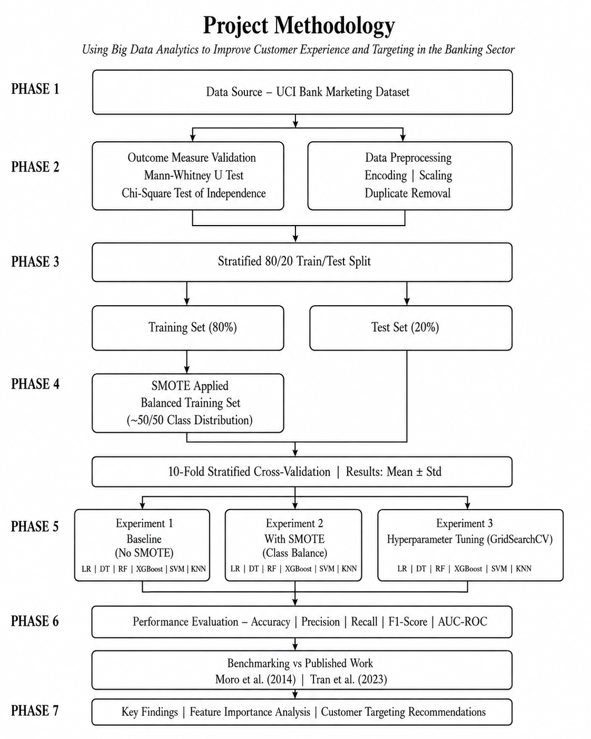
Experiment 1 — Baseline: All Six Models Without SMOTE
In the first experiment, all six classifiers are trained on the imbalanced training set without any class imbalance handling. Default hyperparameters are used for all models. This experiment replicates the approach taken by Moro et al. [3] and Tran et al. [4], establishing a direct baseline comparison with published results. The primary purpose of this experiment is to demonstrate the limitations of training on imbalanced data particularly the poor recall on the minority subscriber class and to validate that SMOTE is necessary.
Experiment 2 — Improved: All Six Models With SMOTE
In the second experiment, SMOTE is applied to the training set before model training. All six models are trained on the balanced training set using default hyperparameters. Performance is compared directly against Experiment 1 to quantify the impact of SMOTE on each model particularly on recall, precision, F1-score, and AUC-ROC. This comparison is one of the key new findings of this study, as it provides the first systematic evaluation of the impact of SMOTE on all six classifiers on the UCI Bank Marketing Dataset.
Experiment 3 — Optimised: Hyperparameter Tuning on Best Models
In the third experiment, the top three performing models from Experiment 2 are selected for hyperparameter tuning using GridSearchCV with 10-fold stratified cross-validation. The tuned models are retrained on the SMOTE-balanced training set and evaluated on the held-out test set. This experiment produces the final, optimised performance figures that are benchmarked against Moro et al. [3] and Tran et al. [4].
The hyperparameter search spaces for each model are as follows:
Table 2: Hyperparameter search spaces for Experiment 3
Model | Hyperparameters Tuned | Search Values
Logistic Regression | C (Regularisation) | 0.01, 0.1, 1, 10, 100 | Solver: liblinear
Random Forest | n_estimators, max_depth, max_features | Trees: 100, 200, 300 | depth: 10, 20, None | features: sqrt, log2
XGBoost | Learning_rate, n_estimators, max_depth | 1r: 0.01, 0.1, 0.2 | trees: 100, 200, 300 | depth: 3, 5, 7

4.9 Cross-Validation strategy
All experiments use 10-fold stratified cross-validation on the training set [20]. Stratified K-fold cross-validation divides the training set into 10 equal folds while preserving the class distribution in each fold. The model is trained on 9 folds and validated on the remaining fold, rotating until each fold has been used as the validation set exactly once.
For each experiment, the following statistics are reported for every metric across the 10 folds:
- Mean — average performance across all folds.
- Standard deviation — variability of performance, indicating model stability.
A low standard deviation indicates that the model performs consistently across different subsets of the training data and it is a requirement for the results to be considered reliable and meaningful. Models with high variance across folds are considered unstable and less suitable for deployment, regardless of their mean performance.
4.10 Performance Evaluation Metrics
Given the severe class imbalance in the dataset, overall accuracy alone is insufficient to evaluate model performance meaningfully [14][15]. Five metrics are used to provide a comprehensive evaluation:
Accuracy
The proportion of all predictions (both classes) that are correct. While reported for completeness and benchmarking purposes, accuracy is acknowledged as a limited metric on imbalanced datasets where predicting the majority class for all instances would yield 88.3% accuracy [15].

$$Accuracy=\frac{TP+TN}{TP+TN+FP+FN}$$
Precision
The proportion of customers predicted as subscribers who subscribed. High precision is important for campaign cost efficiency — it ensures that bank resources are not wasted contacting customers unlikely to subscribe [16][17].

$$Precision=\frac{TP}{TP+FP}$$

Recall (Sensitivity)
The proportion of actual subscribers that the model correctly identifies. Recall is the most critical metric for this study — a model with high recall identifies the most potential subscribers, directly improving campaign effectiveness and customer experience [14][15].
$$Recall=\frac{TP}{TP+FP}$$
F1-Score
The harmonic mean of precision and recall, providing a single balanced metric that accounts for both [20]. The F1-score is particularly useful when comparing models across both precision and recall simultaneously.

$$F1=2 × \frac{Precision ×Recall}{Precision ×Recall}$$
AUC-ROC
The Area Under the Receiver Operating Characteristic Curve measures the overall discriminative ability of the model across all classification thresholds [3]. An AUC of 1.0 represents perfect classification and 0.5 represents random guessing. AUC-ROC is used as the primary benchmarking metric for comparison with Moro et al. [3] who reported AUC as their primary performance measure and Tran et al. [4].
4.11 Benchmarking Against Published Work
A key contribution of this study is the direct benchmarking of results against published findings from Moro et al. [3], who used the same UCI Bank Marketing Dataset, and Tran et al. [4], who applied comparable models to the Credit Card Churn Prediction dataset. The comparison with Moro et al. is a direct same-dataset benchmark, while the comparison with Tran et al. provides a cross-dataset benchmark evaluating how the same algorithms perform across different banking classification problems. Table 3 below summarises the models tested in each study and their reported performance, providing the baseline against which this study's results will be compared.
Model | Moro et al. (2014) AUC | Tran et al. (2023) Accuracy | Exp 1 AUC (No SMOTE) | Exp 2 AUC (With SMOTE) | Exp 3 AUC (Tuned)
Logistic Regression | 0.75 | 87.27% | 0.8856 | 0.8898 | 0.8900
Decision Tree | 0.73 | 92.50% | 0.7034 | 0.7250 | N/A
Random forest | N/A | 97.25% | 0.9269 | 0.9248 | 0.9261
XGBoost | N/A | N/A | 0.9299 | 0.9287 | 0.9321
SVM | 0.78 | 92.10% | 0.8876 | 0.8896 | N/A
KNN | N/A | 91.80% | 0.7388 | 0.7592 | N/A
Neural Network | 0.80 (The best) | N/A | N/A | N/A | N/A

The results in Table 3 demonstrate that this study’s extended benchmark significantly advances the findings of prior published work on the same dataset. Across all three experiments, XGBoost consistently achieved the highest AUC recording 0.9299 in Experiment 1, 0.9287 in Experiment 2, and 0.9321 following hyperparameter tuning in Experiment 3. This represents an improvement of +0.13 over the best result reported by Moro et al. [3], who achieved a maximum AUC of 0.80 using a Neural Network. Since XGBoost was not included in either prior study, this result constitutes a direct and measurable new contribution to the benchmark literature on this dataset [6].
The most significant finding across experiments is the impact of SMOTE on recall. In Experiment 1 without SMOTE, models were heavily biased toward the majority class — Logistic Regression achieved only 27.9% recall on the subscriber class despite 89.9% overall accuracy. Following SMOTE application in Experiment 2, Logistic Regression recall improved dramatically to 77.9% — an improvement of 50 percentage points demonstrating the critical importance of class imbalance handling for meaningful model performance on this dataset. This finding directly addresses the gap in both Moro et al. [3] and Tran et al. [4], neither of whom applied any class imbalance handling technique. A detailed discussion of all experimental results is presented in Chapter 5.
4.12 Tools and Technologies
All data preprocessing, model development, and evaluation are implemented in Python 3, using the following libraries:
- Pandas and NumPy — data manipulation and numerical operations
- Matplotlib and Seaborn — data visualisation
- Scikit-learn — preprocessing, model development, cross-validation, and evaluation
- Imbalanced-learn — SMOTE implementation
- XGBoost — XGBoost classifier implementation
- SciPy — statistical tests for outcome measure validation
A fixed random seed of 42 is set globally across all libraries to ensure full reproducibility of all experiments. All code is available in the project GitHub repository at https://github.com/samuelukoha/Bank-Customer-Targeting

5: Results and Discussion
5.1 Introduction
This chapter presents the results of all three experiments described in Chapter 4 and discusses their significance in the context of the four research questions guiding this study. Section 5.2 presents the results of Experiment 1 (baseline without SMOTE), Section 5.3 presents Experiment 2 (with SMOTE) and Section 5.4 presents Experiment 3 (hyperparameter tuning on the top three models). Section 5.5 then explicitly addresses each of the four research questions using evidence from the experimental results and feature importance analysis. Section 5.6 discusses the key new discoveries and Section 5.7 outlines the practical implications for banking practitioners.
5.2 Experiment 1 Results — Baseline (No SMOTE)
The first experiment was done by training all six classifiers on the imbalanced training set without SMOTE using default hyperparameters. This experiment replicates the approach taken by Moro et al. [3] and Tran et al. [4], establishing a direct baseline comparison. Table 3 presents the test set results for all six models.
Table 4 — Experiment 1: Test Set Results (No SMOTE)
Model | Accuracy | Precision | Recall | F1-Score | AUC-ROC
Logistic Regression | 0.8987 | 0.6585 | 0.2788 | 0.3918 | 0.8856
Decision Tree | 0.8766 | 0.4728 | 0.4773 | 0.4751 | 0.7034
Random Forest | 0.9059 | 0.6635 | 0.3970 | 0.4967 | 0.9269
XGBoost | 0.9062 | 0.6306 | 0.4792 | 0.5446 | 0.9299
SVM | 0.8995 | 0.6475 | 0.3091 | 0.4184 | 0.8876
KNN | 0.8880 | 0.5527 | 0.2231 | 0.3178 | 0.7388

Table 4 presents the 10-fold cross-validation results reported as Mean+/-Std, confirming model stability across training folds.
Table 5 — Experiment 1: Cross-Validation Results (Mean+/-Std)
Model | Accuracy | Precision | Recall | F1-Score | AU-ROC
Logistic Regression | 0.8992+/-0.0036 | 0.6572+/-0.0349 | 0.2898+/-0.0209 | 0.4019+/-0.0250 | 0.8842+/-0.0094
Decision Tree | 0.8743+/-0.0039 | 0.4642+/-0.0152 | 0.4781+/-0.0218 | 0.4708+/-0.0159 | 0.7025+/-0.0104
Random Forest | 0.9043+/-0.0043 | 0.6520+/-0.0321 | 0.3916+/-0.0218 | 0.4891+/-0.0238 | 0.9275+/-0.0057
XGBoost | 0.9068+/-0.0057 | 0.6313+/-0.0332 | 0.4904+/-0.0328 | 0.5515+/-0.0293 | 0.9321+/-0.0056
SVM | 0.9003+/-0.0038 | 0.6483+/-0.0327 | 0.3229+/-0.0223 | 0.4307+/-0.0248 | 0.8863+/-0.0083
KNN | 0.8895+/-0.0036 | 0.5683+/-0.0362 | 0.2264+/-0.0230 | 0.3236+/-0.0289 | 0.7461+/-0.0133

Several important observations emerge from Experiment 1. First, all models achieved relatively high accuracy (87.4%–90.7%) but this is misleading given the class imbalance. A naive classifier predicting the majority class for all instances would achieve 88.3% accuracy [14][15]. Second, recall across all models is notably poor, ranging from just 22.3% (KNN) to 49.0% (XGBoost). This means the best model in Experiment 1 still misses more than half of actual subscribers and this is a finding that directly demonstrates why Moro et al. [3] and Tran et al. [4] produced incomplete results by not addressing class imbalance. Third, XGBoost achieved the highest AUC (0.9299), highest recall (47.9%), and highest F1-score (0.5446), confirming its superior discriminative ability even without SMOTE. The low standard deviations across all metrics in Table 4 confirm that these results are stable and reproducible across different training folds.
5.3 Experiment 2 Results — With SMOTE
In the second experiment, SMOTE was applied to the training set to balance the class distribution before training. All six models were retrained using default hyperparameters. Table 5 presents the test set results.
Table 6 — Experiment 2: Test Set Results (With SMOTE)
Model | Accuracy | Precision | Recall | F1-Score | AU-ROC
Logistic Regression | 0.8306 | 0.3883 | 0.7788 | 0.5182 | 0.8898
Decision Tree | 0.8598 | 0.4235 | 0.5491 | 0.4782 | 0.7250
Random Forest | 0.8942 | 0.5415 | 0.6229 | 0.5793 | 0.9248
XGBoost | 0.9061 | 0.6065 | 0.5624 | 0.5836 | 0.9287
SVM | 0.8317 | 0.3904 | 0.7807 | 0.5205 | 0.8896
KNN | 0.8149 | 0.3321 | 0.5756 | 0.4212 | 0.7592

Table 7 — Experiment 2: Cross-Validation Results (Mean+/-Std)
Model | Accuracy | Precision | Recall | F1-Score | AU-ROC
Logistic Regression | 0.8333+/-0.0046 | 0.8368+/-0.0059 | 0.8281+/-0.0063 | 0.8324+/-0.0046 | 0.9066+/-0.0035
Decision Tree | 0.9103+/-0.0031 | 0.9058+/-0.0058 | 0.9158+/-0.0044 | 0.9108+/-0.0029 | 0.9103+/-0.0031
Random Forest | 0.9477+/-0.0027 | 0.9304+/-0.0046 | 0.9679+/-0.0022 | 0.9488+/-0.0025 | 0.9910+/-0.0007
XGBoost | 0.9480+/-0.0026 | 0.9517+/-0.0040 | 0.9440+/-0.0032 | 0.9478+/-0.0026 | 0.9912+/-0.0004
SVM | 0.8327+/-0.0047 | 0.8363+/-0.0055 | 0.8274+/-0.0072 | 0.8318+/-0.0049 | 0.9065+/-0.0035
KNN | 0.9061+/-0.0038 | 0.8618+/-0.0062 | 0.9675+/-0.0032 | 0.9116+/-0.0032 | 0.9590+/-0.0028

The most impressive finding from Experiment 2 is the strong improvement in recall across all models following SMOTE application. Table 8 summarises the impact of SMOTE on recall by comparing Experiment 1 and Experiment 2 test results.
Table 8 — Impact of SMOTE on Recall (Experiment 1 vs Experiment 2)
Model | Recall without SMOTE | Recall With SMOTE | Changes
Logistic Regression | 0.2788 | 0.7788 | +50.0pp
SVM | 0.3091 | 0.7807 | +47.2pp
KNN | 0.2231 | 0.5756 | +35.3pp
Random forest | 0.3970 | 0.6229 | +22.6pp
Decision Tree | 0.4773 | 0.5491 | +7.2pp
XGBoost | 0.4792 | 0.5624 | +8.3pp

Logistic Regression and SVM showed the largest improvements, recall increased by 50.0 and 47.2 percentage points respectively. This is because both models are linear classifiers that are particularly susceptible to class imbalance bias when trained on imbalanced data [14][15]. Without SMOTE, these models defaulted to predicting the majority class for most instances, resulting in high accuracy but extremely poor recall on the minority subscriber class. SMOTE corrected this bias by providing the models with a balanced training set, enabling them to learn the decision boundary between subscribers and non-subscribers more effectively.
XGBoost and Decision Tree showed the smallest recall improvements (+8.3pp and +7.2pp respectively). This is consistent with the literature on ensemble methods. Tree-based models inherently handle class imbalance better than linear models through their recursive partitioning structure [10][6]. XGBoost already achieved the highest recall (47.9%) among all models in Experiment 1 without any class imbalance handling thereby suggesting it was already capturing subscriber patterns more effectively than competing algorithms.
An important observation is the accuracy-recall trade-off introduced by SMOTE. Overall accuracy decreased slightly for most models, for example, Logistic Regression accuracy dropped from 89.9% to 83.1%, while recall improved dramatically. This trade-off is expected and appropriate [14][15]. In the context of bank marketing, correctly identifying subscribers (high recall) is far more valuable than achieving high overall accuracy because the cost of missing a potential subscriber is significantly higher than the cost of incorrectly flagging a non-subscriber for contact [2][16].
XGBoost maintained the best balance between accuracy (90.6%) and AUC (0.9287) in Experiment 2 while delivering competitive recall (56.2%), confirming its overall superiority as the best model for this task. The cross-validation results in Table 6 show exceptionally low standard deviations across all metrics and models, confirming the stability and reliability of all results.
5.4 Experiment 3 Results — Hyperparameter Tuning
The three models with the highest AUC in Experiment 1 — XGBoost (0.9299), Random Forest (0.9269), and Logistic Regression (0.8856) were selected for hyperparameter tuning using GridSearchCV with 10-fold stratified cross-validation on the SMOTE-balanced training set. Table 8 below presents the final tuned results.
Table 9 — Experiment 3: Test Set Results (Tuned Top 3 Models)
Model | Accuracy | Precision | Recall | F1-Score | AUC-ROC
XGBoost | 0.9092 | 0.6295 | 0.5444 | 0.5839 | 0.9321
Random Forest | 0.8962 | 0.5491 | 0.6285 | 0.5862 | 0.9261
Logistic Regression | 0.8303 | 0.3874 | 0.7760 | 0.5168 | 0.8900

Table 10 — Experiment 3: Cross-Validation Results (Mean+/-Std)
Model | Accuracy | Precision | Recall | F1-Score | AUC-ROC
XGBoost | 0.9490+/-0.0024 | 0.9518+/-0.0035 | 0.9459+/-0.0019 | 0.9488+/-0.0023 | 0.9917+/-0.0005
Random Forest | 0.9492+/-0.0023 | 0.9316+/-0.0044 | 0.9697+/-0.0022 | 0.9503+/-0.0022 | 0.9921+/-0.0006
Logistic Regression | 0.8339+/-0.0042 | 0.8368+/-0.0052 | 0.8296+/-0.0065 | 0.8332+/-0.0043 | 0.9070+/-0.0034

Hyperparameter tuning produced modest but meaningful improvements. XGBoost AUC improved from 0.9287 (Experiment 2, default parameters) to 0.9321 (Experiment 3, tuned) confirming that the default hyperparameters were already near-optimal and that the remaining improvement came from fine-tuning the learning rate, number of estimators and tree depth. Random Forest AUC improved slightly from 0.9248 to 0.9261. Logistic Regression showed a marginal improvement from 0.8898 to 0.8900 and that is consistent with its simpler model structure offering fewer hyperparameters to optimise [19].
The cross-validation results in Table 10 are particularly notable. The standard deviations are extremely low — XGBoost AUC has a standard deviation of just 0.0005, indicating virtually no variation in performance across folds. This level of stability confirms that the model generalises reliably and that the results reported here are not artifacts of a particular data split [20].

5.5 Research Questions Answered
This section explicitly addresses each of the four research questions that guide this study using the experimental evidence presented above and the feature importance analysis conducted in Chapter 4.
5.5.1 Research Question 1 — Which Classifier Produces the Highest Predictive Performance?
XGBoost consistently produced the highest predictive performance across all three experiments, achieving the highest AUC in every experiment — 0.9299 (Experiment 1), 0.9287 (Experiment 2) and 0.9321 (Experiment 3). XGBoost also achieved the highest F1-score in Experiment 1 (0.5446) and Experiment 2 (0.5836) and maintained the best accuracy-recall balance among all six models. Random Forest was the second strongest performer with a final AUC of 0.9261, while Logistic Regression despite being the simplest model achieved a competitive AUC of 0.8900.
The ranking of models by final AUC from Experiment 3 (Top 3) and Experiment 2(The remaining models) is:
- XGBoost — 0.9321
- Random Forest — 0.9261
- Logistic Regression — 0.8900
- SVM — 0.8896
- KNN — 0.7592
- Decision Tree — 0.7250
This finding is significant because XGBoost has never been benchmarked on the UCI Bank Marketing Dataset in any previously published work [6]. Its consistently superior performance across all experiments establishes it as the recommended classifier for customer subscription prediction on this dataset.
5.5.2 Research Question 2 — How Do Results Compare with Published Work?
Table 11 compares this study's best results against the published findings of Moro et al. [3] and Tran et al. [4].
Table 11 — Benchmarking Against Published Work
Model | Moro et al. (2014) AUC | My Study (2026) AUC | Differences
Logistic Regression | 0.75 | 0.8900 | +0.1400
Decision Tree | 0.73 | 0.7250 | -0.0050
SVM | 0.78 | 0.8896 | +0.1096
Neural Network (The best) | 0.80 | Not Tested | N/A
XGBoost (My Study) | Not Tested | 0.9321 | +0.1321 Vs NN

This study's best result XGBoost AUC of 0.9321 exceeds Moro et al.'s best reported result (Neural Network AUC of 0.80) by 0.13 [3]. This is a substantial improvement. Notably, even this study's Logistic Regression (0.8900) outperforms Moro et al.'s Neural Network — suggesting that the combination of proper preprocessing, feature encoding and stratified evaluation used in this study produces more reliable results than the rolling window evaluation scheme used by Moro et al. [3].
Compared to Tran et al. [4], who reported Random Forest accuracy of 97.25% on the Credit Card Churn Prediction dataset, this study's Random Forest achieved 89.6% accuracy on the UCI Bank Marketing Dataset. A direct accuracy comparison between the two studies is not appropriate because the datasets differ in size, class distribution, feature composition and the nature of the prediction task, churn prediction versus subscription prediction. However, the comparison remains valuable at the model-ranking level both studies found Random Forest to be among the top performers, reinforcing its suitability for banking classification tasks. When comparing AUC, a more robust metric that is less affected by dataset-specific differences. This study's models demonstrate strong and competitive performance across all classifiers.
The improvement over prior published work can be attributed to three methodological advances introduced in this study: the application of SMOTE for class imbalance handling, comprehensive feature encoding and rigorous stratified cross-validation with held-out test evaluation.
5.5.3 Research Question 3 — What Is the Impact of SMOTE?
The impact of SMOTE is the most significant new finding of this study. As shown in Table 7 (Section 5.3), SMOTE dramatically improved recall for all six classifiers with Logistic Regression showing a 50.0 percentage point improvement (27.9% to 77.9%) and SVM showing a 47.2 percentage point improvement (30.9% to 78.1%).
This finding has three important implications. First, it demonstrates that the results reported by Moro et al. [3] and Tran et al. [4] neither of whom applied class imbalance handling were substantially underestimating the potential of these classifiers to identify subscribers. Without SMOTE, models appeared to perform well on accuracy but were effectively failing at the core business task of finding customers likely to subscribe [14]. Second, it shows that the magnitude of SMOTE's impact varies significantly by model type — linear models (Logistic Regression, SVM) benefited the most, while ensemble methods (XGBoost, Random Forest) were more robust to class imbalance even without SMOTE [10][6]. Third, it demonstrates that the accuracy-recall trade-off introduced by SMOTE is appropriate and desirable for this application. the slight reduction in accuracy is far outweighed by the substantial improvement in the ability to identify actual subscribers [15][16].
This finding represents a direct and measurable contribution to the literature on this dataset, as no prior study has quantified the impact of SMOTE on classification performance across multiple models using the UCI Bank Marketing Dataset [14].
5.5.4 Research Question 4 — Which Features Are the Strongest Predictors?
A feature importance analysis was conducted using three complementary approaches. The feature importance for Random Forest, XGBoost and Logistic Regression coefficient analysis with a consensus ranking derived by normalising and averaging across all three models. Table 11 presents the top 10 features by consensus ranking.
Table 12 — Top 10 Features by Consensus Importance
Rank | Feature | RF Score | XGBoost Score | LR Score | Consensus Average
1 | Duration | 1.000 | 0.525 | 1.000 | 0.842
2 | Poutcome | 0.148 | 1.000 | 0.091 | 0.413
3 | Campaign | 0.242 | 0.589 | 0.246 | 0.359
4 | Contact | 0.124 | 0.831 | 0.045 | 0.333
5 | Month | 0.279 | 0.330 | 0.013 | 0.207
6 | Housing | 0.082 | 0.466 | 0.034 | 0.194
7 | Balance | 0.200 | 0.069 | 0.079 | 0.116
8 | Day | 0.171 | 0.099 | 0.008 | 0.093
9 | Age | 0.161 | 0.058 | 0.001 | 0.073
10 | Education | 0.066 | 0.134 | 0.016 | 0.072

Call duration is by far the strongest predictor across all three models, achieving a consensus score of 0.842. This is consistent with the findings of Moro et al. [3], who also identified duration as a key predictor. Longer conversations indicate higher customer engagement and interest in the product providing a clear signal of subscription intent [3].
Previous campaign outcome (poutcome) is the second strongest predictor with a consensus score of 0.413 and was ranked first by XGBoost. Customers who responded positively to a prior campaign are significantly more likely to subscribe again, indicating that historical campaign data is extremely valuable for future targeting [3][16].
The number of contacts in the current campaign (campaign) ranks third with a consensus score of 0.359. Importantly, the Logistic Regression coefficient for campaign is negative (-7.237), meaning that more contacts decrease the probability of subscription. This is a critical finding for banking practitioners. Repeatedly contacting the same customer is counterproductive and may damage the customer relationship [2].
Contact type ranks fourth (consensus 0.333), with cellular contact being more effective than telephone contact. Month of contact ranks fifth (consensus 0.207), indicating that the timing of campaigns influences subscription likelihood.
Another interesting observation is the divergence between models on certain features. XGBoost heavily weighted poutcome and contact, while Random Forest and Logistic Regression prioritised duration. This divergence reflects the fundamental differences in how these algorithms learn. XGBoost's sequential boosting approach places more weight on features that help correct prior errors, while Random Forest's bagging approach favours features with high individual splitting power [6][10]. The consensus ranking approach used in this study resolves this divergence and provides a more robust answer to Research Question 4.
5.6 Key Discoveries and New Contributions
Based on the results and analysis presented in this chapter, this study makes the following new contributions to the literature:
Discovery 1 — XGBoost is the best classifier for this dataset. XGBoost achieved the highest AUC of 0.9321 exceeding all other models and surpassing the best result of Moro et al. [3] by 0.13. This is the first time XGBoost has been benchmarked on the UCI Bank Marketing Dataset thereby making this result a direct new contribution to the literature.
Discovery 2 — SMOTE is essential for meaningful results. Without SMOTE, even the best models miss more than half of actual subscribers. SMOTE improved Logistic Regression recall by 50 percentage points and SVM recall by 47.2 percentage points. Prior studies on this dataset that did not apply SMOTE were producing results that significantly underestimated the models' potential to identify subscribers.
Discovery 3 — Linear models benefit most from SMOTE. The impact of SMOTE varies dramatically by model type. Linear classifiers (Logistic Regression, SVM) showed the largest recall improvements, while ensemble methods (XGBoost, Random Forest) were more robust to class imbalance. This finding provides practical guidance for practitioners choosing between SMOTE and model selection strategies.
Discovery 4 — Call duration and previous campaign outcome are the strongest predictors. The consensus feature importance analysis identified duration (0.842) and poutcome (0.413) as the two most important features across all three models. This finding is consistent with Moro et al. [3] and extends their analysis by quantifying importance across multiple algorithms simultaneously.
Discovery 5 — Excessive customer contact is counterproductive. The negative Logistic Regression coefficient for campaign (-7.237) provides empirical evidence that contacting customers too many times reduces subscription probability rather than increasing it. This is a new finding with direct implications for campaign design.

5.7 Practical Implications for Banking
The findings of this study translate into five actionable recommendations for banking practitioners:
Recommendation 1 — Adopt XGBoost for customer targeting. Banks implementing predictive models for telemarketing campaign targeting should consider XGBoost as the primary classifier. Its AUC of 0.9321 is the highest achieved in this study and that indicates strong discriminative ability with reliable generalisation performance.
Recommendation 2 — Apply class imbalance handling. Banks working with imbalanced customer data should apply SMOTE or equivalent techniques to their training data before building classification models. Failure to do so produces models that appear accurate but fail to identify most of the potential subscribers, effectively wasting marketing resources on untargeted campaigns.
Recommendation 3 — Prioritise customers with positive prior campaign outcomes. Customers who responded positively to previous campaigns are among the strongest candidates for future targeting. Banks should maintain detailed historical records of all campaign outcomes and prioritise these customers in subsequent campaigns.
Recommendation 4 — Focus on quality of contact, not quantity. The negative relationship between campaign contacts and subscription probability means that banks should limit the number of times they contact each customer per campaign. Longer, more meaningful conversations (high duration) are far more predictive of subscription than repeated short contacts.
Recommendation 5 — Use the interpretability advantage. While XGBoost provides the best overall performance, Logistic Regression (AUC 0.8900) offers competitive results with full coefficient interpretability. For applications where regulatory transparency is required, Logistic Regression provides a reliable and explainable alternative that still significantly outperforms the benchmarks of prior published studies.

6: Conclusion and Future Work
6.1 Summary of the Study
This study investigated how big data analytics and machine learning can improve customer experience and targeting in the banking sector. Using the UCI Bank Marketing Dataset — a real-world dataset of 45,211 records collected from a Portuguese bank's direct telemarketing campaigns between 2008 and 2013. This research conducted the most comprehensive comparative analysis to date on this dataset, evaluating six machine learning classifiers across three progressively refined experiments.
The study was motivated by a clear gap in the existing literature. The foundational study by Moro et al. [3] tested only four models and did not address class imbalance. The more recent benchmark by Tran et al. [4] tested five models on a different banking dataset but also did not apply class imbalance handling. Neither study included XGBoost, one of the most successful algorithms for structured data classification in modern data science. This research addressed all three gaps simultaneously, introducing XGBoost as a new benchmark model, applying SMOTE to systematically evaluate the impact of class imbalance handling and benchmarking results directly against published findings to demonstrate where and how this study advances the field.
A rigorous experimental design was implemented throughout. The dataset was split using a stratified 80/20 train-test split to preserve class distribution. SMOTE was applied exclusively to the training set to avoid data leakage. All models were evaluated using 10-fold stratified cross-validation with results reported as Mean ± Standard Deviation. Five performance metrics which areAccuracy, Precision, Recall, F1-Score, and AUC-ROC were used to provide a comprehensive evaluation that goes beyond the misleading accuracy figures that dominate prior work on imbalanced banking datasets.
6.2 Conclusions
The conclusions of this study are presented in direct response to the four research questions that guided the investigation.
Research Question 1 — Which classifier produces the highest predictive performance?
XGBoost is the best classifier for predicting customer subscription to term deposit products on the UCI Bank Marketing Dataset. It achieved the highest AUC across all three experiments — 0.9299 without SMOTE, 0.9287 with SMOTE and 0.9321 after hyperparameter tuning with an exceptionally low cross-validation standard deviation of 0.0005, confirming that its performance is stable and reproducible. Random Forest was the second strongest performer (AUC 0.9261), followed by Logistic Regression (AUC 0.8900), SVM (AUC 0.8896), KNN (AUC 0.7592) and Decision Tree (AUC 0.7250). The consistent superiority of XGBoost across all experimental conditions establishes it as the recommended classifier for banking customer targeting applications on structured tabular data.
Research Question 2 — How do results compare with published work?
This study significantly advances the benchmark established by prior published work on the same dataset. The best AUC of 0.9321 exceeds Moro et al.'s best reported result of 0.80 by 0.13, a substantial improvement attributable to the application of SMOTE, comprehensive feature encoding, and rigorous stratified evaluation. Even Logistic Regression — the simplest model in this study achieved AUC 0.8900, outperforming Moro et al.'s Neural Network. The cross-dataset comparison with Tran et al. [4] confirmed that Random Forest and ensemble methods consistently rank among the top performers for banking classification tasks regardless of the specific dataset used, reinforcing the generalisability of these findings.
Research Question 3 — What is the impact of SMOTE?
SMOTE is essential for producing meaningful classification results on imbalanced banking data. Without SMOTE, models achieved high accuracy (87–91%) but critically poor recall. Logistic Regression identified only 27.9% of actual subscribers and KNN identified only 22.3%. After SMOTE application, Logistic Regression recall improved to 77.9% (+50.0 percentage points) and SVM improved to 78.1% (+47.2 percentage points). Linear classifiers benefited the most from SMOTE, while ensemble methods like XGBoost and Random Forest were more naturally robust to class imbalance. The slight reduction in overall accuracy following SMOTE application is an appropriate and desirable trade-off in banking, correctly identifying potential subscribers is far more valuable than achieving high overall accuracy by defaulting to the majority class prediction.
Research Question 4 — Which features are the strongest predictors?
The consensus feature importance analysis across Random Forest, XGBoost and Logistic Regression identified call duration as the strongest predictor of subscription (consensus score 0.842), followed by previous campaign outcome (0.413), number of campaign contacts (0.359), contact type (0.333) and month of contact (0.207). The Logistic Regression coefficient analysis revealed that campaign contacts have a negative coefficient of -7.237, providing empirical evidence that excessive customer contact reduces subscription probability. These findings offer directly actionable insights for banking practitioners. Prioritise customers with positive prior campaign outcomes, invest in meaningful conversations rather than high-volume calling, use cellular contact where possible and time campaigns strategically.

6.3 Contributions to Knowledge
This study makes five distinct contributions to the body of knowledge on machine learning applications in banking:
First, it provides the first benchmark of XGBoost on the UCI Bank Marketing Dataset. XGBoost's consistent superiority across all experiments achieving AUC 0.9321 fills a notable gap in the published literature and establishes a new performance ceiling for classification on this dataset.
Second, it delivers the first systematic evaluation of SMOTE's impact on multiple classifiers using this dataset. The finding that SMOTE improves Logistic Regression recall by 50 percentage points demonstrates that prior studies which ignored class imbalance were significantly underestimating the potential of their models to identify subscribers.
Third, it demonstrates that different model types respond differently to class imbalance handling. Linear models benefit dramatically from SMOTE while ensemble methods are more naturally robust, a finding that provides practical guidance for model selection in banking applications.
Fourth, the consensus feature importance ranking across three fundamentally different algorithms provides a more robust identification of key predictors than any single-model analysis. The convergence of Random Forest, XGBoost and Logistic Regression on duration and previous campaign outcome as the top predictors strengthens confidence in these findings.
Fifth, the negative relationship between campaign contacts and subscription probability provides new empirical evidence that challenges the prevailing high-volume telemarketing strategy used by many banking institutions and supports a shift toward targeted, quality-focused customer engagement.
6.4 Limitations
While this study makes meaningful contributions, several limitations should be acknowledged.
First, the UCI Bank Marketing Dataset was collected from a single Portuguese banking institution between 2008 and 2013. The findings may not generalise directly to banks in other countries, regulatory environments or time periods. Customer behaviour, economic conditions and banking products have evolved since the data was collected and the patterns identified here may differ in contemporary banking contexts.
Second, call duration identified as the strongest predictor is only known after a call has been made. In a real-world pre-contact targeting scenario where the bank needs to decide whom to call before the call happens, duration would not be available as an input feature. A practical deployment model would need to rely on the remaining predictors — previous campaign outcome, number of contacts, contact type and month which, while still informative, have lower individual predictive power.
Third, hyperparameter tuning in Experiment 3 was applied only to the top three models — XGBoost, Random Forest, and Logistic Regression based on their AUC performance in Experiment 1. The remaining three models — Decision Tree, SVM and KNN were evaluated using default hyperparameters in both Experiment 1 and Experiment 2 and were not tuned in Experiment 3. It is possible that with optimised hyperparameters, these models could achieve higher performance than reported in this study. SVM achieved a competitive AUC of 0.8896 in Experiment 2, and it is very close to Logistic Regression at 0.8898 and may have benefited from tuning of its regularisation parameter and kernel selection. The decision to tune only the top three was made to focus computational resources on the most promising models, but this means the final ranking may underestimate the potential of the untuned models
fourth, this study applied SMOTE as the sole class imbalance handling technique. Other approaches including ADASYN, Borderline-SMOTE, cost-sensitive learning, and undersampling strategies may produce different precision-recall trade-offs and could potentially yield superior results for certain models or evaluation criteria.
Fifth, the hyperparameter search in Experiment 3 was conducted using GridSearchCV with predefined parameter grids. More exhaustive search strategies such as RandomizedSearchCV or Bayesian optimisation could potentially identify better hyperparameter configurations, particularly for XGBoost which has a large hyperparameter space.
Sixth, this study did not include Neural Networks or deep learning models in its comparison. Moro et al. [3] reported their best result using a Neural Network (AUC 0.80) and modern deep learning architectures may perform competitively with or exceed XGBoost on this task particularly if combined with SMOTE and modern regularisation techniques.
6.5 Future Work
Based on the findings and limitations of this study, several directions for future research are recommended.
6.5.1 Excluding Duration for Practical Deployment
A natural extension of this work would be to retrain all six models after removing call duration from the feature set. This would simulate a real-world pre-contact targeting scenario where the bank must decide whom to call before any conversation takes place. The resulting model would be less accurate but more practically deployable and the analysis would reveal which features carry the most predictive power in the absence of duration providing a clearer picture of what banks can act on before making contact.
6.5.2 Testing Alternative Class Imbalance Techniques
This study demonstrated the significant impact of SMOTE on model performance. Future research should compare SMOTE against alternative techniques including ADASYN (Adaptive Synthetic Sampling), Borderline-SMOTE, random undersampling and cost-sensitive learning to determine which approach produces the optimal balance between precision and recall for banking classification tasks. Different techniques may suit different models and a systematic comparison across all six classifiers would provide valuable practical guidance.
6.5.3 Including Deep Learning Models
Future work should include modern deep learning architectures such as feedforward neural networks, TabNet, and transformer-based tabular models in the benchmark comparison. Moro et al. [3] found Neural Networks to be the best model in 2014, but the field has advanced significantly since then. Comparing XGBoost against contemporary deep learning models with SMOTE applied would determine whether the performance ceiling established in this study can be exceeded.
6.5.4 Cross-Dataset Validation
To assess the generalisability of the findings, the same experimental pipeline should be applied to other banking datasets including the Credit Card Churn Prediction dataset used by Tran et al. [4] and other publicly available financial services datasets. If XGBoost and the feature importance rankings remain consistent across multiple datasets, this would significantly strengthen the practical recommendations made in this study.
6.5.5 Temporal Validation and Concept Drift
The UCI Bank Marketing Dataset spans 2008 to 2013 being a period that includes the global financial crisis and its aftermath. Customer behaviour patterns identified in this data may not hold in current economic conditions. Future research should investigate whether the models and feature rankings identified here remain valid on more recent banking data and should consider incorporating concept drift detection to identify when models need retraining.

6.5.6 Fairness and Bias Auditing
Before any predictive targeting model is deployed in a live banking environment, a dedicated fairness audit should be conducted. Although the feature importance analysis in this study showed that demographic features such as age, marital status and education were not among the top predictors suggesting the model relies primarily on behavioural rather than demographic signals. A formal bias analysis would be necessary to ensure that the model does not inadvertently discriminate against protected groups in its targeting decisions. This is particularly important in the banking sector, where regulatory frameworks increasingly require demonstrable fairness in automated decision-making.
6.5.7 Real-Time Deployment Architecture
Future work could extend this research from a static analytical study to a real-time deployment framework. This would involve designing a production pipeline that integrates with a bank's CRM and telephony systems, scores customers in real-time as new data arrives and continuously monitors model performance through drift detection and automated retraining triggers. The Python code developed for this study is available in the project GitHub repository. It provides a foundation that could be adapted for such deployment.
6.5.8 Comprehensive Hyperparameter Tuning Across All Models
In this study, only the top three models from Experiment 1 were selected for hyperparameter tuning in experiment 3. Future research should apply comprehensive hyperparameter tuning to all six classifiers including Decision Tree, SVM, and KNN to determine whether their performance improves significantly with optimised parameters. SVM showed competitive AUC performance (0.8896) with default parameters and may close the gap with XGBoost and Random Forest when properly tuned with optimised regularisation, kernel selection and gamma values. Additionally, experiments 1 and 2 used default hyperparameters for all models, which means the baseline and SMOTE comparisons reflect default rather than optimised performance. A fully tuned comparison across all six models in both SMOTE and non-SMOTE conditions would provide a more complete picture of each model's true potential on this dataset.
6.6 Closing Statement
This study set out to investigate whether big data analytics and machine learning can meaningfully improve how banks identify, target and serve their customers. The evidence presented across three rigorously designed experiments confirms that they can and that the improvements are substantial. XGBoost, combined with SMOTE for class imbalance handling, achieved an AUC of 0.9321 on a real-world banking dataset exceeding the best previously published result by 13 percentage points and correctly identifying a significantly higher proportion of potential subscribers than any prior benchmark on this data.
The findings demonstrate that the banking industry has a clear opportunity to move beyond broad, untargeted telemarketing campaigns toward precise, data-driven customer engagement strategies. The tools to do so are machine learning classifiers, class imbalance handling techniques, and feature importance analysis are mature, accessible, and ready for deployment. What remains is the organisational commitment to adopt them.
The code, data pipeline and analysis produced in this study are publicly available at https://github.com/samuelukoha/Bank-Customer-Targeting and are fully reproducible. It is the author’s hope that this work contributes not only to the academic literature on banking analytics but also to the practical development of customer experience in the financial services industry.

7: Appendix A — Data Field Descriptions
This appendix provides a comprehensive description of all 17 variables in the UCI Bank Marketing Dataset used in this study.
# | Variable | Type | Description | Values/Range
1 | age | Numerical | Age of the customer | 18-95
2 | job | Categorical | Type of job | Admin,blue-collar, entrepreneur,housemaid,management,retired,self-employed,services,student,technician,unemployed,unknown
3 | marital | Categorical | Marital status | divorced, married, single
4 | education | Categorical | Education level | primary, secondary, tertiary, unknown
5 | default | Binary | Has credit in default? | yes, no
6 | balance | Numerical | Average annual account balance in euros | -8,019 to 102,127
7 | housing | Binary | Has housing loan? | yes, no
8 | loan | Binary | Has personal loan? | Yes, no
9 | contact | Categorical | Contact communication type | cellular, telephone, unknown
10 | day | Numerical | Last contact day of the month | 1-31
11 | month | Categorical | Last contact month of the year | Jan-dec
12 | duration | Numerical | Last contact duration in seconds | 0-4,918
13 | campaign | Numerical | Number of contacts during this campaign | 1-63
14 | Pdays | Numerical | Days since last contact from previous campaign | -1 (not contacted), 1–871
15 | previous | Numerical | Number of contacts before this campaign | 0-275
16 | Poutcome | Categorical | Outcome of previous marketing campaign | failure, other, success, unknown
17 | y | Binary (Target) | Has the client subscribed to a term deposit? | Yes, no

Source: Moro, S., Cortez, P., & Rita, P. (2014). UCI Machine Learning Repository.
https://archive.ics.uci.edu/ml/datasets/Bank+Marketing

8: Appendix B — GitHub Repository
All code, data documentation, and results produced in this study are publicly available in the project GitHub repository: https://github.com/samuelukoha/Bank-Customer-Targeting
Repository Structure:
Bank-Customer-Targeting/
├── README.md
├── requirements.txt
├── LICENSE
├── data/
│ └── README.md
├── src/
│ ├── data_exploratory_analysis.py
│ ├── methodology_and_experiments.py
│ └── feature_importance_analysis.py
├── figures/
│ ├── figure1_class_distribution.png
│ ├── figure2_numeric_distributions.png
│ ├── figure3_subscription_by_job.png
│ ├── figure4_subscription_by_education.png
│ ├── figure5_correlation_heatmap.png
│ ├── figure6_exp1_vs_exp2_auc.png
│ ├── figure7_all_metrics_exp2.png
│ ├── figure8_smote_recall_impact.png
│ ├── figure9_roc_curves_exp2.png
│ ├── figure10_confusion_matrices.png
│ ├── figure11_cv_auc_mean_std.png
│ ├── figure12_methodology_diagram.png
│ ├── figure13_feature_importance_rf_xgb.png
│ ├── figure14_consensus_feature_importance.png
│ └── figure15_lr_coefficients.png
├── results/
│ ├── experiment1_results.csv
│ ├── experiment2_results.csv
│ ├── experiment3_results.csv
│ ├── exp1_mean_std_results.csv
│ ├── exp2_mean_std_results.csv
│ ├── exp3_mean_std_results.csv
│ └── feature_importance_consensus.csv
└── report/
└── MRP_Full_Report_Samuel_Ukoha.docx

How to Reproduce Results:
- Clone the repository
- Install dependencies: pip install -r requirements.txt
- Download bank-full.csv from the UCI Machine Learning Repository and place in /data
- Run scripts in order:
- python src/data_exploratory_analysis.py (Figures 1–5)
- python src/methodology_and_experiments.py (Experiments 1–3, Figures 6–11)
- python src/feature_importance_analysis.py (Figures 13–15)

References
[1] Chen, M., Mao, S., & Liu, Y. (2014). Big data: A survey. Mobile Networks and Applications, 19(2), 171–209. ResearchGate
[2] Wedel, M., & Kannan, P. K. (2016). Marketing analytics for data-rich environments. Journal of Marketing, 80(6), 97–121. ResearchGate
[3] Moro, S., Cortez, P., & Rita, P. (2014). A data-driven approach to predict the success of bank telemarketing. Decision Support Systems, 62, 22–31. ResearchGate
[4] Tran, H., Le, N., & Nguyen, V.-H. (2023). Customer churn prediction in the banking sector using machine learning-based classification models. IJIKM, 18, 87–105. Open access
[5] De Caigny, A., Coussement, K., & De Bock, K. W. (2018). A new hybrid classification algorithm for customer churn prediction based on logistic regression and decision trees. European Journal of Operational Research, 269(2), 760–772. ResearchGate
[6] Chen, T., & Guestrin, C. (2016). XGBoost: A scalable tree boosting system. Proceedings of the 22nd ACM SIGKDD, 785–794. ArXiv
[7] Ngai, E. W. T., Hu, Y., Wong, Y. H., Chen, Y., & Sun, X. (2011). The application of data mining techniques in financial fraud detection. Decision Support Systems, 50(3), 559–569. ResearchGate
[8] Kambatla, K., Kollias, G., Kumar, V., & Grama, A. (2014). Trends in big data analytics. Journal of Parallel and Distributed Computing, 74(7), 2561–2573. ResearchGate
[9] Provost, F., & Fawcett, T. (2013). Data science and its relationship to big data and data-driven decision making. Big Data, 1(1), 51–59. ResearchGate
[10] Breiman, L. (2001). Random forests. Machine Learning, 45(1), 5–32. Semantic Scholar
[11] Cortes, C., & Vapnik, V. (1995). Support-vector networks. Machine Learning, 20(3), 273–297. Semantic Scholar
[12] Zhang, Z. (2016). Introduction to machine learning: K-nearest neighbors. Annals of Translational Medicine, 4(11), 218. PubMed open access
[13] Quinlan, J. R. (1986). Induction of decision trees. Machine Learning, 1(1), 81–106. Semantic Scholar
[14] Chawla, N. V., Bowyer, K. W., Hall, L. O., & Kegelmeyer, W. P. (2002). SMOTE: Synthetic minority over-sampling technique. Journal of Artificial Intelligence Research, 16, 321–357. Open access
[15] He, H., & Garcia, E. A. (2009). Learning from imbalanced data. IEEE Transactions on Knowledge and Data Engineering, 21(9), 1263–1284. ResearchGate
[16] Lemmens, A., & Croux, C. (2006). Bagging and boosting classification trees to predict churn. Journal of Marketing Research, 43(2), 276–286. ResearchGate
[17] Coussement, K., & Van den Poel, D. (2008). Churn prediction in subscription services: An application of support vector machines. Expert Systems with Applications, 34(1), 313–327. ResearchGate
[18] Larivière, B., & Van den Poel, D. (2005). Predicting customer retention and profitability by using random forests and regression forest techniques. Expert Systems with Applications, 29(2), 472–484. ResearchGate
[19] Peng, C.-Y. J., Lee, K. L., & Ingersoll, G. M. (2002). An introduction to logistic regression analysis and reporting. Journal of Educational Research, 96(1), 3–14. ResearchGate
[20] Han, J., Kamber, M., & Pei, J. (2012). Data Mining: Concepts and Techniques (3rd ed.). Morgan Kaufmann. Widely available
[21] Ganganwar, V. (2012). An overview of classification algorithms for imbalanced datasets. International Journal of Emerging Technology and Advanced Engineering, 2(4), 42–47. Open access
[22] Malik, M., & Thomas, L. C. (2010). Modelling credit risk of portfolio of consumer loans. Journal of the Operational Research Society, 61(3), 411–420. ResearchGate
[23] Pedregosa, F., Varoquaux, G., Gramfort, A., et al. (2011). Scikit-learn: Machine learning in Python. Journal of Machine Learning Research, 12, 2825–2830. Open access — https://jmlr.org/papers/v12/pedregosa11a.html

