Using Big Data Analytics to improve customer Experience and Targeting in the Banking Sector
by
Samuel Ukoha
Toronto Metropolitan University
Supervisor Name – Victor Xie

1: Introduction
  - Background
The rapid advancement of digital technology has fundamentally transformed the banking industry. Financial institutions now generate and store unprecedented volumes of customer data through everyday interactions from transactional records and online banking activity to mobile application usage and direct marketing campaigns [1]. This accumulation of large-scale, complex data commonly referred to as big data presents both a significant opportunity and a growing challenge for banks seeking to remain competitive in an increasingly crowded marketplace [1].
Customer experience has emerged as one of the most critical determinants of success in modern banking. With the rise of financial technology companies and digital-first banking platforms, traditional banks face mounting pressure to move beyond standardised, one-size-fits-all service delivery [2]. Customers today expect personalised, timely and relevant interactions and institutions that fail to meet these expectations risk losing them to more agile competitors [2]. In this context, big data analytics has become an essential tool for understanding customer behaviour, anticipating financial needs, and designing targeted marketing strategies that resonate at the individual level [2].
Despite the enormous volume of data available to them, many banks continue to rely on inefficient and poorly targeted marketing campaigns. Telemarketing — one of the most widely used direct marketing channels in retail banking frequently suffers from low conversion rates, high operational costs and customer dissatisfaction when calls are made to individuals who have no interest in the product being offered [3]. The ability to predict which customers are most likely to respond positively to a campaign before contact is made would represent a significant improvement in both marketing efficiency and customer experience [3].
Machine learning offers a powerful and scalable solution to this problem. By training classification models on historical customer data including demographic characteristics, financial behaviour, and previous campaign interactions, banks can identify patterns that distinguish likely subscribers from non-subscribers and use these patterns to prioritise outreach efforts [4]. However, applying machine learning to real-world banking data is not without its challenges. Class imbalance — where the number of customers who do not subscribe vastly outnumbers those who do is a persistent problem that can cause models to perform poorly on the minority class, precisely the class that matters most for marketing purposes [5].
This study investigates how big data analytics and machine learning can be applied to improve customer targeting and experience in the banking sector. Using the UCI Bank Marketing Dataset — a publicly available, real-world dataset of 45,211 records collected from a Portuguese bank’s direct telemarketing campaigns between 2008 and 2013 — this research builds, evaluates, and compares six machine learning classification models. A key methodological contribution of this work is the systematic application of SMOTE (Synthetic Minority Oversampling Technique) to address class imbalance, and the evaluation of its impact on model performance relative to prior studies that did not apply this technique on the same dataset [3][4].
  - Problem Statement
Despite the increasing availability of customer data, many banking institutions still struggle to translate this data into effective, personalised marketing strategies [2]. Campaign conversion rates remain low, customer contacts are often poorly timed or irrelevant, and the insights locked within customer data go largely unexploited [1][2]. The traditional rule-based targeting approaches are no longer sufficient in a data-rich environment where customer behaviour is complex, dynamic, and influenced by a wide range of demographic, financial, and contextual factors [1].
Existing research on the UCI Bank Marketing Dataset — including the foundational study by Moro, Cortez and Rita (2014) [3] and the more recent benchmark by Tran, Le and Nguyen (2023) [4] — has made important progress in this area but has evaluated different and incomplete subsets of machine learning models. Neither study applied SMOTE for class imbalance handling and neither includes XGBoost — one of the most powerful and widely adopted gradient boosting algorithms in modern data science [6] — in their comparison. There is therefore a clear gap in the literature for a comprehensive, unified benchmark study on this dataset that incorporates modern preprocessing techniques and a broader set of classifiers.
  - Research Objectives
The main objective of this study is to conduct an extended comparative analysis of machine learning classifiers for predicting customer subscription to banking products, and to benchmark results against published work on the same dataset.
The specific objectives are:
- To analyse customer data from the UCI Bank Marketing Dataset to identify patterns in product subscription behaviour.
- To develop and compare six machine learning classification models — Logistic Regression, Decision Tree, Random Forest, XGBoost, SVM, and KNN — on the UCI Bank Marketing Dataset.
- To apply SMOTE to address class imbalance and evaluate its impact on model performance relative to prior studies that did not apply this technique.
- To benchmark results against published findings from Moro et al. (2014) and Tran et al. (2023), who used the same dataset with different model subsets.
- To identify the strongest predictors of customer subscription through feature importance analysis across models.
- To translate my findings into actionable customer targeting recommendations for banking practitioners.
  - Research Questions
- Which machine learning classifier produces the highest predictive performance for predicting customer subscription to term deposit products on the UCI Bank Marketing Dataset?
- How do the results of this extended benchmark compare with published findings from Moro et al. (2014) and Tran et al. (2023) on the same dataset?
- What is the impact of applying SMOTE for class imbalance handling on model performance compared to studies that did not apply this technique?
- Which customer characteristics are the strongest predictors of term deposit subscription, and how can these findings inform bank marketing strategies?
  - Independent and Dependent Variables
Dependent Variables
The dependent variable in this study is the binary outcome indicating whether a customer subscribed to a term deposit product, encoded as yes or no in the dataset [3]. This is the target variable that all six machine learning models will be trained to predict.

Independent Variables
The independent variables are the features used as inputs to the classification models, drawn from four categories within the UCI Bank Marketing Dataset [3]:
- Customer Demographics - Age, Job type, Marital status, and Education Level
- Financial Characteristics – Account Balance, Housing loan status and Personal loan status
- Campaign Related Features – Contact method, call duration, number of contacts in the current campaign, days since last contact and previous campaign outcome
- Socio Economic Indicators – Euribor 3-month rate, employment variation rate, consumer price index and consumer confidence index
  - Structure of the Report
This report is organised as follows. Chapter 2 presents a review of the relevant literature on big data analytics in banking and machine learning classification methods. Chapter 3 provides an overview of the dataset, including its source, structure, and key characteristics. Chapter 4 details the methodology and experimental design, including preprocessing steps, SMOTE application, model development, and evaluation framework. Chapter 5 presents the results of all experiments and benchmarks findings against published work. Chapter 6 discusses the key findings, new discoveries, and practical implications for banking practitioners. Chapter 7 concludes the study and outlines directions for future research.

2: Literature Review
The primary focus of this project is to apply machine learning classification techniques to real-world banking data to predict customer subscription to a term deposit product, and to use the results to improve customer targeting and experience in the banking sector. In this section, I provide an overview of the articles and studies used as reference for this project.
I started by reviewing articles related to big data analytics and its growing role in financial services. Chen, Mao and Liu [1] provided a comprehensive survey of big data, defining its core characteristics of volume, velocity, and variety, and demonstrating how organisations across industries are leveraging it for data-driven decision making. Kambatla et al. [8] further identified key trends in big data analytics, including the growing adoption of machine learning frameworks for real-time decisions — a trend directly relevant to banking institutions seeking to act on customer data at scale. Provost and Fawcett [9] argued that the true value of big data lies not in the data itself but in the analytical methods used to extract actionable insights, which underpins the approach taken in this study. Ngai et al. [7] demonstrated the power of data mining techniques in financial services, showing that machine learning methods consistently outperform traditional statistical approaches in identifying patterns in banking data — a finding that motivates the use of machine learning for customer subscription prediction in this study.
From a marketing analytics perspective, Wedel and Kannan [2] published a highly influential paper in the Journal of Marketing that provides the strategic framework for this research. They identified three key directions for marketing analytics in data-rich environments: optimising marketing-mix spending, enabling personalisation, and managing data privacy. Their work demonstrated that organisations adopting advanced analytics for customer personalisation and targeted outreach achieve significantly higher marketing returns than those that do not [2]. This is particularly relevant to the banking sector, where inefficient telemarketing campaigns result in high costs and low conversion rates. Han, Kamber and Pei [20] provided a foundational treatment of data mining concepts and techniques that informed the overall analytical framework of this research, covering the theoretical basis for classification, clustering, and model evaluation that underpins the experimental design of this study.
The most directly related study to this project is the foundational work of Moro, Cortez and Rita [3], published in Decision Support Systems in 2014. Using the same UCI Bank Marketing Dataset that this study uses, the authors applied four machine learning models — Logistic Regression, Decision Tree, Neural Network, and SVM — to predict the success of bank telemarketing calls for term deposit subscription. They found that the Neural Network performed best with an AUC of 0.80, allowing the bank to reach 79% of subscribers by contacting only the top 50% of best-classified clients [3]. Key predictors identified included call duration, Euribor rate, and bank agent experience. However, this study did not apply any class imbalance handling technique and did not include Random Forest, KNN, or XGBoost in its comparison — gaps that this study directly addresses.
A more recent benchmark study by Tran, Le and Nguyen [4], published in 2023, compared five classifiers — KNN, Logistic Regression, Decision Tree, Random Forest, and SVM — on a banking customer dataset. Random Forest achieved the highest accuracy of approximately 97%, while Logistic Regression performed at 87.27% [4]. The authors also investigated whether applying customer segmentation before prediction improved model accuracy, finding that it did not significantly impact performance. Like Moro et al. [3], however, this study did not apply SMOTE or any other class imbalance handling technique, and XGBoost was not included in the comparison.
To understand which classification algorithms to use and how to evaluate them, I reviewed several foundational studies on the specific methods employed in this project. Breiman [10] introduced Random Forest — an ensemble method that builds multiple decision trees on bootstrapped samples and aggregates their predictions to reduce overfitting and improve accuracy. This method has been widely applied to banking classification problems due to its robustness and strong performance on tabular data [10][18]. Quinlan [13] established the theoretical basis for decision trees through the ID3 algorithm, showing how information gain can be used to select the most informative features at each split. Decision trees are highly interpretable, producing explicit decision rules that non-technical users can understand and act upon directly [13]. Cortes and Vapnik [11] introduced the Support Vector Machine, which finds the optimal separating hyperplane between classes in a high-dimensional feature space — a method that has been successfully applied to banking churn and subscription prediction problems [11][17]. Zhang [12] provided a clear and accessible introduction to the K-Nearest Neighbours algorithm, explaining how it classifies new observations by finding the most similar training examples — a simple but competitive baseline in banking classification tasks [12]. Peng, Lee and Ingersoll [19] provided a comprehensive introduction to logistic regression analysis and reporting, demonstrating its continued value as an interpretable classification method in applied research settings. Logistic regression remains particularly important in banking because its coefficients can be directly interpreted as odds ratios, making model outputs explainable to regulators and stakeholders [19][22]. Malik and Thomas [22] further demonstrated the practical value of statistical classification models in banking, applying credit risk modelling to consumer loan portfolios and showing that interpretable models continue to deliver reliable and actionable predictions in financial services contexts. Chen and Guestrin [6] introduced XGBoost, a gradient boosting framework that builds an ensemble of trees sequentially, each correcting the errors of the previous one, and which has consistently achieved state-of-the-art results on structured tabular data [6]. Despite its strong track record, XGBoost has not previously been benchmarked on the UCI Bank Marketing Dataset — an important gap this study fills.
De Caigny, Coussement and De Bock [5] proposed a hybrid approach — the Logit Leaf Model — that combines Decision Trees and Logistic Regression into a two-stage algorithm. The model first uses a decision tree to segment customers into homogeneous groups, then fits a logistic regression within each segment. Benchmarked across multiple real-world datasets, the LLM outperformed both of its individual components and performed competitively with Random Forest while maintaining full model interpretability [5]. This paper is particularly relevant to this study as it demonstrates the complementary strengths of logistic regression and decision trees and reinforces the importance of interpretable models in banking applications where regulatory transparency is required.
A critical challenge in applying machine learning to banking data is class imbalance — where the number of non-subscribers vastly outnumbers subscribers, causing standard classifiers to be biased towards the majority class [14][15]. Chawla et al. [14] proposed SMOTE (Synthetic Minority Over-sampling Technique), which generates new synthetic minority class samples by interpolating between existing examples in the feature space rather than simply duplicating them. He and Garcia [15] confirmed through a comprehensive review that SMOTE consistently improves minority class recall across a wide range of classification problems. Ganganwar [21] further confirmed that SMOTE-based oversampling is among the most effective strategies for addressing class imbalance in classification datasets. Despite this, neither Moro et al. [3] nor Tran et al. [4] applied SMOTE to the UCI Bank Marketing Dataset — a significant methodological gap given that approximately 88% of customers in the dataset did not subscribe to the product. This study directly addresses that gap by applying SMOTE and systematically evaluating its impact on all six classifiers.
Several studies also demonstrated the effectiveness of machine learning for customer targeting and churn prediction in financial services — problems closely related to the subscription prediction task in this study. Lemmens and Croux [16] showed that ensemble methods such as bagging and boosting consistently outperform individual classifiers for customer churn prediction, particularly on imbalanced datasets — a finding consistent with the broader machine learning literature [10][6]. Coussement and Van den Poel [17] demonstrated that SVMs achieve competitive churn prediction performance in subscription services with proper feature engineering and parameter selection. Larivière and Van den Poel [18] showed that Random Forest produces robust predictions of customer retention and profitability, and highlighted feature importance analysis as a valuable tool for understanding which customer characteristics drive predictions — an approach directly incorporated into this study to translate model findings into actionable targeting recommendations.
Based on this review of the literature, it is clear that while significant progress has been made in applying machine learning to banking customer classification, no published study has compared all six classifiers used in this research — Logistic Regression, Decision Tree, Random Forest, XGBoost, SVM, and KNN — on the UCI Bank Marketing Dataset in a single unified study. Furthermore, neither of the two key published benchmarks applied SMOTE for class imbalance handling. This study addresses both gaps by conducting the most comprehensive classifier comparison to date on this dataset, applying SMOTE, and benchmarking results directly against the published findings of Moro et al. [3] and Tran et al. [4] to demonstrate the contribution of this extended benchmark.

3: Data Overview
3.1. Data Acquisition
The dataset used in this study is the UCI Bank Marketing Dataset, obtained from the UCI Machine Learning Repository — It is a publicly available collection of datasets widely used for machine learning research and benchmarking [3]. The dataset was originally collected and published by Moro, Cortez and Rita [3] as part of their 2014 study on predicting the success of bank telemarketing campaigns. It is freely accessible online and has been used extensively in published academic research, making it a well-validated and reliable source of real-world banking data [3][4].
3.2. Data Source and Description
The dataset contains 45,211 records representing individual customer contacts made during direct telemarketing campaigns conducted by a Portuguese banking institution between May 2008 and November 2010 [3]. Each record corresponds to a single phone call made to a customer, and the target variable indicates whether that customer subscribed to a term deposit product following the contact.
The dataset is structured as a flat tabular file with 17 input features and 1 binary target variable. It contains no missing values, making it suitable for direct use after preprocessing and encoding [3][20].
3.3. Data Structure and Description
The 17 inputs features are organised into four categories as described in Table 1 below.
Table 1 – Data Variables
Category | Variable | Description
Customer Demographics | Age | Customer’s Age
 | Job | Type of job (Admin, Technician,etc)
 | Marital | Marital Status (Single, Married, Divorced)
 | Education | Level of Education (Primary, Secondary, Tertiary)
Financial Status | Default | Credit in Default (Yes/No)
 | Balance | Average annual account balance (Euros)
 | Housing | Housing loan? (Yes/No)
 | Loan | Personal loan? (Yes/No)
Campaign Information | Contact | Contact Communication type (Telephone, Cellular)
 | Day | Last contact day of the month
 | Month | Last contact month of the year
 | Duration | Last contact duration in seconds
 | Campaign | Number of contacts during this campaign
 | Pdays | Days since last contact from previous campaign
 | Previous | Number of contacts before this campaign
 | Poutcome | Outcome of previous marketing campaign
Target Variable | Y | Has the client subscribed to a term deposit? (Yes/No)

The target variable y is binary — encoded as yes (subscribed) or no (did not subscribe). This is the outcome that all six machine learning classifiers in this study are trained to predict [3].
3.4 Class Distribution and Imbalance
One of the most important characteristics of this dataset is its significant class imbalance. As shown in Figure 1 below, most customers did not subscribe to the term deposit product.
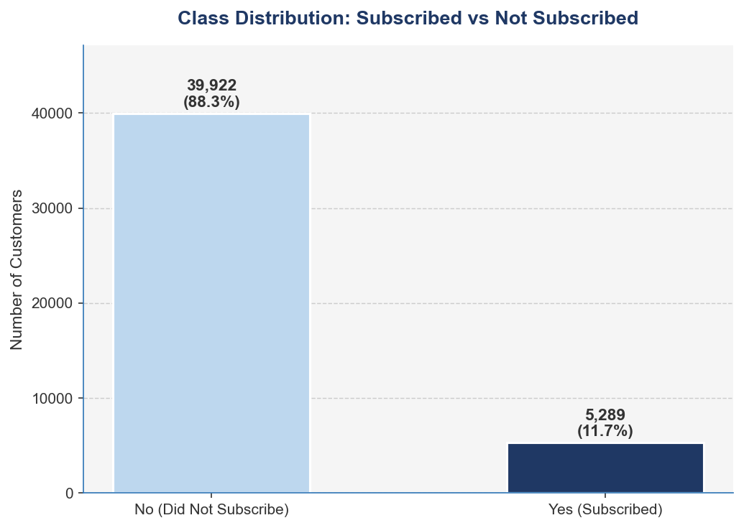
[Figure 1 — Class Distribution: Subscribed vs Not Subscribed] A bar chart showing count of 'yes' (~5,289, 11.7%) vs 'no' (~39,922, 88.3%)
Approximately 88.3% of records belong to the negative class (did not subscribe), while only 11.7% represent the positive class (subscribed). This severe imbalance poses a significant challenge for standard machine learning algorithms, which tend to be biased towards predicting the majority class — resulting in high overall accuracy but poor recall for the minority class that matters most for marketing purposes [14][15].
This is a key methodological finding that motivates the application of SMOTE in this study. Neither Moro et al. [3] nor Tran et al. [4] addressed this imbalance in their published benchmarks on the same dataset — making the class imbalance handling in this study a direct and measurable improvement over prior work [14].
3.5. Key Variable Analysis
To better understand the dataset before modelling, the distribution of key variables was examined. Figure 2 below shows the distribution of three important numerical features — age, account balance, and call duration.
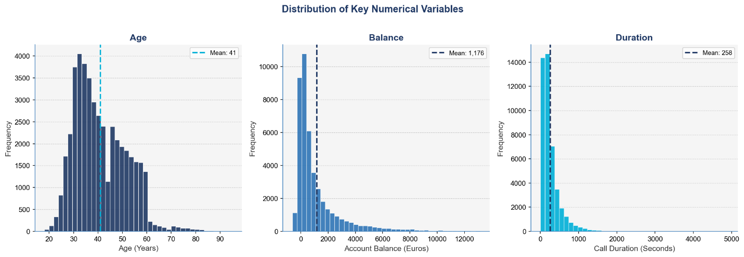
[Figure 2 — Distribution of Age, Balance and Call Duration] Three histograms showing distribution of Age, Balance and Call Duration
The age variable ranges from 18 to 95, with a mean age of 41 years and most customers falling between 25 and 55 years old — consistent with a working-age customer base typical of retail banking [3]. Account balance shows a right-skewed distribution with a mean of €1,176, though some customers carry negative balances, indicating overdraft accounts. The long right tail confirms that a small number of high-balance customers are present in the dataset. Call duration is heavily right-skewed with a mean of 258 seconds, with most calls lasting under 500 seconds and a small number of notably longer calls extending beyond 4,000 seconds. The distribution of call duration is of particular interest — as confirmed by the correlation heatmap in Figure 5, duration has the strongest individual correlation with the subscription outcome (0.39), consistent with the findings of Moro et al. [3].
Figure 3 below examines subscription rates across different job categories, revealing clear differences in how customer occupation relates to the likelihood of subscribing.
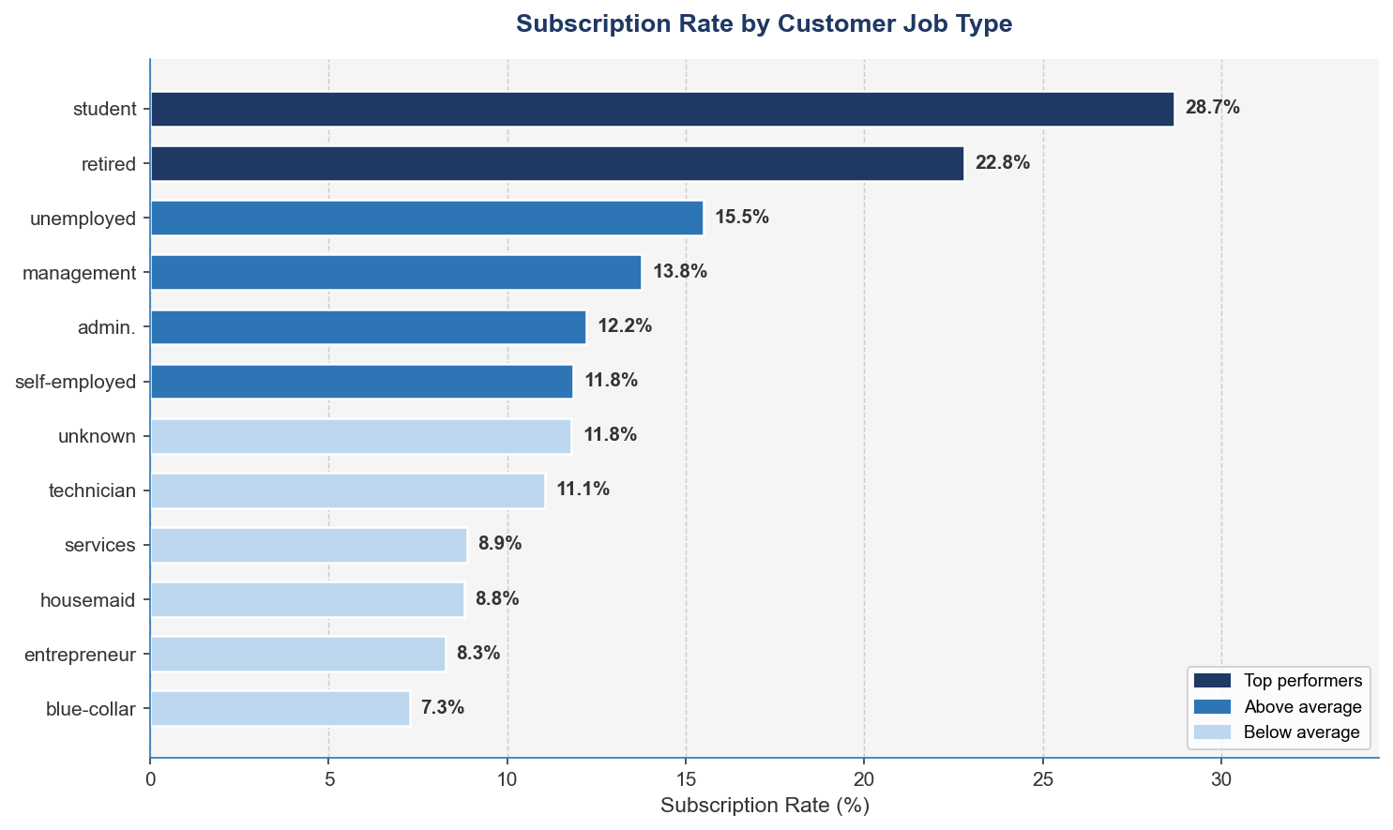
[Figure 3 — Subscription Rate by Job Type] A horizontal bar chart showing subscription rates per job category

Students and retired customers show the highest subscription rates, while blue-collar workers show the lowest. This pattern suggests that customers with more flexible financial situations and fewer financial commitments are more receptive to term deposit products — a finding consistent with the demographic analysis of banking campaign data in prior literature [2][7].
Figure 4 below shows the relationship between education level and subscription rate.
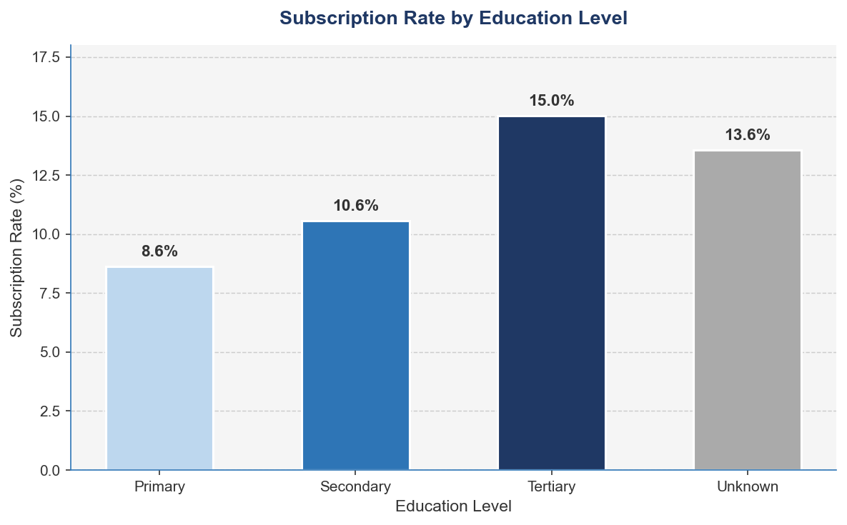
[Figure 4 — Subscription Rate by Education Level] A bar chart showing subscription rates by education level
Customers with tertiary education show the highest subscription rates, followed by those with secondary education. This finding supports the argument that education level is a meaningful predictor of financial product uptake and should be retained as a feature in the classification models [3][20].
Finally, Figure 5 presents a correlation heatmap of the numerical features in the dataset.
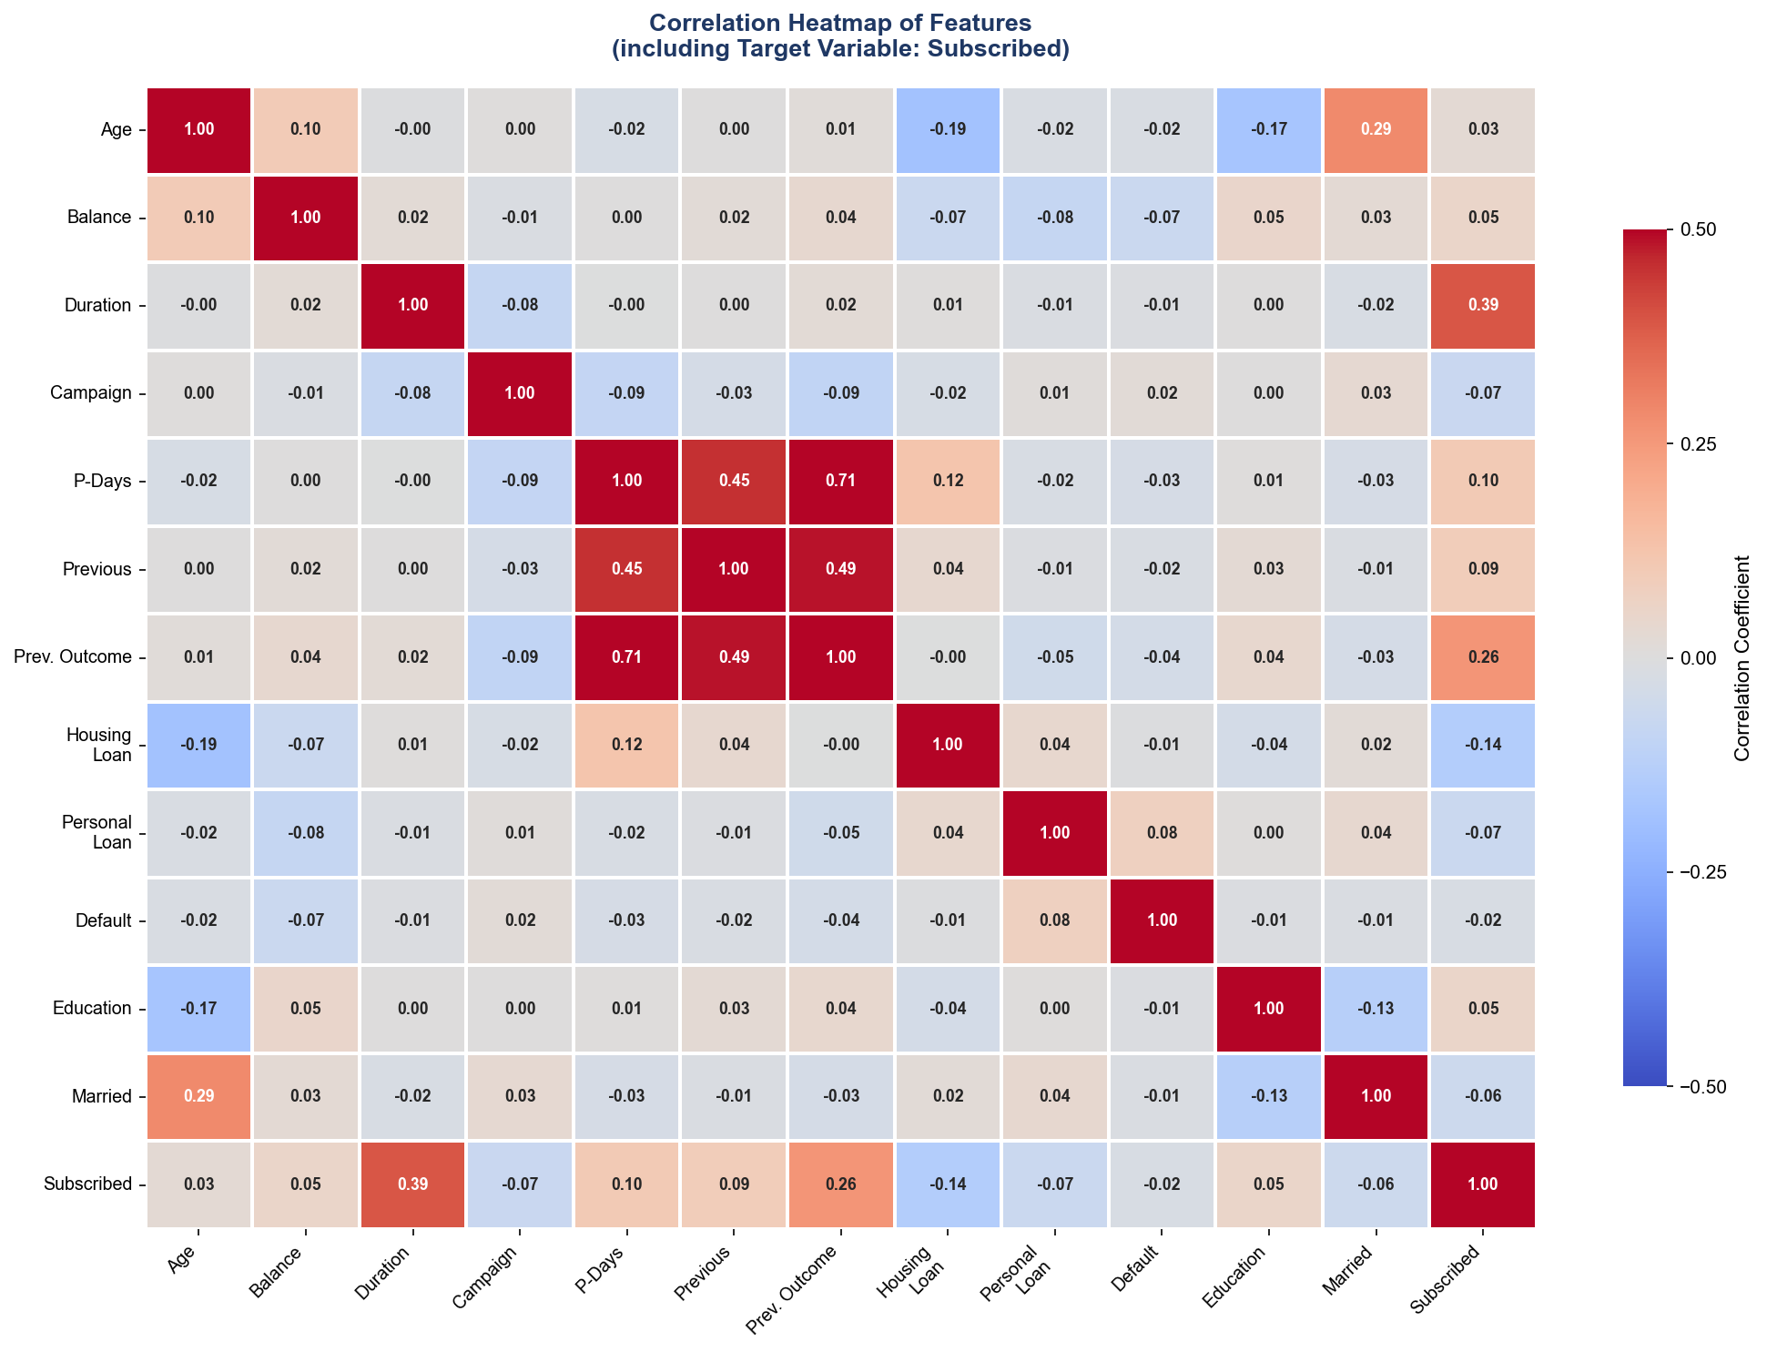
[Figure 5 — Correlation Heatmap of Numerical Features]
The correlation analysis reveals that call duration has the strongest individual correlation with the target variable. The number of days since the previous campaign contact (pdays) and the outcome of the previous campaign (poutcome) also show notable relationships with subscription likelihood. These findings are consistent with Moro et al. [3] and inform the feature engineering and selection decisions that will be described in Chapter 4.
3.6 Summary
This chapter described the UCI Bank Marketing Dataset — its source, structure, variables, class distribution, and key characteristics. The most important finding is the severe class imbalance, with only 11.7% of customers having subscribed to the term deposit product. This imbalance directly motivates the application of SMOTE in the methodology described in Chapter 4. The variable analysis also confirmed that call duration, job type, education level, and previous campaign outcome are among the most informative features for predicting customer subscription — findings that align with prior published work on the same dataset [3][4] and that guide the experimental design in Chapter 4.

4: Methodology and Experiments
4.1. Aim of Study
The aim of this study is to build, evaluate and compare six machine learning language classification models for predicting customer subscription to bank term deposit products using the UCI Bank Marketing Dataset. The study extends the benchmarks established by Moro et al. [3] and Tran et al. [4] by introducing XGBoost as a new classifier not previously tested on this dataset, applying SMOTE for class imbalance handling and implementing a rigorous cross-validated experimental design. Three experiments are conducted — a baseline without class imbalance handling, an improved experiment with SMOTE applied and a final experiment with hyperparameter tuning on the best-performing models. Results are evaluated using five performance metrics and benchmarked directly against published findings to demonstrate the contribution of this study.
4.2. Response (Dependent) and Independent Variables
The response variable in this study is the binary target variable y — indicating whether a customer subscribed to a term deposit product (yes=1, no=0). All six machine learning classifiers are trained to predict this outcome.
The independent variables are the 16 input features drawn from the dataset, organised into four categories as described in chapter 3. For the modelling purposes, all categories’ features are encoded numerically using the following strategies:
- Binary categorical variables (housing, loan, default, y) are encoded using binary encoding (yes = 1, no = 0) [20]
- Ordinal categorical variables (education) are encoded using ordinal encoding: unknown = 0, primary = 1, secondary = 2, tertiary = 3 [20]
- Nominal categorical variables with more than two categories (job, marital, contact, month, poutcome) are encoded using one-hot encoding, creating binary indicator columns for each category level [20]
Following encoding, the dataset expands from 17 columns to 51 features. Feature scaling using Min-Max normalisation is applied to all numerical features prior to training, ensuring that distance-based algorithms — KNN and SVM — are not disproportionately influenced by features with larger numerical ranges [11][12].
4.3. Outcome Measure Validation
Before any model is built, the outcome measure is validated to confirm it is a meaningful and statistically appropriate target variable for this classification task [20]. This validation step directly follows best practices in applied machine learning research [9].
4.3.1. Class Distribution Check
As demonstrated in Figure 1 (Chapter 3), the target variable is severely imbalanced — 88.3% of customers did not subscribe (negative class) and only 11.7% subscribed (positive class). This confirms that standard accuracy alone will be a misleading evaluation metric and that class imbalance handling is essential before training [14][15].
4.3.2. Feature-Target Relationship Validation
To better confirm that the target variable is meaningfully related to the input features — and therefore that a predictive model is theoretically justified — statistical tests are conducted prior to modelling:
- For numerical features (age, balance, duration, campaign, pdays, previous), a Mann-Whitney U test is applied to compare the distribution of each feature between subscribers and non-subscribers. This non-parametric test is appropriate because the numerical features in this dataset are not normally distributed [20]
- For categorical features (job, marital, education, housing, loan, contact, poutcome), a Chi-square test of independence is applied to assess whether each categorical variable has a statistically significant association with the target variable
Features that show no statistically significant relationship with the target variable (p > 0.05) are flagged for consideration in the feature selection step. This validation step ensures that the models are built on features that genuinely carry predictive information [9][20].
4.3.3. Multicollinearity Check
The correlation heatmap presented in Figure 5 (Chapter 3) is used to identify pairs of highly correlated features (|r| > 0.8). High multicollinearity between features can destabilise certain models, particularly Logistic Regression, by inflating coefficient estimates [19]. Where high correlation is identified, one of the correlated features is considered for removal to ensure model stability.

4.4. Data Preprocessing
The following preprocessing steps are applied to the dataset before splitting and model training:
Step 1 — Missing Value Check
The dataset is inspected for missing values. The UCI Bank Marketing Dataset contains no null values; however, several categorical features contain the label 'unknown' which represents missing information. These are retained as a separate category rather than imputed, as 'unknown' itself may carry predictive signal — particularly for the contact and poutcome variables [3].
Step 2 — Duplicate Record Removal
The dataset is checked for duplicate records. Any exact duplicate rows are removed to prevent the same observation from appearing in both the training and test sets.
Step 3 — Feature Encoding
All categorical variables are encoded as described in Section 4.2 using binary encoding, ordinal encoding, and one-hot encoding as appropriate [20].
Step 4 — Feature Scaling
Min-Max normalisation is applied to all numerical features, transforming values to a [0, 1] range. This is particularly important for SVM and KNN, which are sensitive to the scale of input features [11][12].
4.5 Train/Test Split
Following preprocessing, the dataset is divided into a training set and a test set using a stratified 80/20 split — 80% of records (approximately 36,169 records) for training and 20% (approximately 9,042 records) for testing [20]. Stratified splitting ensures that the class distribution of the original dataset (88.3% no, 11.7% yes) is preserved in both the training and test sets — preventing the test set from being unrepresentative of the original population [15].
A fixed random state of 42 is used throughout all experiments to ensure full reproducibility of results. The test set is held out and not used at any stage of model training, hyperparameter tuning, or SMOTE application — it is used exclusively for final model evaluation. This strict separation is critical for obtaining unbiased performance estimates [9][20].
4.6 Handling Class Imbalance — SMOTE
Class imbalance is addressed using SMOTE (Synthetic Minority Over-sampling Technique), proposed by Chawla et al. [14]. SMOTE is applied exclusively to the training set after the train/test split and never to the full dataset or the test set. Applying SMOTE before splitting would constitute data leakage, artificially inflating model performance by introducing synthetic samples that influence the test evaluation [14][15].
SMOTE works by selecting a minority class instance, identifying its k nearest neighbours within the minority class (k=5 by default), and generating a new synthetic sample at a random point along the line segment connecting the instance to one of its neighbours [14]. This produces a more balanced training set without information loss from undersampling. Following SMOTE application, the training set is balanced to approximately a 50/50 class distribution.
The impact of SMOTE is directly evaluated in the experimental design — Experiment 1 trains all models without SMOTE, and Experiment 2 trains all models with SMOTE. The difference in performance between these two experiments — particularly in recall for the minority class — constitutes one of the key new findings of this study, as neither Moro et al. [3] nor Tran et al. [4] applied SMOTE to this dataset.
4.7 Classification Models
Six machine learning classification models are developed and compared in this study. Each model is implemented using Python's Scikit-learn library [23], except for XGBoost which is implemented using the XGBoost library [6].
4.7.1 Justification for Model Selection
Six machine learning classifiers are selected for this study based on four key criteria: diversity of algorithmic approach, range of model complexity, alignment with prior published benchmarks, and suitability for binary classification on tabular data.
Diversity of Algorithmic Approach
The six models collectively represent five fundamentally different learning paradigms — ensuring that the comparison is comprehensive rather than narrowly focused on one family of algorithms [20]:
- Linear model — Logistic Regression models the decision boundary as a linear combination of features, making it the most interpretable and theoretically grounded baseline [19]
- Tree-based model — Decision Tree partitions the feature space through recursive binary splits, producing explicit if-then rules [13]
- Ensemble bagging — Random Forest aggregates predictions from hundreds of independent decision trees, reducing variance through bagging [10]
- Ensemble boosting — XGBoost builds trees sequentially, each correcting the errors of the previous, using gradient descent in function space [6]
- Kernel-based model — SVM finds the optimal separating hyperplane in a transformed feature space, effective for high-dimensional data [11]
- Instance-based model — KNN makes predictions based on the similarity of a new observation to its nearest training neighbours, requiring no explicit training phase [12]
Range of Model Complexity
The models range from simple and fully interpretable (Logistic Regression, Decision Tree) to moderately complex (KNN, SVM) to highly complex ensemble methods (Random Forest, XGBoost). This spectrum allows the study to explicitly quantify the accuracy-interpretability tradeoff — a finding of direct practical relevance in banking, where regulatory requirements often demand explainable predictions [5][22].
Alignment With prior Published Benchmarks
The selection is designed to maximise comparability with the two key published studies on the same dataset. Moro et al. [3] tested Logistic Regression, Decision Tree, and SVM. Tran et al. [4] tested Logistic Regression, Decision Tree, Random Forest, SVM, and KNN. This study includes all models from both prior studies, plus XGBoost — which has not previously been benchmarked on the UCI Bank Marketing Dataset — thereby extending the existing benchmark in a directly comparable and measurable way [6].
Suitability for the Task
All six models are well-established and widely validated for binary classification on structured tabular data in financial services applications [16][17][18]. Each model can produce probability estimates required for AUC-ROC evaluation, and all are implemented within the Scikit-learn and XGBoost Python frameworks, ensuring reproducibility [23].
4.7.2 Logistic Regression (LR)
Logistic regression models the probability of a binary outcome as a function of the independent variables using the logistic sigmoid function [19]. It serves as the interpretable baseline model in this study, consistent with its use in both Moro et al. [3] and Tran et al. [4]. The L2 regularisation penalty is applied with the regularisation parameter C tuned via cross-validation. Logistic regression is particularly valuable in banking applications because its coefficients can be directly interpreted as log-odds ratios — providing explainable predictions to regulators and stakeholders [22].
4.7.3 Decision Tree (DT)
The CART (Classification and Regression Trees) algorithm is used for the decision tree classifier [13]. Decision trees partition the feature space through a series of binary splits based on information gain, producing a hierarchical set of interpretable if-then rules [13]. The maximum tree depth is tuned via cross-validation to prevent overfitting. Decision trees are included because De Caigny et al. [5] demonstrated their value as interpretable classifiers in banking, and because they form the building block of the ensemble methods also tested in this study.

4.7.4 Random Forest (RF)
Random Forest constructs an ensemble of decision trees with each trained on a bootstrapped sample of the training data with a random subset of features considered at each split [10]. The final prediction is the majority vote of all individual trees. This randomisation reduces variance and prevents overfitting compared to a single decision tree [10]. The number of estimators and maximum features per split are tuned via cross-validation. Random Forest is included as the strongest performer in Tran et al. [4], providing a direct benchmark comparison.
4.7.5 XGBoost (XGB)
XGBoost is a gradient boosting framework that builds an ensemble of decision trees sequentially, with each tree trained to correct the residual errors of the previous ensemble [6]. It incorporates L1 and L2 regularisation to control overfitting and supports parallel processing for computational efficiency. XGBoost is the primary new model introduced in this study — it has not been benchmarked on the UCI Bank Marketing Dataset in any previously published work, making its results here a direct contribution to the literature [6]. Key hyperparameters including learning rate, maximum depth, and number of estimators are tuned via cross-validation.
4.7.6 Support Vector Machine (SVM)
The SVM classifier finds the optimal hyperplane that maximises the margin between the two classes in a high-dimensional feature space [11]. The Radial Basis Function (RBF) kernel is used to handle non-linearly separable data. The regularisation parameter C and the kernel coefficient gamma are tuned via cross-validation. SVM was included in Moro et al. [3] and Tran et al. [4], providing direct benchmarking opportunities. Feature scaling is particularly important for SVM performance [11].
4.7.7 K-Nearest Neighbours (KNN)
KNN classifies each observation by finding the K most similar training records and assigning the majority class [12]. The value of K is tuned via cross-validation, with the Euclidean distance metric used for similarity measurement. KNN serves as a non-parametric baseline that makes no assumptions about the underlying data distribution [12]. It was included in Tran et al. [4], enabling direct comparison. Feature scaling is applied before KNN training as the algorithm is sensitive to differences in feature magnitude [12].
4.8 Experimental Design
Three experiments are conducted to systematically evaluate model performance and investigate the impact of class imbalance handling and hyperparameter tuning.
Experiment 1 — Baseline: All Six Models Without SMOTE
In the first experiment, all six classifiers are trained on the imbalanced training set without any class imbalance handling. Default hyperparameters are used for all models. This experiment replicates the approach taken by Moro et al. [3] and Tran et al. [4], establishing a direct baseline comparison with published results. The primary purpose of this experiment is to demonstrate the limitations of training on imbalanced data — particularly the poor recall on the minority subscriber class — and to validate that SMOTE is necessary.
Experiment 2 — Improved: All Six Models With SMOTE
In the second experiment, SMOTE is applied to the training set before model training. All six models are trained on the balanced training set using default hyperparameters. Performance is compared directly against Experiment 1 to quantify the impact of SMOTE on each model — particularly on recall, precision, F1-score, and AUC-ROC. This comparison is one of the key new findings of this study, as it provides the first systematic evaluation of the impact of SMOTE on all six classifiers on the UCI Bank Marketing Dataset.
Experiment 3 — Optimised: Hyperparameter Tuning on Best Models
In the third experiment, the top three performing models from Experiment 2 are selected for hyperparameter tuning using GridSearchCV with 10-fold stratified cross-validation. The tuned models are retrained on the SMOTE-balanced training set and evaluated on the held-out test set. This experiment produces the final, optimised performance figures that are benchmarked against Moro et al. [3] and Tran et al. [4].
The hyperparameter search spaces for each model are as follows:

Model | Hyperparameters Tuned | Search Values
Logistic Regression | C (Regularisation) | 0.01, 0.1, 1, 10, 100
Decision Tree | max_depth, min_samples_split | Depth: 3-20, split: 2-10
Random Forest | n_estimators, max_depth, max_features | Trees: 100-500, depth: 5-20
XGBoost | Learning_rate, n_estimators, max_depth | 1r: 0.01-0.3, trees: 100-500
SVM | C, gamma, Kernel | C: 0.1-100, gamma: scale/auto
KNN | n_neighbors, metric | K: 3-15, metric: Euclidean/Manhattan

4.9 Cross-Validation strategy
All experiments use 10-fold stratified cross-validation on the training set [20]. Stratified K-fold cross-validation divides the training set into 10 equal folds while preserving the class distribution in each fold. The model is trained on 9 folds and validated on the remaining fold, rotating until each fold has been used as the validation set exactly once.
For each experiment, the following statistics are reported for every metric across the 10 folds:
- Mean — average performance across all folds.
- Standard deviation — variability of performance, indicating model stability.
A low standard deviation indicates that the model performs consistently across different subsets of the training data — a requirement for the results to be considered reliable and meaningful. Models with high variance across folds are considered unstable and less suitable for deployment, regardless of their mean performance.
4.10 Performance Evaluation Metrics
Given the severe class imbalance in the dataset, overall accuracy alone is insufficient to evaluate model performance meaningfully [14][15]. Five metrics are used to provide a comprehensive evaluation:
Accuracy
The proportion of all predictions (both classes) that are correct. While reported for completeness and benchmarking purposes, accuracy is acknowledged as a limited metric on imbalanced datasets where predicting the majority class for all instances would yield 88.3% accuracy [15].

$$Accuracy=\frac{TP+TN}{TP+TN+FP+FN}$$
Precision
The proportion of customers predicted as subscribers who subscribed. High precision is important for campaign cost efficiency — it ensures that bank resources are not wasted contacting customers unlikely to subscribe [16][17].

$$Precision=\frac{TP}{TP+FP}$$

Recall (Sensitivity)
The proportion of actual subscribers that the model correctly identifies. Recall is the most critical metric for this study — a model with high recall identifies the most potential subscribers, directly improving campaign effectiveness and customer experience [14][15].
$$Recall=\frac{TP}{TP+FP}$$

F1-Score
The harmonic mean of precision and recall, providing a single balanced metric that accounts for both [20]. The F1-score is particularly useful when comparing models across both precision and recall simultaneously.

$$F1=2 × \frac{Precision ×Recall}{Precision ×Recall}$$
AUC-ROC
The Area Under the Receiver Operating Characteristic Curve measures the overall discriminative ability of the model across all classification thresholds [3]. An AUC of 1.0 represents perfect classification and 0.5 represents random guessing. AUC-ROC is used as the primary benchmarking metric for comparison with Moro et al. [3] — who reported AUC as their primary performance measure — and Tran et al. [4].
4.11 Benchmarking Against Published Work
A key contribution of this study is the direct benchmarking of results against published findings from Moro et al. [3] and Tran et al. [4] on the same UCI Bank Marketing Dataset. Table 2 below summarises the models tested in each study and their reported performance, providing the baseline against which this study's results will be compared.
Model | Moro et al. (2014) AUC | Tran et al. (2023) Accuracy | This Study
Logistic Regression | 0.75 | 87.27% | TBD
Decision Tree | 0.73 | 92.50% | TBD
Random forest | Not tested | 97.25% | TBD
XGBoost | Not tested | Not tested | TBD
SVM | 0.78 | 92.10% | TBD
KNN | Not tested | 91.80% | TBD
Neural Network | 0.80 (The best) | Not tested | TBD

Where performance differences are observed between this study and prior work, they will be discussed in terms of the methodological improvements introduced here — specifically the application of SMOTE, stratified splitting, and cross-validation — as well as any differences in dataset preprocessing and feature engineering. This comparative discussion constitutes the core of the new knowledge contribution of this study.
4.12 Tools and Technologies
All data preprocessing, model development, and evaluation are implemented in Python 3, using the following libraries:
- Pandas and NumPy — data manipulation and numerical operations
- Matplotlib and Seaborn — data visualisation
- Scikit-learn — preprocessing, model development, cross-validation, and evaluation
- Imbalanced-learn — SMOTE implementation
- XGBoost — XGBoost classifier implementation
- SciPy — statistical tests for outcome measure validation
A fixed random seed of 42 is set globally across all libraries to ensure full reproducibility of all experiments.

References
[1] Chen, M., Mao, S., & Liu, Y. (2014). Big data: A survey. Mobile Networks and Applications, 19(2), 171–209. ResearchGate
[2] Wedel, M., & Kannan, P. K. (2016). Marketing analytics for data-rich environments. Journal of Marketing, 80(6), 97–121. ResearchGate
[3] Moro, S., Cortez, P., & Rita, P. (2014). A data-driven approach to predict the success of bank telemarketing. Decision Support Systems, 62, 22–31. ResearchGate
[4] Tran, H., Le, N., & Nguyen, V.-H. (2023). Customer churn prediction in the banking sector using machine learning-based classification models. IJIKM, 18, 87–105. Open access
[5] De Caigny, A., Coussement, K., & De Bock, K. W. (2018). A new hybrid classification algorithm for customer churn prediction based on logistic regression and decision trees. European Journal of Operational Research, 269(2), 760–772. ResearchGate
[6] Chen, T., & Guestrin, C. (2016). XGBoost: A scalable tree boosting system. Proceedings of the 22nd ACM SIGKDD, 785–794. ArXiv
[7] Ngai, E. W. T., Hu, Y., Wong, Y. H., Chen, Y., & Sun, X. (2011). The application of data mining techniques in financial fraud detection. Decision Support Systems, 50(3), 559–569. ResearchGate
[8] Kambatla, K., Kollias, G., Kumar, V., & Grama, A. (2014). Trends in big data analytics. Journal of Parallel and Distributed Computing, 74(7), 2561–2573. ResearchGate
[9] Provost, F., & Fawcett, T. (2013). Data science and its relationship to big data and data-driven decision making. Big Data, 1(1), 51–59. ResearchGate
[10] Breiman, L. (2001). Random forests. Machine Learning, 45(1), 5–32. Semantic Scholar
[11] Cortes, C., & Vapnik, V. (1995). Support-vector networks. Machine Learning, 20(3), 273–297. Semantic Scholar
[12] Zhang, Z. (2016). Introduction to machine learning: K-nearest neighbors. Annals of Translational Medicine, 4(11), 218. PubMed open access
[13] Quinlan, J. R. (1986). Induction of decision trees. Machine Learning, 1(1), 81–106. Semantic Scholar
[14] Chawla, N. V., Bowyer, K. W., Hall, L. O., & Kegelmeyer, W. P. (2002). SMOTE: Synthetic minority over-sampling technique. Journal of Artificial Intelligence Research, 16, 321–357. Open access
[15] He, H., & Garcia, E. A. (2009). Learning from imbalanced data. IEEE Transactions on Knowledge and Data Engineering, 21(9), 1263–1284. ResearchGate
[16] Lemmens, A., & Croux, C. (2006). Bagging and boosting classification trees to predict churn. Journal of Marketing Research, 43(2), 276–286. ResearchGate
[17] Coussement, K., & Van den Poel, D. (2008). Churn prediction in subscription services: An application of support vector machines. Expert Systems with Applications, 34(1), 313–327. ResearchGate
[18] Larivière, B., & Van den Poel, D. (2005). Predicting customer retention and profitability by using random forests. Expert Systems with Applications, 29(2), 472–484. ResearchGate
[19] Peng, C.-Y. J., Lee, K. L., & Ingersoll, G. M. (2002). An introduction to logistic regression analysis and reporting. Journal of Educational Research, 96(1), 3–14. ResearchGate
[20] Han, J., Kamber, M., & Pei, J. (2012). Data Mining: Concepts and Techniques (3rd ed.). Morgan Kaufmann. Widely available
[21] Ganganwar, V. (2012). An overview of classification algorithms for imbalanced datasets. International Journal of Emerging Technology and Advanced Engineering, 2(4), 42–47. Open access
[22] Malik, M., & Thomas, L. C. (2010). Modelling credit risk of portfolio of consumer loans. Journal of the Operational Research Society, 61(3), 411–420. ResearchGate
[23] Pedregosa, F., Varoquaux, G., Gramfort, A., et al. (2011). Scikit-learn: Machine learning in Python. Journal of Machine Learning Research, 12, 2825–2830. ✅ Open access — https://jmlr.org/papers/v12/pedregosa11a.html

