Contents

1 Subsystem Three: Controls and Decision Making 1

1.1 Requirements and Functional Decomposition 1

1.2 Background and Prior Art 3

1.2.1 Jacobian 3

1.2.2 Dynamics 3

1.3 Approach and Execution 5

1.3.1 Jacobian 5

1.3.2 Dynamics 5

1.4 Results and Discussion 5

2 Bibliography 6

Equation 1: Jacobian 3

Equation 2: Relationship between q and x 3

Equation 3: Euler–Lagrange equations (Khatib, 2008) 3

Equation 4: The Lagrangian (Khatib, 2008) 4

Equation 5: Kinetic Energy (Khatib, 2008) 4

Equation 6: Explicit form of EOM 4

Equation 7: Kinetic Energy of Link i 4

Equation 8: Kinetic energy of System 4

# Subsystem Three: Controls and Decision Making

This section details the analysis, design, implementation, and results of the subsystem responsible for determining the actions required by the actuation system.

## Requirements and Functional Decomposition

The overarching purpose of subsystem three (SS3) was to determine the action that should be taken by the actuator system to minimise the error in the system.

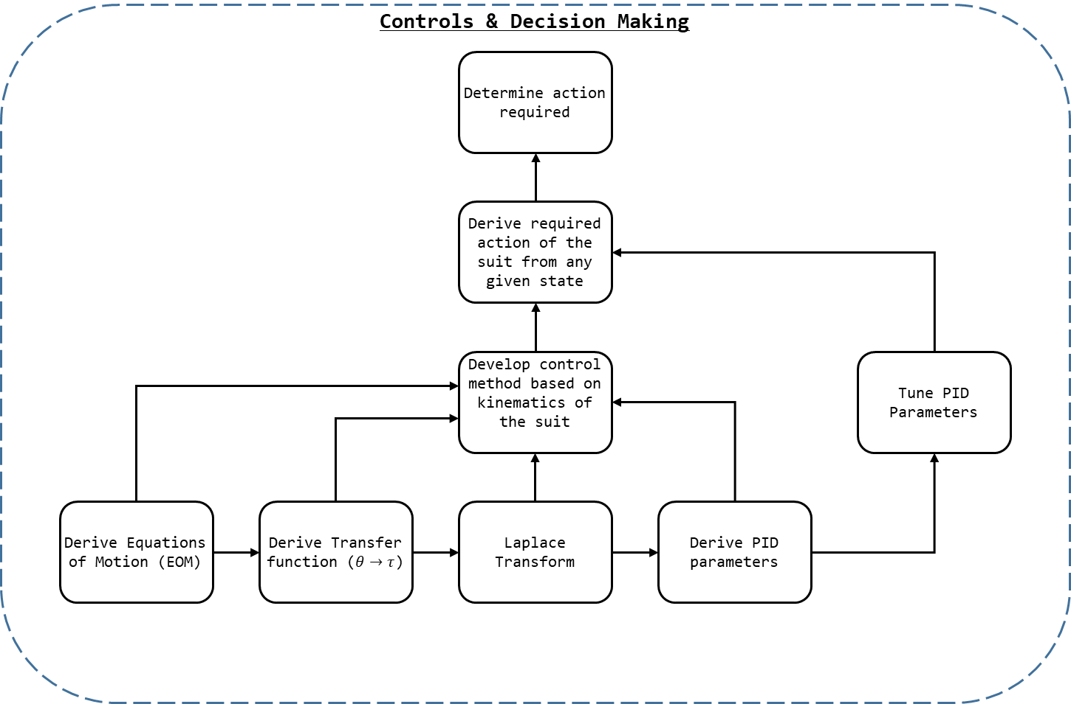

Figure 1: SS3 Breakdown

As seen in Figure 29: SS3 Breakdown, to determine the action required in a state (given by the values determined by SS1, SS2, and SS4) the action required in any given state must be known.

To determine the general solution of what actions should be taken at any given state the controls parameters and method for the system should be derived, and then this model should be refined by practically tuning the solution.

The methodology for tuning the controls parameters of the system is discussed in kt, but the initial values to be refined are best source directly from the theory.

To determine the control parameters for the system the following method is employed:

1. Derive the equations of motion (EOM) for the system;
2. From the EOM derive the transfer function (TF) of the system (torque () with respect to angle ());
3. Transform the TF into the Laplace Domain; and,
4. Derive the PID parameters from the Laplace Domain TF.

Ultimately, five sets of controls were derived during the project: three for the 3 Degree of Freedom (DOF) lower extremity system (each joint had its own parameters), one for the continuous servomotor (which was abandoned as discussed in kt), and the positional servomotor.

The 3 DOF system was to control the lower extremity exoskeleton being constructed by the actuators and structural side of the project. However, as actual values for system parameters (masses, dimensions, moments of inertia, etc…) were never confirmed the solution had to be found algebraically.

The two systems used in testing featured their own embedded control systems, and their torque, angle, velocity, and acceleration could not be directly controlled. As such precise controls could not be derive from first principles. Instead the controls systems would need to be tuned empirically to achieve the desired system response.

## Background and Prior Art

The goal of SS3 is to model the dynamics expected of the system, establish the manipulator equations of motion, and derive the appropriate controls structure to create the behaviour required, in a stable fashion.

### Jacobian

For a system, in this case a manipulator, in the configuration given by the vector there is corresponding psotion for the end-effector given by the vector . The Jacobian matrix, , describes the relationship between the time derivatives of and ( and respectively). The Jacobian matrix, or simply the Jacobian, given by Equation 1, allows use to describe the system by Equation 2.

Equation 1: Jacobian

Equation 2: Relationship between q and x

Where .

### Dynamics

#### Explicit Form of the Equations of Motion

We begin with the Euler–Lagrange equations, or Lagrange's equations of the second kind, Equation 1.

Equation 3: Euler–Lagrange equations (Khatib, 2008)

Where is the vector of applied generalised torques. The Lagrangian, L, is given by Equation 2.

Equation 4: The Lagrangian (Khatib, 2008)

Where V is the potential energy of the system, and K is the kinetic energy of the system. As seen in Equation 3, K may be given in terms of the generalised velocities, (as seen in Equation 1: Euler–Lagrange equations) and the manipulator mass matrix M.

Equation 5: Kinetic Energy (Khatib, 2008)

Substituting the Lagrangian into Equation 1 yield the explicit form of the equations of motion (EOM), see Equation 4. Where is the vector of gravity force and is the vector of centrifugal and Coriolis forces. Equation 4, once found, may be used to map the relationship between the torque applied by the systems actuators and the resulting system configuration.

Equation 6: Explicit form of EOM

#### Explicit form of Manipulator Mass Matrix

Kinetic energy is subject to the adaptive property (Siciliano & Khatib, 2016), and thus the total kinetic energy of a system is the summation of the kinetic energy of its links. Links here refers to the actuated limb segments of the exoskeleton correlating with the thigh, shin, and foot.

The kinetic energy of each link is comprised of a rotational and linear motion component. For a link with linear motion of , an angular motion of , and an inertia tensor of , the kinetic energy of the link , , is given by Equation 5. Where refers to the centre of mass of the link.

Equation 7: Kinetic Energy of Link i

Given Equation 5 and the additive property it may be said that the kinetic of the system in total is given by

Equation 8: Kinetic energy of System

#### Vector of centrifugal and Coriolis forces

#### Vector of gravity force

## Approach and Execution

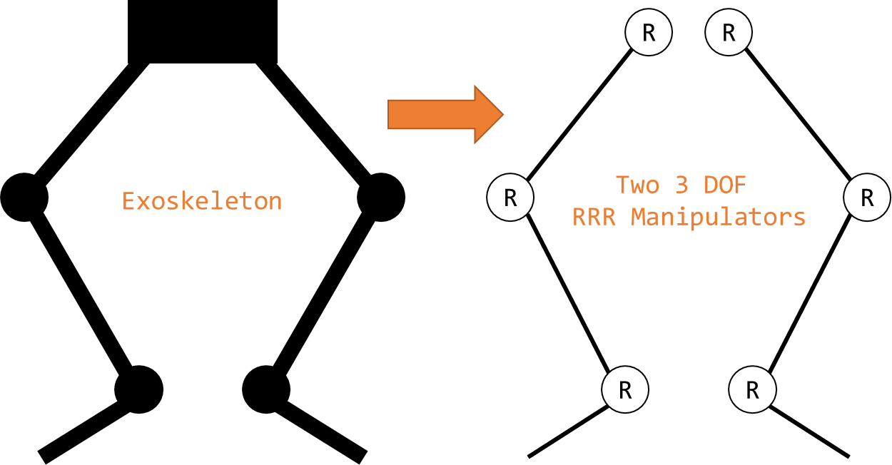

Figure 2: Exoskeleton Abstraction

### Jacobian

### Dynamics

#### Explicit Form of the Equations of Motion

#### Explicit form of Manipulator Mass Matrix

#### Vector of centrifugal and Coriolis forces

#### Vector of gravity force

## Results and Discussion

# Bibliography

Agarwal, A. (2005). *Foundations of analog & digital electronic circuits* (1 ed.). Massachusetts: Massachusetts Institute of Technology. Retrieved June 1, 2018, from https://www.google.com/url?sa=t&rct=j&q=&esrc=s&source=web&cd=1&ved=0ahUKEwiBu7yQl7LbAhUEoZQKHfYlBzkQFggpMAA&url=http%3A%2F%2Fsiva.bgk.uni-obuda.hu%2Fjegyzetek%2FMechatronikai_alapismeretek%2FEnglish_Mechatr%2FElectr_Eng-1%2FLiterature%2FFoundations%2520o

American Technologies Network Corporation. (2018, May 30). *How Does Night Vision Work*. Retrieved from atncorp.com: https://www.atncorp.com/hownightvisionworks

Arrow. (2018). *Magnetoresistive Sensor.* Retrieved May 30, 2018, from arrow.com: https://www.arrow.com/en/categories/sensors/magnetoresistive-sensors

Axe, D. (2012, May 23). *Combat Exoskeleton Marches Toward Afghanistan Deployment*. Retrieved May 30, 2018, from Wired: https://www.wired.com/2012/05/combat-exoskeleton-afghanistan/

Bulgrin, M. (2017, May 11). *The History of the Hose Clamp.* Retrieved from normagroup.com: https://blog.normagroup.com/en/the-history-of-the-hose-clamp/

Bunnings. (2018, May 31). *Kinetic 21 - 44mm 304 Stainless Steel Hose Clamp.* Retrieved May 31, 2018, from Bunnings.com: https://www.bunnings.com.au/kinetic-21-44mm-304-stainless-steel-hose-clamp_p4920194

Charara, S. (2015, July 9). *This robotic exoskeleton helps paralysed patients to walk and it's getting smarter*. Retrieved August 23, 2017, from Wearable: https://www.wareable.com/wearable-tech/exoskeleton-paralysed-patients-ekso-bionics-gt-sarah-thomas

Computer Cable Store. (2018, May 31). *11 7/8 Inch Black Standard Nylon Cable Tie - 100 Pack.* Retrieved May 31, 2018, from computercablestore.com: https://www.computercablestore.com/11-78-inch-black-standard-nylon-cable-tie-100-pack

Cornwall, W. (2015, October 15). *Feature: Can we build an ‘Iron Man’ suit that gives soldiers a robotic boost?* Retrieved August 20, 2017, from sciencemag.org: http://www.sciencemag.org/news/2015/10/feature-can-we-build-iron-man-suit-gives-soldiers-robotic-boost

Cracknell, A. P., & Hayes, L. (2007). *Introduction to Remote Sensing* (2 ed.). London: Taylor and Francis. Retrieved May 30, 2018

Cutnell, J. D., & Johnson, K. W. (1998). *Physics* (4th ed.). New York: Wiley.

Cyberdyne. (2015, August 1). *CYBERDYNE Inc. has begun seeking approval from the U. S. Food and Drug Administration (FDA)*. Retrieved August 23, 2017, from cyberdyne.jp: https://www.cyberdyne.jp/english/company/PressReleases_detail.html?id=1075

Cyberdyne. (2016). *What’s HAL?* Retrieved August 19, 2017, from cyberdyne.jp: https://www.cyberdyne.jp/english/products/HAL/

Cybernetic Zoo. (2010, October 14). *1890 – Assisted-walking Device – Nicholas Yagn (Russian)*. Retrieved May 30, 2018, from Cyberneticzoo.com: http://cyberneticzoo.com/tag/nicholas-yagn/

Cybernetic Zoo. (2010, April 10). *1965-71 – G.E. Hardiman I Exoskeleton – Ralph Mosher (American)*. Retrieved May 30, 2018, from cyberneticzoo.com: http://cyberneticzoo.com/man-amplifiers/1966-69-g-e-hardiman-i-ralph-mosher-american/

Dunietz, J. (2017, July 27). *Robotic Exoskeleton Adapts While It’s Worn*. Retrieved August 20, 2017, from scientificamerican.com: https://www.scientificamerican.com/article/robotic-exoskeleton-ldquo-evolves-rdquo-while-its-worn/

Future Electronics. (2018, May 30). *What is Optoelectronics?* Retrieved from Future Electronics: http://www.futureelectronics.com/en/optoelectronics/infrared-receivers.aspx

Garbett, I. (2001, Janurary 1). *Light attenuation and exponential laws*. Retrieved May 30, 2018, from plus.maths.org: https://plus.maths.org/content/light-attenuation-and-exponential-laws

Gross, K. (2018, Feburary 19). *Ultrasonic Sensors: Advantages and Limitations*. Retrieved May 30, 2018, from MaxBotix: https://www.maxbotix.com/articles/advantages-limitations-ultrasonic-sensors.htm/

Jackson, R., Green, K. R., & Eisenbeis, R. (2017). *Achieve greater precision, reliability with integrated magnetic sensing technology.* Retrieved May 30, 2018, from ti.com: http://www.ti.com/general/docs/lit/getliterature.tsp?baseLiteratureNumber=sszy030&fileType=pdf

Karlin, S. (2011, July 29). *Raytheon Sarcos’s Exoskeleton Nears Production*. Retrieved August 11, 2017, from spectrum.ieee.org: http://spectrum.ieee.org/at-work/innovation/raytheon-sarcoss-exoskeleton-nears-produc

Keller, M. (2016, August 25). *Exoskeleton - Do You Even Lift, Bro? Hardiman Was GE’s Muscular Take On The Human-Machine Interface*. (General Electric) Retrieved May 30, 2018, from GE Reports: https://www.ge.com/reports/do-you-even-lift-bro-hardiman-and-the-human-machine-interface/

Keyence Corporation. (2018). *What is a Inductive Proximity Sensor?* Retrieved May 30, 2018, from keyence.com: https://www.keyence.com/ss/products/sensor/sensorbasics/proximity/info/

Khatib, O. (2008). Chapter 5 - Dynamics. In O. Khatib, *Introduction to Robotics* (pp. 125-150). Stanford: Stanford University.

Liew, S. C. (2018, May 30). *Electromagnetic Waves*. Retrieved from Centre for Remote Imaging, Sensing and Processing.: https://crisp.nus.edu.sg/~research/tutorial/em.htm

Lynch, D. K., & Livingston, W. C. (2001). *Color and Light in Nature* (2nd ed.). Cambridge, United Kingdom: Cambridge University Press. Retrieved May 30, 2018, from https://books.google.com.au/books?id=4Abp5FdhskAC&pg=PA231&redir_esc=y#v=onepage&q&f=false

Merriam-Webster Dictionary. (2018, May 18). *noise*. Retrieved May 30, 2018, from merriam-webster.com: https://www.merriam-webster.com/dictionary/noise

Robomart. (2015, November 9). *Advantages and Disadvantages of ultrasonic distance sensor.* Retrieved May 30, 2018, from Robomart: http://roboticsensors.blogspot.com/2015/11/advantages-and-disadvantages-of.html

Siciliano, B., & Khatib, O. (2016). *Springer Handbook of Robotics* (2 ed.). (B. Siciliano, & O. Khatib, Eds.) Berlin: Springer Nature. doi:10.1007/978-3-319-32552-1

Texas Instruments Incorporated. (2017). *Hall effect sensors*. Retrieved May 30, 2018, from ti.com: http://www.ti.com/sensing-products/magnetic-sensors/hall-effect/overview.html

Thomas Publishing Company. (2018). *Capacitive Proximity Sensors*. Retrieved May 30, 2018, from Thomas: https://www.thomasnet.com/articles/instruments-controls/proximity-sensors

Vishay Semiconductors. (2017, February 8). TCRT5000 - Reflective Optical Sensor with Transistor Output.

Yagin, N. (1890, February 11). *United States of America Patent No. 440684.*

Yuhas, D. (2012, May 24). *Speedy Science: How Fast Can You React?* Retrieved from scientificamerican.com: https://www.scientificamerican.com/article/bring-science-home-reaction-time/

ZJIA. (2018, June 1). *Generic YZC-161B 50kg Body Scale Sensor Human Scale Weighing Load Cell Sensor (Pack of 4)* . Retrieved June 1, 2018, from Amazon.com: https://www.amazon.com/Generic-YZC-161B-Scale-Sensor-Weighing/dp/B00MTJ6WZ2