MBARARA UNIVERSITY OF SCIENCE AND TECHNOLOGY
DBMS Project Report
Banking Management System

AREA OF INTEREST: Risk Management Database

PRESENTED BY : SSEKASI SAMUEL

REG NO : 2025/BCS/172/PS

COURSE NAME : DBMS

LECTURER : KENNETH BAGUMA

1. Selecting a Database Project

1.1 Area of Interest
The selected area of interest is a Banking Management System, specifically focused on building a robust and regulatory-compliant risk management database.

1.2 Possible Database Systems Applicable
- Core banking system (transactional) – e.g., Oracle FLEXCUBE, Temenos T24
- Data warehouse – Snowflake, Amazon Redshift
- CRM database – Salesforce Financial Services Cloud
- Risk management database – custom-built on MySQL, PostgreSQL, or Oracle
- Compliance & fraud detection – Actimize, SAS Fraud Management

1.3 Chosen System: Custom Risk Management Database
After evaluating the options above, the Custom Risk Management Database built on MySQL was selected as the most appropriate solution for this project.

1.4 Reasons for Choice
- Cost-effective – MySQL is open-source with no licensing fees compared to Oracle or SQL Server.
- ACID compliant – The InnoDB engine ensures transactional integrity for risk exposures.
- Scalable – Supports partitioning, read replicas, and InnoDB Cluster for high availability.
- Regulatory ready – Provides binary logging for audit trails, encryption for sensitive data, and role-based access control.
- Flexible – Can store structured risk factors (exposures, Value-at-Risk) and semi-structured data.
- Integration – Easily connects to ETL tools (Python, Talend) and BI dashboards (Tableau, Power BI).

2. Business Case for the Risk Management Database System

2.1 Application Domain
The risk management database system is designed to support the full lifecycle of banking risk operations. The following tasks and operations are supported by the system

Task / Operation | Description
Daily VaR Calculation | Calculation of Value-at-Risk (VaR) per portfolio on a daily basis.
Counterparty Exposure | Tracking counterparty exposures and collateral coverage.
Operational Loss Recording | Recording operational loss events and linking them to risk controls.
Market Risk Factors | Storing market risk factors such as interest rates and asset prices.
Regulatory Reporting | Generating regulatory reports for compliance submissions.

2.2 User Groups Served
- Risk Analysts – run queries, monitor exposures, and validate VaR calculations.
- Chief Risk Officer (CRO) – view dashboard summaries and approve risk limits.
- Compliance Officers – audit data lineage and produce regulatory submissions.
- Internal Audit – verify data integrity and access controls.

2.3 Assumptions
- Daily data feeds from core banking, market data vendors (Bloomberg), and loan origination systems are available.
- The bank has a data governance team in place to maintain data quality.
- Existing spreadsheets or legacy risk databases are slow, error-prone, and not audit-ready, justifying migration to this new system.

3. Analysis of Benefits
The following table summarises the key benefits delivered by the Custom Risk Management Database, categorised by type and tangibility.

Benefit Type | Description | Tangible / Intangible
Regulatory Compliance | Meets BCBS 239 (risk data aggregation) and IFRS 9 requirements – avoids regulatory fines. | Tangible
Operational Efficiency | Reduces manual effort: risk reports generated in minutes instead of days. | Tangible
Lower IT Costs | Uses open-source MySQL instead of expensive proprietary databases, reducing software licensing expenditure. | Tangible
Better Risk Decisions | Real-time exposure views and stress testing capabilities help the bank avoid large financial losses. | Intangible
Audit Readiness | Immutable audit logs and data lineage satisfy internal and external auditors, reducing audit fees and regulatory penalties. | Tangible
Competitive Advantage | Faster risk reporting enables quicker response to market changes, improving investor confidence and market positioning. | Intangible

4. Analysis of Costs
The following table outlines the costs associated with implementing and maintaining the Custom Risk Management Database.

Cost Type | Description | Tangible / Intangible | Est. Amount
Hardware / Cloud | MySQL server (on-premise or cloud VM): 4-core, 16GB RAM, 500GB SSD. | Tangible | ~$200/mo
Software | MySQL Community Edition (free). Optional MySQL Enterprise Backup for automated backups. | Tangible | Low
Development | 2 database developers over 2 months: schema design, ETL scripts, and stored procedures. | Tangible | ~$20,000
Training | Risk analysts and IT staff trained on SQL and database management tools. | Tangible | ~$3,000
Maintenance | DBA support (0.5 FTE), backups, monitoring, and patch management. | Tangible | ~$30,000/yr
Migration Risk | Potential data quality issues or downtime during cutover. Mitigated by parallel run strategy. | Intangible | Low
Change Management | Staff resistance to new system. Addressed through structured training and staff involvement in the design process. | Intangible | Low

5. Feasibility Summary

5.1 Tangible Benefits (Annual)
- Avoided regulatory fines through BCBS 239 and IFRS 9 compliance.
- Significant analyst time saved through automated reporting.
- Licensing savings from adopting open-source MySQL.
- Reduced audit fees through immutable audit logs and data lineage tracking.

5.2 Overall Assessment
The system is highly economically feasible. The tangible benefits — including avoided regulatory fines, operational savings, and reduced IT licensing costs — far exceed the one-time development and ongoing maintenance costs. Intangible benefits such as better risk decisions and improved audit readiness further strengthen the business case and provide long-term strategic value to the organisation.

In conclusion, the Custom Risk Management Database on MySQL represents a cost-effective, scalable, and regulatory-compliant solution that addresses the core risk management needs of the banking organisation, with a strong return on investment expected within the first year of full operation.

Description for the tables in the database

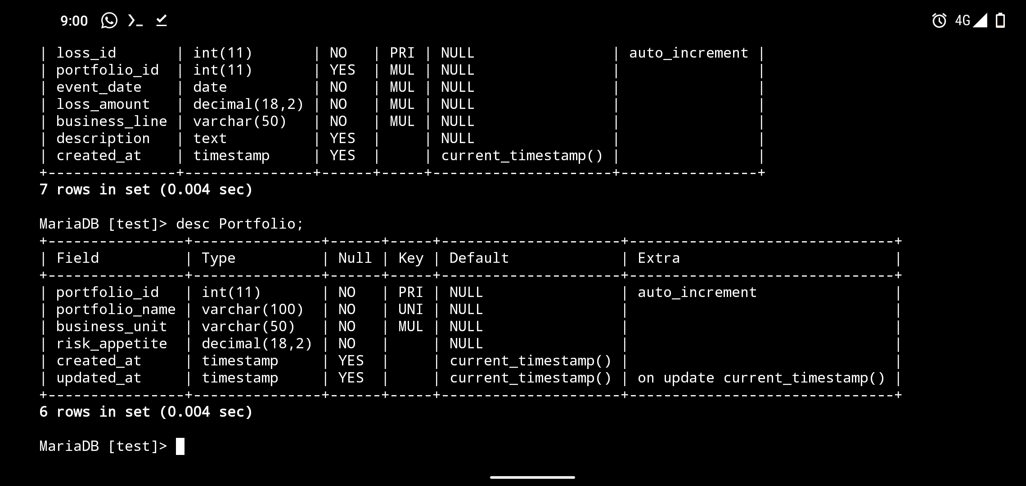

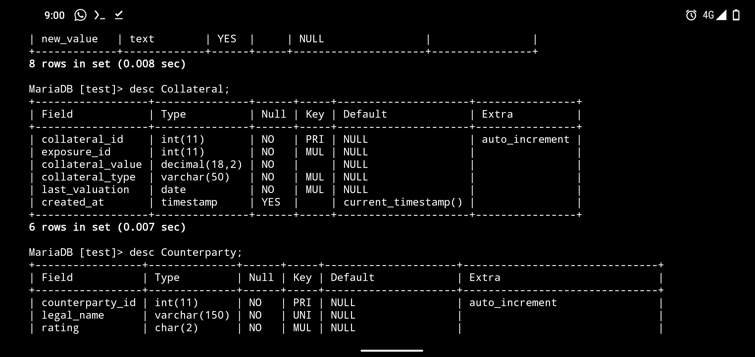

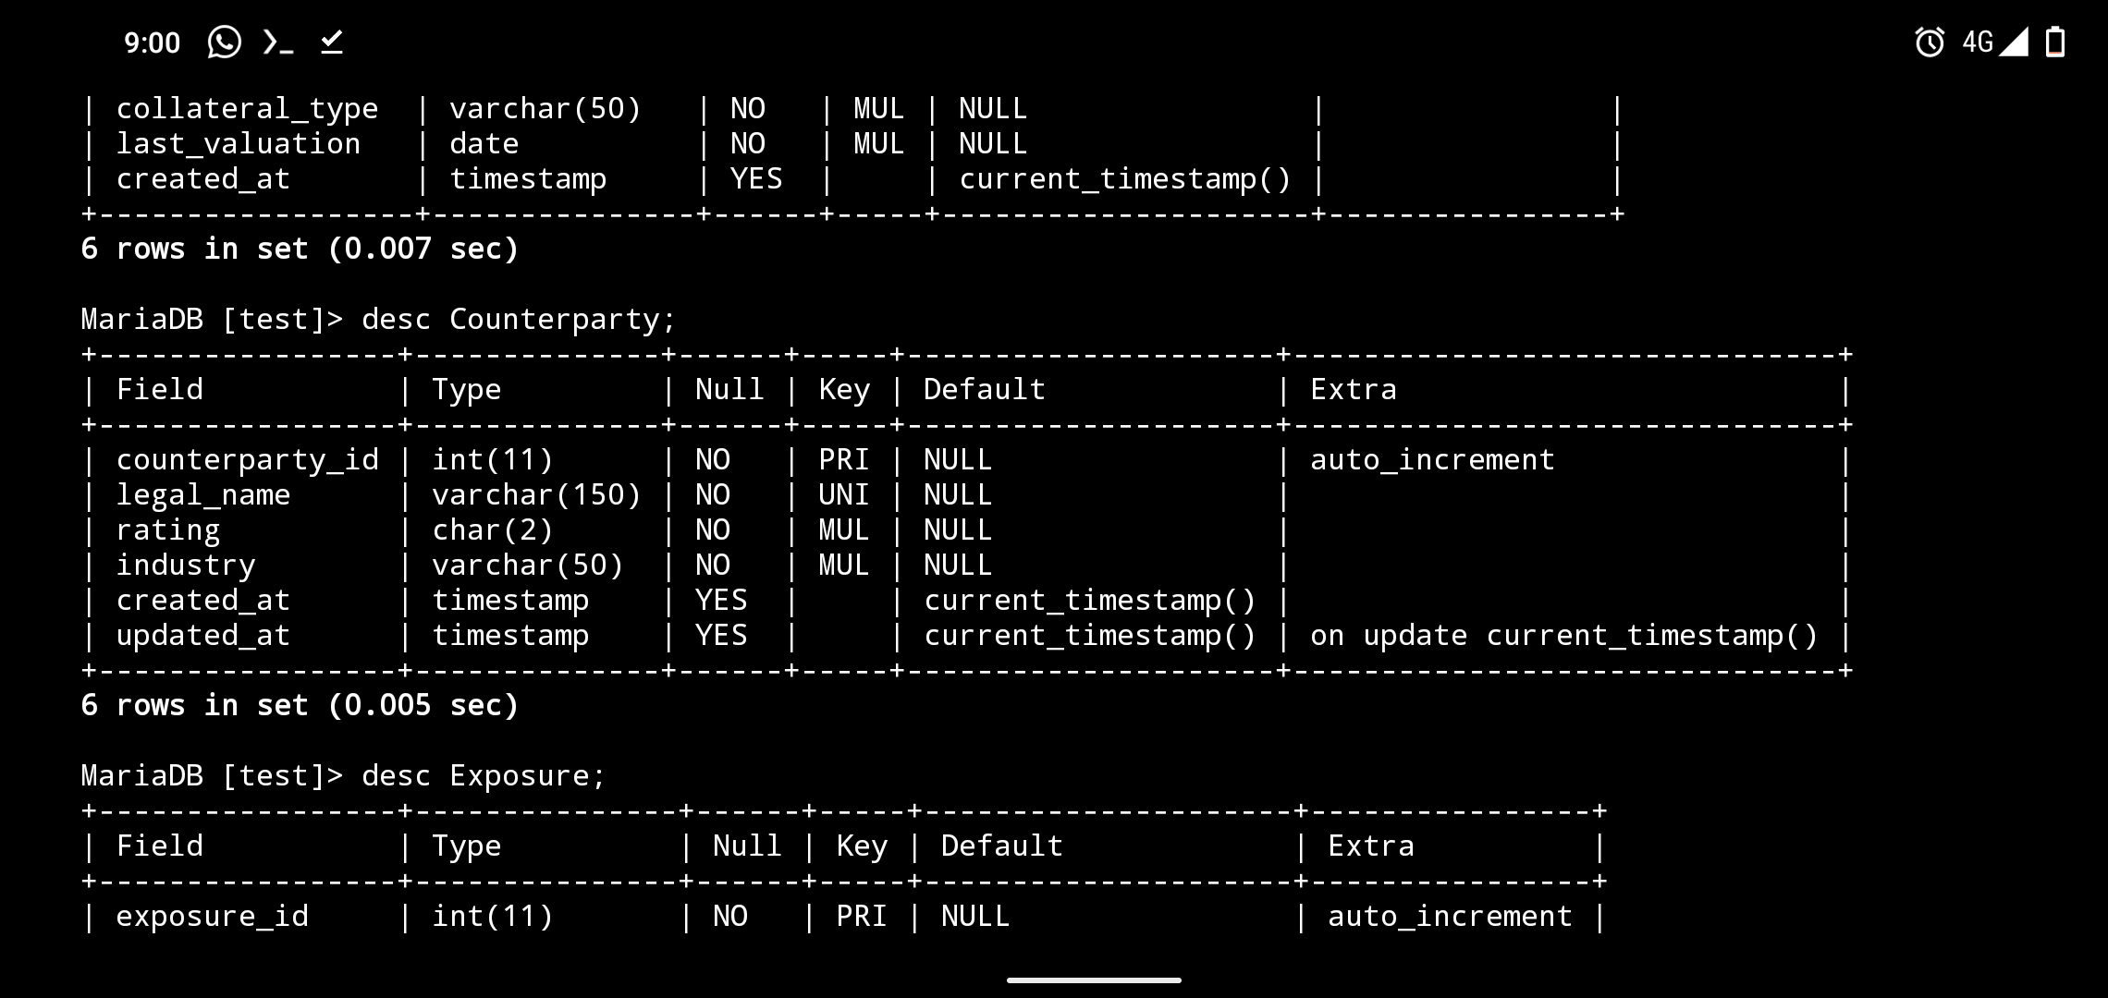

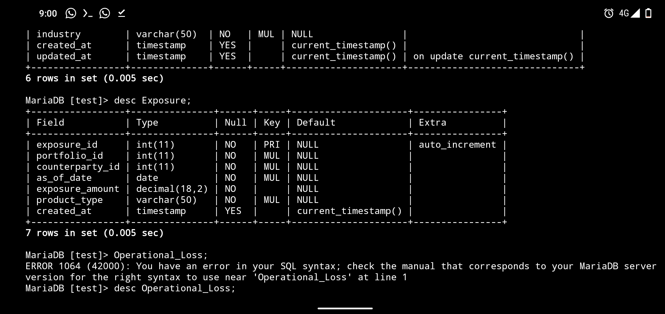

ER DIAGRAM

