

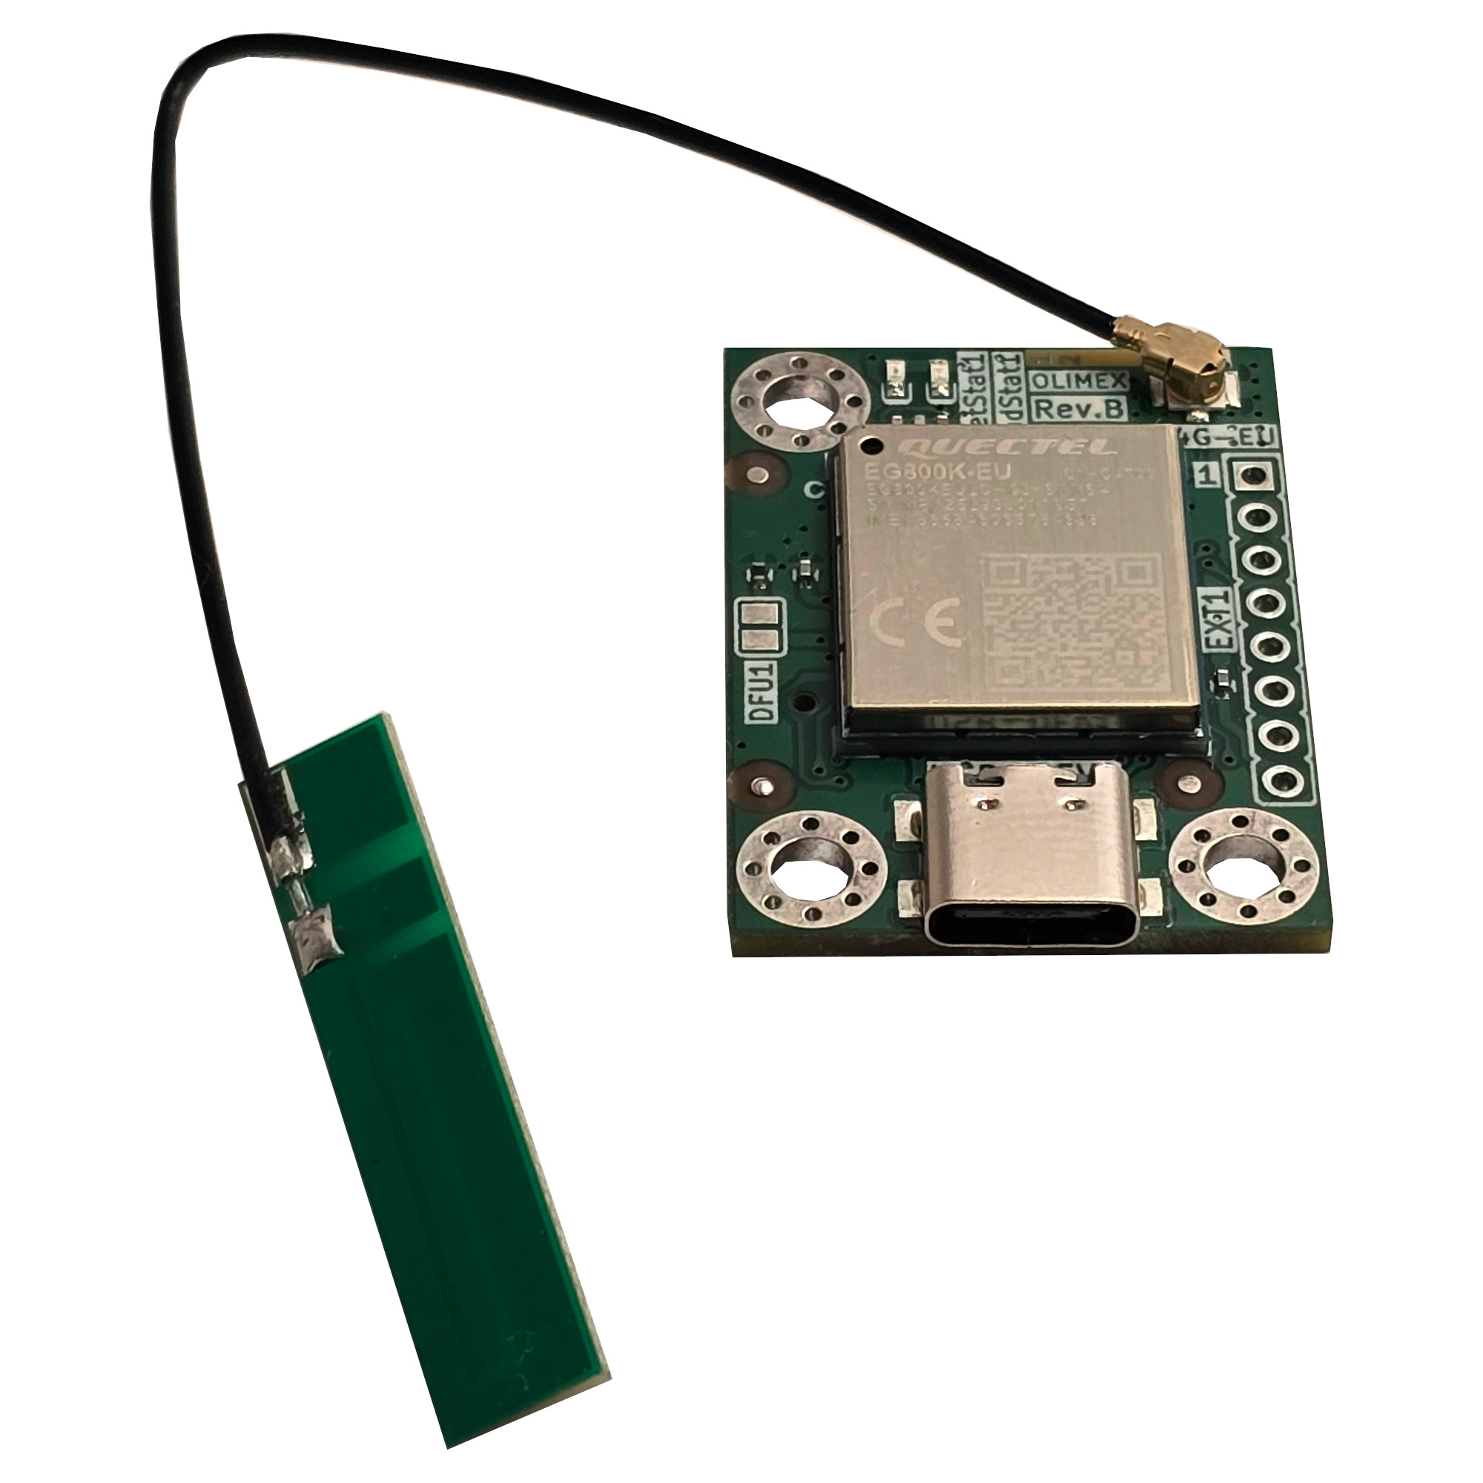
USB-LTE4G-EU
User Manual

Document 1.0 June 2026 | www.OLIMEX.com

Table of Contents
1. Introduction 3
1.1. What is USB-LTE4G-EU 3
1.2. Board features 4
1.3. USB-LTE4G-EU ordering options 5
1.4. License information 6
2. Quick start up 7
2.1. Hardware connection 7
2.2. USB-LTE4G-EU software installation 7
2.3. BOX-LTE4G assembly 7
3. Hardware 8
3.1. USB-LTE4G-EU top layout 8
3.2. USB-LTE4G-EU bottom layout 9
3.3. EXT1 header 10
3.4. LEDs 11
3.5. DFU1 PTH jumper 11
3.6. USB-LTE4G-EU board dimensions 12
3.7. BOX-LTE4G dimensions 12
3.8. USB-LTE4G-EU power consumption 13
4. Software 14
5. Additional documents 14
6. Warranty and returns 14
7. Document revision history 14

1. Introduction

1.1. What is USB-LTE4G-EU
USB-LTE4G-EU is a small and reliable 4G LTE USB modem board with Quectel EG800K-EU module. It delivers reliable, cost-effective, and energy-efficient cellular connectivity for IoT, M2M, industrial automation, telemetry, POS terminals, remote monitoring, and embedded systems.
The LTE speed is 10Mbps downlink and 5Mbps uplink, but is backward-compatible with existing EDGE and GSM/GPRS networks. This allows USB-LTE4G-EU to connect to any existing 2G, 3G and 4G network.
The board has USB type C connector for powering and data connection. The design also has EXT1 header which can be used for powering or data access when embedding in own products or testing.
USB-LTE4G-EU will work with Olimex OSHW Linux computers, Beaglebone and Raspberry Pi and any other PC running Windows, Linux, or Android.

1.2. Board features

- Quectel EG800K-EU LTE module with the following features:
  - LTE Cat 1 bis technology
  - Download speeds up to 10 Mbps
  - Upload speeds up to 5 Mbps
  - Frequency bands EU: B1/B3/B5/B7/B8/B20/B28
  - AT commands: Complies with 3GPP TS 27.007 and 3GPP TS 27.005
  - Supports 3GPP Rel-13 Cat 1 bis FDD
  - Supports UL QPSK and 16QAM modulations
  - Supports DL QPSK, 16QAM and 64QAM modulations
  - Supports 1.4/3/5/10/15/20 MHz RF bandwidths
- USB-C connector with USB 2.0 interface for power and serial communication
- Nano SIM holder
- Automatic module turn on circuit upon power up
- EXT1 header for external power supply input, main UART with RX, TX, and DTR, module reset pin, module turn on-off pin, power out
- Two status LEDs
- U.FL connector for GSM antenna
- Three grounded metallized mounting holes
- Current consumption: 20μA @Power off, 3mA @Sleep, 22mA @Idle, 50-350mA when active, up to 2A burst consumption
- Operating temperature range: -35+75C
- Industrial-grade reliability
- Support for Windows, Linux, and Android platforms
- Dimensions: (34 x 25 x 6)mm

1.3. USB-LTE4G-EU ordering options

It is recommended to start with the USB-LTE4G-EU-ANT version.

USB-LTE4G-EU can be ordered with our without antenna:
- USB-LTE4G-EU-ANT the module with GSM multiband antenna
- USB-LTE4G-EU just the module without u.FL GSM antenna
We can manufacture NA version upon request but the NA version of the module is significantly more expensive.
There is a custom 3D printed plastic box available for the module. It can be purchased separately:
- BOX-USB-LTE4G – keeps the antenna and the module safe, only USB type C connector exposed.
Cables and extras:
- USB-CABLE-A-TO-C-15CM – short USB type C to type A connector to reduce chances for high capacitance; 4G modules have up to 2A burst current consumption
- USB-CAP - USB supply filtering to enable the operation of current-hungry devices with weak USB hosts
- USB-SERIAL-L – this is a USB-serial converter compatible with 1.8V UART levels if you decide to use the EXT1 header for the majn UART, requires connecting VREF to VDD_EXT

1.4. License information
USB-LTE4G-EU and USB-LTE4G-EU-ANT are propriety designs. They are NOT considered OSHW (Open-source HardWare) and design files and schematics will NOT be shared.
This document is considered OSHW and it is made with LibreOffice, you are free to edit it to your liking as long as you respect the copyright of our trade marks.

2. Quick start up

2.1. Hardware connection
The minimum hardware connection is pretty simple:
- Attach the antenna to the USB-LTE4G-EU’s u.FL connector, make sure it clicks and stays firmly attached, you can rotate it the way you like;
- Insert nano SIM card at the back of the board, pay attention to the direction and use pliers or similar tool to make sure it is inserted in place; for absolute beginner maybe remove the PIN from the SIM card using regular GSM device first;
- (Optional) If you also purchased the BOX-LTE4G, now is good time to also put the board in the box, refer to 2.3. for details
- Attach use USB type C connector to attach an USB cable between the board and a computer.

2.2. USB-LTE4G-EU software installation
After attaching the USB, the board should create a few entries in the devices attached to your computer. The most interface you are interested in is the one where you can send AT commands, it is the “Mobile AT Interface (Interface 3)”. After identifying the port, start serial terminal on it at 115200 baud. Now you should be able to send AT commands and receive replies. Type “AT” without the quotes and see if you get reply “OK”.
If you don’t see it properly or there are errors, try to install serial drivers with an open source tool like Zadig. Make sure to list all options and install

This is how it looks under Windows:
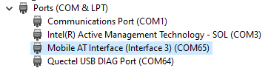

2.3. BOX-LTE4G assembly

3. Hardware

3.1. USB-LTE4G-EU top layout

u.FL antenna connector; GSM antenna is mandatory
ModStat1 green LED
NetStat1 yellow LED
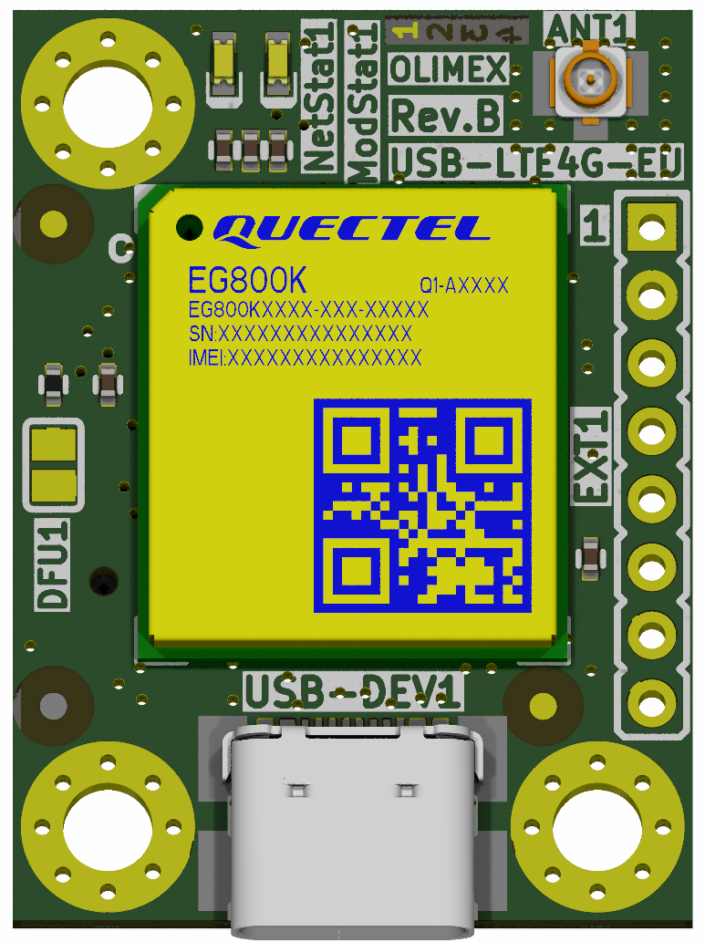
EXT1 header
USB type C
DFU1 PTH jumper (default open)
Yellow LED NetStat1:
- Blink slowly (200ms High/1800ms Low) - search network
- Blink slowly (1800ms High/200ms Low) – idle
- Blink quickly (125ms High/125ms Low) – data transfer
Green LED ModStat1:
- On – module is turned on
Main module EG800K-EU

3.2. USB-LTE4G-EU bottom layout
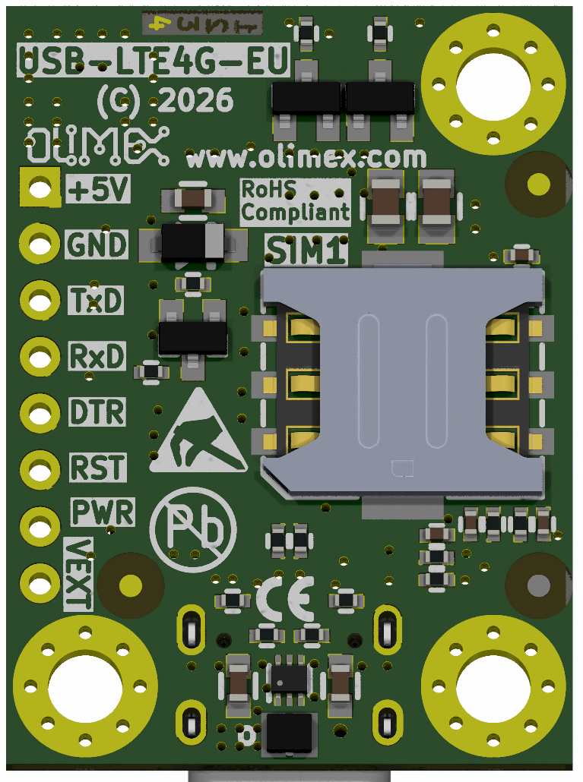
Nano SIM
EXT1
Mount hole D=3.3mm

3.3. EXT1 header
The name of the signal of each pin of the header is printed next to it at the bottom of the board. You can find power in/out, GND, main UART, reset and power pins of the module and VDD_EXT that is 1.8V output (50mA max) or 1.8V VREF.
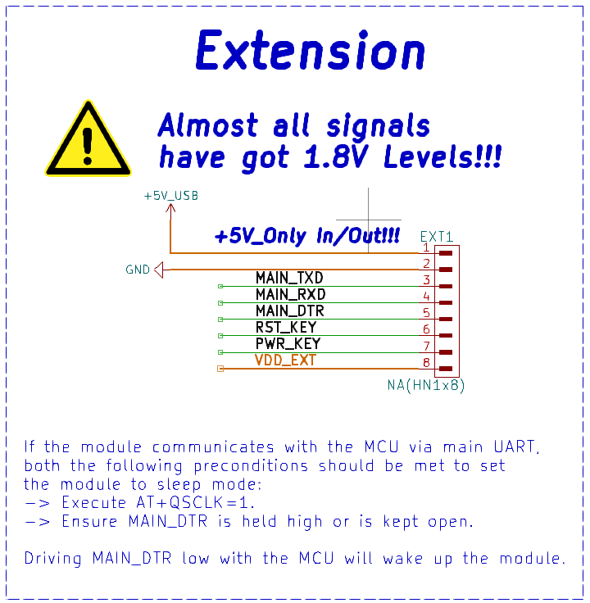
Never apply external power supply at EXT1 header and USB at the same time! This will lead to immediate short-circuit and hardware damage!
Notice the board has no voltage level shifters on the data lines! Make sure your serial connection works at 1.8V (usually data lines of the serial are at 3.3V or 5V and this will lead to hardware damage!).

Consider using Olimex USB-SERIAL-L, remember to first connect Vref to VDD_EXT at EXT1 of USB-LTE4G so that USB-SERIAL-L buffers get set to 1.8V.

3.4. LEDs
The board has two status LEDs:

- NetStat1 – yellow color – shows the network status:

- Blink slowly (200ms High/1800ms Low) - search network
- Blink slowly (1800ms High/200ms Low) – idle
- Blink quickly (125ms High/125ms Low) – data transfer

- ModStat1 – green color – shows the EG800K-EU module status when it is on – the module is turned on normally.

3.5. DFU1 PTH jumper
This jumper is open by default. Close the jumper (e.g. solder the pads together) to enter firmware upgrade mode.
Pulling down USB_BOOT to GND before turning on the module, and then the module will enter forced download mode. In this mode, the module supports firmware upgrade over USB 2.0 interface.
Remember to unsolder the

3.6. USB-LTE4G-EU board dimensions

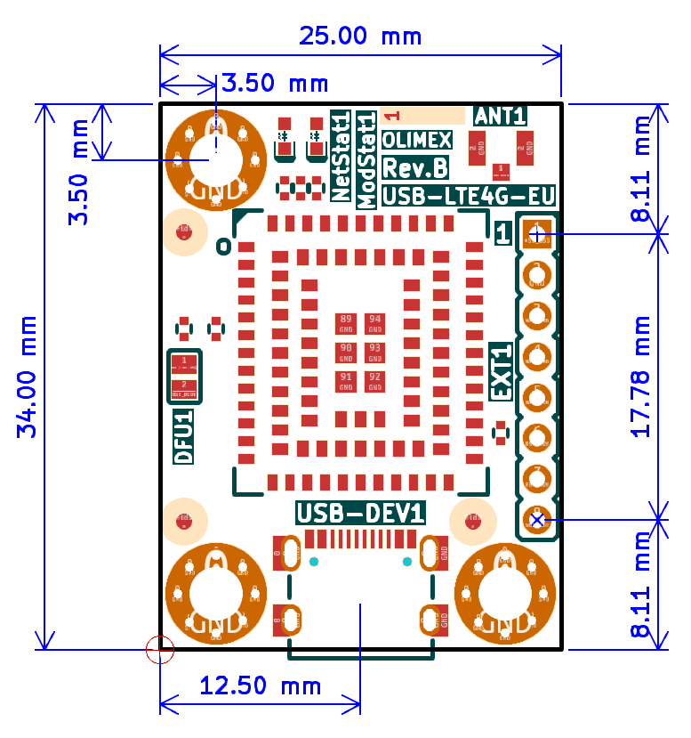
3.7. BOX-LTE4G dimensions

3.8. USB-LTE4G-EU power consumption
Warning! The 4G modem, like most modems has up to 2A transmission burst current consumption!
Make sure that your USB port and cable can handle it. Consider using shorter USB-cable and maybe USB-CAP. If it is still shaky during some commands – consider external power supply (but never connect external power supply and USB at the same time!)
- 0.2A @ Active operation
- 22mA @ Idle
- 3mA @ Sleep
- 20uA @ Power off

4. Software

5. Additional documents

6. Warranty and returns

7. Document revision history
Revision 1.0 June 2026

