Steps to setup docker and docker-compose

Install docker on ubuntu 16.04

To install docker-ce in your system follow these steps :-

Open terminal and run these commands:

$ sudo apt-get install -y docker-ce
=> It will install docker-ce in your computer.

$ sudo systemctl status docker
=> To check the status of docker-ce.

Link followed: https://www.digitalocean.com/community/tutorials/how-to-install-and-use-docker-on-ubuntu-16-04

Install docker-compose on ubuntu 16.04

To install docker-ce in your system follow these steps :-

Open terminal and run these commands:

$ sudo curl -L "https://github.com/docker/compose/releases/download/1.22.0/docker-compose-$(uname -s)-$(uname -m)" -o /usr/local/bin/docker-compose
=> It will install docker-compose in your computer.

$ sudo chmod +x /usr/local/bin/docker-compose
=> it will give the permission to this folder

$ sudo curl -L "https://github.com/docker/compose/releases/download/1.22.0/docker-compose-$(uname -s)-$(uname -m)" -o /usr/bin/docker-compose
=> It will install docker-compose in your computer.

$ sudo chmod +x /usr/bin/docker-compose
=> it will give the permission to this folder

Link followed: https://www.digitalocean.com/community/tutorials/how-to-install-docker-compose-on-ubuntu-16-04

Uninstall docker-compose from ubuntu 16.04

If you want to uninstall docker-compose from your system ( ubuntu 16.04 ) follow these steps :-

Open terminal and run these commands:

$ which docker-compose
=> It will return the path where your docker-compose is installed. Ex. ‘/usr/local/bin/docker-compose’. Then run the remove command ( $ sudo rm -rf /usr/local/bin/docker-compose )

$ sudo rm -rf /usr/local/bin/docker-compose
=> It will remove docker-compose from that directory. To confirm if docker-compose removed or not run this command again :- $ which docker-compose. If it returns another path then remove it to.

$ which docker-compose
=> It will return the path where your docker-compose is installed. Ex. ‘/usr/bin/docker-compose’. Then run the remove command ( $ sudo rm -rf /usr/bin/docker-compose )

$ docker-compose -v
=> To check if it is installed or not.

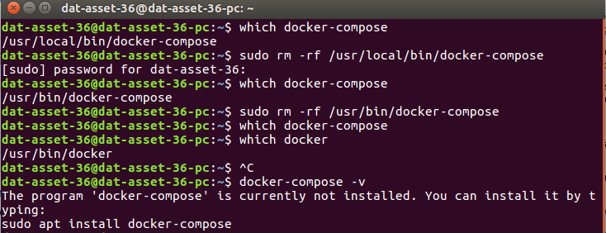
Link followed: https://stackoverflow.com/questions/30988566/how-do-i-uninstall-docker-compose

Uninstall docker from ubuntu 16.04

To completely uninstall docker from your system ( ubuntu 16.04 ) follow these steps:-

Open terminal and run these commands:

$ dpkg -l | grep -i docker
=> It will show a list of application with related to docker.

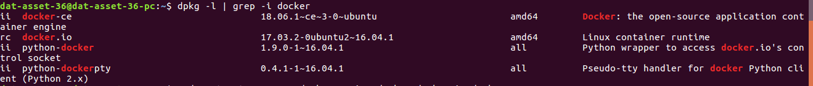

$ sudo apt-get purge -y docker.io docker-ce python-docker python-dockerpty
=> To uninstall the list of application which is related to docker. By executing this command ( $ dpkg -l | grep -i docker ) I have found four application which are docker.io docker-ce python-docker python-dockerpty.

$ sudo apt-get autoremove -y --purge docker.io docker-ce python-docker python-dockerpty
=> To uninstall and remove all the file related to docker completely.

Link followed: https://askubuntu.com/questions/935569/how-to-completely-uninstall-docker

