Documentation for Django-Oscar OpenPay payment gateway integration

For simplicity, let’s assume you’re building a new e-commerce project from scratch and have decided to use Oscar. Let’s call this shop ‘frobshop’.

When you setup django, you don’t have to install django. Because Oscar is built on django.

Follow this link to setup oscar:
https://django-oscar.readthedocs.io/en/releases-1.6/internals/getting_started.html

After setting up oscar, create few product. To do that you need to login as superuser.

- After login, go to Dashboard > Catalog(menu) > Product Type and create a new product type.
- Go to Catalog(menu) > Categories and create a new category.
- Go to Fulfilment(menu) > Partners and create a new partner for you product.
- Go to Catalog(menu) > Product and creat few product.

- product Details: Fill up specific required details.
- Categories: Select the category you just have created.
- Images: Upload an images.(If Images are not showing, then you have to add settings.MEDIA_ROOT in urls.py)
- Stock and pricing: select a partner you have just created and fill other details in fields as well.
Save and create another few products and then click return to site and select all product(menu) and you will see all product you have just created.

Now, you have created few product and want to buy some products. To do that:
- Add to cart few product and click view cart to view the item you have just added and then proceed to checkout or you can directly go to checkout.
- Add shipping address and continue.
- Click place order to confirm your order and your order will be placed.

If you complete these step without any error, that means you have setup django-oscar properly.

Next task is to implement a custom payment gateway which is openpay. We will install openpay-py and implement properly with django-oscar.

Please follow the openpay-py documentation to understand the APIs of openpay sdk. Now follow these steps to properly setup openpay-py in django-oscar:
- first go to terminal or command prompt and install with virtualenv activated- pip install openpay-py
- Open settings.py of your project add these line-

from openpay import Client
JamAuthToken = ‘23464573452345|3g45t43t2-bw45rgq34t-245t34’
CLIENT = Client(JamAuthToken)

Now, we will use this CLIENT object from settings.py in checkout process and other apps as well. As we will first implement openpay gateway so we will create a checkout app and will mention it in settings.py INSTALLED_APPS.
- Go to terminal and execute python mange.py startapp checkout. It will create a checkout app in your project.
- Now open settings.py and add checkout inside get_core_apps.
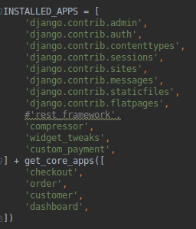

- Open checkout/views.py and import PaymentDetailsView from oscar.apps.checkout.views.
- Create a class based view named ‘PaymentDetailsView’ by extending(inheriting) PaymentDetailsView.
- Override and modify these method as per your need(preview page(http://127.0.0.1:8000/checkout/payment-details/)).

First of all import client from setting and that client will be used in these method.

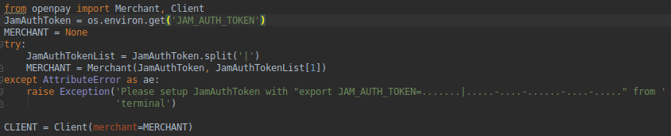
- get: This is used for callback status after payment completion.
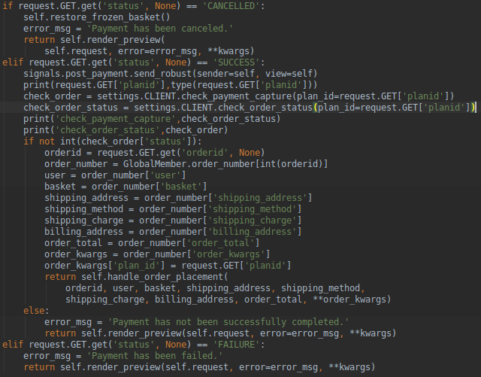
- handle_order_placement: this method will be called when payment has been successfully completed.
- get_pre_conditions: this method will be called when you go to the preview page.
- handle_payment: In this method you need to implement the payment gateway.
:- Here you need to create a new online order using client object.
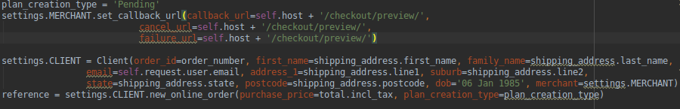
:- After this you need to create online plan and that will return a url which will redirect to openpay login page for payment.

:- handle_payment method is called inside submit method and as you can see this method will raise a RedirectRequired Exception and that exception will be catched and redirect to the openpay login page.
- submit: this method will be called when you clicked the Place Order button.
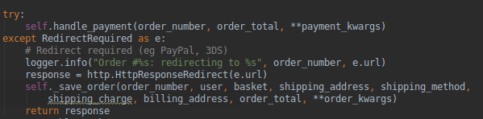

Note: You need to get these code from oscar library from /venv/lib/python3.5/site-packages/oscar. When you need to inherite anything from oscar, just copy the code and modify it as per your need.

Now, create an order and pay using openpay gateway. This will record the order. To check the status of this order go to account > order history. Here you will see the order status.

As per the project requirement we need to record the status of refund and dispatch. To do that we are going to override few oscar app with our custom app.

As per our requirement we need to modify the AbstractOrder and AbstructLine from oscar.apps.order.abstruct_models.

AbstructOrder:- We can add as much as fields as we require like this:
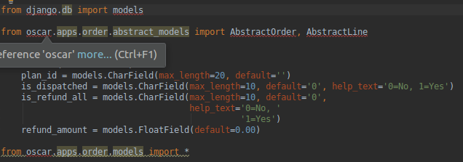
As we can see that we have added plan_id, is_dispatched and is_refund_all fields.

As we can see that we have added req_refund_status field. After modifying all the model we need to import all the oscar builtin model for that paticular section.

Now, we have modified the order model and Line model as per our need. After that, we have to customise and override dashboard app to fullfill our requirement.

Here, create a app called ‘dashboard’ and mention it in the settings file and that will override oscar dashboard app.

Now, you can customise any view or templates as per your reqirements. Our requirements is to customise the template and add two buttons(dispatch and refund) and webservice will be called by clicking those button.

Easy way to customise a template is to copy those template from oscar library and past in a same folder structure.

For dispatch:
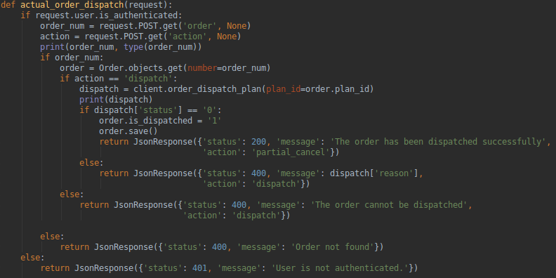

For refund:
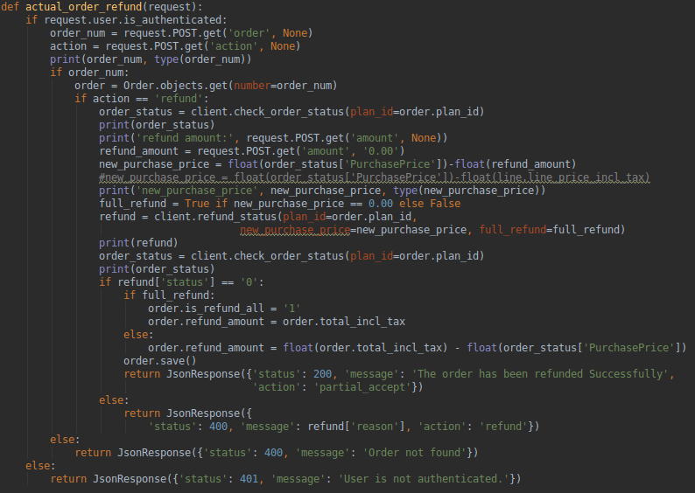

To change in static files like style please add the following code in you setting files:
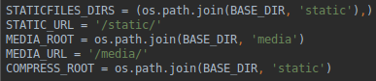

and run this command:
$ python manage.py oscar_fork_statics

That will copy oscar static folder into your project and if you change anything, it will reflect in template.

