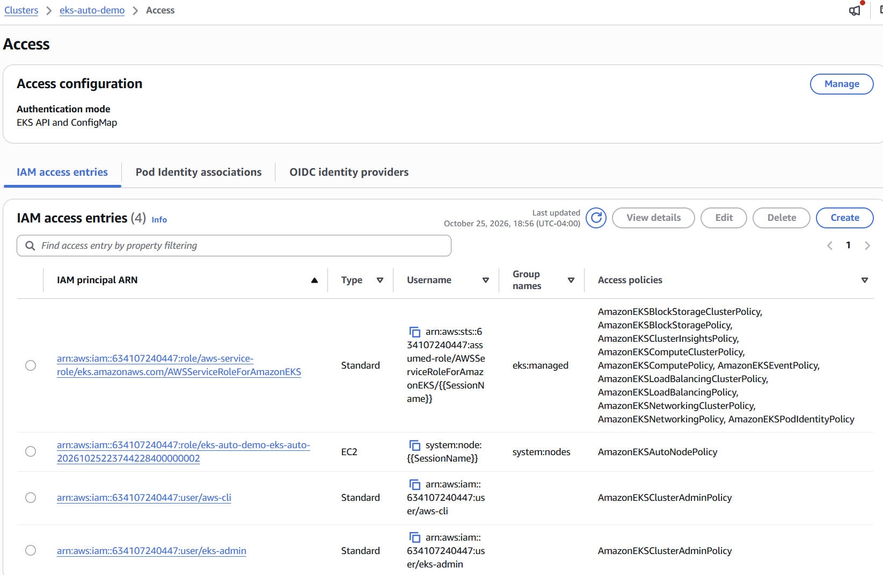

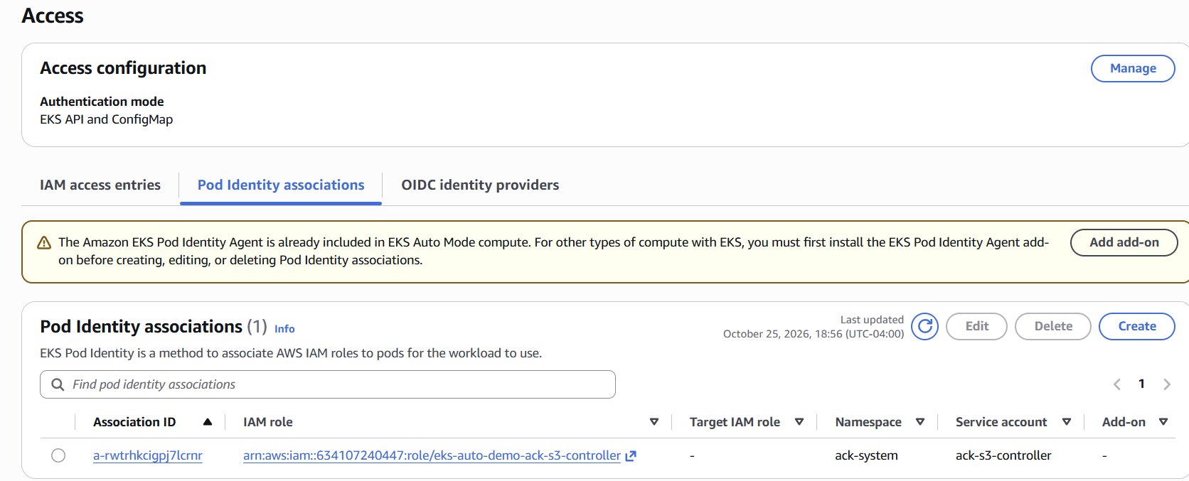
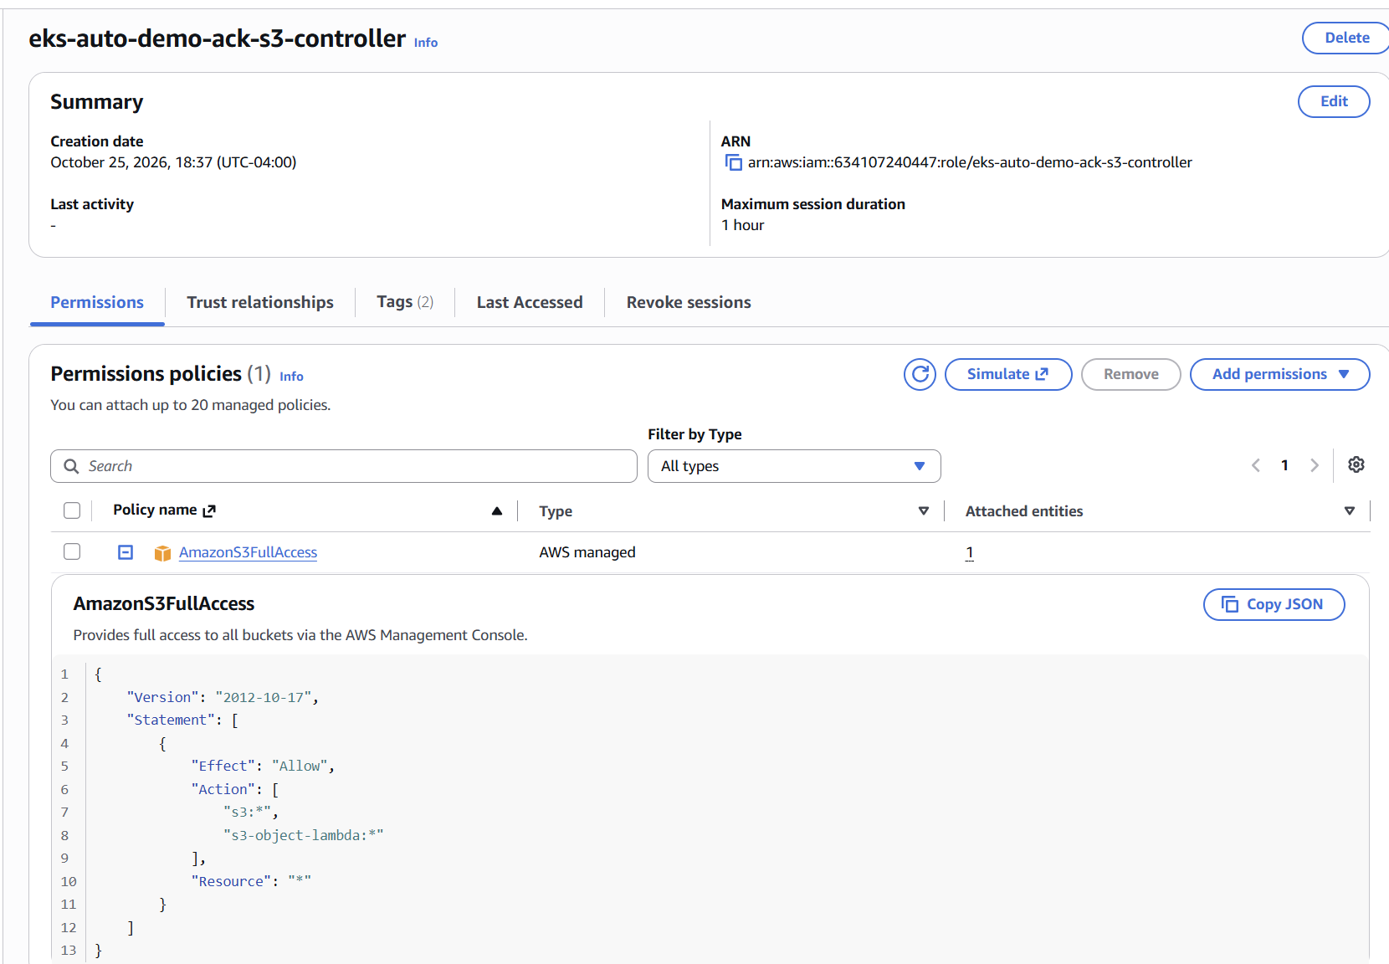
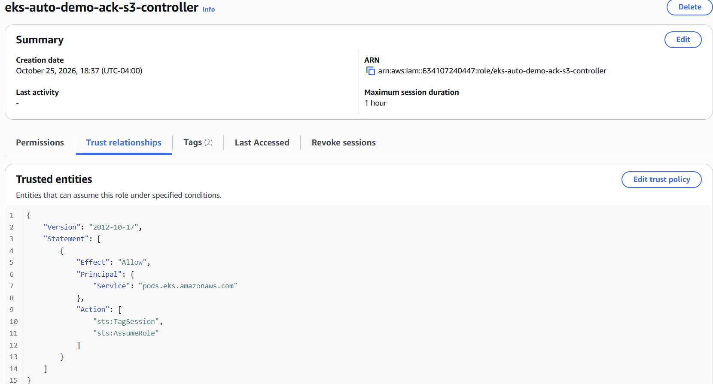
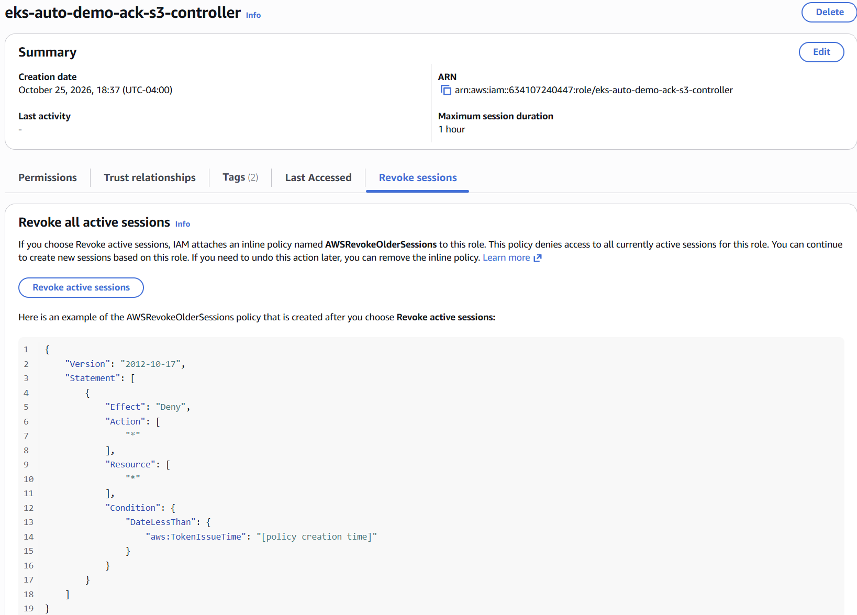
Look at automode node:
kubectl debug node/i-0bc478d8168ac1f6f -it --image=public.ecr.aws/amazonlinux/amazonlinux:2023

ARGOCD APPLICATION SET:
An ApplicationSet is an Argo CD resource that generates many Applications from a single template. Instead of writing one Application manifest per app, per cluster, or per environment, you write one ApplicationSet, and its controller creates, updates, and deletes the Applications for you. Your sample-argocd-app.yaml is a single Application; an ApplicationSet would stamp out many like it.
The two parts
- Generators produce a list of parameter sets. Each set becomes one Application.
- Template is an Application manifest with placeholders like {{name}} that get filled in from each parameter set.
Common generators
- List: you type the values yourself (for example dev, staging, prod).
- Cluster: one Application per cluster registered in Argo CD, which suits rolling out the same thing to many clusters.
- Git directory: one Application per folder in a Git repo, so adding a folder deploys a new app.
- Git file: parameters come from config files in Git.
- Pull request: one temporary Application per open pull request, for preview environments.
- Matrix and merge: combine generators, such as every cluster times every folder.
Example: it creates one guestbook per environment using a List generator:
yaml
apiVersion: argoproj.io/v1alpha1
kind: ApplicationSet
metadata:
name: guestbook-envs
namespace: argocd
spec:
generators:
- list:
elements:
- env: dev
- env: staging
template:
metadata:
name: 'guestbook-{{env}}'
spec:
project: default
source:
repoURL: https://github.com/argoproj/argocd-example-apps.git
targetRevision: HEAD
path: guestbook
destination:
server: https://kubernetes.default.svc
namespace: 'guestbook-{{env}}'
syncPolicy:
automated: {}
syncOptions:
- CreateNamespace=true
Applying it creates two Applications, guestbook-dev and guestbook-staging, each in its own namespace. Adding another env entry creates a third.
Why people use it
- Less copy-paste when many apps or clusters share the same shape.
- A Git-driven workflow: with the Git directory generator, merging a new folder into the repo deploys a new app with no other step.
- Consistency: change the template once and every generated Application follows.
For your setup: with one cluster and one app you don’t need it. It starts to pay off with several environments or clusters, or an “app of apps” style repo where each folder is a service. The ApplicationSet controller comes bundled with the Argo CD Helm chart, so you can try the example above with kubectl apply without installing anything. Like Applications, I’d keep these as YAML files in Git (applied by kubectl or by Argo CD itself) and not as Terraform resources, since their custom resource type only exists after Argo CD installs.
I haven’t verified that the example’s syntax matches the ApplicationSet version your chart installed, so if kubectl apply complains, paste the error.

