FACULTY OF ENGINEERING AND BASIC SCIENCES
ACADEMIC PROGRAM: DATA ENGINEERING AND ARTIFICIAL INTELLIGENCE
COURSE: ETL (G01)
LAB-2. From Business Requirements to a Dimensional Data Warehouse

Part A — Requirements Traceability
Before designing the schema, the five business requirements were translated into analytical questions, the data required to answer them, and the KPI or query that provides the evidence.
ID | Requirement | Analytical Question | Required Data | Expected KPI / Query
R1 | Monitor monthly net sales trends and identify periods of growth or decline. | Which months had the highest and lowest net sales, and how does the trend evolve month over month? | sale_date, quantity, unit_price_sale, list_price | Monthly Net Sales trend (line chart, Jan–Jun 2026).
R2 | Compare sales performance across stores and sales channels over time. | Which stores and which sales channels perform best, and how does this change month by month? | store_id, store_name, region, channel_id, channel_name, sale_date, quantity, unit_price_sale | Net Sales and Quantity by store and by channel, segmented by month.
R3 | Identify the top-performing product categories and brands using revenue and units sold. | Which product categories and brands generate the most revenue and units sold? | product_id, category, brand, quantity, unit_price_sale, list_price | Net Sales and Quantity ranked by category and brand.
R4 | Evaluate promotion performance by comparing sales, units, and discounts across promotion types. | How do different promotion types affect sales volume and discount amounts? | promotion_id, promotion_name, discount_pct, quantity, unit_price_sale, list_price | Net Sales, Quantity and Discount Amount by promotion.
R5 | Analyze gross profit and gross margin by product category, store, and month. | What is the gross profit and gross margin generated by each product category, store, and month? | category, store_name, sale_date, quantity, unit_price_sale, list_price, unit_cost | Gross Profit and Gross Margin % by category, store, and month.

Part B — Dimensional Model Design

Step 1 — Business Process
Business process: Retail Sales — sales transactions recorded across two physical stores and one online store, covering products, dates, sales channels, and promotion conditions. This single process is sufficient to answer all five business requirements (R1–R5), since all of them concern the volume, value, and profitability of sales.

Step 2 — Grain
Grain (declared in one sentence): One row in fact_sales represents one product sold, on one sales line of one transaction, at one store, through one sales channel, on one specific date, under one promotion condition (or "no promotion").

Step 3 — Dimensions
Four dimensions were identified. No additional dimensions were created, since every attribute below is required by at least one business requirement. A separate dim_channel was not created: channel_id and channel_name are low-cardinality, static attributes of a store and are denormalized directly into dim_store, avoiding an unnecessary snowflake join that no requirement demands.
Dimension | Business Question Supported | Main Attributes | Primary / Surrogate Key
dim_date | How do sales evolve over the six-month period? (R1, R2, R5) | sale_date, year, month, month_name, day | date_key (surrogate, integer)  Natural key: sale_date
dim_product | How do products perform by category and brand? (R3, R5) | product_id, product_name, category, brand, unit_cost, list_price | product_key (surrogate, integer)  Natural key: product_id
dim_store | Which stores and channels perform best? (R2, R5) | store_id, store_name, city, region, channel_id, channel_name | store_key (surrogate, integer)  Natural key: store_id
dim_promotion | How do promotion types affect sales? (R4) | promotion_id, promotion_name, discount_pct | promotion_key (surrogate, integer)  Natural key: promotion_id

Step 4 — Facts / Measures
Only additive, currency- or unit-based measures are stored in the fact table, so they can be summed across any dimension without producing incorrect results.
Measure | Meaning | Calculation | Requirement
Quantity | Units sold in the sales line. | quantity (source field) | R1–R5
Gross Sales Amount | Sales value before any discount, at list price. | quantity × list_price | R1, R3, R5
Net Sales Amount | Final sales value actually charged to the customer. | quantity × unit_price_sale | R1, R2, R3, R4, R5
Discount Amount | Monetary value of the discount granted. | Gross Sales Amount − Net Sales Amount | R4
Cost Amount | Total cost of goods sold. | quantity × unit_cost | R5
Gross Profit | Profit after cost of goods sold. | Net Sales Amount − Cost Amount | R5
Note — Gross Margin %: Gross Margin % = Gross Profit / Net Sales Amount × 100. This is a derived ratio and is NOT stored in the fact table, because averaging a pre-calculated percentage across rows produces an incorrect result (it must be computed from the summed numerator and denominator). It is calculated at query time in the R5 KPI query.

Primary Keys, Surrogate Keys, and Foreign-Key Relationships
The fact table fact_sales is connected to each dimension through a foreign key that references the dimension's surrogate primary key. All surrogate keys are auto-incrementing integers, independent of the source system identifiers (natural keys), which are preserved as regular attributes for traceability.
- fact_sales.sale_line_id — Primary Key of the fact table (grain identifier, one row per sales line).
- fact_sales.date_key → dim_date.date_key (Foreign Key)
- fact_sales.product_key → dim_product.product_key (Foreign Key)
- fact_sales.store_key → dim_store.store_key (Foreign Key)
- fact_sales.promotion_key → dim_promotion.promotion_key (Foreign Key)

Part C — Star Schema Diagram
The diagram below shows the complete Star Schema: the fact table fact_sales at the center, connected to the four dimension tables through foreign keys, with primary keys, surrogate keys, and the six stored measures highlighted.
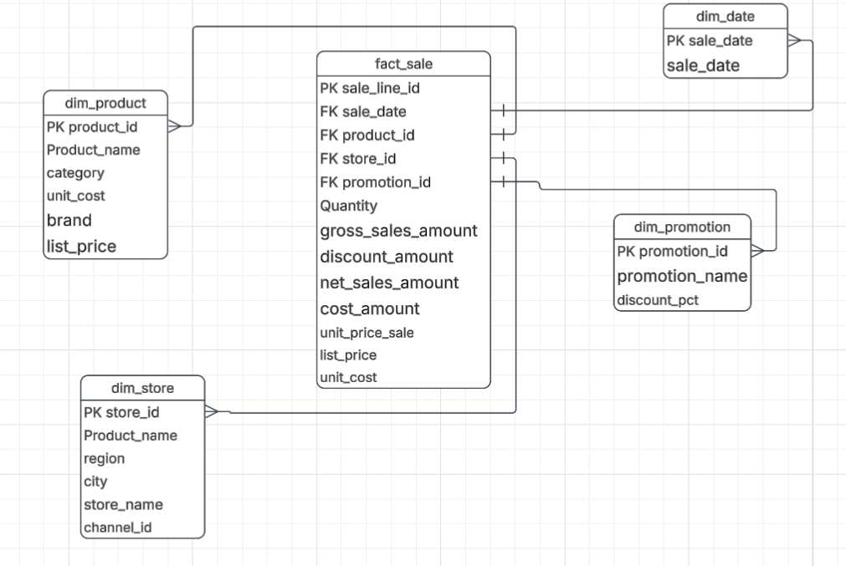
Figure 1. Star Schema — retail_dw (fact_sales + 4 dimensions).

