Architecture

[KUMO]

Version [2.0]

Prepared by

[Alice Huynh]

1 EIP Architecture Diagram

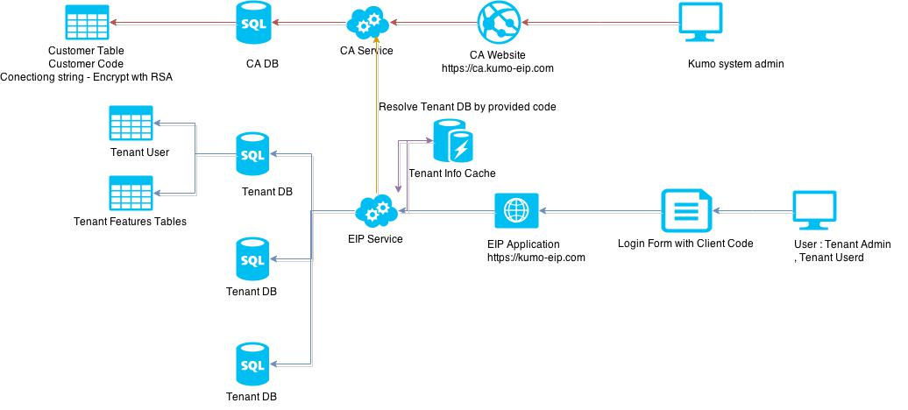

Login form

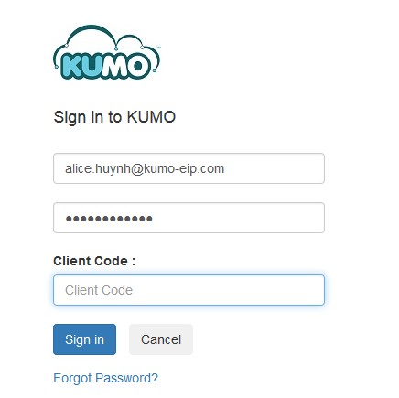

In this approach, we will design EIP system with 2 main application. Central Administration (CA) and client site with separate database for each customer. Customer information are managed by Kumo administrator directly from CA. To make this approach work, There will be an addition field (it may be generated or manage by admin from CA site) called “Client Code”. When customer login, they have to provide client code to identity which company they work or and system will using that code to resolve their database. User only provide client code at login screen, then that information will be cache in the Client Service site.

RSA algorithm will be use in CA and client site to encrypt and decrypt client’s information. EIP application will call a web service on CA site to query information. CA will return data which matches with the client code in encrypted data. EIP application has to use a provided public key to decrypt that data to get database connection information.

1. **Advantage**

* Client information was managed on CA site
* Can using 1 domain for EIP application
* Database for clients is separate and they are only work on their database.
* Don’t need to store client user information on CA website
* Better performance because database separate
* Easy to maintain client database
* Less development effort because don’t need to add additional code to connect to 2 database.

1. **Disadvantage**

* User have to provide client code at login screen, this disadvantage can be fixed by using remember code option at screen login.