Architecture

[KUMO]

Version [2.0]

Prepared by

[Alice Huynh]

1 EIP Architecture Diagram

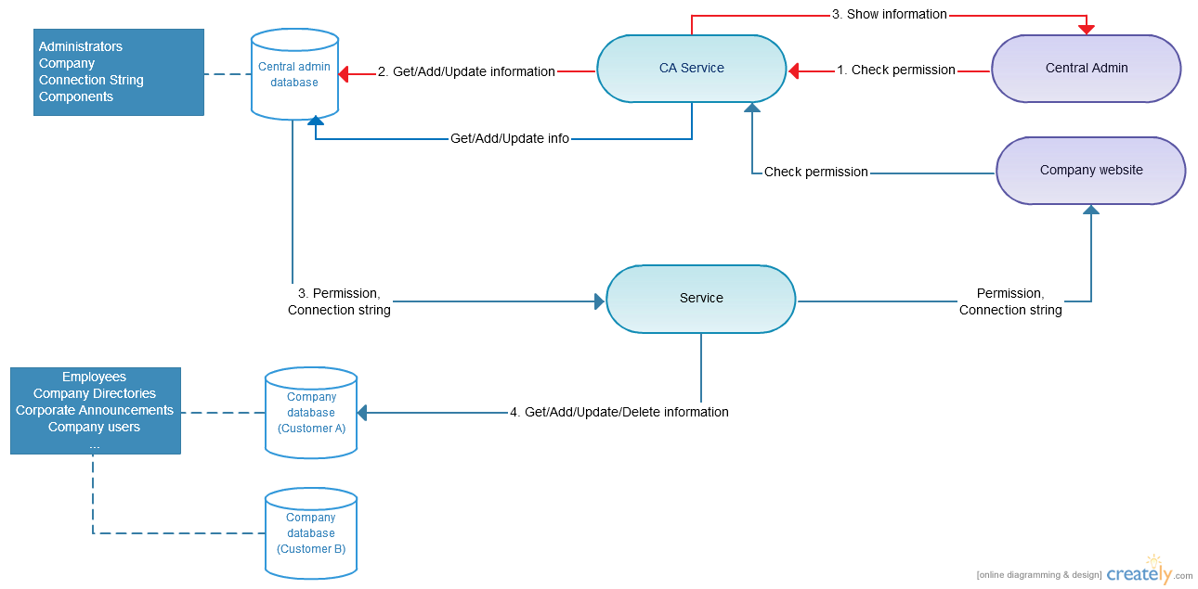

Red line: when administrator sign in

Blue line: when end user sign in

Each custom will have their own separate database.

All customers will use the same company website. The **folder approach** will be applied to know the company of a user (Ex: user Alice in company A will sign in at https:// kumo-eip.com/001, user Bob in company B will sign in at https:// kumo-eip.com/002). Based on user information, the user’s company data will be retrieved and show on the website.

Company website is the MVC website. It’s like the template. The page that end-user see on their screen is the template + data from database.

1. **Administrator sign in**

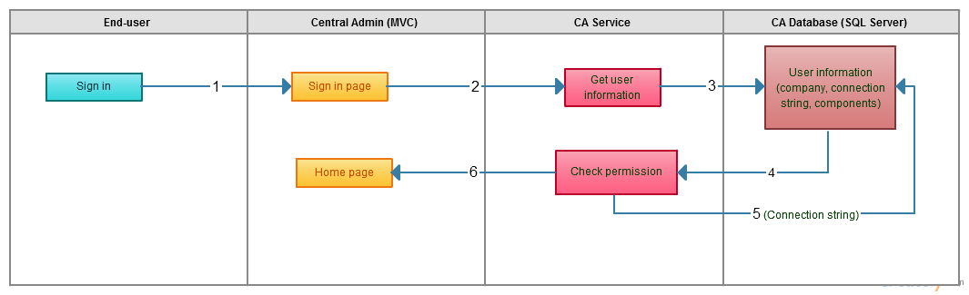

* 1. Administrator sign in to Central Admin website (ex: <https://ca.kumo-eip.com>).
  2. Central Admin website send input information to the Service.
  3. Service use input information (username and password), connect to Central Admin database (CA database).
  4. CA database return user information (Username, password, permission) base on input information.
  5. Service check the account is valid or not. If it’s valid (username and password is correct and has admin permission), it’ll connect to the CA database to get data (company, components).
  6. Central Admin website will show data returning from Service. Administrator can add/update/delete data to CA database. When administrator add a new company, a separate database will be created for the new company by PowerShell script. To running PowerShell script when a new company is added, CA website will be hosted in Azure Virtual machine.

1. **End user sign in**

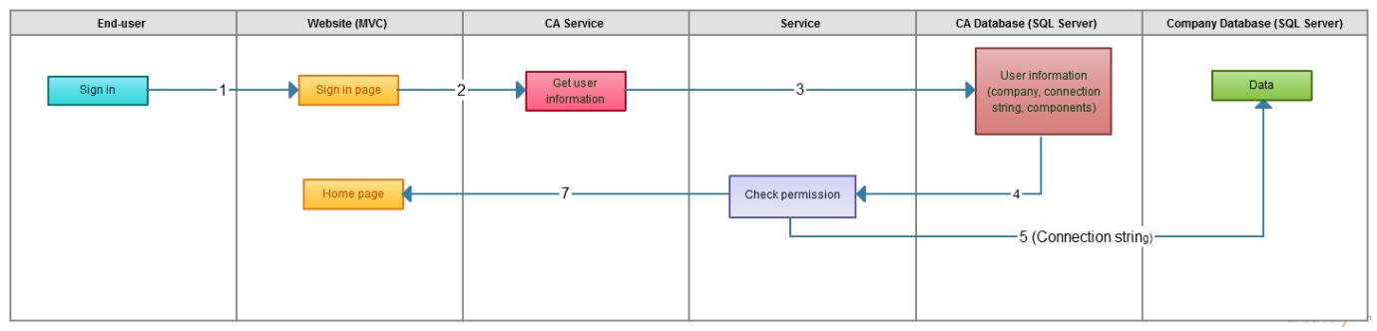

* 1. End user sign in to Company website (ex: https:// kumo-eip.com/companyA)
  2. Company website send input information to the Service.
  3. CA Service use input information (username and password), connect to Central Admin database (CA database) to check the account is valid or not.
  4. If it’s valid (username and password is correct), CA database will return data (company, components, company connection string) to the Service.
  5. Service will user the connection string from CA database to connect to corresponding company database and get data.
  6. Company website show data returning from Company Service.