Architecture

[KUMO]

Version [2.0]

Prepared by

[Alice Huynh]

1 Infrastructure Architecture Diagram

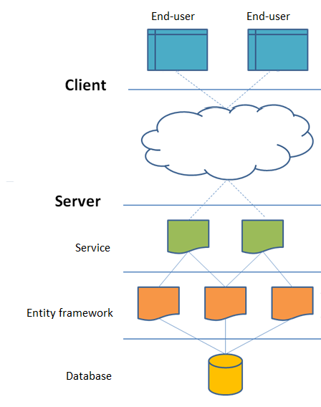

Database, Application (include Service and Entity framework) will be hosted on cloud.