Architecture

[KUMO]

Version [2.0]

Prepared by

[Alice Huynh]

1 Security Architecture Diagram

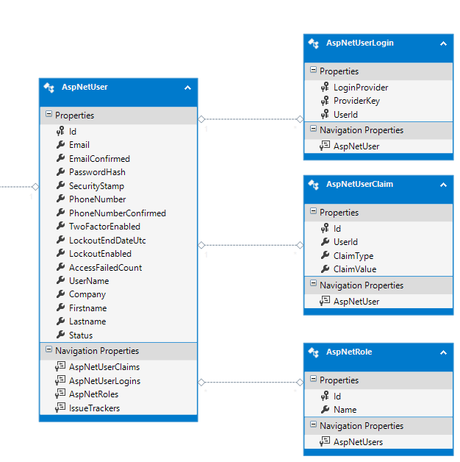

### User & Authentication core

User & Authentication module will delivery by [Identity Framework 2.0](http://www.asp.net/identity/overview/getting-started/introduction-to-aspnet-identity) as the basic model below. This framework was developed and being supported by Microsoft and it provide all the basic function for authentication and authorization which meet to the standard web security and flexibility.