Glass Falling

1. When a sheet of glass is dropped there are two possible outcomes, either the glass shatters or it does not. If the sheet of glass breaks from floor x, only the floors beneath x need to be checked. If the glass does not break then only the floors above x need to be checked.
2. 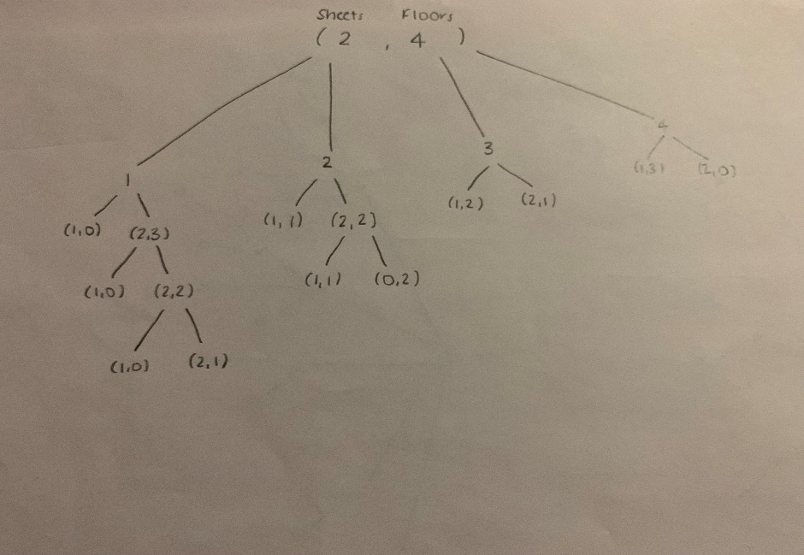
3. Code
4. There are 8 distinct sub problems when there are 4 floors and 2 sheets
5. There are 2*n distinct sub problems when there are n floors and m sheets because at each floor there are two outputs , either the glass breaks or it does not
6. In order to memoize, there would have to be a 2D array that stores the amount of trials needed for each floor / sheet combination. Other than the array, it would be very similar to the recursive version.

Rod Cutting

a.

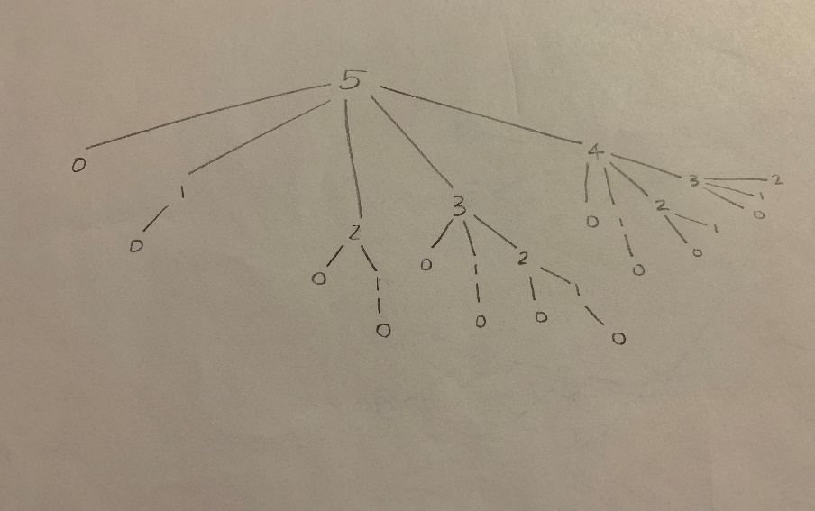

d.

|  |  |  |  |  |
| --- | --- | --- | --- | --- |
| Lengthi | 1 | 2 | 3 | 4 |
| Price pi | 1 | 20 | 27 | 28 |
| Pi/i | 1 | 10 | 9 | 7 |

Given a rod of length 4, if it were done the greedy way, we would cut a rod of length 3 for a price of 27. This leaves us with a rod of length 1 & price 1. The total price for the rod is 28. The optimal way is to cut it into two rods each of length 2, each which would be 40 dollars.