Det Nom Verb Pro

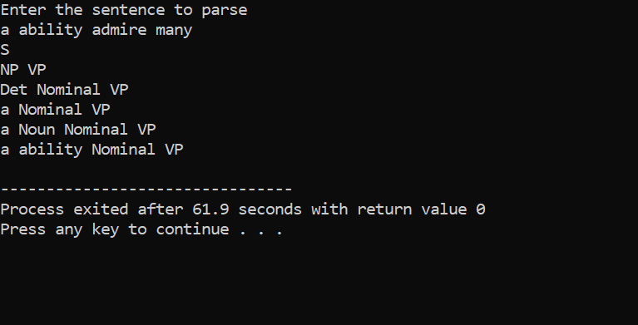

Clash between verb and noun (admire)

Det Nom Verb PN

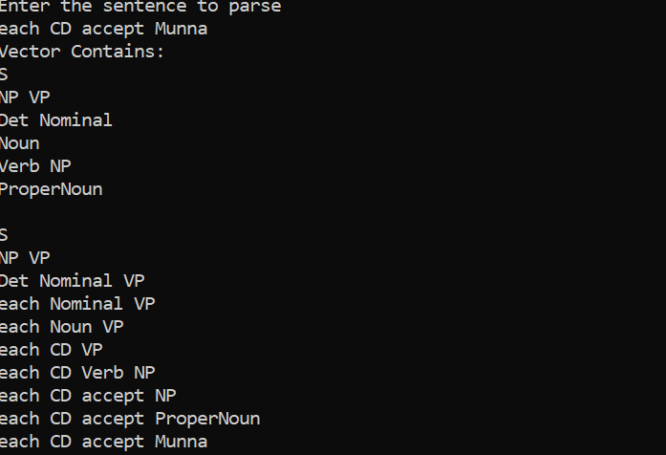

(success)

Det Nom Verb Det Nom

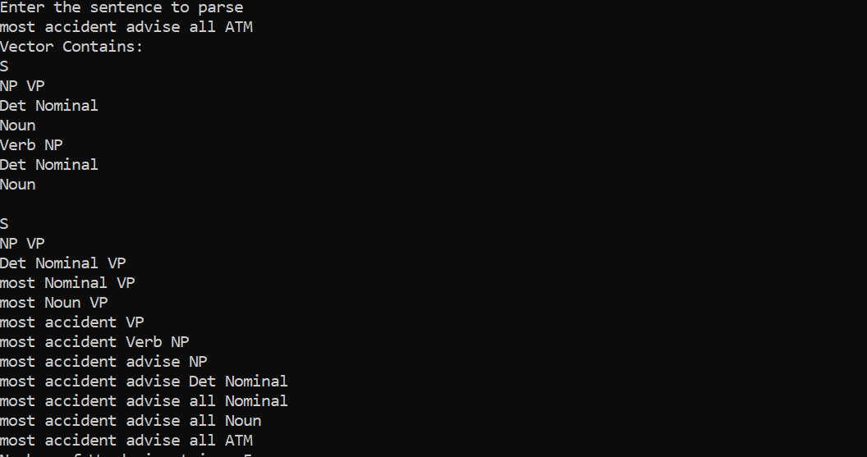

(success)

Det N V Pro Prep Noun

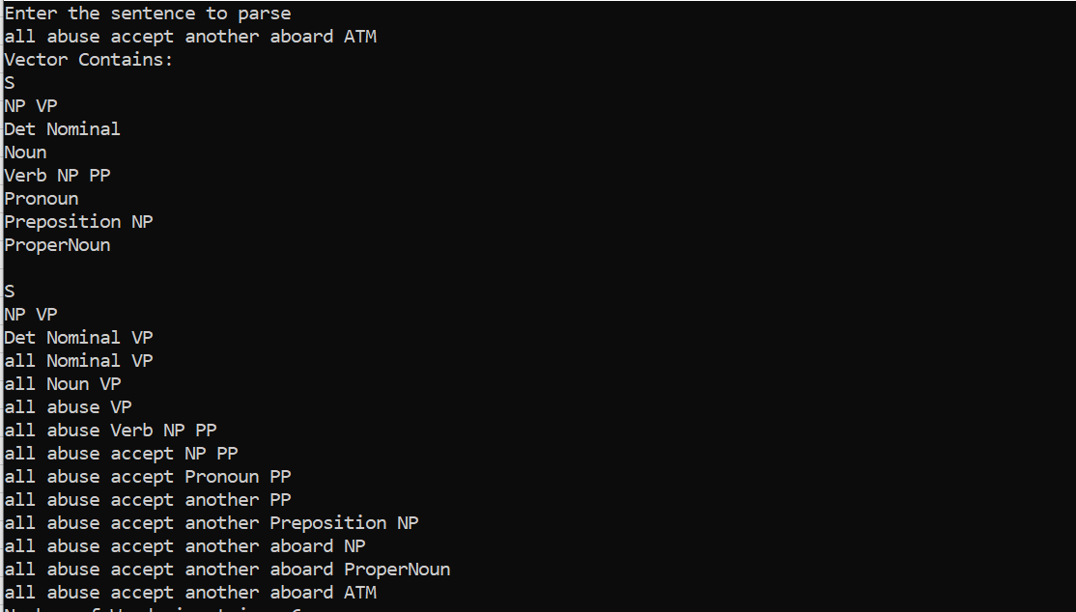

(success)

Det N V Pro Prep Pro



(success)

Det N V Pro Prep PN

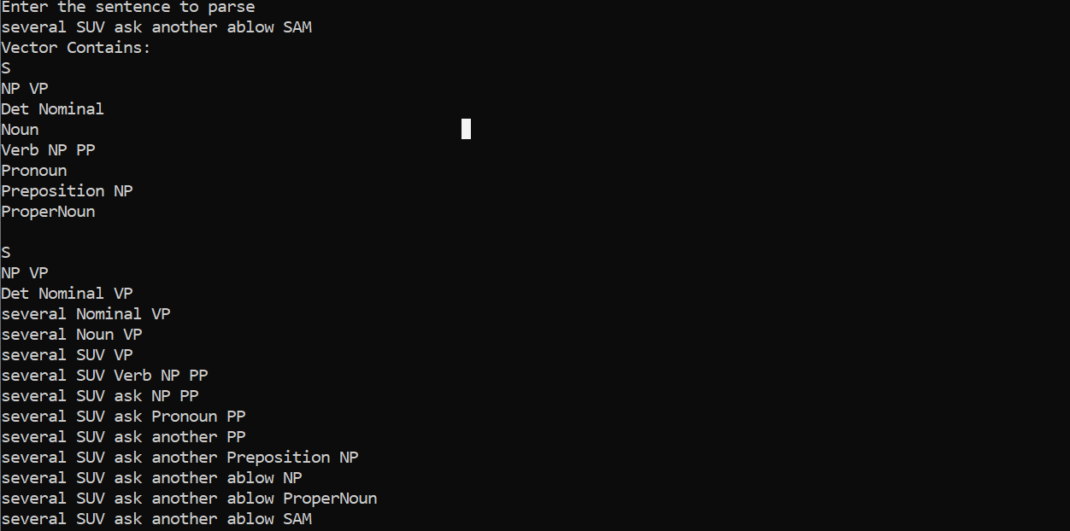

(success)

Det N V Pro Prep Det Nom

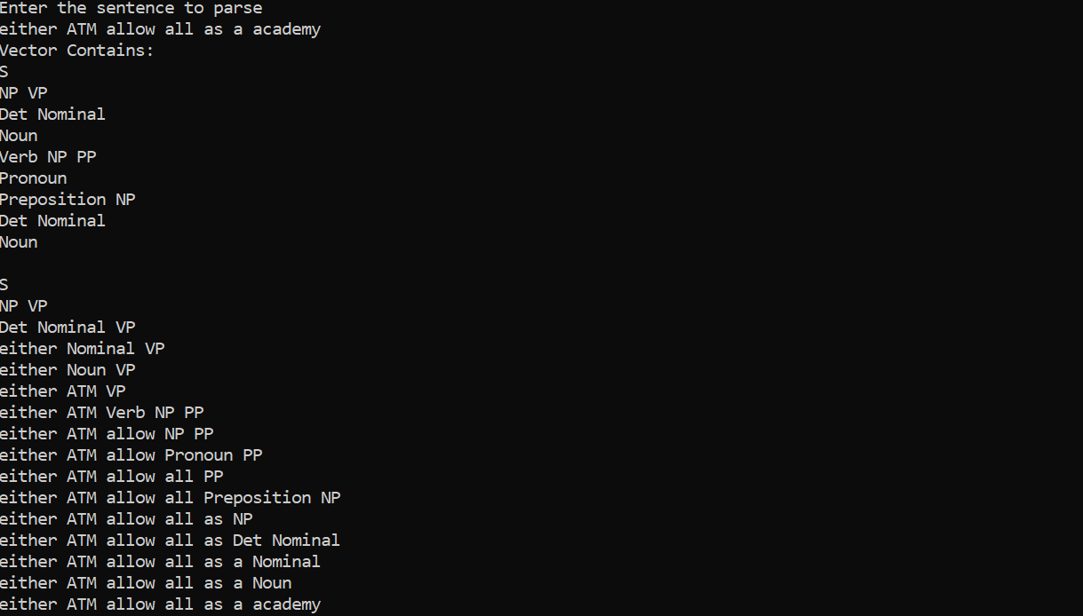

(success)

Det N V Prep Pro

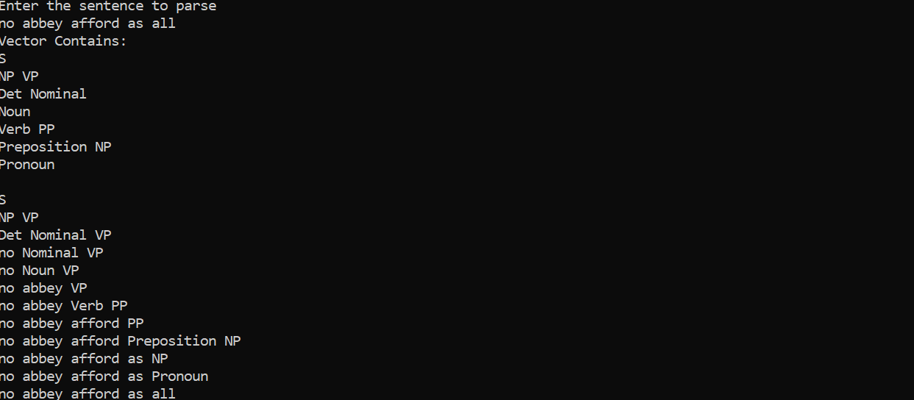

(success)

Det N V Prep PN

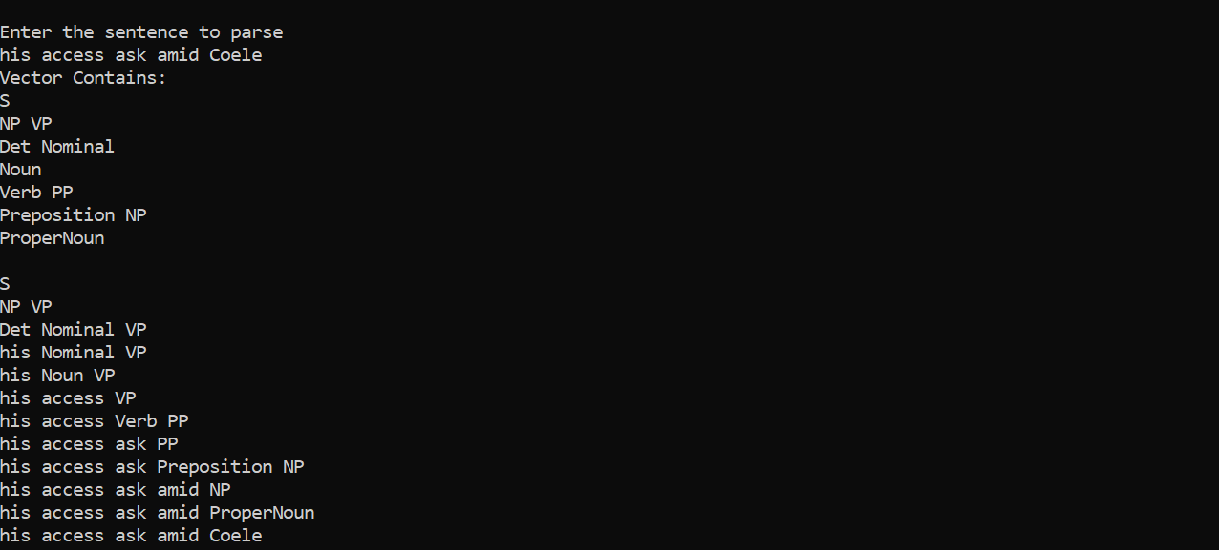

(success)

Det N V Prep Det N

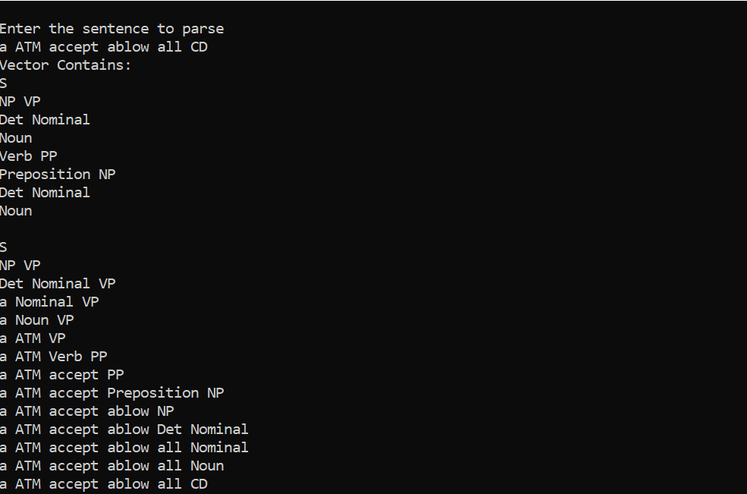

(success)

Det Noun V PN Prep Pro



(Success)

Det Noun V PN Prep PN

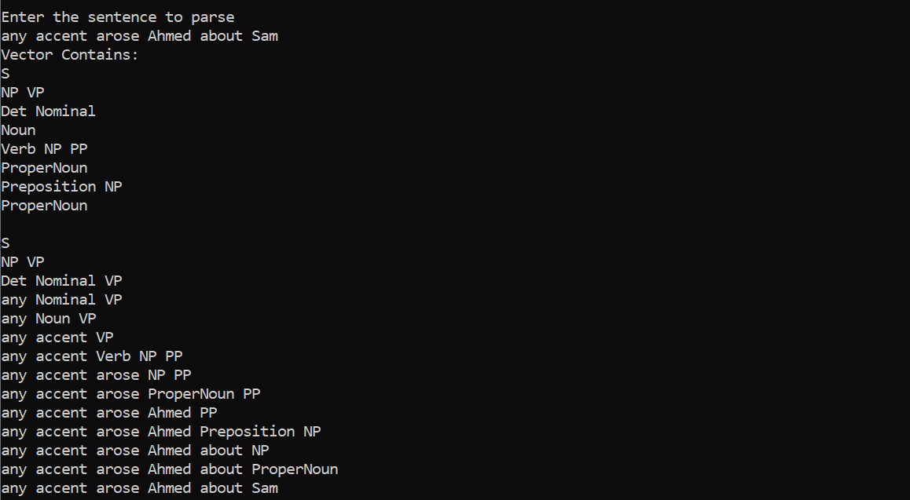

(success)

Det Noun V PN Prep Det Nom

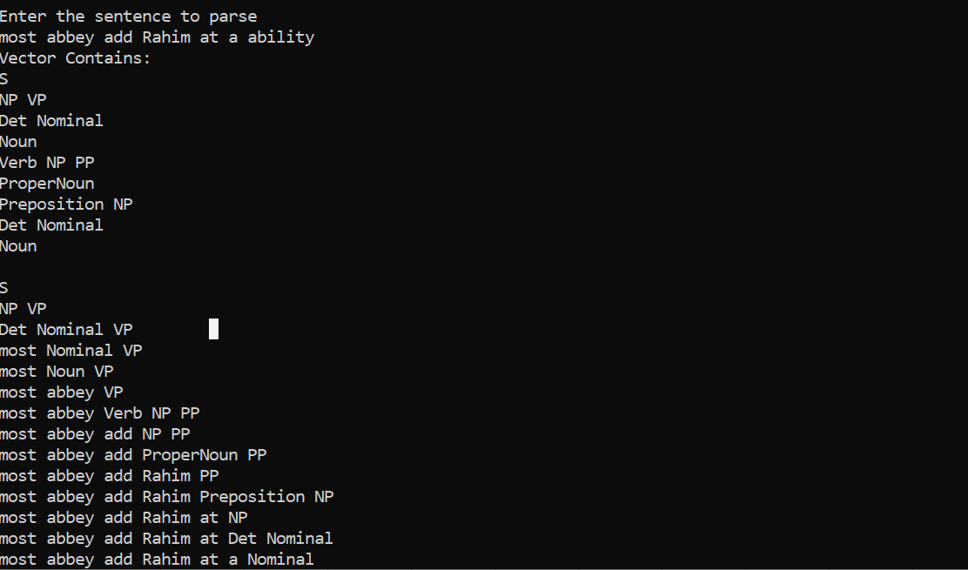

(Success)

Det Noun V Det Nom Prep Pro



(Succes)

Det Noun V Det Nom Prep PN

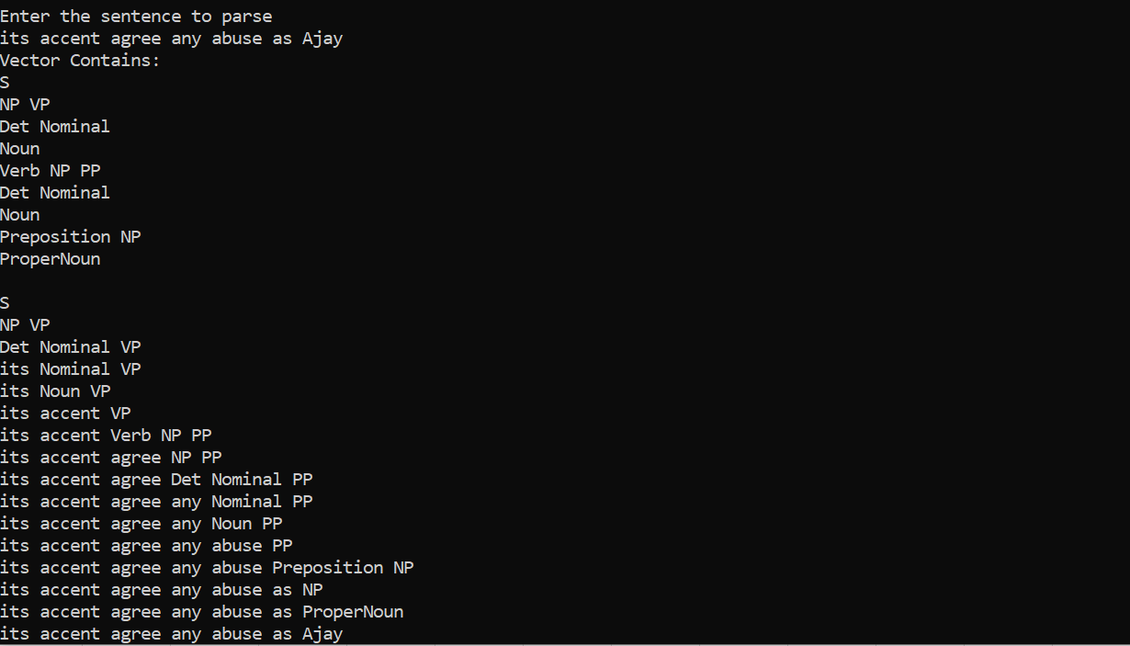

(Success)

Det Noun V Det Nom Prep Det Nom



(success)

Det Noun Noun V Det Noun Noun Prep Det Noun Noun

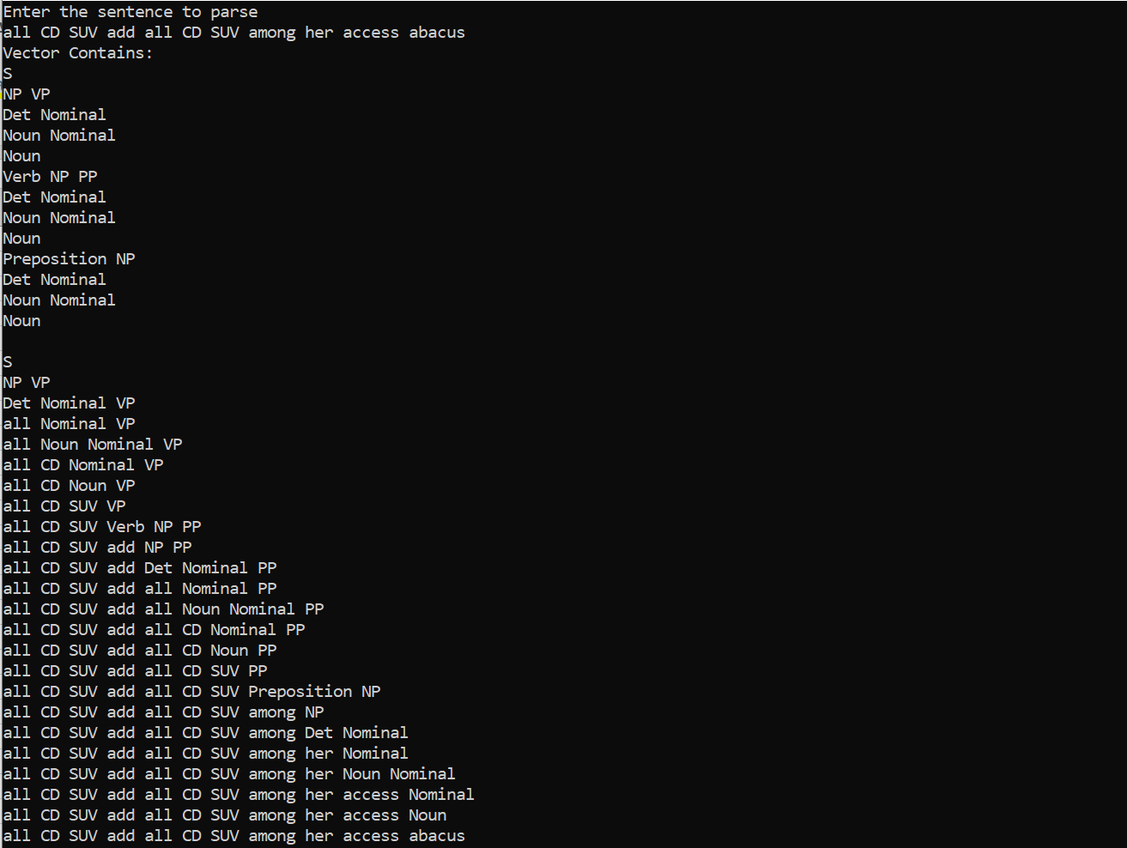

(Success)