CS301 - Theory of Automata
Teacher - M. Shahzad

Assignment 01:
Write a program to implement the CFG and parse the sentence provided by user

Note: The last date of submission is 30-April-2020

Problem Statement:

In this assignment you will implement parser for the English language statements. List of terminals against any given Non-terminals can be retrieved from the corpus given in URL.

Grammar:

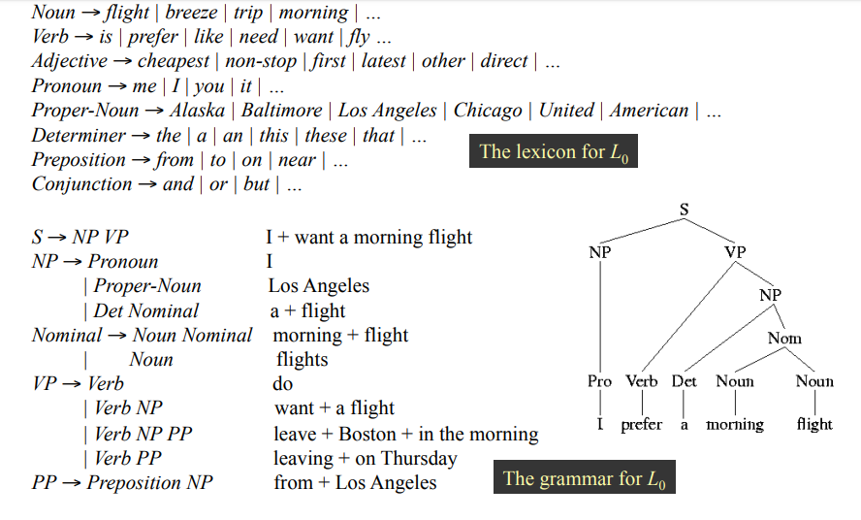
List of Corpus:

Nouns: http://www.desiquintans.com/downloads/nounlist/nounlist.txt
Verbs: https://www.talkenglish.com/vocabulary/top-1000-verbs.aspx
Prepositions: https://www.thefreedictionary.com/List-of-prepositions.htm
Pronouns: http://www.esldesk.com/vocabulary/pronouns
Adjectives: https://www.paperrater.com/page/lists-of-adjectives
Determiners: https://www.ef.com/wwen/english-resources/english-grammar/determiners/
Conjunctions: http://www.marshall.k12.il.us/data/webcontent/245/file/realname/files/List-of-Conjunctions.pdf
Sample Input / Output:

Valid Input:
I prefer a morning flight
Output:
S
NP VP
PRO VP
I VP
I VERB NP
I prefer NP
I prefer Det Nom
I prefer a Noun Nom
I prefer a morning Nom
I prefer a morning flight

In-Valid Input:

Student Cricket Play

Output:

Incorrect Structure

Requirements

Your program may be written in automated parser generator like Flex-bison, Irony or you can write your own hand-written parser on Python, R, C, C++, Java, or C#. (If you would like to use a different programming language, please discuss it with me.)
Submission Instruction
- This assignment must be attempt in the form of group.
- Group members comprises two or maximum three person.
- Each group should only submit one hard copy of solution containing your code together with the output of your program.
- Submit the deliverables as a zip bundle or as a tarball using the SLATE system.
- Marks will be given on the basis of individual viva.

Hand Out Date

Week-commencing April 08, 2020.

Hand In Date
Week-commencing April 30, 2019.

Penalties
- Work submitted any later than this will receive a mark of zero.
Plagiarism
Very severe penalties will apply if you copy or otherwise reuse the work of others.

Note: The assignment may be subject to oral discussion.

