**OS PROJECT-HYPERVISORS  
COMPARISON**

**What is Hypervisor?**

A hypervisor is a computer software that allows the physical host machines to create and operate multiple virtual machines. Each virtual machine is able to run its own programs and the hypervisor is responsible to securely allocate computer resources – memory, bandwidth, clock cycles, etc – between them. The Hypervisor is also sometimes known as the Virtual Machine Manager (VMM).

**Benefits of Hypervisor**

Hypervisor allows secure distinct operating environment to be run without internal conflicts by individualizing the workload so that one environment does not affect the other. It is not dependent on the physical OS resources and applications which enables us to achieve a better level of computing performance, availability and scalability. VMM also reduces time consumption in testing and run-time debugging. It moreover, automates the management processes, resulting in low operational expenses.

**Types**

There are two types of hypervisors:

1. Bare metal, native or type I hypervisors.
2. Embedded, hosted or type II hypervisors.

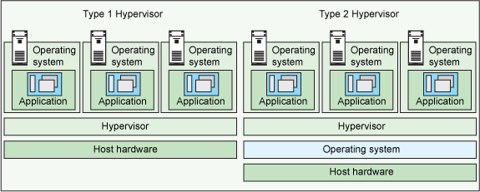

Figure 1 Diagram of Hyper-visor differences

**Type 1**

A Type 1 hypervisor runs directly on the host machine's physical hardware, and it's referred to as a bare-metal hypervisor; it doesn't have to load an underlying OS first. With direct access to the underlying hardware and no other software -- such as OSes and device drivers -- to contend with, Type 1 hypervisors are regarded as the most efficient and best-performing hypervisors available for enterprise computing.

While considered efficient and well performing, these hypervisors are also known to be very secure. This is because the flaws and vulnerabilities that are endemic to Operating Systems are often absent from Type 1, bare metal hypervisors. The underlying OS has been eliminated. Therefore, each Virtual Machine is isolated from the other and that same isolation guards them against malicious activities or threats.

**Hardware Support: Type 1**

When it comes to hardware support, Type 1 hypervisors use hardware acceleration software and cannot function without the availability of this technology. Hardware acceleration technologies basically help the Hypervisor perform the intensive tasks required to manage the virtual resources of the computer. Without these technologies, the hypervisor would have to handle the intensive tasks required for virtualization on its own. This would ultimately lead to a drop in virtualization performance and also restrict the number of guests VMs that could be hosted on a computer.

**Type 2**

A Type 2 hypervisor is typically installed on top of an existing OS, and it's called a hosted hypervisor because it relies on the host machine's pre-existing OS to manage calls to CPU, memory, storage and network resources.

Type 2 hypervisors are usually used in environments where there are a small number of servers. They do not need a separate management console to set up and manage the virtual machines. These operations can typically be done on the server that has the hypervisor hosted. This hypervisor is basically treated as an application on your host system. They are also convenient for testing any new software or research projects. You can simply run multiple instances with different OSes to test how the software works in each environment.

**Hardware Support: Type 2**

Type 2 Hypervisors typically use hardware acceleration technologies, if the features are available. However, they tend to fall back on software emulation if the support isn’t available on the physical host system.

One interesting technology is the KVM hypervisor. This open sourced Linux-based hypervisor is mostly classified as a Type-1 hypervisor, which turns the Linux kernel into a “bare metal” hypervisor. At the same time, the overall system is categorized as a type-2 hypervisor due to the full functional Operating System used. The unique KVM model allows for full virtualization and customized kernels (the core component of computer operating systems), allowing you the opportunity to set limits for the resources used, it also ensures that your virtual machines are more isolated and can host different Operating Systems other than Linux.

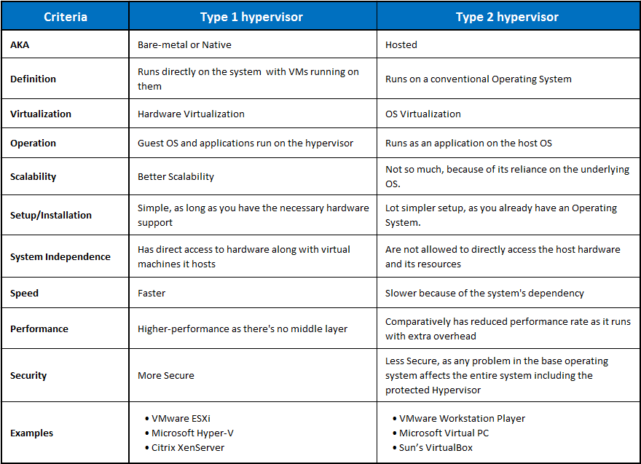

**Native v/s Hosted Hypervisor: Which is the better option of the two?**

For enterprise applications and cloud computing, the Bare-metal hypervisors are preferable, primarily because of its independence from the host operating system. For the same reason, type 1 generates lesser overhead, and any malfunction in an individual VM does not harm the rest of the system.

The native hypervisors are a more secure option. Unlike the hosted hypervisor, they do not depend upon the underlying OS. So, if under attack, you have better chances with the bare-metal hypervisor (Type 1). This dependency also costs the type 2 server, a little bit of its efficiency, performance, and speed.

Type 2 does not have direct access to the host hardware and resources, so this may make a certain degree of latency inevitable. The already present OS manages the requirements for memory, storage, and network resources.

Although this is not the case for more straightforward scenarios, Hosted Hypervisors are still popular for personal use and SMBs.

For some developer environments, like where access to multiple OSs and their variants is required, Type 2 hypervisors are a better option. On devices not dedicated to the VMs Host role, hosted hypervisors are recommended.