**OS PROJECT-HYPERVISORS  
BENCHMARKS**

**hdparm**

1. **Installing hdparm  
   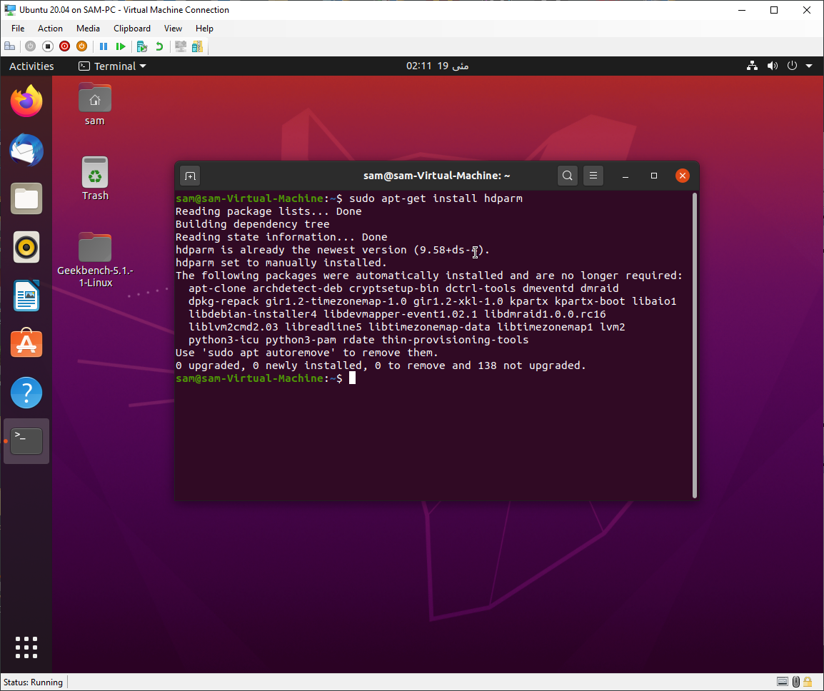**
2. **Hyperv results**  
   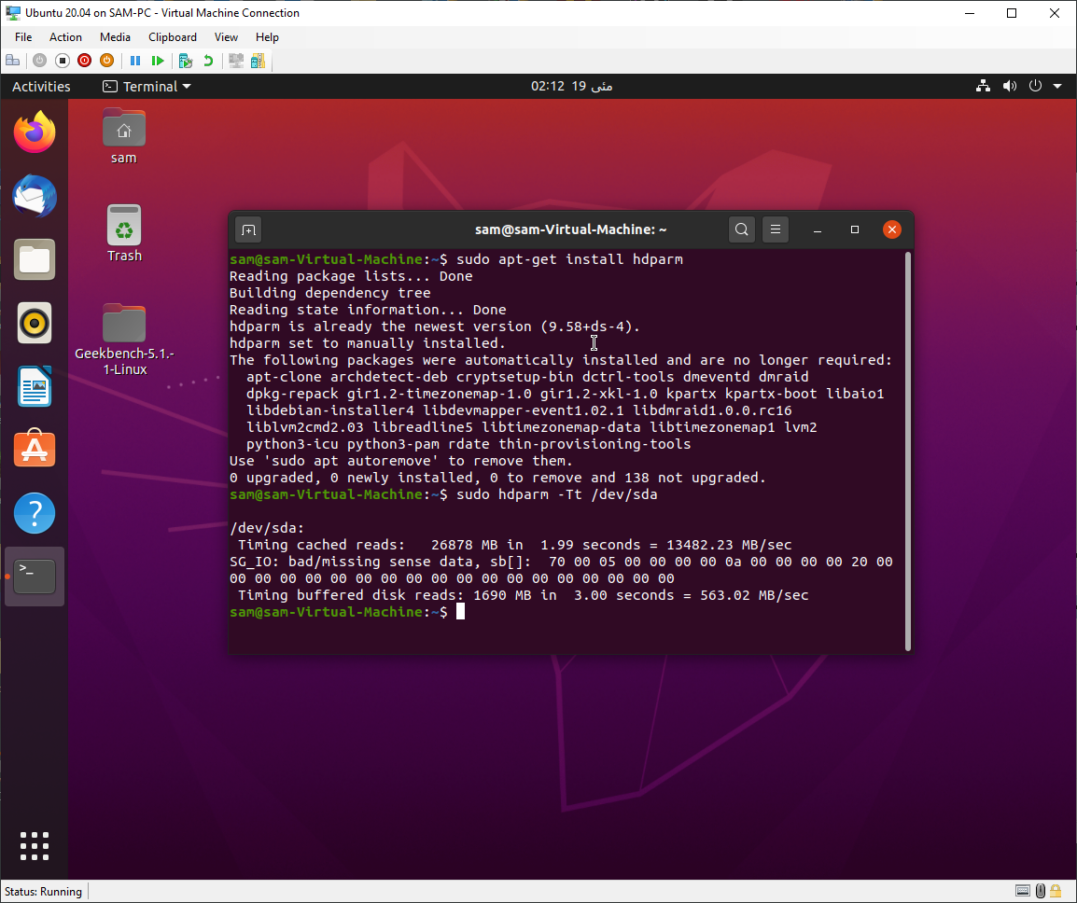
3. **VMware results**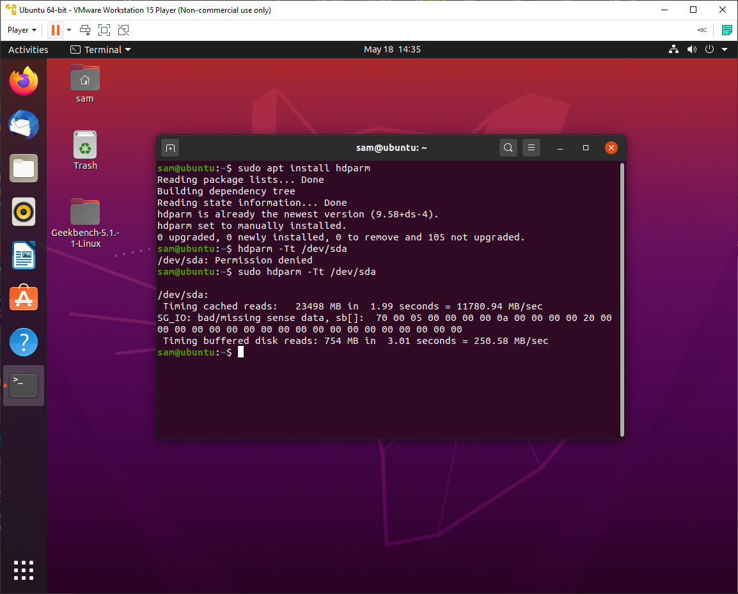
4. **VirtualBox results**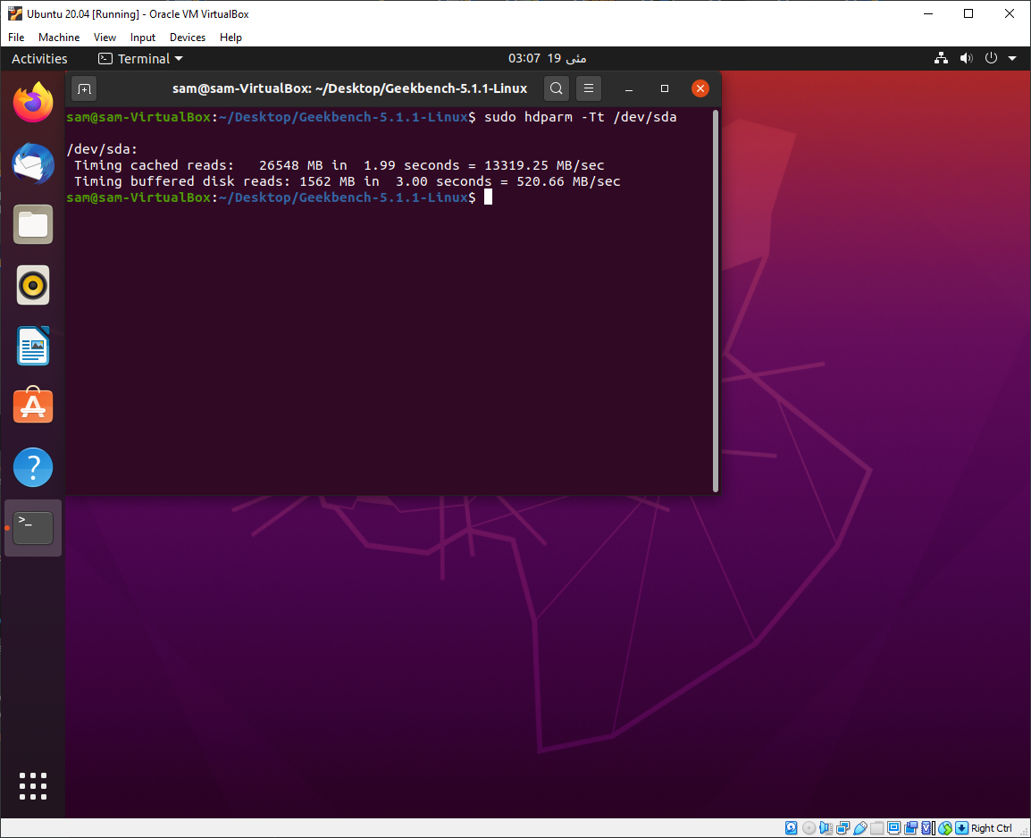

**sysbench**