Rahim Muhammad Syed 18k-0122  
Syed Abdullah Muzaffar 18k-0169  
Muhammad Ahmed Khan 18k-1103

OS PROJECT **HYPERVISORS**

**CLOSING THOUGhTS**

**OS PROJECT-HYPERVISORS****CLOSING THOUGHTS**

**Performance:**  
For general purpose/personal use, Type II hypervisors have matured enough that you can use them for almost any purpose(that does not require specialized hardware).  
However, if disk speed is a factor for you, then Native Hypervisors(Type I) are by far the best in terms of Disk I/O speed, as they do not have to interface with the Host OS I/O Scheduler, and instead get direct access to storage.  
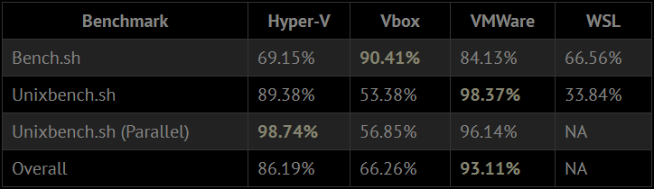  
The above table shows the performance in certain benchmarks, the reference link can be found at the end of the document. The author goes into deep details during his testing of the different hypervisors.

**Explaining the Performance:**

The performance deficit of Hyper-V can be attributed to the kernel having to manage both the guest and native OS.  
Secondly the performance gap has closed in recent years due to advancements in technology, especially with the introduction of Hardware Assisted Virtualization, called VT-x on the intel platform and AMD-V on the AMD platform, which are a set of instructions related to virtualization. These carry flags that can be checked in Linux using “/proc/cpuinfo”

**Caveats:**  
On most Hypervisors, GPU Performance is subpar, as most of the graphics processing occurs on the CPU, which is not ideal for these kinds of computations. This is done via software-based rendering which is marginally slower than hardware-based rendering. An alternative is to use GPU Passthrough, which however, requires an additional GPU and output (so that the main GPU can still display the hypervisor OS).  
However, Nvidia Quadro cards do support GPU Passthrough without having an extra card, as this is mostly a driver issue. Some workarounds do exist but are not recommended.  
Type II Hypervisors also have higher I/O latency and lower bandwidth(especially in the case of VMware disk performance).  
  
  
**Recommendations:**For personal use, I would recommend VMware, as it has easy host integration (drag and drop), and quite good performance, sometimes even beating the native Windows Host (due to Linux optimizations). However, for any storage-based tasks, it does fall short.  
For large scale and commercial use, Native Type I Hypervisors are a much better option, as they have direct access to hardware, which may speed up certain workloads by a large amount.  
However, if the majority of your work is done on a certain OS, then a Native install is much better, as hypervisors should only be used for testing/prototyping programs, and not for the majority of tasks (which should ideally be done natively).  
An exception to this is for security reasons, as a virtualized OS is less risky for the company.  
  
**References:**

<https://xioustic.com/2019/06/07/windows-hypervisors-benchmarks/>

<https://en.wikipedia.org/wiki/Virtualization>