Software Requirement and Design Specifications

**Workout and Fitness Tracker**

Version: [1.1]

|  |  |
| --- | --- |
| Course Code | CS-324 |
| Instructor | Javeria Farooq |
| Project Team | Rahim Muhammad (18K-0122)  Ahmed Khan (18K-1103)  Abdullah Muzaffar (18K-0169) |
| Submission Date | 12-01-2021 |

**Table of Contents**

**1.INTRODUCTION.................................................................................................................................3**

1.1. Purpose of Document.........................................................................................................3

1.2. Intended Audience .............................................................................................................3

1.3. Definitions of Terms, Acronyms and Abbreviations............................................................3

1.4. Document Convention.......................... .............................................................................3

**2. OVERALL SYSTEM DESCRIPTION.................................................................................................4**

2.1. Project Background.............................................................................................................4

2.2. Project Scope .....................................................................................................................4

2.3. Not In Scope ......................................................................................................................4

2.4. Project Objectives ..............................................................................................................4

2.5. Stakeholders ......................................................................................................................5

2.6. Operating Environment ......................................................................................................5

2.7. System Constraints.............................................................................................................5

2.8. Assumptions & Dependencies ...........................................................................................5

**3. EXTERNAL INTERFACE REQUIREMENTS.....................................................................................6**

3.1. Hardware Interfaces ...........................................................................................................6

3.2. Software Interfaces.............................................................................................................6

3.3. Communications Interfaces ...............................................................................................6

**4. FUNCTIONAL REQUIREMENTS.......................................................................................................7**

4.1. FUNCTIONAL HIERARCHY ..............................................................................................7

4.2. Use Cases..........................................................................................................................7

**5. NON-FUNCTIONAL REQUIREMENTS.............................................................................................9**

5.1. Performance Requirements................................................................................................9

5.2. Safety Requirements .........................................................................................................9

5.3. Security Requirements .......................................................................................................9

5.4. User Documentation...........................................................................................................9

SDS ......................................................................................................................................................10

**6. SYSTEM ARCHITECTURE .............................................................................................................11**

6.1. SYSTEM LEVEL ARCHITECTURE .................................................................................11

**7. APPLICATION DESIGN ..................................................................................................................12**

**8. REFERENCES ................................................................................................................................13**

1. **Introduction**
   1. **Purpose of Document**

The purpose of this document is to give an outline about the workout tracker app which is specifically designed to get you fit according to your body type and requirements. This document covers the major and minor details related to the application, its development and implementation.

* 1. **Intended Audience**
* Both Male and Female
* 13+
* For those who are seeking to get fit or improve their physique
  1. **Definitions of Terms, Acronyms and Abbreviations**
* **Rep:** Repetition
* **Curr:** Current
* **Set:** Multiple Repetitions grouped together
  1. **Document Convention**
* Font: Arial
* Size: Title:18B Subtitle:14B Body:11

1. **Overall System Description**
   1. **Project Background**Health is one of the most crucial concern for a human being. Now in this age with technology and diversity, many people have been neglecting their health due to either being distracted or becoming complacent, which is of course human nature. The Workout Tracker app aims to provide a healthy, effective and easy to implement routine to all those who wish to seek a healthy lifestyle. With this our goal is to allow our customers to enjoy this interactive technology as well reap its health benefits.
   2. **Project Scope**The Workout Tracker app is designed to present a customized workout routine based upon the users’ choices. We offer three plans: home exercise, powerlifting, and bodybuilding. The user will select a custom plan out of these only. Furthermore, the Workout Tracker app will provide a customized diet plan as well to cater the daily body requirement in order fully maximize the results obtained after a dedicated time period. It also considers diabetic and lactose intolerant users and provide them with a diet plan suitable to nurture them throughout the time period.
   3. **Not in Scope**The Workout Tracker app is not designed specifically for those who want to lose their weight. Although they can choose a common plan called home exercise that is designed to both lose weight and gain muscle doing home exercises, however, the app cannot cater the needs of users who have above 30% body fat. Furthermore, users having allergic reactions to certain diet components or have any other sensitive intolerance other to that which have been mentioned above, will not be able to benefit from this app.
   4. **Project Objectives**The Workout tracker app aims to provide a concrete solution to all those whose live busy lifestyle seeking to improve their health or find it difficult to go hire an effective personalized trainer due to time constraints or monetary disadvantage. Not only it offers a really effective home exercise plan but also those who go to the gym or have right machinery at home can benefit from its timely, well planned, well organized, customized, effective, and well researched plans. The diet plan mentions all the nutritional facts so that the user can keep track of their intake providing improvisation and flexibility of alternative choices the user can make in case he is not fond of a particular food item. The Workout Tracker app’s goal is to make a highly interactive and engaging platform that makes workout fun, challenging and easy to manage.
   5. **Stakeholders**The Stakeholders for this project include: the customers, the designers (UI designs), the developers (both frontend and backend), the researchers, and the owner/manager.
   6. **Operating Environment**The Workout tracker app is designed to work on the Android operating system, with a future iOS port as it takes its implementation from flutter and dart platforms, which are platform agnostic.
   7. **System Constraints  
      Software constraints:** The Workout Tracker App does not provide offline in-app functionality  
      **Hardware Constraints:** The Workout Tracker App does not support desktop-based systems, and requires a touch display.  
      **Cultural constraints:** The Workout Tracker App only supports English as primary mode of communication  
      **User constraints:** The Workout Tracker App is designed for age 13+ users only
   8. **Assumptions & Dependencies**The Workout tracker app does not give any explicit dependency, however, for the plans such as powerlifting and bodybuilding, it is assumed that the users have right machinery around them to execute these plans and they well aware how to use them in the right manner. The diets are customized; however, they do not cover all the wide variety of food items available all across the world. Due this reason nutritional facts are given to allow users to have a flexibility of choice with the available food items around them
2. **External Interface Requirements**
   1. **Hardware Interfaces**

* API 16 and above
* 1.2 GHz Processor
* Storage at least 40 MB
* RAM at least 512 MB
* At least 4” Device Display with minimum Resolution 1280*720  
  1. **Software Interfaces**
* Android v4.4 and above  
  1. **Communications Interfaces**
* Connection to the internet
* Http protocol that allows for a connection to the mongodb server on which the database is stored

1. **Functional Requirements**
   1. 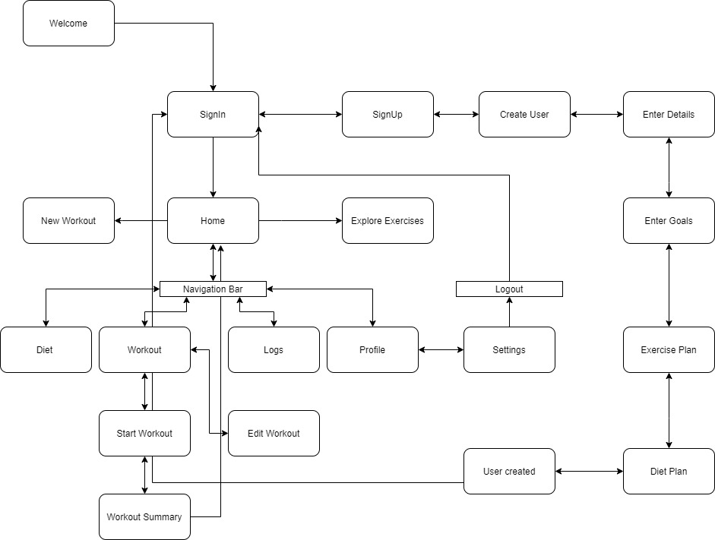**Functional Hierarchy**
   2. **Use Cases**
      1. **[Title of use case]**
2. **Non-functional Requirements**
   1. **Performance Requirements**

* Minimum Android Version: Kitkat 4.4
* Display Resolution: 1280*720 or above
* Internet Connectivity: Wifi/4G
* Response within <5s from API
* Scalable to 1000’s of users
  1. **Safety Requirements**
* The app is not a replacement for a professional dietitian or physician
* Users should follow the rules of their workout environment
* Users should consult their physician in cases of any health issues
* User performs the mentioned workout routines at their own risk
  1. **Security Requirements**
* Users should insert a correct name, email and a secure password
* Users should not share any sensitive or private information within the app, or its related sites, developers etc
* User information should be securely stored
  1. **User Documentation**
* Play Store Tutorial/Screenshots (once available)

**SDS**

1. **System Architecture**
   1. **System Level Architecture**
      1. 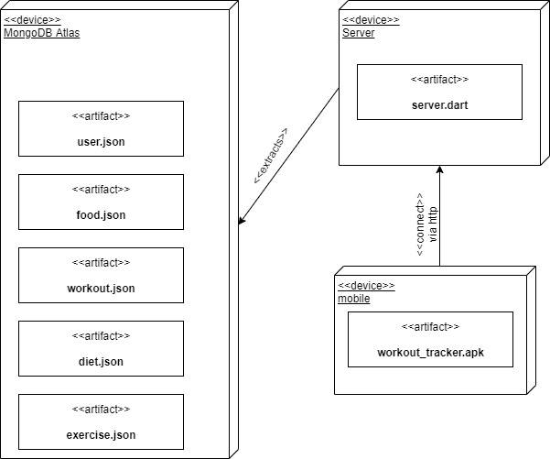**Deployment Diagram**
2. **Application Design**
   1. **Sequence Diagram**
      1. 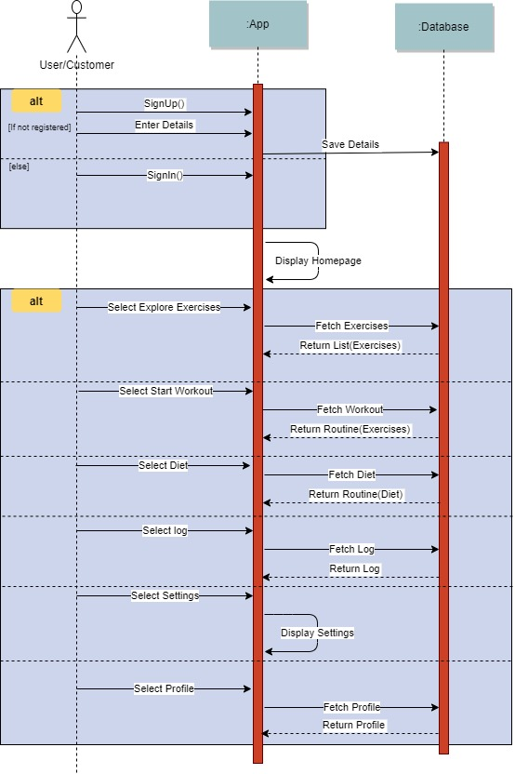
   2. **State Diagram**
      1. 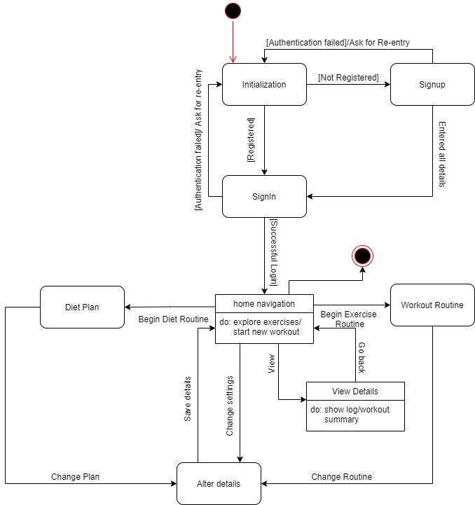
   3. **Activity Diagram**
      1. 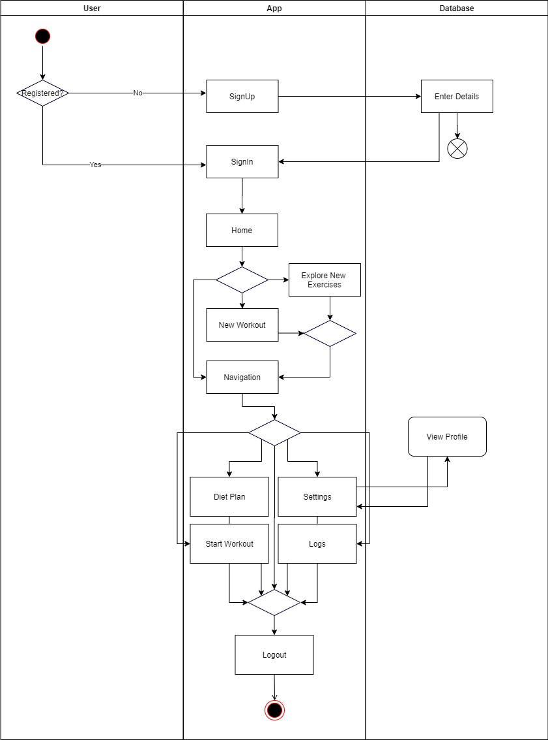
3. **References**
   1. [**https://stackoverflow.com/**](https://stackoverflow.com/)
   2. [**https://www.youtube.com/**](https://www.youtube.com/)
   3. [**https://github.com/**](https://github.com/)
   4. [**https://medium.com/**](https://medium.com/)
   5. [**https://flutter.dev/**](https://flutter.dev/)
   6. [**https://pub.dev/**](https://pub.dev/)
   7. [**https://material.io/**](https://material.io/)