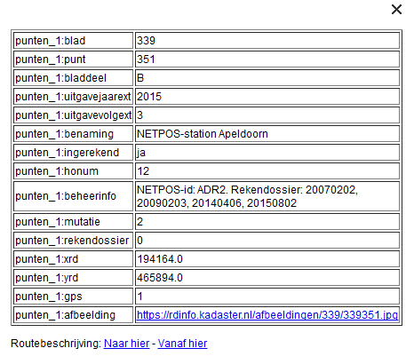
<Placemark id="punten.2555">
<ExtendedData>
<SchemaData schemaUrl="#punten_1">
<SimpleData name="blad">339</SimpleData>
<SimpleData name="punt">351</SimpleData>
<SimpleData name="bladdeel">B</SimpleData>
<SimpleData name="uitgavejaarext">2015</SimpleData>
<SimpleData name="uitgavevolgext">3</SimpleData>
<SimpleData name="benaming">NETPOS-station Apeldoorn</SimpleData>
<SimpleData name="ingerekend">ja</SimpleData>
<SimpleData name="honum">12</SimpleData>
<SimpleData name="beheerinfo">NETPOS-id: ADR2. Rekendossier: 20070202, 20090203, 20140406, 20150802</SimpleData>
<SimpleData name="mutatie">2</SimpleData>
<SimpleData name="rekendossier">0</SimpleData>
<SimpleData name="xrd">194164.0</SimpleData>
<SimpleData name="yrd">465894.0</SimpleData>
<SimpleData name="gps">1</SimpleData>
<SimpleData name="afbeelding">https://rdinfo.kadaster.nl/afbeeldingen/339/339351.jpg</SimpleData>
</SchemaData>
</ExtendedData>
<Point>
<coordinates>5.960875677499551,52.17998675762006</coordinates>
</Point>
</Placemark>

Bron | Longitude (X) | Latitude (Y)
KML uit PDOK | 5,96087567749955 | 52,17998675762000
RDinfo.nl | 5,95981835833333 | 52,17979812222220
Verschil | 0,00105731916622 | 0,00018863539780
in meter | 117,47990735777600 | 20,95948864422330

1° = 40.000 km / 360° = 111.111,111 meter

