

Maternal Serum Screening – Dual Marker Report

{d.patientName}

Patient Name

{d.referredBy}

{d.patientName}

Referred By

Patient ID

**First Trimester Combined Screening - Double Marker with NT**

Patient Information

|  |  |  |  |
| --- | --- | --- | --- |
| Date of Birth | {d.dateOfBirth} | Collected On | xxxxxxx |
| Ethnicity | {d.ethnicity} | Reported On | xxxxxxx |
| Weight | {d.weight} KG | Height | {d.height} CM |
| Smoking | xxxxxxx | Diabetes | {d.diabetes} |
| HCG Injection | {d.hcgInjection} | HCG Injection (Last Dose On) | {d.hcgInjectionDate} |

Pregnancy Information

|  |  |  |  |
| --- | --- | --- | --- |
| LMP | {d.lastMenstrualPeriod} | # of Fetus | {d.numberOfFetus} |
| Gravida | {d.gravida} | Parity | {d.parity} |
| Previous History | {d.previousTrisomy21} {d.previousTrisomy13} | {d.previousTrisomy18} {d.previousTurner} | {d.previousNTD} |

|  |  |  |  |
| --- | --- | --- | --- |
| Method of Conception | {d.methodOfConception} | If IVF (Self/ Donor) | {d.ivfPersonType} |
| If IVF (Fresh/Frozen) | {d.ivfState} | If Donor, DOB of Donor | {d.donorDOB} |
| Date of Egg Collection | {d.eggColDate} | Date of Egg Transfer | {d.previousNTD} |

**ADVANCED GENOMICS INSTITUTE AND LABORATORY MEDICINE PVT LTD**

1513, First Floor, Guman Puri Complex, Wazir Nagar, Bhishma Pitamah Marg, New Delhi – 110003

Phone: +91 11 24603559, +919999746045, Email: customercare@labassure.com, Website: labassure.com

Ultrasound Information

|  |  |  |  |
| --- | --- | --- | --- |
| Name of Sonologist | {d.sonologistName} | Ultrasound Date | {d.ultrasoundDate} |
| Gestational Age  (based on biometrics) | {d.gestationalAgeBiometrics} | Gestational Age  (based on USG) | {d.gestationalAgeUSG} |
| BPD | {d.bpd} | Fetal Heart Rate | {d.fetalHeartRate} |
| CRL | {d.crl} | NT | {d.nt} |



Page 1 of 2

Results

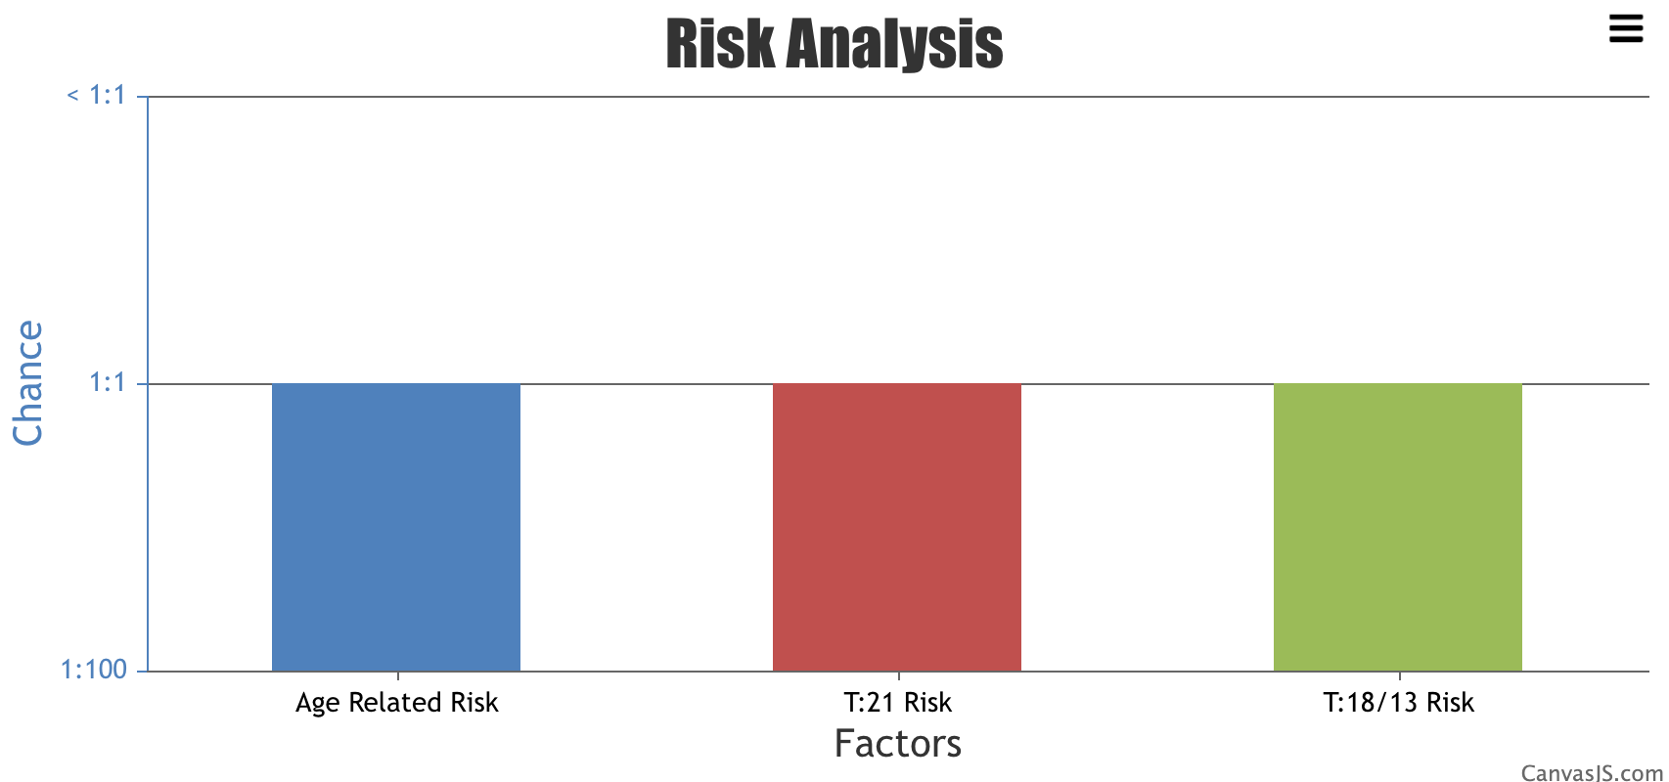

|  |  |  |
| --- | --- | --- |
| **Date of Testing** | {d.dateOfTesting} | {d.immunoassayAnalyzer} |
| **Free BHCG** | {d.} IU/ML | {d.momBHCG} MOM |
| **PAPPA** | {d.} IU/ML | {d.momPappa} MOM |
| **NT** | {d.} mm | {d.momNT} MOM |

|  |  |  |
| --- | --- | --- |
| Age Related Risk (Background Risk) | {d.ageRelatedRisk} |  |
| RISK ASSESSMENT | | |
| Trisomy 21 Risk (Downs Syndrome) | {d.trisomy21Risk} |  |
| Trisomy 13/18 Risk (Edwards & Patau Syndrome) | {d.trisomy1318Risk} |  |
| Final Assessment: The risk assessment for this pregnancy based on the biochemical screening and ultrasound findings (if provided) is found to be NEGATIVE | | |
| These risks were analyzed with SsdwLab 5.0.14. The risk values are based on the information provided by the referring doctor and the ultrasound markers. Any change or discrepancy in this information can affect the test results. LABASSURE does not bear responsibility for the ultrasound markers and patient information provided by the customer. LABASSURE assumes that the ultrasound markers for risk assessment are provided by qualified individuals currently holding Fetal Medicine Foundation FMF (UK) or equivalent accreditation and have used the FMF (UK) or equivalent guidelines in their measurements. | | |

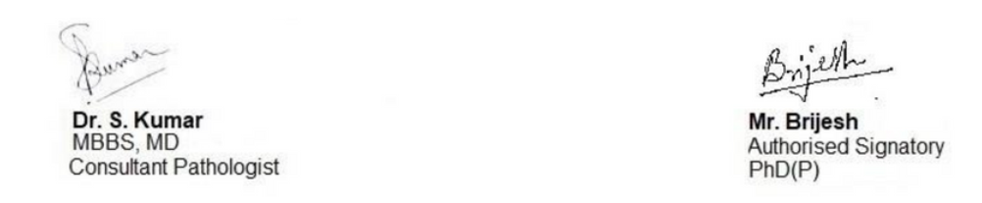

Page 2 of 2

**ADVANCED GENOMICS INSTITUTE AND LABORATORY MEDICINE PVT LTD**

1513, First Floor, Guman Puri Complex, Wazir Nagar, Bhishma Pitamah Marg, New Delhi – 110003

Phone: +91 11 24603559, +919999746045, Email: customercare@labassure.com, Website: labassure.com

NOTE: The test results should be clinically correlated and additional testing may be warranted before taking any medical decision. It must be clearly understood that the results represent risks and not diagnostic outcomes. Increased risk does not mean that the baby is affected and further test must be performed before a firm diagnosis can be made. A low risk does not exclude that the possibility of Down syndrome or other abnormalities, as the risk assessment does not detect all affected pregnancies. The results assume that the sample is provided from this patient only and that all patient information provided is correct

Eqqdq