|  |  |  |  |
| --- | --- | --- | --- |
| ***Patient Name*** | driz | | |
| ***Patient ID*** | 00001 | ***Referred By:*** | njk |

|  |  |  |  |
| --- | --- | --- | --- |
| **Pregnancy Details** | | | |
| **Last Menstrual Period (LMP)** | sddws | **Gravida (# of times pregnant)** | efwfew |
| **No.** **of** **Fetus** | wefwef | **Parity (GA>20 wks)** | wefwef |
| **Previous History** | Yes | **Method of** **Conception:** | Spontaneous |
| **Previous Trisomy 21** | true | **If** **IVF** **(Self/** **Donor)** | Self |
| **Previous Trisomy 18** | false | **If** **Donor,** **DOB** **of** **Donor** |  |
| **Previous Trisomy 13** | false | **If** **IVF** **(Fresh/Frozen)** |  |
| **Previous Turner** | false | **Date** **of** **Egg** **Collection** |  |
| **Previous** **NTD** | false | **Date of Egg Transfer** |  |

|  |  |  |  |
| --- | --- | --- | --- |
| **PATIENT** **DETAILS** | | | |
| Date of Birth | 2024-03-10 | **Diabetes** **(ID/NID)** | wqdqwd |
| **Weight (in Kg)** | 213 | **HCG** **Injection** **(Yes/No)** | false |
| **Height (in cm)** | 87987 | **HCG** **Injection** **(Last Dose On)** | 2024-03-29 |
| **Ethinicity** | wdvvw |  |  |

|  |  |  |  |
| --- | --- | --- | --- |
| **ULTRASOUND** **DETAILS** | | | |
| **Name of Sonologist** | 83134 | | |
| **Ultrasound Date** | 2024-03-29 | **BPD** |  |
| **Gestational** **Age based on biometrics** | qewfeqw | **Gestational** **Age based on USG** | qfqfqw |
| **Fetal Heart Rate** | eqfwe | **CRL** | qfeqew |
| **NT** | qefqewf |  |  |
|  |  |  |  |

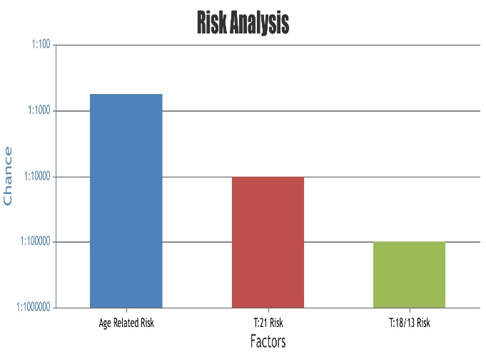

|  |  |  |  |  |
| --- | --- | --- | --- | --- |
| **TEST** **DETAILS** | | | | |
| Date of Testing | 2024-03-05 | | Immunoassay Analyzer | qwdqw |
| Free BHCG | qeqefq | IU/L | dvqwefew | MoM |
| PAPPA | qfqfeq | IU/L | qfwqfqw | MoM |
| NT | fqwqf | mm | jb | MoM |

|  |  |  |
| --- | --- | --- |
| Age Related Risk (Background Risk) | jib |  |
| RISK ASSESSMENT | | |
| Trisomy 21 Risk (Downs Syndrome) | qwdq | Low |
| Trisomy 13/18 Risk (Edwards & Patau Syndrome) | bbjk | Low |
| Final Assessment: The risk assessment for this pregnancy based on the biochemical screening and ultrasound findings (if provided) is found to be NEGATIVE | | |

NOTE: The test results should be clinically correlated and additional testing may be warranted before taking any medical decision. It must be clearly understood that the results represent risks and not diagnostic outcomes. Increased risk does not mean that the baby is affected and further test must be performed before a firm diagnosis can be made. A low risk does not exclude that the possibility of Down syndrome or other abnormalities, as the risk assessment does not detect all affected pregnancies. The results assume that the sample is provided from this patient only and that all patient information provided is correct.

**Understanding the Risk Assessment Methodology**

These risks were analyzed with SsdwLab 5.0.14. The risk values are based on the information provided by the referring doctor and the ultrasound markers. Any change or discrepancy in this information can affect the test results. LABASSURE does not bear responsibility for the ultrasound markers and patient information provided by the customer. LABASSURE assumes that the ultrasound markers for risk assessment are provided by qualified individuals currently holding Fetal Medicine Foundation FMF (UK) or equivalent accreditation and have used the FMF (UK) or equivalent guidelines in their measurements.