1. In google calendar add new event “My event” with time 18:35

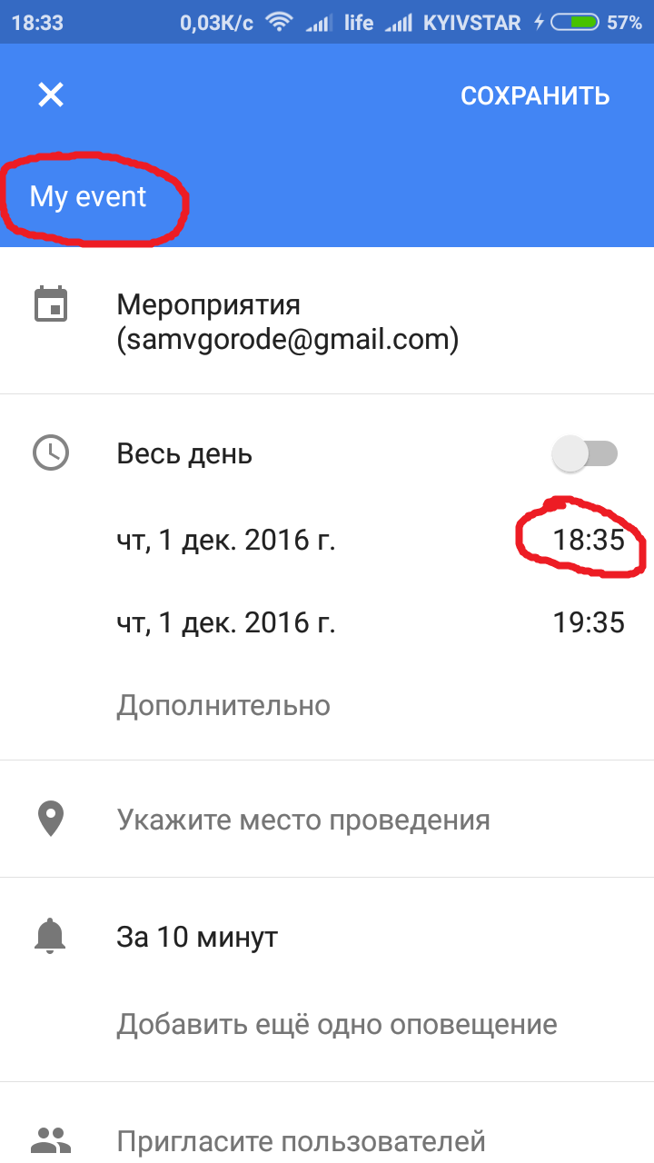

1. Open my app CalendaNot and choose calendar where owner of account is me [samvgorode@gmail.com](mailto:samvgorode@gmail.com)

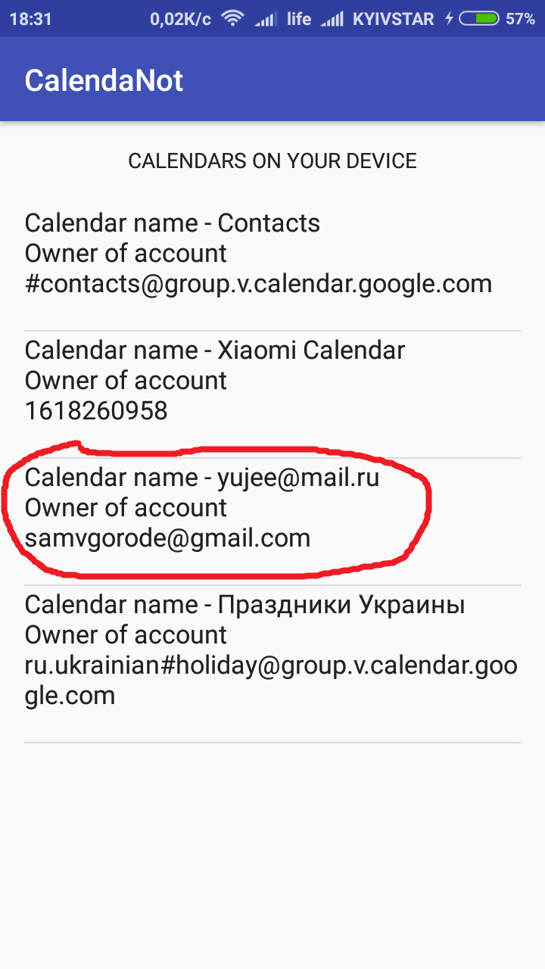

1. Click on it and see list of events. Choose with title “My event” and time start 6:35:00 pm (I’ve just added in from google calendar)

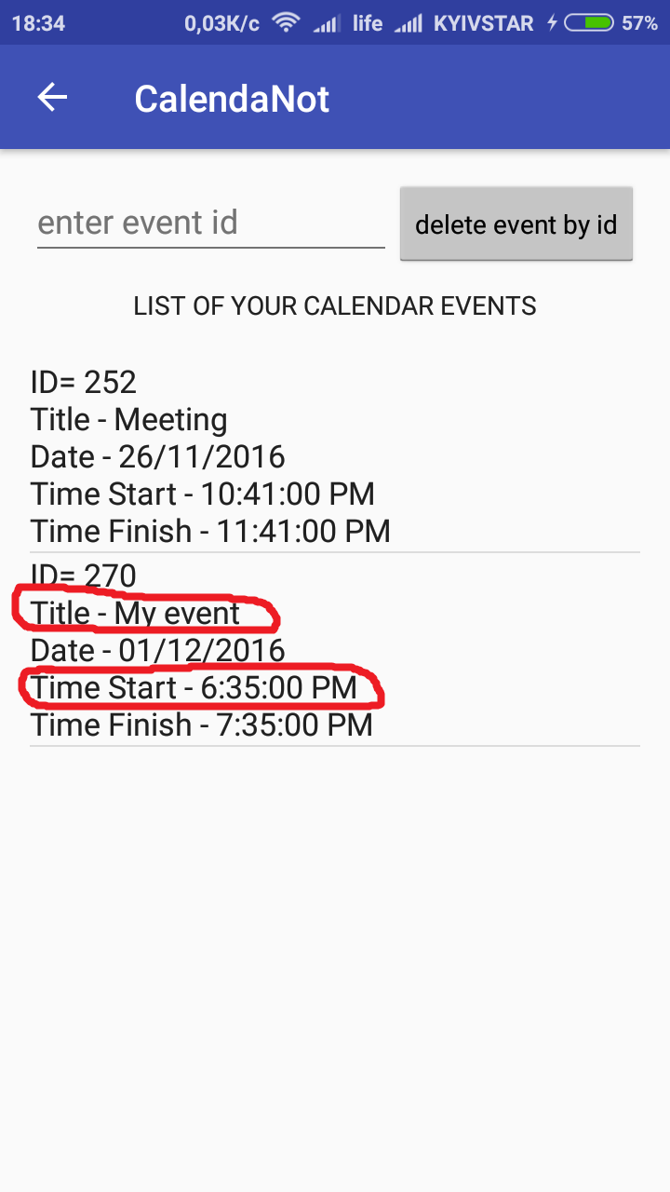

1. In EditText near button “add min after to fill form” enter 1 (one minute), then click this button.

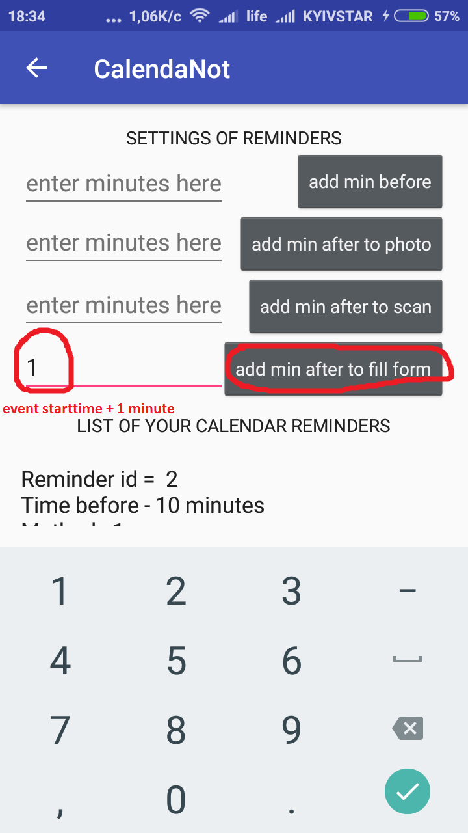

1. Wait for a minute (the time 18:35+1 minute=18:36) and you will see a notification. Click on it.

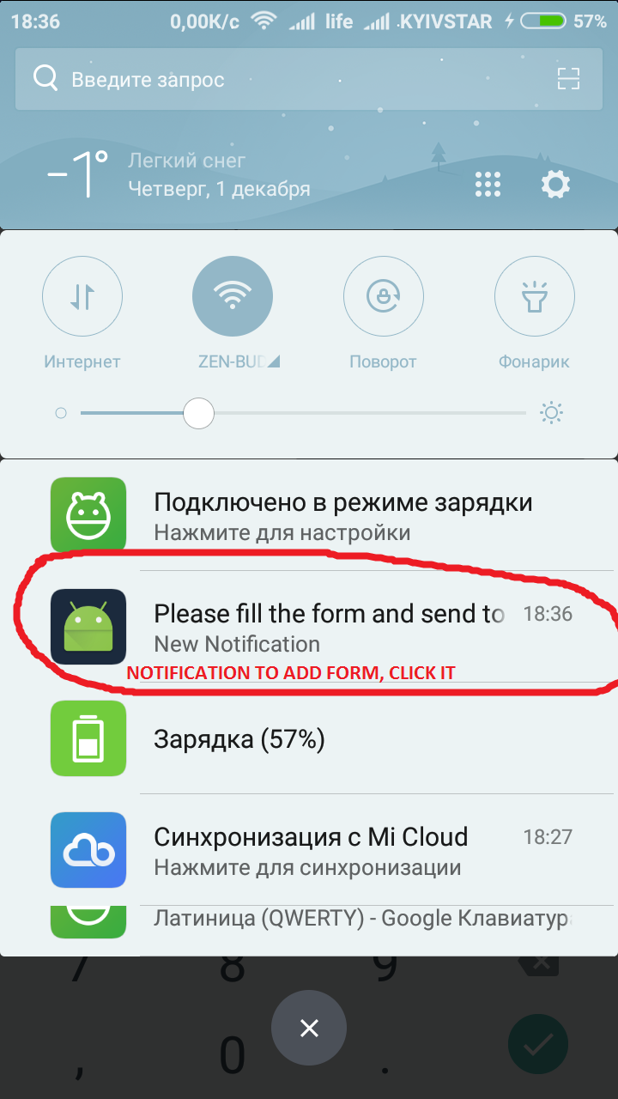

1. After that you will see the form. Fill it with some data.

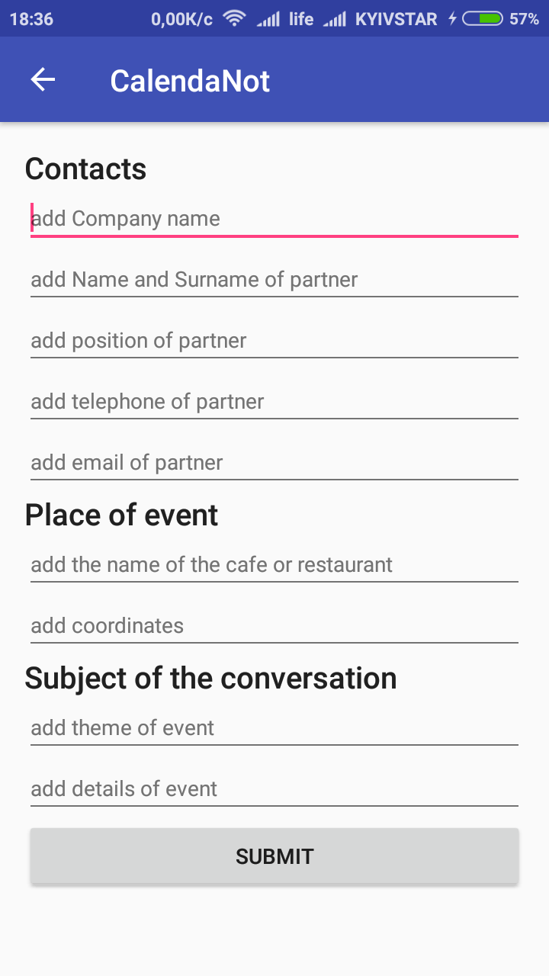

1. Fill the form as I’ve done. Click button “Submit”

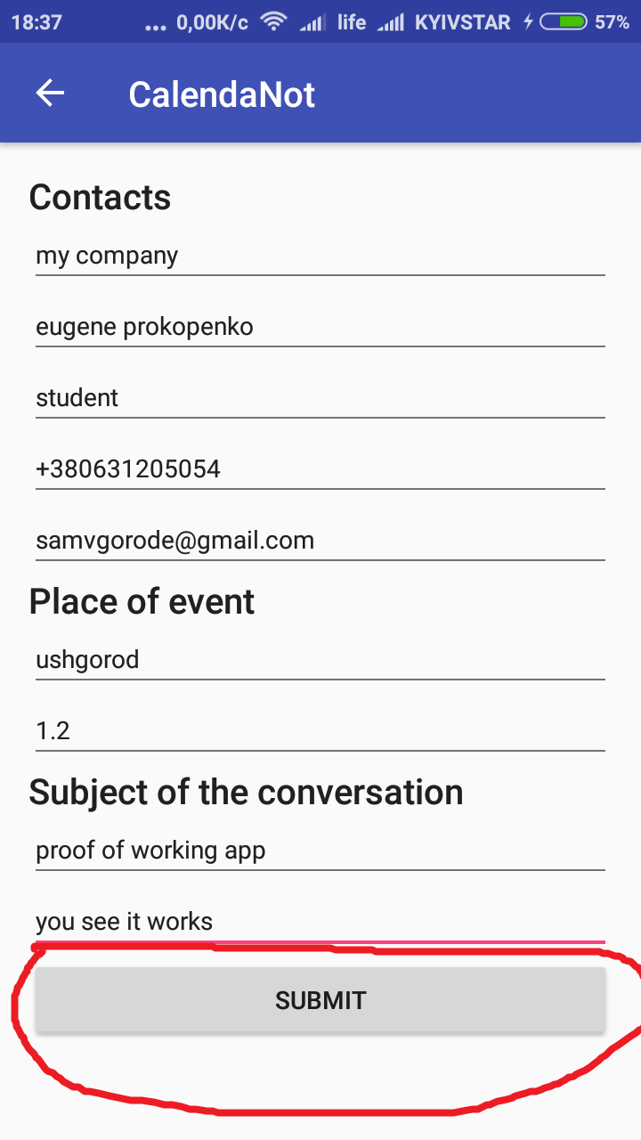

1. I check google sheet <https://docs.google.com/spreadsheets/d/1-o1G1SKLlO9oPzLzwoAvp2Nkq2QPx8NbnUnWEBx3LnE/edit?usp=sharing> and see my results, which I’ve entered before…

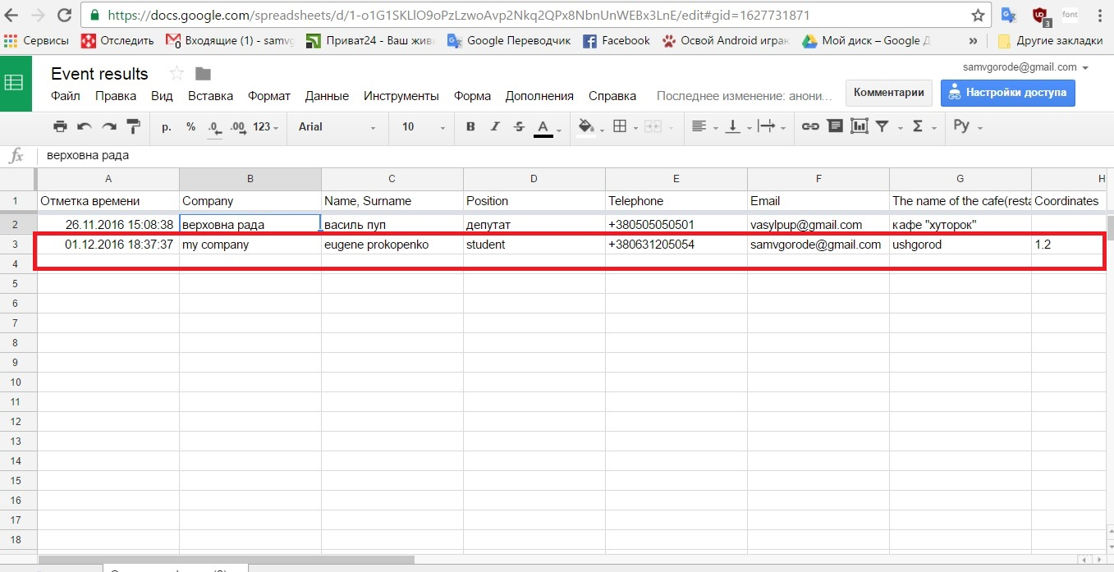

ALL WORKS!!!