Library Management System

This System is for monitoring and controlling the transactions in a library, which mainly focuses on basic operations in a library like adding new member, new books, and updating new information, searching books and members and facility to borrow and return books.

“Library Management System” is an attractive user interface, combined with strong searching Insertion and reporting capabilities.

The software Library Management System has four main modules.

Insertion to Database Module – User friendly input screen

Extracting from Database module – Attractive Output Screen

Report Generation module – borrowed book list & Available book list

Search Facility system – search for books and members

SYSTEM ANALYSIS

EXISTING SYSTEM:

In our existing system all the transaction of books are done manually, So taking more time for a transaction like borrowing a book or returning a book and also for searching of members and books. Another major disadvantage is that to preparing the list of books borrowed and the available books in the library will take more time, currently it is doing as a one day process for verifying all records. So after conducting the feasibility study we decided to make the manual Library management system to be computerized.

PROPOSED SYSTEM

Proposed system is an automated Library Management System. Through our software user can add members, add books, search members, search books, update information, edit information, borrow and return books in quick time. Our proposed system has the following advantages.

User friendly interface Fast access to database less error
                More Storage Capacity

Search facility

Look and Feel Environment

Quick transaction

All the manual difficulties in managing the Library have been rectified by implementing computerization.

DATA FLOW Diagram

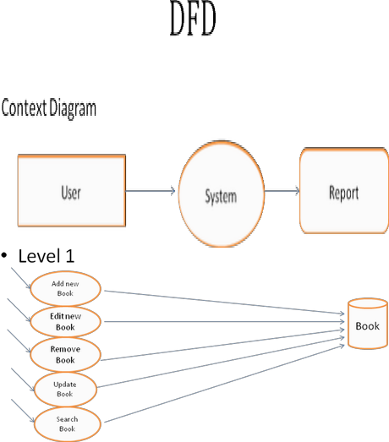

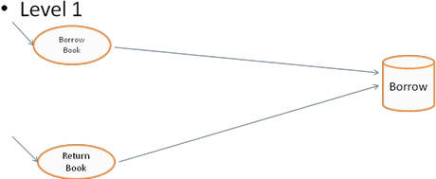

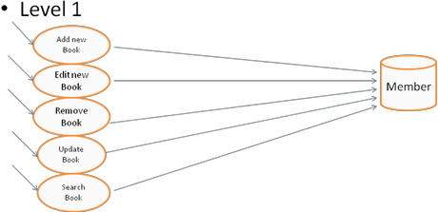

SOFTWARE INTERFACE

Add New Book

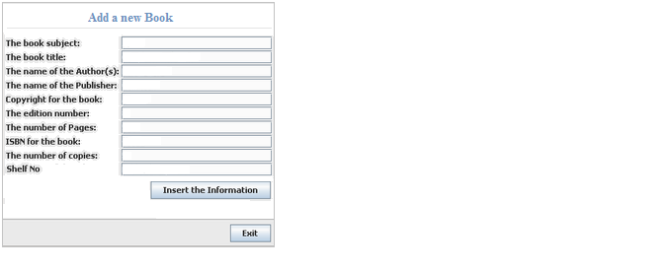

Listing All Books

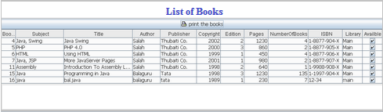

Available Books

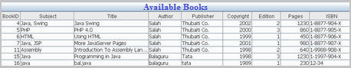

Borrowed Books

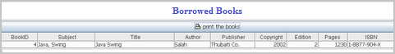
Remove Book

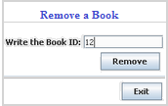

Edit Book Details

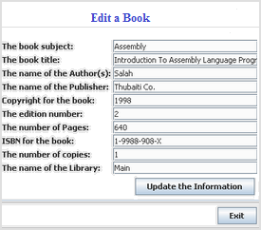

Add a Member

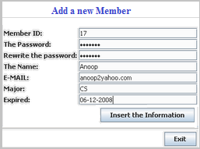

Listing all Members

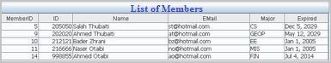

Edit a member

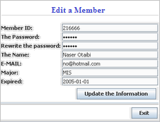

Remove a member

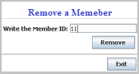

Search for Members and Books

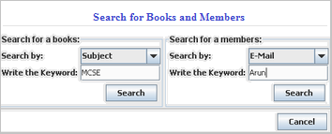

Borrow Books

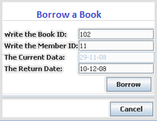

Returning a Book

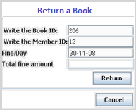

List of Issued Books

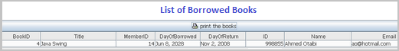

TABLES USED

Table Name: Books

Field Name | Data Type | Description
BookId | AutoNumber | Primary Key
Subject | Text (30) | -
Title | Text (30) | -

Author | Text (25) | -
Publisher | Text (25) | -
Copyright | Number | -
Edition | Number | -
Pages | Number | -
ISBN | Text | -
NumberOfBooks | Number | -
NumberOfAvailbleBooks | Number | -
NumberOfBorrowedBooks | Number | -
Library | Text(25) | -
Availble | Yes/No | -
ShelfNo | Number | -

Table Name: Borrow

Field Name | Data Type | Description
BookId | Number | Primary Key
MemberID | Number | -
DayOfBorrowed | Date/Time | -
DayOfReturn | Date/Time | -

Table Name: Members

Field Name | Data Type | Description
MemberId | AutoNumber | Primary Key
ID | Number | -
Password | Text(10) | -
NAME | Text(25) | -
EMAIL | Text(25) | -
Major | Text(10) | -
NumberOfBooks | Number | -
Mony | Number | -
Expired | Date/Time | -

