**FURSA LAB REQUIREMENTS FOR ONLINE APPLICATION – IN TEKNOHAMA WEBSITE**

FURSA LAB PROGRAMME – Online Application

Email: [rajabupazi89@gmail.com](mailto:rajabupazi89@gmail.com)

1. **FURSA LAB MAIN MENU**
   1. DASHBOARD – FURSA LAB Information (See in attachment)
   2. PERSON PARTICULARS INFORMATION

* First Name/ji
* Middle
* Last Name
* Gender
* Birthdate
* Place of birth
* Country of Residence
* Nationality
* Disability
  1. CONTACT INFORMATION
* Mobile Number
* Email
* Physical Address
* Residence Location
  1. PAYMENT INFORMATION
* Application Payment Information

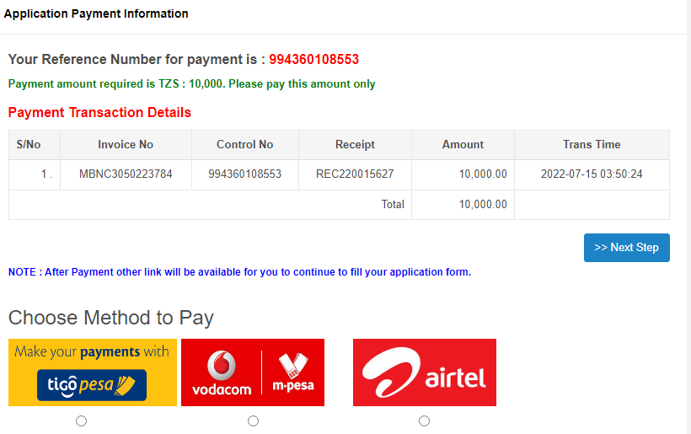

* 1. PARENT/GURDIANS/NEXT OF KIN INFORMATION
* Full Name
* Mobile Number
* City
* Street
* Email
* Address
* Occupation
* Relation
  1. CHOOSE COURSE
* Basic Computer Application
* Advanced Computer Application
* Graphics Design
* Motion Graphics
* Website Development
* Digital Marketing and Business Strategies
* Basic Computer (Primary & Secondary)
* Scratch Programming (Primary & Secondary)
* Lego Mindstorms Robotics (Primary & Secondary)
* Robotics with Arduino (Secondary)
* Basic Programming ((Primary & Secondary))
* Other Specify………………………………………………………………………
  1. APPLICATION SUBMISSION
* **Preview Application, Print and Submit**

*Dear* ***Applicant****,*  
  
*Congratulations, You have submitted your application successfully. You are registered to join* ***DTBI*** *& AIRTEL* ***FURSA LAB****. In here you can realise your potential today.*  
*Thank you for choosing FURSA LAB.*  
*Regards,*  
*Admission Officer*

*Dear* ***Applicant****,*  
  
*Congratulations, You have submitted your application successfully. You are registered to join* ***DTBI*** *& AIRTEL* ***FURSA LAB****. In here you can realise your potential today.*  
  
  
*Thank you for choosing FURSA LAB.*  
  
  
*Regards,*  
  
  
*Admission Officer*