1.Click-----> <https://www.google.com/maps> OR

<https://www.google.com/maps/@api=1&map_action=pano&parameters>

2.Click-----> On the top left Conner write the name of your area including district name and word

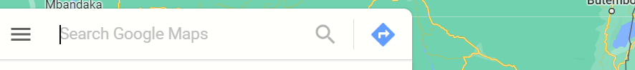

3. then click on the Google icon and click share at the left near upper conner

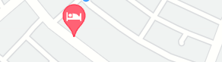

4. Copy the link shown

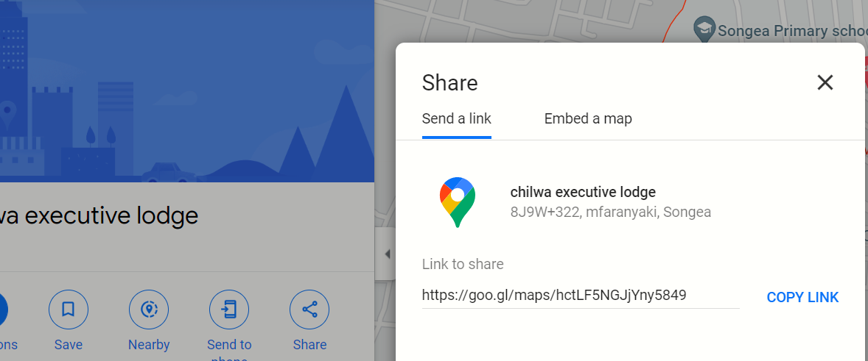

5. Past the copied link to your google location

6.Finish.