**WATCH AND GUARD (T) LIMITED**

**SECURITY COMPANY**

***WE WATCH TO PROTECT***



**COMPANY PROFILE**

**PURPOSE**

Businesses face an ever increasing security risk in a pressurized trading environment and therefore require dynamic and innovative security solutions

**H**ISTORY

WATCH AND GUARD (T) LTD was established in 2002 for meeting the clients’ needs stated above. Meanwhile it is headquartered in Dar es Salaam with branch offices in Mbeya, Moshi, Arusha and Zanzibar. It is our aim to have offices in all regions by 2025.

**EXPECTATONS**

* We offer a service which at all times is measurable through the implementation of a mutually agreed service level agreement
* We are a 100% Tanzanian company - We know and understand our environment.
* Hands on Management and dedicated supervisory support infrastructure
* Pay strictly in accordance with legislation and are 100% statutory compliant
* We endeavour to foster stability in Management and staff
* Personalized Executive Director involvement
* Value Added Services

**VISION**

To provide distinct services in security through our understanding of the local landscape, with, excellence, innovation and dedication as key drivers of our core business philosophy to provide exceptional client services

**MISSION**

Provide secure solutions that ensure local growth and set industry benchmarks of service excellence

**VALUES**

1. **Integrity** - We can be consistently relied upon to practice high ethical and professional standards in our service delivery.
2. **Customer Focus** - We have close, open relationships with our customers that generate trust to ensure the mutual benefits of our organizations.
3. **Expertise** - We develop and demonstrate our expertise through our innovative, leading edge approach to creating and delivering the right security solution.
4. **Performance** - We challenge ourselves to improve performance on a day to day basis to create long-term sustainability.
5. **Best People** - We take care to employ the best quality people, develop their competence through skills transfer programs, provide further opportunities within the organization and inspire them to perform in accordance with our company values.
6. **Collaboration and Teamwork** - We collaborate to ensure the success of ourselves, our staff and our customers.

**SERVICES**

Watch and Guard (T) Limited’s principal business activity is providing man guards and total technology security solutions for clients in t 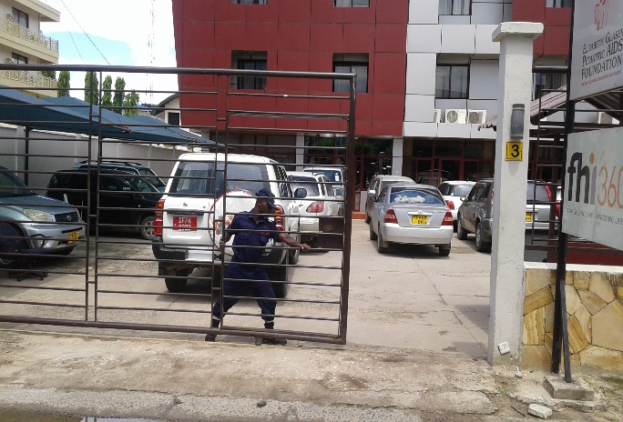he commercial, industry, residential, governmental and market places. Watch and guard offers a wide range of security services and alarm systems such as:

* Site Security Evaluations / Risk Analysis
* Armed and Unarmed Guards
* Access Control Systems
* Gated Estate Security Solutions
* Urban Community Guarding
* Alarm Monitoring and Armed Response
* CCTV Surveillance & Online Monitoring
* Security Investigations
* Covert Operatives
* Industrial Unrest Protection
* Body Guards & VIP Protection
* Electric Fencing

**OUR CONTACTS:**

**Watch and guard (T) Limited,**

**Plot 58 Block E Tabata Aroma,**

**P.O. Box 8532,**

**Dar-Es-Salaam.**

[**info@watchandguard.com**](mailto:info@watchandguard.com); [www.watchandguard.co](http://www.watchandguard.com).tz

**+255 752 002205, +255 784 335566, +255 719 777737**