Introduction

This is the Integrated Development Environment (IDE) of Distributed Matlab, in which user can program mathematical scripts and executes them. IDE contains Text editor in which user can edit their scripts and compiler which compiles the user scripts so they can be executed on LocalMachine.
The software is so light weight and easy to use, editor provides all important functions required to edit code like, copy, paste, undo, redo…etc. And it provides a shortcut key for each function so user can access the functions through keyboard also. User can also run the scripts from the Integrated Development Environment.
Software provides a window through which user can change the settings of LocalMachine easily by graphical interface, like configuring the remote processors and external devices.

Application Workspace

Run
Compile
Paste
Copy
Cut
New
Open
Save
Editor
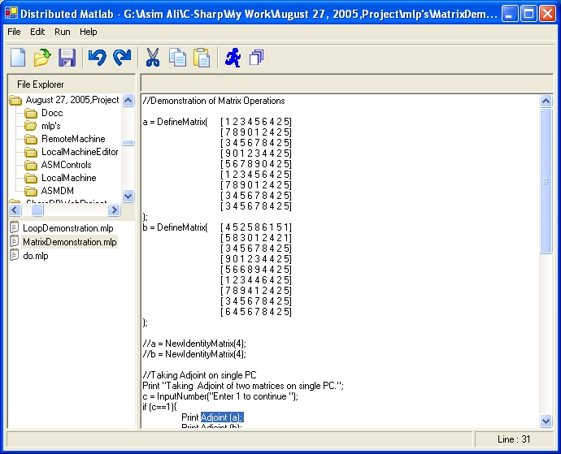
Folder Explorer
File Explorer

Above is the picture of Integrated Development Environment of Distributed Matlab.

Accessing Tools and Features
New (CTRL+N) | Create a new program file
Open (CTRL+O) | Open an existing program file.
Save (CTRL+S) | Save program file on disk.
Undo (CTRL+Z) | Undo action
Redo (CTRL+Y) | Redo action
Copy (CTRL+C) | Copies the selected text
Cut (CTRL+X) | Cut the selected text
Paste (CTRL+V) | Paste
Run (CTRL+F9 | Compile and execute the current program file.
Compile (CTRL+F8) | Compile the current program file.
Execute (CTRL+F7) | Execute the current program file
Load Compiled File | Execute a precompiled file.

Conclusion

Now this Integrated Development Environment is not much powerful, now it provides you only the basic functions so you can compile and execute your mathematical scripts. Currently It does not provide the syntax checking and extra helpful features.
But I am looking forward to make this IDE more powerful and helpful, so it can provide you the syntax checking mechanism also. And some other extra features normally other IDE provide you.
And soon I will make a standalone compiler for Distributed Matlab, not attached with IDE, so you will be able to write your code in any good Integrated Development Environment and compile it manually with the standalone compiler and launch the compiled file in LocalMachine by just passing it through command line argument.

